1. a)
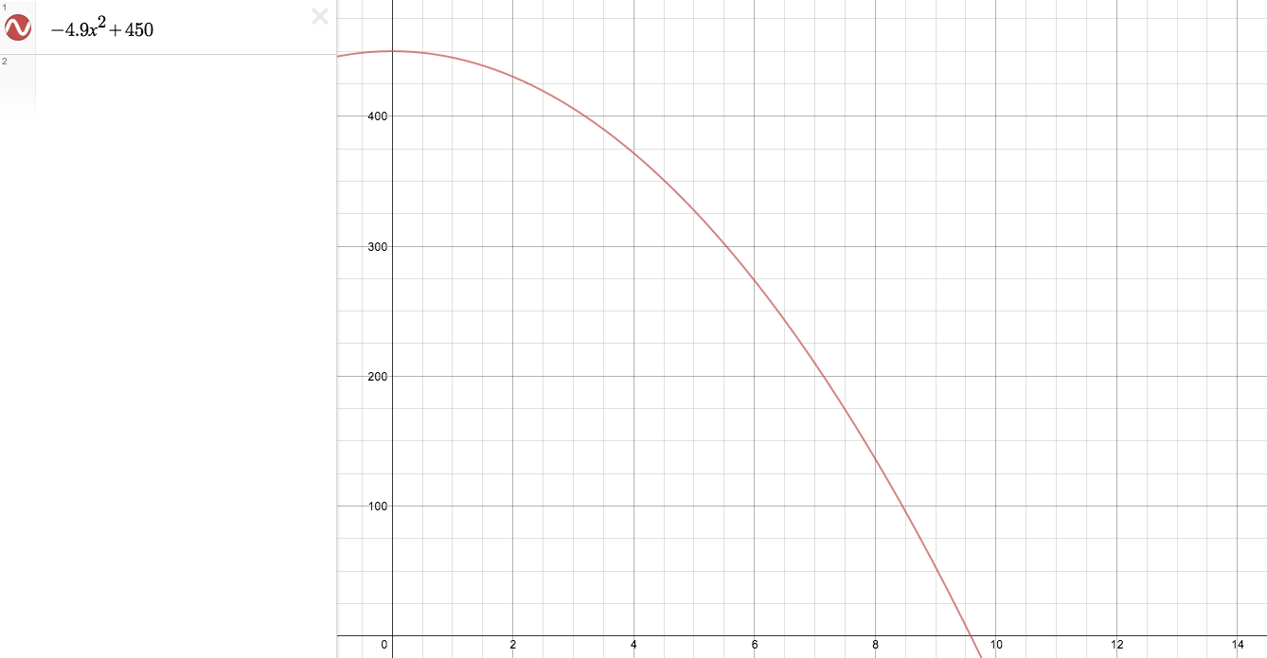
b)
$$v_{a}=\frac{f\left(b\right)-f\left(a\right)}{b-a}=\frac{f\left(2\right)-f\left(0\right)}{2-0}=\frac{-4.9{\left(2\right)}^{2}+4.9{\left(0\right)}^{2}}{2}=-\frac{19.6}{2}=-9.8$$
c) i)
$$v_{a}=\frac{f\left(4\right)-f\left(1\right)}{4-1}=\frac{-4.9{\left(4\frac{m}{s}\right)}^{2}+4.9{\left(1\frac{m}{s}\right)}^{2}}{3}=\frac{-78.4\frac{m}{s}+4.9\frac{m}{s}}{3}=-\frac{73.5\frac{m}{s}}{3}=-24.5\frac{m}{s}$$
ii)
$$v_{a}=\frac{f\left(2\right)-f\left(1\right)}{2-1}=-4.9{\left(2\frac{m}{s}\right)}^{2}+4.9\frac{m}{s}=-19.6\frac{m}{s}+4.9\frac{m}{s}=-14.7\frac{m}{s}$$
iii)
$$v_{a}=\frac{f\left(1.5\right)-f\left(1\right)}{1.5-1}=2\left(-4.9{\left(1.4\frac{m}{s}\right)}^{2}+4.9\frac{m}{s}\right)=2\left(-11.025\frac{m}{s}+4.9\frac{m}{s}\right)=2\left(-6.125\frac{m}{s}\right)=-12.25\frac{m}{s}$$
d)
$$v_{a}=\frac{f\left(1.001\right)-f(0.999)}{1.001-0.999}=\frac{-4.9{\left(1.001\frac{m}{s}\right)}^{2}+4.9{\left(0.999\frac{m}{s}\right)}^{2}}{0.002}=\frac{-4.9\left(1.002001\frac{m}{s}\right)+4.9(0.998001\frac{m}{s})}{0.002}=\frac{-4.9049098\frac{m}{s}+4.8902049\frac{m}{s}}{0.002}=\frac{-0.0147049\frac{m}{s}}{0.002}=-7.35245\frac{m}{s}$$
2. a)
$$t=\frac{-b±\sqrt{b^{2}-4ac}}{2a}=\frac{0s±\sqrt{0s-4\left(-0.4s\right)\left(10.5s\right)}}{2(0.4)}=\frac{±\sqrt{-4\left(-0.4s\right)\left(10.5s\right)}}{0.8}=\frac{±\sqrt{16.8s^{2}}}{0.8}≅\frac{±4.02s}{0.8}≅±5.03s$$
b)
$$\frac{f\left(1\right)-f(0)}{1-0}=f\left(1\right)-f\left(0\right)=10.5s-0.4s{\left(1\right)}^{2}+10.5s-0.4s{\left(0\right)}^{2}=0.4s$$
c)
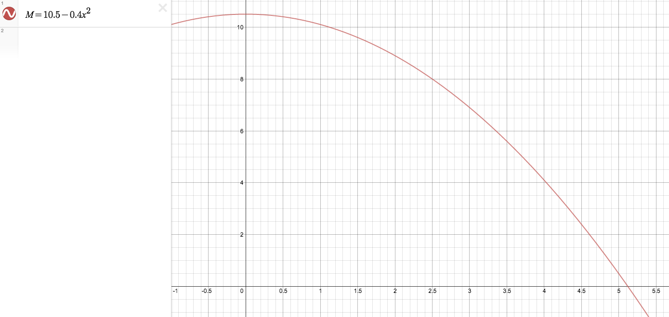
3. a)
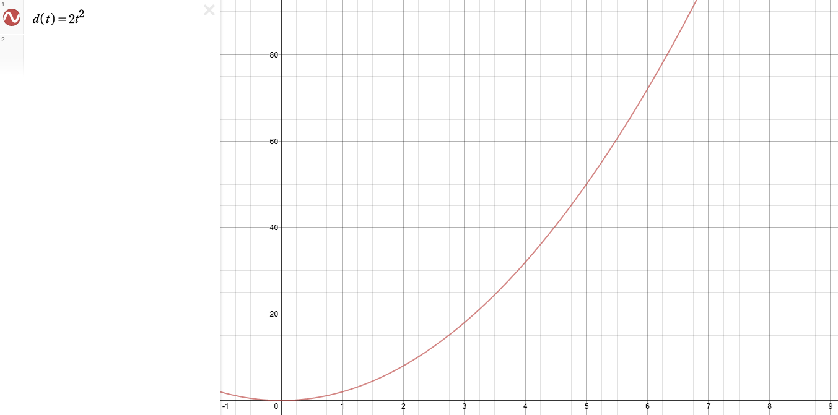
b)
$$s_{a}=\frac{f\left(7\right)-f\left(4\right)}{7-4}=\frac{2{\left(7\right)}^{2}-2{\left(4\right)}^{2}}{3}=\frac{2s\left(49\right)-2s\left(16\right)}{3}=\frac{98s-32s}{3}=\frac{66s}{3}=22s$$
c)
$$s=\frac{f\left(4.001\right)-f\left(3.999\right)}{4.001-3.999}=\frac{2s{\left(4.001\right)}^{2}-2{s\left(3.999\right)}^{2}}{0.002}=\frac{2s\left(16.008001\right)-2s\left(15.992001\right)}{0.002}=\frac{32.016002s-31.984002s}{0.002}=\frac{0.032s}{0.002}=16s$$
4. a) To determine the instantaneous rate of change of a function I would use function:
$$\lim_{h→0}{\frac{f\left(a+h\right)-f\left(a\right)}{h}}$$
This is effective because it would allow me to specifically identify the rate of change at a given point instead of making approximations.
b) i)
$$\lim_{x→0}{\frac{x-3}{2x^{2}-5}}=\frac{0-3}{2{\left(0\right)}^{2}-5}=\frac{-3}{-5}=\frac{3}{5}$$
ii)
$$\lim_{x→2}{\frac{2x^{2}-7x+6}{x-2}}=\lim_{x→2}{\frac{\left(2x-3\right)\left(x-2\right)}{x-2}}=\lim_{x→2}{2x-3}=2\left(2\right)-3=1$$
5. a)
$$\lim_{h→0}{\frac{f\left(2+h\right)-f\left(2\right)}{h}}=\lim_{h→0}{\frac{\left(-5\frac{m}{s}{\left(2+h\right)}^{2}+20\frac{m}{s}\left(2+h\right)+1\frac{m}{s}\right)-\left(-5\frac{m}{s}{\left(2\right)}^{2}+20\frac{m}{s}\left(2\right)+1\frac{m}{s}\right)}{h}}=\lim_{h→0}{\frac{-20\frac{m}{s}-20h\frac{m}{s}-5h^{2}\frac{m}{s}+40h\frac{m}{s}+41\frac{m}{s}-21\frac{m}{s}}{h}}=\lim_{h→0}{\frac{-5h^{2}\frac{m}{s}+20h\frac{m}{s}}{h}}=\lim_{h→0}{-5h\frac{m}{s}+20\frac{m}{s}}=-5\left(0\right)\frac{m}{s}+20\frac{m}{s}=20\frac{m}{s}$$
b)
$$\lim_{h→0}{\frac{f\left(4+h\right)-f\left(4\right)}{h}}=\lim_{h→0}{\frac{{\left(4+h\right)}^{2}\frac{m}{s}-8\left(4+h\right)\frac{m}{s}+15\frac{m}{s}-\left(4^{2}\frac{m}{s}-8\left(4\right)\frac{m}{s}+15\frac{m}{s}\right)}{h}}=\lim_{h→0}{\frac{\left(16\frac{m}{s}+8h\frac{m}{s}+h^{2}\frac{m}{s}-32\frac{m}{s}-8h\frac{m}{s}+15\frac{m}{s}\right)-16\frac{m}{s}+32\frac{m}{s}-15\frac{m}{s}}{h}}=\lim_{h→0}{\frac{h^{2}\frac{m}{s}+8h\frac{m}{s}-8h\frac{m}{s}-16\frac{m}{s}+15\frac{m}{s}+16\frac{m}{s}-15\frac{m}{s}}{h}}=\lim_{h→0}{\frac{h^{2}\frac{m}{s}}{h}}=\lim_{h→0}{h\frac{m}{s}}=0\frac{m}{s}$$
6. a) Positive: $x<-1, x>1$
Negative: $-1<x<1$
b) $x=±1$
c) $max:f\left(-1\right)=2$
$min:f\left(1\right)=-2$
7. a)
$$f\left(x\right)=2x^{3}-7x^{2}+4x+1 \\ f\left(0\right)=2{\left(0\right)}^{3}-7{\left(0\right)}^{2}+4\left(0\right)+1=1 \\ f\left(1\right)=2{\left(1\right)}^{3}-7{\left(1\right)}^{2}+4\left(1\right)+1=2-7+4+1=0 \\ f\left(0+h\right)=2{\left(0+h\right)}^{3}-7{\left(0+h\right)}^{2}+4\left(0+h\right)+1=2h^{3}-7h^{2}+4h+1 \\ f\left(1+h\right)=2{\left(1+h\right)}^{3}-7{\left(1+h\right)}^{2}+4\left(1+h\right)+1=2\left(1+h+h^{2}+h^{3}\right)-7\left(1+h+h^{2}\right)+4+4h+1=2+2h+2h^{2}+2h^{3}-7-7h-7h^{2}+4h+5=2h^{3}-7h^{2}+2h^{2}+4h-7h+2h+5-7+2=2h^{3}-5h^{2}-h$$
$$\lim_{h→0}{\frac{f\left(0+h\right)-f\left(0\right)}{h}}=\lim_{h→0}{\frac{2h^{3}-7h^{2}+4h+1-1}{h}}=\lim_{h→0}{\frac{2h^{3}-7h^{2}+4h}{h}}=\lim_{h→0}{2h^{2}-7h+4}=2{\left(0\right)}^{2}-7\left(0\right)+4=4$$
$$\lim_{h→0}{\frac{f\left(1+h\right)-f\left(1\right)}{h}}=\lim_{h→0}{\frac{2h^{3}-5h^{2}-h}{h}}=\lim_{h→0}{2h^{2}-5h-1}=-1$$
b) The function is increasing at $f\left(0\right)$because the instantaneous rate of change (4) is positive. The function is decreasing at $f\left(+1\right)$ because the instantaneous rate of change (-1) is negative.
c) There should be a local maximum since the slope at $x=0$ is changing from positive to negative as it reaches $x=1$.
8. a)
$$f^{'}\left(x\right)=\lim_{h→0}{\frac{f\left(x+h\right)-f\left(x\right)}{h}}=\lim_{h→0}{\frac{{\left(x+h\right)}^{2}-2\left(x+h\right)+1-x^{2}+2x-1}{h}}=\lim_{h→0}{\frac{x^{2}+2xh+h^{2}-2x-2xh-2h+h^{2}}{h}}=\lim_{h→0}{\frac{x^{2}-x^{2}-2x+2x+2xh-2h+h^{2}}{h}}=\lim_{h→0}{\frac{2xh-2h+h^{2}}{h}}=\lim_{h→0}{2x-2+h}=2x-2$$
b)
$$f^{'}\left(x\right)=\lim_{h→0}{\frac{f\left(x+h\right)-f\left(x\right)}{h}}=\lim_{h→0}{\frac{{\left(x+h\right)}^{3}-3{\left(x+h\right)}^{2}-x^{3}+3x^{2}}{h}}=\lim_{h→0}{\frac{x^{3}+3x^{2}h+3xh^{2}+h^{3}-3x^{2}-6xh-3h^{2}-x^{3}+3x^{2}}{h}}=\lim_{h→0}{\frac{3x^{2}h+3xh^{2}+h^{3}-6xh-3h^{2}}{h}}=\lim_{h→0}{3x^{2}+3xh+h^{2}-6x-3h}=3x^{2}-6x$$
c)
$$f^{'}\left(x\right)=\lim_{h→0}{\frac{f\left(x+h\right)-f\left(x\right)}{h}}=\lim_{h→0}{\frac{{\left(2\left(x+h\right)\right)}^{\frac{1}{2}}-{\left(2x\right)}^{\frac{1}{2}}}{h}}=\lim_{h→0}{\frac{{\left(2x+2h\right)}^{\frac{1}{2}}-{\left(2x\right)}^{\frac{1}{2}}}{h}}=\lim_{h→0}{\frac{{\left(2x+2h\right)}^{\frac{1}{2}}-{\left(2x\right)}^{\frac{1}{2}}}{h}×\frac{\sqrt{2x+2h}+\sqrt{2x}}{\sqrt{2x+2h}+\sqrt{2x}}}=\lim_{h→0}{\frac{\left(\sqrt{2x+2h}-\sqrt{2x}\right)\left(\sqrt{2x+2h}+\sqrt{2x}\right)}{h\left(\sqrt{2x+2h}+\sqrt{2x}\right)}}=\lim_{h→0}{\frac{{\left(\sqrt{2x+2h}\right)}^{2}-{\left(\sqrt{2x}\right)}^{2}}{h\left(\sqrt{2x+2h}+\sqrt{2x}\right)}}=\lim_{h→0}{\frac{2x+2h-2x}{h\left(\sqrt{2x+2h}+\sqrt{2x}\right)}}=\lim_{h→0}{\frac{2h}{h\left(\sqrt{2x+2h}+\sqrt{2x}\right)}}=\lim_{h→0}{\frac{2}{\sqrt{2x+2h}+\sqrt{2x}}}=\frac{2}{\sqrt{2x}+\sqrt{2x}}=\frac{2}{2\sqrt{2x}}=\frac{1}{\sqrt{2x}}$$
d)
$$f^{'}\left(x\right)=\lim_{h→0}{\frac{f\left(x+h\right)-f\left(x\right)}{h}}=\lim_{h→0}{\frac{\left(\frac{4}{x+h+1}\right)-\left(\frac{4}{x+1}\right)}{h}}=\lim_{h→0}{\frac{\frac{4\left(x+1\right)-4(x+h+1)}{\left(x+h+1\right)\left(x+1\right)}}{h}}=\lim_{h→0}{\frac{\frac{4x+4-4x+4h+4}{x^{2}+xh+x+x+xh+1}}{h}}=\lim_{h→0}{\frac{\frac{4h}{x^{2}+2xh+2x+1}}{h}}=\lim_{h→0}{\frac{4h}{x^{2}h+2xh^{2}+2xh+h}}=\frac{4}{x^{2}+2x+1}$$
9. The process that was used to conclude that the derivative of the cubic function is a quadratic was from identifying that leading exponent would experience a $x-1$ operation which resulted in the leading exponent changing from $x^{3}$ to $x^{2}$. Therefore indicating that the derivative of a cubic function was a quadratic function.
10. a)
$$f^{'}\left(x\right)=4x^{3}-4x+1$$
b)
$$f^{'}\left(x\right)=2\left(2x-3\right)\left(x^{2}-3x\right)=\left(4x-6\right)\left(x^{2}-3x\right)=4x^{3}-12x^{2}-6x^{2}+18x=4x^{3}-18x^{2}+18x$$
c)
$$f^{'}\left(x\right)=\left(2x\right)\left(2x^{3}-5x^{2}+4x\right)+\left(x^{2}+2\right)\left(6x^{2}-10x+4\right)=4x^{4}-{10}^{3}+8x^{2}+6x^{4}-10x^{3}+4x^{2}+12x^{2}-20x+8=8x^{4}-20x^{3}+24x^{2}-20x+8$$
d)
$$f^{'}\left(x\right)=\frac{1}{2}x^{-\frac{1}{2}}-\frac{1}{3}x^{-\frac{2}{3}}=\frac{1}{2\sqrt{x}}-\frac{1}{3\sqrt[3]{x^{2}}}$$
e)
$$f^{'}\left(x\right)=3{\left(x^{2}+4\right)}^{-1}+\left(3x\right)\left(-1\right)\left(2x\right){\left(x^{2}+4\right)}^{-2}=3{\left(x^{2}+4\right)}^{-1}-\left(6x^{2}\right){\left(x^{2}+4\right)}^{-2}=\frac{3}{x^{2}+4}-\frac{6x^{2}}{{\left(x^{2}+4\right)}^{2}}=\frac{3\left(x^{2}+4\right)-6x^{2}}{{\left(x^{2}+4\right)}^{2}}$$
11.$$y=-\frac{3}{2}x-1 \\ f\left(x\right)=\frac{2}{3x-2}=2{\left(3x-2\right)}^{-1} \\ f^{'}\left(x\right)=-2{\left(3x-2\right)}^{-2}\left(3\right)=-6{\left(3x-2\right)}^{-2}=\frac{-6}{{\left(3x-2\right)}^{2}} \\ m=-\frac{3}{2} \\ f^{'}\left(x\right)=-\frac{3}{2} \\ \frac{-6}{{\left(3x-2\right)}^{2}}=-\frac{3}{2} \\ -12=-3{\left(3x-2\right)}^{2} \\ 0, 4=3x \\ 0, \frac{4}{3}=x \\ f\left(0\right)=\frac{2}{3\left(0\right)-2}=\frac{2}{-2}=-1 \\ f\left(\frac{4}{3}\right)=\frac{2}{3\left(\frac{4}{3}\right)-2}=\frac{2}{4-2}=\frac{2}{2}=1$$
The points are $\left(0, -1\right)$ and $\left(\frac{4}{3}, 1\right)$.
12.
$$y=7x+3 \\ f\left(x\right)=x^{2}-3x-4 \\ f^{'}\left(x\right)=2x-3 \\ m=7 from y \\ f^{'}\left(x\right)=m \\ 2x-3=7 \\ 2x=10 \\ x=5 \\ f\left(5\right)={\left(5\right)}^{2}-3\left(5\right)-4=25-15-4=1--4=6 \\ y=mx+b=7\left(x-5\right)+6$$

