13.
$$f^{'}\left(x\right)=\left(3\left(2\right)x+1\right)e^{3x^{2}+x}=\left(6x+1\right)e^{3x^{2}+x} \\ f^{'}\left(2\right)=\left(6\left(2\right)+1\right)e^{3{\left(2\right)}^{2}+2}=13e^{14}$$
14.
$$f^{'}\left(x\right)=\left(2x+3\right)2^{x^{2}+3x}\ln{2} \\ f^{'}\left(2\right)=\left(2\left(3\right)+3\right)2^{3^{2}+3\left(3\right)}\ln{2}=\left(9\right)2^{18}\ln{2}$$
15. a)
$$y^{'}=e^{2x}+2xe$$
b)
$$f^{'}\left(x\right)=3^{x}\ln{3}+3x^{2}$$
c)
$$y^{'}=-2e^{-\left(2x+5\right)}$$
d)
$$y^{'}=\left(6x-5\right)e^{3x^{2}-5x+7}$$
e) The derivative of $f\left(x\right)=e^{x}$ is $f^{'}\left(x\right)=e^{x}$ because $e$ is the constant to which the natural logarithm equals one. The constant is found through identifying $k$ of the proof $f^{'}\left(x\right)=kf\left(x\right)$ where $k$ would be equal to $\ln{x}$ within an exponential function such as $f\left(x\right)$. When $\ln{x}$ reaches one, then you have reached $e$. This would therefore mean that $f^{'}\left(x\right)=kf\left(x\right)=\ln{e}f\left(x\right)=1×f\left(x\right)=f(x)$.

16.
$$f\left(x\right)=\frac{\cos{x}}{1-x}=\left(\cos{x}\right){\left(1-x \right)}^{-1} \\ f^{'}\left(x\right)=\left(-\sin{x}\right){\left(1-x\right)}^{-1}+\left(\cos{x}\right)\left(-1\right){\left(1-x\right)}^{-2}\left(-1\right)=\left(-\sin{x}\right){\left(1-x\right)}^{-1}+\left(\cos{x}\right){\left(1-x\right)}^{-2}=\frac{-\sin{x}}{1-x}+\frac{\cos{x}}{{\left(1-x\right)}^{2}}=\frac{{\left(-\sin{x}\right)}^{2}+\cos{x}}{{\left(1-x\right)}^{2}}$$
17.
$$y=x^{2}+4x-3 \\ y^{'}=2x+4 \\ -3=2x+4 \\ 2x=-7 \\ x=-\frac{7}{2}$$
$$y={\left(-\frac{7}{2}\right)}^{2}+4\left(-\frac{7}{2}\right)-3=\frac{49}{4}-\frac{28}{2}-3=12.25+14-3=-4.75$$
Points on the curve of $y$ where the tangent is equal to $-3$: $\left(-3, -4.75\right)$.

18. a)
$$f\left(x\right)=\sqrt{x}{\left(2x+3\right)}^{2} \\ f^{'}\left(x\right)=\frac{1}{\sqrt{x}}{\left(2x+3\right)}^{2}+2\sqrt{x}\left(2x+3\right)\left(2\right)=\frac{1}{\sqrt{x}}{\left(2x+3\right)}^{2}+4\sqrt{x}\left(2x+3\right)=\frac{1}{\sqrt{x}}{\left(2x+3\right)}^{2}+\sqrt{x}\left(8x+12\right)$$
b)
$$g\left(x\right)=\frac{\sin{x}}{x^{3}-2x}=\left(\sin{x}\right){\left(x^{3}-2x\right)}^{-1} \\ g^{'}\left(x\right)=\left(-\cos{x}\right){\left(x^{3}-2x\right)}^{-1}+\left(\sin{x}\right)\left(-1\right){\left(x^{3}-2x\right)}^{-2}\left(3x^{2}-2\right)=\left(-\cos{x}\right){\left(x^{3}-2x\right)}^{-1}-\left(\sin{x}\right){\left(x^{3}-2x\right)}^{-2}\left(3x^{2}-2\right)=\frac{-\cos{x}}{x^{3}-2x}-\frac{\left(\sin{x}\right)\left(3x^{2}-2\right)}{{\left(x^{3}-2x\right)}^{2}}=\frac{{\left(-\cos{x}\right)}^{2}-\left(\sin{x}\right)\left(3x^{2}-2\right)}{{\left(x^{3}-2x\right)}^{2}}$$
c)
$$h\left(x\right)=3e^{\sin\left(x+2\right)} \\ h^{'}\left(x\right)=3e^{\sin\left(x+2\right)}\left(-\cos\left(x+2\right)\right)$$
19. a)
$$y={\left(3x+2\right)}^{2} \\ y^{'}=2\left(3x+2\right)\left(3\right)=6\left(3x+2\right)=18x+12$$ b)
$$f\left(x\right)=5x^{2}-2x \\ f^{'}\left(x\right)=10x-2 \\ f^{''}\left(x\right)=10$$
c)
$$g\left(x\right)=2{\left(x+4\right)}^{-1}=\left(2x-3\right){\left(x+4\right)}^{-1}=\frac{2}{x+4}-\frac{4-2x-3}{{\left(x+4\right)}^{2}}=\frac{1-2x}{{\left(x+4\right)}^{2}}$$
20. a) Increasing: $x>-2$
Decreasing: $x<-2$

b) Max: $\left(-5, g\left(-5\right)\right)$
Min: $\left(1, g\left(1\right) \right)$
c) Concave Up: $x>-2$
Concave Down: $x<-2$

21. a) Increasing: $x≠2$
Decreasing: None
b) Max: None
Min: None
c) Concave Up: None
Concave Down: None

d) Inflection Point: $\left(2, h\left(2\right)\right)$
e)
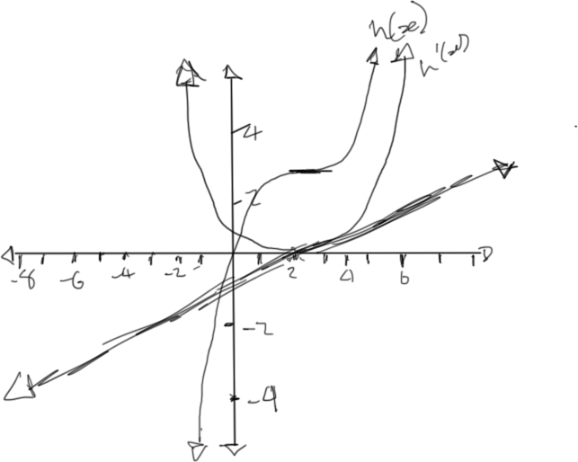

22. a)

$$f\left(x\right)=x^{3}-x^{2}+4x-3 \\ f^{'}\left(x\right)=3x^{2}-2x+4 \\ f^{''}\left(x\right)=6x-2 \\ \frac{2±\sqrt{{\left(-2\right)}^{2}-4\left(3\right)\left(4\right)}}{2\left(3\right)}=2±\sqrt{4-24}=2±\sqrt{-20}$$
Intervals of Increase: $nϵR$
Intervals of Decrease: None

b) There are no local maximum or minimums for this function.

c)
$$f^{''}\left(x\right)=6x-2=0 \\ 6x=2 \\ x=\frac{2}{6}=\frac{1}{3}$$ Concave Down: $x<\frac{1}{3}$
Concave Up: $x>\frac{1}{3}$
d) Since $P\left(x\right)$ cannot have 0 within its range, then there are no inflection points.

23.
$$g\left(1\right)=1 \\ g^{'}\left(1\right)=3 \\ g^{''}\left(1\right)=6$$
$$g\left(x\right)=ax^{2}+bx+c \\ g^{'}\left(x\right)=2ax+b \\ g^{''}\left(x\right)=2a$$

$$g^{''}\left(1\right)=g^{''}\left(x\right) \\ 1=2a \\ a=\frac{1}{2}$$

$$g^{'}\left(1\right)=g^{'}\left(x\right) \\ 1=2ax+b=2\left(\frac{1}{2}\right)\left(1\right)+b=1+b \\ b=0$$

$$g\left(1\right)=g^{'}\left(x\right) \\ 1=ax^{2}+bx+c=\left(\frac{1}{2}\right){\left(1\right)}^{2}+\left(0\right)\left(1\right)+c=\frac{1}{2}+c \\ c=0.5$$

$$g\left(x\right)=\left(\frac{1}{2}\right)x^{2}+0.5$$
24.

$$f\left(2\right)=-1 \\ f^{'}\left(x\right)=mx+b=\frac{0-8}{4-0}x+8=-\frac{8}{4}x+8=-2x+8 \\ f\left(x\right)=-x^{2}+8x+k \\ -1=-{\left(2\right)}^{2}+8\left(2\right)+k=-4+16+k=12+k \\ k=13 \\ ∴f\left(x\right)=-x^{2}+8x+13$$

25. These characteristics state that the function is not even and not odd. The function is also quadratic and downward facing.

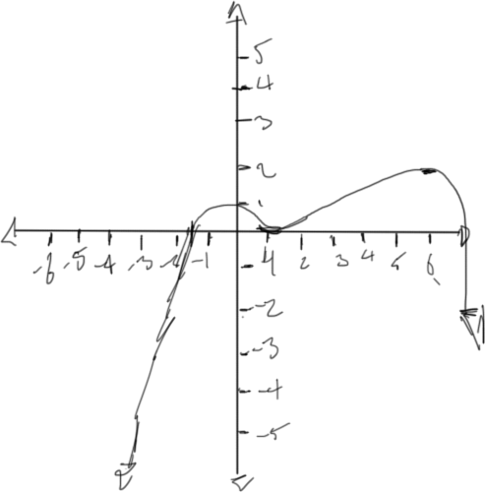

26. i)
$$g\left(x\right)={\left(1-2x\right)}^{2}\left(x-3\right)=\left(1-4x+4x^{2}\right)\left(x-3\right)=x-3+4x^{2}+12x+4x^{3}-12x^{2}=4x^{3}-8x^{2}+13x+13$$
Since $g\left(x\right)$ has both odd and even exponents, then it is neither odd nor even.
ii) x-intercepts $\left(3, 0\right), \left(\frac{1}{2}, 0\right)$
y-intercepts: $\left(0, -3\right)$
Iii) First Derivative:
$$g^{'}\left(x\right)=12x^{2}-16x+13$$Second Derivative
$$\frac{12±\sqrt{{12}^{2}-4\left(12\right)\left(13\right)}}{2\left(12\right)}$$
Since the second derivative is always positive, then $g'\left(x\right)$ is always increasing.

27. a) Domain: $xϵR,x≠2$
b) y-asymptote: $\frac{x}{2x}=\frac{1}{2}∴x=\frac{1}{2}$
x-asymptote: $2x-4=2\left(x-2\right)∴y=2$
c) x-intercept
$$f\left(0\right)=\frac{x+5}{2x-4}=\frac{0+5}{2\left(0\right)-4}=\frac{5}{-4}=-1.25 \\ \left(0, -1.25\right)$$
y-intercept
$$0=\frac{x+5}{2x-4}=x+5 \\ x=-5 \\ \left(-5, 0\right)$$
d)
$$f\left(x\right)=\frac{x+5}{2x-4}=\left(x+5\right){\left(2x-4\right)}^{2} \\ f^{'}\left(x\right)={\left(2x-4\right)}^{-1}+\left(x+5\right)\left(-1\right){\left(2x-4\right)}^{-2}\left(2\right)={\left(2x-4\right)}^{-1}+\frac{-2x-10}{{\left(2x-4\right)}^{2}}=\frac{1}{2x-4}+\frac{-2x-10}{{\left(2x-4\right)}^{2}}=\frac{2x-4-2x-10}{{\left(2x-4\right)}^{2}}=\frac{-14}{{\left(2x-4\right)}^{2}}=\left(-14\right){\left(2x-4\right)}^{-2} \\ f^{''}\left(x\right)=\left(0\right){\left(2x-4\right)}^{-2}+\left(-14\right)\left(2\right)\left(-2\right){\left(2x-4\right)}^{-3}=-\frac{56}{{\left(2x-4\right)}^{-3}}$$ Increasing: Never, since $f'(x)$ is never positive
Decreasing: $x≠2$

e)
