28. a) 1985: $97±1$
1996: $42±1$
b) 1986: $-5.98$
1991: $-5.60$
c) $≈1998$

29.
$$P^{'}\left(t\right)=\frac{\left(1+e^{-t}\right)\left(0\right)-\left(500\right)\left(0+\left(-e^{-t}\right)\right)}{{\left(1+e^{-t}\right)}^{2}}=\frac{-500\left(-e^{-t}\right)}{{\left(1+e^{-t}\right)}^{2}}=\frac{500\left(e^{-t}\right)}{{\left(1+e^{-t}\right)}^{2}} \\ P^{'}\left(3\right)=\frac{500\left(e^{-t}\right)}{{\left(1+e^{-t}\right)}^{2}}≈\frac{24.894}{1.102}=22.59$$

30. a)
$$C_{A}\left(x\right)=\frac{C\left(x\right)}{x} \\ C_{A}\left(x\right)=\frac{2500+100\left(200\right)-0.1{\left(200\right)}^{2}}{200}=\frac{2500+20000-0.1\left(40000\right)}{200}=\frac{22500-4000}{200}=\frac{18500}{200}=\frac{185}{2}=92.5 \\ C_{M}\left(x\right)=C^{'}\left(x\right)=100-0.2x \\ C_{M}\left(200\right)=100-0.2\left(200\right)=100-40=60$$

The average cost is $92.50 and the marginal cost is $60.00.

b) i)
$$A\left(t\right)=A_{O}{\left(\frac{1}{2}\right)}^{\frac{t}{k}} \\ \frac{1}{32}A_{O}=A_{O}{\left(\frac{1}{2}\right)}^{\frac{t}{k}} \\ \frac{1}{32}={\left(\frac{1}{2}\right)}^{\frac{t}{k}}={\left(\frac{1}{2}\right)}^{\frac{t}{\left(20\right)\left(24\right)}}={\left(\frac{1}{2}\right)}^{\frac{t}{480}} \\ t=480\log_{0.5}\left(\frac{1}{32}\right)=480\left(0.2\right)=96$$
The amount of time it takes for 1/32 of this substance to be left is 96 hours or 4 days.
ii)
$$A^{'}\left(t\right)={\left(\frac{1}{2}\right)}^{\frac{t}{k}}\ln{\frac{1}{2}}\left(\frac{1}{k}\right)={\left(\frac{1}{2}\right)}^{\frac{480h}{2400h}}\ln{\frac{1}{2}}\left(\frac{1}{2400h}\right)≈2.5×{10}^{-4}$$
The rate of decay is $2.5×{10}^{-4}$ kg per year.

31.

$$R\left(x\right)=x\left(1200\left(1.50-x\right)\right)=1200x\left(1.50-x\right)=1800x-1200x^{2} \\ R{\left(x\right)}^{'}=1800-2400x \\ 0=1800-2400x \\ 2400x=1800 \\ x=\frac{1800}{2400}=0.75$$
The fare that will maximize the revenue is $0.75.

32.
$$N\left(t\right)=30t-t^{2} \\ N^{'}\left(t\right)=30-2t \\ 0=30-2t \\ 2t=30 \\ t=15 \\ N\left(15\right)=30\left(15\right)-{15}^{2}=450-225=225$$
The maximum number of conversations is 225 at 15 minutes.

33. a)
$$C\left(x\right)=\left(15\right)\sqrt{{120}^{2}+x^{2}}+\left(10\right)\left(300-x\right)=\left(15\right){\left({120}^{2}+x^{2}\right)}^{\frac{1}{2}}+3000-10x \\ C{\left(x\right)}^{'}=\left(15\right){\left({120}^{2}+x^{2}\right)}^{-\frac{1}{2}}\left(\frac{1}{2}\right)\left(2x\right)-10 \\ 0=\frac{15x}{\sqrt{{120}^{2}+x^{2}}}-10 \\ 10=\frac{15x}{\sqrt{{120}^{2}+x^{2}}} \\ \sqrt{{120}^{2}+x^{2}}=\frac{15x}{10}=\frac{3x}{2} \\ {120}^{2}+x^{2}=\frac{9x^{2}}{4} \\ x^{2}-\frac{9x^{2}}{4}=-{120}^{2} \\ -\frac{5x^{2}}{4}=-{120}^{2} \\ \frac{5x^{2}}{4}={120}^{2} \\ x^{2}=\frac{4\left({120}^{2}\right)}{5}=11520 \\ x=\sqrt{11520}=16\sqrt{45} \\ l_{river}\left(x\right)=\sqrt{{120}^{2}+x^{2}} \\ l_{river}\left(16\sqrt{45}\right)=\sqrt{{120}^{2}+{\left(16\sqrt{45}\right)}^{2}}=\sqrt{14400+11520}=\sqrt{25920}≈160.996≈161$$

The length across the river under the water should be 161 metres in length. You can prove that this is the minimum length by testing if it creates the minimum cost via $C\left(x\right)$.

$$C\left(16\sqrt{45}-1\right)=\left(15\right)\sqrt{{120}^{2}+{\left(16\sqrt{45}-1\right)}^{2}}+\left(10\right)\left(300-16\sqrt{45}-1\right)=4361.67 \\ C\left(16\sqrt{45}\right)=\left(15\right)\sqrt{{120}^{2}+{\left(16\sqrt{45}\right)}^{2}}+\left(10\right)\left(300-16\sqrt{45}\right)=4341.64 \\ C\left(16\sqrt{45}+1\right)=\left(15\right)\sqrt{{120}^{2}+{\left(16\sqrt{45}+1\right)}^{2}}+\left(10\right)\left(300-16\sqrt{45}+1\right)=4361.67$$

When C(x) is $16\sqrt{45}$ then the lowest cost is met.

b)
$$R\left(n\right)=\left(40-2n\right)\left(2000+200n\right) \\ E\left(n\right)=8\left(2000+200n\right) \\ P\left(n\right)=R\left(n\right)-E\left(n\right)=\left(40-2n\right)\left(2000+200n\right)-8\left(2000+200n\right) \\ P^{'}\left(n\right)=\left(40-2n\right)\left(2000+200n\right)-8\left(2000+200n\right) \\ P^{'}\left(n\right)=\left(-2\right)\left(2000+200n\right)+\left(40-2n\right)\left(200\right)-8\left(200\right)=\left(-4000-400n\right)+8000-400n-1600=2400-800n \\ 0=2400-800n \\ 800n=2400 \\ n=\frac{2400}{800}=3 \\ price\left(n\right)=40-2n=40-2\left(3\right)=40-6=34$$

The price that will lead to the maximum profit is $34.

c)
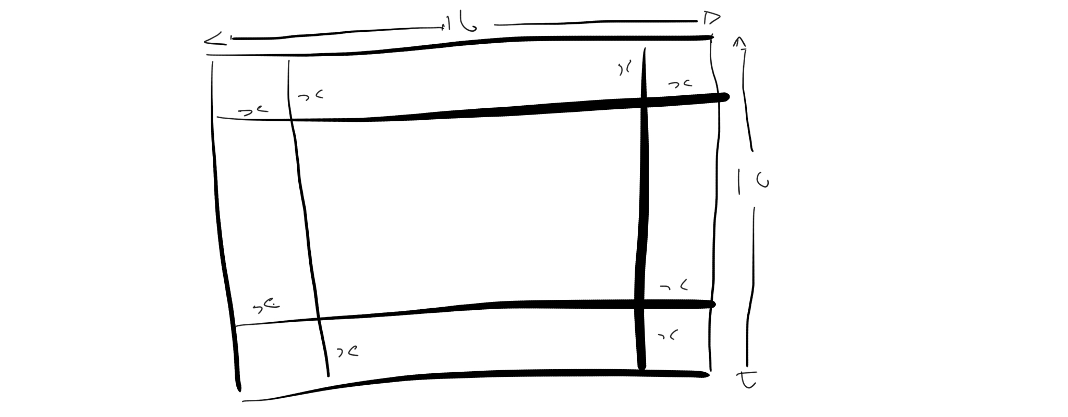
$$V\left(x\right)=\left(10-2x\right)\left(16-2x\right)x=\left(160-20x-32x+4x^{2}\right)x=\left(160-52x+4x^{2}\right)x=160x-52x^{2}+4x^{3} \\ V^{'}\left(x\right)=160-104x+12x^{2} \\ \frac{104±\sqrt{{\left(-104\right)}^{2}-4\left(160\right)\left(12\right)}}{2\left(12\right)}=\frac{104±\sqrt{10816-7680}}{24}=\frac{104±\sqrt{3136}}{24}=\frac{104±56}{24}=2,\frac{20}{3} \\ V\left(2\right)=\left(10-2\left(2\right)\right)\left(16-2\left(2\right)\right)\left(2\right)=\left(10-4\right)\left(16-4\right)\left(2\right)=\left(6\right)\left(12\right)\left(2\right)=144 \\ V\left(\frac{20}{3}\right)=\left(10-2\left(\frac{20}{3}\right)\right)\left(16-2\left(\frac{20}{3}\right)\right)\left(\frac{20}{3}\right)=\left(10-\frac{40}{3}\right)\left(16-\frac{40}{3}\right)\left(\frac{20}{3}\right)=\left(\frac{30-40}{3}\right)\left(\frac{48-40}{3}\right)\left(\frac{20}{3}\right)=\frac{\left(-10\right)\left(8\right)\left(20\right)}{3}=\frac{-1600}{3}≈-533.3$$
The maximum volume is $144 cm^{3}$.

d)
$$V=3456cm^{3} \\ S=2πr^{2}+2πrh=2πr\left(r+h\right) \\ V=πr^{2}h \\ h=\frac{V}{πr^{2}} \\ S=2πr\left(r+\frac{V}{πr^{2}}\right)=2πr\left(\frac{πr^{3}+V}{πr^{2}}\right) \\ S\left(r\right)=\frac{2\left(πr^{3}+V\right)}{r} \\ S^{'}\left(r\right)=\frac{\left(r\right)\left(6πr^{2}\right)-\left(2\left(πr^{3}+V\right)\right)\left(1\right)}{r^{2}}=\frac{6πr^{3}-2πr^{3}-2V}{r^{2}}=\frac{4πr^{3}-2V}{r^{2}} \\ 0=\frac{4πr^{2}-2V}{r^{2}} \\ 0=4πr^{3}-2V \\ 2V=4πr^{3} \\ V=2πr^{3} \\ 3456π=2πr^{3} \\ 3456=2r^{3} \\ r^{3}=1728 \\ r=\sqrt[3]{1728} \\ r=12$$

$$h=\frac{V}{πr^{2}}=\frac{3456π}{π{\left(12\right)}^{2}}=\frac{3456}{144}=24$$

The minimum radius and height for the large soup can is 3cm in radius and 24cm in height.

e)
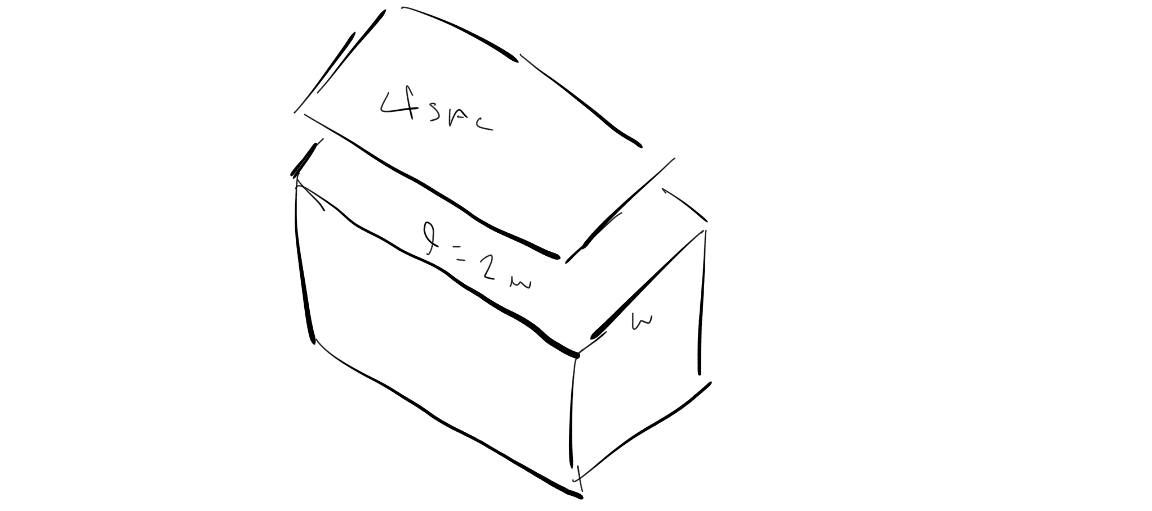
$$SA_{c}=lw+2wh+2lh=lw+2h\left(w+l\right) \\ V=lwh \\ SA_{l}=4lw \\ SA=SA_{c}+SA_{l}=lw+2h\left(w+l\right)+4lw=5lw+2h\left(w+l\right)=5\left(2w\right)w+2h\left(w+2w\right)=10w^{2}+6hw \\ V=lwh \\ h=\frac{V}{lw} \\ SA=10w^{2}+6\left(\frac{V}{lw}\right)w=10w^{2}+\frac{6W}{l}=10w^{2}+\frac{6V}{2w}=10w^{2}+\frac{3V}{w}=10w^{2}+3Vw^{-1} \\ SA^{'}=20w-3Vw^{-2} \\ 0=20w-3Vw^{-2} \\ 3Vw^{-2}=20w \\ 3Vw^{-3}=20 \\ w^{-3}=\frac{20}{3V} \\ w=\sqrt[3]{\frac{3V}{20}}=\sqrt[3]{\frac{3\left(1440\right)}{20}}=\sqrt[3]{3\left(72\right)}=\sqrt[3]{216}=6 \\ l=2w=2\left(6\right)=12 \\ h=\frac{V}{lw}=\frac{1440}{\left(12\right)\left(6\right)}=\frac{1440}{72}=20$$

The dimensions are 12dm x 6dm x 20dm
f)

$$CP=\sqrt{{\left(6\sqrt{2}\right)}^{2}+x^{2}} \\ CH=\frac{CP}{5}+\frac{4-x}{15}=\frac{\sqrt{{\left(6\sqrt{2}\right)}^{2}+x^{2}}}{5}+\frac{4-x}{15}=\frac{\sqrt{72+x^{2}}}{5}+\frac{4-x}{15}=\left(\frac{1}{5}\right){\left(72+x^{2}\right)}^{\frac{1}{2}}+\left(4-x\right)\left(\frac{1}{15}\right) \\ CH^{'}=\left(\frac{1}{5}\right){\left(72+x^{2}\right)}^{-\frac{1}{2}}\left(\frac{1}{2}\right)\left(2x\right)+\left(\frac{1}{15}\right)\left(-1\right)=\frac{2x}{10\sqrt{72+x^{2}}}-\frac{1}{15} \\ \frac{1}{15}=\frac{2x}{10\sqrt{72+x^{2}}} \\ 10\sqrt{72+x^{2}}=30x \\ \sqrt{72+x^{2}}=3x \\ 72+x^{2}=9x^{2} \\ 8x^{2}=72 \\ x^{2}=9 \\ x=3$$

Simon should land 3km from the campsite on the opposite bank.

34. i) $90°+90°+90°-15°=180°+75°=255°$
ii) $N105°W$
iii) $S75°W$
iv) $E165°W$

35. a)
$$v=\sqrt{{\left(-8\right)}^{2}+{\left(8\right)}^{2}}=\sqrt{64+64}=\sqrt{128}≈11.31 \\ θ=\tan^{-1}\left(\frac{8}{-8}\right)=\tan^{-1}\left(-1\right)=-45° \\ \overset{⃑}{v}=11.31, -45°$$
b)
$$v=\sqrt{2^{2}+{\left(-6\right)}^{2}}=\sqrt{4+36}=\sqrt{40}≈6.32 \\ θ=\tan^{-1}\left(\frac{-6}{2}\right)=\tan^{-1}\left(-3\right)≈-71.56° \\ \overset{⃑}{v}=6.32, -71.56°$$

36. a)
$$y=6\sin{θ}=6\sin{45°}≈4.24 \\ x=6\cos{θ}=6\cos{45°}≈4.24 \\ \overset{⃑}{v}=\left(4.24, 4.24\right)$$
b)
$$y=10\sin{θ}=10\sin{240°}≈-8.66 \\ x=10\cos{θ}=10\cos{240°}≈-5 \\ \overset{⃑}{v}=\left(-5, -8.66\right)$$
c)
$$y=4\sin{θ}=4\sin{90°}=4 \\ x=4\cos{θ}=4\cos{90°}=0 \\ \overset{⃑}{v}=\left(0, 4\right)$$

37. a)
$$\overset{⃑}{OC}=\overset{⃑}{OA}+\overset{⃑}{OB}=\left(1, 2\right)+\left(-2, 3\right)=\left(-1, 5\right) \\ \left|\overset{⃑}{OC}\right|=\sqrt{{\left(-1\right)}^{2}+5^{2}}=\sqrt{1+25}=\sqrt{26}$$

b)
$$\overset{⃑}{OO}=\overset{⃑}{OM}+\overset{⃑}{ON}=\left(-3, 3, 4\right)+\left(-3, 4, 6\right)=\left(-6, 7, 10\right) \\ \left|\overset{⃑}{OO}\right|=\sqrt{{\left(-6\right)}^{2}+7^{2}+{10}^{2}}=\sqrt{36+42+100}=\sqrt{178}$$

38.
$${\overset{⃑}{uv}}^{2}={\overset{⃑}{u}}^{2}+{\overset{⃑}{v}}^{2}-2\overset{⃑}{u}\overset{⃑}{v}\cos\left(140°\right)=6^{2}+2^{2}-2\left(6\right)\left(2\right)\cos\left(140°\right)≈36+4-24\left(-0.766\right)=40+18.384=58.384 \\ \overset{⃑}{uv}≈7.64$$

$$\frac{\sin{40}}{7.64}=\frac{\sin{α}}{6} \\ 6\sin{40°}=7.64\sin{α} \\ 7.64\sin{α}≈3.86 \\ \sin{α}≈0.5 \\ α=30°$$

The magnitude of $\overset{⃑}{uv}$ is 7.64 with an angle of 30 degrees from $\overset{⃑}{v}$ to $\overset{⃑}{u}$.

39.
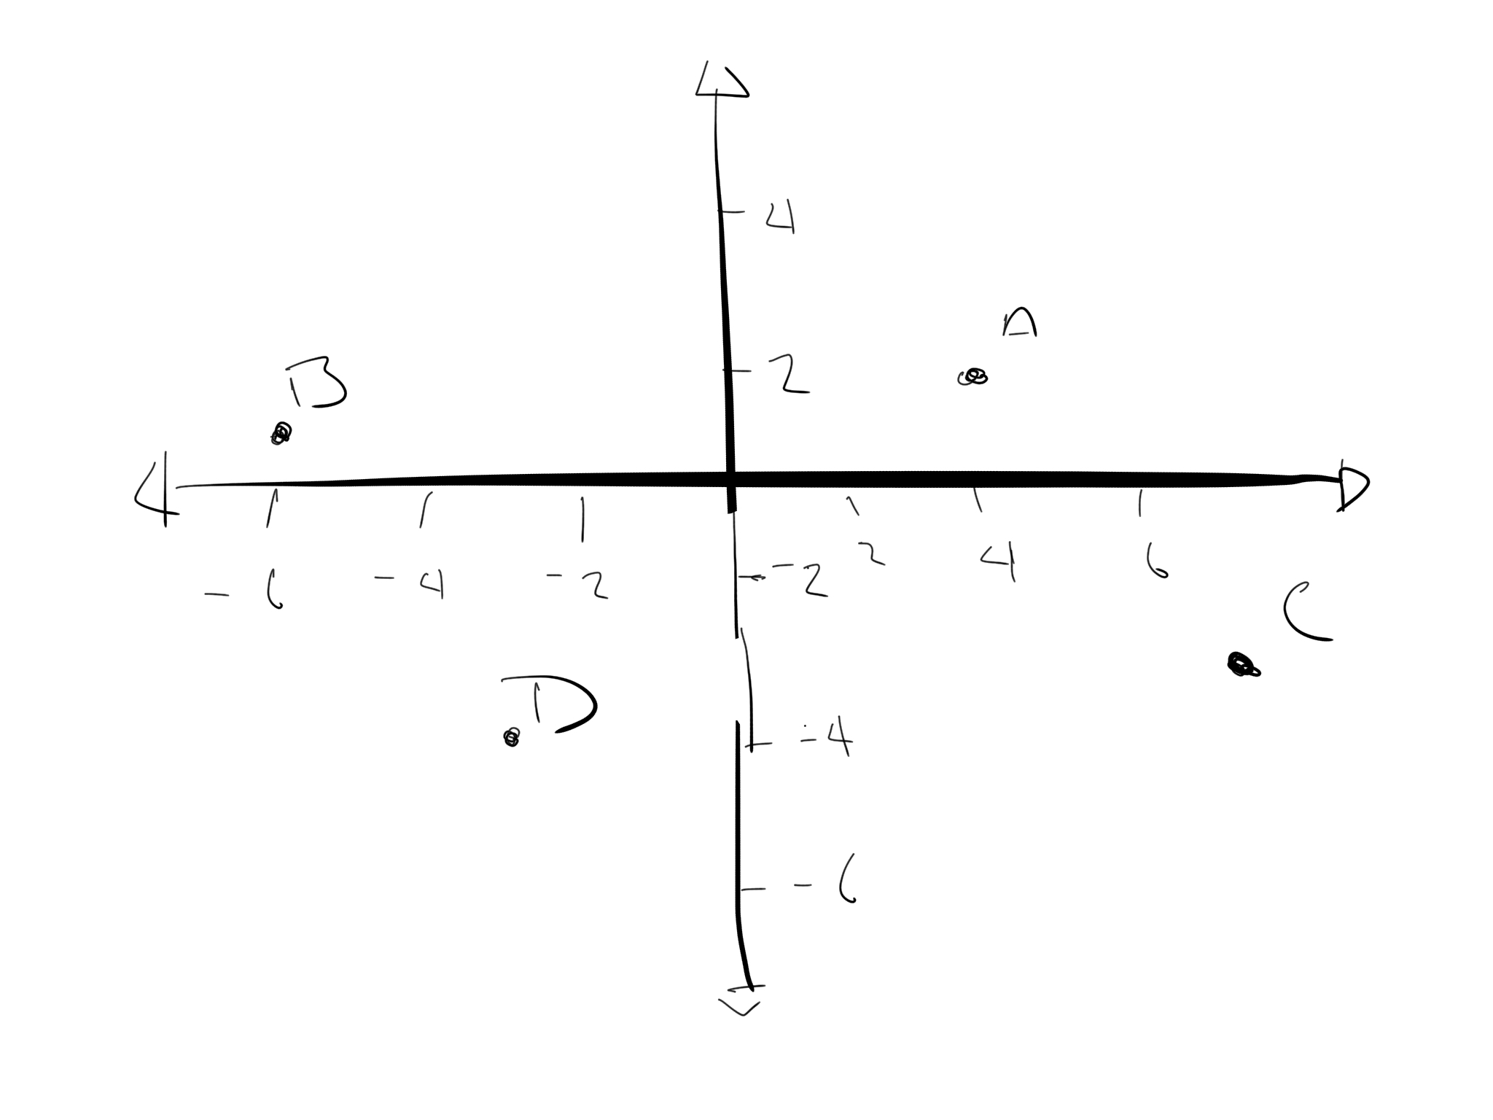
$$\overset{⃑}{AC}=\overset{⃑}{BD}=\sqrt{{\left(-6+2\right)}^{2} +{\left(1+4\right)}^{2}}=\sqrt{{\left(-3\right)}^{2}+5^{2}}=\sqrt{9+25}=\sqrt{36}=6 \\ C=\left(D_{1}–B_{1}+A_{1}, D_{2}-B_{2}+A_{2}\right)=\left(-3-\left(-6\right)+4, -4-1+2\right)=\left(7, -3\right)$$
40.
$$A^{2}={\left(-8\right)}^{2}+4^{2}+{\left(-2\right)}^{2}=64+16+4=84 \\ A≈9.2 \\ B^{2}={\left(-6\right)}^{2}+3^{2}+5^{2}=36+9+25=70 \\ B≈8.4 \\ C^{2}={\left(-10\right)}^{2}+5^{2}+{\left(-9\right)}^{2}=100+25+81=206 \\ C≈14.4$$

Given the magnitudes of the sides of the figure, it is not an equilateral pyramid, but it is a pyramid where the sides are not equal.

41. a)
$$3\left(2\overset{⃑}{u}-3\overset{⃑}{v}\right)-2\left(-2\overset{⃑}{v}+3\overset{⃑}{u}\right)=6\overset{⃑}{u}-9\overset{⃑}{v}+4\overset{⃑}{v}-6\overset{⃑}{u}=-5\overset{⃑}{v}$$
b)
$$5\left(\overset{⃑}{a}+2\overset{⃑}{b}+4\overset{⃑}{c}\right)-4\left(2\overset{⃑}{a}-3\overset{⃑}{b}-5\overset{⃑}{c}\right)=5\overset{⃑}{a}+10\overset{⃑}{b}+20\overset{⃑}{c}-8\overset{⃑}{a}+12\overset{⃑}{b}+20\overset{⃑}{c}=-3\overset{⃑}{a}+22\overset{⃑}{b}+40\overset{⃑}{c}$$

42.
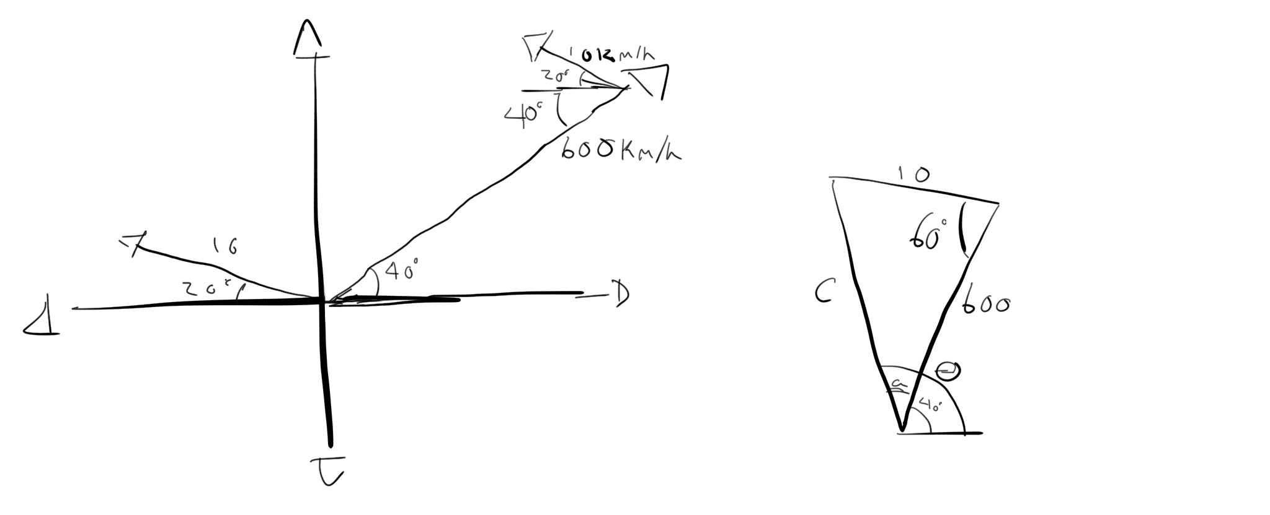
$$c^{2}={10}^{2}+{600}^{2}-2\left(10\right)\left(600\right)\cos{60°}=100+360000-12000\left(0.5\right)=360100-6000=354100 \\ c≈595 \\ \frac{\sin{a}}{10}=\frac{\sin{60°}}{595} \\ 595\sin{a}=10\sin{60°}≈8.66 \\ \sin{a}=\frac{8.66}{595} \\ a=\sin^{-1}\left(\frac{8.66}{595}\right)≈0.83° \\ θ=40°+a=40°+0.83°=40.83$$
The plane will be flying 595 km/h at W40.83⁰N

43.
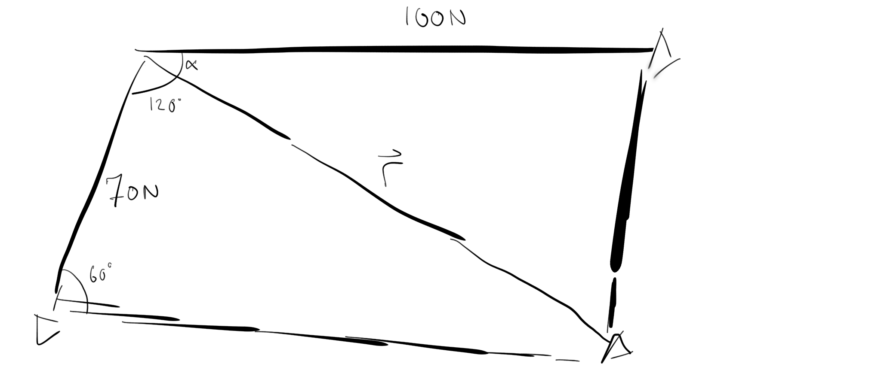
$${\left|\overset{⃑}{r}\right|}^{2}={70}^{2}+{100}^{2}-2\left(70\right)\left(100\right)\cos{60°}=4900+10000-14000\left(0.5\right)=14900-7000=7900 \\ \left|\overset{⃑}{r}\right|≈88.88 \\ \frac{\sin{α}}{70}=\frac{\sin{60°}}{88.88} \\ 88.88\sin{α}=70\sin{60°}≈60.62 \\ \sin{α}=\frac{60.62}{88.88} \\ α=\sin^{-1}\left(\frac{60.62}{88.88}\right)≈43°$$
The resultant of the two forces is 88.88N at an angle of 43⁰ from the 100N force.

44.
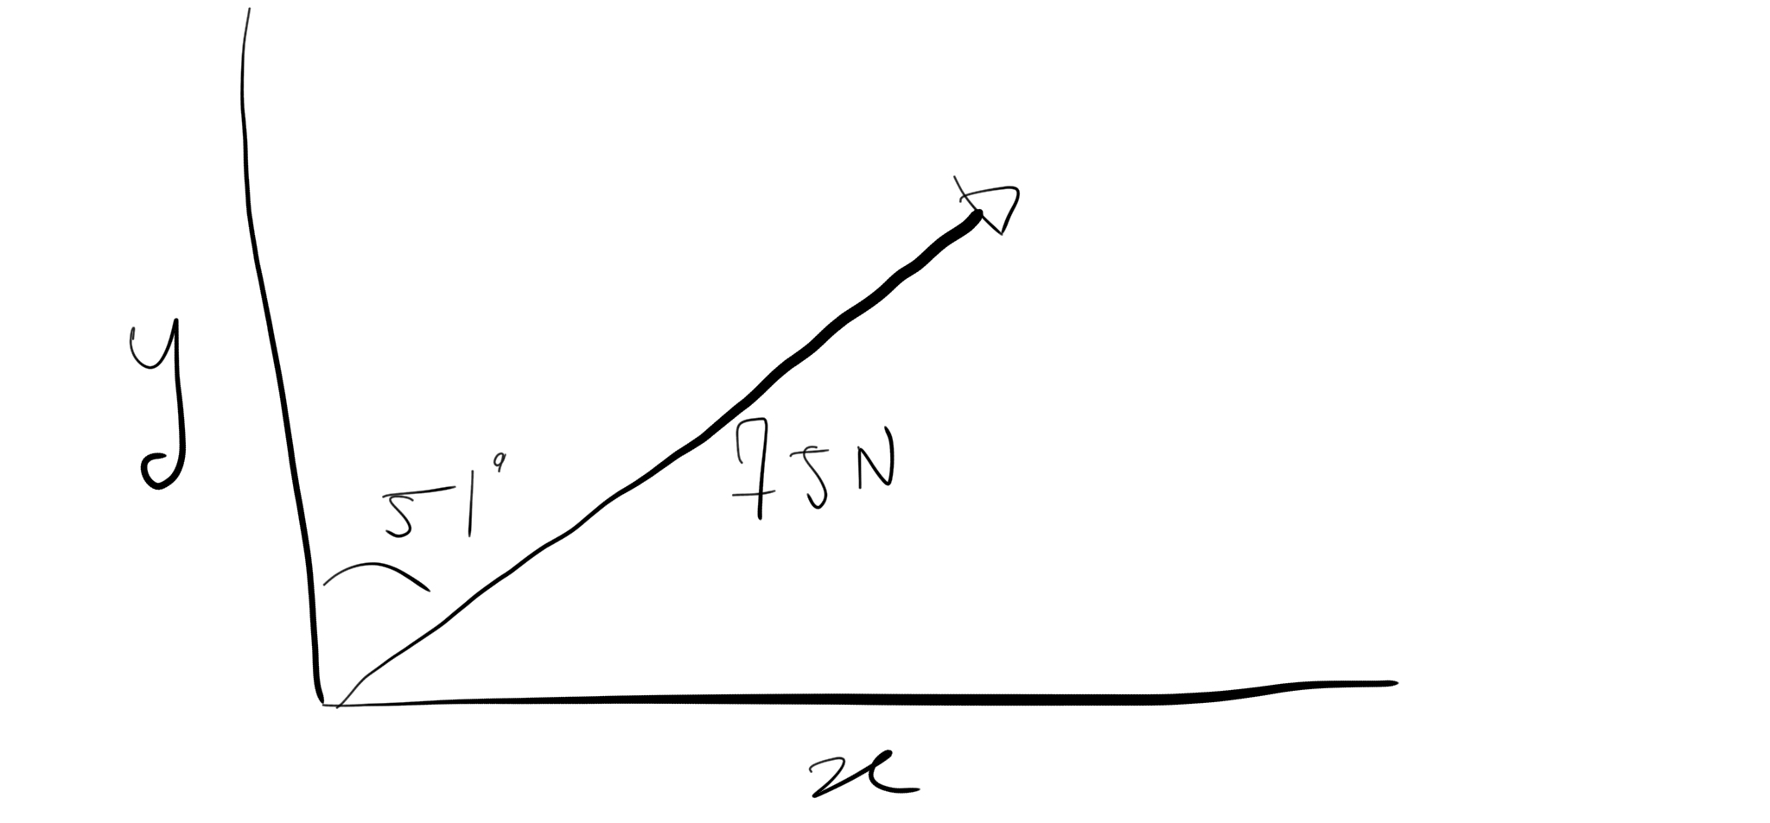
$$\sin{51°}=\frac{\overset{⃑}{x}}{75N} \\ \overset{⃑}{x}=75N\sin{51°}≈58.29N \\ \cos{51°}=\frac{\overset{⃑}{y}}{75N} \\ \overset{⃑}{y}=75N\cos{51°}≈47.20N$$
$\overset{⃑}{y}$ is 47.2N at an angle of 51⁰ from the 75N force. $\overset{⃑}{x}$ is 58.29N at an angle of 39⁰ from the 75N force.

45.

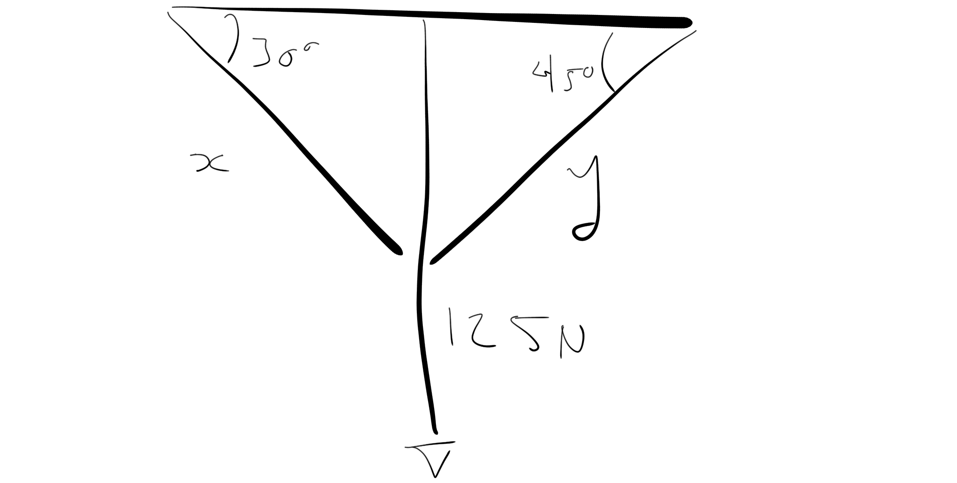
$${\left|\overset{⃑}{y}\right|}^{2}=2{\left(125N\right)}^{2}=2\left(15625N^{2}\right)=31250N^{2} \\ \left|\overset{⃑}{y}\right|=176.78N \\ \sin{30°}=\frac{125N}{\left|\overset{⃑}{x}\right|} \\ \left|\overset{⃑}{x}\right|=\frac{125N}{\sin{30°}}=\frac{125N}{0.5}=250N$$

