SPH4U Unit 1 Questions
- 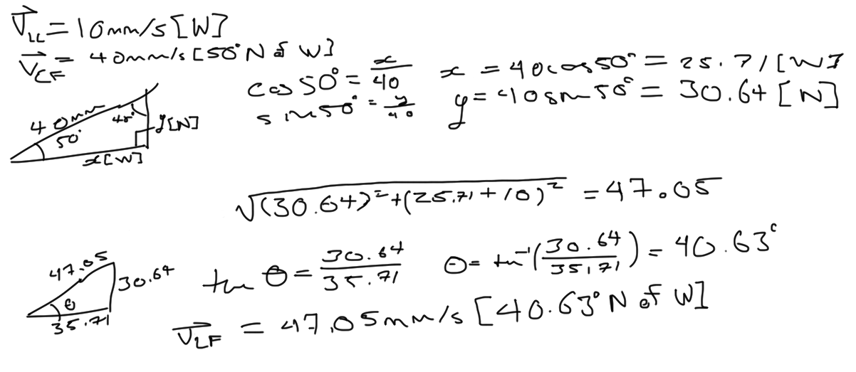
- If the wind is pushing the plane southwest and the plane is to travel west, then it would need to northwest. See Figure 1.
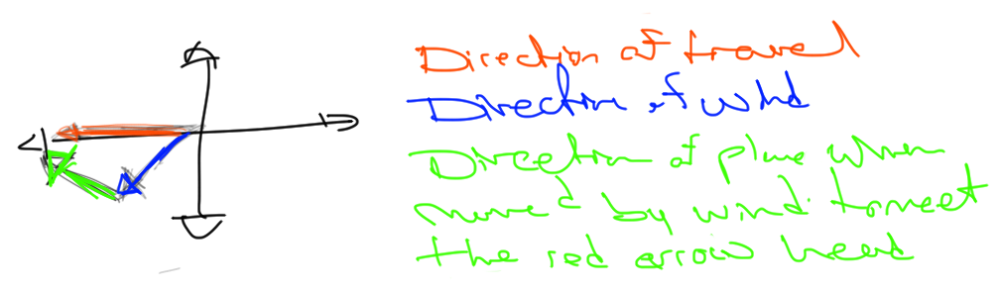
Figure 1
- Relative velocity is used in science to correctly calculate where a rocket is moving towards and away from. As the rocket is being launched, the temperature, wind velocities, and atmospheric changes are closely observed when launching the rocket. The rocket will be adjusted for a day when the wind speeds will move in the direction that would prove economically viable to tilt the rocket in that direction and to have it moved upwards precisely and efficiently.
The benefits of utilizing specific directions when firing a rocket can be both economical and environmental. On January 28, 1986, the Challenger shuttle blew up when being launched. The shuttle was launched on that day because it was an economically viable day for NASA. The wind speeds and atmosphere were perfect, as well as for other political functions. The shuttle exploded due to temperature reasons, but the economical reasons for the date allowed the shuttle to be lifted at a faster rate than on other days by shortening the duration of the flight, lessening the amount of fuel that would be used, and decreasing the amount of fuel and atmospheric interaction that would occur when the shuttle is in flight.
- Analysis:
a) 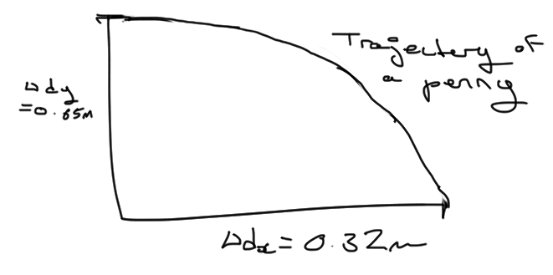
b)
$${Δd}_{ax}=\left(\frac{27.5+29+34.25+35.5+36.25}{5}\right)cm±1cm=0.325m±0.01m \\ {Δt}_{a}=\left(\frac{0.28+0.37+0.26+0.25+0.34}{5}\right)s±0.05s=0.3s±0.05s \\ {\overset{⃑}{v}}_{a}=\frac{0.325m}{0.3s}±\frac{0.01m}{0.05s}=\frac{1.08\overline{3}m±0.2m}{s}$$
c) i) The stopwatch is not highly accurate when timing the fall of the penny. It produces an amount of human error since it starts and stops from the push of the thumb.
ii) The measuring stick could have been off since one was not available. the dimensions of paper and the accurate measurements in inches was used then converted to metres.
d) Precautions are necessary when using fragile items, launching at high distances, and/or when there is a risk of people being injured or property being damaged.
Conclusion:
When projecting a penny from a height of 0.65 metres, the average horizontal range was measured to be 0.325m give or take 0.01 metres and the magnitude of the initial velocity was calculated to be 1.083 metres per second give or take 0.2 metres per second.
- a) The vertical velocity is at a maximum at it’s point of launch.
b) The horizontal velocity is always constant in a projectile.
c) The vertical velocity is at a minimum when the object is at its maximum height.
d) The acceleration of the object when it is at the very top is $9.8m/s^{2}$ [down]. This is because gravity is always acting on an object at all times.
e) Since the initial is below the final, then it would take a greater distance to traverse the upward motion. Therefore it should consequently take longer for the projectile to go upwards than downwards.
- a) 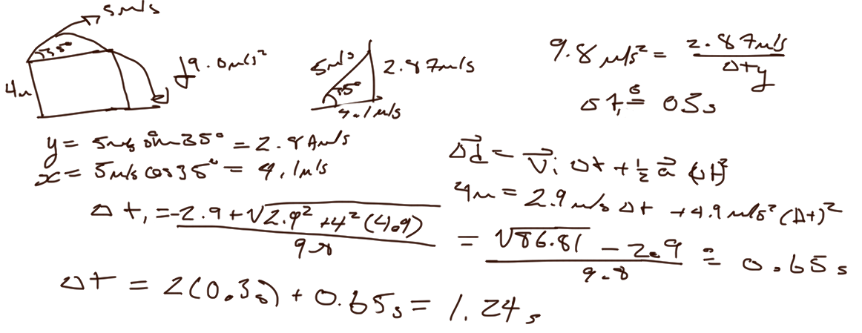
b) 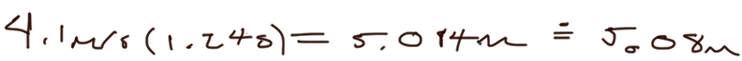
c) 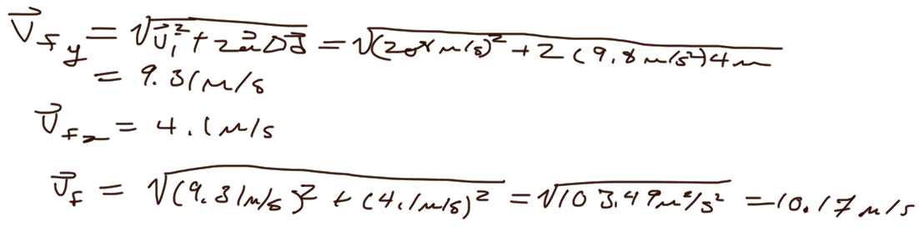
- i) One way in understanding projectile motion to improve your performance in a baseball game would be where to hit the ball. In understanding that, the vertical motion of the ball would achieve the maximum horizontal distance from the force of the bat.
ii) Another way to improve performance is to understand how much velocity or force is required to hit a ball a certain distance. In understanding that, the player would know how much arm force is required to hit certain distances.
iii) A third way is to understand trajectory and timing. The distance for a homerun is different for every direction since the boundaries of the game are shaped linearly. The player would therefore need to know when to release the bat and the amount of acceleration that is required to make the ball go at a fast speed and traversing a short distance.
- Since motion requires movement, then the object is in motion. As to the net force, I believe that would be a yes since when all the forces are applied together, motion occurs.
- a) The box that should start to slide first is the heavier box since the force of the full box is twice that downwards than the half-full box of nails.
b) 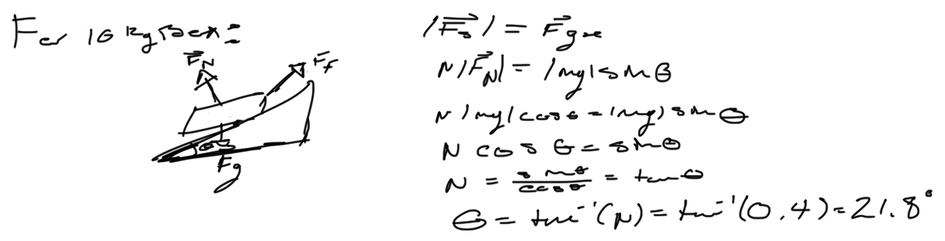
c) 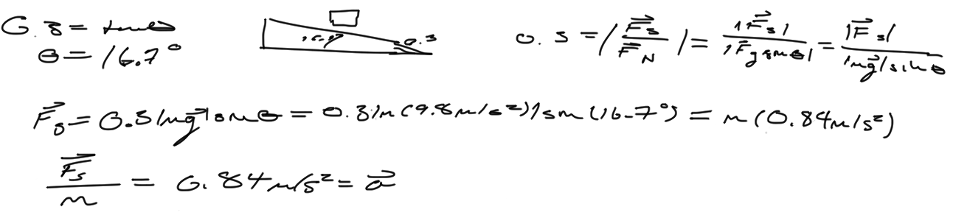
- a) Hypothesis
The mass will have no effect on the degree when finding the coefficient of friction using the method of raising the degree of the plane, that the mass lies on, until it begins to slide.
Materials:
- Box
- Book
- Coin
- Shoe
- Two smooth Planes (one portable)
- Protractor
- Tape
Procedure:
- Place the coin in the box with it taped to the bottom. Record the weight.
- Put the two surfaces on top of each other then the box on top.
- Lift the top plane and record the degree when the box starts to slide.
- Repeat steps 1 – 3 with the book inside the box instead of the coin.
- Repeat steps 1 – 3 with the shoe inside the box instead of the coin.
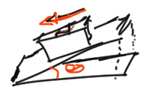
Figure 2
b) Analysis:
Using the data obtained, a comparison of the three masses will present a broad enough comparison of the results that are obtained off the degree to which they slide. If the degree is the same for all masses, then the mass is not a factor in finding the coefficient of friction.
c) One possible source of error that one might encounter is taking the measurement. They may be off by a few degrees as one hand would have to hold up the diagonal plane while the other hand is using the protractor. Since the person is multi-tasking at the same time trying to record and get results, then there may be a source of error. To minimize multi tasking, one could raise the diagonal plane with both hands and have a partner measure the degree to which the plane is above the ground.
- a) An example in which friction is maximized is when there is rain or snow on the road which can cause hydrolysis (tristanmac.tripod.com). Hydrolysis is when an automobile is driving on water, causing the friction to go down. This is dangerous when the driver needs to brake and since the phenomenon of hydrolysis lowers the friction, the car can slide and possible crash into someone. Friction in the car tire is maximized to avoid this from occurring.
b) An example of when friction is minimized is when the asphalt is “maximized” to allow the car tire to drive smoothly across the road and for the velocity of the car itself to minimize the loss of kinetic energy. This loss of energy is estimated to have cost the U.S. “more than 500 billion dollars.” (Baragiola, 2002)
c) See References.
- No, because the centripetal force is similar to the net force. You don’t put the net force on the full body diagram; you put the forces that contribute to it.
- Cars have a banked curve so that the outward force of the car pushing from the inside as it changes direction (changes its tangent) is opposed and the car does not slide into the ditch. If the slant of the banking is too high, the car may slide into the inside of the curve. If the bank is too low, the car may slide into the outside of the curve. See Figure 3.
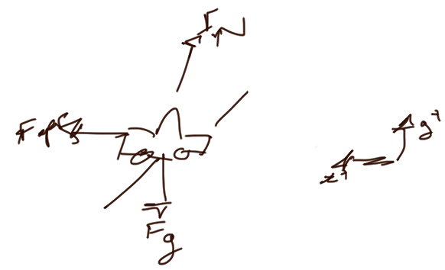
Figure 3

$$F_{s}=\frac{mv^{2}}{r}=μF_{N}=μmg \\ μg=\frac{v^{2}}{r} \\ μ=\frac{v^{2}}{gr}=\frac{\left(\frac{100m^{2}}{s^{2}}\right)}{\left(\frac{9.8m}{s^{2}}\right)25m}≅\frac{1.1m}{s}$$
- a) If the diameter is equal to the force of gravity:
$$F_{c}=\frac{1}{2}mg=\frac{mv^{2}}{r} \\ \frac{1}{2}g=\frac{v^{2}}{r}= \\ v=\sqrt{\frac{gr}{2}}=\sqrt{\frac{\left(\frac{9.8m}{s^{2}}\right)0.25m}{2}}≅\frac{1.1m}{s}$$
b) Using the velocity from (a):
$$F_{c}=\frac{mv^{2}}{r}=F_{T}-F_{g}=F_{T}-mg \\ F_{T}=m\left(\frac{v^{2}}{r}+g\right)=0.1kg\left(\frac{{\left(\frac{1.1m}{s}\right)}^{2}}{0.25m}+\frac{9.8m}{s^{2}}\right)=14.7N$$
16. Artificial gravity is where one creates a force on an object where instead of using $g$, one substitutes it for $a$ . Artificial gravity is related to centripetal force because one can create a rotating body and with the right speed, it would have the exact same centripetal force as the Earth has. Artificial gravity can be created in space by creating a space station that rotates at a given speed to create the effects of gravity. Gravity is important to humans because the human physiology depends on the effects of the gravitational force. The effects of artificial gravity would allow the human race to live in space with the same effects of the Earth’s gravity (Cardus, 1994).

References
Baragiola, R. (2002). Friction. Retrieved December 10, 2012, from EP733/MSE722 Surface Science: http://www.virginia.edu/ep/SurfaceScience/friction.html
Cardus, D. (1994, May 1). Artificial gravity in space and in medical research. Journal of Gravitational Physiology, 1(1), 19-22.
tristanmac.tripod.com. (n.d.). Friction between car tires and the road. Retrieved December 10, 2012, from Physics and Car Safety: http://tristanmac.tripod.com/id13.html

