SPH4U Unit 2 Questions
17. High Concentration Photovoltaic (HCPV), or Sun Simba, is a type of solar energy that works as follows:
- The Sun Simba uses a Light-guide Solar Optic (LSO) which is a thin optical structure that is made from acrylic and glass.
- The acrylic and glass internally traps and redirects the sunlight to a single point.
- The point to where the light is redirected is also where a photovoltaic cell is; allowing for a concentration of sunlight to produce a large amount of solar energy.
An advantage to the HCPV is that it is able to concentrate sunlight and have far less mass than Fresnel Lens, Parabolic Mirrors, or Cassegrain Optics. LSOs are also not affected by thermal expansion, and not toxic and 100% recyclable. A disadvantage of the Sun Simba is that it is relatively expensive compared to silicon based solar power. This means that the Sun Simba, although relatively cheap of its own genres competition, would require a bigger investment than, for example, a Medium CPV. (Morgan Solar, n.d.)
18. 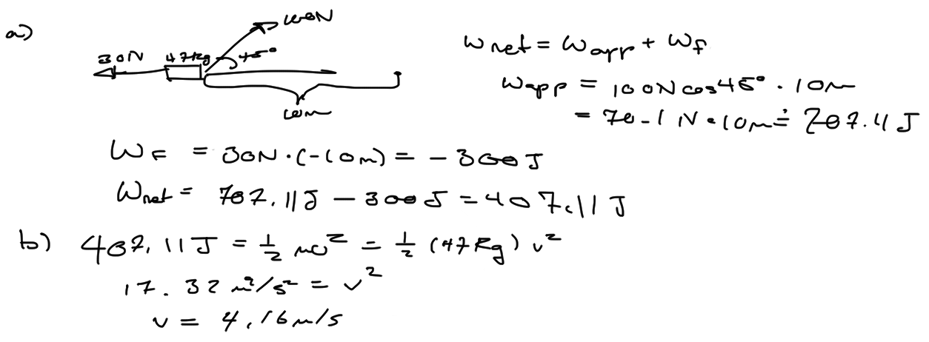
19. 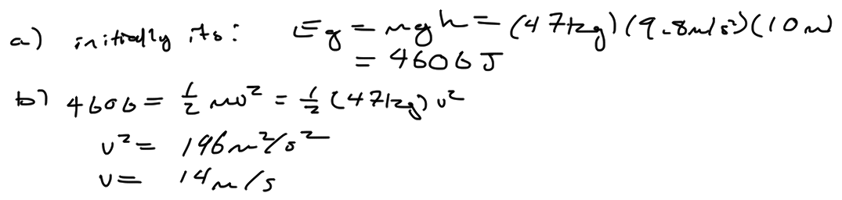
c) This does not defy the laws of conservation in energy because the child was sliding down an inclined plane, which means that friction and the normal force would have played a factor as well.
20. 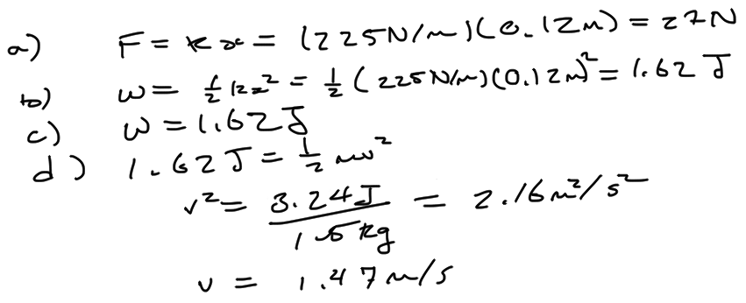
21. a) i) The speed would be at the maximum when the amount of kinetic energy would be at a maximum. The kinetic energy is at a maximum when it is passing the rest position for the spring.
ii) The speed is at a minimum when all the energy is in the elastic potential energy rather than the kinetic. This is when the spring is at either a maximum compression or a maximum expansion.
iii) The acceleration is at a minimum when the change in distance is at a maximum. The change in distance is at a maximum when the spring is either at a maximum in expansion or compression.
b) Damping systems are used to settle down vibrations so that shock is absorbed efficiently. Damping is meant by trying to “dampen” unwanted vibrations. A specific technology that utilizes the damping system is automobiles. An automobile would have a damping system attached to the axles of the car so that when the car goes over a bump, the damping system can effectively absorb the shock and the driver only feels the initial spring rather than the automobile being damaged by the bump or by the automobile continuing to expand and contract after it has gone over the bump.
22. 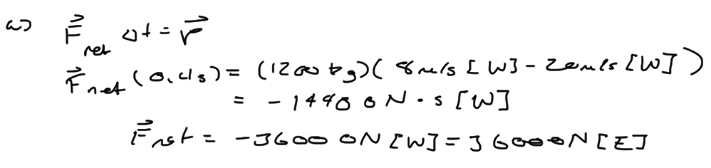
b) The time of the collision would go down, causing the net force to increase. This would in turn cause the final velocity to increase since the initial velocity and mass are constants.
c) In cold environments, the water would become solid in the winter, making a crash worse. Also, crashes are more likely to happen in the winter sine black ice would be present.
23. 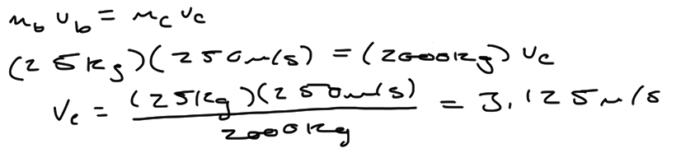
24. 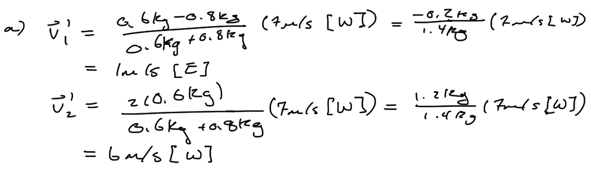
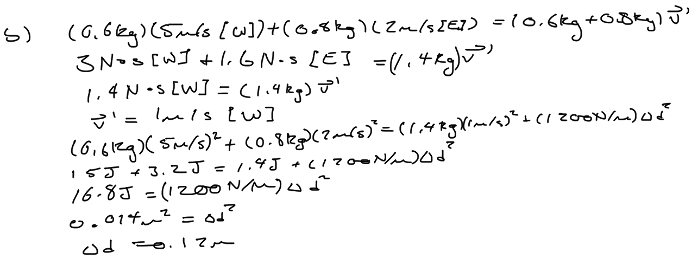
25. 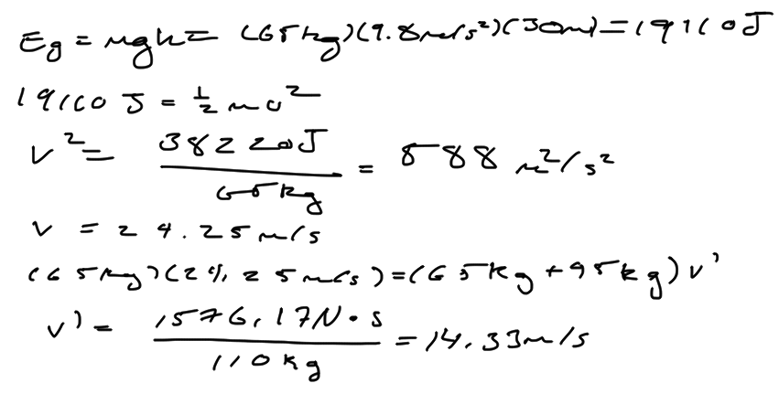
26. 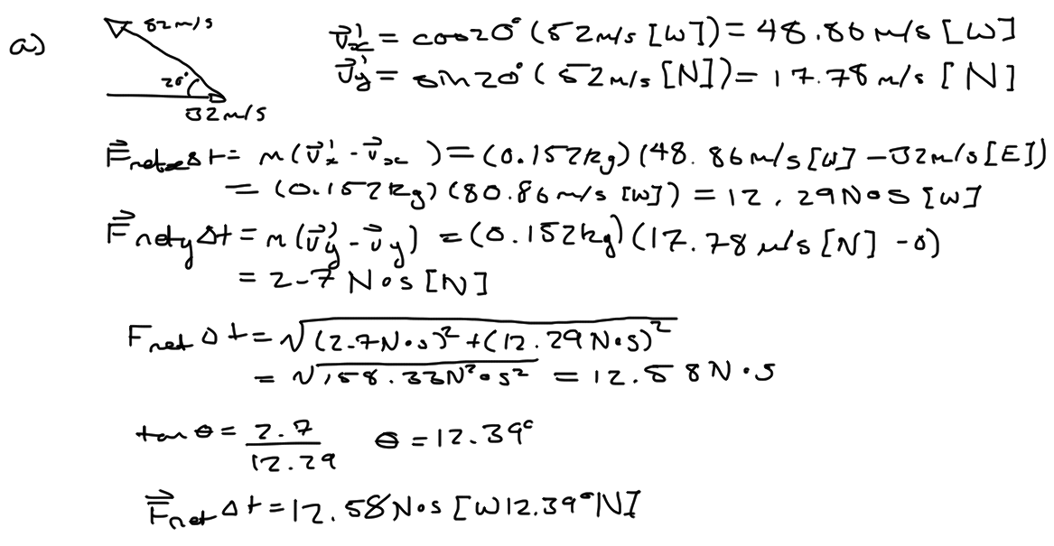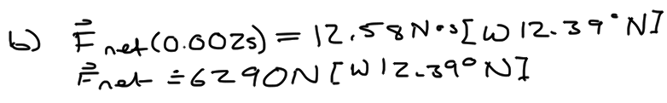
27. 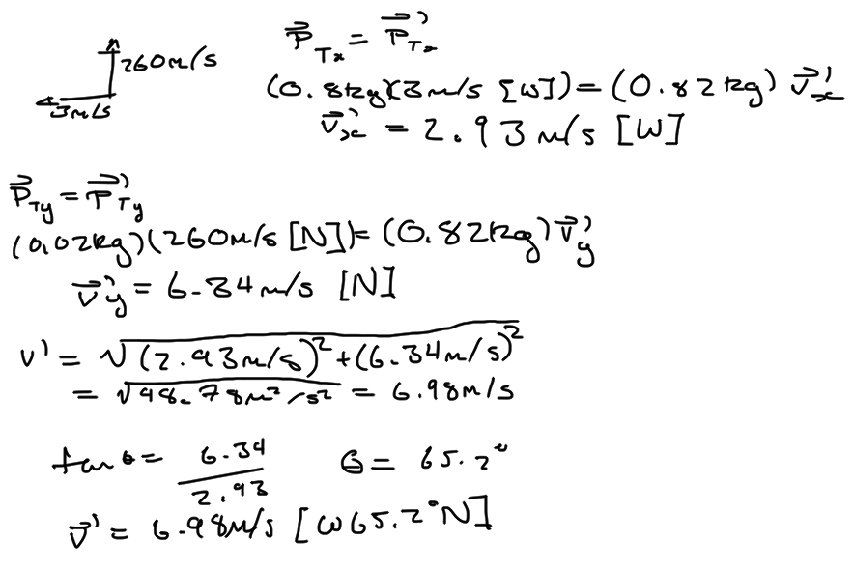
28. 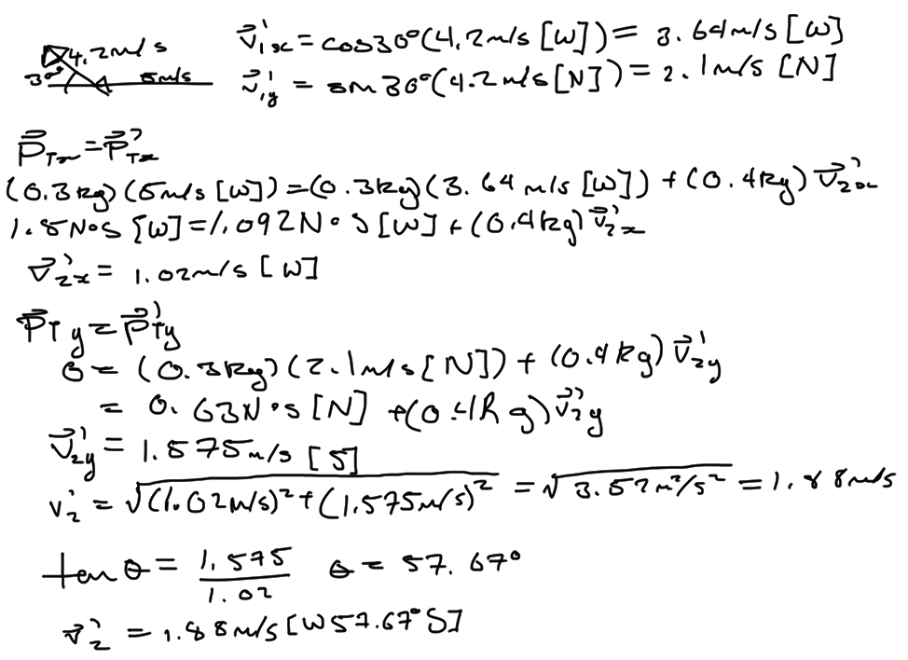

References
Morgan Solar. (n.d.). How it Works | Morgan Solar. Retrieved December 31, 2012, from Morgan Solar: http://www.morgansolar.com/product/how-it-works

