1.
Name | Z | A | Number of Protons | Number of Electrons | Number of Neutrons | Nuclide Symbol
Iron | 26 | 58 | 26 | 26 | 32 | $${}_{26}^{58}{Fe}$$
Lead | 82 | 207 | 82 | 82 | 125 | $${}_{82}^{207}{Pb}$$
Tin | 50 | 132 | 50 | 50 | 72 | $${}_{50}^{132}{Sn}$$
Xenon | 54 | 131 | 54 | 54 | 77 | $${}_{54}^{135}{Xe}$$
Mercury | 80 | 202 | 80 | 80 | 162 | $${}_{80}^{202}{Hg}$$
Barium | 56 | 139 | 56 | 56 | 83 | $${}_{56}^{139}{Ba}$$

2.
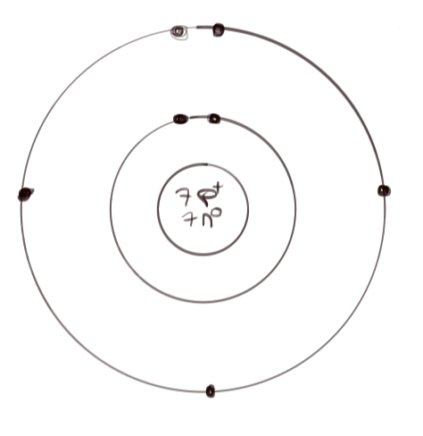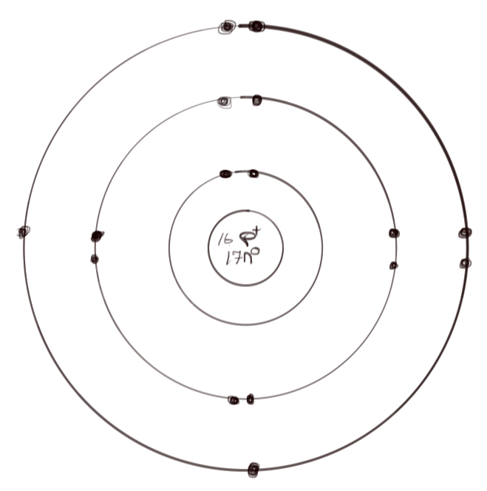
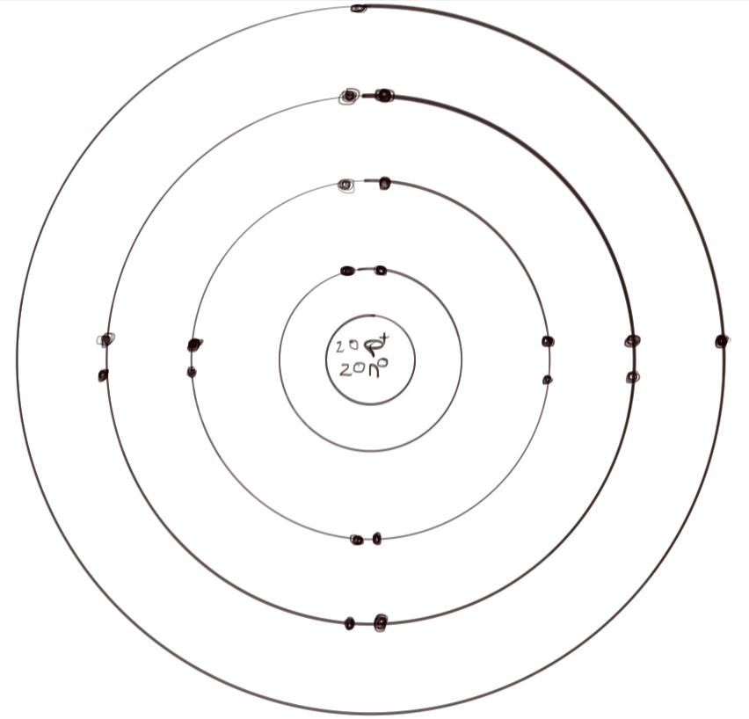
3. a) i) 1
ii) 8
iii) 2
iv) 9 and 10
v) 1, 3, and 8
b) 4, 6, 7, 8, 10
4. Na, Si, and then C because Carbon has one less valence shell than Silicon causing the Carbon atom to be smaller and Silicon before Sodium because Silicon has more protons than sodium, making the atom smaller.
5. F, P, and then N because Flourine has more valence electrons than Phosphorus meaning that it would take a greater amount of energy for Flourine to lose an electron than Phosphorus. And Phosphorus is one more period higher than Nitrogen, meaning the Phosphuros has tighter bind no its electrons than Nitrogen, giving Phosphuros a greater need for energy than Nitrogen to ionize.
6. F, Cl, and then Al because Flourine has a smaller atomic radius due to having one less inner shell than Clorine and can therefore attract electrons easier. Clorine is greater than Aluminum because Chlorine has less valence electrons than Aluminum.
7. Na, Rb, and then Mg. Magnesium is placed last because it’s an Alkaline Earth Metal while all the others are Alkali Metals. Sodium comes before Rubidium because Sodium has less inner shells than Rubidium.
8. Ionization energy and electronegativity should follow the same trend because they are both dependent on the concept on gaining electrons. While electronegativy refers to the ability to attract electrons, electron affinity refers to the ability to gain an electron. Because of this, they are both dependent on the electron’s from the distance from the nucleus and the nuclear charge of the atom.
9. a) Ionic
b) Covalent
c) Ionic
d) Ionic
10. i) Ionic reacts more violently than with covalent reactions
ii) The electrons are shared in covalent reactions
iii) There can be double or triple bonds for covalent reactions
11. a)

b)

c)

d)
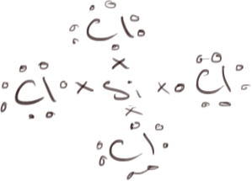
e)
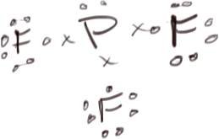
f)

g)
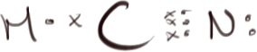
12. a) Polar
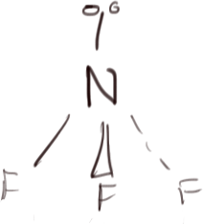
b) Non-Polar
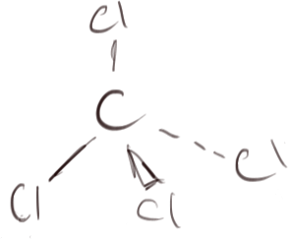
c) Polar

d) Polar

13.
Substance | Polarity | Reason
A | Non-Polar Covalent | Since A is insoluble, it is immediately judged as being a non-polar covalent. The low melting point also helps to confirm this.
B | Polar Covalent | Since B is soluble, it is either ionic or polar covalent. Since the melting point is below room temperature, then therefore it is a polar covalent.
C | Ionic | C is an ionic molecule because of its exceedingly hihg melting point. The solubility also helps to confirm this.
D | Non-Polar Covalent | Since D is insoluble, it is immediately identified as being a non-polar covalent. The low melting point also helped to confirm this.
E | Polar Covalent | Since the substance was soluble, it was either polar covalent or ionic. The low melting point point identified that E is a polar covalent.
F | Ionic | F is an ionic molecule because the substance has a high melting point and it is also soluble.

