42. a) Heterogeneous
b) Solvent: Water
Solute: Organic acids, sugars, and gums
c) Solvent: Water
Solute: Some minerals and gases
d) Solvent: Water
Solute: Silver/Copper
43. Gasoline: No, since gasoline is non-polar and a lot heavier than water.
Methanol: Yes because methanol is polar and has an OH group to allow for a hydrogen bond.
Sodium Bicarbonate: Yes, since it is an ionic compound and will dissolve into the solvent through ionic dissociation.
44. a)
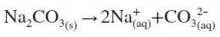
b)
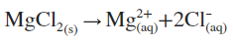
c)
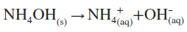
45. In both the ionic and covalent compounds, the water will attach to both through its polarity as well as surround both the molecules as to disassociate both of them further.
46. Water is a fantastic solute because of its capability to hydrogen bond, its incredible abundance, and its polarity.
47. a) Barium Phosphate will be the precipitate.
b) Silver Acetate will be the precipitate.
c) Copper (II) Chloride will be the precipitate.
48. a) Balanced Chemical Equation:
Net Ionic Equation:
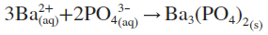
Spector Ions:
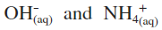
b) Balanced Chemical Equation:
Net Ionic Equation:
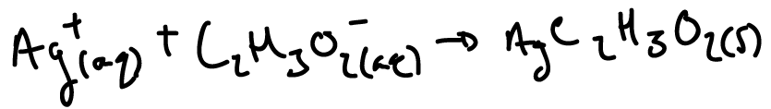
Spector Ions:
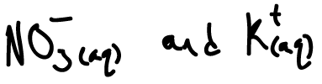
c)
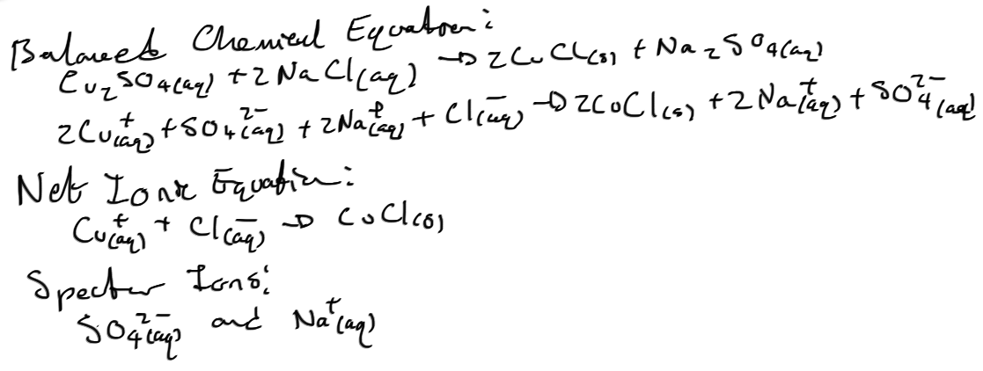
49.
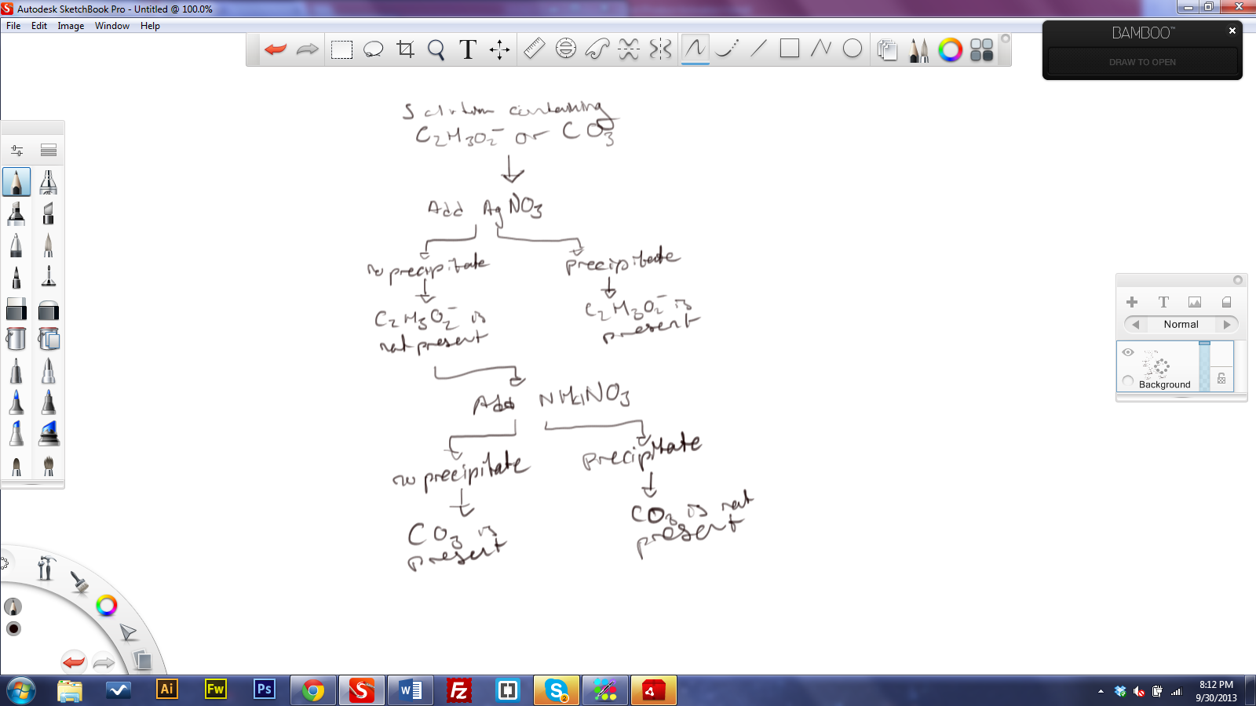
50. Precipitation reactions can be used in water treatment plants to test for pollutants. For example, if a technician wanted to test for SO₄, then they would take a sample and mix perhaps Ca(NO₃) into it. If there was a precipitate, then they may want to repeat with AgNO₃, Pb(NO₃)₂, or even Ba(NO₃)₂ to ensure if they have SO₄ as a pollutant.
51. a) Bottled Water in Local Municipality (Vancouver)
Benefits | Challenges
Cheap | Environmental Waste
Convienent* | Use of Public Water

b) Country with Limited Water Resources
Benefits | Challenges
Access to Clean Water | Environmental Waste
Convenient* | Expensive

* Note that convenience for a person in a municipality may mean that they can have water next to their desk rather going to the kitchen. Convenience to a person who has limited access to clean water may mean that a person won’t have to travel long distances and can instead relax and not expend a large amount of calories or time. In other words, the benefit of convenience to a person with limited access has a different meaning than to a person living in a municipality; although there are people inside municipalities that have limited access to water such as the homeless to whom, at times, have to use a public bathroom tap for water.
52.
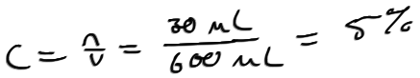
53.
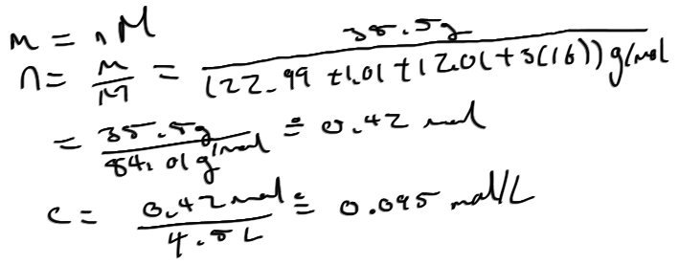
54.
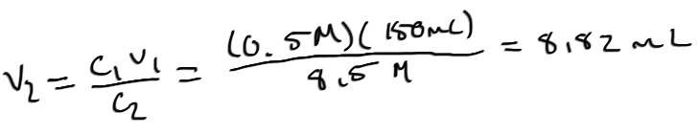
55. First, the final volume would need to be calculated. Second, the student would measure out the solute using a pipette. Third, the student would add at least half of the final volume (4.41 millilitres) in distilled water to a volumetric flask. Fourthly, the student will rinse the pipette three times and pour it into the flask. Finally, the student then fills up the flask to the final volume.
56. Solutes should be added to water because sometimes it may splash and it is safer for water to splash than a concentrated solution that may react or become heated.
57.
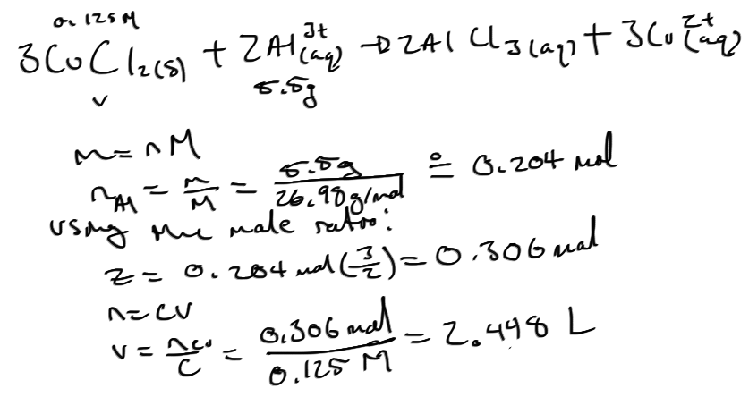
58.
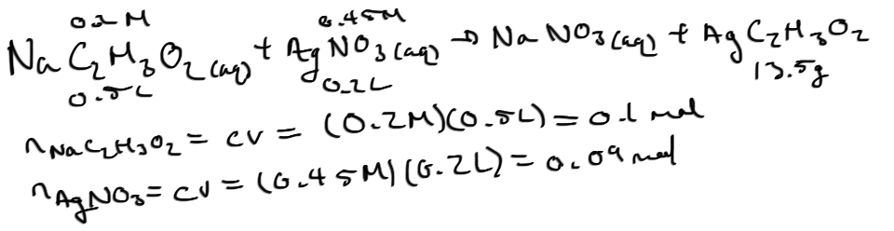
And let AgNO₃ be the limiting reagent.
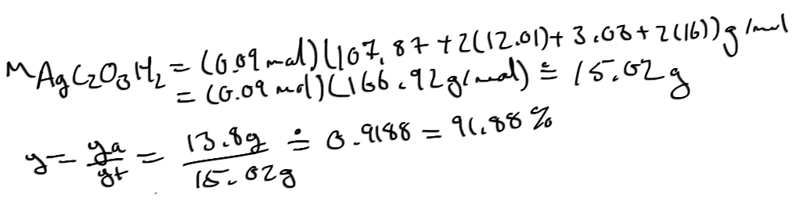
59. The Arrhenius Theory of acids predicts that the conductivity of water with an acidic solute is caused from the acid dissociating into two separate ions. Of these ions, the hydrogen cation will attach itself to the water molecule from the oxygens electron pairs creating H₃O⁺_{(aq)}.
60. The nitrous acid with a pH of approximately 4 has a low electrical conductivity because the nitrous acid doesn’t easily ionize in the solution. The nitric acid which is more acidic than the nitrous acid at 4 easily ionizes in the solution which is why it has a high electrical conductivity.
61.
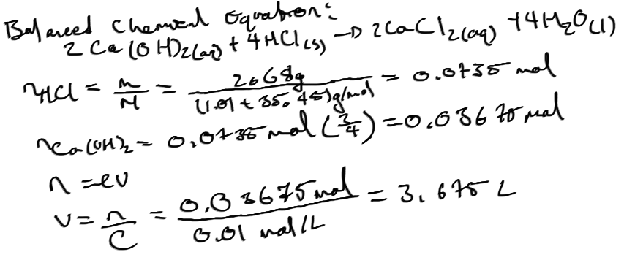
62.
