1.

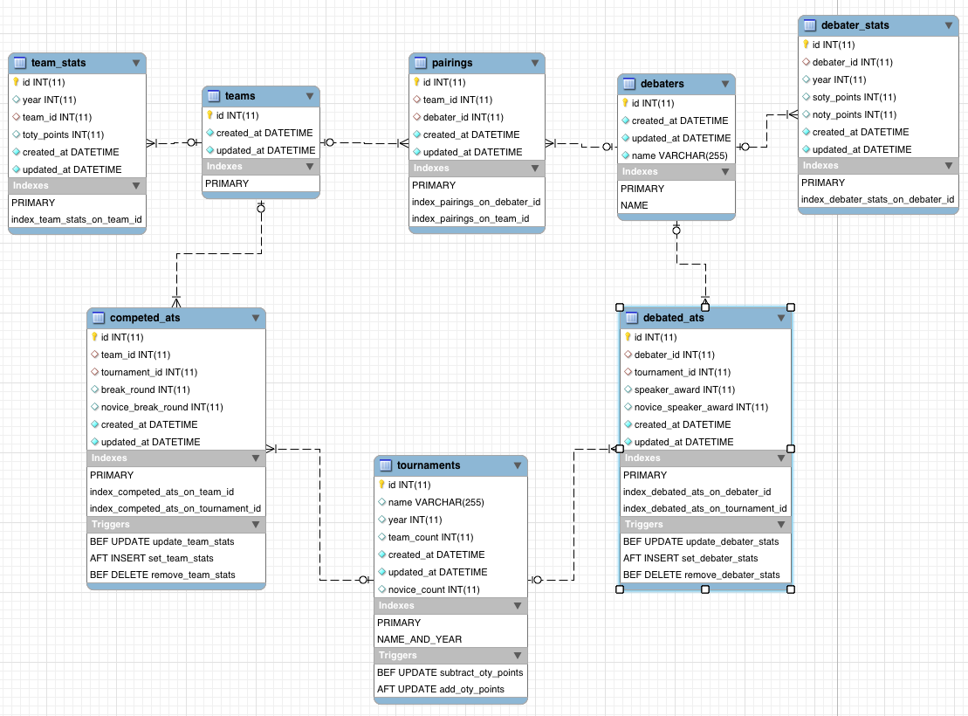

2.

|  |  |  |
| --- | --- | --- |
| **Noun** | **Verb** | **Noun** |
| Debater | Has | Debater Stats |
| Debaters | Debate At | Tournaments |
| Debaters | Have Pairings | Teams |
| Teams | Compete At | Tournaments |
| Team | Has | Team Stats |

Debater, Team and Tournament are the primary entities. Multiple Debaters compose a Team, which is tracked in Pairings. Debaters can belong to multiple teams. Debaters and Team both have stats, which are tracked on a year-by-year basis in their respective stats entity. Teams can debate at multiple tournaments, which is tracked in the CompetedAts table, and debaters’ individual performance at Tournaments is tracked in the DebatedAts table.

Triggers are stored on the Tournaments, CompetedAts and DebatedAts in order to update the stats after information about the tournament changes, or information about the team/debater’s performance at the tournament changes.

The id, created_at and updated_at fields are all necessary when using Rails. Id must be used as the primary key for every entity because it is possible for the user to change the value of other fields.

3. The team_stats and debater_stats tables are composition, where a single aspect of info about the debaters and teams is composed of a separate entity