Benre Nel
ST10278761
PROG6212 POE PART1

Documentation

Design Choices
The Contract Monthly Claim System is designed to efficiently manage the submission, processing, and tracking of monthly claims for contracts. The primary considerations include:
- Scalability: The system should accommodate growing data and user interactions over time.
- Maintainability: The architecture and codebase should be easy to maintain and extend.
- Usability: The user interface should be intuitive and accessible to users with varying levels of technical expertise.
- Security: Sensitive data, such as contract details and financial information, must be securely handled.

Database Structure
The database design is crucial as it underpins the system’s functionality and performance. Here’s an overview of the database structure:

Core Tables:
Contracts: This table stores information about the contracts.
- ‘ContractID’: Unique identifier for each contract.
- ‘ClientID’: Reference to the client associated with the contract.
- ‘ContractStartDate’: The start date of the contract.
- ‘ContractEndDate’: The end date of the contract.
- ‘ContractValue’: The total value of the contract.
- ‘ContractTerms’: Textual details regarding the contract terms.
Claims: This table holds the claims submitted under each contract.
- ‘ClaimID’: Unique identifier for each claim.
- ‘ContractID’: Reference to the associated contract.
- ‘ClaimDate’: Date the claim was submitted.
- ‘ClaimAmount’: The total amount claimed.
- ‘ClaimStatus’: The status of the claim (e.g., Submitted, approved, Rejected).
- ‘ClaimComments’: Any additional comments or notes about the claim.
Clients: This table stores client information.
- ‘ClientID’: Unique identifier for each client.
- ‘ClientName’: Name of the client.
- ‘ClientContact’: Contact details (e.g., phone number, email).
- ‘ClientAddress’: Physical address of the client.
Invoices: This table tracks invoices generated from approved claims.
- ‘InvoiceID’: Unique identifier for each invoice.
- ‘ClaimID’: Reference to the associated claim.
- ‘InvoiceDate’: Date the invoice was generated.
- ‘InvoiceAmount’: Total amount of the invoice.
- ‘PaymentStatus’: Status of the payment (e.g., Paid, Unpaid, Overdue).
Users: This table manages system users.
- ‘UserID’: Unique identifier for each user.
- ‘Username’: The username for login.
- ‘PasswordHash’: Hashed password for secure authentication.
- ‘UserRole’: The role of the user (e.g., Admin, Claim Processor).
ClaimItems: This table details individual items within a claim.
- ‘ClaimItemID’: Unique identifier for each claim item.
- ‘ClaimID’: Reference to the associated claim.
- ‘ItemDescription’: Description of the claim item.
- ‘Quantity’: Quantity of the item claimed.
- ‘UnitPrice’: Price per unit of the item.
- ‘TotalPrice’: Total price for the item (calculated as ‘Quantity * UnitPrice’).

Design Considerations:
- Normalisation: The database is normalised to eliminate redundancy and ensure data integrity.
- Foreign Keys: Relationships between tables are maintained using foreign keys to ensure referential integrity.
- Indexes: Indexes are created on frequently searched fields (e.g., ‘ContractID’, ‘ClaimDate’) to optimise query performance.

GUI Layout
The WPF-based GUI is designed with the following considerations:

Main Components:
Login Screen:
- Fields: Username and Password fields for user authentication.
- Buttons: “Login button to submit credentials, “Forgot Password” link for recovery.
Main Dashboard:
- Navigation Menu: Sidebar or top bar with links to different sections (Contracts, Claims, Invoices, Reports).
- Summary Panels: Display key metrics such as total contracts, pending claims, approved claims, and unpaid invoices.
- Search Bar: Allows quick searching of contracts, claims, or invoices.
Contracts Section:
- List View: Displays a list of all contracts with columns for contract ID, client name, start date, and end date.
- Details Panel: Shows detailed information about the selected contract, including associated claims and invoices.
- Action Buttons: “Add Contract”, “Edit Contract”, and “Delete Contract.”
Claims Section:
- List View: Displays all claims with filtering options (e.g., by date, status).
- Claim Submission Form: Form for submitting new claims, with fields for claim date, amount, and items.
- Claim Details View: Displays detailed information about a selected claim, including its status, items, and associated invoice.
Invoices Section:
- List View: Displays a list of all invoices with columns for invoice ID, claim ID, date and amount.
- Invoice Details Panel: Shows detailed information about the selected invoice, including payment status.
- Action Button: “Mark as Paid”, “Generate Report”
Reports Section:
- Reports Generator: Interface for generating reports based on selected criteria (e.g., monthly claim summary, unpaid invoices).
- Export Options: Buttons to export reports in different formats (e.g., PDF, Excel).

Design Considerations:
- User Experience: The interface should be user-friendly with clear navigation paths and intuitive forms.
- Consistency: Consistent use of colours, fonts, and layout across all sections to provide a unified experience.
- Responsiveness: The GUI should be responsive to different window sizes and screen resolutions.
- Accessibility: Features such as keyboard navigation, text-to-speech support, and high contrast mode should be included to make the application accessible to all users.

Assumptions and Constraints
In designing the Contract Monthly Claim System, several assumptions and constraints must be considered to ensure that the system meets the desired requirements and operates effectively within its intended environment.

Assumptions
User Base and Roles
- Assumption: The system will be used by a defined set of users with specific roles such as Administrators, Claim Processors, Clients, and Financial Officers.
- Implication: Role-based access control will be implemented to ensure users have appropriate permissions aligned with their responsibilities.
Volume of Data
- Assumption: The system will handle a moderate volume of contracts and claims initially, with expected growth over time.
- Implication: The database design should support scalability to accommodate increasing data without significant performance degradation.
Technology Stack
- Assumption: The application will be developed using .NET Core for backend services and WPF for the desktop GUI.
- Implications: The development team should have proficiency in these technologies, and the deployment environment should support them adequately.
Deployment Environment
- Assumption: The system will be deployed in an on-premises environment within the organisation’s network.
- Implication: Network infrastructure and hardware resources must be sufficient to support the system’s operational requirements.
Internet Connectivity
- Assumption: Users will have reliable internet/network connectivity when accessing the system.
- Implication: Real-time data synchronisation and remote access functionalities can be reliable implemented.
Integration with External Systems
- Assumption: There is a need to integrate with existing systems such as accounting software and client management systems.
- Implications: APIs and data exchange protocols should be designed to facilitate seamless integration and data consistency across systems.
Security Requirements
- Assumption: The system must adhere to standard security practices to protect sensitive financial and contractual data.
- Implication: Implementation of features like encryption for data at rest and in transit, secure authentication mechanisms, and regular security audits will be necessary.
Regulatory Compliance
- Assumption: The system must comply with relevant legal and regulatory standards such as GDPR for data protection and financial reporting standards.
- Implication: Data handling and storage processes must be designed to meet these compliance requirements, including proper consent management and data retention policies.
User Proficiency
- Assumption: Users have varying levels of technical proficiency.
- Implication: The GUI should be intuitive and user-friendly, with tooltips and help documentation to assist users in navigating the system effectively.
Operational Hours
- Assumption: The system will primarily be used during standard business hours with occasional after-hours access.
- Implication: Maintenance and updates can be scheduled during off-peak hours to minimise disruption.
Reporting Needs
- Assumption: Users require comprehensive reporting capabilities for decision-making and compliance purposes.
- Implication: The system should include flexible and customised reporting features, allowing data export in various formats.
Backup and Recovery
- Assumption: Regular backups are necessary to prevent data loss.
- Implication: Backup and disaster recovery strategies must be implemented, ensuring minimal downtime and data integrity in case of failures.

Constraints
Time Frame
- Constraint: The system must be developed and deployed within a specified timeline.
- Implication: Prioritisation of core functionalities over optional features, adoption of agile development methodologies to ensure timely delivery.
Resource Availability
- Constraint: Limited availability of skilled developers and IT personnel (limited to one person).
- Implication: May necessitate simplifying system complexity where feasible.
Data Privacy and Security Regulations
- Constraint: Strict adherence to data protection laws and industry-specific regulations.
- Implication: Comprehensive security measures are mandatory; may increase development complexity and require compliance assessments.
User Accessibility
- Constraint: The system must be accessible to users with disabilities as per accessibility standards (e.g., WCAG).
- Implication: Incorporation of accessibility features such as screen reader compatibility, keyboard navigation, and appropriate colour contrasts.
Localisation
- Constraint: The system may need to support multiple languages and regional formats.
- Implication: Incorporation of localisation and internationalisation features from the outset to support diverse user bases.
Legal and Contractual Obligations
- Constraint: The system must adhere to specific legal and contractual obligations related to contract management and financial reporting.
- Implication: Legal review during design and development phases; implementation of features that ensure compliance with contractual stipulations.

Impact on Design Choices
Considering these assumptions and constraints influences various aspects of the system design:
- Architecture: Adoption of a modular and scalable architecture to accommodate future growth and ease of maintenance.
- Security Measures: Implementing robust security protocols to protect data and comply with regulatory requirements.
- User Interface Design: Creating an intuitive and accessible GUI that caters to users with different technical abilities and accessibility needs.
- Developing Methodology: Utilising agile methodologies to adapt to changing requirements and deliver incremental values within time and budget constraints.

UML Class Diagram

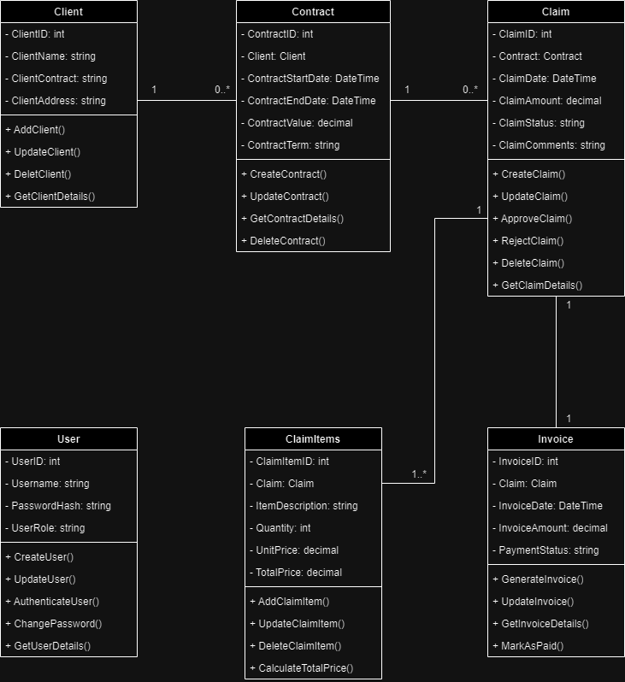

Project Plan for Contract Monthly Claim System Prototype
Overview
This project plan outlines the tasks, dependencies, and timeline for developing the prototype of the Contract Monthly Claim System. The plan is structured to ensure the project is completed within a realistic and achievable timeframe, taking into consideration the key phrases: Requirements Gathering, Design, Development, Testing, and Deployment.

Project Timeline and Phases
Total Duration: 12 Weeks (3 Months)
Phases:
- Requirements Gathering and Analysis – 2 Weeks
- Design – 2 Weeks
- Development – 5 Weeks
- Testing – 2 Weeks
- Deployment and Documentation – 1 Week

Detailed Task Breakdown

Phase 1: Requirements Gathering and Analysis (2 Weeks)
Task 1.1: Define Project Scope
- Duration: 2 Days
- Description: Finalise the scope of the prototype, including the features to be implemented in this phase.
- Output: Project Scope Document
Task 1.2: Develop High-Level Use Cases
- Duration: 3 Days
- Description: Create high-level use cases based on the gathering requirements.
- Dependencies: Task 1.2
- Output: Use Case Document

Phase 2: Design (2 Weeks)
Task 2.1: Database Schema Design
- Duration: 4 Days
- Description: Design the database schema, including tables, relationships, and constraints.
- Output: Database schema
Task 2.2: GUI Wireframing
- Duration: 3 Days
- Description: Create wireframes for the WPF interface, focusing on key screens and navigation flow.
- Output: GUI Wireframes
Task 2.3: System Architecture Design
- Duration: 3 Days
- Description: Define the overall system architecture, including application layers, modules, and data flow.
- Output: System Architecture Documents.

Phase 3: Development (5 Weeks)
Task 3.1: Set Up Development Environment
- Duration: 2 Days
- Description: Configure the development environment, including necessary tools, libraries and frameworks.
- Output: Development Environment Ready
Task 3.2: Database Implementation
- Duration: 5 Days
- Description: Develop and implement the database schema, including the creation of tables, relationships, and indexing.
- Output: Database Created and Functional
Task 3.3: Backend Development
- Duration: 10 Days
- Description: Implement the backend services and logic, including data access layers, business logic, and API development.
- Output: Backend Services Developed
Task 3.4: GUI Development
- Duration: 10 Days
- Description: Develop the WPF-based GUI, focusing on the layout, navigation, and core functionalities.
- Output: GUI Developed
Task 3.5: Integration
- Duration: 3 Days
- Description: Integrate the backend services with the GUI, ensuring seamless data flow and interaction.
- Output: Fully Integrated Prototype

Phase 4: Testing (2 Weeks)
Task 4.1: Unit Testing
- Duration: 5 Days
- Description: Conduct unit tests for individual components.
- Output: Test Cases and Results
Task 4.2: Integration Testing
- Duration: 3 Days
- Description: Perform integration testing to ensure that all components work together as expected.
- Output: Integration Test Results
Task 4.3: User Acceptance Testing (UAT)
- Duration: 4 Days
- Description: Engage a small group of end-users to test the system and provide feedback.
- Output: UAT Feedback and Final Test Report

Phase 5: Deployment and Documentation (1 Week)
Task 5.1: Deployment Preparation
- Duration: 2 Days
- Description: Prepare deployment scripts, environment setup, and documentation.
- Output: Deployment Plan
Task 5.2: Prototype Deployment
- Duration: 2 Days
- Description: Deploy the prototype to the staging or production environment.
- Output: Prototype Deployed
Task 5.3: Documentation and Training
- Duration: 3 Days
- Description: Create user manuals, technical documentation, and provide training for users.
- Output: Documentation and Training Materials

Time Table Overview
Week | Task | Duration
1-2 | Requirements Gathering and Analysis | 2 Weeks
3-4 | Design | 2 Weeks
5-9 | Development | 5 Weeks
10-11 | Testing | 2 Weeks
12 | Deployment and Documentation | 1 Week

Milestones
- End of Week 2: Finalised Requirements Document and Project Scope.
- End of Week 4: Approved Design Documents and Wireframes.
- End of Week 9: Functional Prototype with Integrated Backend and GUI.
- End of Week 11: Completed Testing with Final Test Report.
- End of Week 12: Deployed Prototype and Delivered Documentation.

GUI IU

Login
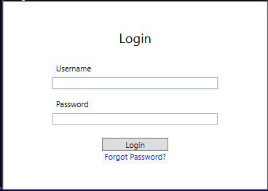

Main Dashboard
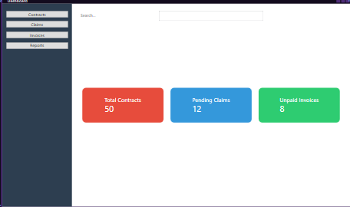

Claims
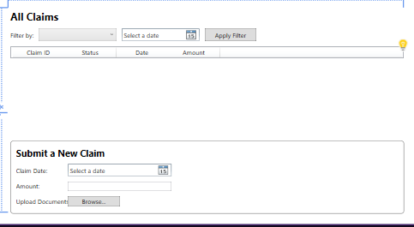

Report
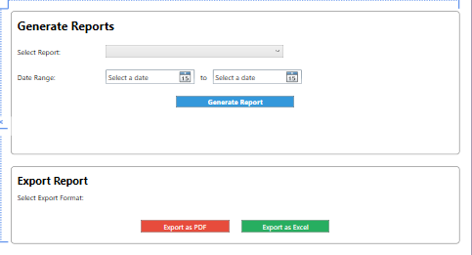

Contracts
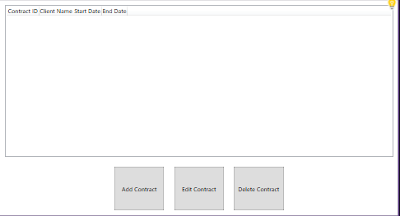

Version Control
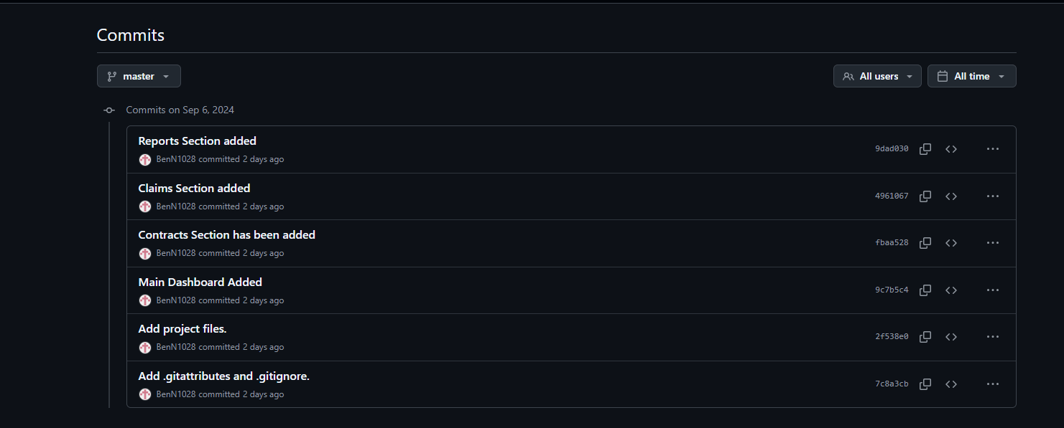

Report
Report on User Interface Design for the Contract Monthly Claim System
The design of the Contract Monthly Claim System focuses on creating a user-friendly and intuitive interface. This report outlines the key components of the Claims Section and the Reports Section, emphasising how the layout improves usability and user experience.
Claims Section Design
The Claims Section allows users to manage their claims efficiently. It is split into two main parts: the Claim List View and the Claim Submission Form.
- Claim List View: A ListView displays all claims with details such as Claim ID, Status, Date, and Amount. The filtering options include a ComboBox for status-based filtering (e.g., “Pending Claims” or “Approved Claims”) and a DatePicker for filtering by date. This enables users to quickly find relevant claims, improving overall system efficiency.
- Claim Submission Form: The form is neatly organised within a Border for visual clarity, allowing users to input claim details such as the claim date, amount, and upload documents. The fields are aligned for better readability, and the submit button is highlighted with a green background, prompting user action. This form ensures that users can easily submit claims, track their status, and upload necessary documents.
This section is designed to offer transparency and accessibility, allowing users to submit claims and track their progress. Program coordinators and managers can also approve claims easily through the interface.
Reports Section Design
The Reports Section simplifies report generation and exporting. It consists of two parts: Report Generation and Export Options.
- Report Generation: Users can select the type of report (e.g., "Monthly Claim Summary" or "Unpaid Invoices") using a ComboBox. Date range selection is done via two DatePicker controls. The “Generate Report” button is styled with a blue background to stand out, ensuring users can easily generate reports based on their chosen criteria. This layout makes it simple for users to generate detailed reports quickly.
- Export Options: Users can export reports in different formats, such as PDF or Excel. These export options are color-coded for clarity, with red representing PDF and green for Excel. This visual distinction enhances usability by providing clear, recognisable options for exporting reports.
Key Design Considerations
Key considerations during the design process included:
- User Experience: The layout is clean and well-organised, ensuring users can navigate and perform tasks without confusion.
- Consistency: Elements such as margins, borders, and colours are used consistently to maintain visual clarity and avoid clutter.
- Accessibility: The interface is designed to accommodate users with varying technical expertise, making actions like claim submission, filtering, and report generation intuitive.
Conclusion
The UI design for the Contract Monthly Claim System enhances usability through a well-structured layout in both the Claims Section and Reports Section. By focusing on clarity and ease of use, the system allows users to manage claims, generate reports, and export data with minimal effort. These design elements ensure that the system remains efficient, transparent, and accessible for all users.

Repository Link
https://github.com/IIEMSA/poe-part-1-BenN1028.git

