COMP5009 DATA MINING

Assignment Report

October 3, 2024

Student ID: 21678145

Surname: Niu

Given name: Ben

Table of Contents

1. Summary 2

2. Methodology 2

2.1 Data preparation 2

2.1.1 Data overview 2

2.1.2 Identify and remove irrelevant attributes 5

2.1.3 Detect and handle missing entries 7

2.1.4 Detect and handle duplicates 8

2.1.5 Select suitable data types for attributes 8

2.1.6 Perform data transformation 8

2.1.7 Perform other data preparation operations 9

2.2 Data classification 9

2.2.1 Class imbalance 9

2.2.2 Model training and tuning 11

2.2.3 Model comparison 12

2.2.4 Prediction 13

2.2.5 Other inventive steps 13

3. Conclusion 13

4. References 14

5. Appendices 14

# Summary

In this assignment of Data Mining, I tried to solve a real-world data mining problem. I used Google Colab, Python and sklearn to complete this assignment.

The dataset contains 5000 data, and I use them to train 4 models and select the best 2 models to predict 500 new data. The model prediction accuracy achieved 85%.

During this assignment, I studied how to prepare data, classify data and tune models. I learned how to identify and remove irrelevant attributes, handle missing entries and duplicates, and transform data. I learned how to handle imbalanced data and tune model parameters.

# Methodology

## Data preparation

After downloading the SQLite DB from the website, we can examine all data attributes and identify issues present in the data.

### Data overview

The data shape is 5000 rows × 32 columns.

The name and type of columns are as follows:

Table ‑ Data Types

|  |  |  |  |  |  |  |  |
| --- | --- | --- | --- | --- | --- | --- | --- |
| **Column** | **Type** | **Column** | **Type** | **Column** | **Type** | **Column** | **Type** |
| Index | int64 | Buyer | float64 | Storage | object | Session | int64 |
| System | float64 | Insect | float64 | Resource | float64 | Guitar | object |
| Science | float64 | Music | object | Writer | float64 | Shopping | float64 |
| Method | float64 | Guidance | float64 | Member | float64 | Trainer | int64 |
| People | float64 | Power | float64 | Cookie | float64 | Office | float64 |
| Estate | float64 | Knowledge | int64 | Virus | float64 | Country | float64 |
| Tennis | float64 | Owner | int64 | Moment | float64 | Tension | float64 |
| Problem | float64 | Oven | float64 | Driver | float64 | class | int64 |

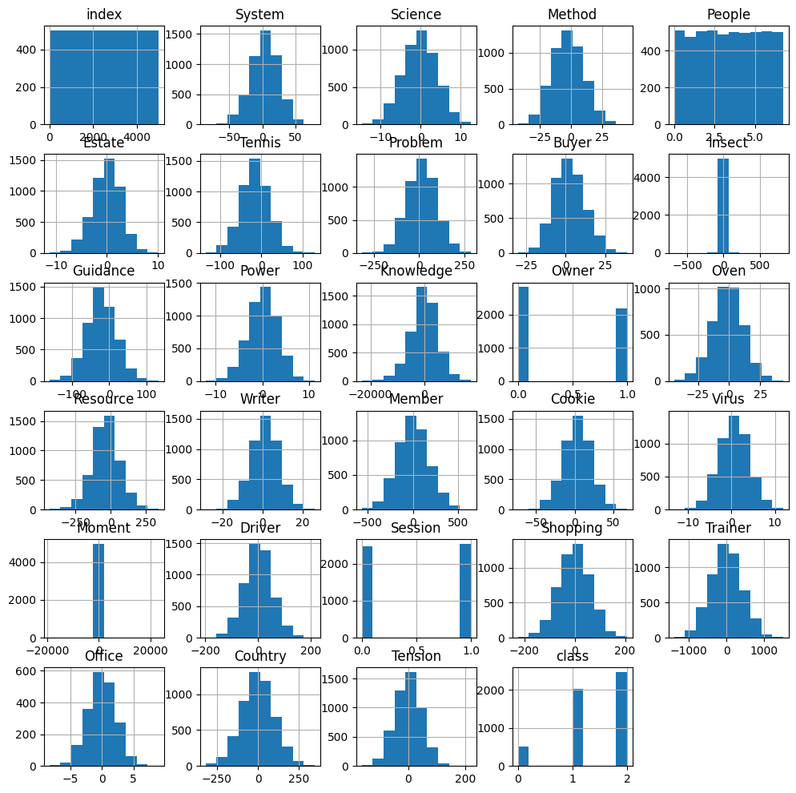

Figure ‑ Data Histogram

From the histogram, I found that the columns “Insect” and “Moment” distribution show some outlier values. So, check the standard deviation.

Figure ‑ Standard Deviation

I filtered all standard deviations more than 100 except “index”.

Table ‑ Columns with STD > 100

|  |  |
| --- | --- |
| **Column** | **STD** |
| Knowledge | 5012.001888066708 |
| Moment | 756.8477835397937 |
| Trainer | 415.3156156627911 |
| Member | 172.2754715353466 |

I used “RobustScaler” in sklearn to handle the outliers.

The distribution before handling and after handling as follows:

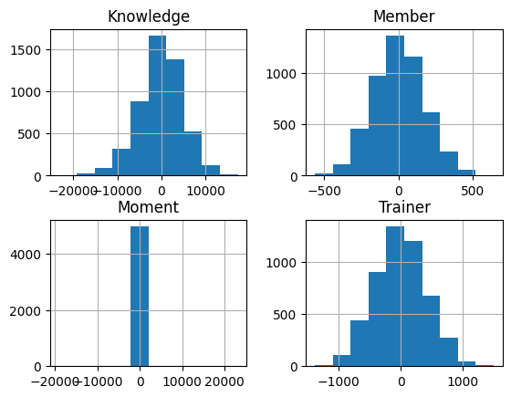

Figure ‑ Before Handling

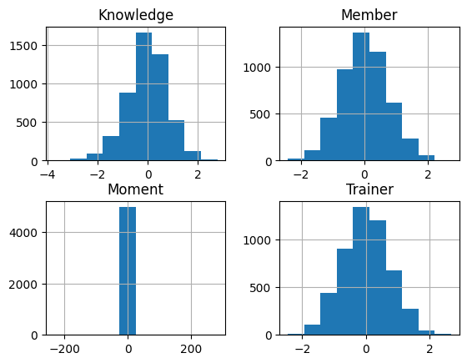

Figure ‑ After Handling

### Identify and remove irrelevant attributes

1. Remove the “index” column: “index” is only an order number to label the data; it is unrelated to the label.
2. Analyse correlations of columns: use “pd.corr” and “sns.heatmap” to monitor the correlations of columns.

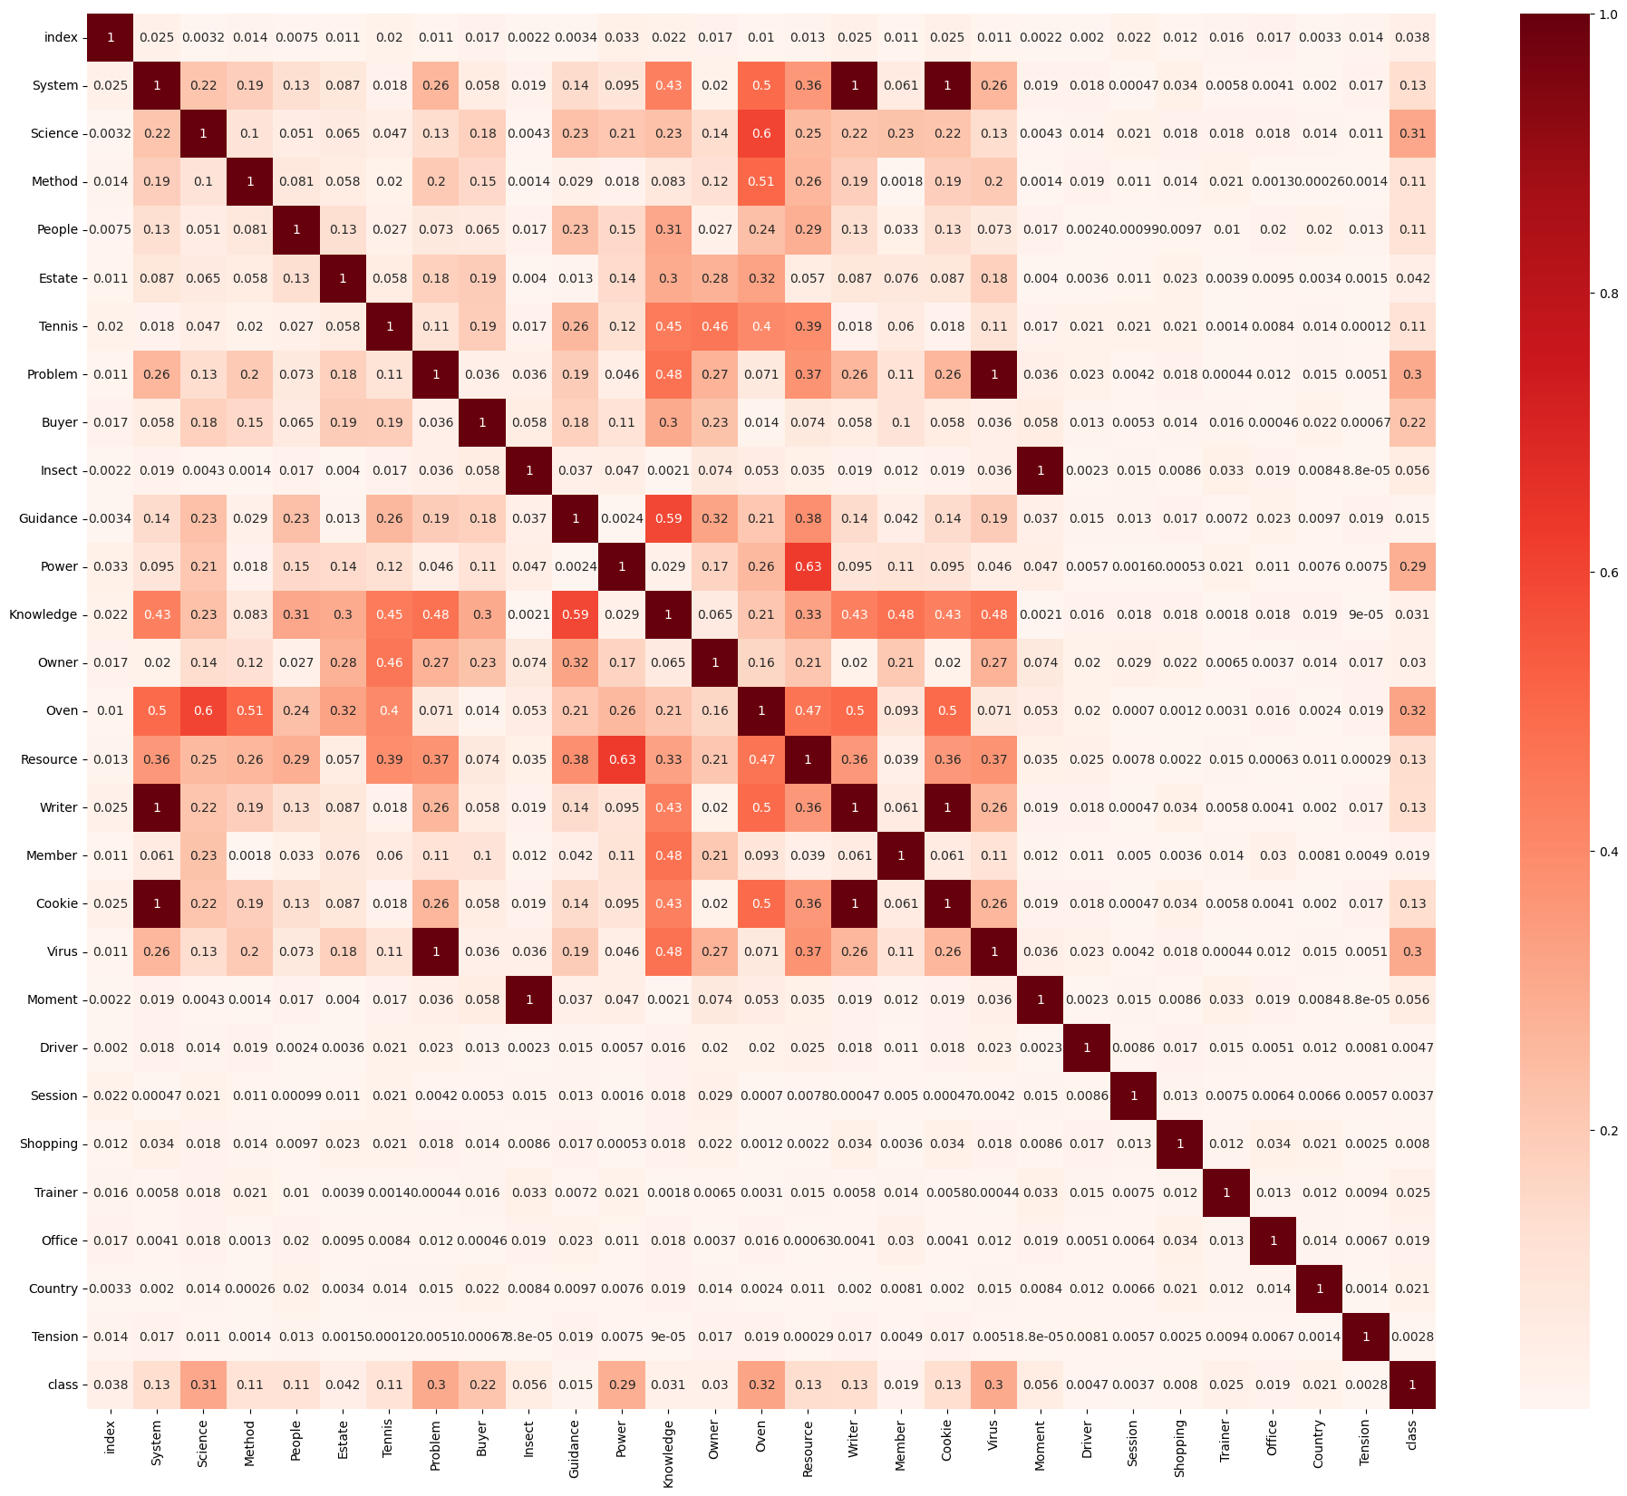

Figure ‑ Heatmap for Correlations

I found that some columns are highly correlated. Set the correlation high threshold as 0.8 and filter all correlation items. Drop the “Writer”, “Cookie”, “Virus”, and “Moment” columns.

Table ‑ Column Correlation > 0.8

|  |  |  |
| --- | --- | --- |
| **Column 1** | **Column 2** | **Correlation** |
| System | Writer | 1.0000000000000004 |
| System | Cookie | 1.0 |
| Problem | Virus | 1.0000000000000024 |
| Insect | Moment | 0.9999999999999984 |
| Writer | Cookie | 0.9999999999999972 |

Continue checking the correlation of all attributes with column “class”, and filter all attributes which have low correlation (set correlation low threshold as 0.1):

Table ‑ Columns Correlation with class < 0.1

|  |  |  |
| --- | --- | --- |
| **Column 1** | **Column 2** | **Correlation** |
| class | index | 0.03766008168623011 |
| class | Estate | 0.04238407557518169 |
| class | Insect | 0.05622949087833261 |
| class | Guidance | 0.015080251130552235 |
| class | Knowledge | 0.030992414281511914 |
| class | Owner | 0.029526606860980856 |
| class | Member | 0.018503421901164586 |
| class | Moment | 0.056229490878332504 |
| class | Driver | 0.0046604714092332595 |
| class | Session | 0.0036983105394678556 |
| class | Shopping | 0.00801755216832826 |
| class | Trainer | 0.024601270464653678 |
| class | Office | 0.01856881780794045 |
| class | Country | 0.021209070634925237 |
| class | Tension | 0.00281650689440731 |

Drop columns of “Estate”, “Insect”, “Guidance”, “Knowledge”, “Owner”, “Member”, “Moment”, “Driver”, “Session”, “Shopping”, “Trainer”, “Office”, “Country”, “Tension”.

1. Drop the columns whose type equals “object”: “Music”, “Storage”, “Guitar”.

The dataset is reduced to 10 columns.

### Detect and handle missing entries

Calculate the missing rate for each column:

Table ‑ Missing Rate

|  |  |  |  |  |  |
| --- | --- | --- | --- | --- | --- |
| **Column** | **Missing Rate (%)** | **Column** | **Missing Rate (%)** | **Column** | **Missing Rate (%)** |
| System | 0 | Tennis | 1.0 | Oven | 22.36 |
| Science | 0 | Problem | 0 | Resource | 0 |
| Method | 0 | Buyer | 0 |  |  |
| People | 0 | Power | 0 |  |  |

1. Drop missing rate greater than 20: “Oven”
2. Fill in the missing data using the mean value for the missing rate less than 5.

The dataset is reduced to 10 columns.

### Detect and handle duplicates

1. Check the row duplicated

There are 50 rows duplicated, and the duplicated indexes are:

42, 91, 111, 508, 682, 763, 872, 983, 1222, 1225, 1462, 1537, 1560, 1816, 1935, 2003, 2118, 2250, 2415, 2474, 2631, 2719, 2740, 2745, 2970, 2974, 3249, 3393, 3551, 3557, 3620, 3681, 3885, 3993, 4024, 4128, 4161, 4238, 4287, 4327, 4443, 4562, 4642, 4771, 4785, 4826, 4928, 4944, 4962, 4986.

1. Check the column duplicated

There is no duplication.

Now the data shape is 4950 rows x 9 columns.

### Select suitable data types for attributes

Check the type of all attributes:

Table ‑ Attributes and Type

|  |  |  |  |  |  |
| --- | --- | --- | --- | --- | --- |
| **Column** | **Type** | **Column** | **Type** | **Column** | **Type** |
| System | float64 | People | float64 | Buyer | float64 |
| Science | float64 | Tennis | float64 | Power | float64 |
| Method | float64 | Problem | float64 | Resource | float64 |

All the types are “float64”, don’t need more handling.

### Perform data transformation

Attributes with different scales or distributions can cause bias in the data mining application.

Table ‑ Attributes Describe

|  |  |  |  |  |  |  |  |  |  |
| --- | --- | --- | --- | --- | --- | --- | --- | --- | --- |
| **index** | **System** | **Science** | **Method** | **People** | **Tennis** | **Problem** | **Buyer** | **Power** | **Resource** |
| **count** | 4950 | 4950 | 4950 | 4950 | 4950 | 4950 | 4950 | 4950 | 4950 |
| **mean** | 3.670037 | -0.20402 | -2.20297 | 3.374596 | -15.1987 | 14.75373 | 2.4189 | 0.105462 | -35.528 |
| **std** | 21.06388 | 4.25023 | 12.61826 | 1.939023 | 33.96617 | 81.05217 | 9.637839 | 3.195017 | 96.88005 |
| **min** | -86.1559 | -14.6682 | -42.3718 | 0.001222 | -135.559 | -315.53 | -30.2006 | -12.1974 | -435.234 |
| **25%** | -10.4049 | -3.09724 | -11.1447 | 1.711706 | -37.5888 | -39.648 | -4.43419 | -1.99157 | -98.1736 |
| **50%** | 4.202203 | -0.15908 | -2.5402 | 3.376959 | -15.1897 | 15.4177 | 1.97323 | 0.183484 | -35.9764 |
| **75%** | 18.2044 | 2.805944 | 6.456216 | 5.055354 | 7.223578 | 69.10684 | 8.977011 | 2.272641 | 25.33945 |
| **max** | 79.52288 | 12.53653 | 45.13045 | 6.722135 | 129.5476 | 284.9823 | 38.67819 | 11.2812 | 338.5063 |

Do Z-score scaling using “StandardScaler” in sklearn. After transformation, each column data mean is 0 and the standard deviation is 1.

Table ‑ Attributes Describe after Scaling

|  |  |  |  |  |  |  |  |  |  |
| --- | --- | --- | --- | --- | --- | --- | --- | --- | --- |
| **index** | **System** | **Science** | **Method** | **People** | **Tennis** | **Problem** | **Buyer** | **Power** | **Resource** |
| **count** | 4950 | 4950 | 4950 | 4950 | 4950 | 4950 | 4950 | 4950 | 4950 |
| **mean** | -2.30E-17 | 2.30E-17 | 3.45E-17 | 1.38E-16 | -4.59E-17 | 0 | 0 | 0 | -4.59E-17 |
| **std** | 1.000101 | 1.000101 | 1.000101 | 1.000101 | 1.000101 | 1.000101 | 1.000101 | 1.000101 | 1.000101 |
| **min** | -4.26489 | -3.4035 | -3.18371 | -1.7399 | -3.54388 | -4.07537 | -3.38487 | -3.85104 | -4.1262 |
| **25%** | -0.66827 | -0.68079 | -0.7087 | -0.85768 | -0.65926 | -0.67126 | -0.71113 | -0.65641 | -0.6467 |
| **50%** | 0.025267 | 0.010575 | -0.02673 | 0.001219 | 0.000266 | 0.008193 | -0.04625 | 0.024422 | -0.00463 |
| **75%** | 0.690083 | 0.70826 | 0.686312 | 0.866894 | 0.660202 | 0.670662 | 0.680523 | 0.678368 | 0.62834 |
| **max** | 3.601449 | 2.997916 | 3.751563 | 1.72658 | 4.261914 | 3.334345 | 3.76256 | 3.498219 | 3.861187 |

We should apply the same handling for the test data.

Table ‑ Attributes Describe for Test Data

|  |  |  |  |  |  |  |  |  |  |
| --- | --- | --- | --- | --- | --- | --- | --- | --- | --- |
| **index** | **System** | **Science** | **Method** | **People** | **Tennis** | **Problem** | **Buyer** | **Power** | **Resource** |
| **count** | 500 | 500 | 500 | 500 | 500 | 500 | 500 | 500 | 500 |
| **mean** | -0.07047 | 0.001066 | -0.00386 | -0.05364 | 0.042565 | 0.042216 | -0.07322 | 0.033123 | -0.03668 |
| **std** | 1.035409 | 0.960692 | 0.987809 | 1.015752 | 0.953415 | 1.007975 | 0.964691 | 1.024279 | 1.064561 |
| **min** | -3.36434 | -2.6629 | -2.94146 | -1.74053 | -2.41562 | -3.02083 | -2.86147 | -3.04302 | -4.46288 |
| **25%** | -0.75266 | -0.67892 | -0.69182 | -1.03642 | -0.6007 | -0.63384 | -0.78428 | -0.61892 | -0.65987 |
| **50%** | -0.08314 | 0.025394 | -0.03144 | -0.05048 | 0.058703 | 0.025674 | -0.11451 | 0.092811 | -0.05921 |
| **75%** | 0.612187 | 0.682995 | 0.656082 | 0.824809 | 0.657751 | 0.751336 | 0.522145 | 0.752678 | 0.618869 |
| **max** | 3.243257 | 3.420597 | 2.845443 | 1.706404 | 2.692774 | 2.897639 | 2.358577 | 2.778631 | 2.998217 |

### Perform other data preparation operations

NA

## Data classification

### Class imbalance

Use “train_test_split” in sklearn to split the dataset (size: 4950) into the training dataset (3464, 70%), validation dataset (743, 15%), and testing dataset (743, 15%).

Check the class distribution in the training dataset:

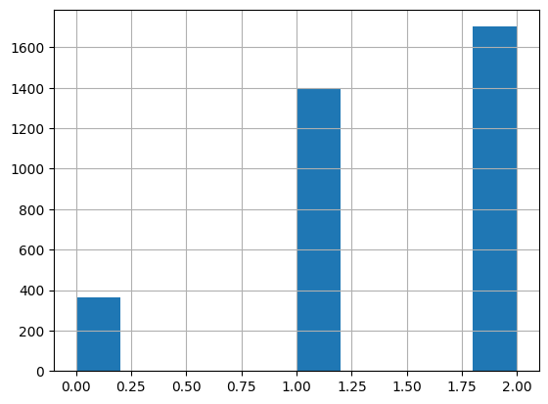

Figure ‑ Class Distribution in Training Dataset

The dataset is imbalanced. If I use the dataset to train the model directly, I find the predictable label is very imbalanced for class “0”.

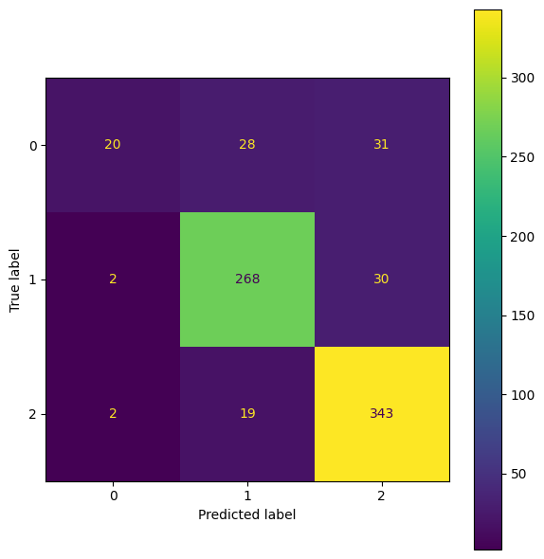

Figure ‑ Default training data predict

I used “RandomOverSampler” in sklearn to balance the training dataset. Then check the class distribution in the training dataset again: total 5106, 1702 for each class.

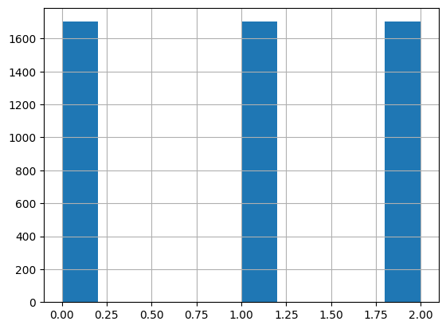

Figure ‑ Class Distribution in Training Data after Oversampling

Using the oversampled dataset to train the model again, I found that the predictable label is balanced for class “0”.

Figure ‑ After Oversample

### Model training and tuning

I split 15% of the data as a validation dataset; I used “PredefinedSplit” as cross-validation (cv) in “GridSearchCV” to validate the model parameters.

Because the validation dataset is imbalanced, I use “precision_score” with “weighted” average parameter as scorer in “GridSearchCV”.

I select 4 models to train and tune, using “GridSearchCV” to select the best parameters.

1. KNN

Table ‑ KNN Tuning

|  |  |  |  |
| --- | --- | --- | --- |
| **Parameter** | **Values** | **Best Param** | **Best Score** |
| weights | 'uniform','distance' | distance | 0.8703840669201928 |
| neighbors | 1,3,7,11,17,21,25,30,35,40,45,50,55,60 | 25 |

1. DT

Table ‑ DT Tuning

|  |  |  |  |
| --- | --- | --- | --- |
| **Parameter** | **Values** | **Best Param** | **Best Score** |
| criterion | 'gini','entropy' | gini | 0.782205912087215 |
| min_samples_split | 2,3,4,5,7,10,15,20 | 2 |
| max_depth | 5,7,8,9,10,11,12,13,14,15 | 7 |

1. NB

Table ‑ NB Tuning

|  |  |  |  |
| --- | --- | --- | --- |
| **Parameter** | **Values** | **Best Param** | **Best Score** |
| var_smoothing | 1e-10, 1e-09, 1e-08, 1e-07 | 1e-10 | 0.763941400117287 |

1. SVM

Table ‑ SVM Tuning

|  |  |  |  |
| --- | --- | --- | --- |
| **Parameter** | **Values** | **Best Param** | **Best Score** |
| kernel | 'linear', 'poly', 'rbf' | kbf | 0.8808395376802616 |
| C | 1.0, 2.0, 3.0, 4.0, 5.0, 6.0 | 4.0 |
| gamma | 'scale', 'auto' | scale |

### Model comparison

After getting the best parameters for each model, we must use the validation and testing datasets to score the models.

Table ‑ Model Param and Comparison

|  |  |  |  |  |
| --- | --- | --- | --- | --- |
| **Name** | **Param** | **Score** | **Validation** | **Test** |
| KNN | {'n_neighbors': 25, 'weights': 'distance'} | 0.870384 | 0.847914 | 0.847914 |
| DT | {'criterion': 'gini', 'max_depth': 7, 'min_samples_split': 2} | 0.782206 | 0.755047 | 0.728129 |
| NB | {'var_smoothing': 1e-10} | 0.763941 | 0.705249 | 0.666218 |
| SVM | {'C': 4.0, 'gamma': 'scale', 'kernel': 'rbf'} | 0.88084 | 0.87214 | 0.873486 |

So the best 2 models are SVM and KNN, and their estimated prediction accuracy are 0.873 and 0.848.

### Prediction

I use the best 2 models to predict the 500 test samples, write the result out a table “predict” and store it in “Answers.sqlite”.

Table ‑ Predict Model Accuracy

|  |  |  |
| --- | --- | --- |
| **Predict** | **Model** | **Accuracy** |
| Predict1 | SVM | 0.873 |
| Predict2 | KNN | 0.848 |

Figure ‑ Predict Output

### Other inventive steps

NA

# Conclusion

I followed the instructions in the “Assignment.pdf” and practicals to complete the data preparation, classification and prediction tasks.

I tried my best to handle the data's irrelevant attributes, missing entries, duplicates and transformations, and tune the best 2 models with an accuracy of 85%. Then, the models predict 500 new data and store them in an SQLite database.

# References

‌2. over-sampling — Version 0.11.0. (n.d.). Welcome to imbalanced-learn documentation!. https://imbalanced-learn.org/stable/over_sampling.html

1.4. Support vector machines. (n.d.). scikit-learn. Retrieved October 4, 2024, from https://scikit-learn.org/stable/modules/svm.html

GridSearchCV. (n.d.). scikit-learn. Retrieved October 4, 2024, from https://scikit-learn.org/dev/modules/generated/sklearn.model_selection.GridSearchCV.html

Precision_score. (n.d.). scikit-learn. Retrieved October 4, 2024, from https://scikit-learn.org/dev/modules/generated/sklearn.metrics.precision_score.html#sklearn.metrics.precisio

# Appendices

NA