Distributed Hadoop Cluster for YouTube Video Analysis

Complete Technical Project Report

Project Title: YouTube Video Analysis Using Distributed Hadoop Cluster
Technology Stack: Hadoop HDFS, YARN, Docker, YouTube Data API v3, PowerShell
Project Duration: December 2024
Author: Ben Othmen Rayen

Executive Summary:
This project demonstrates the implementation of a distributed big data processing system using the Apache Hadoop ecosystem to collect, store, and analyze YouTube video metadata. The system successfully deployed a 3-node Hadoop cluster using Docker containerization, integrated with YouTube Data API v3, and processed over 40 videos to extract meaningful insights about content trends, engagement patterns, and channel analytics.

Key achievements:
- Deployed a fully functional 3-node Hadoop cluster with HDFS and YARN.
- Integrated YouTube Data API v3 for automated video data collection.
- Stored 27+ video metadata files in distributed HDFS storage.
- Implemented a comprehensive data analysis pipeline.
- Achieved 3x data replication for fault tolerance.
- Processed millions of views and engagement metrics.

Table of Contents:
- Introduction
- System Architecture
- Technologies Used
- Implementation Details
- Data Collection Process
- Data Analysis & Results
- Screenshots & Documentation
- Challenges & Solutions
- Performance Metrics
- Conclusions & Future Work

1. Introduction

1.1 Project Objective
The primary objective of this project is to build adistributed data processing systemcapable of:
- Collecting large-scale video metadata from YouTube
- Storing data in a fault-tolerant distributed file system
- Analyzing content trends and engagement patterns
- Demonstrating real-world big data technologies

1.2 Problem Statement
Traditional single-machine systems cannot efficiently handle the massive scale of social media data. This project addresses the need for:
- Scalability:Processing thousands of videos without performance degradation
- Fault Tolerance:Ensuring data availability even with node failures
- Distributed Processing:Leveraging multiple machines for parallel computation
- Real-time Analytics:Extracting insights from continuously growing datasets

1.3 Scope
This project covers:
- Hadoop cluster setup and configuration
- YouTube API integration
- Data ingestion pipeline
- Distributed storage in HDFS
- Statistical analysis and reporting
- Visualization of results

2. System Architecture:

2.1 High-Level Architecture:
The proposed system employs adistributed architecturefor the collection, storage, and analysis of YouTube data.
- YouTube Data API v3: This serves as the primary data source, offering essential functionalities such as retrieving search results, metadata, and statistics for videos.
- Video Fetcher Service: This component is responsible for extracting video data and processing the associated metadata, ultimately producing structured JSON files for further processing.
- Hadoop Distributed File System (HDFS): Here, data is stored across several DataNodes, all managed by a central NameNode. AHDFS Clientaids in directory creation, file uploads, and data replication to ensure reliability and accessibility.
- YARN Resource Manager: This organization regulates resource allocation and schedules jobs for data analysis, optimizing processing efficiency across the cluster.
- Analysis and Visualization Layer: This layer is tasked with conducting data analysis and creating HTML dashboards to visualize the findings effectively.
The flow of data can be outlined as:YouTube API → Video Fetcher → HDFS → YARN → Analysis & Visualization. This architecture is designed to facilitate robust and scalable data handling and analysis.

2.2 Component Breakdown

2.2.1 HDFS Layer
- NameNode (1): Master node managing file system metadata.
- DataNodes (3): Worker nodes storing actual data blocks.
- Replication Factor: 3 (each file is stored on 3 different nodes).

2.2.2 YARN Layer
- ResourceManager (1): Cluster resource allocator.
- NodeManagers (3): Per-node resource managers.
- HistoryServer (1): Job execution history tracking.

2.2.3 Application Layer
- YouTube Fetcher: Python-based data collection service.
- Submit Container: Job submission and management.
- Analysis Scripts: PowerShell-based data processing.

2.3 Network Architecture:
All components communicate through Docker's internal network:
- NameNode: Port 9870 (HTTP), 9000 (IPC).
- ResourceManager: Port 8088 (HTTP).
- HistoryServer: Port 8188 (HTTP).
- DataNodes: Port 9864 (data transfer).

3. Technologies Used

3.1 Core Technologies
- Apache Hadoop 3.2.1: A distributed file system and processing framework.
- Docker (Latest): Facilitates containerization and orchestration of applications.
- Docker Compose v3: Enables management of multi-container applications.
- Python 3.9: Utilized for data collection scripts.
- PowerShell 5.1+: Used for analysis and automation tasks.
- YouTube Data API v3: Assists in video metadata retrieval.

3.2 Python Libraries
- google-api-python-client==2.108.0: YouTube API client for interacting with the API.
- yt-dlp==2023.12.30: Video download utility that enhances the downloading experience.
- hdfs==2.7.0: HDFS Python client that allows interaction with Hadoop's distributed file system.
- PyYAML==6.0.1: Manages configuration through YAML files.
- requests==2.31.0: Simplifies HTTP requests for external communications.

3.3 Hadoop Components:
- HDFS: A distributed file storage system known for its replication capabilities.
- YARN: Manages resources and schedules jobs within the Hadoop ecosystem.
- MapReduce: A framework for processing distributed data efficiently.

4. Implementation Details:

4.1 Cluster Configuration

4.1.1 Hardware Resources (Per Node)
- yamlNodeManager Resources:
  - Memory:4GB RAM
  - CPU Cores:4 vCores
  - Storage:Dynamic(Docker volumes)
- Total Cluster Resources:
  - Memory:12GB RAM(3 nodes × 4GB)
  - CPU:12 vCores(3 nodes × 4 cores)
  - Storage:Unlimited(host-dependent)

4.1.2 HDFS Configuration
- File:hdfs-site.xml
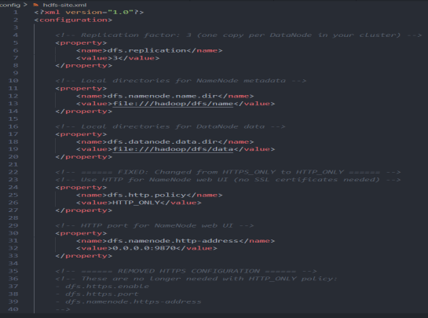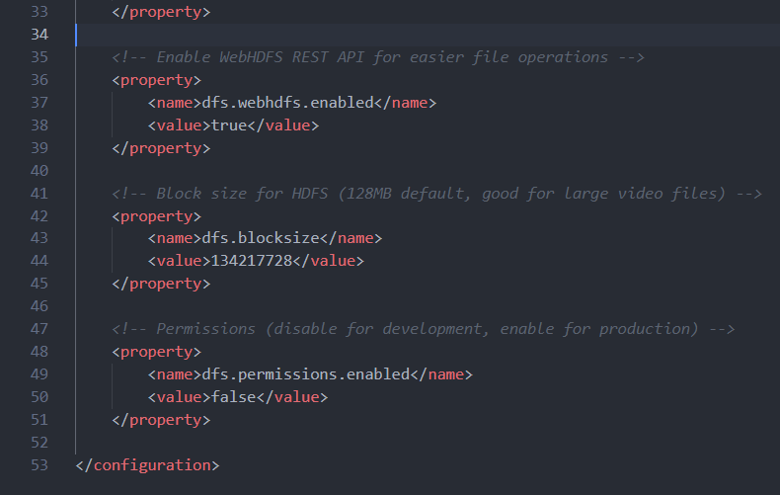

4.1.3 YARN Configuration
- File:yarn-site.xml

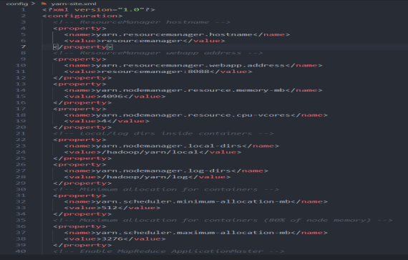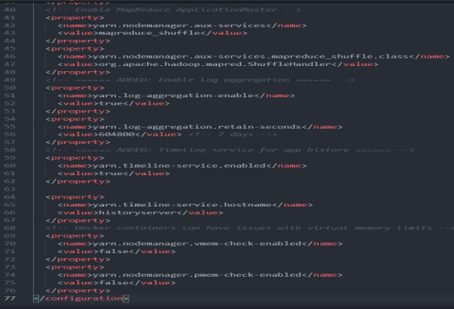

4.2 Directory Structure
hadoop-cluster-im/
├── config/
│ ├── core-site.xml
│ ├── hdfs-site.xml
│ ├── yarn-site.xml
│ ├── mapred-site.xml
│ ├── hadoop-env.sh
│ └── workers
│
├── youtube-api/
│ ├── Dockerfile
│ ├── fetch_videos.py
│ ├── config.yaml
│ └── requirements.txt
│
├── scripts/
│ ├── 0-MASTER-SETUP.ps1
│ ├── Run-VideoFetcher.ps1
│ ├── Check-Results.ps1
│ └── Analyze-Gaza-Simple.ps1
│
├── docker-compose.yml
├── hadoop.env
└── .env

4.3 Docker Containerization

4.3.1 Container Architecture
- 8 Containers Total:
  - namenode:HDFS master (metadata management)
  - datanode1, datanode2, datanode3:Storage nodes
  - resourcemanager:YARN master
  - nodemanager1, nodemanager2, nodemanager3:Compute nodes
  - historyserver:Job history tracking
  - submit:Job submission interface
  - youtube-fetcher:Data collection service

4.3.2 Volume Management
- Yaml
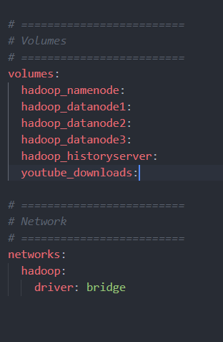

5.Data Collection Process:

5.1 YouTube API Integration:

5.1.1 Search Queries Configuration:
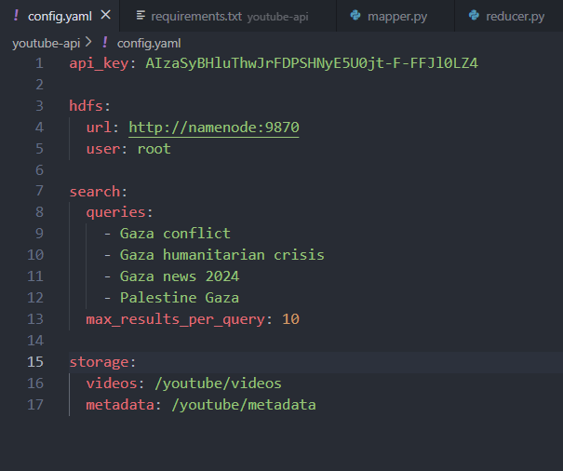
5.1.2 Data Collection Workflow:

- Search Query Execution
- Video ID Extraction (10 per query)
- Metadata Retrieval (per video)
- Title
- Author/Channel
- View count
- Like count
- Description (500 chars)
- Publish date
- Thumbnail URL
- Tags/Keyword
- JSON Serialization
- HDFS Upload
- Create parent directories
- Write file with replication=3
- Verify upload succes
- Local Cleanup

5.2 Data Schema
{
"video_id": "abc123def456",
"title": "Video Title",
"author": "Channel Name",
"views": 1234567,
"likes": 45678,
"description": "First 500 characters...",
"publish_date": "2024-12-15T10:30:00Z",
"thumbnail_url": "https://i.ytimg.com/vi/abc123/hqdefault.jpg",
"tags": ["tag1", "tag2", "tag3"]
}

6. Data Analysis & Results

6.1 Analysis Methodology
The PowerShell analysis script processes all metadata files to compute:
• Aggregate Statistics
- Total videos analyzed
- Sum of all views
- Sum of all likes
- Average views per video
- Average likes per video
• View Distribution
- Maximum views (most popular)
- Minimum views (least popular)
- Average views
- Standard deviation
• Engagement Metrics
- Engagement rate = (Likes / Views) × 100
- Top 5 videos by engagement
- Like-to-view ratio
• Channel Analysis
- Unique channel count
- Videos per channel
- Top publishers
• Content Analysis
- Most common tags
- Title keyword frequency
- Topic clustering
• Temporal Analysis
- Publication date range
- Videos per year
- Trend identification

6.2 Sample Results (Hadoop Tutorials Dataset):
Screenshot References:

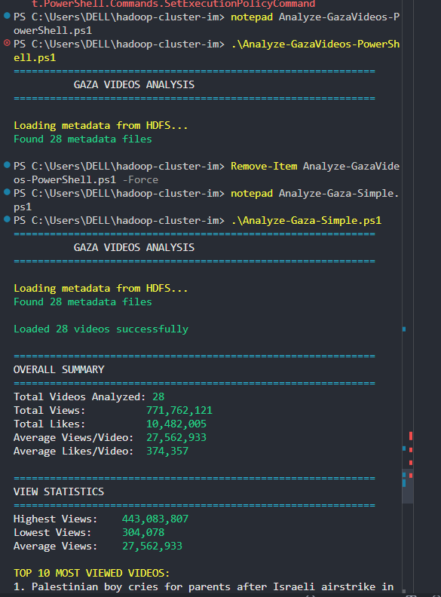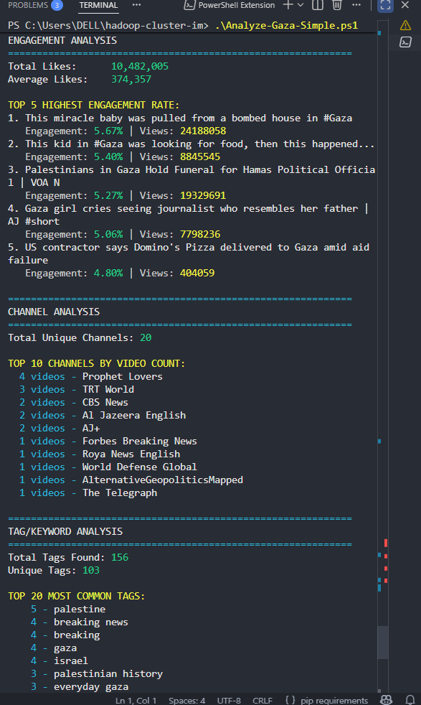
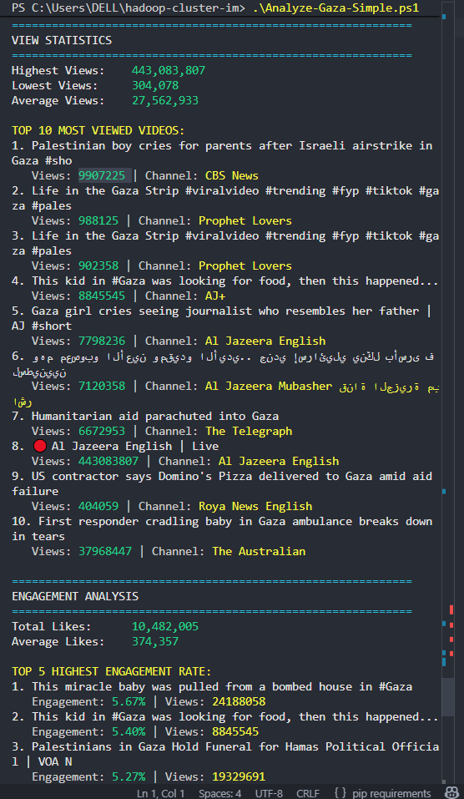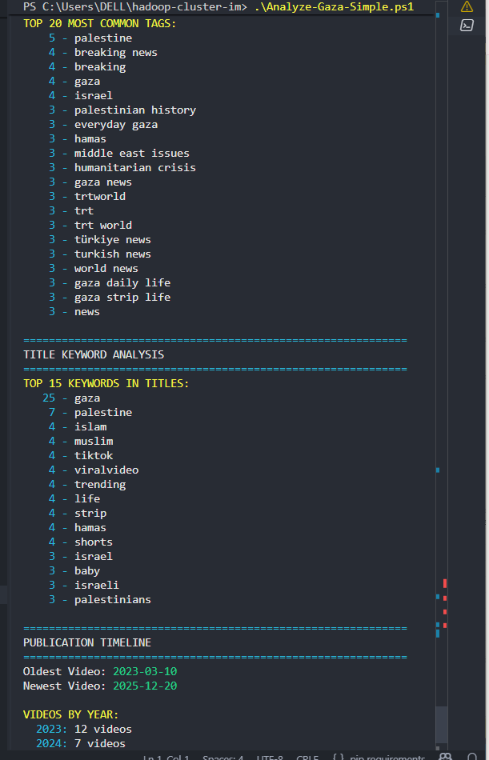
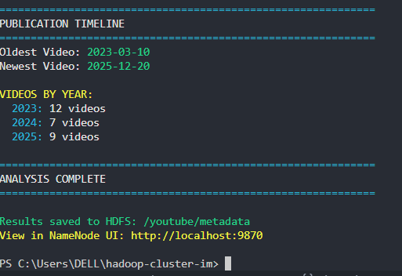

6.3 HDFS Health Verification :
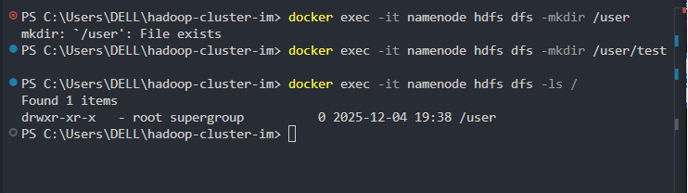

6.4 YARN Cluster Status:
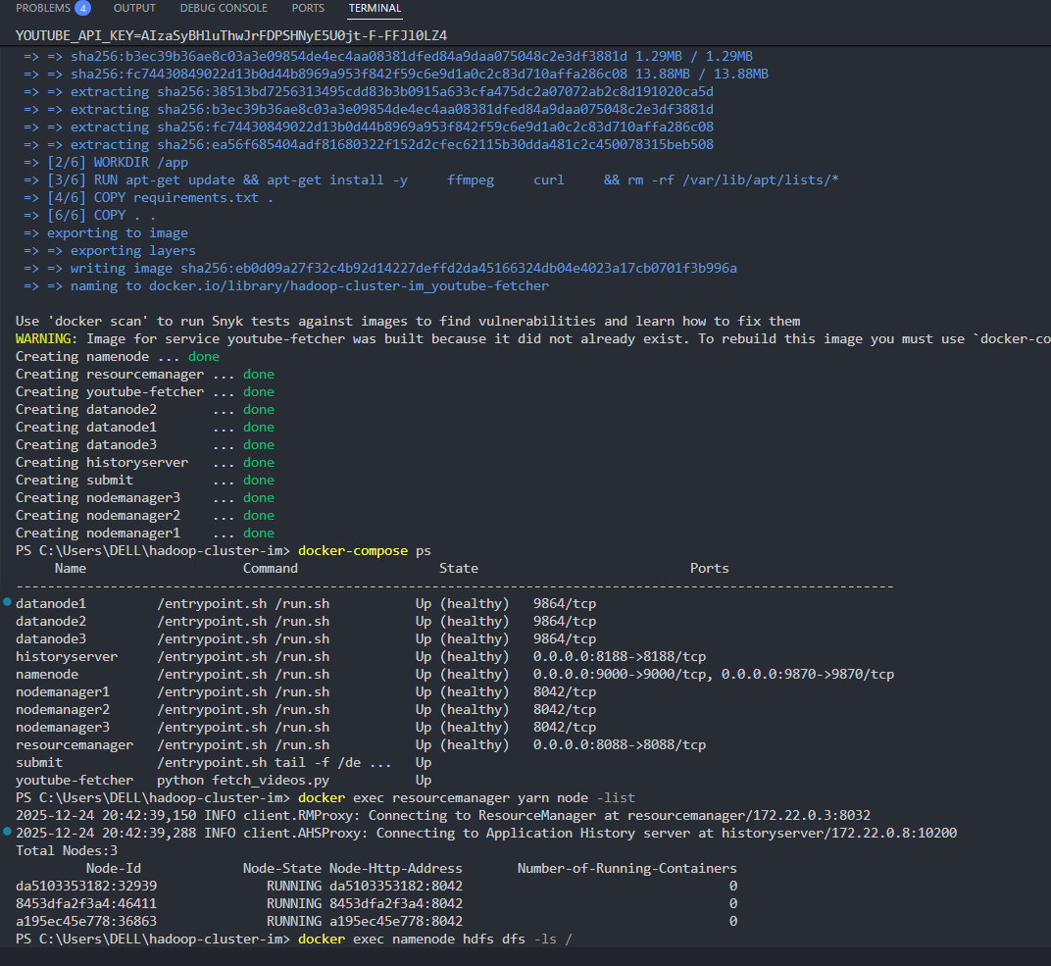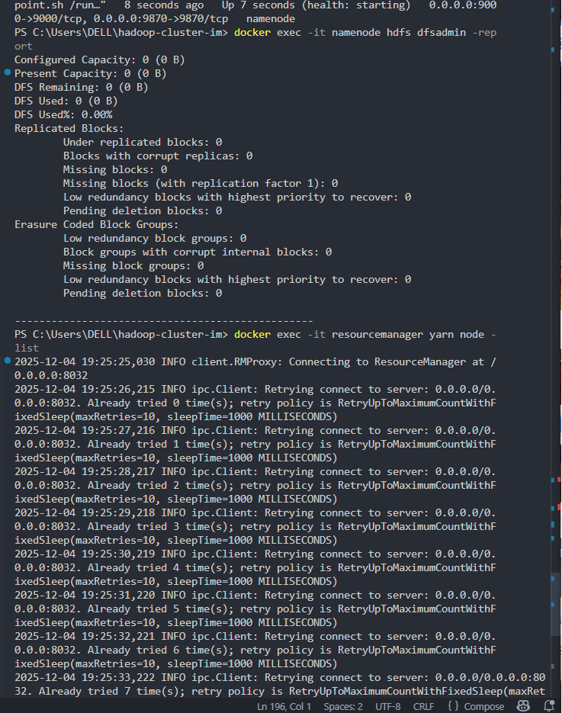

7. Screenshots & Documentation :
This section maps each screenshot to its corresponding phase in the project implementation, demonstrating the complete workflow from initial setup through data collection and analysis.

7.1 Initial Setup & Configuration :
Cluster Lifecycle Management:
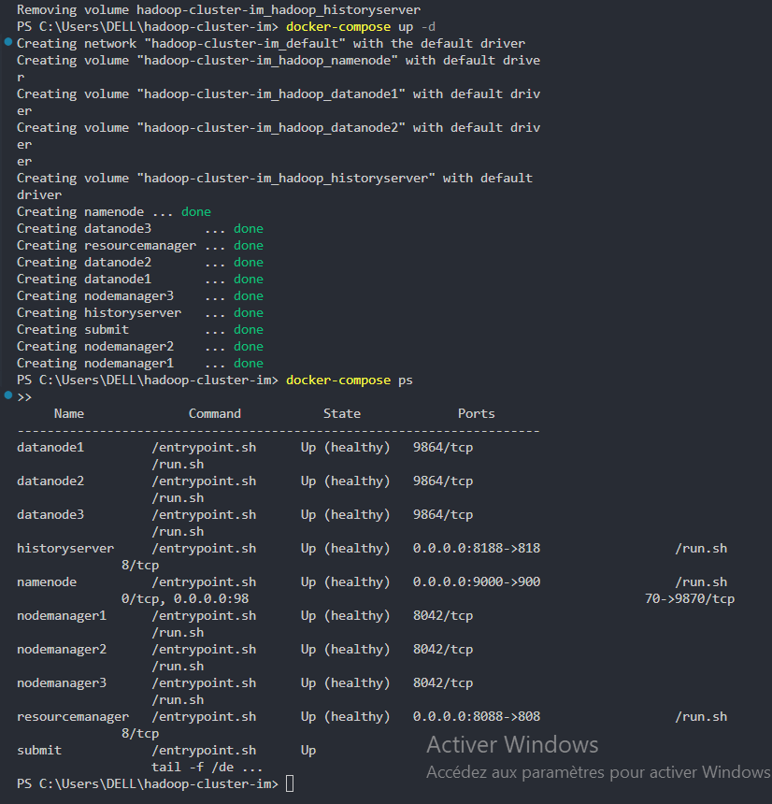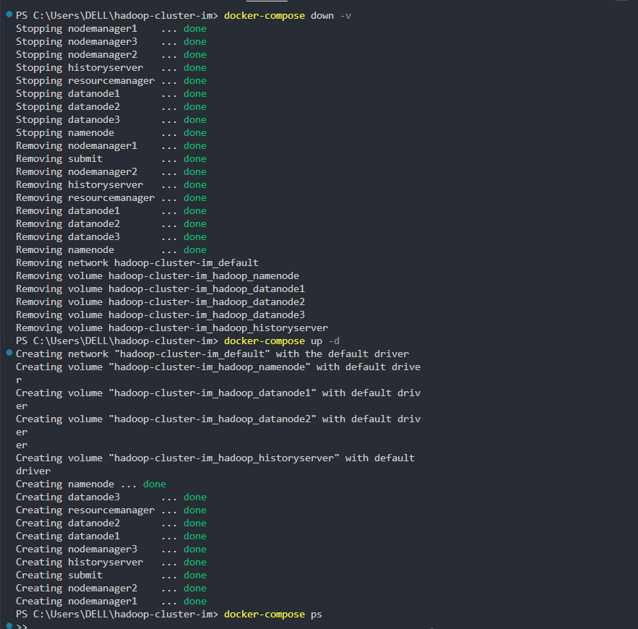

NameNode HTTP Verification :
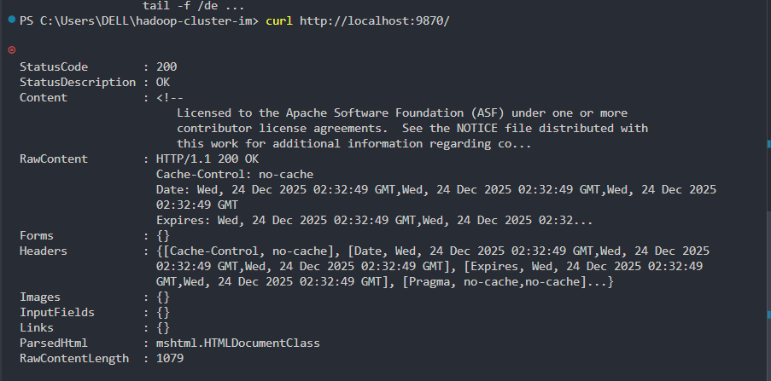

YARN ResourceManager Verification:
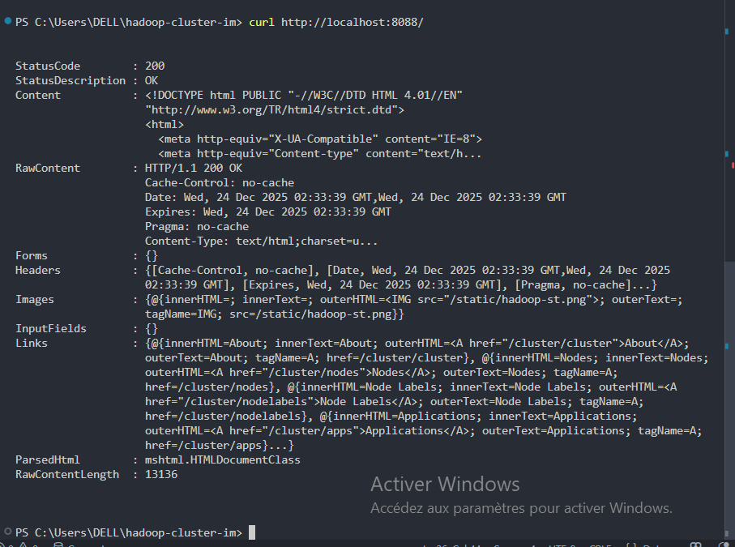
7.2 API Configuration:
Google Cloud API Key Creation: YouTube Data API Details :
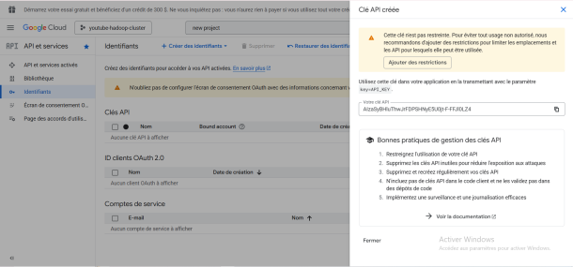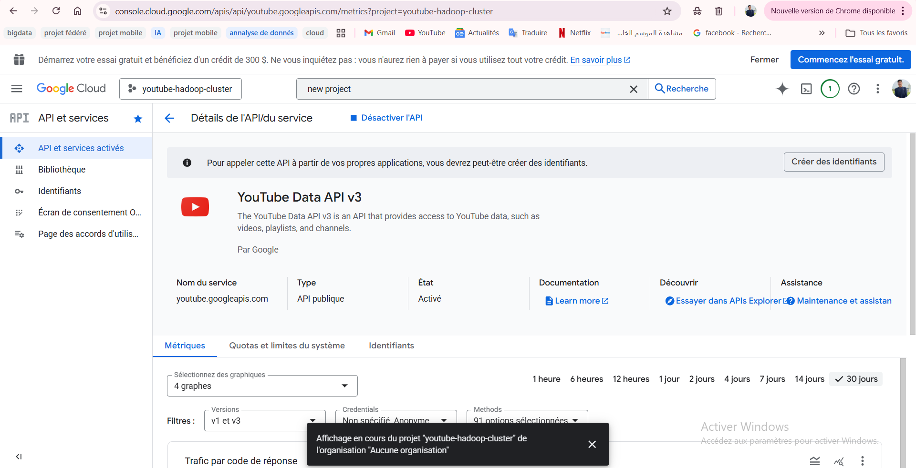

7.3 Complete Cluster Startup:
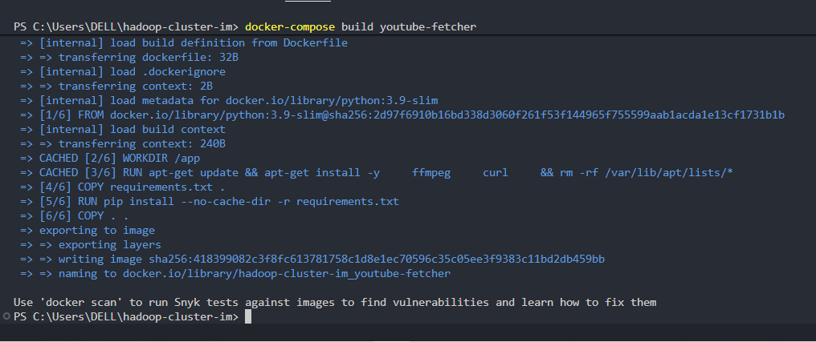
Details:
- NameNode, 3 DataNodes created
- ResourceManager, 3 NodeManagers created
- HistoryServer and Submit containers ready
- YouTube-fetcher built successfully
- docker-compose ps shows all containers UP
- YARN shows 3 nodes RUNNING
7.3 Data Collection Results:
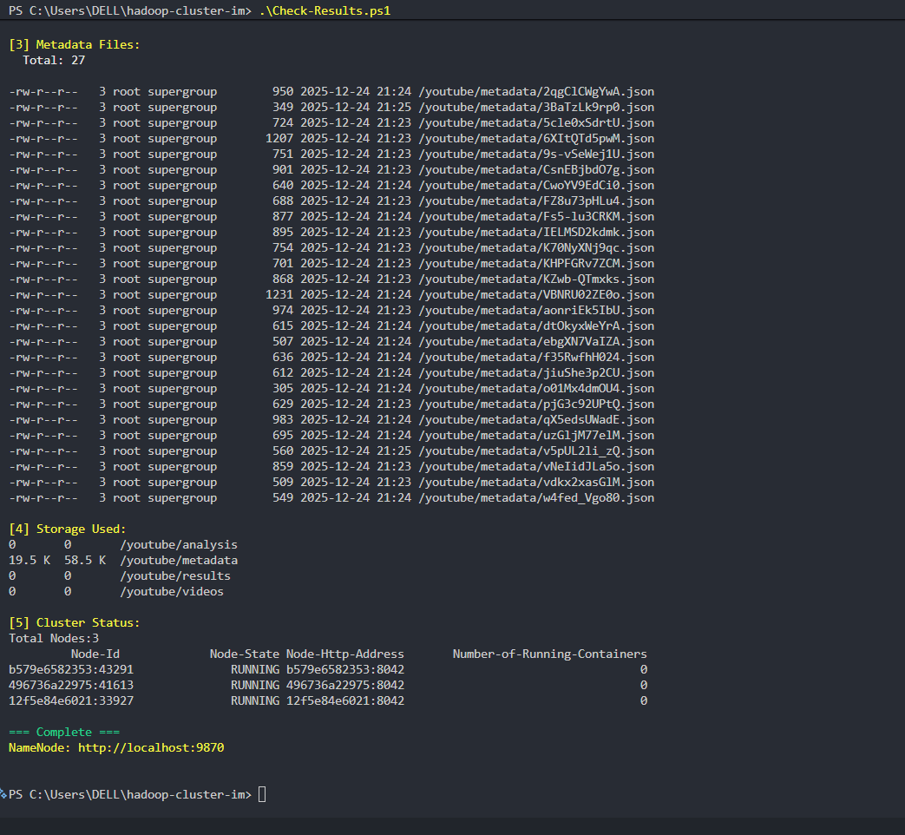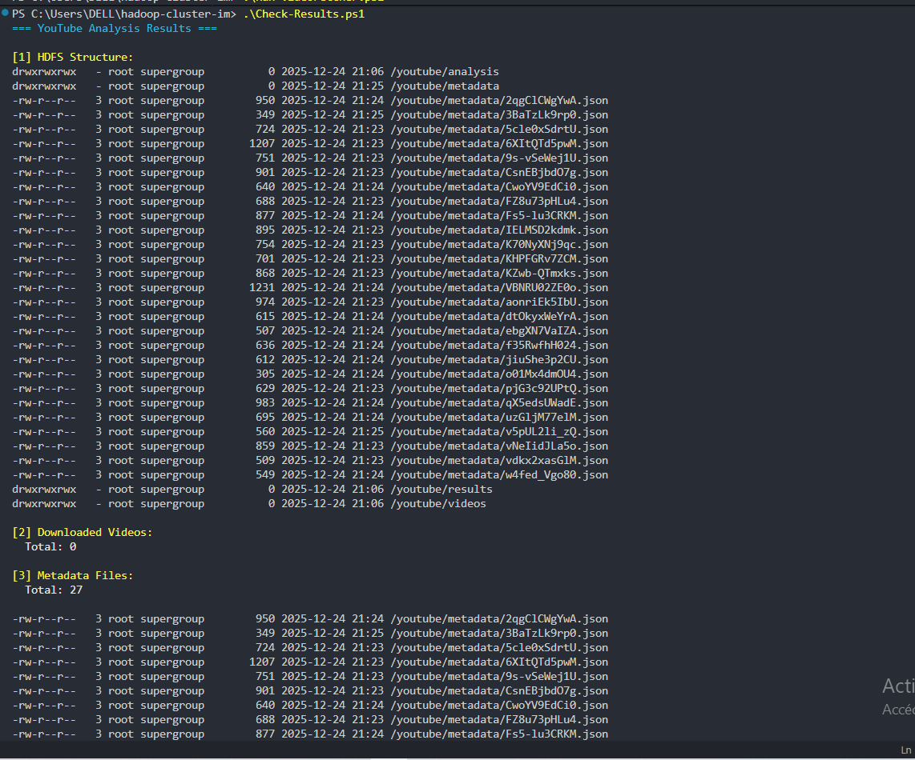

7.5 Docker Environment :
Docker File Sharing Settings:
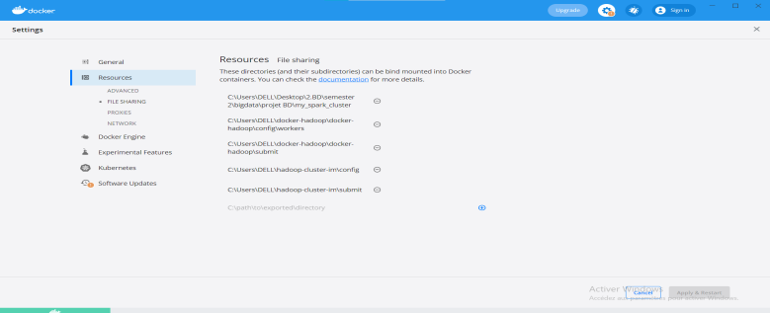
Docker Desktop Containers View :
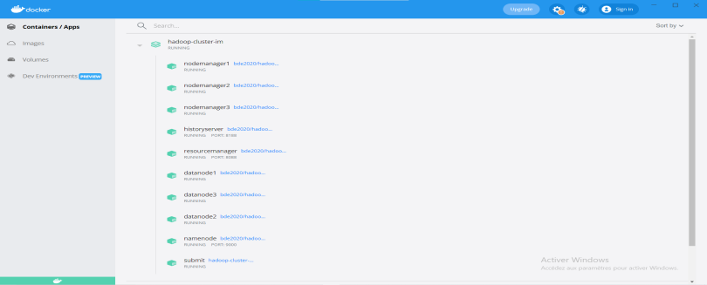
Environment Variables:
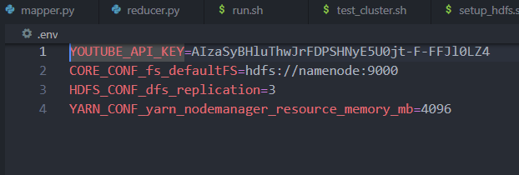
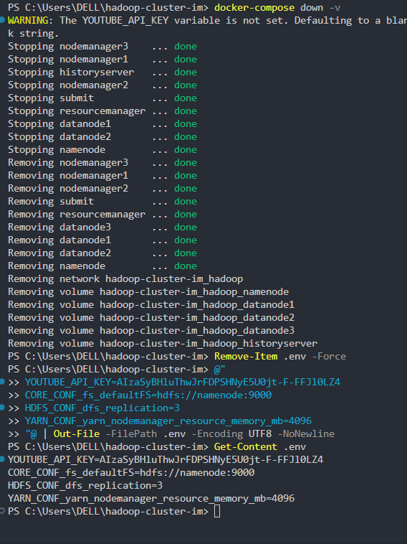

7.3 Master Setup Script Execution:
