Simple Operating System from Scratch

Start off by installing a hex editor, such as GhHx. This will be used to view the binary files you create from assembling your code. The first exercise can be done by editing the bytes in memory with your hex editor. Next, you should install nasm and bochs. Netwide Assembler (nasm) is an 80x86 and x86-64 assembler. Bochs is a CPU emulator that will be used to run your binaries on.

nasm filename.asm -f bin -o filename.bin

16-bit Real Mode

Exercise 1 – hello.asm
This exercise will be using a computer’s BIOS (Basic Input/Output Software) to run our 16-bit real mode operating system. The BIOS is a collection of software routines that are initially loaded form a chip into memory and initialized when the computer is switched on. BIOS has no notion of a file system and must read specific sectors of data (512 bytes) from specific physical locations. The binary file should be in the boot sector, the first sector of one of your disks, and the last 2 bytes of the 512 must be 0xaa55.
Now that we have some back ground on the BIOS and what it does, lets begin writing our first OS.

Exercise 2 – print_str.asm

Exercise 3 – print_hex.asm

Exercise 4 – reading_disk.asm
One of the first things operating systems do is bootstrap the rest of their code from the disk into memory and then begin executing that code. In 16-bit real mode, registers hold 16 bits. This limits our memory addressing to a maximum of 0xffff, ~64 KB (65,536 bytes). Since a typical operating system won’t fit in that space we need a solution. The solution is segmentation.
There are special segmentation registers, cs, ds, ss, and es; these are called segment registers (stack, code, data, extra, f, g segments; e, f, d are all extra data regs). Main memory is split into segments. These segments are then indexed via the segment registers. When you specify an address, the CPU automatically calculates the absolute address as the appropriate segment’s start address offseted by our specified address. Appropriate address means that it infers which segment you are accessing from the instruction you are executing. (16 * segment_address + specified_address)
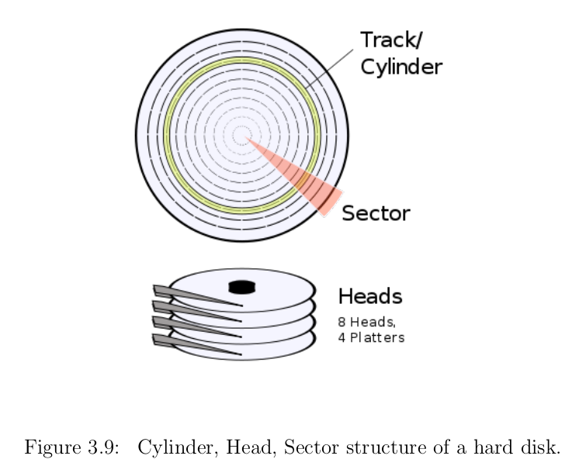
Disk drives have three major components: cylinders, sectors, and heads. The cylinder, or track, is the circular track that is a specific distance from the center of the disk. From there the disk is split into sectors, which specify a small section (512 bytes) of the cylinder. Lastly, we have the heads. The head specifies which specific surface within the cylinder and sector. Could be top or bottom of platter.
Now onto using the BIOS to read the disk. Interrupt 0x13 is the interrupt we want to raise after setting register al to 0x02. (Must specify the first block to be read using a CHS addressing scheme).
dh = head number, index begins at 0
dl = drive number, also begins at 0
ch = cylinder, index begins at 1
cl = sector, index begins at 1
ah = 0x02
al = number of sectors to read
Lastly we have to set the address that we’s like BIOS to read the sectors to. BIOS uses EX:BX

We can’t assume that this will work. BIOS updates some registers to inform us of what happens. The carry flag is set to signal a general fault, and al is set to the number of sectors actually read. Should perform a simple check to after read to make sure everything went well.

32-bit Protected Mode

Differences between 32-bit and 16-bits modes:
- Registers are now 32 bits long, prefixed with an ‘e’
- Additional general purpose segment registers, fs and gs
- 32-bit memory offset, can access 4GB of memory (0xffffffff)
- Supports more sophisticated memory segmentation
  - code in one segment can be prohibited from executing code in a more privileged segment, so you can protect your kernel code from user applications
  - Can implement virtual memory for user processes. Pages of a process’s memory can be swapped transparently between the disk and memory, on an as-needed basis. Ensures main memory is used efficiently.
- Interrupt handling is also more sophisticated

First thing we need to do is prepare the Global Descriptor Table (GDT). The GDT defines memory segments and their protected-mode attributes. Higher level languages, such as C, are usually compiled to 32-bit instructions rather than the less-efficient 16-bit instructions. This switch over is necessary if we want to load a kernel written in a higher level language.
We can no longer use the BIOS when we make the switch to 32-bit protected mode. It is possible for a 32-bit protected mode operating system to switch temporarily back into 16-bit mode whereupon it may utilize BIOS, but this technique can be more trouble than it is worth, especially in terms of performance.

Exercise 5 - Printing to the Screen
Display device has 2 operating modes: text and graphics. What is displayed on the screen is a visual representation of what is in memory. To manipulate the screen we must find the specific memory range it uses in its current mode. This is an example of memory-mapped hardware.
When the computer boots it begins in a simple Video Graphics Array (VGA) color text mode with dimensions 80x25 characters. You don’t need to render individual pixels because there is already a predefined font in memory. Each character cell is represented by 2 bytes: character to be displayed and character attributes (color, background color, blinking, etc.).
To display a character we must set its ASCII code and attributes at the correct memory address for the current VGA mode, which is usually at address 0xb80000. To map to a specific row/col pair use this formula: 0xb80000 + 2 * (row *80 + col).
Let’s talk about the Global Descriptor Table. Similar to the idea of segmenting memory and using offsets, but it has been changed to afford more flexibility. When in 32-bit protected mode translating a local address to physical address is done by using a segment register as an index to a particular segment descriptor in the GDT.
Segment descriptor is an 8-byte structure that defines the following properties of a protected-mode segment:
- Base Address (32 bits) – defines where the segment begins in physical memory
- Segment Limit (20 bits) – defines the size of the segment
- Various flags – affect how the CPU interprets the segment (privilege level, read/write restrictions)

Simplest workable configuration of segment registers is the basic flat model. Basic flat mode covers the full 4GB of addressable memory with two overlapping segments, one for code and the other for data. Since they overlap there is no attempt to protect one segment from another and there is no use of paging features for virtual memory. It is okay to keep things simple now because later on we can alter the segment descriptor more easily once we have booted into a higher level language.
First entry in GDT needs to be a null descriptor ( a structure of all zeros). Will catch mistakes where we forget to set a particular segment register before accessing it. The CPU will raise an exception, essentially an interrupt, if an addressing attempt is made using the null descriptor.
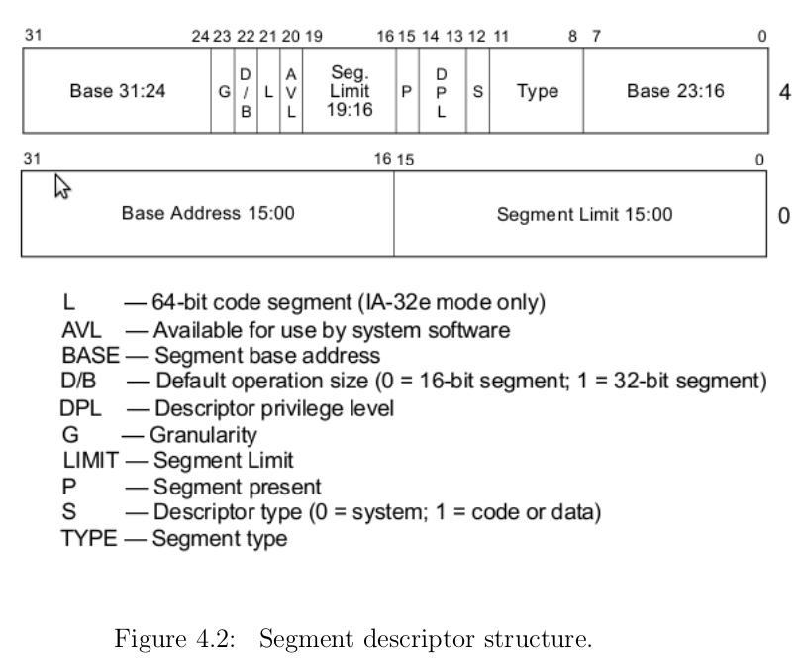
Now that we have coded up the Global Descriptor Table we need to make the switch from 16-bit real mode to 32-bit protected mode.
First we must disable interrupts. This is done with the ‘cli’ instruction (clear interrupt). This will make the CPU ignore any future interrupts until they are later enabled again. Reason: interrupt handling in protected mode is implemented differently than in real mode. This makes the IVT that BIOS set up completely meaningless. Even if the interrupts were working correctly for protected mode, the BIOS routines execute 16-bit code and would have no concept of 32- bit segments we define in out GDT. Ultimately, this would crash the CPU.
Second, we tell the CPU about the GDT that we just prepared. We use a single instruction to do this, to which we pass the GDT descriptor:
lgdt [gdt_descriptor]
All that is left to do is make the actual switch. Set the lsb of the special CPU control register, cr0. Cannot set the register directly so we copy cr0 to eax, or it wil 0x01 and store the value back in cr0. After cr0 has been updated, the CPU is in 32-bit protected mode.
Modern processors use pipelines which makes the last statement not entirely true. Pipelines don’t like jmp or call instructions because until those instructions execute fully the CPU doesn’t know what the next instruction is. On a far jmp instruction the pipeline will be flushed before the next instruction is executed. To issue a far jump we additionally provide the target segment:
jmp <segment>:<address_offset>
If we make a label: start_protected_mode, which marks the beginning of our 32-bit code. It might be too near of a jump to do: jmp start_protected_code. Set ‘cs’ to our code segment descriptor of our GDT. ‘cs’ = 0x08 for the 2nd descriptor which is the code descriptor. To make the long jump:
jmp CODE_SEG:start_protected_mode

[bits 32]
start_protected_mode:
; By now we are assuredly in 32-bit protected mode
Don’t need to jump far in distance, the important part if how we jumped.
Now that we have entered protected mode, we should update all of the other segment registers so they point to our 32-bit data segment and update the position of the stack.

Chapter 5: Writing, Building, and Loading Your Kernel

Let’s generate some raw machine code form C code.
$gcc – ffreestanding -c filename.c -o output_filename.o
This outputs an object file. This is annotated machine code, where meta information, such as text labels, remains present to enable more flexibility in how the code is eventually put together. May be more easily relocated into a larger binary file when linked in with routines, since code in object files use relative rather than absolute internal memory references.
$objdump -d object_filename.o
We need to use a linker to link together all of the routines described in the input object file into one executable binary file. The linker co0nverts the relative addresses into absolute addresses within gthe aggregated machine code.
To output raw machine code into a file basic.bin, we can use the following command:
$ld -o basic.bin -Ttext 0x0 --oformat binary basic.o
The ‘-Ttext 0x0’ works the same way as ‘org’. Tells the compiler to offest label addresses in our code to their absolute memory addresses when later loaded to a specific origin in memory. Will be more important when we load kernel code into memory.
To look at the binary in assembly instructions we are familiar with use the following command:
$ndisasm -b 32 filename.bin > filename.dis
CPUs operate less efficiently on a datatype that is not aligned on memory boundaries that are multiples of the datatype’s size. Since C would like all variables to be properly aligned, it uses the maximum datatype width (16 bytes) for all stack elements, at the cost of wasting some memory. (Is this how files can be compressed? If we close all the unused spaces on the stack can we decrease the size of the program?) “leave” instruction is equivalent to ‘mov esp, ebp; pop ebp”, arguably less efficient though. Common C practice to push parameters to the stack in the reverse order so they are in order from the top of the stack down.
Now that we have learned much of the foundation let us move on to actually writing, building and loading a kernel. Here are the steps we will take from here to get our first kernel up and running:
1. Write and compile the kernel code
2. Write and assemble the boot sector code
3. Create a kernel image that includes not only our boot sector but our compiled kernel code
4. Load our kernel code into memory
5. Begin executing our kernel code

1. Writing our kernel
This will be easy because our first kernel will be very basic. We can make our kernel more complicated later. Make a C program called kernel.c. Define a character pointer with the memory address for the beginning of the Video Graphics Array (VGA), 0xb8000. Set the value at that memory location to be an ‘X’. Compile the file into a binary with the techniques taught above.
When compiling the object file into the binary make sure you set the offset address to 0x1000, -Ttext 0x1000.

2. Create a boot sector to bootstrap (load and begin executing) our kernel
The program will load and begin executing our kernel from the disk. Must switch to 32-bit protected mode because the kernel is compiled to 32-bit instructions.
The BIOS will load only our boot sector, the first 512 bytes of the disk. We can use the BIOS disk routines to have our boot sector load additional sectors from a disk; however, once we switch to protected mode the lack of BIOS will make it hard for us to use the disk. (we would have to write a floppy or hard disk driver ourselves). (Is there an advantage to writing your own disk driver? Or is there a disadvantage to graft our boot sector and kernel code into a kernel image?). To solve the problem of not having BIOS to load from disks we create a kernel image by grafting the boot sector and kernel together. This can be done like this:
$cat boot_sect.bin kernel.bin > os-image

