**Activity Code User Manual**



Version 0.5 February 2014

Contents

Introduction 3

Input & Data Files 4

How to Use 5

SRIM EXYZ File 5

Compiling The Activity Code 7

Activity Equations 13

# Introduction

The Activity code is used to calculate the ion induced radioactivity of a sample material in an ion beam.

The ion trajectory data (energy,x,y,z ion coordinates) are supplied by the user, using the SRIM ion transport code to generate the exyz file. The reaction cross section data has already been prepared for the user, and is taken from the TALYS TENDL-2013 cross section database. Decay path/mode/half-life data from work by Tuli and Sonzogni has also been prepared for the user and included with the code, as well as general isotope/element data (mass, charge, isotopic composition etc) from the nist.gov website.

The code tallies the amounts of each starting isotope then calculates the reaction rates of the starting isotope conversion to product isotopes due to the ion beam. Finally, the code calculates the expected tally of isotopes after the required amount of time, after taking into consideration:

* the loss of starting isotopes due to the ion beam
* the creation of product isotopes due to the beam
* the loss and creation of radioactive isotopes due to decay

# Input & Data Files

The activity code has several data files already prepared in the data directory:

1. decaymodes.txt
2. gammaenergies.txt
3. isotopes.txt
4. xs directory containing xs data files

The user must prepare an ion exyz datafile using SRIM. The file output by SRIM (named EXYZ.txt) should not be modified. A final file must be created by the user that contains all the parameters needed by the code.

# How to Use

## SRIM EXYZ File

Install SRIM on a Windows computer and run the SRIM.exe file

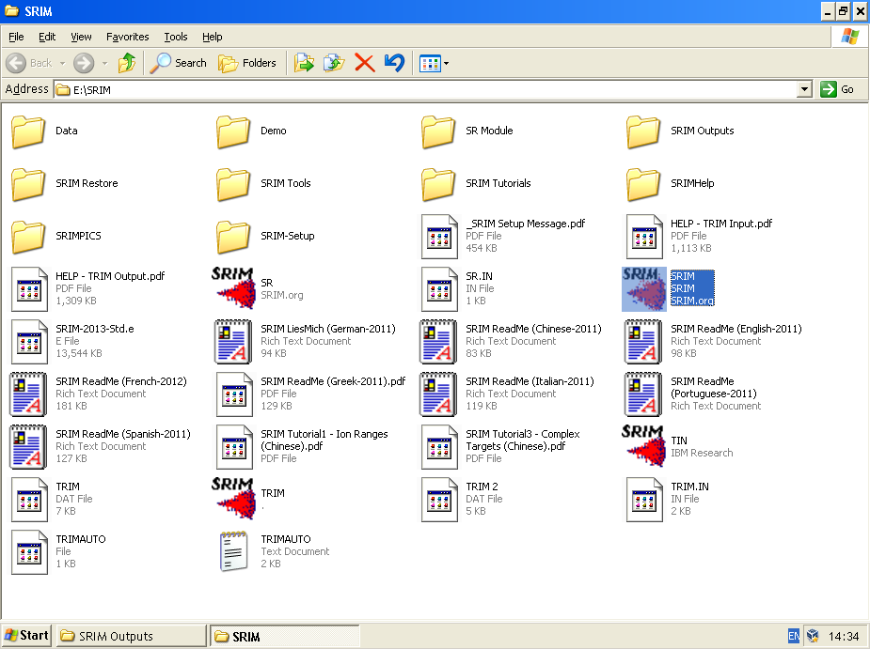

Run “TRIM Calculation”

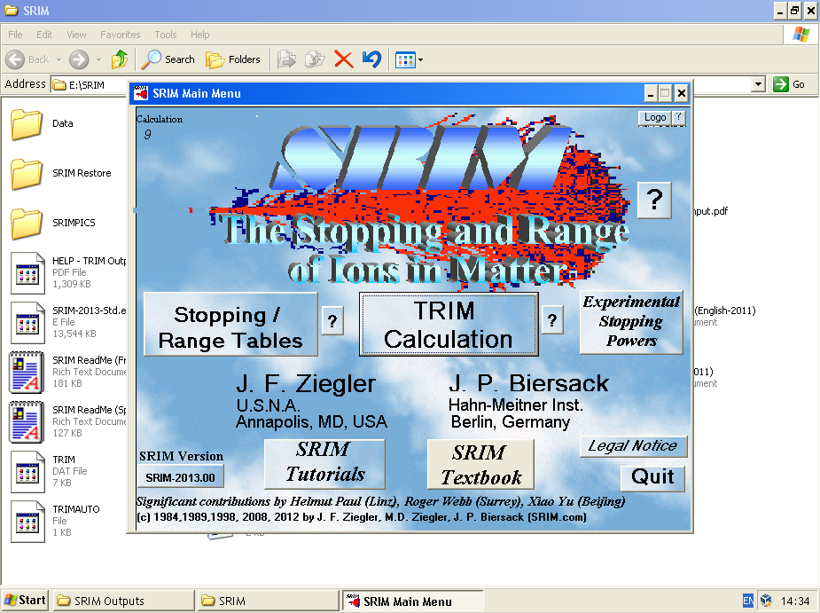

Set the TRIM calculation:

* Detailed Calculation with full Damage Cascades
* Set the ion energy (in KeV)
* Set a reasonable target width that will stop all ions (I usually use 1E10 angstroms)
* Add elements to the layer/layers and set the stoichiometry
* Set the number of ions (100 to 1000 will give a file size of 20-100Mb, otherwise the data file will be very large)
* Enter the EXYZ increment in eV (10-50eV are reasonable values)

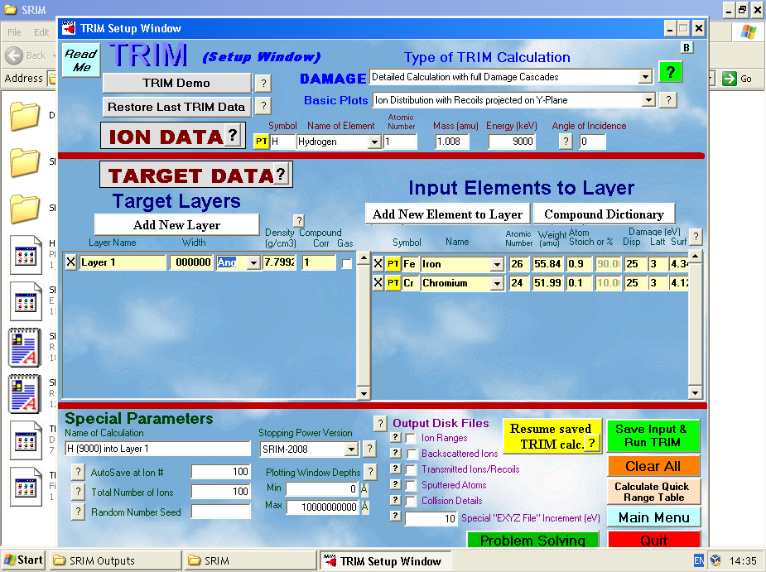

Wait for the calculation to run:

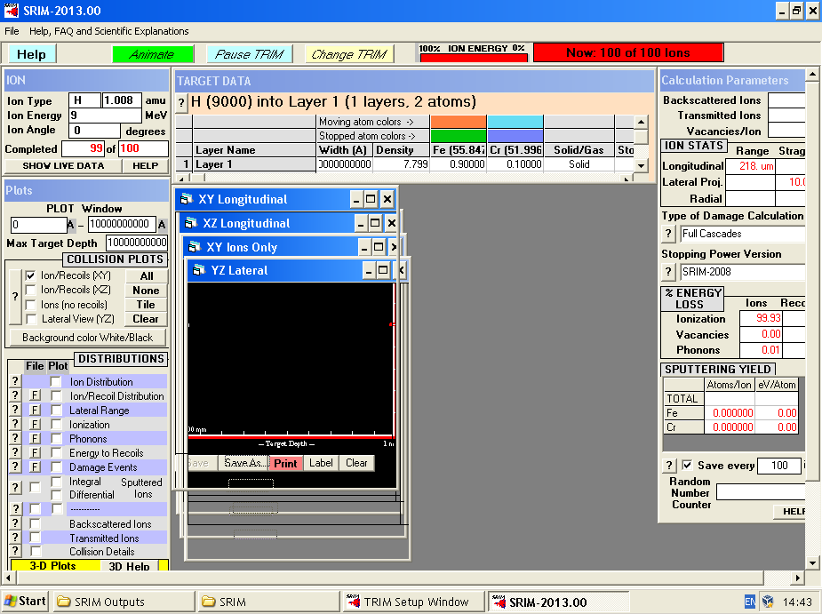

Go the the “SRIM Outputs” folder in the SRIM installation directory, and the EXYZ.txt data file will be output there.

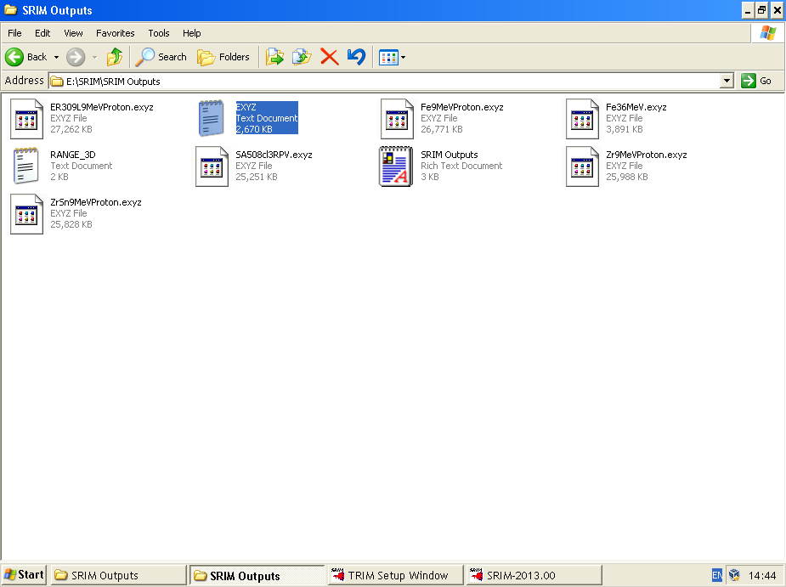

## Compiling The Activity Code

Log on to a Linux computer or virtual computer (these notes are specific to Linux Mint, but aren’t too different to any other Linux OS).

**Install required packages**

In the terminal type:

$ sudo apt-get install -y wget gfortran

**Download the Source Code**

Download the latest release from https://github.com/BenPalmer1983/activity/releases either through the web or with wget to the home directory:

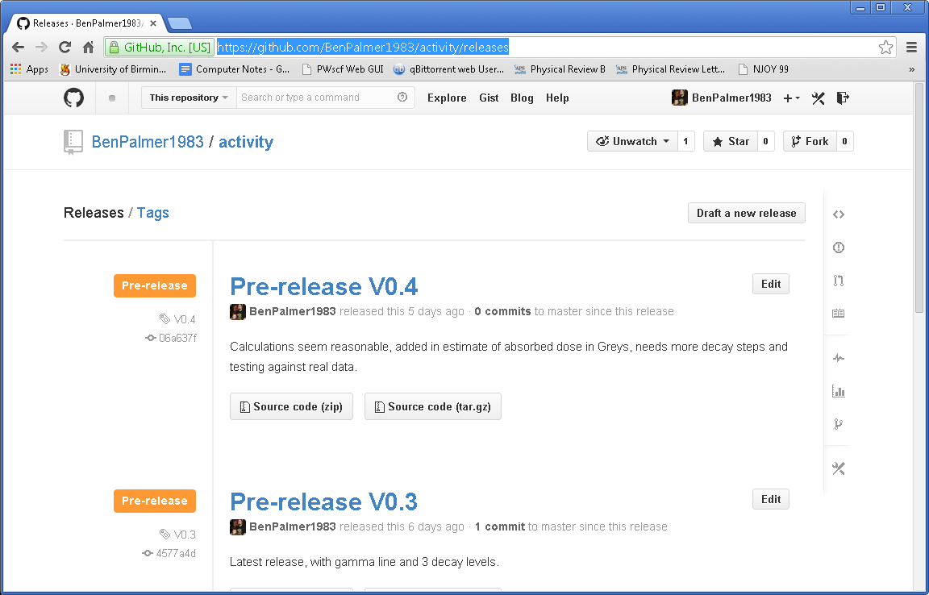

In the terminal:

$ cd $HOME

$ mkdir activity

$ cd activity

$ wget https://github.com/BenPalmer1983/activity/archive/V0.4.tar.gz

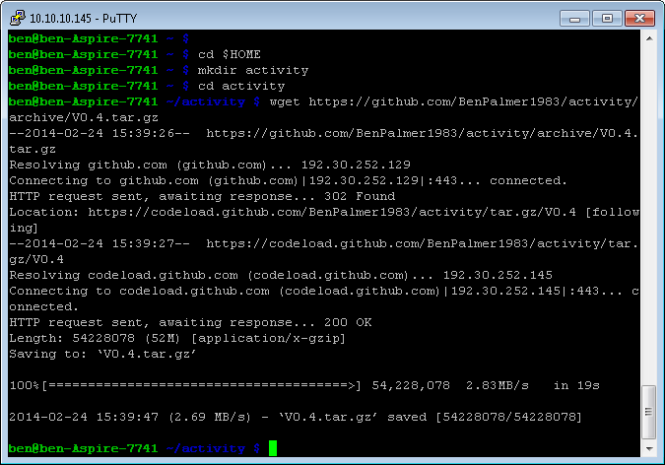

Now in the terminal, extract the files and compile:

$ tar -xzf V*.tar.gz

$ cd activity*

$ $sh ./make.sh

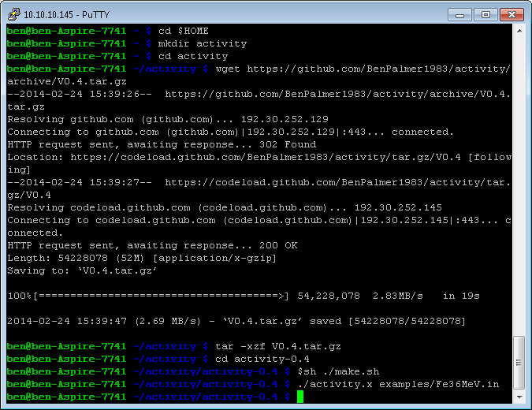

The make.sh script makes the activity.x program. To run the example Iron input file, run the activity program followed by the name of the input file:

$ ./activity.x examples/Fe36MeV.in

This will produce several output files in the directory the activity.x is run in:

* activityHistory.dat
* output.dat

The activityHistory.dat contains the activity calculated at different times, from the start of the simulation to the end. The output.dat file contains a log of the calculation process, the start/end tallies of isotopes, the activities of these isotopes and also the predicted gamma energies and counts at the end of the simulation.

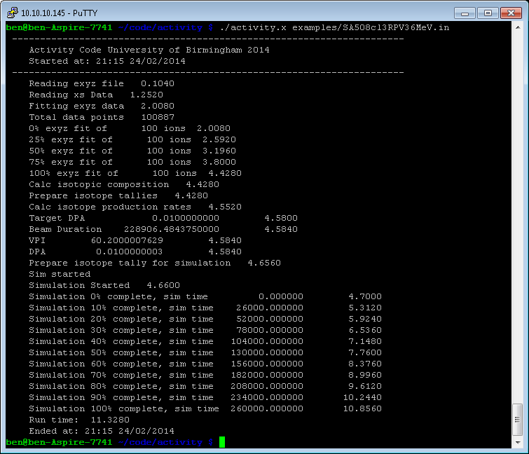

## User Input File

The user input file is structured as follows:

#elements

Fe 90

Cr 10

#isotopes

"data/isotopes.txt"

#decaymodes

"data/decaymodes.txt"

#gammaenergies

"data/gammaenergies.txt"

#xsfiles

"data/xs"

#trajfile

"examples/Fe36MeV.exyz"

#polyfitorder

3

#integrationgranularity

10

#beamflux

0.5 uA

#beamenergy

36 MeV

#beamduration

300 s

#beamarea

100 mm2

#amtime

260000 s

#timestep

1000 s

#projectile

1 1

#targetthickness

0.5 mm

#materialdensity

8000 kgm3

#vpi

60.2

#individualisotopeactivity

no

#verboseterminal

Yes

#targetdpa

0.0

#elements

The elements are listed under #elements with the percentage by mass next to the element symbol.

#isotopes

This is the path from where the activity.x executable is run to the isotopes.txt file

#decaymodes

This is the path from where the activity.x executable is run to the decaymodes.txt file

#gammaenergies

This is the path from where the activity.x executable is run to the gammaenergies.txt file

#xsfiles

This is the path from where the activity.x executable is run to the directory that contains the cross section data files

#trajfile

This is the path from where the activity.x executable is run to the trajectory (EXYZ) file generated by the User, using SRIM

#polyfitorder

This is the order of the polynomial used to fit to the EXYZ data. A 3rd order polynomial should be sufficient.

#integrationgranularity

This determines how many sections the ion EXYZ paths are split up into, to calculate the average cross-section from the ion’s maximum to minimum energy. There isn’t much of an advantage using a very high number, as the resolution of the cross section data across the whole energy range isn’t very high. 10 is a sensible value to start with.

#beamflux

The flux of the ion beam, usually stated in uA.

#beamenergy

The energy of the beam, assumed to be mono-energetic.

#beamduration

The duration of the beam, from the start of the simulation (t=0), followed by s for seconds hrs for hours and d for days. E.g. 300 s

#beamarea

The actual area of the beam on the target, usually measured in mm2 (mm2).

#amtime

Activity measurement time, or end of simulation time. This is the point where the final activity and isotope tally is calculated at.

#timestep

It is possible to output the total activity every n seconds. This is set under the #timestep heading.

#projectile

The Z and A (charge and atomic mass) of the projectile, e.g. 1 1 for a proton, 1 2 for a deuteron.

#targetthickness

The thickness of the target being irradiated. If the beam stops before leaving the target, that target depth is used.

#materialdensity

The density of the target material, usually given in kgm-3 (kgm3)

#vpi

The vacancies per ion calculated by SRIM of a target of the specified target thickness and specified beam parameters. (optional).

#individualisotopeactivity

Either yes or no – this determines whether or not the individual isotope activities are output too. This option generates a lot of data, so it is best to set this to no unless needed.

#verboseterminal

Either yes or no – this determines whether or not information is printed out to the user terminal – the default is yes.

#targetdpa

This is ignored if set to 0.0, otherwise the beam duration and simulation end time are adjusted so that the target DPA is reached.

# Activity Equations

The amounts of the first three isotopes in a decay chain are calculated with exact equations. The amounts for the 4th isotope onwards are calculated in the Laplace Transform domain, and the inverse is calculated numerically using the Gaver-Stehfest algorithm.

Some decay chains are terminated early if the isotope has a sufficiently small decay constant relative to the time at which the activity is being measured.

**Exact Equations**

Isotope 1 (Isotope P) Stable

Isotope 1 (Isotope P) Unstable

Isotope 2 (Isotope A) Stable

Isotope 2 (Isotope A) Unstable

Isotope 3 (Isotope B) Stable

Isotope 3 (Isotope B) Unstable

**Laplace Transforms, Inverted Numerically**

Gaver-Stehfest coefficients:

|  |  |
| --- | --- |
| 1 | -0.016666666667 |
| 2 | 16.016666666667 |
| 3 | -1247.000000000000 |
| 4 | 27554.333333333300 |
| 5 | -263280.833333333000 |
| 6 | 1324138.700000000000 |
| 7 | -3891705.533333330000 |
| 8 | 7053286.333333330000 |
| 9 | -8005336.500000000000 |
| 10 | 5552830.500000000000 |
| 11 | -2155507.200000000000 |
| 12 | 359251.200000000000 |

Isotope 4 (Isotope C) Stable

Isotope 4 (Isotope C) Unstable

Isotope 5 (Isotope D) Stable

Isotope 5 (Isotope D) Unstable

# Notes

When running the code and analysing the activityHistory.dat file, it might appear that the beam and post-beam activities don’t join up. If this is found it may be the result of a very sharp drop in activity. If the activity is measured at short enough time steps, this can be seen: