
Department of Metallurgy & Materials

EAMPA [Embedded Atom Method Potential Analyser] User Manual
by
Ben Palmer
Metallurgy & Materials, University of Birmingham

Metallurgy & Materials
College of Engineering & Physical Sciences
January 2015

Table of Contents
Table of Contents ii
Abbreviations iv
1 Introduction 1
1.1 Aim of Activity Program 1
1.2 Source Code 1
1.3 Recommended System Settings 1
2 Background 2
2.1 Ion Irradiation 2
2.2 Transmutation of Nuclei by Ion Irradiation 3
2.3 Radioactive Decay 3
Radioative Decay Constant 3
Bateman Equations for Radioactive Decay 4
Modified Equations for Radioactive Decay 4
Numerical Inversion of the Laplace Transform 6
3 Acknowledgements 8
3.1 TALYS/TENDL Cross Section Database 8
3.2 SRIM Ion Transport Code 8
3.3 Matplotlib 8
4 Installation 9
4.1 Prerequisites 9
4.2 Downloading/Preparing Source Files 9
4.3 Compiling Package 10
5 Usage Instructions 11
5.1 Introduction 11
5.2 Basic Usage 11
5.3 Input File 11
6 Examples 12
6.1 Developer Notes 17
6.1.1 Source Files 17

Abbreviations

Abbreviations
DPA | Displacements per atom – measurement of damage in a material
MPI | Message Parsing Interface
SRIM | Stopping and Range of Ions in Matter
TRIM | Transport of Ions in Matter
VPI | Vacancies Per Ion

Introduction
As energetic ions pass through matter they lose energy via interactions with electrons and nuclei. There is a probability, depending on the energy of the ion, that it will react with and transmute nuclei in the target material. The activity code was designed to calculate how radioactive an ion irradiated target would become.

Aim of EAMPA Program
The EAMPA program

Source Code
The source code for the EAMPA code was developed by the University of Birmingham. It is freely available, with no warranty, from:
https://github.com/BenPalmer1983

Recommended System Settings
- Multicore Processor (2+ cores)
- 1GB RAM
- 1GB Hard Drive Space
- Linux operating system
- Fortran compiler
- OpenMPI
- Matplotlib

Background

Interatomic Potentials
Classical molecular dynamics simulations are used to study small volumes of a material, with up to 10⁷ atoms in a typical simulation. Such simulations have been used to model grain boundaries, and within these models irradiation damage may be simulated by initiating atom cascades that result from neutron radiation. Trautt and Mishin used molecular dynamics to study grain boundary migration in copper (12), and a more relevant example is the study by Shibuta et al and their model of grain boundary energy in bcc iron-chromium (13).
The temperature and pressure of the model can also be controlled, and this is important because there may be a temperature dependence on the rate of depletion of PGMs at the grain boundary, if there is depletion at all.
One key ingredient to any classical molecular dynamics simulation is the interatomic potential used to describe the forces between atoms in the model. Initially, simple pair potentials that described the force between two atoms were used.

Morse, Lennard Jones Pair Potentials
Early interatomic potentials were two-body pair potentials, where the force on an atom was determined by summing the pair potentials between that atom and other atoms in its neighbourhood, determined by a cutoff radius.
The Lennard-Jones and Morse potentials are examples of pair-potentials, but they are too simple. They cannot capture the many-body aspect of how atoms in a metal interact with each other. Many-body potentials such as the Finnis-Sinclair or Embedded Atom Model do have a pair potential function, and this can take the form of a LJ potential, Morse potential or other standard Pair Potentials.

Many-Body Potentials
Finnis Sinclair, EAM

Embedded Atom Method
Pair potentials are inadequate to accurately describe the many-body nature of forces between metal atoms and several many body potentials were proposed in the 1980s. The Finnis-Sinclair and the embedded atom method (EAM), developed in 1984 and 1985 respectively, are the standard potential used to model metals.
Despite being theorised in the 1980s, there are few potentials in existence and there no exhaustive list of potentials for binary systems. At the time of writing, an iron-palladium and iron-ruthenium EAM potentials are unavailable or do not exist, and so to model the grain boundary a new potential would need to be derived.
The embedded atom method potential consists of a pair-potential function, an electron density function and an embedding energy functional that depends on the density function. The total energy of a system of atoms is calculated using the pair V(r), density ρ(r) and embedding functional F(ρ).
$$U_{EAM}=U_{pair}+U_{embe}=\frac{1}{2}\sum_{i=1}^{N}{\sum_{j≠i}^{N}{V_{ij}\left(r_{ij}\right)+\sum_{i=1}^{N}{F_{i}\left[ρ_{i}\right]}}}$$
$$where ρ_{i}=\sum_{j=1,j≠i}^{N}{ρ_{ij}}\left(r_{ij}\right)$$

The energy of an individual atom and force acting on that atom may also be calculated with these three functions.
Energy of single atom i:
$$U_{i,EAM}=\frac{1}{2}\sum_{j≠i}^{N}{V_{ij}\left(r_{ij}\right)}+F_{i}\left[ρ_{i}\right] where ρ_{i}=\sum_{j=1,j≠i}^{N}{ρ_{ij}}\left(r_{ij}\right)$$
Force on atom i:
$$\vec{F_{i}}= -{\vec{∇}}_{\vec{ij}}\sum_{i}^{N}{U_{i,EAM}}$$
$$\vec{F_{i}}=-\sum_{j}^{N}{\left[{\left.\frac{∂F_{i}\left(ρ\right)}{∂ρ}\right|}_{ρ=ρ_{i}}{\left.\frac{∂ρ_{ji}\left(r\right)}{∂r}\right|}_{r=r_{ij}}+{\left.\frac{∂F_{j}\left(ρ\right)}{∂ρ}\right|}_{ρ=ρ_{j}}{\left.\frac{∂ρ_{ij}\left(r\right)}{∂r}\right|}_{r=r_{ij}}+{\left.\frac{∂V_{ij}\left(r\right)}{∂r}\right|}_{r=r_{ij}}\right]}\frac{\left(\vec{r_{i}}-\vec{r_{j}}\right)}{r_{ij}}$$

(DLPOLY manual and University of Virginia, MSE 4270/6270: Introduction to Atomistic Simulations, Leonid Zhigilei)
Professor Howard Sheng created a website with many EAM potentials, and the plots for the three functions of the Aluminium EAM potential are shown below.

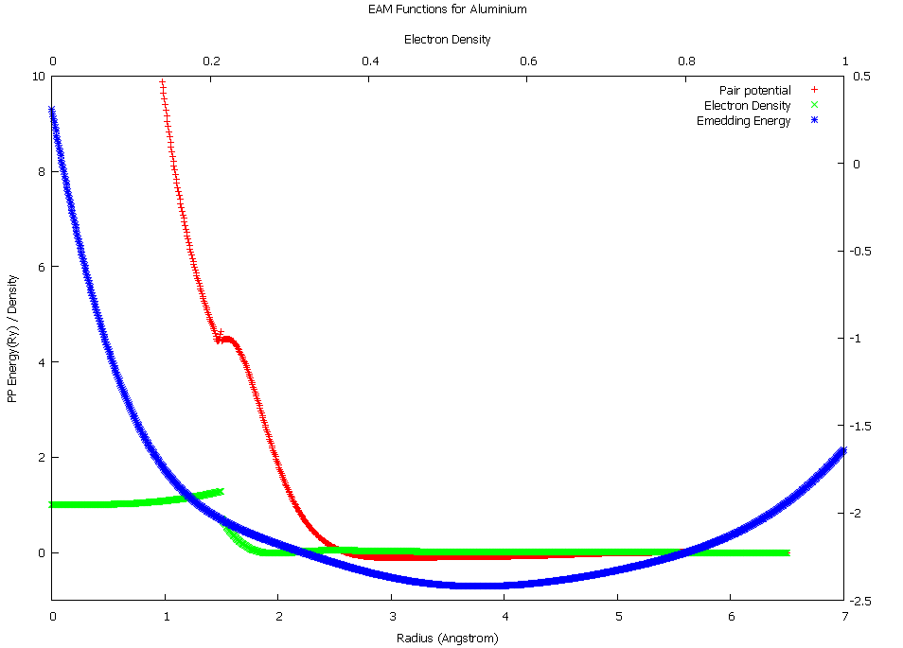

Two Band Embedded Atom Method
There are several variations of the EAM potential, and one of particular interest to us is the two-band model EAM (2BMEAM) that has two electron density and embedding energy terms. This formalism was originally developed to model Caesium (14), and the transition of electrons between S and D bands under pressure, but it has been modified to apply to alloys.
An alloy version of the two-band model was developed by Olsson et al. to investigate the α-prime phase formation in Fe-Cr (15). It was further developed by Bonny et al to provide a reliable EAM type potential to model high-chromium ferritic alloys (16). This potential correctly predicts the change of sign in mixing enthalpy as the local concentration of Chromium changes, and the functions take the following form.
$$U_{EAM}=\frac{1}{2}\sum_{i=1}^{N}{\sum_{j≠i}^{N}{V_{ij}\left(r_{ij}\right)+\sum_{i=1}^{N}{F_{d}\left(ρ_{d,i}\right)}}}+\sum_{i=1}^{N}{F_{s}\left(ρ_{s,i}\right)}$$
$$where ρ_{d,i}=\sum_{j=1,j≠i}^{N}{ρ_{d,ij}}\left(r_{ij}\right) and ρ_{s,i}=\sum_{j=1,j≠i}^{N}{ρ_{s,ij}}\left(r_{ij}\right)$$
This allows a second embedding functional and electron density function to add/subtract energy to an atom when mixed as an alloy, but reverts to the original EAM for that element when in local concentrations of like-atoms.

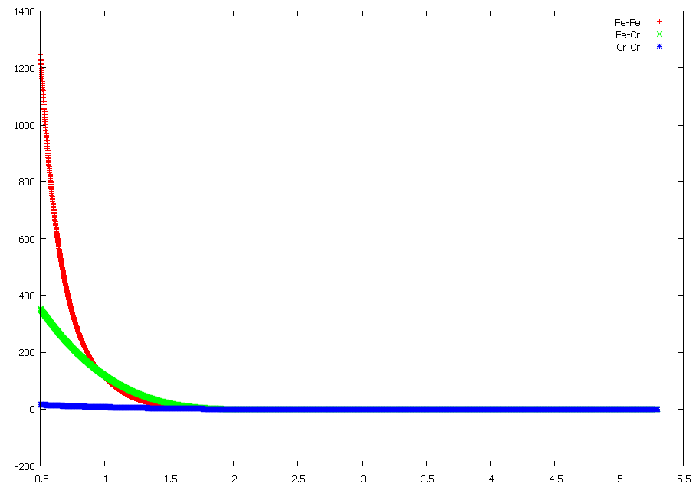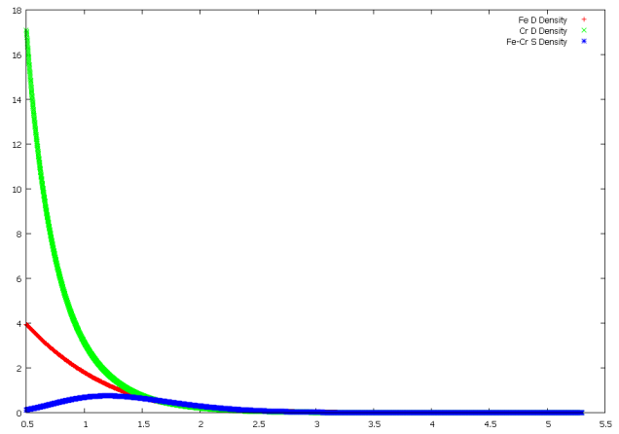
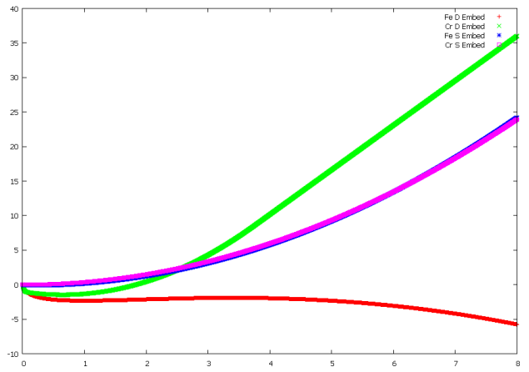

Functional Forms of Embedded Atom Method Potentials
The functions used to represent the pair potential, electron density and embedding functional can be tabulated or calculated from analytic functions. By using an analytic function, there is the advantage of being able to produce tabulated versions of the potential functions and functional if required.
In a derivation of an EAM potential for Iron by Mendelev et al (17) the authors use a hybrid function between two exponential functions and a polynomial spline to represent the pair potential, and polynomial splines to represent the electron density function and embedding functional. Similarly, a potential has been derived for Uranium by Smirnova et al (18) that uses polynomial splines exclusively for the pair and density functions, and embedding functional.
Polynomial splines are attractive because they are continuous, have a continuous first order derivative for third order polynomials, a continuous second order derivative for fifth order polynomials, and they are flexible enough to create a potential that reproduces the forces predicted by Ab Initio. Although each segment of the spline is determined by four parameters, the knots between splines can be adjusted which reduces the number of parameters that are adjusted during the derivation process.
Two forms of polynomial spline have been used in the literature:
$$f\left(r\right)=\sum_{i=1}^{n}{A_{i}\left(r_{i}-r\right)Θ\left(r_{i}-r\right)}$$
$$f\left(r\right)=\sum_{i=1}^{n}{\left(a_{i}r^{3}+b_{i}r^{2}+c_{i}r+d_{i}\right)Θ\left({r-r}_{i}^{lower}\right)Θ\left(r_{i}^{upper}-r\right)}$$
The first type of spline has fewer parameters, but is a superposition of two or more polynomials up until the spline segment between the final two cutoff points. This makes it tricky to fit the parameters to give a desired starting potential. In the second type of spline, a single polynomial stitches between any two nodes. The boundary conditions at each node are:
- the output of the functions either side of the node be equal
- the first and second derivatives of the polynomials either side of the node are equal at the node
While there are more parameters to fit for the second type of spline, the number can be reduced by varying the position of the nodes and calculating the parameters by fitting the polynomials between the nodes.
Given that we are modelling a metal, a many body is needed. The EAM potential is a more general form of the Finnis-Sinclair type potential, and it has been used in many molecular dynamics investigations into metals. For these reasons, our aim is to derive EAM potentials for Fe-Pd and Fe-Ru.
Two-band method EAMs have additional degrees of freedom and may be useful as they can capture any changes in the potential as the species mix and form the alloy. This is a secondary aim, the primary being standard EAM potentials.
Molecular dynamics codes are capable of using tabulated functions. The form of the potential derived will be a spline of many polynomials that will be used to produce the tabulated versions of the potential functions. These are more flexible than other analytical potentials, they can be easily splined to other functions (such as the hard core Ziegler Biersack Littmark [ZBL] hard core potential) and continuous first and second derivatives can be forced.
Four a fourth order polynomial spline, the functions all take the following form:
$$f\left(r\right)=\sum_{i=1}^{n}{\left(a_{i}r^{3}+b_{i}r^{2}+c_{i}r+d_{i}\right)Θ\left({r-r}_{i}^{lower}\right)Θ\left(r_{i}^{upper}-r\right)}$$

Computational Method

Acknowledgements

Support and Funding from the University of Birmingham
I would like to acknowledge the funding and support of the University of Birmingham, staff and students. This includes contiued help and support from my supervisors Dr. Brian Connolly and Dr. Mark Read, Molybdenum irradiation data from PhD candidate John Hewett and Steel irradiation data from Dr. Chris Cooper and the 2013-2014 third year Physics students.

The Scientific Community
I have had many interesting email conversations regarding EAM potentials. I would like to thank the following for help and guidance:
Ilian Todorov, Derek Hepburn, Graeme Ackland, G. Bonny, Julian Gale,

Matplotlib
The activity code is written in Fortran and will only output text/data files. However, if your computer has Python and the Matplotlib Python library installed, it will also generate useful charts and graphs to help display the data. The website for the library is:
http://matplotlib.org/

Installation

Prerequisites
The Activity program will need a Fortran compiler to build as well as the MPI libraries. The recommended compiler and libraries are the GCC Gfortran and OpenMPI library, as these have been used extensively during the development of the code.
To enable the code to create plots of isotope activity/amount, Python and matplotlib must also be installed.
If you are using a Debian distro, these packages may be installed using apt-get:
sudo apt-get install gcc gfortran openmpi-bin openmpi-doc libopenmpi-dev python python-matplotlib
If you are using a Redhat distro, these packages will possibly be available for installation through YUM.

Downloading/Preparing Source Files
Download the source tar.gz and unzip it:
tar xzf activity.tar.gz
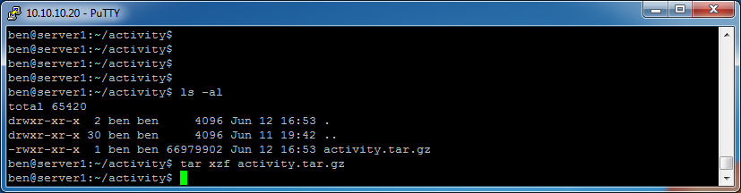
The list of files should be similar to this:

Run the install script:
./install.sh

The script will give you four options.
Option 1: check fomatting and layout of source code - default is No and should be specified as no unless you're developing the code.
Option 2: check for unused variables - default is No and should be specified as no unless you're developing the code.
Option 3: choose to optimise Fortran code - if you choose yes this will take longer to compile, but the resulting bin will execute faster.
Option 4: choose where to extract the data files to - default location is the activity/data directory that the data tar file is store in.
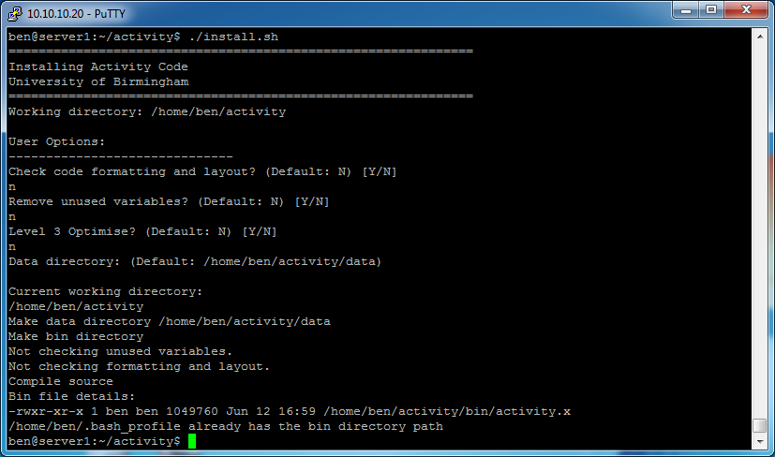

Source the .bash_profile for this session if you want to start using the code straight away.
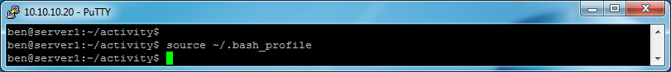
Installation is now complete.
To run an example calculation, go to the examples directory:
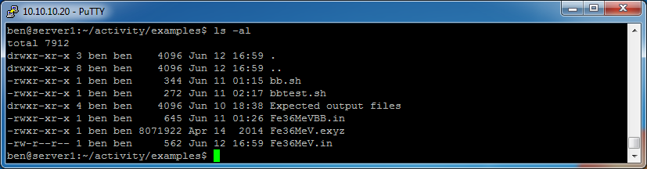
Run the program with mpirun:
mpirun -n 2 activity.x Fe36MeV.in
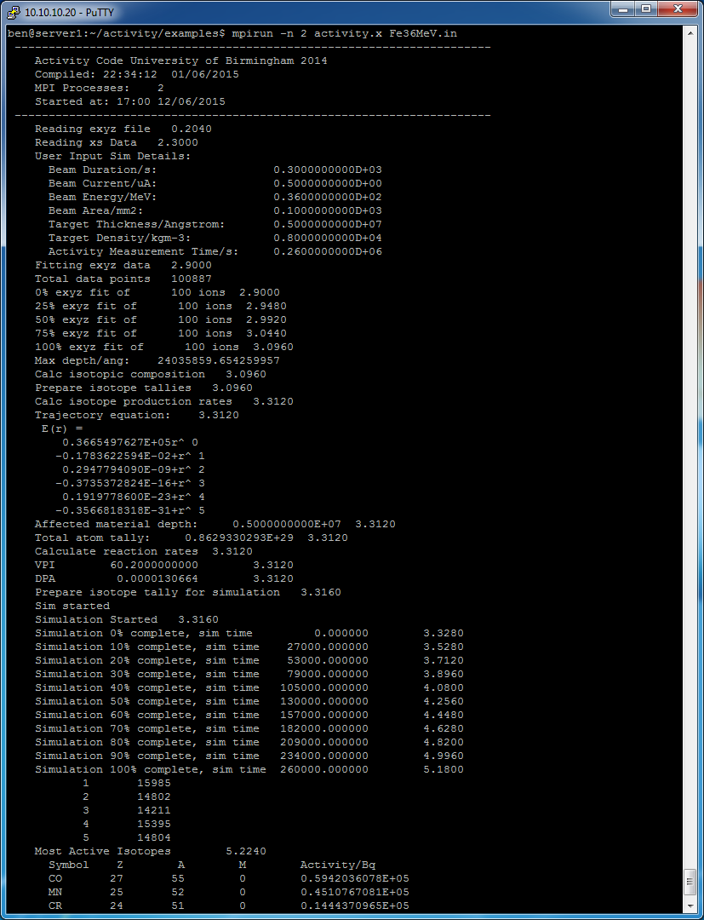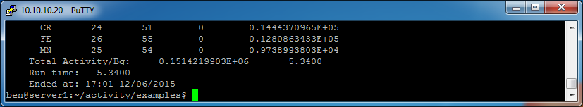

The program will output files in the examples/output directory. If you do not have matplotlib installed it will throw up a few errors, but the only difference in the output is there will be no graphs/charts. The raw data will still be there, and the python scripts used to make the graphs will be in the temp directory, ready to run at a later date.

Usage Instructions

Introduction
An input file is required to run the program at the very least. If multiple cores are required mpirun must be used and the number of processes must also be specified.
For example:
mpirun -n 2 activity.x Fe36MeV.in

Input File
The example input file is for Iron being irradiated at 36MeV.
#elements
Fe 100
#isotopes
"/data/activity/isotopes.txt"
#decaymodes
"/data/activity/decaymodes.txt"
#gammaenergies
"/data/activity/gammaenergies.txt"
#xsfiles
"/data/activity/xs"
#trajfile
"Fe36MeV.exyz"
#polyfitorder
5
#integrationgranularity
10
#beamflux
0.5 uA
#beamenergy
36 MeV
#beamduration
300 s
#beamarea
100 mm2
#amtime
260000 s
#timestep
1000 s
#projectile
1 1
#targetthickness
0.5 mm
#materialdensity
8000 kgm3
#vpi
60.2
#individualisotopeactivity
yes
#verboseterminal
yes
#targetdpa
0.0
#gammachartresolution
200

Examples

