|  |  |
| --- | --- |
| Account Number | «AccountNumber» |
| Amount Due | «AmountDue» |
| Payment Due Date | «DueDate» |

|  |  |
| --- | --- |
| **BILLING DETAILS** |  |
| Total From Last Bill | «PriorCharge» |
| «PriorPaymentDate» Payment Received – Thank you! | «PriorPaymentAmount» |
| **CURRENT CHARGES** |  |
| Current Charge | «CurrentChargeAmount» |
| Electri City Sales Tax @ «SalesTaxRate» | «SalesTaxValue» |
| Bill Due Date | «DueDate» |
| TotalAmount Due | «AmountDue» |



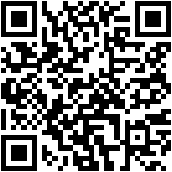

|  |  |  |
| --- | --- | --- |
| **Billing Month** | **Electric Usage** | **Billed Amount** |
| «TableStart:UsageHistory»«Month» | «Usage» | «Amount»«TableEnd:UsageHistory» |

|  |  |
| --- | --- |
| Account Number | «AccountNumber» |
| Amount Due | «AmountDue» |
| Payment Due Date | «DueDate» |

Globomantics Electric Company1234 Power Grid WayElectri City, PA 98765-4321

PLEASE DETACH LOWER PORTION AND RETURN WITH PAYMENT

1234 Power Grid Way

Electri City, PA 98765-4321

1-800-POWER-UP

help@Globomantics.kwh

«FirstName» «LastName»

«Line1»

«CityStateZip»

Scan this QR code to open our online bill pay site!