Specification of the CST–To–FastHenry User interface
Contents
Prerequisites 1
Starting the macro 1
Frequency range, units, etc. 3
Material definition 3
Bricks 3
Brick names 3
Defining “series” connection of bricks by means of Curves 3
Curve names 4
Prescribing the order of the ports in the FH output file 4
Defining “parallel” connection of bricks by means of Curves 4
Automatically defined ports 5
User defined ports of zero length 5
Curves without corresponding bricks – equivalenced nodes 6
Groundplanes 6
Output file(s) 7
Checking the result – the “FastHenry to CST” macro 7

Prerequisites
To run the macro, you need a CST STUDIO SUITE license for one of the 3D modules (MWS, EMS, PS), as well as the option for Import/Export of STEP files.
The CST STUDIO SUITE version should be higher than 2009 SP1.

Starting the macro
The macro can be started from the “Home” ribbon: Macros – Construct – FastHenry – CST to FastHenry Converter.

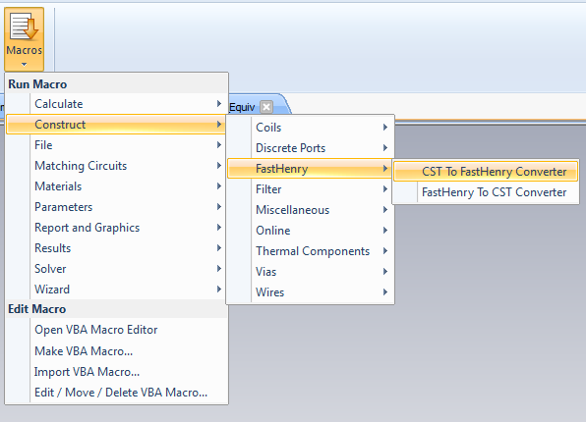

After starting the macro, user-input data can be provided, as shown in the picture below.

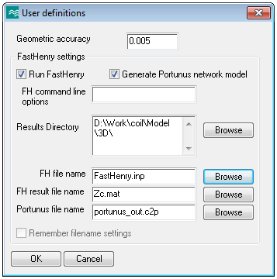

The input data are:

- The accuracy of the geometry (in project units, e.g. mm)

- Options to automatically run FastHenry subsequently and to generate a network model in a format readable by the Portunus network simulator

- The directory in which the results should be written; if the current model’s name is model_name.cst, by default the result directory is the subdirectory model_name\Model\3D\

- The names of the output files: FastHenry input file, FastHenry output file, Portunus output file

Before running the macro, the CST model needs to be prepared. These preparations are described below.

The model must contain:
- Frequency range, units
- Bricks
- Curves
- Material definitions

Frequency range, units, etc.
Define the frequency range of interest, material properties, geometrical units, etc., as if you wanted to simulate the structure in MWS.

In MWS, the upper and lower limits of the frequency range need to be different.

Material definition
Define a material for each object.
Define the conductivity as such, not as a dispersion model or constant tg. delta.

Bricks
Approximate your structure by means of bricks. Bricks can have any position in space. Existing geometry can be used for easier generation of the bricks (e.g. you can use picks, local coordinates, transformations, etc.)

Define a brick for each segment that needs to be written into the FH file.

Avoid using “Cut by UV plane”, inserts, etc. to define bricks. Although the macro can in principle deal with such bricks, there is no guarantee that it will always function correctly.

Brick names
The naming of bricks and of the components they are placed in is irrelevant for the FH file generation, with two exceptions:
- the ground planes (described below);
- it is preferable that the names of the components do not contain any spaces; for instance, name a component “Cylinder_1” instead of “Cylinder 1”.

Defining “series” connection of bricks by means of Curves
Define a separate curve for “series” connection of bricks for which a partial inductivity needs to be calculated. The curve can best be defined as a “3dpolygon”, by picking midpoints of consecutive faces.
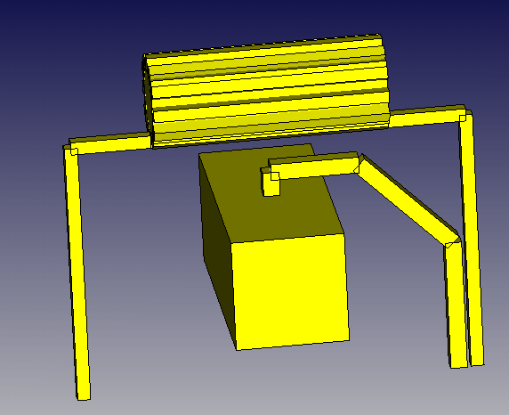 → 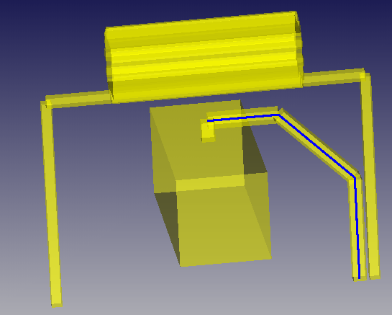

A curve (shown in blue in the picture above) describes the current flow through the metal part.

The number of segments in the curve = the number of bricks along the curve, always!

The midfaces for adjacent bricks need to be identical, within a user defined absolute accuracy USER_EPS (e.g. USER_EPS = 5e-3). The FH Converter requests this “geometric accuracy” as input from the user.

There must be no other curves defined, except those necessary for the FastHenry output.

Do not delete segments of already defined polygons by means of the command “Curve -> Delete segments” ! This would lead to incorrect recognition of the curve type (open or closed).

A special issue is the one of closed polygons. The program identifies them as follows:
- a closed trajectory must be placed into a separate Curve
- it can consist of:
  - only one 3D Polygon (preferred) or
  - of several open polygons, forming a closed trajectory and defined within the same Curve.
If, for a closed curve made of several parts, the result of the macro execution is not correct, please try to redefine the closed curve as a single 3D Polygon.

Curve names
Curve names are in principle arbitrary. The curves which represent ports in the FH output file will be added to the FH file in alphabetical order.
The curve names may not include special letters which are not specific to the English language, such as ä, ü, ö, ß, é, â ...

Prescribing the order of the ports in the FH output file
If you would like the ports in the FH file to be arranged in a certain order, the easiest way is to use numbers as first characters in the curve name. For example, the user could use names like “1-coil”, “2-capacitor”, etc. to this purpose.

Defining “parallel” connection of bricks by means of Curves
Curved objects, such as cylinders, may need to be split into several bricks.

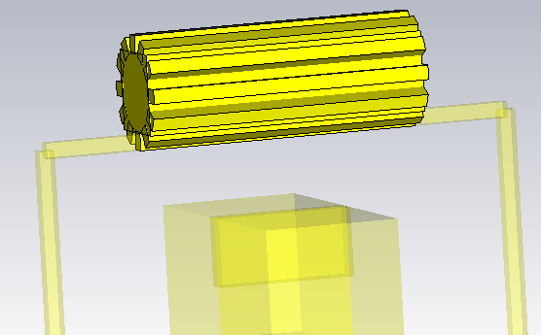

Put all these bricks into a single component, as shown in the picture above.
Define just one curve segment, for any one of the “parallel”-connected bricks. The CST MWS – FastHenry converter will automatically generate segments for all the other bricks in the component, parallel to the user-defined one, one segment per brick.

Name the curve as follows: add “+parallel” to the end of the curve name: <curve_name>+parallel, e.g. “Curve1+parallel”.

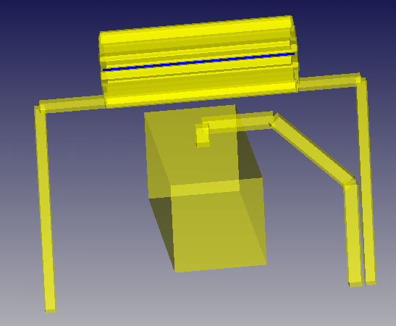

Please note that the end points of the parallel-connected bricks will be shortcircuited (all the upper ends connected together, all the lower ends connected together), as shown in the figure below (blue lines).
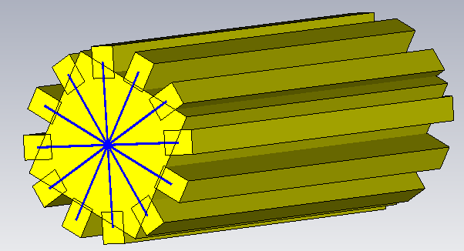

If you don’t want this, please do not use the “+parallel” feature, but define all the necessary segments explicitly.

Automatically defined ports
Ports are defined automatically at the ends of curves, allowing the FastHenry calculation of partial inductivities of these curves. This includes closed curves, for which the beginning and the end nodes are identical: in this case, a port of length zero is defined at this node.

If you want the automatically defined ports to have a special name, rename the curve so that it has the desired name.
E.g. for the “Leiterübermasse” example define the curves as:
- first curve: conductor_back
- second curve: conductor_front

If you don’t want a port to be defined automatically at the end of a curve, name the curve as follows: <curve_name>-ports.

User defined ports of zero length
This is a particular case of the previous one – automatically defined ports.
For this, define a separate curve for this port and name it as desired. Within this curve, define a single 3D-polygon by picking twice the same point.

Ports of zero length may not be defined at points representing intersections of more than two segments. For example, in the picture below, a port cannot be defined at the desired location, since this is the intersection of four different segments.

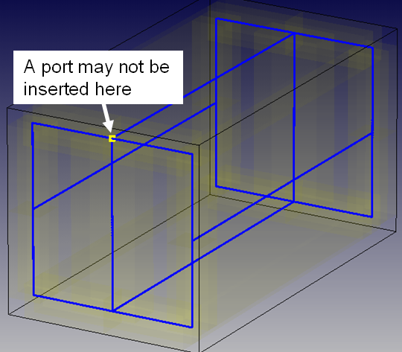

Curves without corresponding bricks – equivalenced nodes
A curve (usually a single segment) can be defined even if there is no corresponding brick, in order to instruct the MWS-FastHenry converter to electrically connect (.equiv) the nodes of the segment. The name of the curve should include “-ports”, since there should be no automatically defined port at the ends of this segment.
The user will be asked whether the nodes of this segment should be equivalenced.
If there are several segments of this type in the model, the user can answer the question once and then check “Do not ask again” to instruct the converter to apply the same answer for all the subsequent segments without corresponding brick.
The user can avoid the need to answer such questions by starting the name of such a curve by “Equivs”, e.g. “Equivs_capacitor-ports” or “Equivs_capacitor”. Such a curve can contain several different segments (no need to have one curve for each segment that describes an equivalence). No ports are automatically set for these curves.

Groundplanes
A brick whose component-name starts with “Ground” will be considered to define a groundplane. There is no need to define a curve for this brick.

The only implemented type of groundplane is the nonuniform groundplane, with no mesh-type initial discretization.

A user dialog requests the following information for each groundplane:
- data about the initial uniform discretization (space-step, etc.); please note that there appears to exist a bug in FastHenry, which makes that the FH computation fails for some values of the initial discretization. If this occurs, try modifying the “Initial discretization stepsize”.
- if the space below traces should be refined, and how fine the discretization should be
- if the space below ports should be refined, and how fine the discretization should be

Output file(s)

The results of the macro run are all placed in the same directory, by default in the subdirectory “3D” of the current MWS project.

The user can however prescribe a different directory in which the results are saved, as well as different names for the FastHenry input and output files. This is especially useful when all results should be placed in a certain directory which might contain files stemming from different FH runs.

The main output file is the FastHenry input file. It is called by default “FastHenry.inp”.

If the user chooses to also run FastHenry after the generation of the .inp file, then a second file, the output of the FastHenry run, is generated. It is called by default “Zc.mat”.

If the user chooses to also write the result of the FastHenry run in Portunus format, then a third file is generated. Its default name is “portunus_out.c2p”.

Checking the result – the “FastHenry to CST” macro
In order to check if the structure as entered in CST STUDIO SUITE is correctly “understood” by FastHenry, you can use the macro
Macros – Construct – FastHenry – FastHenry to CST Converter.

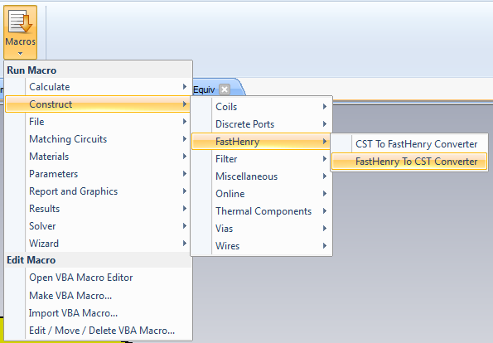

If you have used the default settings when constructing the FastHenry model, then please just press OK in the window below. Otherwise, you can browse for the FastHenry file by pressing “Browse”:
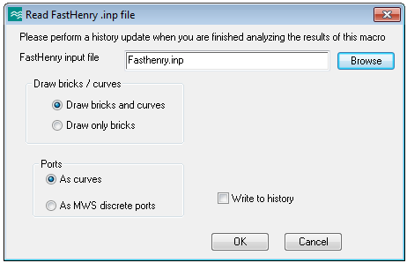

The macro reconstructs, over the existing CST model, a model corresponding to the data in the FastHenry file. The names of the components and of the curves all start with “Z_”.

Please check especially the curves corresponding to the equivalenced nodes .

Ports are also visualized by means of segments between the two points of each port. This is just a CST visualization feature – these segments are not part of the FastHenry file. Since ports of length 0 are represented by very short segments, it might be necessary to strongly zoom-in into the structure in order to be able to see them.

By default, the constructed bricks and curves are not written into the model’s history. After performing an update, they are deleted and the initial model is restored.

Please see the documentation of this macro for more information.

