FastHenry-to-CST Macro

Contents
Starting the macro 1
Usage 1

The program “FastHenry to CST Converter” was initially written as an internal CST debugging tool. As such, it is delivered “as is”, without any guarantee of proper functioning and it may not function as the user would like it to.

Starting the macro

The macro can be started from the “Home” ribbon: Macros – Construct – FastHenry – CST to FastHenry Converter.

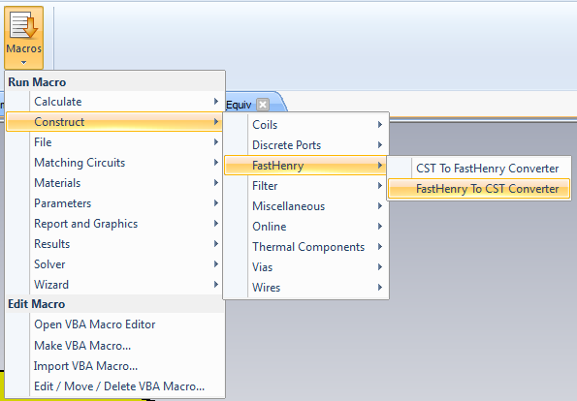

The program can be used to transform a FastHenry file into MWS objects and curves.
It requests the name of the FastHenry input file and generates bricks and curves corresponding to the FH edges, as well as curves corresponding to the FH equivs and ports.

Usage

If you have used the default settings when constructing the FastHenry model, then please just press OK in the window below. Otherwise, you can browse for the FastHenry file by pressing “Browse”:
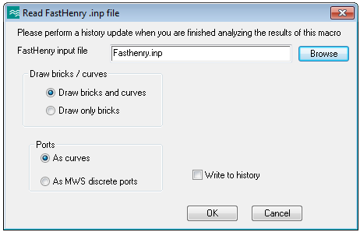

The macro reconstructs, over the existing CST model, a model corresponding to the data in the FastHenry file. The names of the components and of the curves all start with “Z_”.

Please check especially the curves corresponding to the equivalenced nodes.

Ports are also visualized by means of segments between the two points of each port. This is just a CST visualization feature – these segments are not part of the FastHenry file. Since ports of length 0 are represented by very short segments, it might be necessary to strongly zoom-in into the structure in order to be able to see them.

By default, the objects and curves are generated into the current MWS file without writing anything into the history list. An update is necessary in order to restore the original MWS file (if there were simulation results in the MWS file, they may be lost in this process). An update is also necessary if the macro needs to be run again.

By choosing “Write to history”, the commands for the construction of the bricks and curves are inserted into the model’s history. Use this option (usually starting from an empty project) for generating a complete and valid MWS model from any FastHenry input file.

