To get the arduino code working for the scale, you need to download the hx711 library first. Go to Tools -> mangage libraries -> search for ‘hx711’ and the result should look like this: 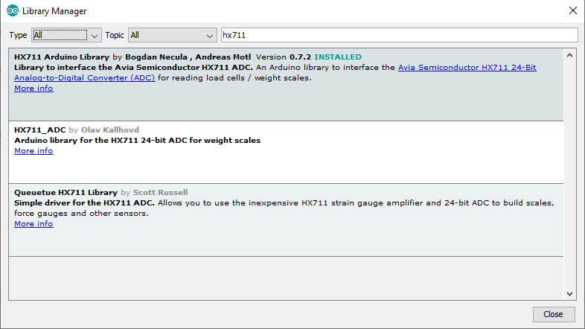

Select the circled one.