# Web Applications Development

# Lab/Activity 2

Course Learning Outcome: CLO2- Create rich web-based user interfaces using current standards-compliant client-side web technologies

Chapters: Chapter 2

Cognitive Levels: Apply

Aim: The student should be able to:

* HTML Semantics
* Understanding Form elements
* Understanding CSS styles
* Understanding Responsive web design (RWD)
  + Setting – Viewport, Responsive Images, Responsive Text, Media Queries.
  + Using Frameworks
  + Step-by-Step example convert Static web page to Responsive web page.

Tools: Laptop, Brackets, Notepad++,

# [MCQ- UNDERSTAND]

***Question 1.***

*Analyze the line of code found in a Cascading Stylesheet.*

*#firstname{border-style: solid; border-color:red ;}*

*Which of the following code sections can make use of this style selector?*

1. *<div class="firstname"> <p>My firstname is Madeleine</p> </div>*
2. *<p ="firstname">My firstname is Madeleine</p>*
3. *<p id="firstname">My firstname is Madeleine.</p>*
4. *<p id="lastname">My firstname is Jones.</p>*

***Question 2.***

*Analyze this HTML code which aims to make use of responsive images. Select the missing code which should scale the image so that it fits to a browser window size for any device.*

*<html>*

*<head>*

*<meta name="viewport" content="width=device-width, initial-scale=1.0">*

*<style>*

*//missing code......*

*</style>*

*</head>*

*<body>*

*<img src="img_HCT.jpg" width="300" height="150">*

*<p>Welcome to HCT</p>*

*</body>*

*<html>*

*a. img {*

*width: 100%;*

*height: auto;*

*}*

*b. img {*

*width: 50%;*

*height: auto;*

*}*

*c. img {*

*width: auto;*

*height:70%;*

*}*

*d. img {*

*100%;*

*auto;*

*}*

# Exercise 1- APPLY – FORMS, RWD and CSS

*Download the form (****Simple_Form.html****) from the Lab2 files folder. This is the exercise as found in the Chapter 2 Lecture.*

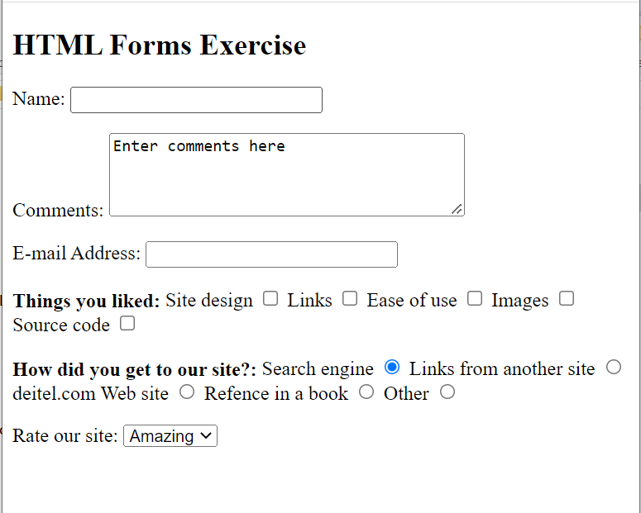

We are going to update and improve this form further by using some semantic features, formatting, and some inline and external styles.

1. Create a **fieldset** element and name it ***about***with a legend ***About Your Course***

<fieldset name="about">

<legend>About Your Course</legend>

</fieldset>

1. Inside the fieldset create a table with 3 rows and 2 columns (no Border). Add your labels and checkboxes, etc. into to the table. Look at the picture below of checkbox. Keep your table within a paragraph.

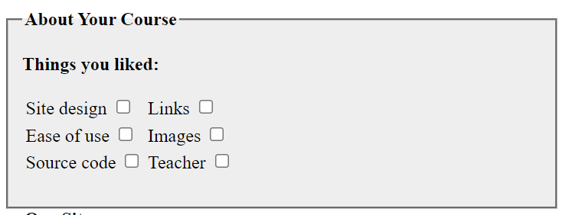

1. Now do the same with the radio buttons and make the form look as showing below:

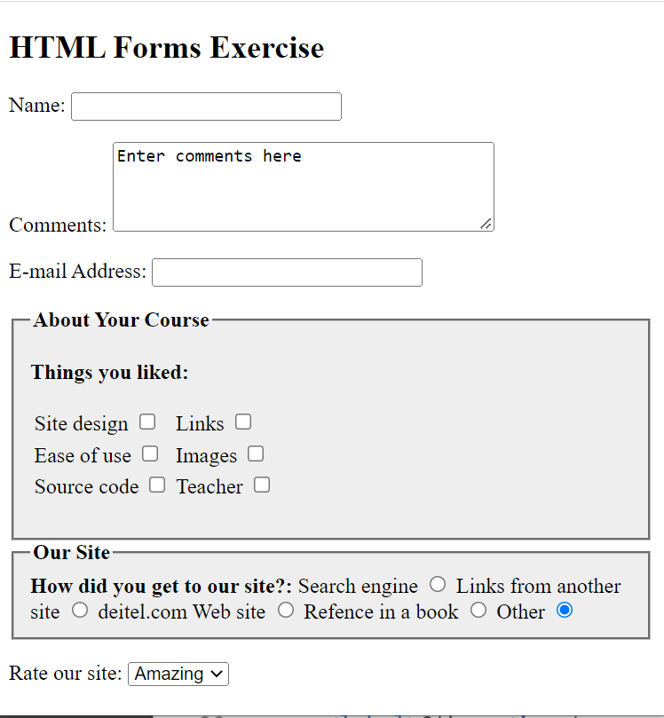

1. Create an inline style and set the background of the fieldset to lightgrey #eeeeee and the font-weight of the legend to bold as shown above.
2. We will now make use of the semantic tags so we can creation different sections for our page.

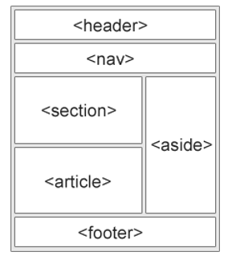

Ensure sure that all content is enclosed in body tags with <div> giving it an ID of “container”. Place the H2 inside of the <header>.

<body>

<div id ="container">

<header>

<h2>HTML Forms Exercise</h2>

</header>

1. In the main body of our page we will add 2 different <sections>. In the 1st section we will include the fieldset “about” and in the 2nd section we will include the fieldset named “site” and the dropdown list.

<section>

<fieldset name="**about**">

<legend>About Your Course</legend>

……..more codes

</section>

<section>

<fieldset name="**site**">

<legend>Our site</legend>

<select name = "rating">

<option selected>Amazing</option>

<option>10</option>

<option>9</option>

…..

….

<option>Awful</option>

</select>

</section>

1. Add a <footer> to the bottom of the page and add HCT as the author of the webpage with the copyright and all rights reserved in italics.

Copyright &copy; 2022, HCT <i> All rights reserved.</i>

Your page should now resemble the following:

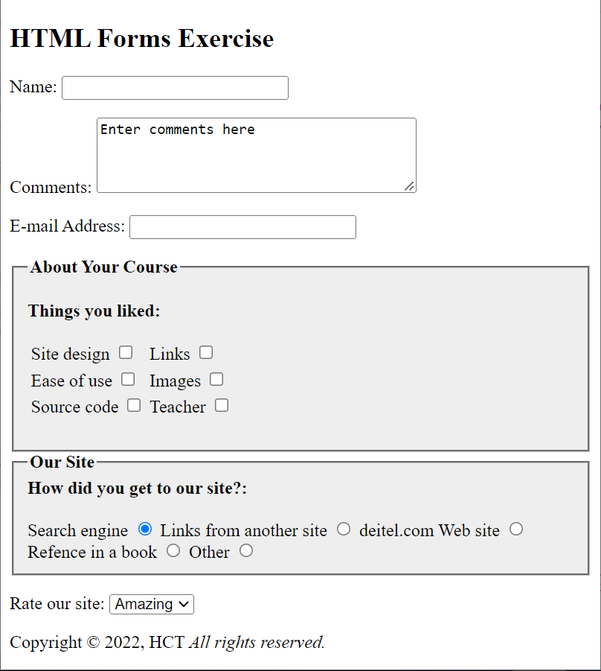

footer

header

Section

Section

|  |  |
| --- | --- |
| 1. Let’s now use Responsive Web Design so that any text or images respond to the change in the screen size. We need to add the following statement into the <head> tags in our web page.   <head>  <meta name="viewport" content="width=device-width, initial scale=1.0">  </head>   1. Now we will make the text of the main heading H2 responsive by using 4VW. Use the code below:   <header>    <h2 **style="font-size:4vw;"**>HTML Forms Exercise</h2>    </header> | |
|  | | Note: The heading text will now become larger or smaller depending on the size of the screen. Try it.   1. Now let’s make the rest of the page responsive by setting each of the paragraphs to 2VW. See the code needed below. Then expand and contract your page   <p **style="font-size:2vw;"**> |
|  | | You page should look like the following when it is smaller: |
|  | | And when it is maximized to a larger screen: |

There may still be further adjustments needed to make it fully responsive.

1. Create a CSS file and set the header and the footer to light blue as shown in the image below. You will need to include the file in the same folder and refer to it in the head of this webpage.

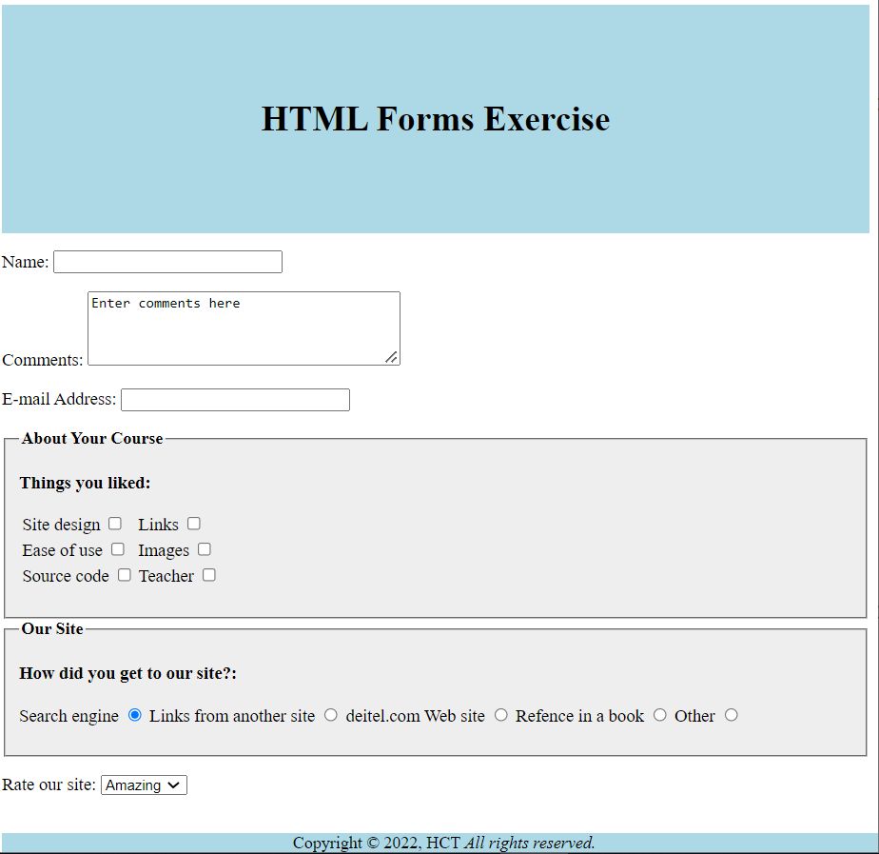

***Solution file can be found will all codes included.***

# Exercise 2- Apply - Homework

*Work on* ***Lab 2 HTML and CSS Homework Exercises****.*

*There are 3 separate tasks for you to complete* ***Task1****,* ***Task 2*** *and* ***Task 3****. Solutions are provided.*

*This exercise will review the HTML and CSS from CIS 1203 and some new knowledge from previous week.*