# Lab 3/Implementing the Design Features of Bootstrap

Course Learning Outcome: CLO2- Create rich web-based user interfaces using current standards-compliant client-side web technologies

Chapters: Chapter 3

Cognitive Levels: Apply

Aim: The student should be able to:

* Apply Bootstrap Semantics to implement front-end frameworks for faster and easier web development
* Apply Bootstrap to include HTML and CSS based design templates for typography, forms, etc…….
* Apply Bootstrap Form elements
* Apply Responsive web design (RWD) using Bootstrap

Tools: Laptop, Notepad++, Brackets, Text Editor, Bootstrap CDN

Document Revision Control: 001

# [MCQ- APPLY LEVEL]

1. Select container class to provide a responsive but full width container size (Content spans whole length of the page) for our web page which uses Bootstrap

a. <div class="container-fluid">

b. <div class="container">

c. <<div class="contains">

d. <<div class="contains-fluid">

2. Which section of code which uses Bootstrap will create a row with 3 equal columns?

a. <div class="row">

<div class="col p-3 bg-primary text-white">.col</div>

<div class="col p-3 bg-dark text-white">.col</div>

<div class="col p-3 bg-primary text-white">.col</div>

</div>

b. <div class="row">

<div class="col p-1 bg-primary text-white">.col</div>

<div class="col p-2 bg-dark text-white">.col</div>

<div class="col p-3 bg-primary text-white">.col</div>

</div>

c. <div class="row">

<div class="col p-3 bg-primary text-white">.col</div>

</div>

d. <div class="row">

<div class="p-3 bg-primary text-white">.col</div>

</div>

# Exercise 1- APPLY LEVEL

*We will use the same theme of the travel Website from Week 2 to demonstrate some of our bootstrap features.*

*Download extract the files which can be found in Week 3 Lab 3. Open file index.html in Brackets++.*

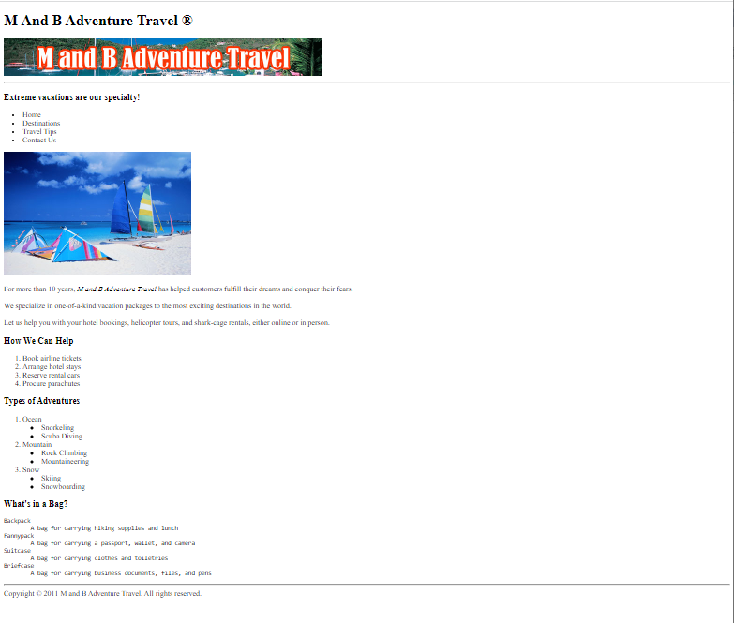

*This web page currently does not use RWD or Bootstrap.*

*Update the html file to include Bootstrap and RWD. Add some codes references to the <head> section. Use* ***CDN*** *for the purpose of this Lab.*

# Exercise 2- APPLY LEVEL

*Place the content of the html page into a container class which will provides a responsive but fixed width container size (Padding for the fixed width).*

*Hint: surround the internal content of the <body> with <div></div> tags and set the container class.*

Save your file and preview in the browser to see the notable differences.

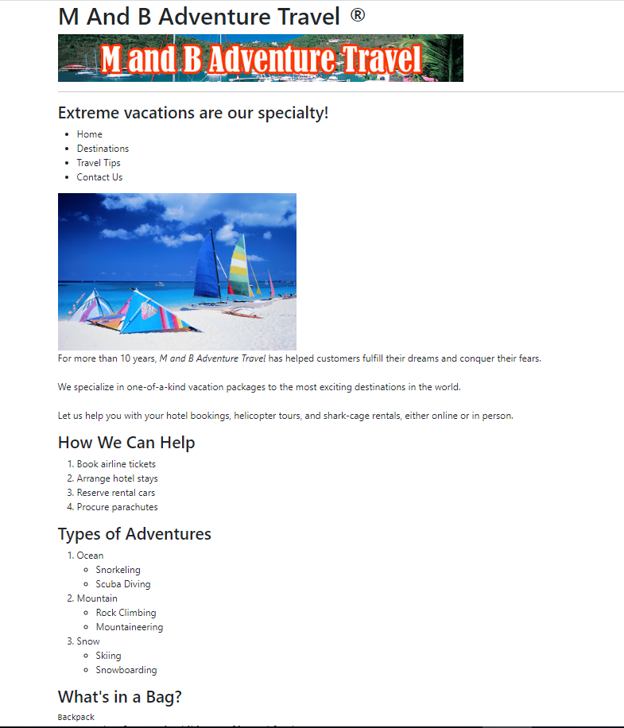

# Exercise 3- APPLY LEVEL

*Let’s alter the 2nd image in our web page. Make it a round circle as shown below.*

*Hint: Add the class directly to the image source code.*



# Exercise 4- APPLY LEVEL

*Alter the text color for the <h1> and for all <h3> using Bootstrap. See image below:*

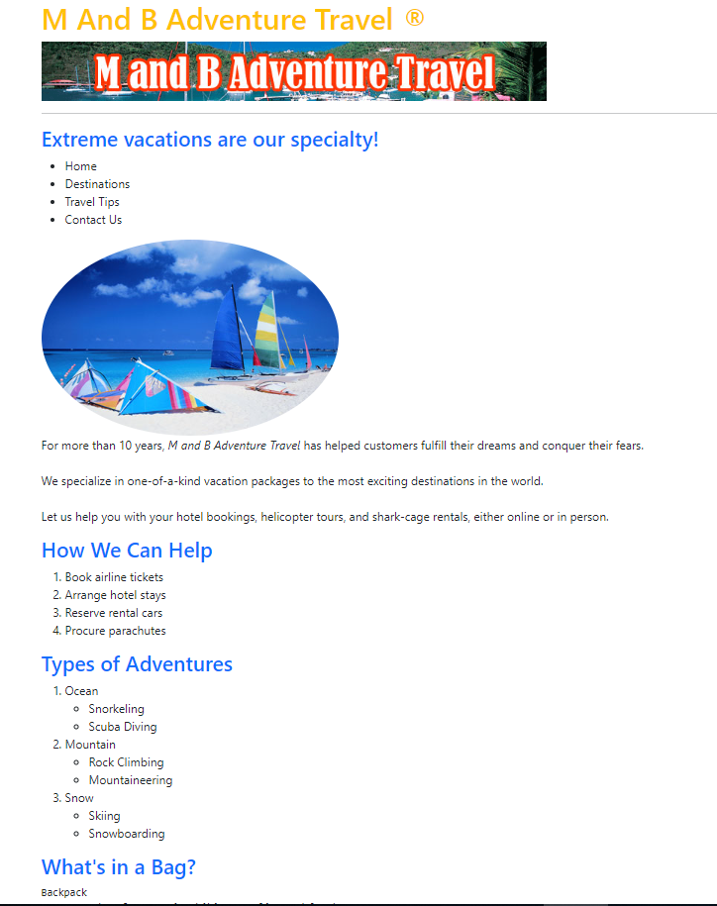

# Exercise 5- APPLY LEVEL

*Set the back ground of the text to light blue and the foreground writing to white as seen in the image.*

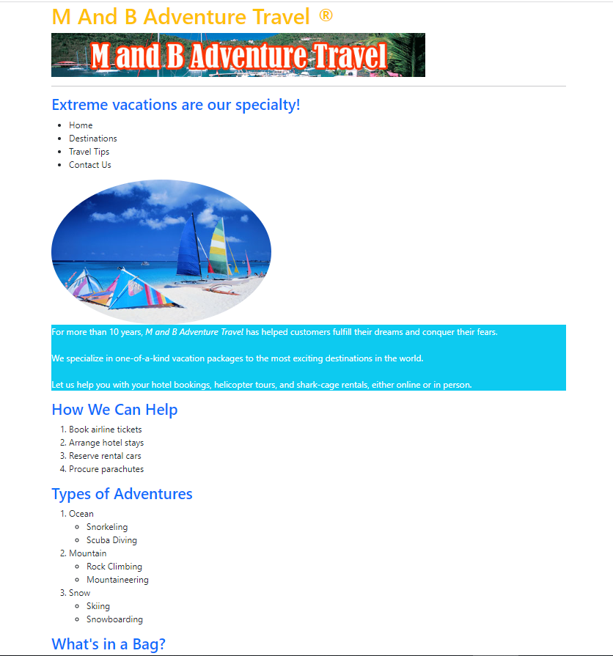

# Exercise 6- APPLY LEVEL

*Set the text in the list to* ***UPPERCASE*** *and* ***red*** *as seen in the image below:*

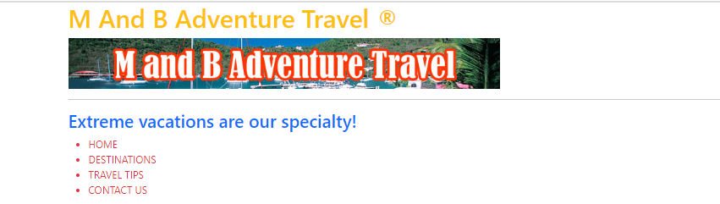

# Exercise 7- APPLY LEVEL

*Add some pagination to your index page as shown below. You will to move between the index page and a Customer Form. We will create the customer form in the next step.*

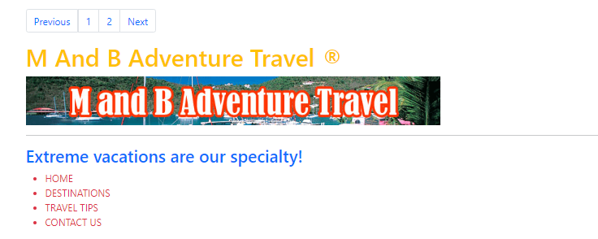

# Exercise 8 - APPLY LEVEL

*Create a basic Customer Registration form which we can link to using our Bootstrap pagination. See below:*

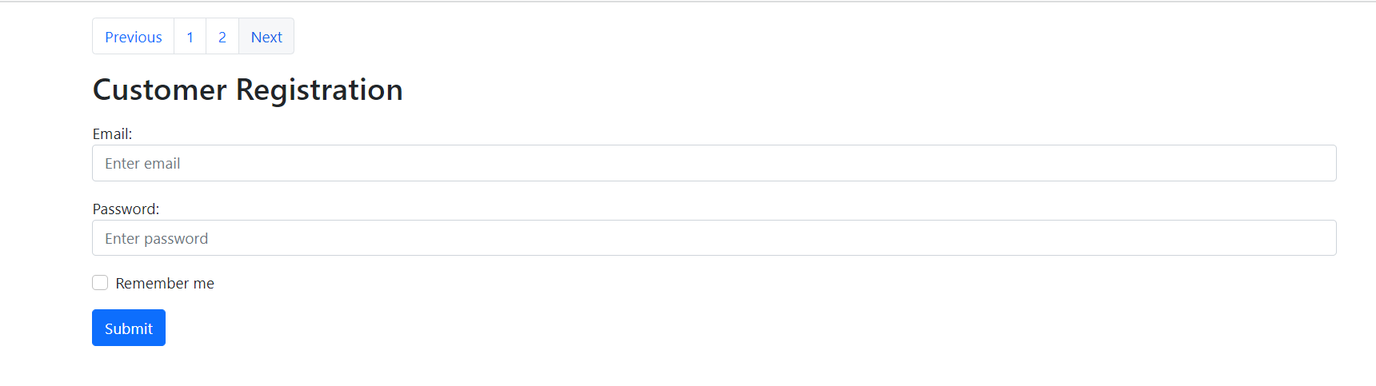

# Exercise 9 - APPLY LEVEL

*Update the Pagination code on each of the html pages to move easily back and forward within the website. Hint: html files will need to be saved/located in the same folder*