**Assignment 1**

a)

mean: 0.508

median: 0.545

variance: 0.1415956

b)

mean = 0.9982699

median = 0.4995539

var = 0.08299303

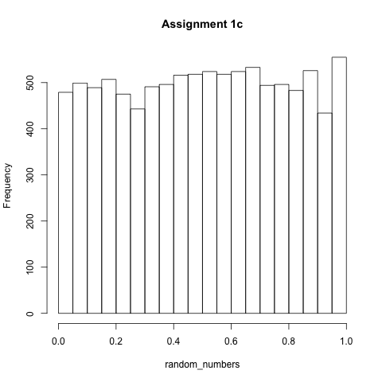

c)

**Assignment 2**

min(faithful$eruptions) = 1.6

max(faithful$eruptions) = 5.1

median(faithful$eruptions) = 4.0

mean(faithful$eruptions) = 3.488

difference between mean and median: 0.512

min(faithful$waiting) = 43

max(faithful$waiting) = 96

median(faithful$waiting) = 76

mean(faithful$waiting) = 70.89706

difference between mean and median: 5,10294

**Assignment 3**

a)

Unique Values and how often they occur:

Iris-setosa : 50

Iris-versicolor : 50

Iris-virginica : 50

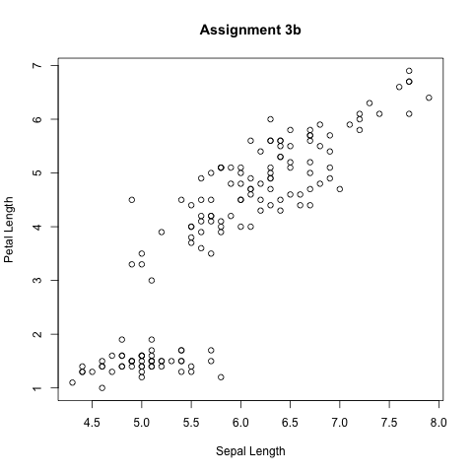b)

c)

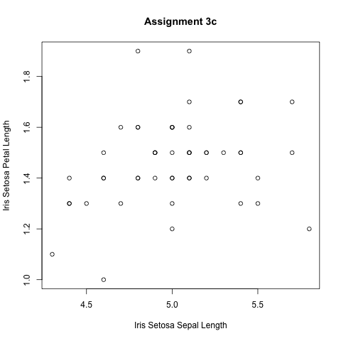

The Petal Length and Sepal Length of Iris Virginica and Versicolor are also correlated positively.

The Petal Length and Seapal Length of Iris-Setosa is not correlated.

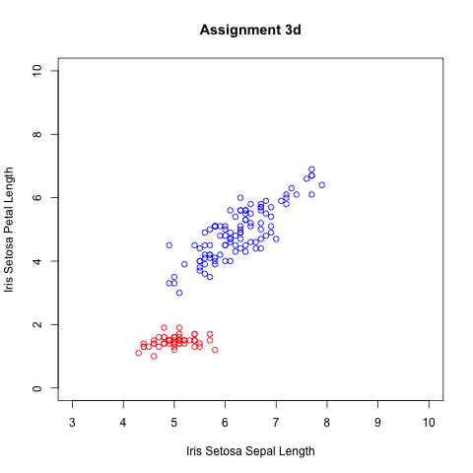

d)

**Assignment 4**

a)

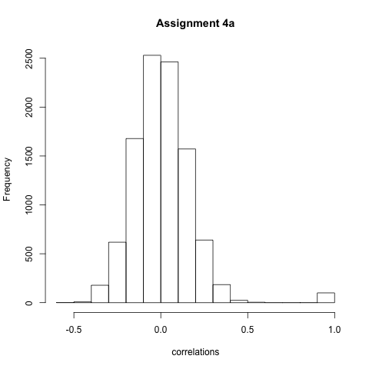

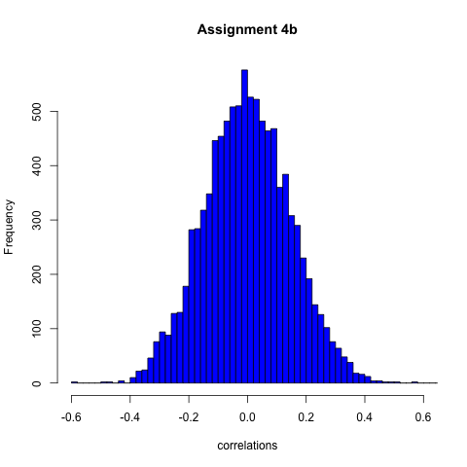

b)

**Assignment 5**

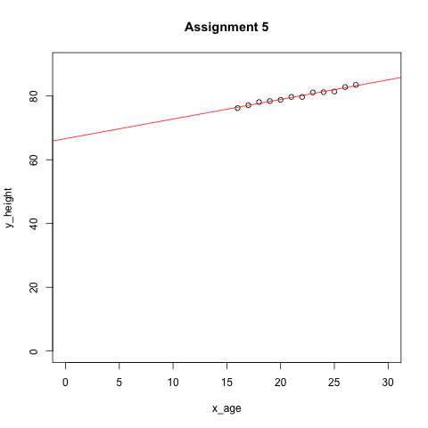

**Assignment 6**

High accuracy:

Detecting Cancer is something that needs high accuracy. People who do not have cancer should not be treated with chemo therapy and all people who have cancer should be classified as having cancer.

High Precision:

An Antivirus progamm is an example which should have a high recall. It is not problematic to accuse a 'program' of being malicious when it is not but highly important to find all virus programs.

**Assignment 7**

maximum precision: score > 0.93

This way only the first element with a score of 0.05 would be classified into class C which would be correct and lead to a precision of 100%.

maximum recall: score >= 0.48

This way all items get classified into class C. This leads to a recall of 100% because all items belonging to C are found.

maximum accuracy: score > 0.93

**Bonus Assignment 1**

