**How to Format Data for the IGS**

To use your own data in the **IGS**, you need at least a **1) floor plan/image file** and **2) movement file(s)** formatted as described below. You may also include **conversation transcripts, video, and code files** formatted as described below.

**Required Data (Image and Movement File)**

**1. Floor Plan/Image File (PNG/JPG)**

* The floor plan/image must be in **PNG** or **JPG** format.
* You can create a floor plan by hand and take a picture or use software like **Adobe Illustrator** or **AutoCAD** for a higher-quality image.
* Ensure that the **floor plan/image used for recording movement matches the one imported into the IGS**.

📌 **Example Floor Plan:**

**2. Movement File(s) (CSV)**

**Creating Movement Files**

If you do not have positioning data from an automated tracking system, you can use **Mondrian Transcription Software** to transcribe and create movement files. Ensure the **floor plan used for recording matches the imported image file** in IGS.

**Movement File Format**

Must be formatted as a **CSV file** with the following columns:

✅ **time** – A number in seconds elapsed from 0.

✅ **x** – Whole number or decimal (pixel position on floor plan image).

✅ **y** – Whole number or decimal (pixel position on floor plan image).

*\*The filename of the movement file becomes its label in the IGS interface.*

📌 **Example Movement File Format:**  
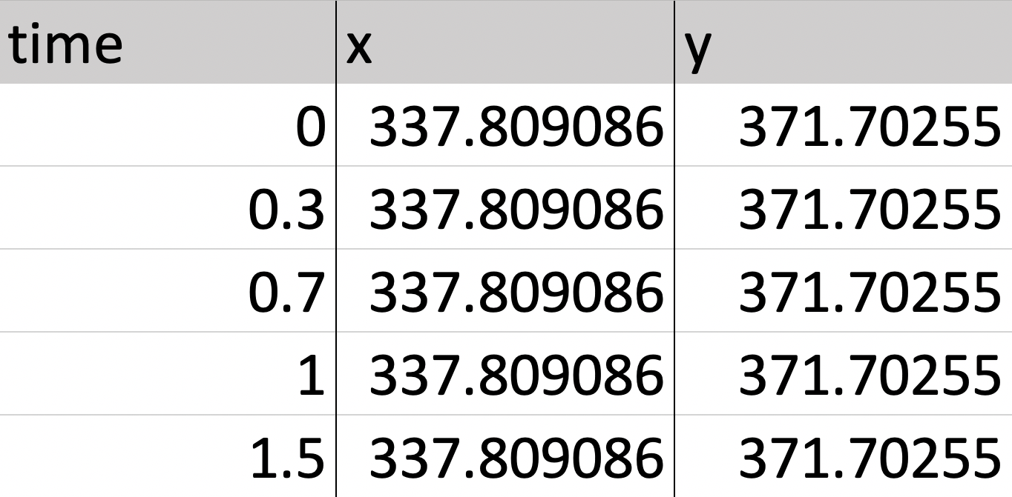

**Optional Data (Video, Transcripts and Code Files)**

**3. Video File (MP4)**

* Must be in **MP4 format** to ensure compatibility across web browsers.
* The **length of your video should match the time range of your movement file(s)**.

**4. Conversation File (CSV)**

Must be formatted as a **CSV file** with the following columns:

✅ **time** – A number in seconds elapsed from 0.

✅ **speaker** – Text name of the speaker for each turn.  
✅ **talk** – The transcript text for that speaker’s turn.

*\* To match individual speakers to movement paths, the filename of the movement file should match the corresponding speaker in the conversation file.*

📌 **Example Conversation File Format:**

**5. Code File(s) (CSV)**

**Code files** allow you to **highlight movement and conversation data over time**. Code files muse be formatted in one of the two following formats:

**Single Code File Format**

Each file represents **one type of event**. The **filename becomes the code label** in the IGS. Must be formatted as a **CSV file** with the following columns:

✅ start – A number in seconds elapsed from 0 marking event start.  
✅ end – A number in seconds elapsed from 0 marking event end**.**

***\* The file must be sorted in ascending order by start time.***

📌 **Example Single Code File Format:**

**Multi-Code File Format**

* Allows multiple event types in **one file**.
* Must be formatted as a **CSV file** with the following columns:

✅ **code** – Text name of the code.

✅ **start** – A number in seconds marking event start.  
✅ **end** – A number in seconds marking event end.

***\* The file must be sorted in ascending order by start time***

📌 **Example Multi-Code File Format:**  
