[](http://www.swufe.edu.cn/version3/xuexiaogaikuang/xiaohui.jpg)**西南财经大学**

Southwestern University of Finance and Economics

**课堂练习**

**学年学期：** 2021-2022-1

**课程名称：** 数据库原理及应用

**小组编号：** 2

**学号/姓名1： 41934063 税家晖**

**学号/姓名2： 41934049 刘彦升**

**学号/姓名3： 41933008 赵宏泽**

**学号/姓名4：**

第一题

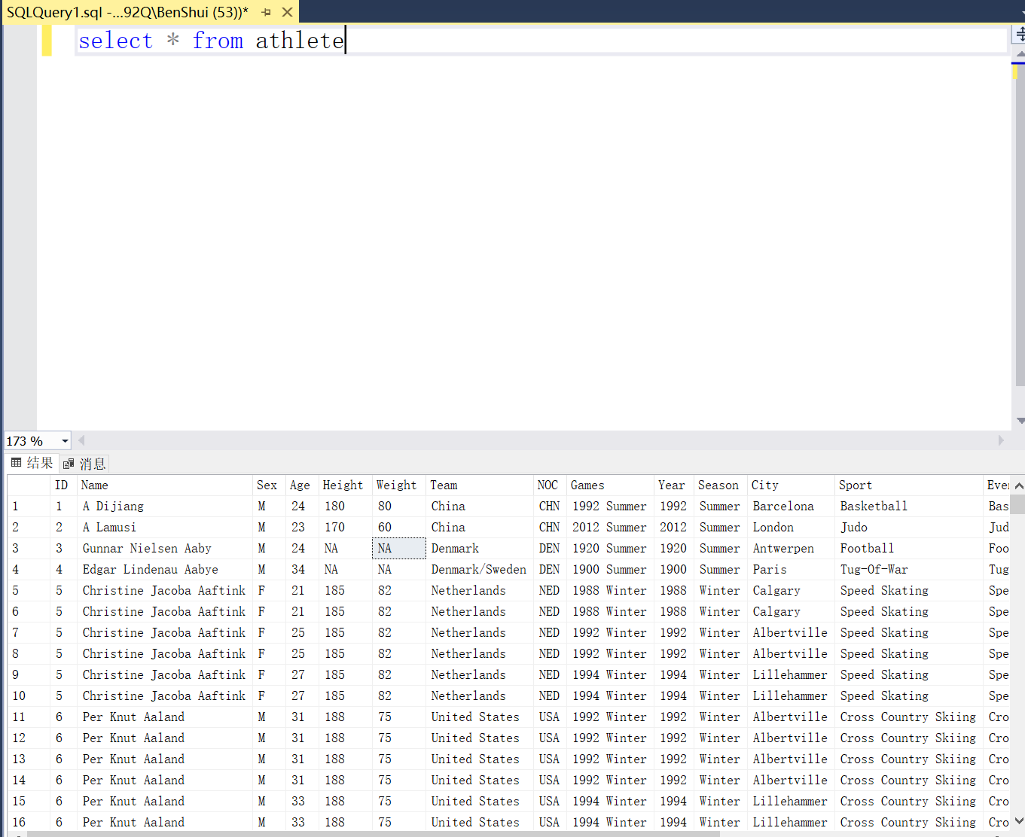

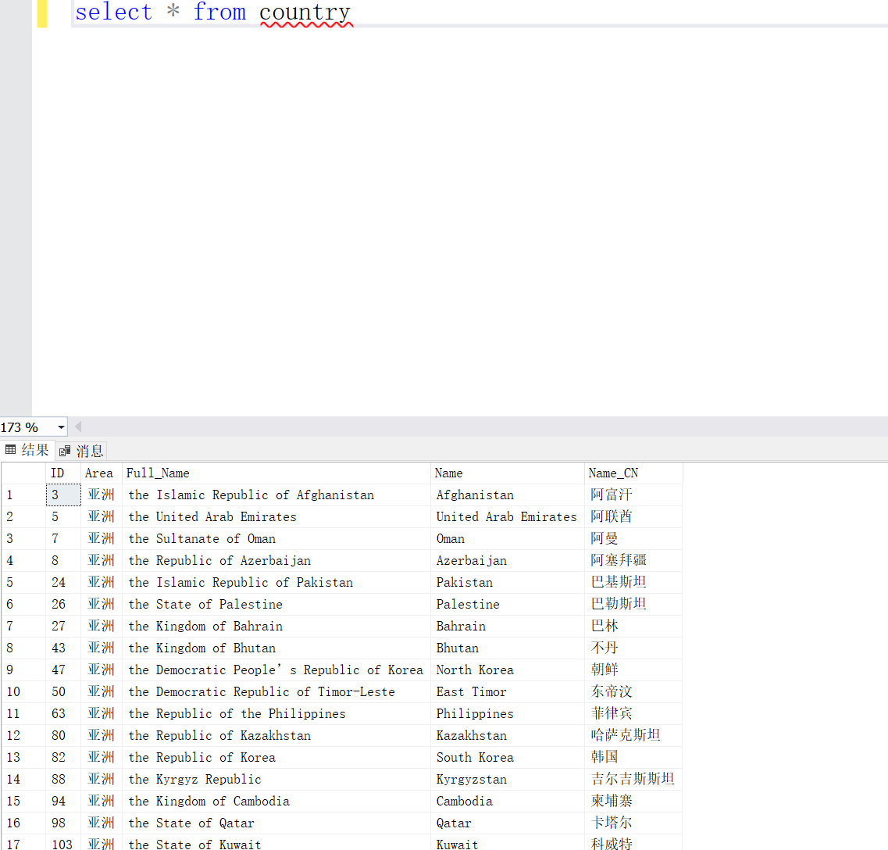

第二题

select year from athlete

where Team like '%China%' and year<=1949

group by year

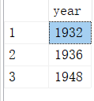

第三题

select year,count(*) jinpaishu from athlete

where games like '%Summer%' and Medal='Gold'

and team like '%Japan%'

group by year

order by jinpaishu descselect year,count(*) jinpaishu from athlete

where games like '%Winter%' and Medal='Gold'

group by year

order by jinpaishu desc

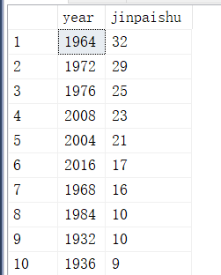

答案是1964年

第四题

select year,count(*) jinpaishu from athlete

where games like '%Winter%' and Medal='Gold'

group by year

having count(*)>100

order by jinpaishu

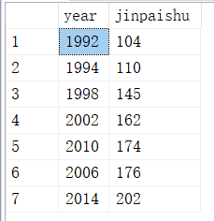

第五题

select sum(cnt) M from

(select sport, sex, count(*) cnt from athlete

where height<>'NA'

group by sport, sex

having avg(convert(int, height))>180 ) a

where a.sex = 'M'

select sum(cnt) F from

(select sport, sex, count(*) cnt from athlete

where height<>'NA'

group by sport, sex

having avg(convert(int, height))>180 ) a

where a.sex = 'F'

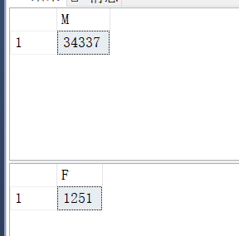

结果：27.447641

**第六题**

select sport, count(*) cnt

from athlete

where team='Russia' and medal='Gold'

group by sport

order by cnt desc

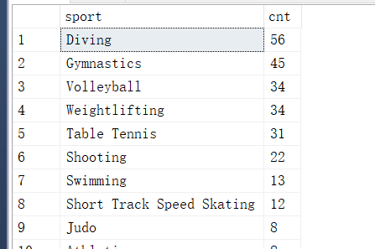

中国是跳水

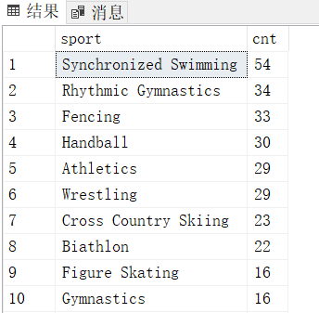

俄罗斯是Synchronized swimming

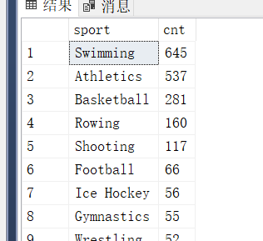

美国是swimming

第七题

create view vw_athlete_sex

as

select year, sex, count(*) cnt

from athlete

group by year, sex

select a.year, a.cnt*1.0/b.cnt nannvbi

from vw_athlete_sex a, vw_athlete_sex b

where a.year = b.year and a.sex='M' and b.sex='F'

order by nannvbi desc

最悬殊的为1904年（事实上为1896年，没有女性参赛）

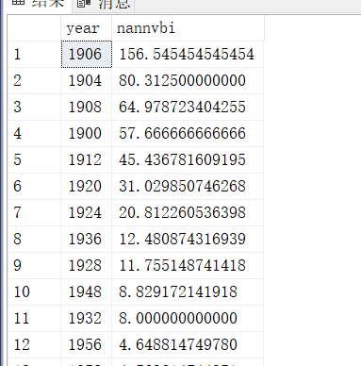

第八题

select avg(10000*convert(int,a.weight)*1.0/(convert(int,a.height)*convert(int,a.height)))

from athlete a,country b

where a.weight<>'NA' and a.height<>'NA'

and a.team = b.name and b.area='欧洲'

and a.year = 2016

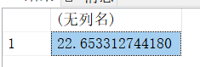

第九题

北美 大洋 非洲身高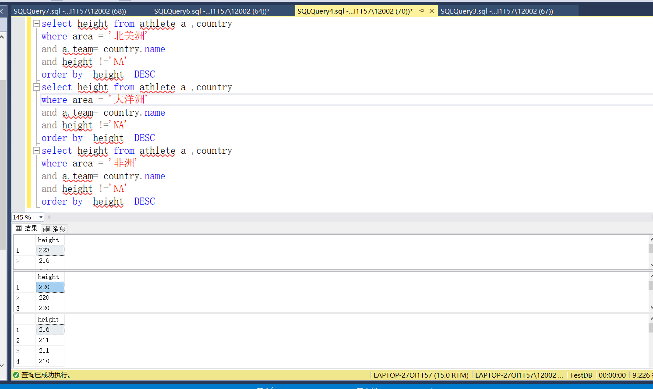

南美 欧洲亚洲身高

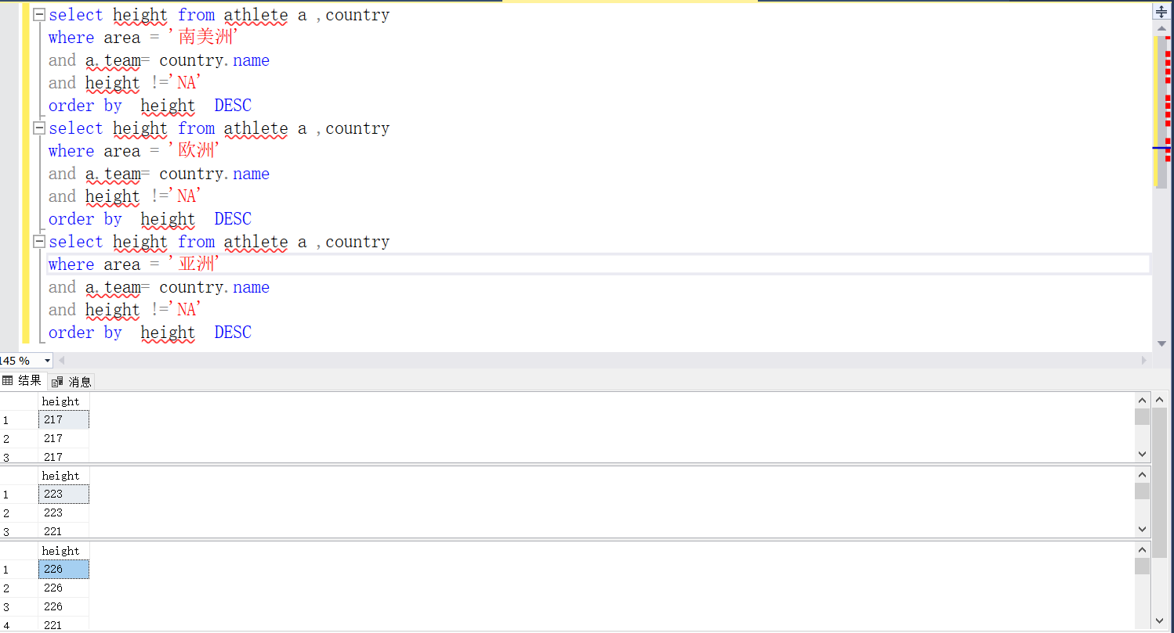

南美欧洲 亚洲体重

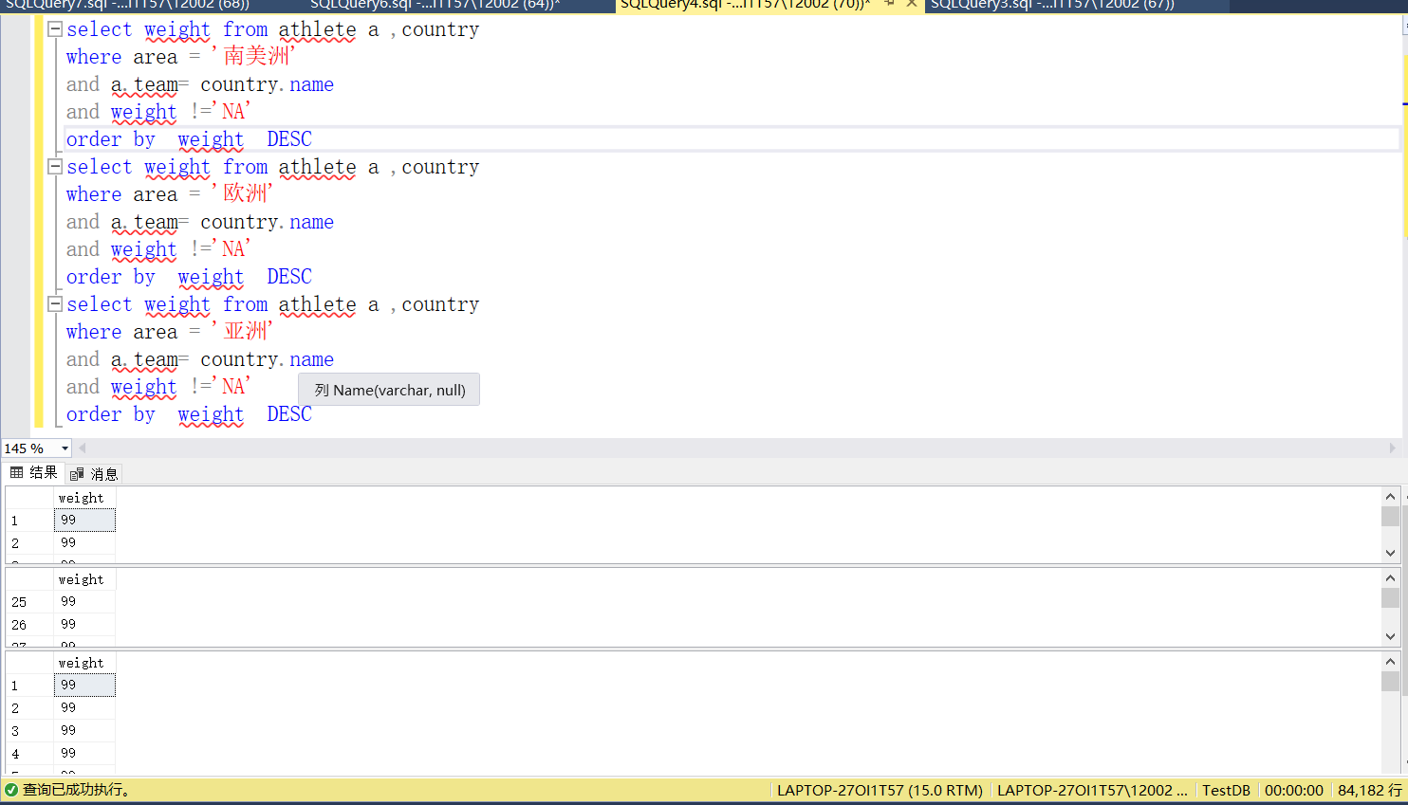

北美大洋体重

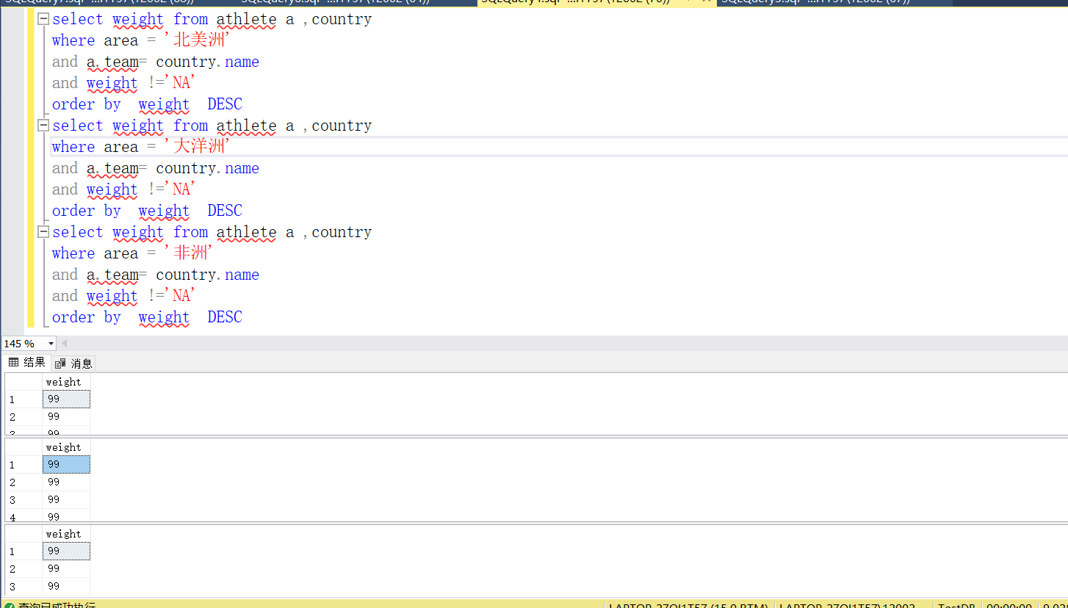

第十题

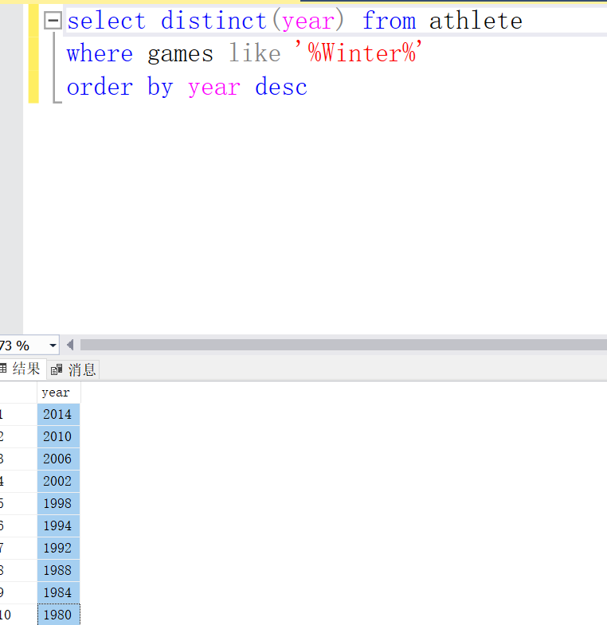

1980年及以后的夏季运动会

select b.area, a.year, count(*) gold

from athlete a, country b

where a.team=b.name and (b.area= '亚洲' or b.area='欧洲' or b.area='北美洲')

and a.medal='Gold' and a.year>=1980 and a.games like '%Summer%'

group by b.area,a.year

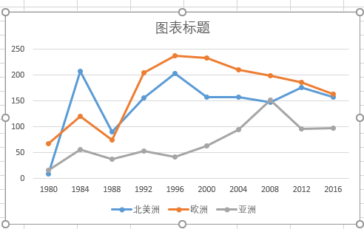

1.黑板题目{AB->C, C->AD, E->B}

L: A, E

LR: B, C,

R: D

候选码为(A，E)，非主属性为(B, C, D)

（A,B）-F> C，

C -P> (A,D)，

E -F> B，

B – E, C –(A,B) – (A,E)， D – C – (A,E)

B 部分依赖于码AE，故是1NF