Developing novel methods for gene editing in trees

Ben Sivan

August 2022

Student:\_\_\_\_\_\_\_\_\_\_\_\_\_\_\_Date:\_\_\_\_/\_\_\_\_/\_\_\_\_\_\_\_ Signature of

Supervisor: Prof. Martin Goldway. Date:31/08/2022 Signature of 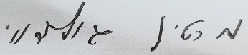

supervisor: Dr. Amir Raz. Date:31/08/2022 Signature of C:\Users\goldway\AppData\Local\Microsoft\Windows\INetCache\Content.Outlook\BRU3B2YE\20220731_110038.jpg