**DBI LAB 1**

FULL NAME: DƯƠNG HỒNG QUÂN

STUDENT ID: SE170057

Q1:

SELECT ProductID, Name, ListPrice from SalesLT.Product

WHERE ListPrice >

(SELECT AVG(UnitPrice) FROM SalesLT.SalesOrderDetail)

ORDER BY ProductID;

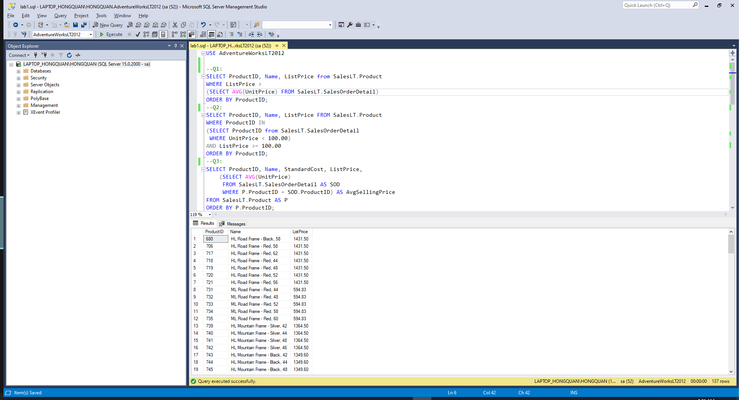

Q2:

SELECT ProductID, Name, ListPrice FROM SalesLT.Product

WHERE ProductID IN

(SELECT ProductID from SalesLT.SalesOrderDetail

WHERE UnitPrice < 100.00)

AND ListPrice >= 100.00

ORDER BY ProductID;

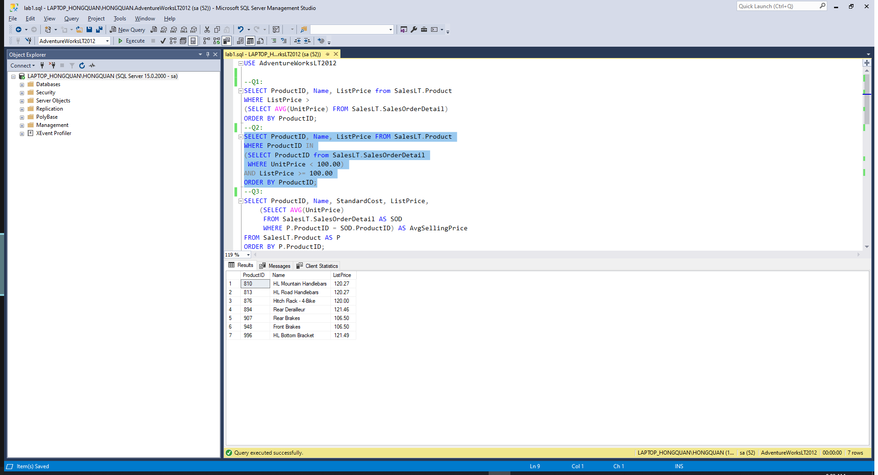

Q3:

SELECT ProductID, Name, StandardCost, ListPrice,

(SELECT AVG(UnitPrice)

FROM SalesLT.SalesOrderDetail AS SODetails

WHERE P.ProductID = SODetails.ProductID)

AS AvgSellingPrice

FROM SalesLT.Product AS P

ORDER BY P.ProductID;

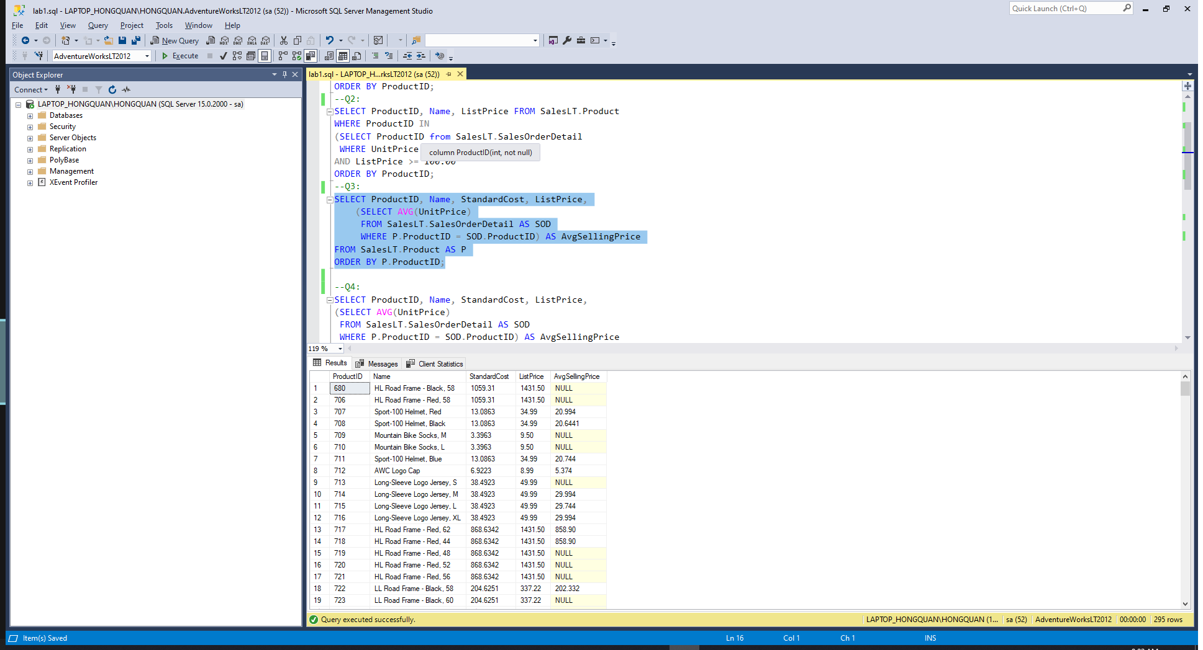

Q4:

SELECT ProductID, Name, StandardCost, ListPrice,

(SELECT AVG(UnitPrice)

FROM SalesLT.SalesOrderDetail AS SODetails

WHERE Pd.ProductID = SODetails.ProductID) AS AvgSellingPrice

FROM SalesLT.Product AS Pd

WHERE StandardCost >

(SELECT AVG(UnitPrice)

FROM SalesLT.SalesOrderDetail AS SODetails

WHERE Pd.ProductID = SODetails.ProductID)

ORDER BY Pd.ProductID;

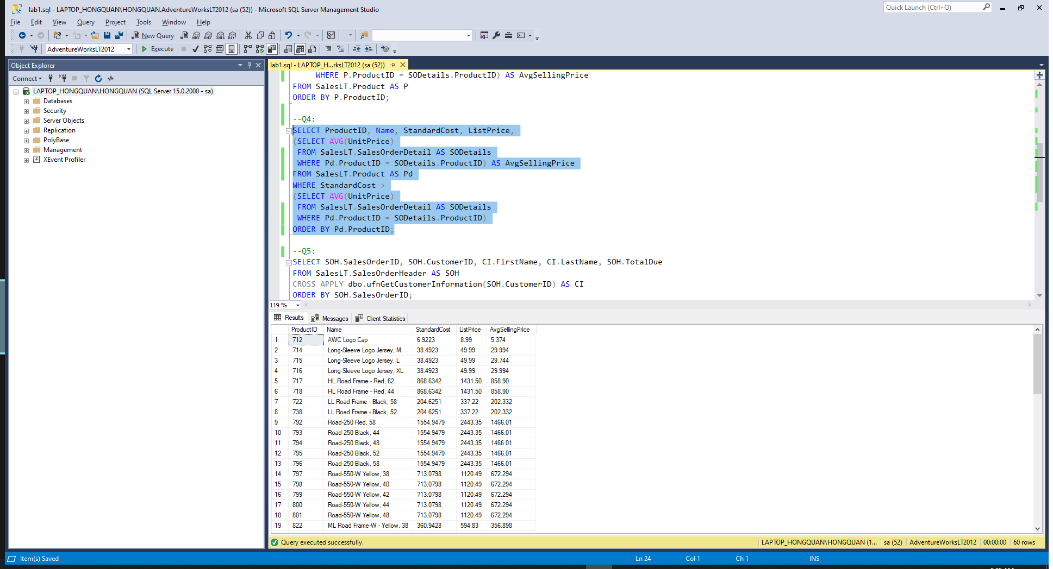

Q5:

SELECT SOH.SalesOrderID, SOH.CustomerID, CI.FirstName, CI.LastName, SOH.TotalDue

FROM SalesLT.SalesOrderHeader AS SOH

CROSS APPLY dbo.ufnGetCustomerInformation(SOH.CustomerID) AS CI

ORDER BY SOH.SalesOrderID;

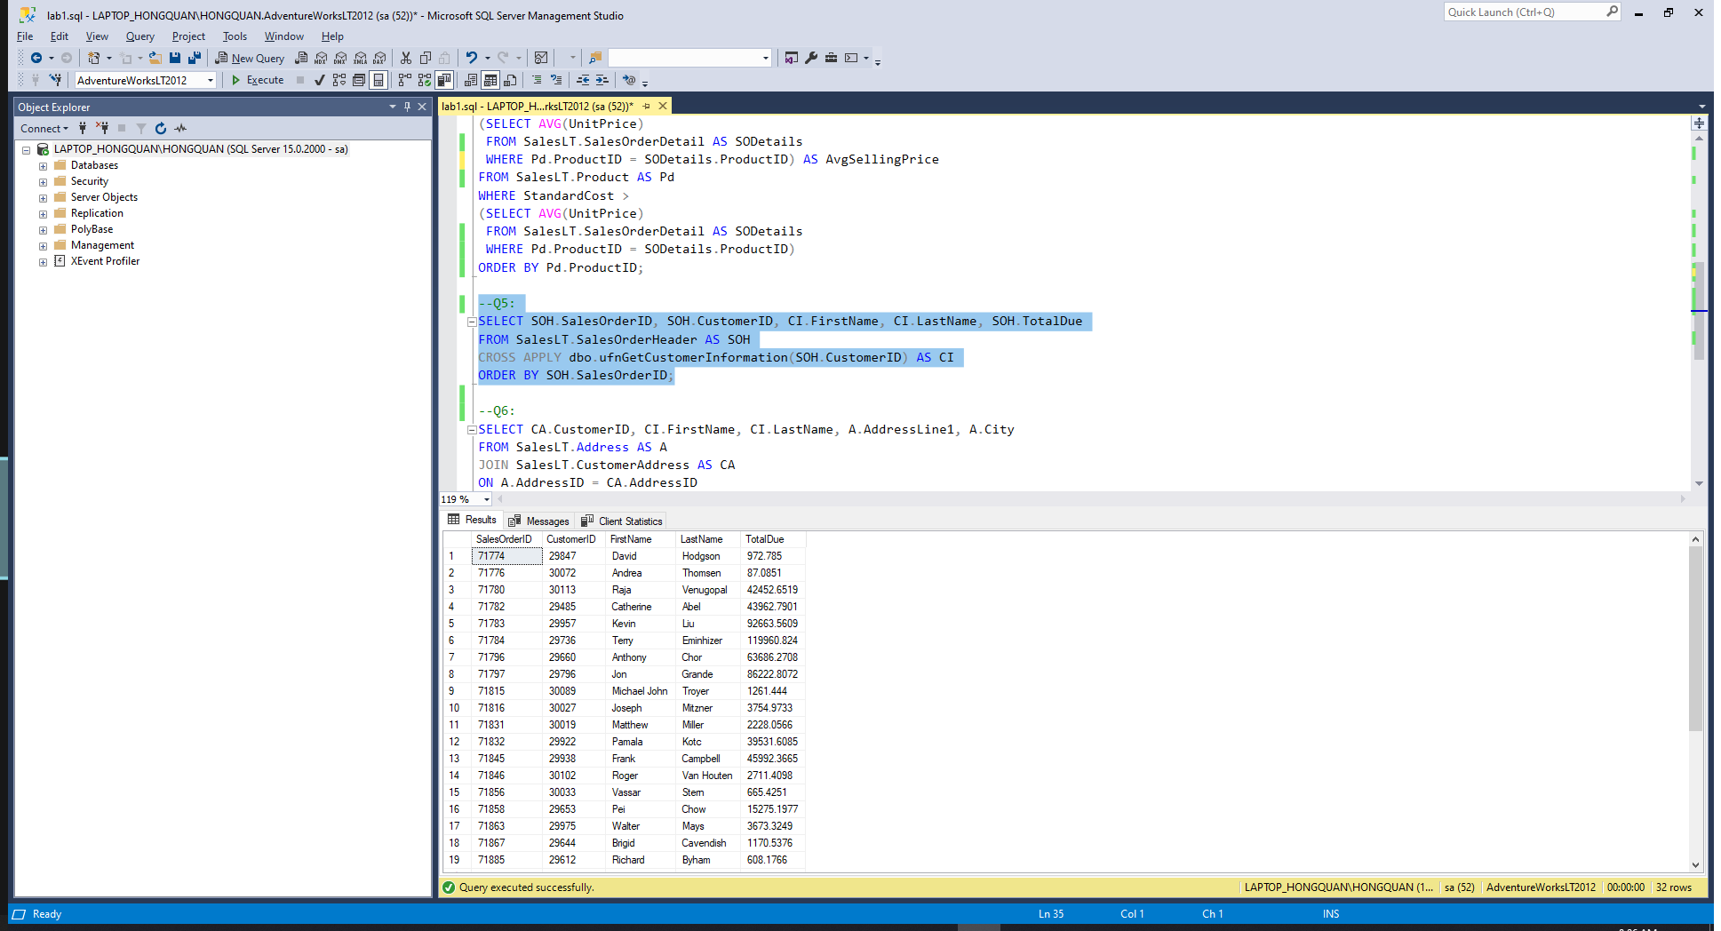

Q6:

SELECT CA.CustomerID, CI.FirstName, CI.LastName, A.AddressLine1, A.City

FROM SalesLT.Address AS A

JOIN SalesLT.CustomerAddress AS CA

ON A.AddressID = CA.AddressID

CROSS APPLY dbo.ufnGetCustomerInformation(CA.CustomerID) AS CI

ORDER BY CA.CustomerID;

