**DBI ASSIGNMENT 1**

FULL NAME: DƯƠNG HỒNG QUÂN

STUDENT ID: SE170057

1.

a. Show the piece of an E-R diagram that would result in this schema for Purchase, including any relationships and entities directly related to Purchase.  
(Do not draw the diagram for the whole schema.)

from

From Stock

Customer by Purchase stocks

For Book

Isbn

The fact that Purchase does not include from in its key makes it difficult to get this entirely correct. The key is the union of these two, plus the additional critical element of when, because Customer and Book are weak points in the argument.  
(I gave most full credit for getting that Purchase is weak, and involving Customer  
and Stock and / or Book.)

b. Show the piece of an E-R diagram that would result in this schema for Stock,  
including any relationships and entities directly related to Stock

from

Stock

From stocks

Purchase Books

when isbn

This is a rather simple situation. On Book, the stock is weak. And Purchase is related to Stock.

c. A many-many, Wrote.

2.

a. A relational database management system (RDBMS) does not do which of the following?  
A. Provide mechanisms to help protect the integrity of the data.  
B. Allow for concurrent transactions against the database.  
C. Facilitate crash recovery of the database in case of hardware failure.  
D. Optimize query evaluation for arbitrary SQL queries.  
**E. Ensure that relational schemas are in at least 3NF**

b. Which of the following is not a relational schema? (The underlined attributes indicate  
the key.)  
A. Book(title: the title of the book,  
year: the year it was published,  
author: who wrote it,  
publisher: who published the book,  
text: the entire text of the book)  
B. Personal(name: name of the individual,  
birthdate: when he or she was born,  
from: where the individual lives,  
hobbies: a list of that person’s hobbies (references hobby))  
C. Procedure(name: a unique name for this piece of code,  
language: which computer language it is written in (references language),  
code: the code itself,  
description: a description of what the code does)  
D. Marriage(wife: name of the wife,  
husband: name of the husband,  
when: the date when they were married)  
E. Disease(name: medical name of the disease,  
symptom 1: boolean, whether the disease has symptom #1,  
...  
symptom 1219: boolean, whether the disease has symptom #1219)  
c. Codd’s rule of physical data independence is that  
A. all information in the database is to be represented in one and only one way, namely  
by values in column positions within rows of tables.  
B. all views that are theoretically updatable must be updatable by the system.  
**C. changes that are made to the physical storage representations or access methods  
must not require changes be made to application programs.**  
D. changes that are made to tables that do not modify any of the data already stored  
in the tables must not require changes be made to application programs.  
E. data in different tables must not be related

d. Why are NULL values needed in the relational model? NULL values can be used for all  
except which one of the following?  
**A. To allow duplicate tuples in the table by filling the primary key column(s) with  
NULL.**B. To avoid confusion with actual legitimate data values like 0 for integer columns and  
‘ ’ (the empty string) for string columns.  
C. To leave columns in a tuple marked as “unknown” when the actual value is unknown.  
D. To fill a column in tuple when that column does not really “exist” for that particular  
tuple.  
E. To opt a tuple out of enforcement of a foreign key.

. Consider the following schema.  
create table T (  
c integer primary key,  
d integer);  
create table S (  
b integer primary key,  
c integer references t(c) on delete cascade);  
create table R (  
a integer primary key,  
b integer references s(b) on delete set null);  
Suppose the current contents of R, S, and T are as follows.

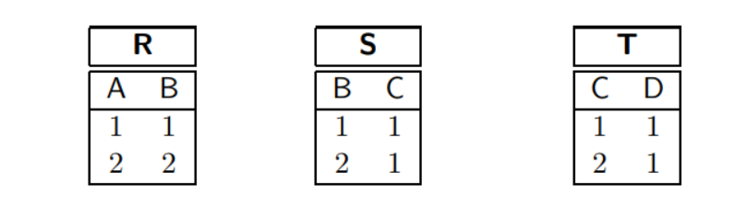

After executing the command:  
delete from T;  
what tuples will R contain?  
A. R will not be changed.  
B. (1, NULL) and (2, 2).  
**C. (1, NULL) and (2, NULL).**  
D. (2,2) only.  
E. R will contain no tuples

f. Under a relational database system, in the most general case, if table R has a foreign  
key (FK) constraint referencing table S, then, via the FK?  
A. each tuple in R is related to zero or more tuples in S.  
**B. each tuple in R is related to zero or one tuple in S.**  
C. each tuple in R is related to exactly one tuple in S.  
D. each tuple in R is related to one or more tuples in S.  
E. all tuples in R are related to the same one tuple in S.

g. In translating from an entity-relationship (E-R) diagram to a relational schema, one  
piece of E-R logic that cannot be captured by primary keys, uniques, and foreign keys is  
A. the weak entity.  
B. any ternary relationship.  
C. mandatory participation for one-time occurrence (that is, with the arrow).  
**D. mandatory participation for many-time occurrence (that is, without the arrow).**E. aggregation.

h. In an E-R diagram, if one sees a bold line with no arrow between an entity set and  
relationship set, this means  
**A. every entity in the entity set must participate in the relationship set.**  
B. every entity in the entity set must appear exactly once in the relationship set.  
C. a relationship in the relationship set need not involve an entity from the entity set.  
D. the entity set is weak.  
E. the entity set is an instance of the relationship set

i.A weak entity  
A. is an entity with no key.  
B. is an entity with no attributes besides its key.  
**C. inherits part of its key from the “parent” entities to which it is related.**  
D. is the same thing as ISA in E-R.  
E. is never mapped to a table in conversion to a relational schema.

j. Consider converting the following E-R diagram into a relational schema, and that we  
must have tables for both A and B.

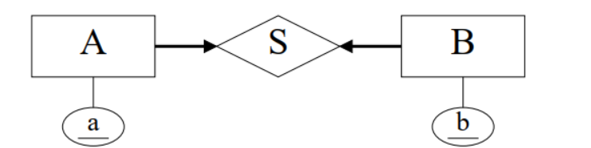

A. To model S, we just need one foreign key from A to B.  
B. To model S, we just need one foreign key from B to A.  
C. To model S, we need a foreign key from A to B and a foreign key from B to A  
**D. It requires that we make a table for S.**  
E. Its logic cannot be captured properly by a relational schema.

k. Ternary relationships  
A. can always be equivalently replaced by several binary relationships.  
B. cannot be used in aggregation.  
C. have keys like entities.  
D. are used to relate weak entities.  
**E. relate more than two entities**

l. Why are the normal forms useful?  
A. They are just a tool for checking whether our relational design makes sense or not.  
B. A schema in BCNF will always consist of fewer tables than an “equivalent” schema  
not in BCNF.  
C. They help us find anomalies in the data.  
**D. They guarantee that certain types of data anomalies cannot occur.**  
E. They are useless, but earn database consultants lots of money. (Don’t tell anyone!)

m. If we know that table Q has only one candidate key, then which of the following is true?  
A. Q is in 2NF, but is not in 3NF.  
B. Q is in 2NF, but we cannot tell about 3NF.  
C. Q cannot be in BCNF.  
**D. If Q is in 3NF, it is also in BCNF.**  
E. None of the above.

n. Consider table R with attributes A, B, C, D, and E. How many possible candidate keys  
are there for R?  
A. 1  
B. 5  
**C. 10**D. 31  
E. 365

3. E/R Modeling. Revolving Schema

The Allegheny Medical Consortium has hired Duey, Cheatem, & Howe, Inc.’s (DC&H’s)  
Information Systems Division to do a database design for them. They want to track medical  
interns through their rotations. DC&H has assigned Dr. Bas—and hence, you too—to the  
project.

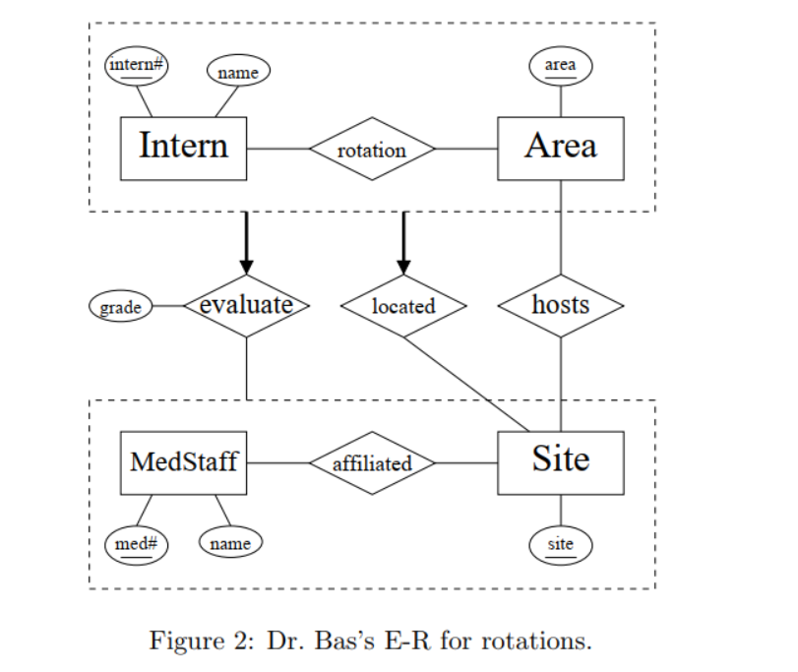

Dr. Bas designed the E-R diagram in Figure 2 based on Allegheny’s design requirements as  
below.  
Medical staff members evaluate the medical interns who train at their site. An intern’s stay  
at a site (for instance, a hospital, a medical research centre, or a clinic) is called a rotation.  
An intern is a medical student. Throughout the intern’s training, he or she has half a dozen  
rotations. Each rotation is in a particular area (for instance, pediatrics, psychiatry, and  
internal medicine). The intern will have a rotation in each area, but never two rotations in  
the same area. Certain sites are equipped to host certain rotation areas. Ideally, the database  
should ensure that any rotation in a given area assigned to a site is, in fact, in an area that  
site hosts. Medical staff are affiliated with sites. A medical staff member can be affiliated  
with a number of sites, and of course, a site will have many medical staff.  
For each intern’s rotation, there is one medical staff member who oversees the rotation. At the  
end of an intern’s rotation, this member of the medical staff evaluates the intern. Essentially,  
he or she gives a grade to the intern for the rotation.

1. (10 points) Write a relational schema for the rotation database based upon Dr. Bas’s  
   design in Figure 2 and the (English) specifications above.  
   • Use the abbreviated notation for schemas used in Figure 1 for Question 1 instead of  
   writing out SQL CREATE statements.  
   • Do not create more tables than necessary. Be certain to account for mandatory  
   participations.  
   • Ensure in your schema design that any MedStaff who evaluates an Intern for a  
   rotation is, in fact, affiliated with the Site at which the rotation is located.

1. Intern(intern#, name)  
2. Area(area)  
3. MedStaff(med#, name)  
4. Site(site)  
5. rotation(intern#, area, med#*, site*, grade)

FK (intern#) refs Intern

FK(area) refs Area

FK(med#,site) refs affiliated //evaluate 6

8. hosts(area, site)

FK (area) refs Area  
FK (site) refs Site

9.affiliated(med#, site)  
 FK (med#) refs MedStaff  
 FK (site) refs Site

* = not nullable

10. Setting med# and site# to NOT NULL in 5. for manditory participation,  
and having attribute grade in rotation  
Note the fourth FK in 5. for ”located” can be dropped because it is  
logically subsumed by the third FK

b.(3 points) A couple of days later, Allegheny Medical Consortium requests a change to  
the design: a panel of medical staff members—instead of just a single medical staff  
member—at the site evaluates an intern’s rotation, still assigning the intern collectively  
a single grade for the rotation.  
What changes do you make to your relational design for Question 3a for this?  
Just discuss / show your changes. Do not entirely redo the design! And do not discuss  
changes to the E-R diagram! These are changes to your relational schema

1. Add back FK in rotation  
FK (site) refs Site // located  
2. Drop FK in rotation representing ”evaluated”.  
3. Make a table evaluated  
evaluated(intern#, area, med#, site)  
FK (intern#, area, site) refs rotation (intern#, area, site)  
FK (med, site) refs affiliated  
(Can add unique(intern#, area, site) to rotation so the FK works.)  
4. Attach grade to rotation

b.(2 points) What addition to your relational design for Question 3a could you make to  
ensure that, for any rotation in a given area located at a site, that site indeed hosts that  
area?  
You are limited to relational design tools here: primary keys, unique, and foreign keys.  
(You may not use CHECK or ASSERTION constraints or other such techniques.)

Add to table rotation the FK  
FK (area, site) refs hosts

4. (10 points) Normal Forms. This just isn’t normal!   
Consider table R with attributes A, B, C, D, E, F, & G, and the set of functional dependencies

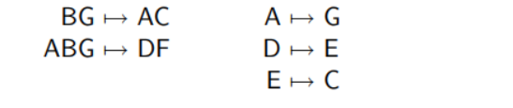

a. (3 points) Is AD a candidate key? Prove your answer

The attribute closure of AD is ACDEG, which does not include all attributes. Therefore AD is not a key.

b. (2 points) Is BDG a superkey? Prove your answer

The attribute closure of BG consists of all the attributes; hence, BG is key and BDG  
is superkey.

c. (2 points) Does ADC 7→ F logically follow from the set of functional dependencies? Prove  
your answer.

The attribute closure of ADC is ADCGE. This does not contain F. Therefore the  
answer is no.

d. (3 points) Determine whether R is in 2NF, 3NF, and BCNF

The candidate keys are BG and AB.  
Is in 2NF. No FD violates.  
Is not in 3NF. E.g., D 7→ E violates.  
So is not in BCNF either.

|  |  |
| --- | --- |
| 1NF: | Domain of each attribute is an elementary type; that is, not a set or a record structure. |
| 2NF: | Whenever X → A is a functional dependency that holds in relation R and A !∈ X , then either |
|  | A is prime, or |

|  |  |
| --- | --- |
|  | X is not a proper subset of any key for R. |
| 3NF: | Whenever X → A is a functional dependency that holds in relation R and A !∈ X , then either  • A is prime, or • X is a key or a super-key for R. |

|  |  |
| --- | --- |
| BCNF: | Whenever X 7→ A is a functional dependency that holds in relation R and A !∈ X , then  X is a key or a super-key for R. |

An attribute A is called prime if A is in any of the candidate keys