**DBI LAB 2**

FULL NAME: DƯƠNG HỒNG QUÂN

STUDENT ID: SE170057

Q1:

CREATE VIEW CustomerInfo AS

SELECT C.CustomerID, C.CompanyName, C.ContactName, C.ContactTitle, C.Address,

C.City,C.Country, C.Phone, O.OrderDate, O.RequiredDate, O.ShippedDate

FROM Customers C INNER JOIN Orders O

ON C.CustomerID = O.CustomerID;

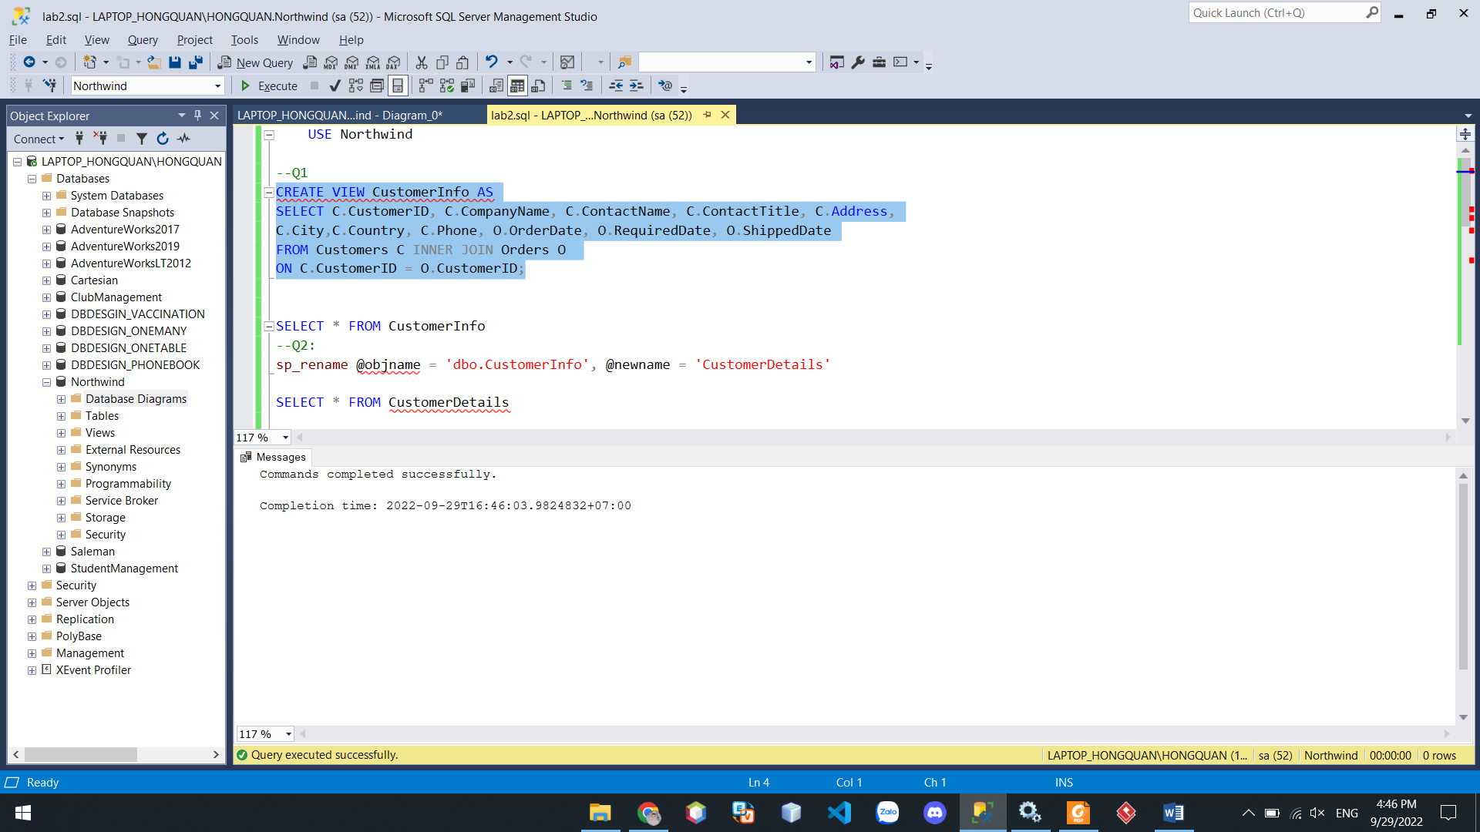

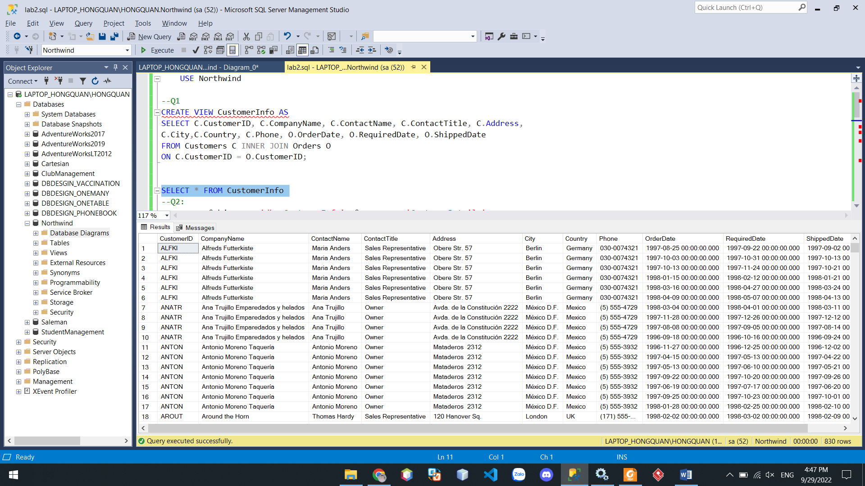

Q2:

sp_rename @objname = 'dbo.CustomerInfo', @newname = 'CustomerDetails'

SELECT * FROM CustomerDetails

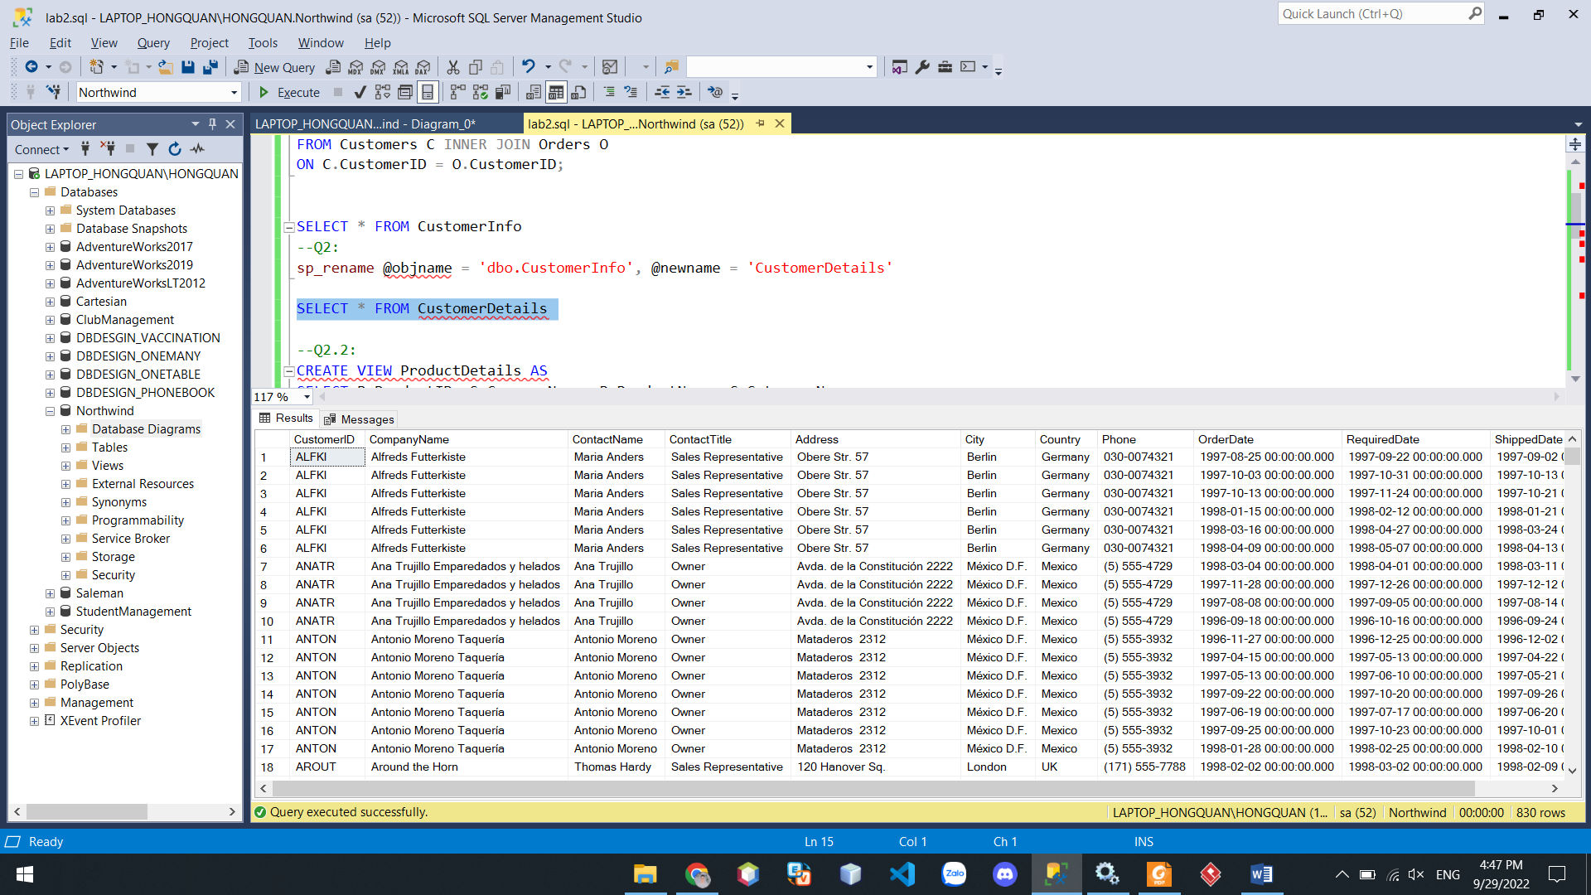

Q2.2:

CREATE VIEW ProductDetails AS

SELECT P.ProductID, S.CompanyName, P.ProductName, C.CategoryName,

C.Description, P.QuantityPerUnit, P.UnitPrice, P.UnitsInStock, P.UnitsOnOrder, P.ReorderLevel,P.Discontinued

FROM Products P INNER JOIN Suppliers S ON S.SupplierId = P.SupplierId

INNER JOIN Categories C ON C.CategoryID = P.CategoryID

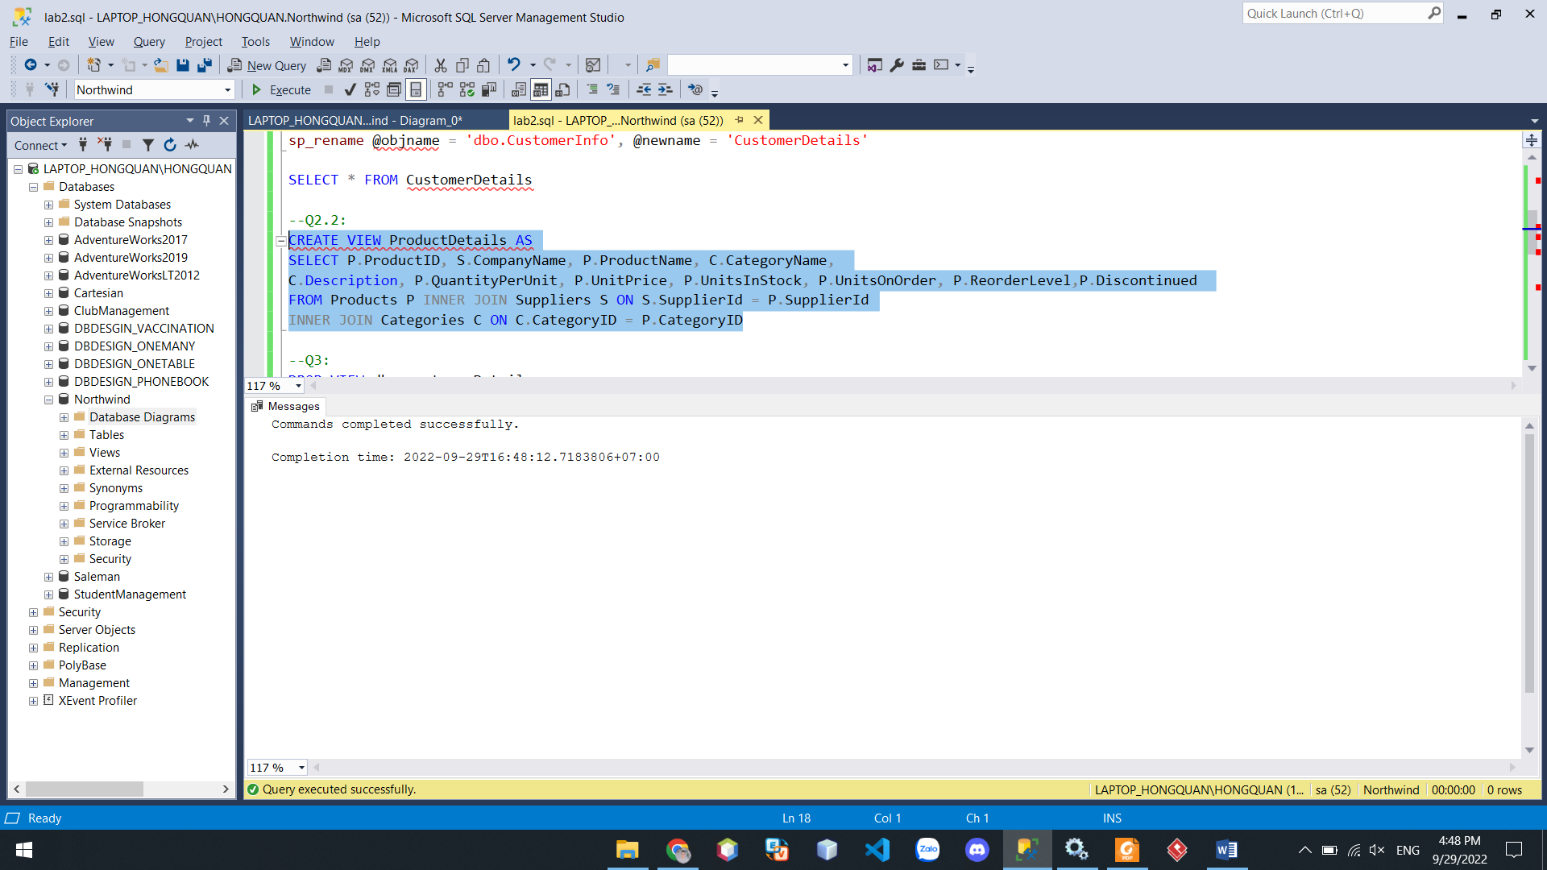

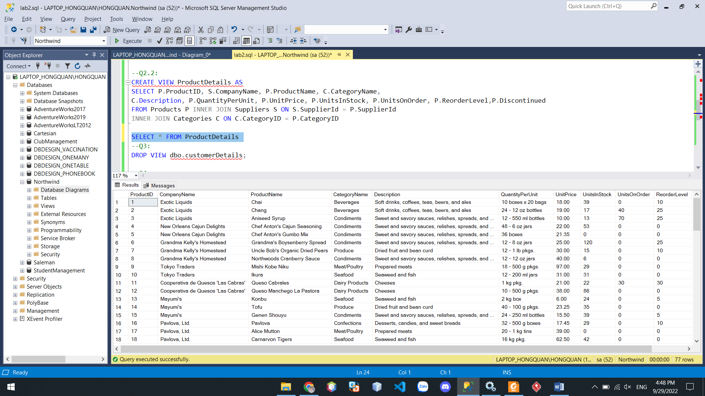

Q3:

DROP VIEW dbo.customerDetails;

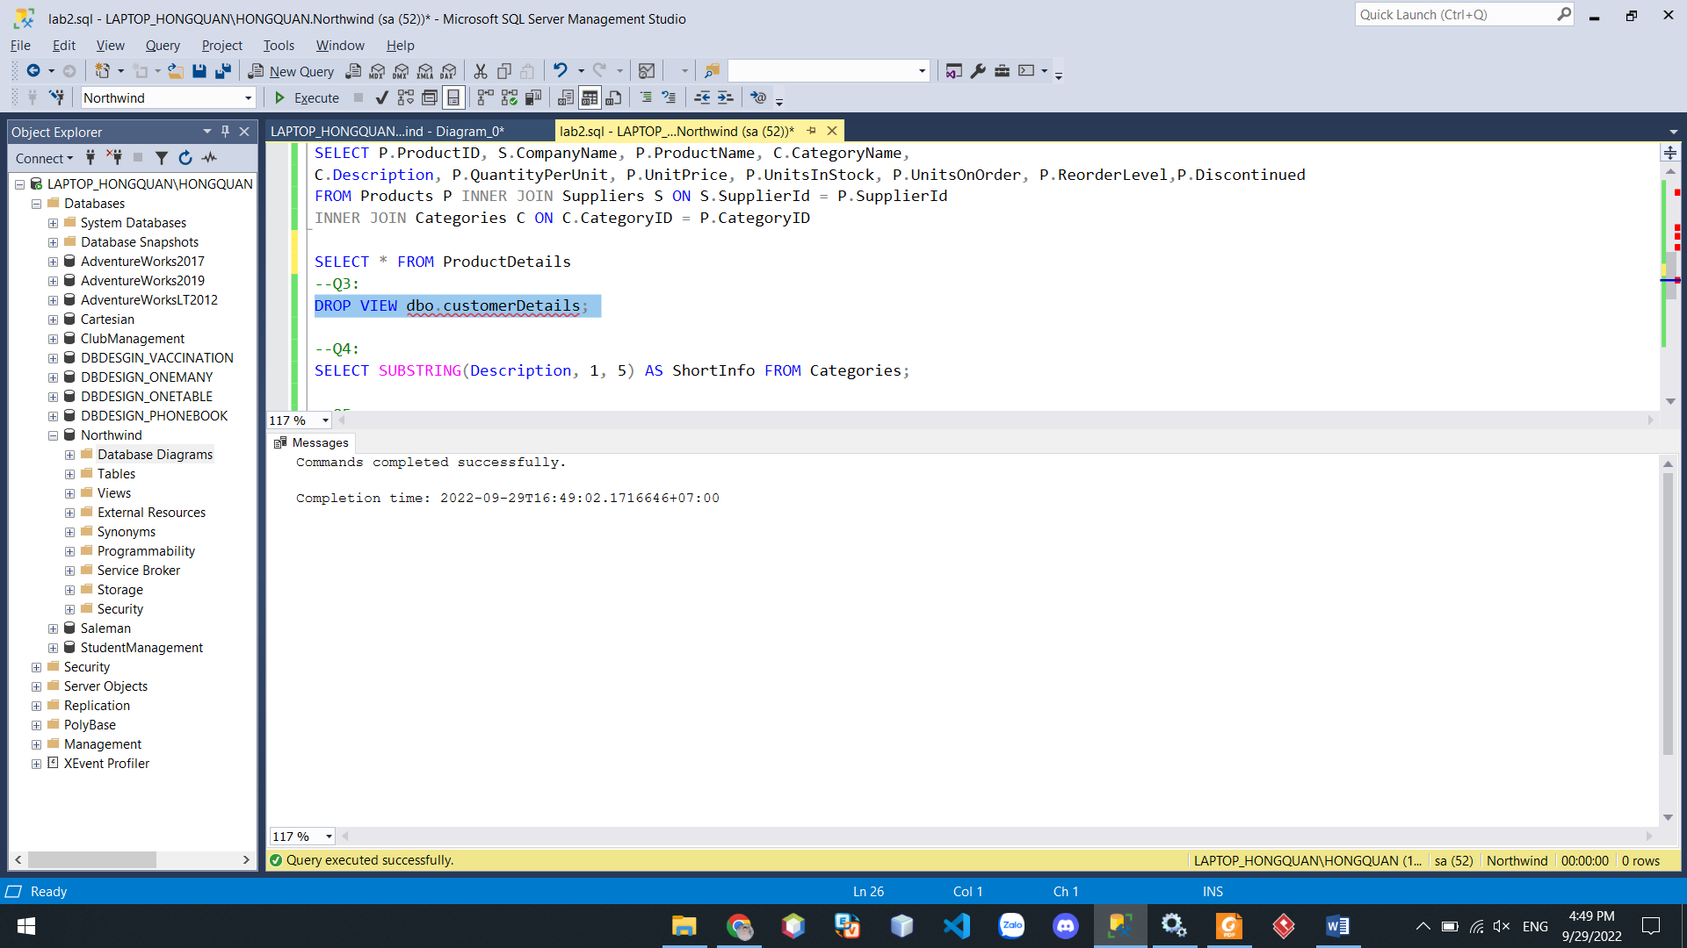

Q4:

SELECT SUBSTRING(Description, 1, 5) AS ShortInfo FROM Categories;

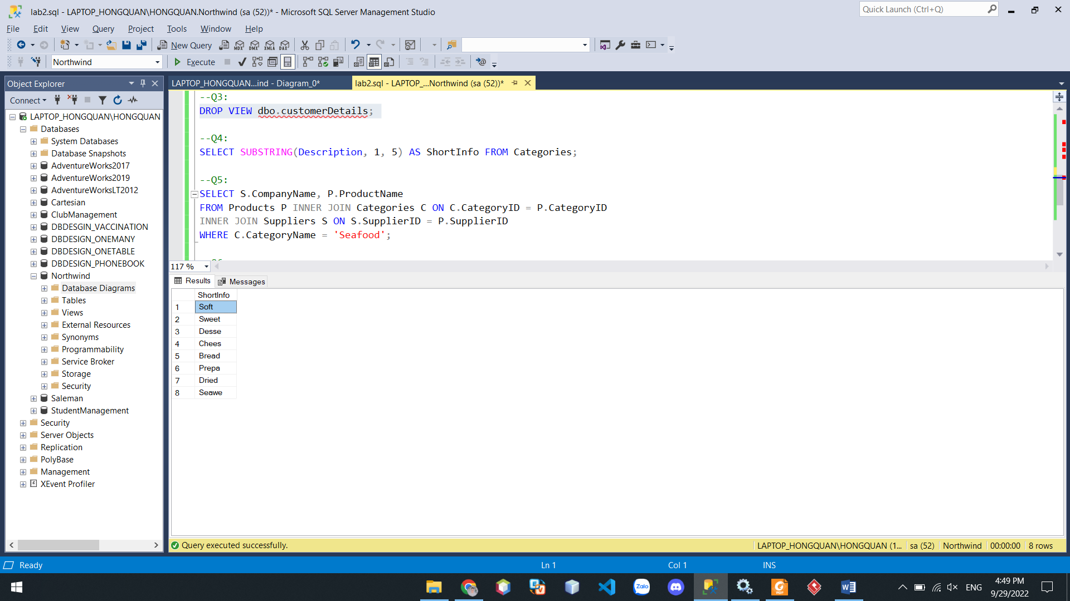

Q5:

SELECT S.CompanyName, P.ProductName

FROM Products P INNER JOIN Categories C ON C.CategoryID = P.CategoryID

INNER JOIN Suppliers S ON S.SupplierID = P.SupplierID

WHERE C.CategoryName = 'Seafood';

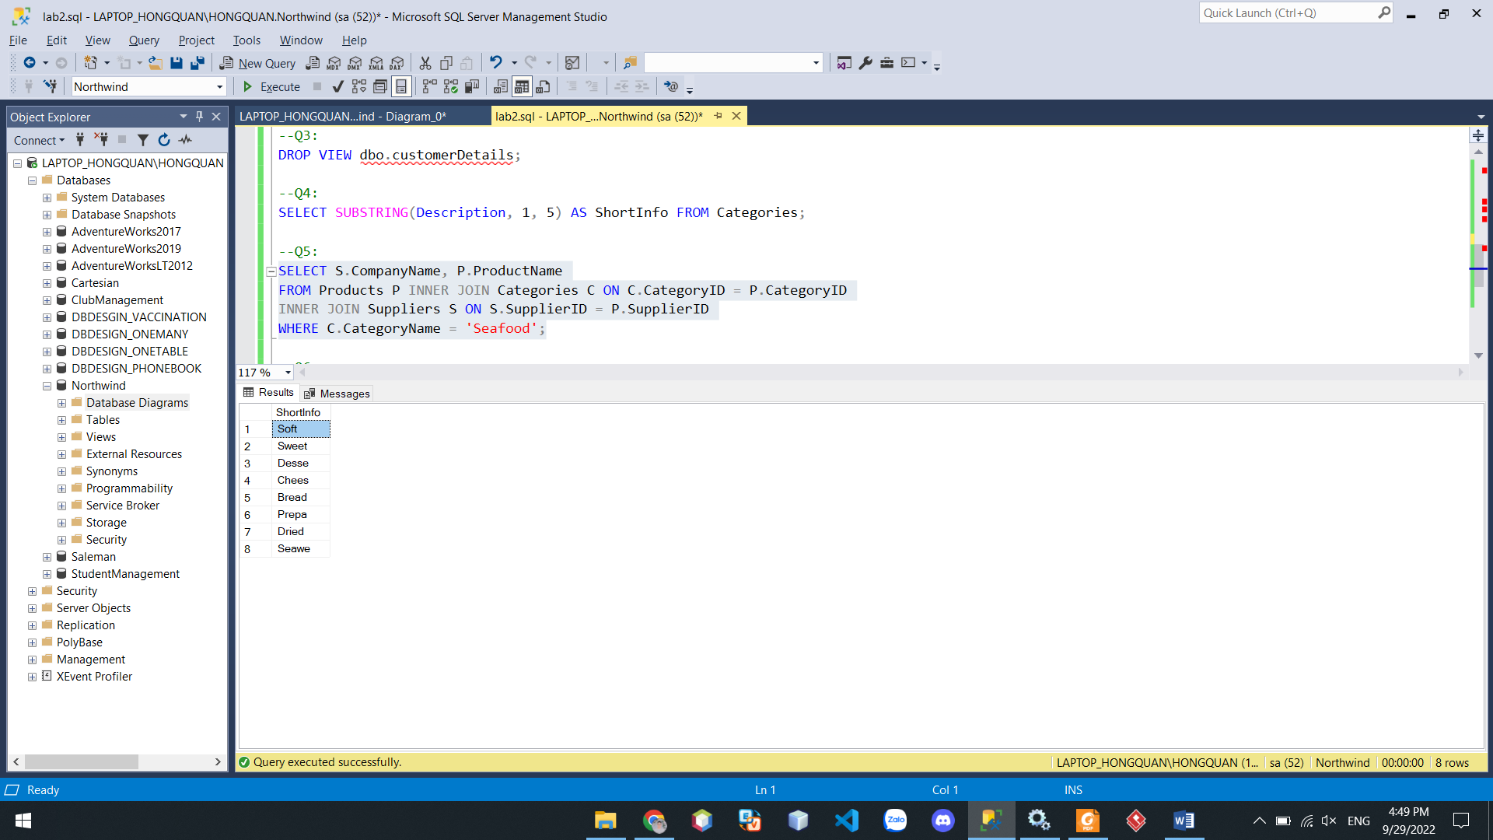

Q6:

SELECT c.CategoryID,p.ProductName,s.CompanyName

FROM Categories c FULL JOIN Products p ON c.CategoryID = p.CategoryID

FULL JOIN Suppliers s ON p.SupplierID = s.SupplierID WHERE p.CategoryID = '5'

