**DBI LAB 3**

FULL NAME: DƯƠNG HỒNG QUÂN

STUDENT ID: SE170057

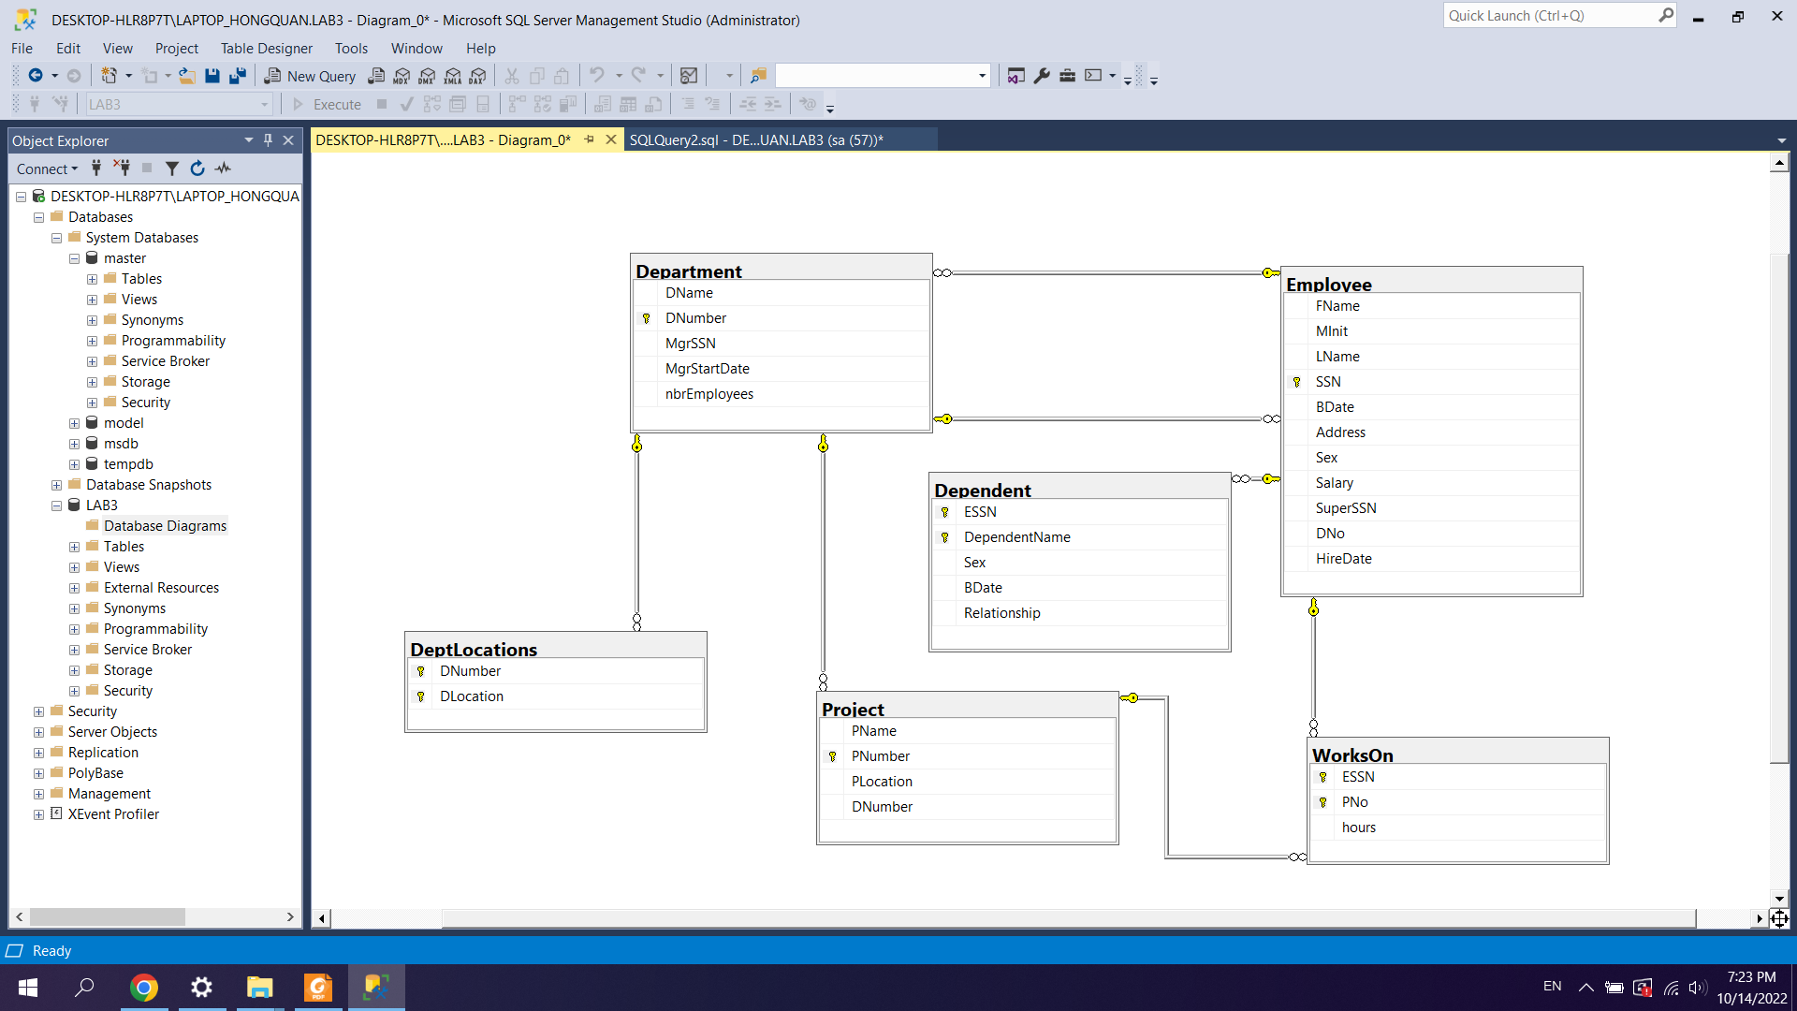

CÂU 1:

create trigger age18

on Employee

after insert, update

as

if exists (

select *

from Inserted

where dateadd(year,18,BDate) > getdate() )

begin

raiserror('Constraint Violation: The age of an employee

must be greater than 18', 1, 1)

rollback

end

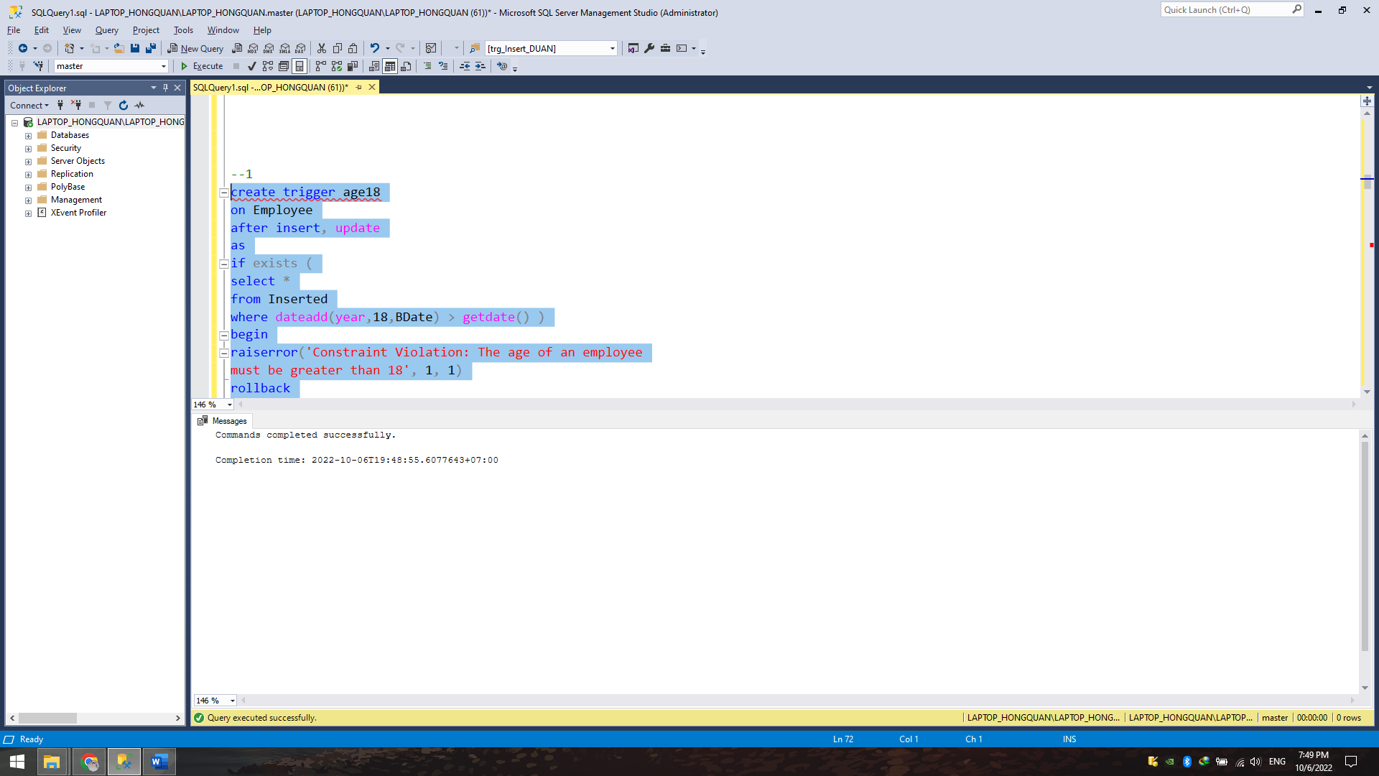

Câu 2:

create trigger supervisorAge

on Employee

after insert, update

as

if exists (

select *

from Inserted I,

Employee E

where ( I.SuperSSN = E.SSN and I.BDate < E.BDate )

or ( E.SuperSSN = I.SSN and E.BDate < I.BDate ) )

begin

raiserror( 'Constraint Violation:

The age of an employee must be less than

the age of his/her supervisor', 1, 1)

rollback

end

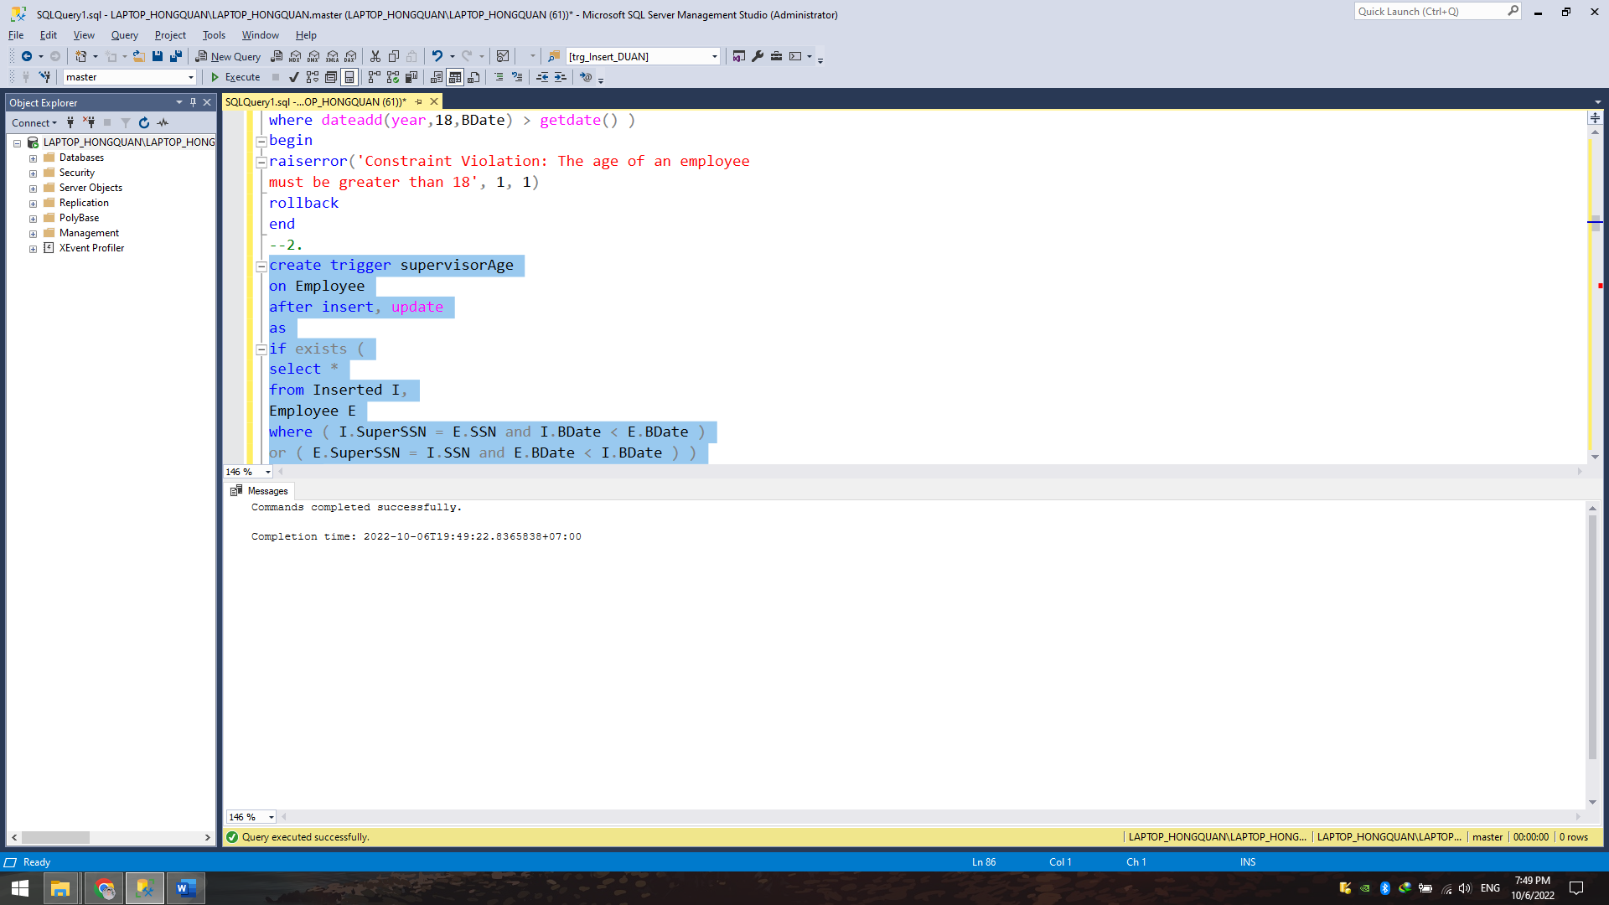

Câu 3:

create trigger supervisorSalary

on Employee

after insert, update

as

if exists (

select *

from Inserted I,

Employee E

where ( I.SuperSSN = E.SSN and I.Salary > E.Salary )

or ( E.SuperSSN = I.SSN and E.Salary > I.Salary ) )

begin

raiserror('Constraint Violation:

The salary of an employee cannot be greater than

the salary of his/her supervisor', 1, 1)

rollback

end

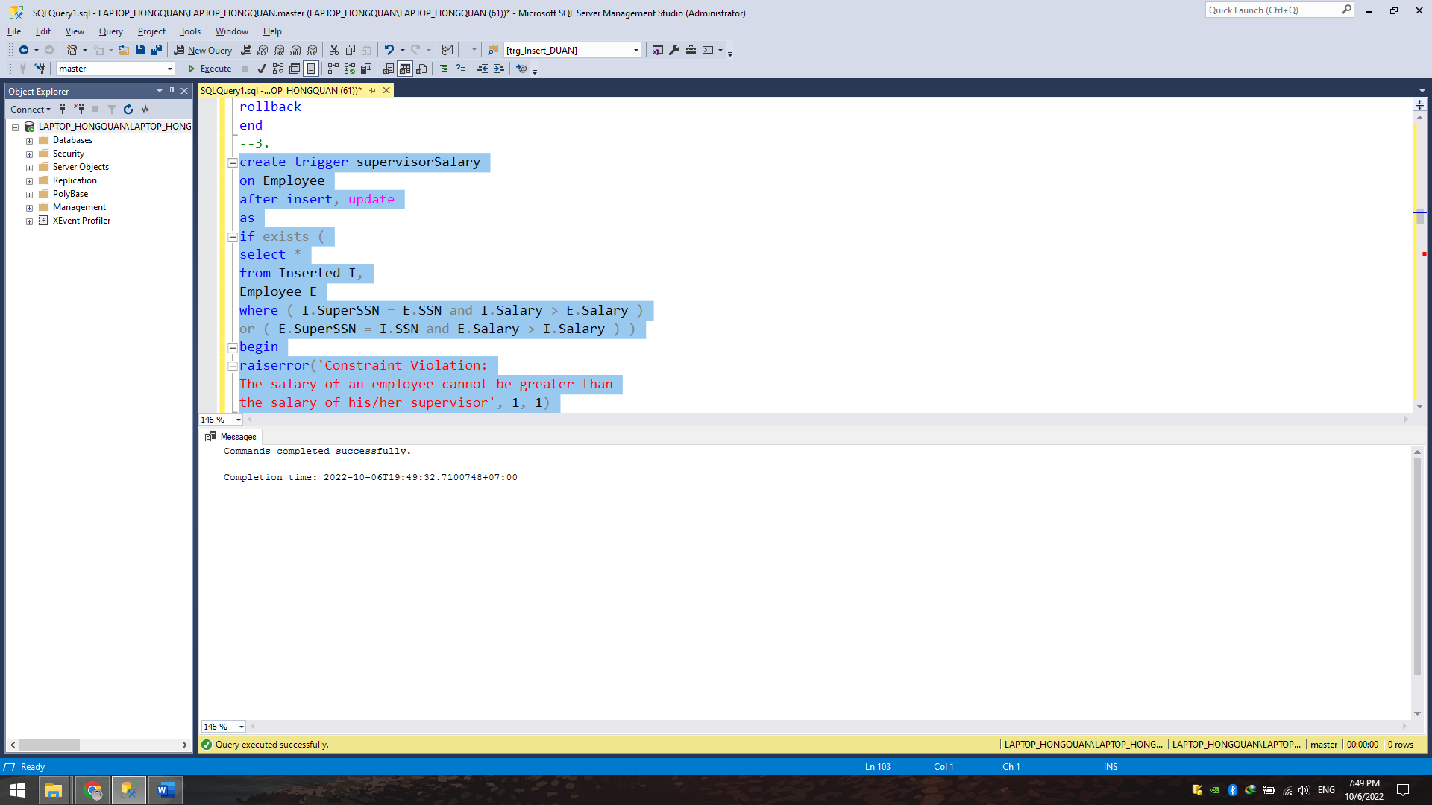

Câu 4:

alter table Employee

add constraint UN_Employee_SSN_DNo

unique( SSN, DNO )

alter table Department

add constraint FK_Employee_SSN_DNo

foreign key( MgrSSN, DNumber )

references Employee( SSN, DNo )

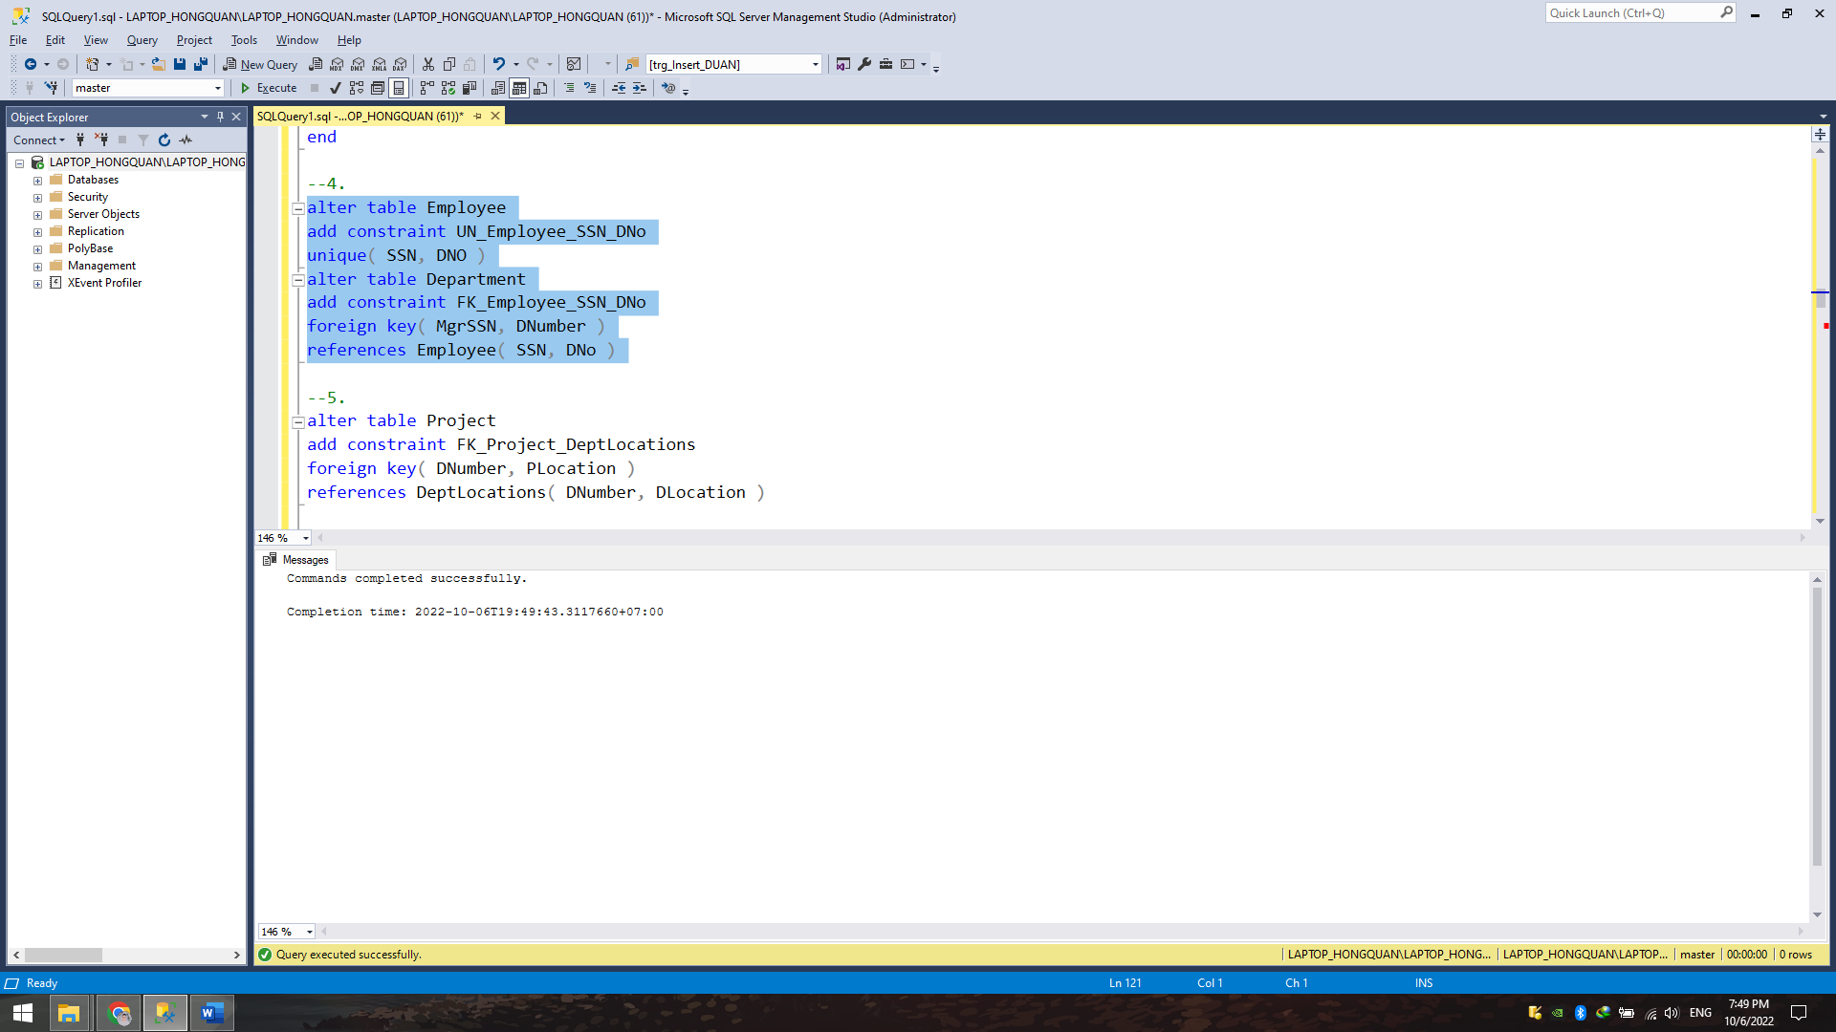

Câu 5:

alter table Project

add constraint FK_Project_DeptLocations

foreign key( DNumber, PLocation )

references DeptLocations( DNumber, DLocation )



Câu 6:

alter table Employee

add constraint HireDate_BDate

check( HireDate > BDate )

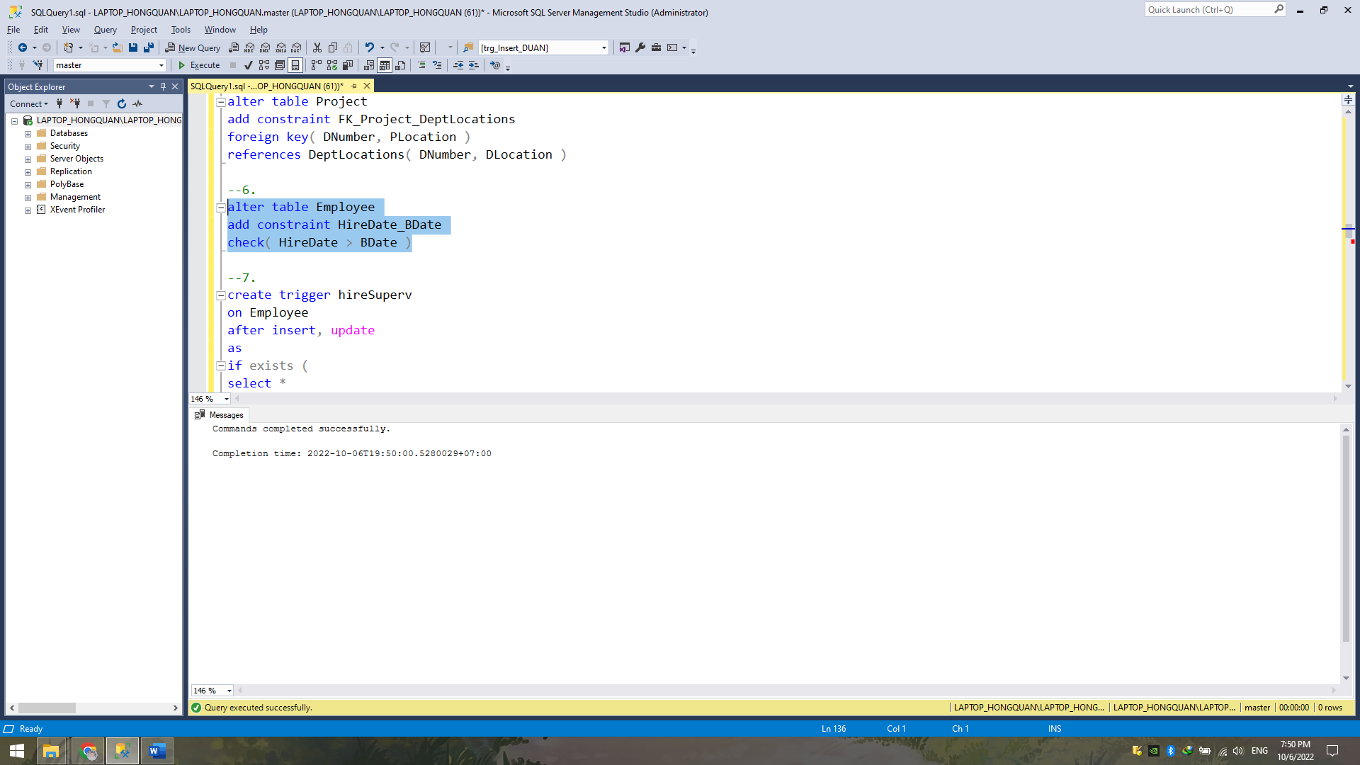

Câu 7:

create trigger hireSuperv

on Employee

after insert, update

as

if exists (

select *

from Inserted I,

Employee E

where ( I.SuperSSN = E.SSN and datediff(year, E.HireDate, I.HireDate) < 1

)

or ( E.SuperSSN = I.SSN and datediff(year, I.HireDate, E.HireDate) < 1

) )

begin

raiserror('Constraint Violation:

A supervisor must be hired at least 1 year before

every employee s/he supervises', 1, 1)

rollback

end

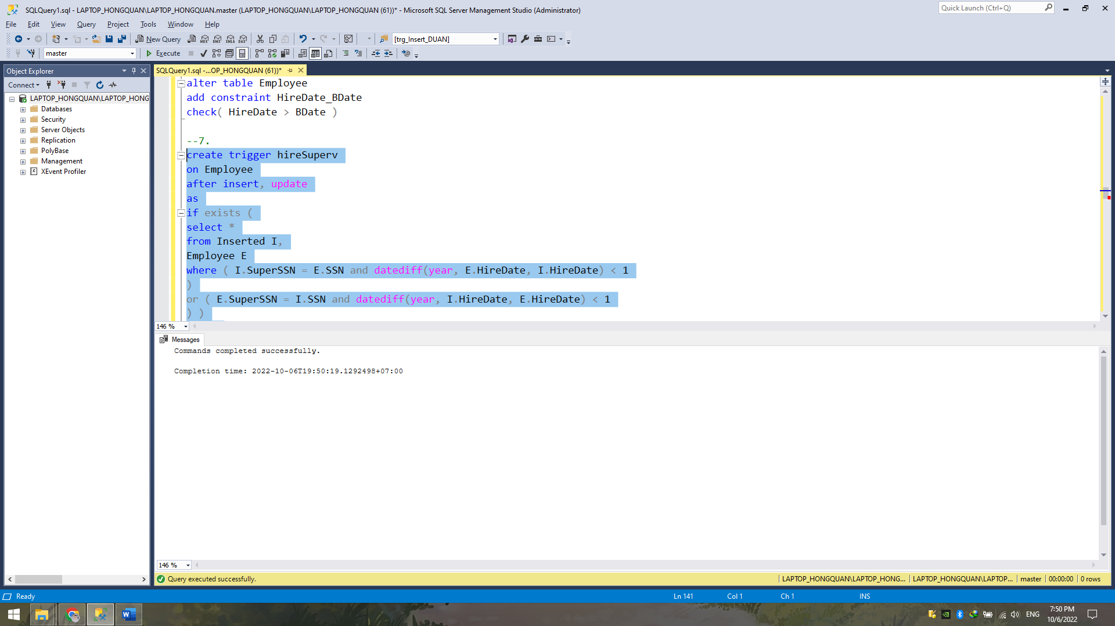

Câu 8:

create trigger derived_Department_NbrEmployees_Employee

on Employee

after insert, update, delete

as

begin

update Department

set NbrEmployees = NbrEmployees +

( select count(*) from Inserted I where DNumber=I.DNo ) -

( select count(*) from Deleted D where DNumber=D.DNo )

where DNumber in ( select DNo from Inserted )

or DNumber in ( select DNo from Deleted )

end

create trigger derived_Department_NbrEmployees_Department

on Department

after insert, update

as

if exists ( select *

from Inserted

where NbrEmployees <> ( select count(*)

from Employee E

where E.DNo = DNumber ) )

begin

raiserror('Constraint Violation:

The attribute Department.NbrEmployees is a derived

attribute from Employee.DNo', 1, 1)

rollback

end

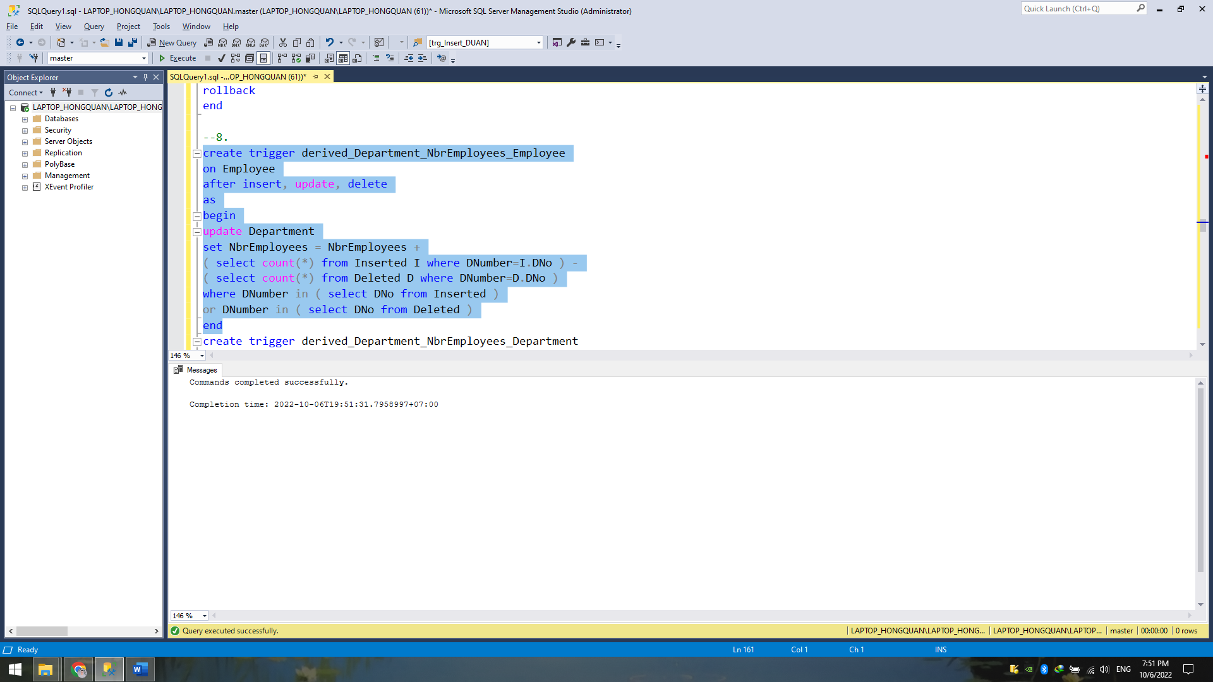

Câu 9:

create trigger empNbrProj

on WorksOn

after insert, update

as

if exists (

select *

from WorksOn W

group by W.ESSN

having count(*) > 4 )

begin

raiserror('Constraint Violation: An employee works at

most in 4 projects', 1, 1)

rollback

end

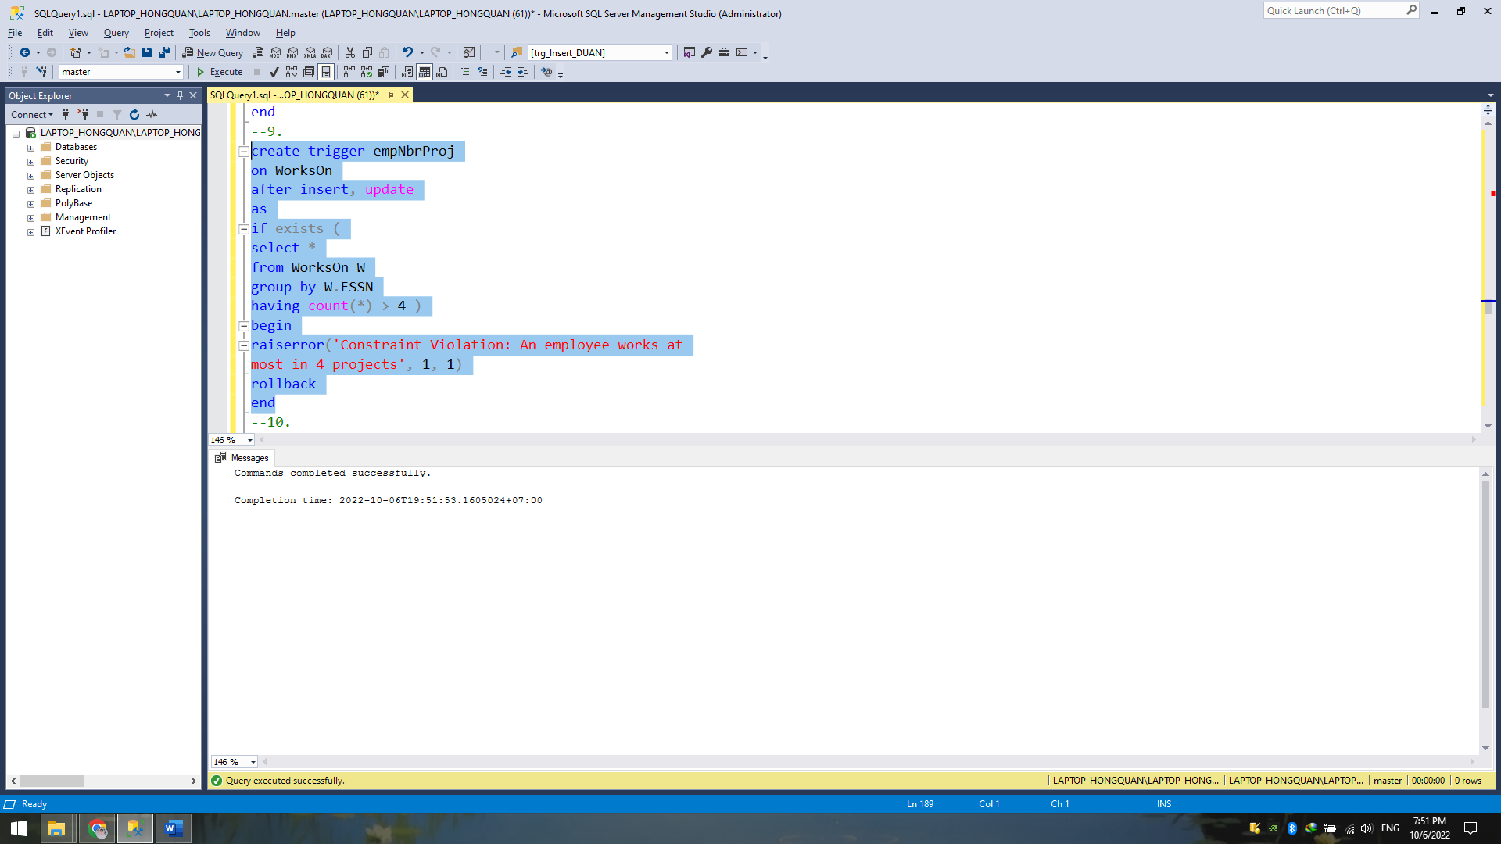

Câu 10:

create trigger workson_30_50

on WorksOn

after insert, update, delete

as

if exists ( select *

from WorksOn

group by ESSN

having ( sum(Hours) < 30 )

or ( sum(Hours) > 50 ) )

begin

raiserror('Constraint Violation: An employee works at

least 30 h/week and at most 50 h/week on all its projects', 1, 1)

rollback

end

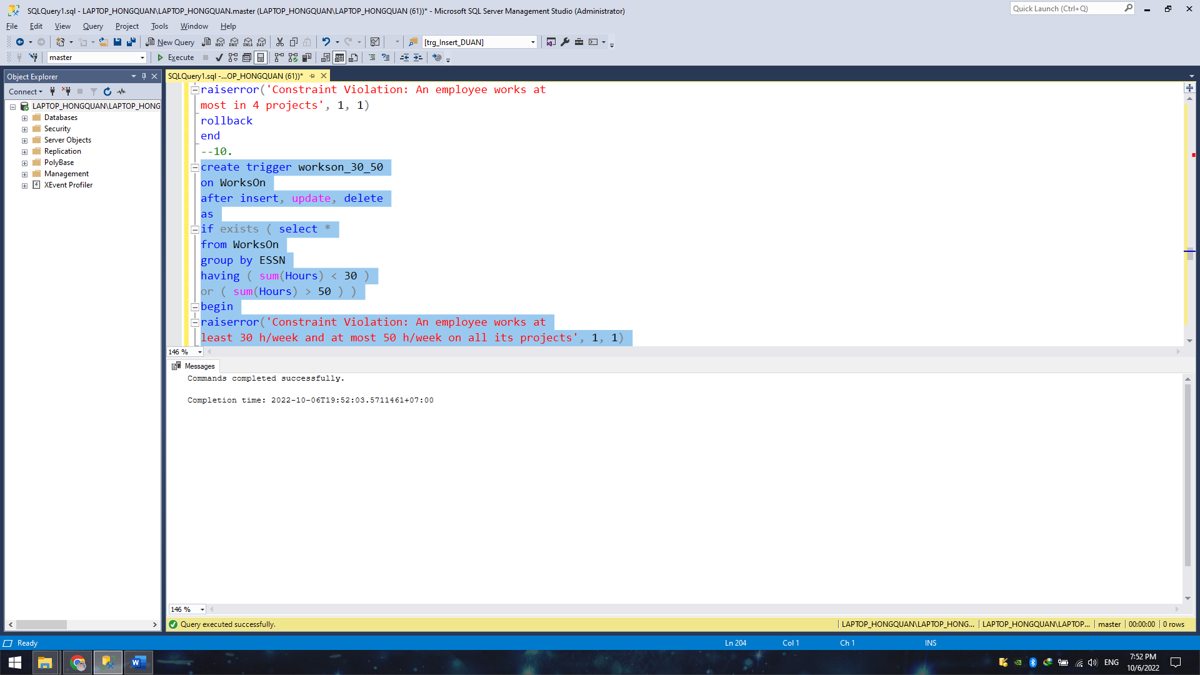

Câu 11:

create trigger worksonLess10h

on WorksOn

after insert, update

as

if exists ( select *

from WorksOn

where Hours < 10

group by PNo

having count(*) > 2 )

begin

raiserror('Constraint Violation: A project can have at

most 2 employees working on the project less than 10 hours', 1, 1)

rollback end

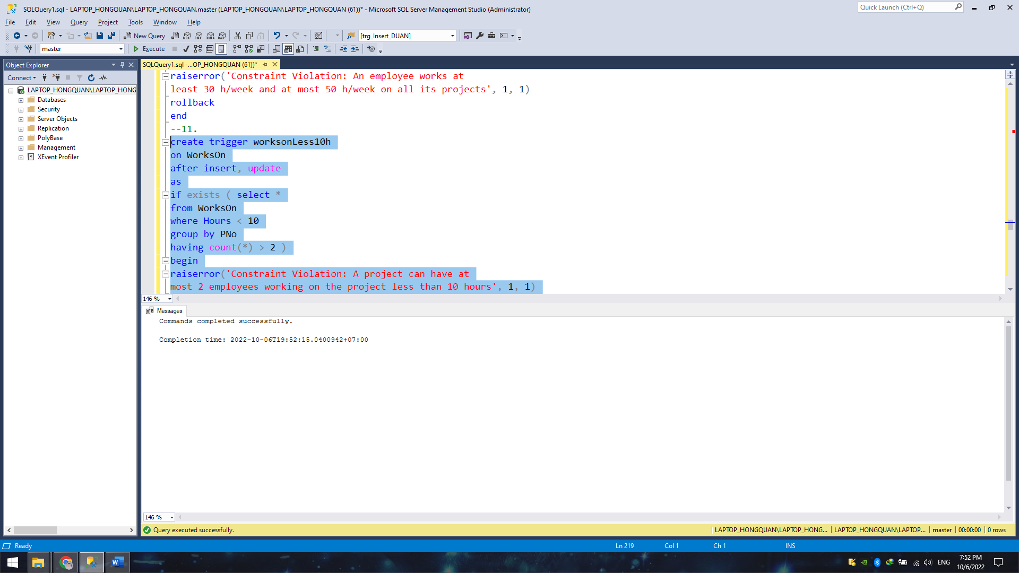

Câu 12:

create trigger worksonLess5h_WorksOn

on WorksOn

after insert, update

as

if exists ( select *

from Inserted

where Hours < 5

and ESSN not in (

select MgrSSN

from Department

where MgrSSN is not null ) )

begin

raiserror('Constraint Violation: Only department managers

can work less than 5 hours on a project', 1, 1)

rollback

end

create trigger worksonLess5h_Department

on Department

after update, delete

as

if exists ( select *

from Deleted

where MgrSSN not in (

select MgrSSN

from Department )

and MgrSSN in (

select ESSN

from WorksOn

where Hours < 5 ) )

begin

raiserror('Constraint Violation: Only department managers

can work less than 5 hours on a project', 1, 1)

rollback

end

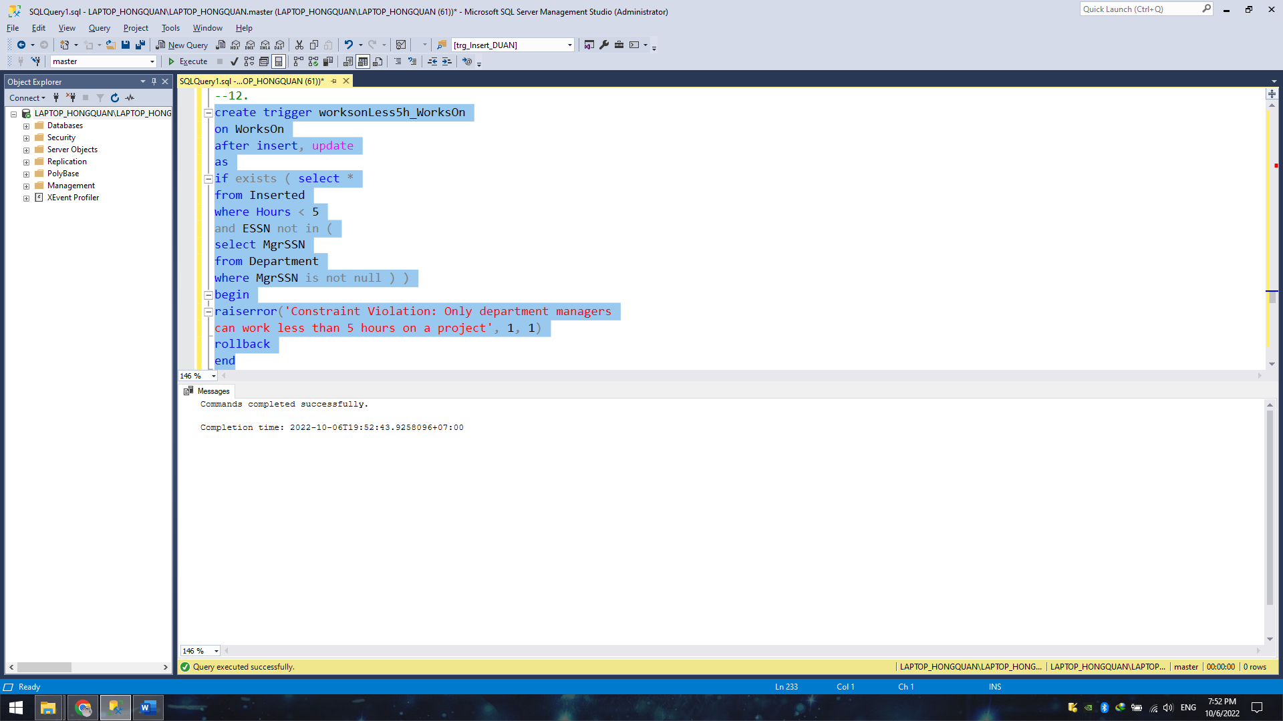

Câu 13:

create trigger workson10h_WorksOn

on WorksOn

after insert, update

as

if exists ( select *

from Inserted

where Hours < 10

and ESSN not in (

select SuperSSN

from Employee

where SuperSSN is not null ) )

begin

raiserror('Constraint Violation: Employees that are not supervisors

must work at least 10 hours on every project they work', 1, 1)

rollback

end

create trigger workson10h_Employee

on Employee

after update, delete

as

if exists ( select *

from Deleted

where SuperSSN not in (

select SuperSSN

from Employee

where SuperSSN is not null )

and SuperSSN in (

select ESSN

from WorksOn

where Hours < 10 ) )

begin

raiserror('Constraint Violation: Employees that are not supervisors

must work at least 10 hours on every project they work', 1, 1)

rollback

end

