**Introduction**

The city's school district is dedicated to promoting a high-quality education that prepares all students for future success. As the newly appointed Chief Data Scientist for the district, I've been entrusted with the task of analyzing district-wide standardized test results. The primary source of data for this task is a comprehensive dataset that provides a range of information on students' math and reading scores, along with details about the schools they attend.

To compile a detailed snapshot of the district's key performance metrics. This will offer a broad overview of our district’s academic performance, including insights on school budget allocations, student enrollment, and performance in reading and math. To analyze the data on a school-by-school basis. This granular analysis will help us understand trends and variations among different schools, thus guiding us to identify areas of success and opportunities for improvement. Through this analysis, we aim to provide the school board and mayor with accurate and actionable insights that can inform strategic decisions regarding future school budgets and priorities. It is our hope that these data-driven insights will enable us to enhance our students' learning experience and overall academic success.

**District Summary**



**School Summary**

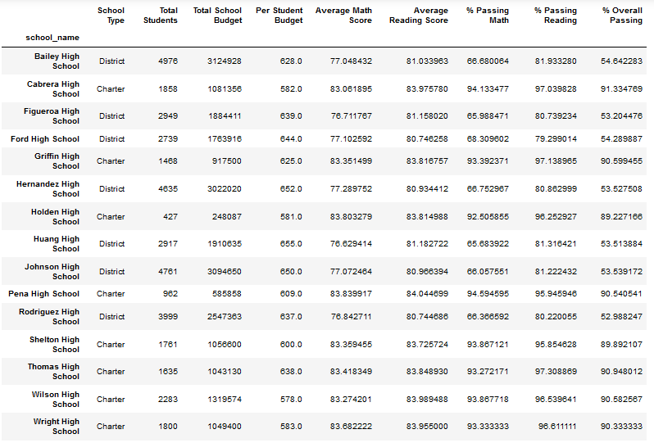

**Performance Analysis**

Highest-Performing Schools (by % Overall Passing)

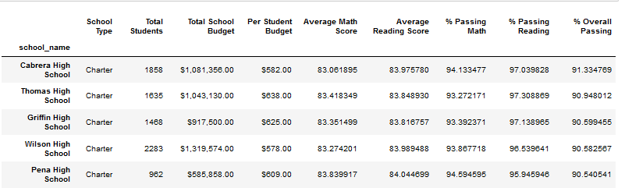

Lowest-Performing Schools (by % Overall Passing)

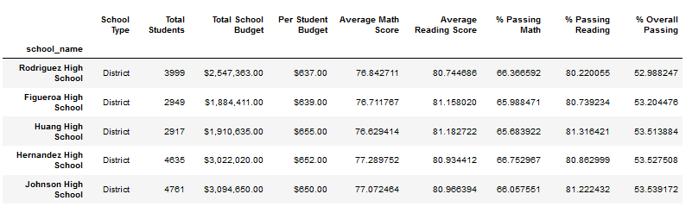

**Scores by Grade**

Math Scores by Grade

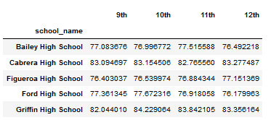

Reading Scores by Grade

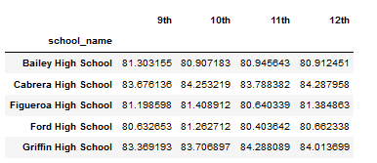

**Scores by School Spending**

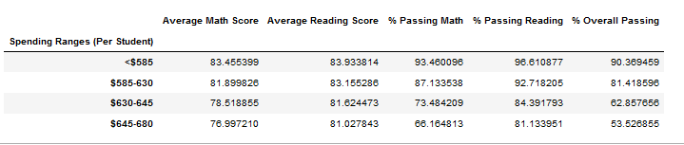

**Scores by School Size**

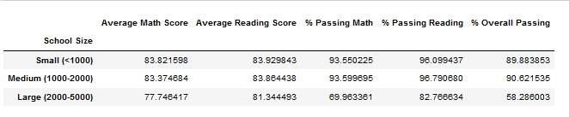

**Scores by School Type**

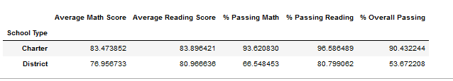

**Discussion**

Based on the analysis of the school data, two observable trends can be highlighted:

**School Type Impact:** Charter schools outperform district schools in terms of academic performance. The average math and reading scores, as well as the percentage of students passing math, reading, and overall, are consistently higher for charter schools compared to district schools. This suggests that the charter school system is more effective in providing quality education and supporting student success.

**Budget Influence:** There is a noticeable relationship between per student budget and academic performance. Generally, schools with lower per student budgets tend to have higher average math and reading scores, as well as a higher percentage of students passing math, reading, and overall. On the other hand, schools with higher per student budgets show lower academic performance. This finding challenges the notion that higher funding automatically leads to better academic outcomes and suggests that other factors, such as effective resource allocation and instructional strategies, play a significant role in student success.

**Conclusion**

The analysis of the school data provides valuable insights for the school board and the mayor. It is evident that charter schools demonstrate better academic performance compared to district schools. This highlights the importance of studying and implementing successful practices from charter schools within the district schools to enhance overall student achievement. The relationship between per student budget and academic performance raises questions about the effectiveness of resource allocation. It is recommended that the school board assesses how funds are allocated and explore strategies to optimize resource utilization to improve student outcomes. It is crucial to identify and address any underlying factors contributing to the lower academic performance of certain schools. This could involve targeted interventions, professional development for teachers, and a focus on creating a positive and supportive learning environment. Overall, by leveraging the findings from this analysis, the school board and the mayor can make informed decisions to enhance the quality of education and support the success of students in the district.