Chapter 1. Improve the Accuracy and Speed Starategy 2
1. Model Size vs. Performance Trade-off 2
2. Improving Accuracy 2
3. Use Pre-trained Models (Transfer Learning) 3
4. Augment the Data 3
5. Improving Speed 5

Chapter 1. Improve the Accuracy and Speed Starategy

Model Size vs. Performance Trade-off
YOLOv8 offers several model sizes, each optimized for different trade-offs between speed and accuracy:
- YOLOv8n (Nano): Smallest and fastest but less accurate. Good for real-time applications with limited resources.
- YOLOv8s (Small): A balance between speed and accuracy.
- YOLOv8m (Medium): More accurate but slower.
- YOLOv8l (Large): Very accurate but resource-intensive and slower.
- YOLOv8x (Extra Large): Best accuracy but highest resource consumption.
If you're aiming for both speed and accuracy, consider starting with YOLOv8s or YOLOv8m.

Improving Accuracy

2.1. Dataset Quality and Quantity
- Diverse and Representative Data: Collect images in various conditions (lighting, angles, distances, backgrounds).
- Increase Data: More data generally leads to better performance. If collecting more data isn't feasible, focus on data augmentation techniques to create diversity.
- Balanced Classes: Ensure that each disease class is well-represented in the dataset.

2.2. Hyperparameter Tuning
- Learning Rate: A smaller learning rate helps fine-tune weights better.
- Batch Size: Larger batch sizes can improve the generalization of your model, but ensure it fits in memory.
- Epochs: Training for more epochs might help the model learn better features, but watch for overfitting (when validation accuracy stops improving).
Modify these settings in the training command:
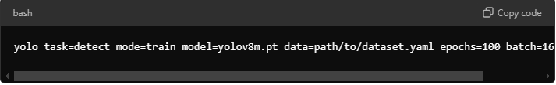
yolo task=detect mode=train model=yolov8m.pt data=path/to/dataset.yaml epochs=100 batch=16 lr0=0.01

Use Pre-trained Models (Transfer Learning)
YOLOv8 models are pre-trained on the COCO dataset. Fine-tuning these models with your rice leaf data can improve accuracy faster than training from scratch.
When you start training with a pre-trained model (yolov8m.pt or yolov8s.pt), the model already has good feature extraction capabilities, which can be adapted to your task:
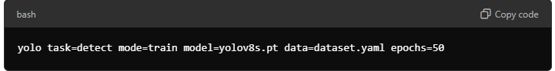

Steps for Transfer Learning with Fine-tuning
- Choose a Pre-trained Model: Select a model that has been trained on a dataset similar to your task. For example, YOLOv8 for object detection tasks.
- Load the Pre-trained Model:
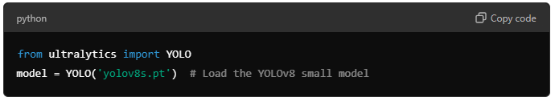
- Freeze Initial Layers:
You can freeze the first few layers of the model:
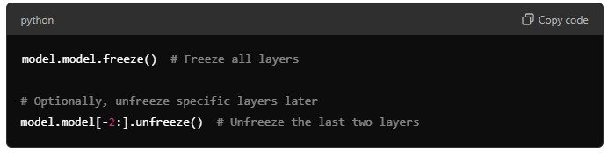
- Train on Your Custom Dataset:
Train the model using your dataset configuration, starting with frozen layers:
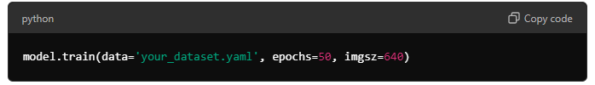
- Evaluate Performance:
Monitor performance metrics to determine how well the model is learning and adjusting.
- Unfreeze Additional Layers:
After observing initial training results, you can unfreeze more layers to allow the model to learn more complex features:
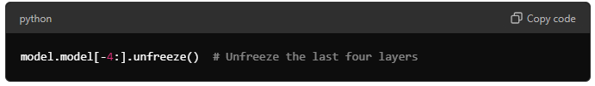
- Continue Training:
Resume training, allowing the model to adapt further to your specific dataset.
- Final Evaluation:
After the entire process, evaluate the model's performance on your validation/test set.
yolo detect train data=my_dataset.yaml model=yolov8s.pt epochs=100 imgsz=640 freeze=[1-15] lr0=0.001

Augment the Data
import cv2
import albumentations as A
import os
from glob import glob
from matplotlib import pyplot as plt

# Function to visualize the augmented image (optional)
def visualize(image, title=""):
plt.figure(figsize=(5, 5))
plt.axis('off')
plt.title(title)
plt.imshow(cv2.cvtColor(image, cv2.COLOR_BGR2RGB))
plt.show()

# Augmentation pipeline
def get_augmentations():
return A.Compose([
A.HorizontalFlip(p=0.5),
A.VerticalFlip(p=0.5),
A.RandomRotate90(p=0.5),
A.Rotate(limit=40, p=0.5),
A.Transpose(p=0.5),
A.OneOf([
A.HueSaturationValue(hue_shift_limit=20, sat_shift_limit=50, val_shift_limit=50, p=0.7),
A.RandomBrightnessContrast(brightness_limit=0.3, contrast_limit=0.3, p=0.7),
], p=0.9),
A.OneOf([
A.GaussianBlur(blur_limit=3, p=0.5),
A.GaussNoise(var_limit=(10.0, 50.0), p=0.5),
], p=0.5),
A.CLAHE(clip_limit=2, p=0.2),
A.RandomResizedCrop(height=416, width=416, scale=(0.8, 1.0), ratio=(0.9, 1.1), p=1),
A.ShiftScaleRotate(shift_limit=0.1, scale_limit=0.2, rotate_limit=20, p=0.5, border_mode=cv2.BORDER_REFLECT)
])

# Function to augment images and save them
def augment_and_save_image(image_path, output_folder):
image = cv2.imread(image_path)
file_name = os.path.basename(image_path)

# Apply augmentations
augmentations = get_augmentations()
augmented = augmentations(image=image)
augmented_image = augmented['image']

# Save the augmented image
output_image_path = os.path.join(output_folder, f"aug_{file_name}")
cv2.imwrite(output_image_path, augmented_image)

visualize(augmented_image, title=f"Augmented: {file_name}") # Optionally visualize

# Function to augment all images in the input folder
def augment_images_from_folder(input_folder, output_folder):
os.makedirs(output_folder, exist_ok=True) # Ensure output folder exists
image_paths = glob(os.path.join(input_folder, "*.jpg")) # Adjust if your images are in a different format (e.g., PNG)

print(f"Found {len(image_paths)} images to augment.")

for image_path in image_paths:
augment_and_save_image(image_path, output_folder)
print(f"Augmented and saved {os.path.basename(image_path)}")

# Main function
if __name__ == "__main__":
# Input folder containing images captured from the camera
input_folder = './captured_images/' # Update with your actual folder path
output_folder = './augmented_images/' # Folder where augmented images will be saved

# Augment and save images
augment_images_from_folder(input_folder, output_folder)

Improving Speed

5.1. Use Smaller Models
If inference speed is critical, consider using smaller models like yolov8n.pt or yolov8s.pt. While these may sacrifice a bit of accuracy, they run faster on lower-end hardware, especially mobile devices.

5.2. Image Size Reduction
YOLOv8 allows you to resize images during training and inference. Using smaller image sizes like 416x416 instead of 640x640 can improve speed with a minor loss in accuracy:
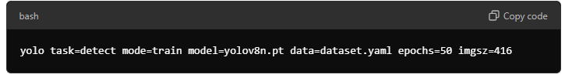

5.3. Inference Optimizations
After training, you can export the model to different formats optimized for speed:
- TensorRT: Best for GPU inference.
- ONNX: Supports a range of platforms (can be optimized for CPU/GPU).
- CoreML: For iOS devices.
- TFLite: For mobile devices.
Convert the model using:
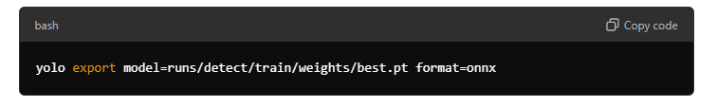

Error
- cv2.imshow(“Window”, frame)

GTK installation errors on this function
This is caused by the opencv-python GUI support problem

Step1. Check the module installtion status

Pip show opencv-python
Pip show opencv-python-headless

Step2. Uninstall the cv module

Pip install opencv-python-headless
Pip install opencv-python

Step3. Install again

Pip install opencv-python

