Computer Games Development CW208

Technical Design Document

Year IV

|  |
| --- |

[Ben Stynes]

[C00239718]

[30/08/22]

Contents

Table of Contents

Technical Design **2**

UML Diagrams **3**

Basic Overview Diagram 3

Basic GameLoop Diagram 4

Godot **4**

References **5**

# Technical Design

# UML Diagrams

## Basic Overview Diagram

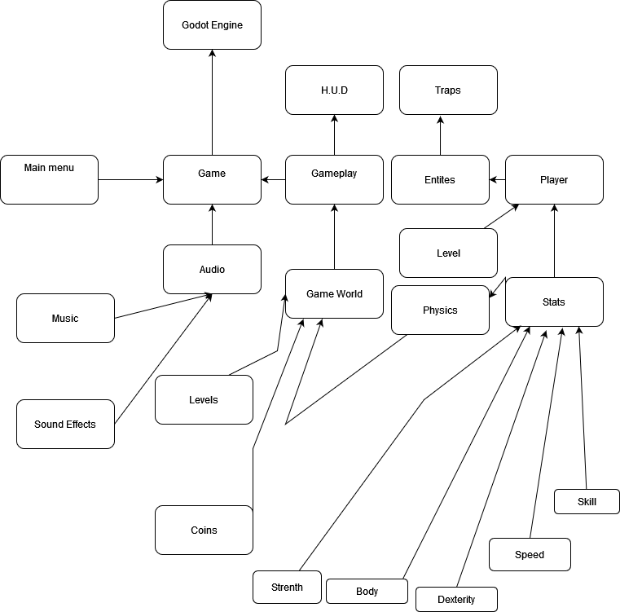

## Basic GameLoop Diagram

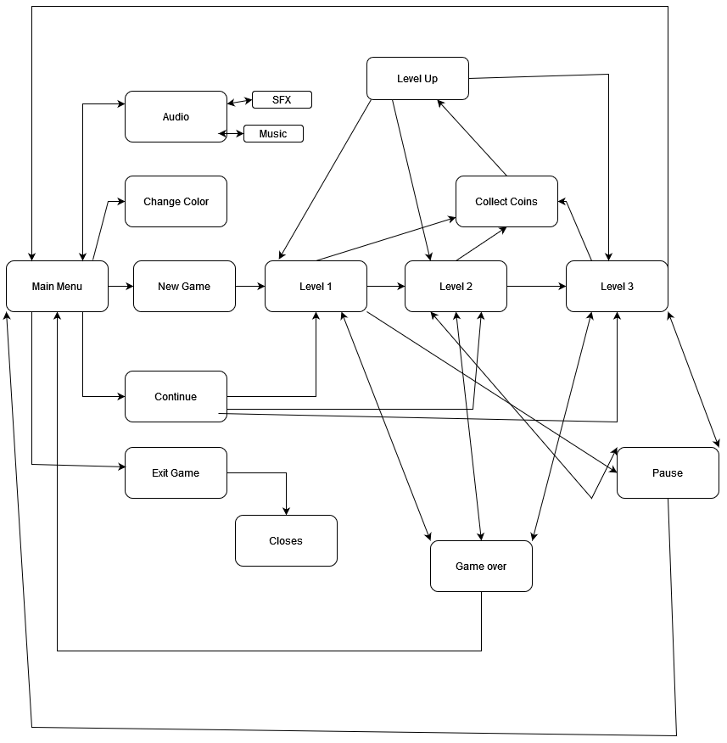

# Godot

For the Making of this game I used Godot. Is an open source game engine that uses its own script based system that is loosely based off python, it is called GD script , Godot uses scenes and nodes in its editor. I created multiple scripts and scenes in godot every object in the game had its own scene, each object was made up of components that were being used in both the editor and the script.

# References

[1][Godot Docs](https://docs.godotengine.org/en/stable/index.html)