CSG Software Solutions Ltd.

Software Design Description

Car-Pooling: “Share My Ride”

Prepared By:

Elif Selin ALKAN –
Cansu HELVACIOĞLU –
Gökhan BABACAN –

May 5th, 2008
Bilkent University - Ankara

1.Scope
- This report will define the high level design and technology decisions of the Online Carpooling System.
- This sdd defines and describes the use of each view, the architectural constraints of the system, the functional requirements with a significant impact on the architecture, use-case realization, concurrency aspects, the layers and subsystems of the application, performance issues and constraints.

2. References
[14] Software Engineering Standards Committee of the IEEE Computer Society, “IEEE Recommended Practice for Software Design Descriptions”, IEEE Std 1016-1998.

3.Definitions

Car-Pooling: Carpooling (also known as ride-sharing, lift-sharing), is shared use of a car, in particular for commuting to work, often by people who each have a car but travel together to save costs and in the interest of other socio-environmental benefits. [1]
IE: Internet Explorer.ew

4. Considerations for producing an SDD

4.1 Software life cycle
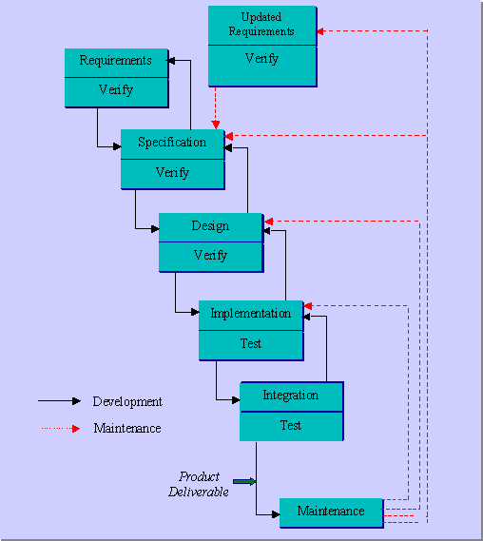

4.2 SDD within the life cycle
In the design part of our waterfall model life cycle we define our sdd. After determining the requirements and specifications as the cycle goes through design part we make a prototype of our software design. Before implementation it is vital to design the software to be more controlled on coding part. As the cycle shows if there is a problem in maintanence about the design part we can go back and fix it.

4.3 Purpose of an SDD
The purpose of this sdd is to define and describe the use of each view, the architectural constraints of the system, the functional requirements with a significant impact on the architecture, use-case realization, concurrency aspects, the layers and subsystems of the application, performance issues and constraints.

5. Design Description Information

Introduction
This document is adopted from the Software Engineering Standards Committee of the IEEE Computer Society, “IEEE Recommended Practice for Software Design Descriptions”, IEEE Std 1016-1998.
The Software Design Descriptions (SDD) provides an architectural overview of Online Carpooling System. This document presents to various stakeholders different types of abstraction It aims to provide the stakeholders a clear understanding of the system.

Scope
The scope of this SAD is to define high level design and technology decisions of the Online Carpooling System

Overview

In order to fully document all the aspects of the architecture, the Software Design Document contains the following subsections.
Section 5.2: describes the use of each view
Section 5.3: describes the architectural constraints of the system
Section 5.4: describes the functional requirements with a significant impact on the architecture
Section 5.5: describes the most important use-case realization. Will contain the Analysis Model and the Design Model
Section 5.6: describes design’s concurrency aspects
Section 5.7: describes how the system will be deployed. Will contain the Deployment Model
Section 5.8: describes the layers and subsystems of the application
Section 5.9: describes any significant persistent element. Will contain the Data Model
Section 5.10: describes any performance issues and constraints
Section 5.11: describes any aspects related to the quality of service (QoS) attributes

Architectural Representation
The views used to document the Carpooling System in current phase are:

Deployment view
Audience: Deployment managers.
Area: Topology: describes the mapping of the software onto the hardware and shows the system's distributed aspects.
Related Artifacts: Deployment model.

Use Case view
Audience: all the stakeholders of the system, including the end-users.
Area: describes the set of scenarios and/or use cases that represent some significant, central functionality of the system.
Related Artifacts : Use-Case Model, Use-Case documents

Architectural Goals and Constraints
This section describes the software requirements and objectives that have some significant impact on the architecture.

Technical Platform
Carpooling application will be deployed onto a J2EE application server.

Transaction
J2EE platform already has built in transaction capabilities, they will be used.

Security
The system must be secured, so that a customer can make online payments (Premium Membership)
Basic security behaviors:
- Authentication: Login using at least a user name and a password
- Authorization: according to their profile, online user must be granted or not allowed to receive some specific services (Automatic match finding, Ride Suggestion, etc...)
For internet access, the following requirements are mandatory
- Confidentiality: sensitive data must be encrypted if any (credit card payments) .
- Safety: Credit card data must not be kept at a local database.
- Data integrity : Data sent across the network cannot be modified by a tier
- Auditing: Every sensitive action can be logged
- Non-repudiation : gives evidence a specific action occurred
J2EE security model will be reused

Persistence
Data persistence will be addressed using a relational database and J2EE s Object Relational Mapping capability will be reused.

Reliability/Availability
High availability is required since there are monetary issues related to the systems availability. Advertisers and premium users should not be disappointed. The system’s high availability will also ensure customer satisfaction and loyalty. J2EE solutions will be used.
Targeted availability: 16 hours a day, 7 days a week (Maintenance at night)

Performance
Search queries should return %90 of the time below 5 sec.
Credit card payment transaction should finish in 10 sec.

Internationalization
Initially the system will support Turkish and English. It should be easily modifiable to extend language support.

Use-Case View

This section provides a functional overview of the system by a use-case diagram.

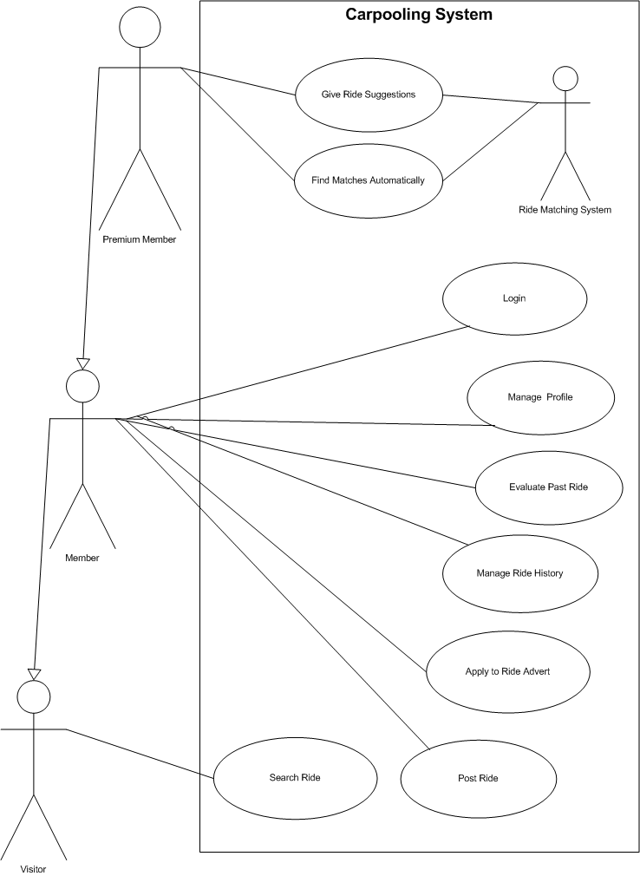

Use-Case Realizations
Not the scope of this phase.

Logical View

Overview
The Carpooling application is divided into layers based on the N-tier architecture
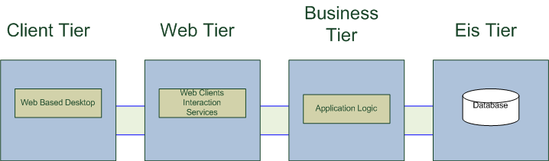
(Adopted from SOA course slides)
The layering approach is the mostly accepted solution for enterprise applications, which require scalability, modularity and easy maintenance.
- The web tier deals with the presentation logic and the pages rendering
- The business tier deals with the core functionalities of the system. (Search, post, match rides, manage profiles)
- The EIS tier is responsible for storing user profiles, and ride advertisements.

Deployment View

Logical Structure
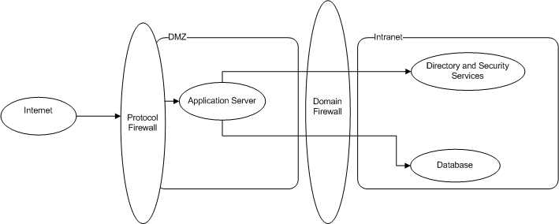
Physical structure
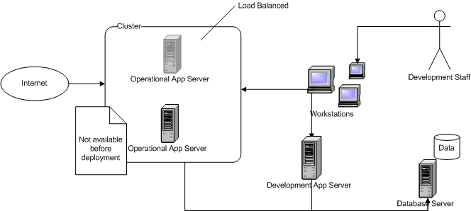

Details
- Runtime Pattern is applied.
- Development is done on an extra application server
- Application is deployed into 2 application servers working in a cluster. (4 in the future)
- Application servers are IBM servers running Jboss Application Server
- Database server is IBM server running MySQL server.
- All application servers and Database server have redundancy using mirroring RAID mode.
- Workstations run Linux and use Eclipse platform for development.

Size and Performance

Volumes:
- Targeted member count: 10000
- Daily user access: %10 + non members = 1000 + 1000
- Estimated member count in 1 month: 1000
- Daily user access %5 + non member = 50 + 200.

Quality

Scalability:
- Description : System’s reaction when user demands increase
- Solution : System is built to support 10000 members, further scalability is supported by new hardware and J2EE
Reliability, Availability:
- Description : Transparent failover mechanism, mean-time-between-failure
- Solution : : J2EE application server supports load balancing through clusters, RAID mirroring is used diminish software crashes.
Portability:
- Description : Ability to be reused in another environment
- Solution : The system is fully J2EE compliant and thus can be deployed onto any J2EE application server
Security:
- Description : Authentication and authorization mechanisms
- Solution : J2EE native security mechanisms will be reused

Risks and Mitigation Plans

Hardware failure
- During development the development server fails
Request support from vendor if not solvable internally
- After deployment the development server fails
Use one of the operational servers if urgent until problem is fixed
- One of the operational servers fails
The two deployment servers will be the replacements of each other, use other.
- Any of the development workstations fail
There are 3 spare workstations in case of workstation failure.

Software failure
- Development/Operational/Database server fails
Recover using mirror RAID disks
- Development workstations fail.
Use spare workstations if not fixed in short time.

6. Design description organization
6.1 Introduction

The Software Design Description (SDD) details the chosen software architecture and the justification for selecting that architecture. In this project the team was tasked with architecting and implementing a Car Pooling Software System.

6.2 Design views

Entity attribute information can be organized in several ways to reveal all of the essential aspects of a design. In so
doing, the user is able to focus on design details from a different perspective or viewpoint. A design view is a subset of design entity attribute information that is specifically suited to the needs of a software project activity. Each design view represents a separate concern about a software system. Together, these views provide a comprehensive description of the design in a concise and usable form that simplifies information access and assimilation. A recommended organization of the SDD into separate design views to facilitate information access and assimilation is given in Table 1. Each of these views, their use, and representation are discussed in detail.

6.2.1 Decomposition description

6.2.1.1 Scope

We first must understand our organization's business functions before beginning developing information systems. The decomposition descriptions are done in order to plan business functions, processes, and sub processes within “Car Pooling”Project.

6.2.1.2 Use

Our Project will perform a variety of different functions. Before we plan what systems to build for the organization, it is helpful to first understand the functions of “Car Pooling” Projects needs to perform. Then it is much easier to identify processes that occur within the business functions, and ultimately the systems that will support those processes. This is a top-down approach to systems development. (As we mentioned we are going to use a Top- Down watefall like design in earlier stages.)

The process of starting at a high level and moving into smaller and smaller subsystems is called decomposition. The functional decomposition diagram (FDD) is a planning tool for identifying business functions and the processes that comprise them. The diagram is the starting point for more detailed process diagrams, such as data flow diagrams

Objectives

- Understand the rules and style guidelines for functional decomposition diagrams (FDDs).
- Understand the process used to create FDDs.
- Be able to create a Functional Decomposition Diagram.

6.2.1.3 Representation

Membership
Ride
Operations
Activities
Post a
Ride
Register
Members
Member
Operations
Ride Activities
Apply a
Ride
Matched
Activities
Activity Schedule
Validate
Membership
Member
Registration
System
Process
Membership
Report
Membership
Search a Ride

6.2.2 Dependency description
6.2.2.1 Scope

In our Project many methods are available for visualization and measurement of structure during the design of a programming solution.
6.2.2.2 Use
In order to avoid the possible problems might occur due to visualizing the program structure we draw as many diagrams as possible since the diagrams are more clear and easily understandable under any case. As we are working on, adding, moving and deleting pieces as the program developed and problems with the translation from design through pseudo-code to high-level language code were overcome. Over time, we decided that it was most helpful to make the diagram show the relationships between sections of the program.
A decomposition diagram shows a hierarchy between modules but does not show that some modules are dependent on other modules. When one module cannot occur until another module is completed, there is a dependency between the two modules. These dependencies are illustrated on a Dependency Diagram. Just as a decomposition diagram does not show dependencies, a Dependency Diagram does not show program structure.

6.2.2.3 Representation

STRUCUTRE CHART

APPLY TO
A RIDE

SEARCH RIDE

FIND
SUFFICIENT
RIDES

LOGIN
APPLY
TO RIDE
SHARE
RIDE

İf share canceled

CANCEL
RIDE

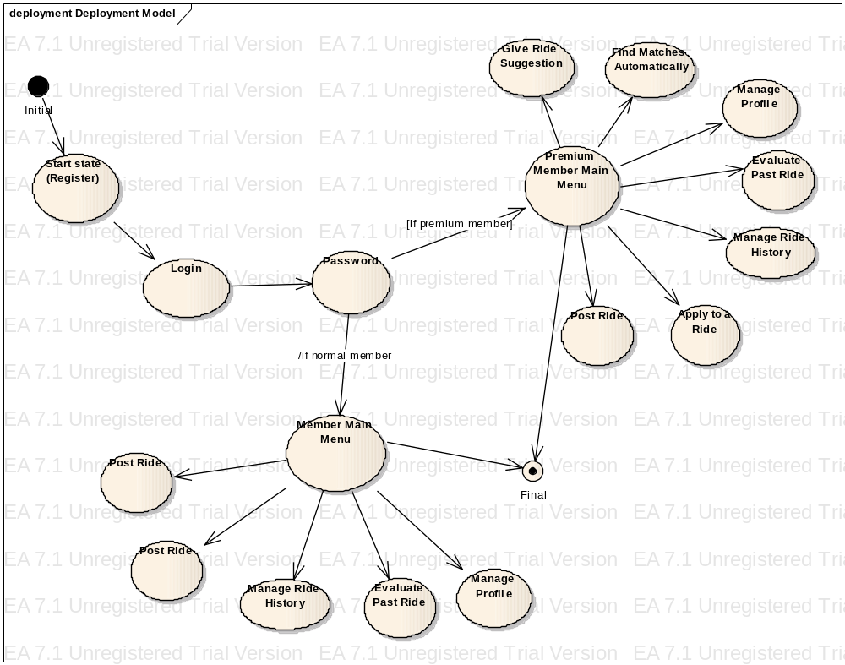

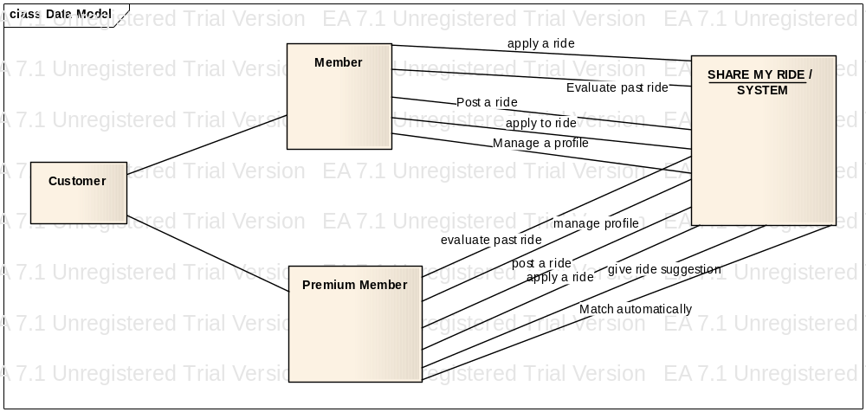
6.2.3 Interface description
6.2.3.1 Scope
Here in this part we will consider 2 main part one is the structure and navigation that describes the structure of the application and the ways in which users can navigate and the other is the screen descriptions which comprises the main part of the document, and contains detailed description of each screen and their component parts.

6.2.3.2 Use

Since our project is going to work through a web site the main screen we met with user is very important. Because if we can attract the user to stay in our site this means we possibly have one more customer. The graphic user interface (GUI) of a computer system comprises the interaction metaphors, images, and concepts used to convey function and meaning on the computer screen. It also includes the detailed visual characteristics of every component of the graphic interface and the functional sequence of interactions over time that produce the characteristic look and feel of Web pages and hypertext linked relations. Graphic design and visual "signature" graphics are not used simply to enliven Web pages — graphics are integral to the user's experience with your site. In interactive documents graphic design cannot be separated from issues of interface design.
There are some criteria that we are going to apply to our web site in order to have effective, efficient, easily understandable and usable interface. These are;
Visibility of system status
The system should always keep users informed about what is going on, through appropriate feedback within reasonable time.
Match between system and the real world
The system should speak the users' language, with words, phrases and concepts familiar to the user, rather than system-oriented terms. Follow real-world conventions, making information appear in a natural and logical order.
User control and freedom
Users often choose system functions by mistake and will need a clearly marked "emergency exit" to leave the unwanted state without having to go through an extended dialogue. Support undo and redo.
Consistency and standards
Users should not have to wonder whether different words, situations, or actions mean the same thing. Follow platform conventions.
Error prevention
Even better than good error messages is a careful design which prevents a problem from occurring in the first place. Either eliminate error-prone conditions or check for them and present users with a confirmation option before they commit to the action.
Recognition rather than recall
Minimize the user's memory load by making objects, actions, and options visible. The user should not have to remember information from one part of the dialogue to another. Instructions for use of the system should be visible or easily retrievable whenever appropriate.
Flexibility and efficiency of use
Accelerators -- unseen by the novice user -- may often speed up the interaction for the expert user such that the system can cater to both inexperienced and experienced users. Allow users to tailor frequent actions.
Aesthetic and minimalist design
Dialogues should not contain information which is irrelevant or rarely needed. Every extra unit of information in a dialogue competes with the relevant units of information and diminishes their relative visibility.
Help users recognize, diagnose, and recover from errors
Error messages should be expressed in plain language (no codes), precisely indicate the problem, and constructively suggest a solution.
Help and documentation
Even though it is better if the system can be used without documentation, it may be necessary to provide help and documentation. Any such information should be easy to search, focused on the user's task, list concrete steps to be carried out, and not be too large.

6.2.3.3 Representation

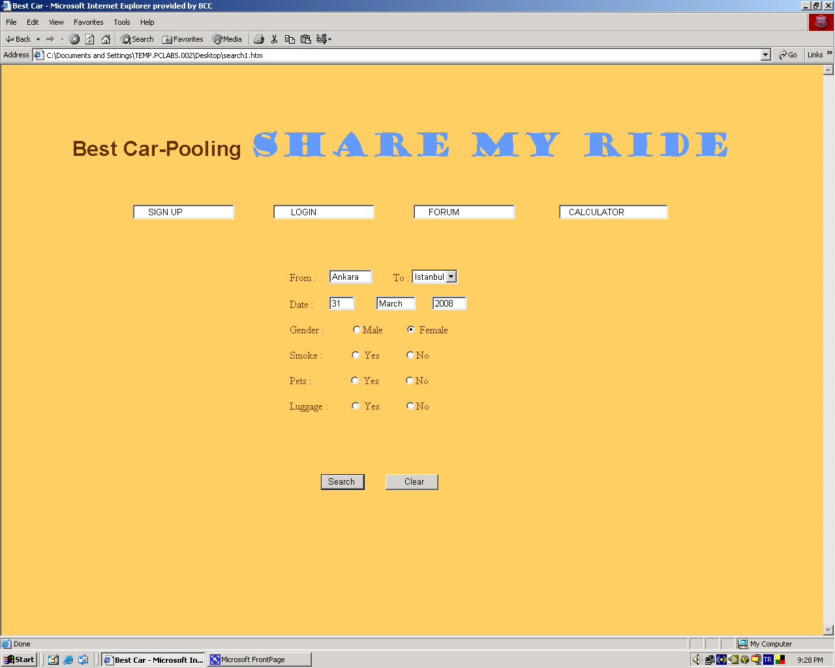

this isthe interface of search for a car. Here user
selects the destination as mentioned above “from = Ankara” ,“to = İstanbul”
Selects the date to travel
Selects whether he/she is looking for a smoking or non-smoking ride
Selects whether he/she has any pets
Selects whether he/she has any luggages
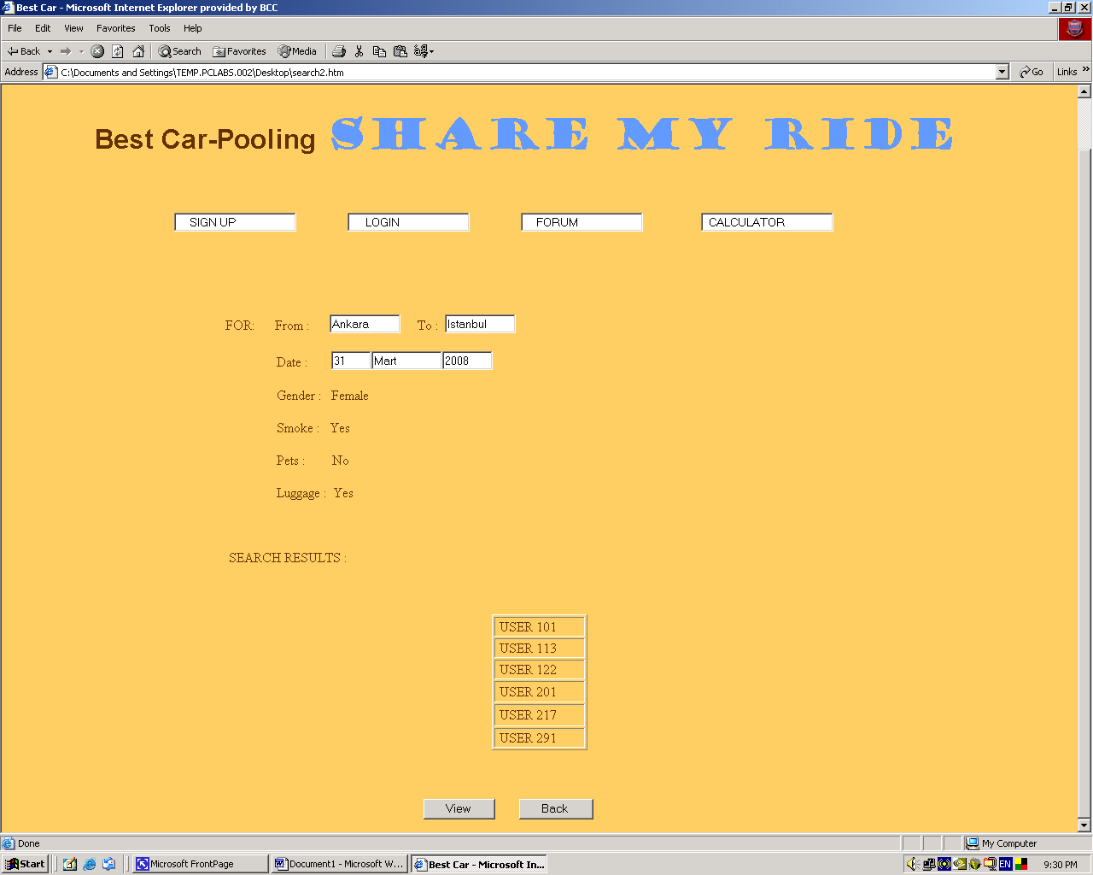

Here the results are displayed with user ids. User is able to view the results by clicking on the link for example USER 101 we click “View” to display the results “Back” to new search
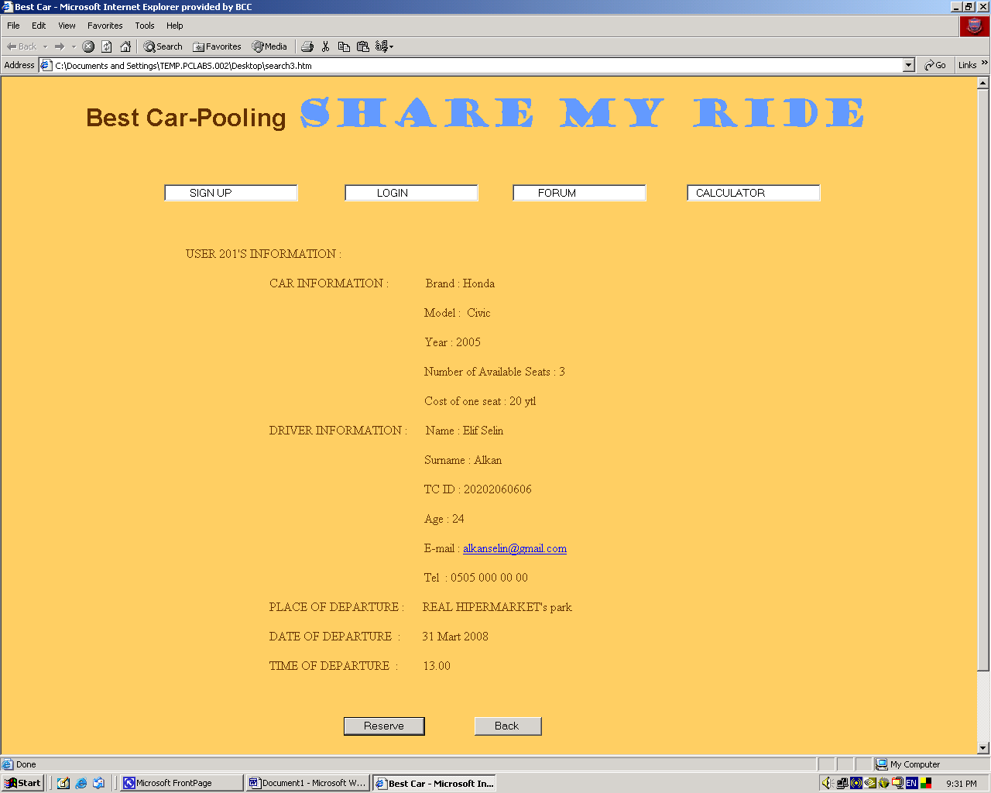
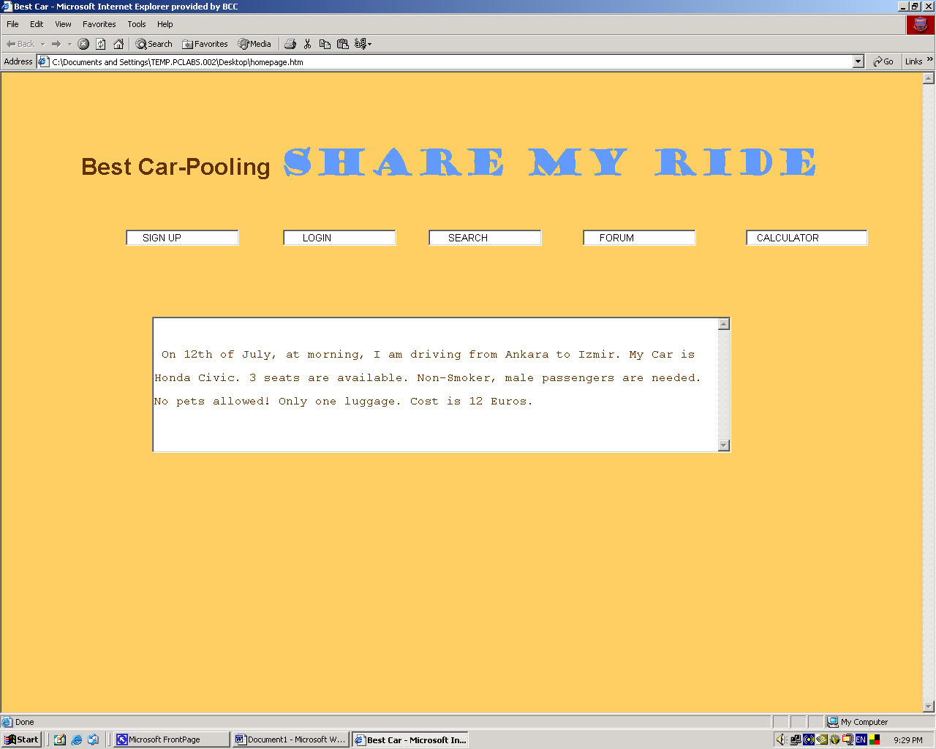

6.2.4 Detailed design description
6.2.4.1 Scope
The detailed design description contains the internal details of each design entity. These details include the attribute
descriptions for identification, processing, and data. This attribute information should be provided for all design
entities.

6.2.4.2 Use
This description contains the details needed by programmers prior to implementation. The detailed design description
can also be used to aid in producing unit test plans.

6.2.4.3 Representation
