Table of Contents
Models 3
Data 3
VBO 3
Texture 3
Normal 3
Rasterization 4
Shaders 4
Vertex Shader 4
Geometry Shader 4
Example 4
GLSL operators 5
Evaluation 7
Fragment Shader 7
Lightening 8
Texture Filtering 9
Luminance 9
Texture Compression 10
Bump Mapping 10
Embossing 10
Offset Map 11
Height Field Map 11
Dot3 Bump Normal Mapping 11
Procedure 12
Analysis 12
Displacement Mapping 12
Parallax Mapping 13
Inverse Height Map 14
Steep Parallax Mapping 15
Parallax Occlusion Mapping 15
Environment mapping 15
Spherical Environment Mapping (SEM) 15
Blinn-Newell’s Method 17
Cube Mapping 17
Dual Paraboloid Mapping 20
Anti-Aliasing 21
Super-sampling 22
Grid 22
Random 22
Poisson Disc 22
Jittered 23
Rotated Grid 23
Filtering 23
Mean Filter 24
Median Filter 24
Quincunx Filtering 24
Adaptive Anti-aliasing 26
MIP Mapping 26
Blobby Surfaces 28
Background Info: 28
Computational Cost: 28
Meta Balls 28
Soft Objects 29
Applications 29
Iso Lines 29
Iso-surfaces 30
Tessellation 32
Introduction 32
Method 34
Input Patches 34
Tessellation Control Shader 35
Basic 35
Primitive Generator 38
Tessellation Evaluation Shader 38
Method 38
Bi-linear interpolation… 39
Marching Square Algorithm 40
Marching Cubes 40
Dividing Cubes 43
Finger Tracking with the Kinect 45
Look-up Tables 46
Magic Wand 47
Psuedo code 47

Models

Data
Vertices = Points, that defines an object
Edges = Lines connecting vertices
Faces = Defines surface of object

VBO
VBO (Vertex Buffer Objects) contains all model data and vertices.
Index VBO or Face Buffer contains the order in which to draw vertices.
VBO are stored on the GPU making data call more efficiency.

Texture
Texture Coordinates, maps the vertex to a point on an image. Texture is a typically 2D image that is painted onto a model.
- As for 2D shapes, texture coordinates are assigned to each vertex and map the vertex to a point in an image (typically 2D images, but 1D and 3D textures are also possible).
- However, 3D shapes need to be split into regions (collectively collected a texture atlas) in order to have textures correctly applied. Edges between each region are referred to as seam edges.
- When a mesh is split up, a vertex will effectively have multiple texture coordinates assigned to it. For in-game rendering using VBOs, we need to maintain a 1:1 correspondence between vertex positions, texture coordinates (and other per-vertex data items). To maintain this 1:1 correspondence, when a mesh is split across a seam edge, a new vertex is created, so both regions either side of the seam edge have their own copy of the vertex.

Normal
Normal and Tangents describes the curvature of a mesh. The tangent vector describes the direction. Normal vectors lie perpendicular to the tangent.
Rasterization Pipeline
Vertex Data

Vertex Shader

Geometry Shader

Perspective Transform and Clipping
Rasterization
Fragment Shader

FrameBuffer
The input vertex packets are sent to the vertex processing stage of the pipeline. Here each vertex packet becomes the input to a vertex shader. The vertex shaders process their input packets, perform transformations, animations and projections and output a new vertex packet containing the transformed data.
Vertex shaders are strictly one vertex in, one vertex out. No new vertices are created! The vertex positions output from the vertex shader must be in clip coordinates (so the modelview and projection matrices must be applied in the vertex shader stage).The vertex packets are then passed onto the next stage where perspective divide and clipping is performed.

Rasterization
The rasteriser collects the required number of vertices to form the primitive being rendered (triangles in this case) and converts the geometry to pixels on screen. The pixel (fragment) shader takes one fragment as input. The output typically contains the final (RGBA) information for the associated pixel in the chosen render target – the framebuffer / screen for example, but can include depth data and multiple framebuffers can be written to at the same time if need be.

Shaders
Shaders are small programs that allow us to alter vertex data and pixel data on the GPU. Programs to alter vertex data are called vertex shaders. Programs to alter pixel data are called pixel shaders, or fragment shaders. These allow developers to apply their own operations to the data, providing large degree of control over what can be rendered.

Vertex Shader
Matrices for transformations. These are constant for all vertices and are thus provided as a Uniform variable.Per-vertex attributes (position, colour, normal, texture coordinate for example). These are input from primitive assembly which in turn is sourced from VBOs.

Geometry Shader

Example
Geometry shaders can create new vertices! Geometry shaders can be applied to problems requiring the efficient creation of new geometry. Examples include.
  - Shadow volume creation on the GPU Cube environment map creation
  - Terrain synthesis Basic subdivision of meshes.
It is important to note that geometry shaders are not a panacea for geometry-limited problems.

GLSL operators
In GLSL a geometry shader operates on each primitive being rendered. The input primitives to a geometry shader can be...
- Points
- lines (list or strip – the geometry shader does not distinguish)
- triangles (individual or strip – the geometry shader does not distinguish)
- lines_adjacency (line and line strip with adjacent line info)
- triangles_adjacency (triangle and triangle strip with adjacent triangle info)
So, if no geometry shader is specified the rasteriser collects as many vertices as necessary for each primitive (2 for a line, 3 for a triangle etc.) When a geometry shader is present then it is the geometry shader that collects the necessary vertices. They are accessed as an array parameter (see later slide...)
In GLSL a geometry shader outputs one of three stream types. These streams can be...
- points
- line_strip
- triangle_strip
OpenGL allows multiple streams of vertices to be output from the Geometry Shader at the same time. Only one of these streams (stream 0) can be sent down the pipeline to the rasteriser. Other output streams can be sent to the transform-feedback stage to be stored back in buffer resources (we’ll revisit this when we look at particle systems later).
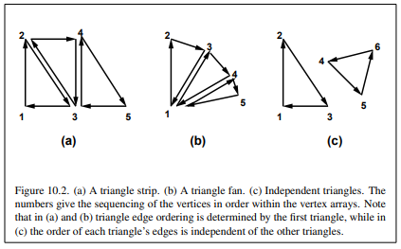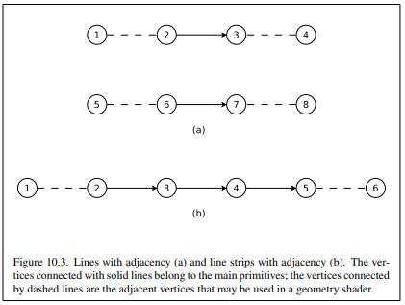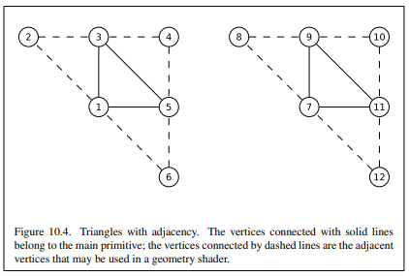

Evaluation
- Geometry shaders allow a number of fundamental operations to be performed:
  - Transform existing geometry: so the input and output primitive types are the same, but we perform some operation on the primitive as a whole
  - Map one primitive type to another. This is the most common use for the geometry shader. Here we change the primitive type which gets rendered. We could draw our object as a triangle mesh from our C++ code, but turn it into a point cloud by outputting points from the geometry shader, not triangles. The rasteriser and fragment shader see points, not triangles.
  - Discard primitives according to some criteria
  - Modify vertex data and stream the results back into a vertex buffer. This is the basis of GPU-based particle systems which we will look at later.
- Geometry shaders can be applied to problems requiring the efficient creation of new geometry. Examples include
  - Shadow volume creation on the GPU
  - Terrain synthesis
  - Cube environment map creation
  - Basic subdivision of meshes

Fragment Shader
The fragment shader will pickup any per-vertex data sent down the pipeline, as well as contain uniforms to represent other data such as textures, light sources etc.

Lightening
- Lighting is a large complex subject, and there are a large number of algorithms to model how light behaves and how surface properties can be described and how light interacts with these surfaces.
- This introduction will focus on three general algorithms…
  - Ray Tracing and Radiosity (two algorithms that fall into the classification of Global Illumination algorithms).
  - Direct Lighting (a simple lighting model used in games). Direct lighting is typically used in conjunction with other algorithms to create more realistic effects.
- The simplest model of a light source is a directional light. This consists of a vector that points in the direction the light is coming from. Every point in the scene sees the light as coming from the same direction. This is used to model large, very distant light sources such as the sun.
- In contrast to a directional light, a point light source has a given position in the 3D scene.
- When calculating the brightness for a given surface point, we take into account (i) the distance between the surface point and the point light’s position and (ii) the orientation of the surface point with respect to the light’s position.
- So, unlike a directional light, for each surface point we need to calculate the vector to the point light source’s position in order to calculate the brightness.
- Since we know the distance from each surface point to the light’s position, we can also calculate attenuation (how the light’s brightness fades the further we are from the light source i.e. the light’s position.
- Diffuse Reflection – Diffuse surfaces reflect incoming light ‘evenly’ in all direction. Diffuse surfaces appear equally bright no matter the position of the viewer.
- Specular Reflection – Light reflected from a specular surface is reflected in a direction coincident with the direction the light hit the surface.
- To calculate how bright a point on an object is relative to a light source, we need to know:
- For positional lights and spotlights, the position (distance) from the light source. This is used to calculate the attenuation – the larger the distance between a surface point and the light’s position, the less brightness there will be.
- It’s orientation relative to the direction of the light source. This is used to calculate the Lambertian – a term that describes the brightness based on the direction a surface point is facing with respect to the light’s position.
- Note: By ‘point on an object’ we mean a vertex, or more generally, any point on the surface of the object, or object’s faces.

  - The distance easy to calculate – every surface point (vertex for example) has by definition a position in 3D space (x, y, z), so we can subtract the surface point’s position from the light’s position and calculate the length of the resulting vector to obtain the distance. We can use Pythagoras’s Theorem to calculate the vector length i.e. the distance!

  - The brightness of light decays exponentially as you move further from the light source, but in OpenGL, a lighting model is given that provides a little more control over this decay (attenuation).
  - A light source can model 3 types of attenuation: constant (kc) (so the brightness of every point is scaled by a constant in the range of 0 to 1, linear (kl) (so the light attenuates at a constant rate) and quadratic (kq) (physically realistic attenuation).
  - The Lambertian term is calculated using
    - (i) the normal vector of the surface point (so the vertex normal if we’re calculating brightness at a vertex position). The length of the normal vector is 1.0!
    - (ii) the normalised vector from the surface point to the light source. Remember, to normalise a vector…
  - Given the surface normal vector (A) and vector pointing towards the light source (B) , we calculate the Lambertian term (the brightness) using the vector dot product operator (also referred to as the inner product). This is represented as A • B. The OpenGL Shading Language provides the dot product function for this purpose.
  - Above we saw the vector cross product (outer product) take two vectors and return a vector (the normal). The dot product takes two vectors and produces a single (scalar) value (the brightness in the context of lighting).
  - Geometrically, the dot product gives the degree which one vector overlaps another.
  - Calculating brightness for a diffuse surface material
    - The diffuse brightness of a point on an object is based on the distance from the light source (if the light source is a point or spotlight) and it’s orientation (determined by the dot product of the normal vector and direction vector from the point on the object to the light source)
    - This is viewer independent – in other words the brightness is not changed when the camera moves.
    - Given a normal vector N and direction to light D’ (both unit length), the attenuation a based on the distance to the light, a diffuse material colour C and a light colour L, the diffuse colour at a given surface point is calculated as…
C * L * (N • D’) * a
  - Specular surface calculation is a little more involved and takes into account the position of the viewer (i.e. camera location)…
- Specular colour = S * L * (R • E)σ * (N • D’) * a
  - In the above notes, we spoke about calculating lighting at a ‘surface point’. This can be either (i) a vertex position or (ii) a point on the surface of the object at a given pixel.
  - Calculating brightness per-vertex and using the rasteriser to interpolate the brightness across each pixel is called Gouraud shading. Since lighting is calculated at each vertex this approach is quicker but artefacts can result (see below – right sphere).
  - Alternatively, interpolating the surface positions and normals using the rasteriser and then calculating the brightness in the fragment shader is called Phong shading. This is typically slower than Gouraud but produces much better results since we’re now doing per-pixel lighting. (see below – left sphere. The Gouraud artefacts are not present).

Texture Filtering

Luminance
When we think about the luminance (brightness) of pixels on a display we usually assume that the luminance behaves linearly with respect to the pixel values we set in OpenGL.
So, if we set a pixel as RGB = (1.0, 1.0, 1.0) we expect a white pixel and if we set its neighbour as RGB = (0.5, 0.5, 0.5) we expect a grey pixel half as bright. This is referred to as a linear colour space. However, display hardware does not output brightness this way – it actually outputs brightness non-linearly…
The problem with this is there are fewer bits per colour to represent the darker colours – so posterisation (banding) can occur. To compensate for this non-linear property, images, textures etc. are often stored in a non-linear colour space. These “gamma corrected” images then appear to have the correct brightness when displayed.
This also enables more bits for lower intensity values and fewer bits for higher intensity values – so posterisation effects are reduced or eliminated….A common non-linear colour space is sRGB (Standard RGB) developed by HP and Microsoft.
OpenGL allows us to store textures in the sRGB colour space. Some of the texture formats include:
- GL_SRGB
- GL_SRGB8
- GL_SRGB_ALPHA
- GL_SRGB8_ALPHA8
When we access textures in a shader the sRGB values are automatically transformed into linear RGB values.
In addition to setting up textures in the sRGB colour space, the framebuffer can also be configured to store values in the sRGB colour space. This is done in 2 stages…
1) Specify the attribute when setting up the pixel format for the OpenGL context.
2) Enable sRGB rendering in the framebuffer
When working with colour in OpenGL operations such as lighting and blending require we operate in a linear colour space. We’ve been doing this all along anyway! However, using sRGB textures and framebuffers requires we keep in mind the colour space we work in. The general approach is:
Store and load textures using the sRGB colour space. When the texture is accessed in GLSL it’s automatically mapped to linear colour space
Store per-vertex colour data and lighting colour data as normal (in linear colour space).
Setup a framebuffer with sRGB capability. If using multi-pass rendering, intermediate textures you write to via an FBO should NOT be setup with the sRGB format – the intermediate rendering steps should stay in linear colour space.

Texture Compression
- Compressing textures allows you to store large texture resources on the GPU. This facilitates efficient storage and texture access. Texture compression can be specified in the call to glTexImage2D. Generic compressed texture formats are…
  - GL_COMPRESSED_RGB
  - GL_COMPRESSED_RGBA
  - GL_COMPRESSED_SRGB
  - GL_COMPRESSED_SRGB_ALPHA
  - GL_COMPRESSED_RED
  - GL_COMPRESSED_RG
  - OpenGL 3.2 Introduced new formats to compress GL_LUMINANCE and GL_LUMINANCE_ALPHA image types. These include…
  - GL_COMPRESSED_SIGNED_RED_RGTC1
  - GL_COMPRESSED_RG_RGTC2
  - GL_COMPRESSED_SIGNED_RG_RGTC2
- We can verify the compression status of the created texture. To determine to resulting size of the compressed texture, we call glGetTexLevelParameteriv…
GLint textureSize;
glGetTexLevelParameteriv(GL_TEXTURE_2D, 0, GL_TEXTURE_COMPRESSED_IMAGE_SIZE, &textureSize);

Bump Mapping
- Introduced by Blinn in 1978 bump mapping is a technique used to make surfaces appear uneven, i.e. rough, wrinkled, pitted, etc.
- Bump mapping can be used to increase the detail within an object, without increasing the number of polygons used to create the object. Instead of using a texture to change a colour component in the illumination model, we access a texture to modify the surface normal.
- The geometric normal of the surface remains the same. Instead, we modify the normal used in the lighting equation. This means that the geometric surface remains unchanged.
- Bump mapping is calculated on a per pixel basis modifying the surface normal at each pixel (Phong shading) within the lighting equation.

Embossing
- Embossing is a simple form of bump-mapping which uses a 2-bit per pixel texture map (i.e. Black and white image).
- Rules when traversing the texture map:
  - If we land at a location where there is a transition from white to black– Rotate surface normal by angle theta.
  - If we land at a location where there is a transition from black to white – Rotate surface normal by angle -theta.
  - If no colour transition takes place – Leave surface normal alone
  - The angle theta controls the sharpness / smoothness of the emboss – i.e. the greater the angle the more pronounced the emboss appears.

Offset Map
- The offset mapping procedure stores in a texture two signed values at each point. These values correspond to the amount to vary the normal along the u and v image axis (tangential). These two values are used to scale two vectors that are perpendicular to the surface normal.
- The two vectors are then added to the surface normal to change its direction.
- This type of bump map texture is called an offset vector bump map or offset map.

Height Field Map
- Another method to represent bumps is to use a height field map. Each monochrome texture represents a height, where white is a high area and black is a low area.
- The difference in pixel intensity, of neighbouring pixels, is used to calculate the rate of change in height (slope). This is done by taking the difference in neighbouring columns to get the slopes for u, and between neighbouring rows for v
- Height field mapping can also be used to alter the geometric properties of the surface.
  - This can be integrated within the tessellation stage of the graphics pipeline. The texture map is used then to control the amount of displacement for each vertex

Dot3 Bump Normal Mapping
- Normal mapping (Dot3 bump mapping) first developed by Jim Blinn in 1978
Used to create highly detailed (bumpy/uneven) surfaces, without increasing the geometric complexity of the mesh
- Normal mapping is the primary method of performing bump mapping on modern graphics hardware.
Very high resolution texture maps required to avoid pixelization
- Bent normals representing each texel on the surface of a mesh are stored as x,y,z vectors in a 2D texture map.
- Can be stored as 3 x unsigned 8 bit colour channels (0-255).
- Colour information is read from the texture map and converted to the range -1 to +1
  - The value 0 represents -1, and the value 255 represents 1
  - Note: Higher resolution maps (i.e. 16 bits per channel) are more commonly used to store the normal data
- Object-space:
  - Very easy to implement
  - Suitable for static objects – i.e. fixed orientation
- Tangent-space:
  - Suited to dynamic game-play worlds where objects move!
  - A little trickier to implement
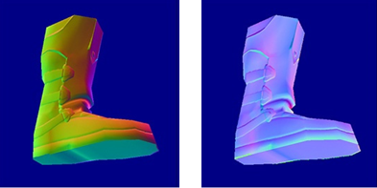

Procedure
- Steps required to implement the normal mapping algorithm in tangent space:
  - Pass the geometric normal and tangent vectors (stored within the vertex data structure) to the vertex shader.
  - Calculate the view vector and light vector in the vertex shader
    - Pass these vectors to the fragment shader for interpolation.
      - Phong shading approach.
  - Transform the normal and tangent vectors by the NormalMatrix.
  - Derive the bi-tangent, using the cross product of the normal and tangent vectors.
  - Combine the normal, tangent and bi-tangent vectors to create a tangent-space matrix
  - Transform the directional vectors from the vertex to each light source into tangent space using the tangent-space matrix at each vertex.
  - Transform the view vector into tangent space using the tangent space matrix at each vertex
  - Normalize both vectors
- Final step..
  - Use the view direction, light direction and bent normal vector (from normal map) to calculate the intensity of light at the pixel

Analysis
- Strengths:
  - Can be fully integrated within the graphics shader pipeline
  - Reduced geometry required
  - Increased visual quality / level of detail achieved
  - Tangent-space mapping supports dynamic game-worlds
    - i.e. objects can be moved during gameplay without having to re-generate a new normal map
  - Plenty of existing tools available to generate normal maps
Weaknesses:
  - Output quality dependent on size of map
  - Expensive to calculate the bent normal for every texel
  - No physical displacement of the underlying geometry – poor silhouettes

Displacement Mapping
- Displacement mapping is an alternative approach to Bump Mapping
  - Used to:
    - increase the sense of depth and level of detail
    - add small scale detail to surfaces
  - Introduced by Cook (1984)
ref: Cook, Robert L. 1984. "Shade Trees." In Computer Graphics (Proceedings of SIGGRAPH 84) 18(3), pp. 223–231.
  - Unlike normal mapping, which only affects the shading of a surface, displacement mapping actually adjusts the positions of surface elements
- Uses a grey-scale texture map and the geometric normal to control the direction and amount of displacement
- Micro Polygons:
  - Displacement mapping requires an adaptive tessellation of the surface of the mesh to ensure the size of each polygon matches the size of a pixel
Traditionally displacement mapping has only been used with high-end rendering systems (off-line rendering)
  - RenderMan
  - PhotoRealistic
  - More recently, displacement mapping been possible in real-time applications
  - Can be fully integrated within the graphics shader pipeline
  - OpenGL and DirectX now support displacement mapping
  - This is due to hardware support of real-time adaptive tessellation

Parallax Mapping
- Also called:
  - Offset Mapping
  - Virtual Displacement Mapping
- Parallax mapping is an enhancement of Dot3 bump mapping – refer back to Lecture04 Part 4 - Bump Mapping
- Introduced by Tomomichi Kaneko (2001)
Kaneko, T., et al., 2001. “Detailed Shape Representation with Parallax Mapping”. In Proceedings of ICAT 2001, pp. 205-208
- Increases the apparent depth within 2D texture maps when applied to 3D objects without increasing the polygon count
  - Overcomes the limitations of the graphics card:
  - Currently unable to modify a pixel location in a pixel shader
  - Allows one surface feature to occlude another
- Non-polgonal silhouttes
  - This is a major failing for the normal mapping techniques previously covered
- Parallax Mapping is the displacement of the texture coordinate – not the geometry
- This means that no tessellation is required
  - Low-polygon models used
- Geometric properties of the object remain un-altered
- However, poor results are achieved when the object is viewed at an acute angle
- The red line denotes the height adjusted values taken from the height map
  - As can be seen below, a properly displaced point A on the geometric surface, would be obscured by the height-adjusted point B
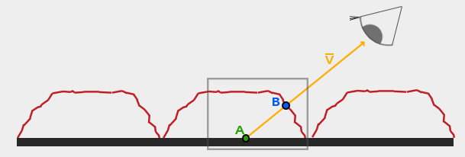
- First we need to convert the fragment-to-view direction vector v into tangent space
  - Remember that this same step is taken in dot3 mapping
  - This aligns the fragment-to-view direction vector (x, y components) to the surface’s tangent and bi-tangent vectors
    - the z component aligns with the geometric normal
- The view vector P is then scaled by the height value H(A) to find a crude approximation of point B
- The x and y values of P are then used as texture coordinate offsets
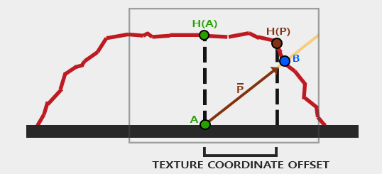
- This approach generally produces good results
- However the illusion tends to look unrealistic when using height maps that change rapidly
- variations of Parallax Mapping exist
- Some of the more common techniques are listed below:
  - Parallax Mapping using an Inverse Height Map
  - Steep Parallax Mapping
  - Parallax Occlussion Mapping (POM)

Inverse Height Map
- The inverse of the height map is commonly used for Parallax Mapping as it is often easier to fake depth than height on a flat surface
- This is referred to as depth mapping
- Light, view and fragment positions are first transformed into tangent space within the vertex shader, and passed to the fragment shader
- The normalized viewDir is scaled by H(A) and subtracted from the texture coordinates at A to find P
  - NB> the height value at texture coordinate H(A) is subtracted from 1.0
- xy coordinates of P are used as texture offsets to approximate B

Steep Parallax Mapping
- The illusion of Parallax Mapping falls down when objects are viewed from steep angles.
  - This is due, in part to the crude method used to approximate the offset point B
- This can be overcome by dividing the depth into a number of layers
- Multiple samples are then taken along the view vector at the corresponding depth value for each layer, until a sampled depth value (T3)is found that lies below the depth value of the current layer

Parallax Occlusion Mapping
POM follows a similar procedure to steep parallax mapping. However, rather than taking the texture coordinates at the depth layer after the collision, we linearly interpolate between the depth layers before (T2) and after (T3) the collision.
This enables us to more accurately determine the exact point of intersection (TP)
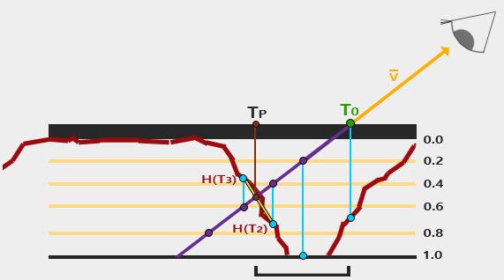

Environment mapping
- Normal texture mapping relies on mapping a 2D surface onto a 3D object.
- This is accomplished using position information (texture coordinates)
- However, this is not suitable for all scenarios – reflective surfaces cannot be textured this way as they rely on directional information, not positional information.
- In environment mapping, typically the reflection vector at each point on a surface is used to access the texture.
- First mentioned by Williams (1983) , and also independently developed by Miller & Hoffman (1984)
- A single pre-processed texture map is used to represent the whole environment around a single point. This represents the entire environment to be reflected.

Spherical Environment Mapping (SEM)

- To calculate (u, v) texture coordinates using SEM:
  - Basis matrix is used as the frame of reference for the texture generated
    - z - direction the camera points
    - y - up vector
    - x – side vector
    - All three vectors are normalized and orthogonal to one another
  - The camera position (view) and vertex normal are multiplied by this matrix. This transforms them into the local space of the SEM image.
  - Reflection vector R is then calculated as usual, using the newly transformed view and normal vectors
  - The spheres normal n is the half-angle vector between the reflection vector R and the direction vector to the eye in spheres map space, i.e. (0, 0, 1)
    - The normal vector n is the sum of the eye and R vectors: n = (Rx, Ry, Rz + 1)
  - The x,y coordinates from the unit vector n are the uv texture coordinates used to access the appropriate fragment from the sphere map
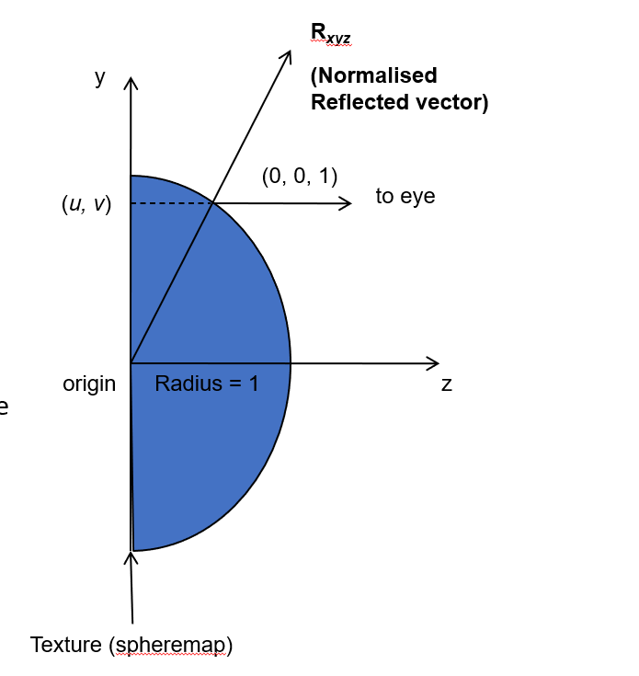
- The SEM is view-dependent. In other words, the SEM is only valid from a single viewpoint.
- Moving around the object produces incorrect results (appears as if the object is moving also).
- SEM also suffers from singularities. Mapping a 2D image onto a sphere will cause this. The singularity in the SEM lies at the edge of the image.
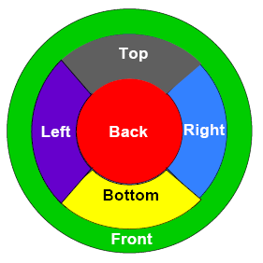

Blinn-Newell’s Method
- A related spherical mapping technique developed by Blinn and Newell requires a texture image is mapped around the entire sphere.
- Two important problems exist however:
  - Distortion at the poles
  - The seam edge that exists where the left and right edges of the image join must be eliminated.

Cube Mapping
- Most commonly used environment mapping procedure
- In cube mapping, 6 faces of a cube represent the environment we want to render.
- Cube-mapping is view independent - so the reflection is valid from all points of view.
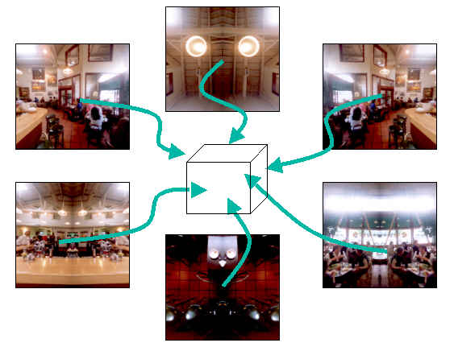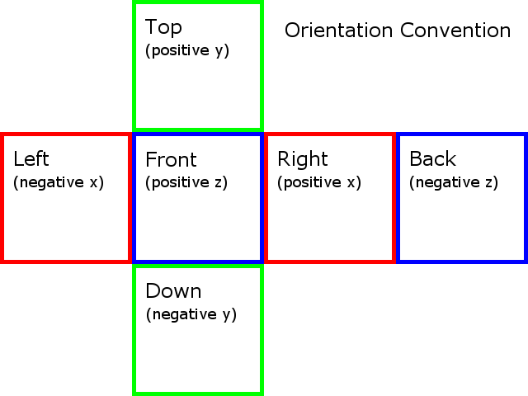
- Unlike 2D texture mapping, a 3D vector is used to look up a cube map.
- To obtain the texture coordinates, the vector from the camera to a point on the object surface reflected about the surface normal vector is used.
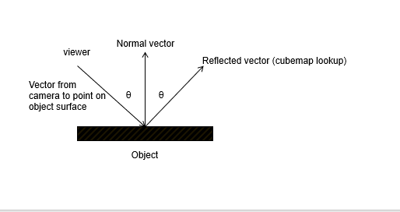

- The component in the reflected vector with the largest value is used to select the cubemap face.
  - For example, given a reflection vector of (0.2, 0.8, 0.0), the top face of the cube will be selected.
- The remaining coordinates (0.2, 0.0) are then used as 2D texture coordinates to access texture colours within the chosen cubemap face
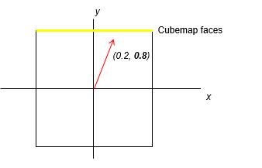
- The reflection vector is calculated per-pixel, not per-vertex.
- Older techniques that relied on per-vertex reflection vectors that are linearly interpolated over the surface of a polygon required polygons to be subdivided so they projected to one face of the cubemap.
- This prevented errors in projection when the texture was mapped onto the polygon surface
- GLSL provides the samplerCube type (which is typically declared as a uniform variable) to store cube map textures and the texture() function to access the texture values given a 3D vector as the texture coordinates.
- Example...
- Cube mapping can be used to render realistic reflections.
- Dynamic reflections are possible by rendering 6 views from the position of the reflective object. However, rendering 6 images per frame for a single reflective object is computationally expensive.
- One problem is overcoming seam edges where the textures meet. In OpenGL, using the GL_MIRRORED_REPEAT mapping mode addresses this problem.

Dual Paraboloid Mapping
- Dual-Paraboloid mapping uses 2 parabolic surfaces, oriented along the positive and negative z-axes.
- Reflection vectors are then mapped to the texture.
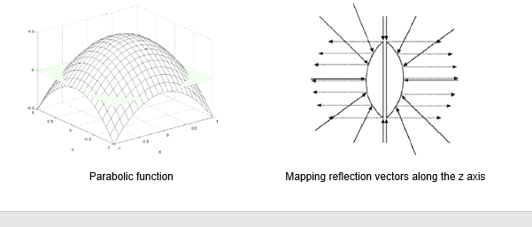
- Like spheremaps, special texture mapped images have to be created in order to render accurate reflections.

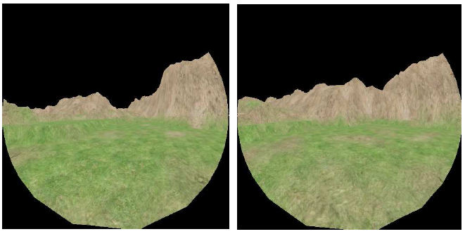
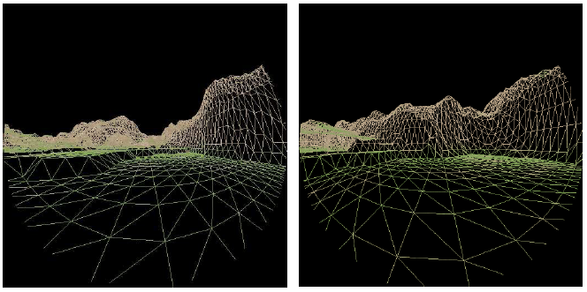
FASFASF

- However, paraboloid maps are view independent, and don’t suffer from the distortion inherent in spheremaps.
- They can also be used instead of cube maps – rendering 2 surfaces instead of 6 makes them more efficient. Much of the work for rendering the paraboloid maps is done in the vertex shader (see Zink).
- Suitable for other applications such as omni-directional shadow mapping as well as environment mapping.

Anti-Aliasing
- Although computer screens are capable of producing near perfect vertical and horizontal lines, generating diagonal lines of any angle produces jagged edges (steps)
- Dividing a continuous image into discrete chunks using pixels to build up an image, causes these inaccuracies to be visible. These jagged edges are referred to as aliasing.
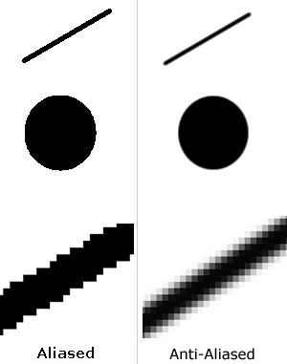
- Methods used to combat this problem are called Anti-Aliasing.
- Anti-aliasing falls into two broad categories:
  - Super-sampling
  - Filtering
- The basic idea of Anti-aliasing is to use subtle colour changes around curved / diagonal edges to smooth out the lines, and thus fool the eye into thinking the edges are smooth.
Fig.1 Zoomed in Fig.2 Actual Size
- Figure 1 shows a zoomed-in image with/out anti-aliasing applied. When the image is displayed at ‘actual size’ most of the blurriness disappears and the edges appear smoother

Super-sampling
- Full-scene anti-aliasing (FSAA) requires rendering the original image at a higher resolution than required. This larger image provides a number of samples for each pixel which can be averaged to provide a final value. This is an expensive process, but yields the best visual results.
- A sub-pixel weighting mask can be used to give more weight to pixels towards the centre of a pixel area.
- NB> The values in the mask are measured in sixteenths
- 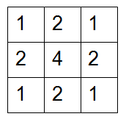

Grid
- The simplest algorithm. The pixel is split in several sub-pixels, and a sample is taken from the center of each. It is fast and easy to implement, although due to the regular nature of sampling, aliasing can still occur if a low number of sub-pixels is used.
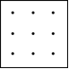

Random
- Also known as Stochastic Sampling, it avoids the regularity of grid super-sampling. However, due to the irregularity of the pattern, samples end up being unnecessary in some areas of the pixel and lacking in others.
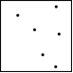

Poisson Disc
- Again an algorithm that places the samples randomly, but then checks that any two are not too close. End result is even but random distribution of samples. Unfortunately, the computational time required for this algorithm is too great to justify its use in real-time rendering.
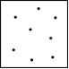

Jittered
- A modification of the grid algorithm to approximate the Poisson disc. A pixel is split into several sub-pixels, but a sample is not taken from the center of each, but from a random point within the sub-pixel. Congregation can still occur, but to a lesser degree.
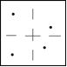

Rotated Grid
- A 2x2 grid layout is used but the sample pattern is rotated to avoid samples aligning on the horizontal or vertical axis greatly improving antialiasing quality for the most commonly encountered cases.
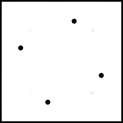
Accumulation Buffer
- This method relates to FSAA, however, instead of using a large off-screen buffer, the image is rendered at the same resolution as the desired output image.
- To obtain a 2x2 Grid sampling, four images are generated with the view moved half a pixel in the screen x or y direction.
- These images are then summed up and averaged to create the final output image.
- Accumulation buffers are part of the OpenGL API

Filtering
- This is the fastest method which involves taking a rendered image, and using neighbouring pixel values to smooth out the ‘jaggies’. This method is much quicker, but is visually inferior to super-sampling.
- Filtering is based around a Kernel, which represents the shape / size and influence of the neighbourhood to be sampled.
- Common Kernels used are:
  - Box
  - Cone
  - Gaussian

Mean Filter
- Mean filtering is an easy way to smooth out images, i.e. reduce the amount of intensity variation between neighbouring pixels. It can also be used to reduce noise within an image.
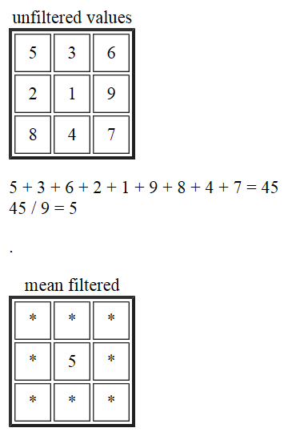

Median Filter
- A variation of the Mean Filter is the Median Filter.
- Instead of simply replacing the pixel with the mean (average) of neighbouring pixel values, it replaces it with the median of those values.
- First, all pixel values within the filter are sorted into numerical order. The pixel is then replaced with the middle value.

Quincunx Filtering
nVidia’s quincunx filtering (GeForce 3 cards) is done at the stage where the buffer is rasterized to the screen. This is built into the hardware.
The pixel shader stores each pixel twice in different locations of the render buffer. This does not cost more rendering power than rendering without anti-aliasing. However, it does require twice the memory bandwidth of the pixel write operation.
Once the first buffer has been fully rendered, all the pixels of the second buffer are (virtually) shifted ½ a pixel in both the x and y directions. This has the effect of surrounding each pixel within the first sample with four pixels of the second sample.
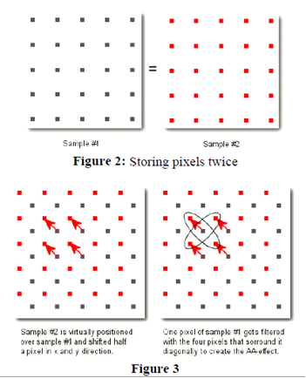
The HRAA-engine filters over all five pixels to create the anti-aliased pixel using the following weighting function:

- A similar approach has been proposed by Cant1 that combines the weighting function used by nVidia as follows:

Adaptive Anti-aliasing
- Anti-aliasing is a relatively expensive process. However, adaptive anti-aliasing, samples just the pixels found along an edge.
- Edges are detected using threshold values – colour intensity changes.
- This speeds up the process considerably. The visual results are inferior to Super-sampling.

MIP Mapping
- MIP is the acronym of the Latin phrase ‘multum in parvo’ which means ‘many things in a small place’

- Mipmaps are textures that have been filtered down repeatedly into smaller images (versions) using super-sampling techniques.
- The texture is down-sampled to a quarter of its’ original area. Each new texel value being calculated as the average of four neighbouring texels from the original image. The reduction is performed recursively until one or both of the dimensions of the texure equals one texel. The set of images is often referred to as a mipmap chain.
- Anti-aliasing is automatically incorporated within each down-sampled image, thus reducing the amount of anti-aliasing needed during the rendering process.

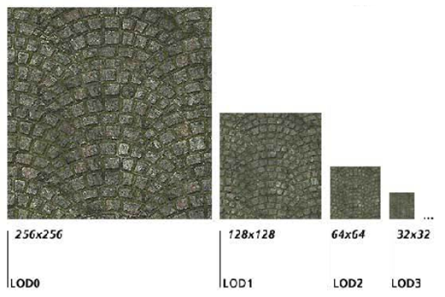

Blobby Surfaces

Background Info:
  - Originally developed by Jim Blinn (1982)
  - Also referred to as blobby molecules, meta balls, or soft objects
  - Implicit Modelling
    - Provide an alternative to conventional 3D polygonal modelling approaches
    - Used to model organic forms, i.e. trees, leaves, arms etc Bloomenthal (1988)
Ref: http://paulbourke.net/geometry/implicitsurf/index.html
- Blobby Surfaces use Field Functions
  - These are based on electron density fields:

  - where r represents the distance from a point in 3D space to a particular control point
  - A number of control points p are used to generate the field
  - We can calculate the total field strength fs as follows:

Computational Cost:
  - Becomes computationally expensive to generate an iso-surface as the number of control points increases
    - As all control points influence the final iso-value for a given point in 3D space.
  - The use of tapers off very quickly. However, its influence only ever tends to infinity
    - Never actually reaches zero
- Blinn’s original field function:
    - ..where, b is related to the standard deviation of the curve, and a the height
    - A ‘half’ Gaussian curve, centered at the origin
Ref: http://paulbourke.net/geometry/implicitsurf/index.html

Meta Balls
- Reduction in computation time:
  - Very small values get clamped to zero
    - ..where a is a scaling factor and b is the maximum distance used to sum contributions to the total density field.
    - Notice the third condition clamps the contribution to zero when

Soft Objects
Attributed to the Wyvill brothers (1986)
where a is a scaling factor, and each control primitive has no influence after a distance b.
Note> Slightly more efficient than Meta Balls because it only uses the squares of the distance - rather than the square roots
Negating the value of a converts the soft object into a subtractive contributor
Used to create holes within objects

Applications
- Often used as the basic building blocks for difficult to model blobby objects
The final iso-surface can be converted to a 3D polygonal mesh using the marching cubes algorithm
Refer to last weeks seminar
Surface topology can be animated - to change its physical shape – i.e. more organic movement.
This would be almost impossible with a polygonal modelling approach

Iso Lines
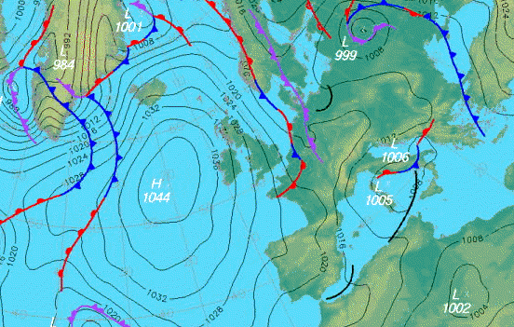
- Steps required to determine if a pixel is part of the isoline:
  - Sum the distance r from a given pixel to each control point using a field function
  - Compare r to a given threshold value
    - Values > the threshold are inside the isoline
    - Values < the threshold are outside the isoline
    - Values for r that equal the threshold value are part of the isoline

Iso-surfaces
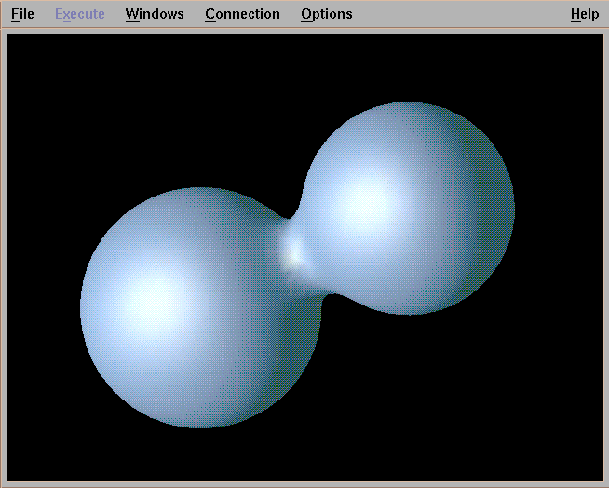

- 3D Example
- Steps required to determine if a 3D point is part of the iso-surface:
  - For each pixel, raycast into the 3D scene
  - Incrementally step along this ray and perform a distance check - i.e. from the current position on the ray, sum the distance r to all control points in the scene using a field function
  - Compare r to a given threshold value
    - Values for r that equal the threshold value are part of the iso-surface
Issues
- The previous approach taken is not suitable for real-time applications
  - This is because the iso-surface is defined as the set of all points in 3D space where the field function is equal to some chosen constant threshold
  - It’s just too costly to evaluate all points within a 3D space
Real-time approaches
- Wyvill suggests an cleaver optimization that consists of two steps:
  - Step 1: Divide the 3D space about the object into a 3D grid of small cubes
    - Starting from the nearest cube
      - Test each corner of the cube, using the field function to determine if the cube straddles the boundary of the iso-surface
      - i.e. some corners are > the threshold (inside), whilst others are < the threshold (outside)
    - Using the fact that all points on an iso-surface are connected:
      - Check neighbouring cubes to determine if they also form part of the iso-surface
      - Store all neighbouring cubes that straddle the surface
  - Step 2: Using the Marching cubes algorithm, create an approximation of the iso-surface
Rendering the iso-surface
- The weighted surface normal for a single point on an iso-surface can be calculated as follows:

Tessellation

Introduction
- What is Tessellation?
  - Tessellation is the process of splitting up a shape into smaller, connected shapes
  - Conversely, we can create larger shapes by piecing together smaller shapes of different size and form.
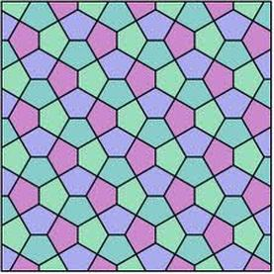
- What is Tessellation?
  - In Computer Graphics, we want to decompose a model, or set of polygons, into a larger collection of smaller polygons in order to add detail to the model.
  - The process of tessellation creates a high resolution model from a low resolution model.
  - Tessellation allows us to dynamically create higher resolution models on the GPU allowing for more realistic looking models to be rendered in real-time.
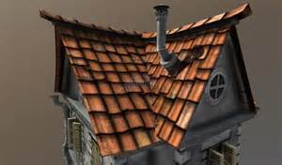
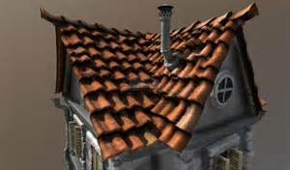
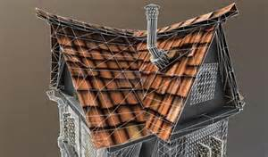

Method
- What we need:
  - 2 points in 2D or 3D space (P1 and P2)
- Tessellation also addresses two long-standing problems in real-time rendering:
    - The creation of higher-order curves and surfaces in real-time on the GPU
    - Real-time adaptive / dynamic level of detail

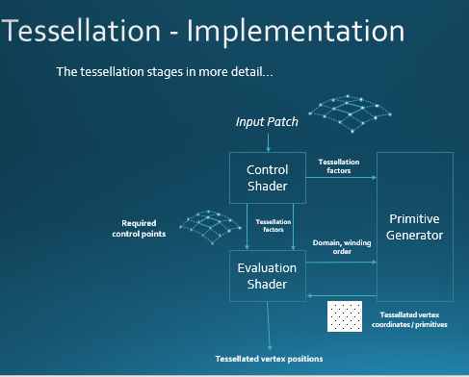

Input Patches
- So far we've focused on polygon based rendering - models are made up of vertices which are connected together to form polygons (typically triangles)
- When we talk about tessellation we often talk about Control Points and Patches instead of vertices and polygons.
- Think of a patch as a polygon and a control point as a vertex but with some key differences:
  - A patch is defined not just by it's own vertices / polygon, but also by surrounding vertices that make up adjacent polygons
  - We never actually render a patch directly, whereas previously the geometry / polygons we sent down the pipeline were rendered. When tessellation is used, the patch is split into smaller polygons that do get rendered.

- Why include neighbouring vertices / adjacent polygons in a patch?
  - This is needed for higher-order surface modelling and dynamic LOD
  - It’s necessary when calculating derivatives and create smooth curves and surfaces.
- The adjacency topologies outlined above are quite limiting.
- OpenGL 4.0 introduces the more flexible GL_PATCHES topology type
- Unlike the above adjacency topologies, there is no mention of the patch / geometry type (i.e. lines or triangles). It’s left to the developer to deal with each patch however they want.
- Input patches are described with vertex and index buffers as are normal polygons. However, the control point ordering is given in the index buffer and the number of vertices per patch is specified with the function glPatchParameteri. This gives a significant amount of freedom in the models we can send to the tessellation stages.
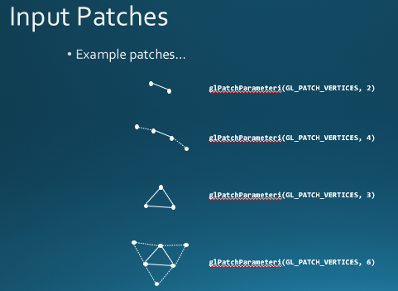
- Although the patch topology types do not specify an underlying polygon type for the patch (which we call the domain), OpenGL provides 3 types of domain over which we can tessellate…
  - quads
  - triangles
  - isolines (curves)

Tessellation Control Shader

Basic
- The Tessellation Control Shader stage has the responsibility of doing two things…
  - Output the relevant control points needed to render the patch (not all control points may be needed – this depends on the application). In the simplest case, the Tessellation Control Shader simply passes all the input control points through as output control points.
  - Output the tessellation factors for the patch. These control how the patch is split into smaller polygons by the tessellation stage.
- gl_in[ ] – implicitly defined array containing control points for the patch such as gl_Position (see notes).
- The number of control points in gl_in is determined by the value passed to glPatchParameteri.
- We can provide our own per-control point input packet too!
- gl_out[ ] – implicitly defined array containing control points for the output patch - including gl_Position.
- We can provide our own per-control point output packet too!
- The number of output control points does not have to match the number of input control points. The control shader will specify the number of output points with a layout statement. For example, to tell the control shader to output 4 control points we would specify…
- layout (vertices = 4) out;
- Addition input variables (built-in)
- gl_InvocationID – Current output vertex we’re processing. The Control Shader runs once per output vertex, not per input-vertex.
- gl_PrimitiveID – Index of current patch being processed.
- gl_PatchVerticesIn – Size of the gl_in array
- gl_PatchVerticesOut – size of the gl_out array (also value specified in the layout statement)
- Tessellation Factors – There are two arrays output (the size dependent on the tessellation domain) that control the outer edge tessellation and the inner patch surface tessellation. These are:
- The amount of tessellation is specified by providing two key items of information:
  - The edge tessellation factor (how much should the edges of the patch geometry be subdivided)
  - The interior tessellation factor (how much should the interior of the patch be subdivided)
- Modern GPUs allow a tessellation factor of between 1 (no tessellation) and (at least) 64.
- Tessellation factors are not limited to integer values! However, it doesn’t make sense to say “split an edge into 2.5 polygons”. As such the tessellation process utilises one of 3 partitioning schemes – more later!.
- The chosen domain of the patch (specified in the evaluation shader) dictates what information needs to be provided in …

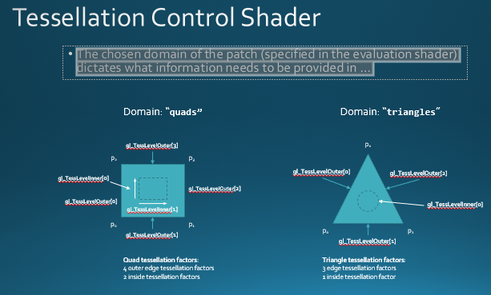
- The chosen domain of the patch dictates what information needs to be provided (continued…)
- When using tessellation, the Tessellation Control Shader needs to do two things as outlined on slide 16 above. To recap, these are:
  - Calculate control points to help generate geometry in the Tessellation Evaluation Shader
  - Calculate the tessellation factors to break down the patch into smaller primitives in the Primitive Generator.
- Many applications don’t really require the first use-case – the input patch is passed through to the Evaluation Shader and only the tessellation factors are created.
- Because of this, OpenGL makes the Control Shader optional!
- When not provided, the control points of the patch pass through directly to the Evaluation Shader.
- When the Control Shader is not provided, the control points of the input patch pass through directly to the Evaluation Shader.
- The tessellation factors are then provided by our C++ code through API calls. For example:
- One caveat: If you want view-dependent tessellation this needs to be calculated on the CPU – unless we use compute shaders for example and read back the results – this is not as convenient as using the Control Shader directly. But the options are there!

Primitive Generator
- The Primitive Generator (or “tessellator” in Direct3D) is a non-programmable unit on the GPU that takes the domain (what shape will be tessellated) and the tessellation factors (how much the shape will be broken down), and subdivides the given domain into a number of smaller primitives.
- The Primitive Generator outputs the primitives using the domain specified in the Evaluation Shader.
- The vertex coordinates are not output as (x, y, z) points in 3D space. Instead, the coordinates generated by the Primitive Generator are domain coordinates (see lecture part 1)

Tessellation Evaluation Shader
Where the Primitive Generator is akin to Primitive Assembly, the Evaluation shader is akin to the Vertex shader, processing the points generated by the Primitive Generator.
The Evaluation shader takes a number of different inputs and specifies the type of primitive to get from the Primitive Generator…
gl_in[] is an implicit array that contains the gl_Position values of control points output from the Control Shader.
In addition, you can provide an input array for your own user-defined data.
Whereas the inputs are specified as arrays, the output of the Evaluation shader is a singular vertex structure – including gl_Position – which is passed to the Geometry Shader or Rasteriser.
As part of the Evaluation Shader we specify the type of domain the Primitive Generator should create, the partitioning scheme and winding order of the generated primitive vertices.

Method
  - A parameter (t) which varies between 0 and 1
- To generate any point on the line between P1 and P2 using the single parameter t:
Pt = P1 + t(P2 – P1)
or…

Pt = (1-t)P1 + tP2
- We refer to t as the parameter and it varies over the domain [0, 1].
- Any other point on the quad can be calculated using the logical, or 2D domain coordinate (u, v).
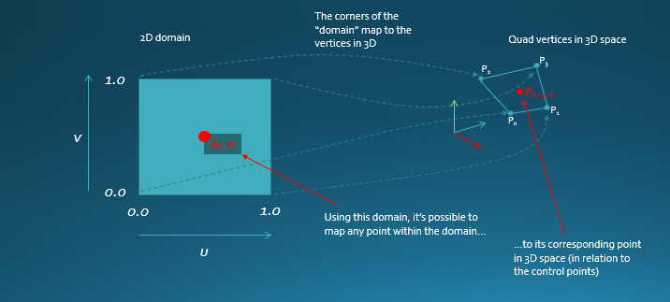Two simple averaging algorithms (which achieve the same result) are as follows…

Bi-linear interpolation…
A = P0 + u(P1 – P0)
B = P2 + u(P2 – P3)
Pxyz = A + v(B – A)
Weighted averaging…
w0 = (1-u) * (1-v)
w1 = u * (1-v)
w2 = u * v
w3 = (1-u) * v
Pxyz = w0P0 + w1P1 + w2P2 + w3P3
The algorithms shown here are simply averaging the control point locations. However, we can use whatever algorithm we want.
Triangle domain
- In the triangle domain, each control point has it’s own barycentric coordinate…
- 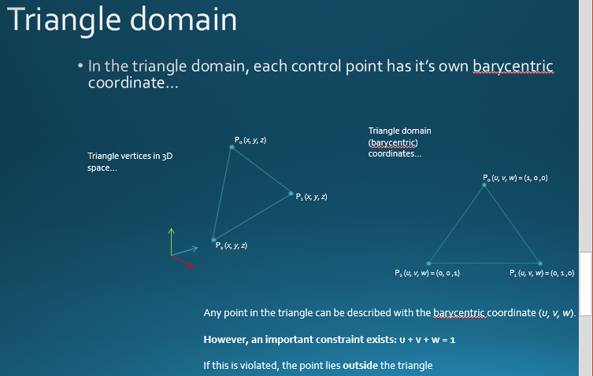

Marching Square Algorithm

Marching Cubes
- Background Info:
  - Published in the 1987 SIGGRAPH proceedings by William E. Lorenson & Harvey E. Cline
  - Used to define an iso-surface
    - Medical imaging
      - Rendering the surface of a 3D point cloud
    - Particle based fluid Dynamics
http://paulbourke.net/geometry/polygonise/
- Explicit Functions
  - Defines a dependent variable with respect to an independent variable
    - Lines: y=mx+b
    - Height fields: height=f(x,y)
- Implicit Functions
  - Defined by a function of all possible points on a surface
    - i.e. the set of zeros of a function of three variables:
f(x, y, z) = 0
- Basic Principle:
  - Subdivide 3D space into a series of small cubes
    - voxels
  - Loop through each cube and test each corner for containment
  - Replace cube with an appropriate set of polygons
  - Sum total of all polygons will be an approximation of the surface described by the original dataset
- Strengths:
  - Combines simplicity with high speed since it works almost entirely on lookup tables
- First, lets start with a simplified version of the marching cubes algorithm
  - Marching Squares Algorithm:
    - 2D domain
    - Using a simple circle as the original shape
    - Create an Isoline (contour line)
      - Defined using the implicit function for a circle:
f (x, y) = 0
- First sub-divide the 2D space up into squares
  - NB> The size of the squares controls the resolution of the object.
    - smaller squares = higher resolution
- Identify all corners contained within the implicit shape
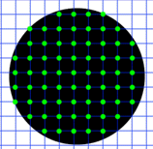
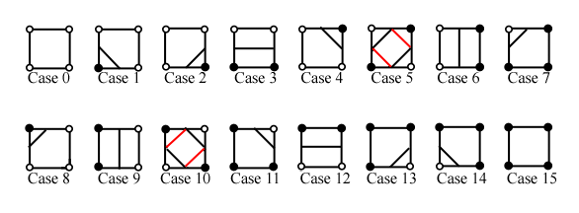
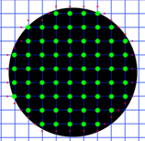
- Approximate intersections using edge mid-point:
- The final step requires joining up each intersection point to create the iso-line!
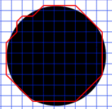
- Improving the final output:
  - Increase the resolution of the grid
  - Linear interpolation along the edges to locate more accurately the point of intersection.
- Suggested optimisation:
  - The generation of line segments used to form the iso-line can be optimised by storing each possible combination in a look-up table

Dividing Cubes
- For medical imaging it is more efficient to display point primitives directly on the display device
- Dividing cubes algorithm sub-divides voxels into smaller cubes that lie on the surface of the object and projects the intensity of the cube onto the viewing plane.
  - Produces a gradient shaded representation of the underlying object
  - Tri-linear interpolation is used to calculate the surface normal at the iso-surface using the eight vertex normals at the voxel.
- The voxel scale is chosen to ensure the size of the small cube corresponds to the size of a pixel on the raster display
- The display resolution, rather than the voxel size, controls the image resolution
- The selection of a surface element equal in size to the pixel is based on the approach taken for ray-tracing.
  - In ray-tracing, the surface is calculated in image space
  - The Dividing Cubes algorithm uses an object space approach to create a display list that is view invariant- i.e. once calculated, the object can be viewed from any orientation.
- The dividing cubes algorithm improves on previous work undertaken to model solid 3D objects using voxels
  - The Dividing Cubes algorithm models the iso-surface representing the mesh object – utilising a sparse-voxel octree
  - Doesn’t waste time/memory calculating and storing data that cannot be seen – i.e. internal sections of a solid object
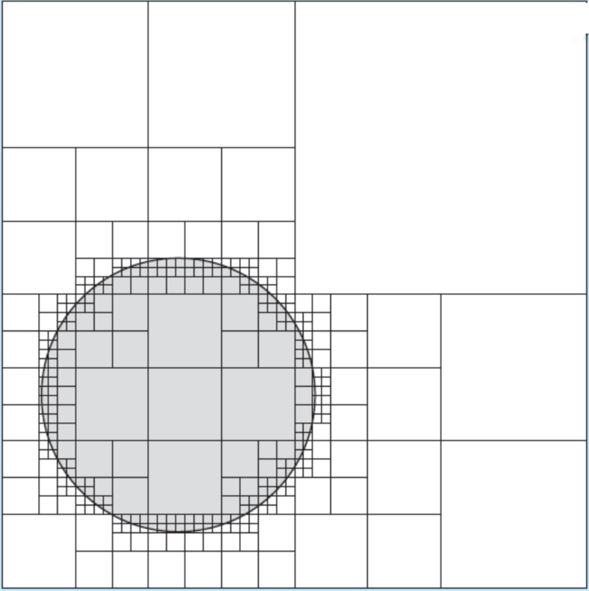

Finger Tracking with the Kinect
- Finger Tracking software
  - A version of the Marching Squares Algorithm was used with the Microsoft Kinect to track the player’s fingers
  - The integrated camera captured a depth point cloud in real-time
    - Each pixel within the image represented the distance from the camera (Kinect) to all visible real-world positions.
- The basic idea – extract finger positions from live camera footage using the marching squares algorithm.
  - OK, so the Kinect no longer exists… but the marching squares algorithm does, and it provides a valid approach used to solve real-world problems
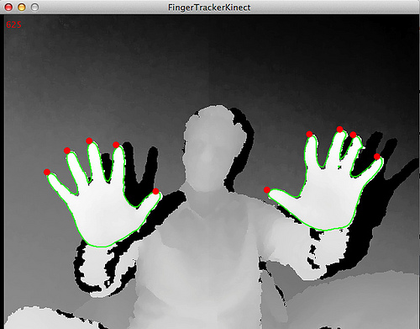

- Thresholding
  - Reduces the image down to a 2bit image
    - i.e. pixel values above / below a given threshold value
      - Note: in the case of the Kinect, the threshold values would be a z-depth range.
  - Take blocks of four pixels
    - Compare each pixel intensity against the given threshold value and set block flags accordingly:

Look-up Tables
- The marching squares algorithm combines simplicity with high speed since it works almost entirely on a set of lookup tables.
  - Once an edge / corner is found (i.e. a mix of pixel depth-values above and below the given threshold value), then the lookup tables are used to determine the direction of travel to traverse the image.
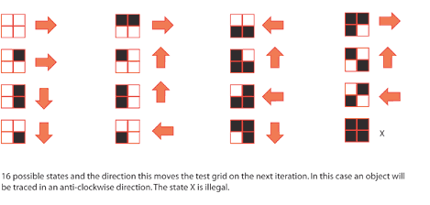

Magic Wand
Many graphics applications (e.g. Photoshop, Illustrator etc.) have tools to help with the selection of parts of an image.
One tool commonly used by the Artist is called the Magic Wand Tool.
Concept:
Select a group of connected pixels that share a common intensity value
Accept / reject neighbouring pixels based on a specified tolerance value
Trace a contour line around the selection
Selections can be used for cut / copy and paste operations within a 2D graphics application

Psuedo code
  - First select a tolerance to control the range of pixel intensity values to use
  - User selects a point from screen – store this starting pixel intensity value
    - The entire image can now be reduced to a 2 bit mask, where all pixels outside the selected pixel intensity (+/- tolerance) can be set to black and those within the specified tolerance set to white (the actual re-processing of the image is not necessary)
  - Step backwards along scan line (checking each neighbouring pixel) to locate left-most boundary pixel with same intensity value (white) as starting pixel
  - Store this boundary pixel position
  - Consider current 2x2 pixel square that includes the current boundary pixel
    - Boundary pixel will be located in either the top left or the bottom left section of the 2x2 pixel block
  - Recursion
    - Draw the current pixel
    - Match-up the 2x2 grid with one of 16 possible combinations and use the corresponding movement directions to step one pixel in the recommended direction around the outline
    - Consider the 2x2 pixel square that includes this new boundary pixel
    - Repeat above step until you reach your starting point

