Embedded Systems Labs – Homework 1
Name: 蔡丞昊 Student ID: B03901028

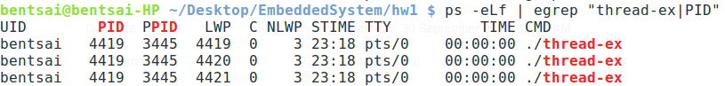
1. thread-ex
We can find that program thread-ex creates three threads with same PID(Process ID) and PPID(Parent Process ID), but different LWP/Thread ID.

2. socket
I create a socket server that continuously runs and sends the time and date when a client connects to it. Then as soon as a socket client is created through a call to socket() function, the client will receive the time and date sent from the server.
3. Raspberry Pi 3 Setup
First I need to prepare a boot SD card for Rpi. After writing Raspberry Jessie Image into SD card, we can use command to verify that two partitions are on SD card:
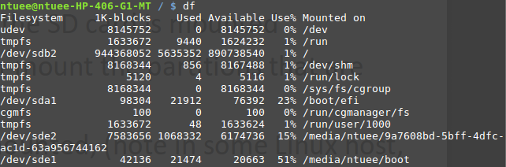
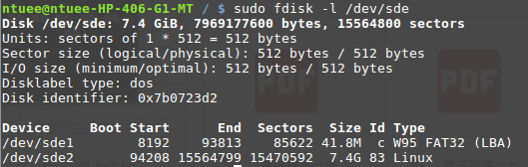
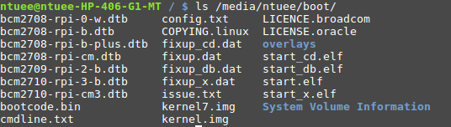
We can check what is in /boot of SD card:
After revising /boot/config.txt, now a boot SD card is prepared.

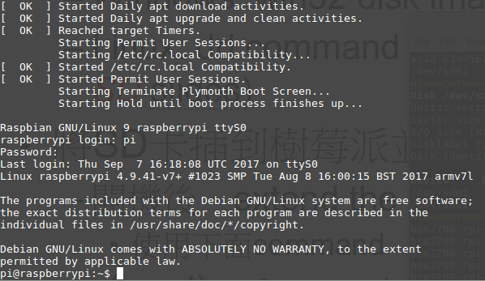
We can use minicom to connect USB-TTL serial console to Rpi to see boot and console messages:

