Soccer Score Tracker

User Manual

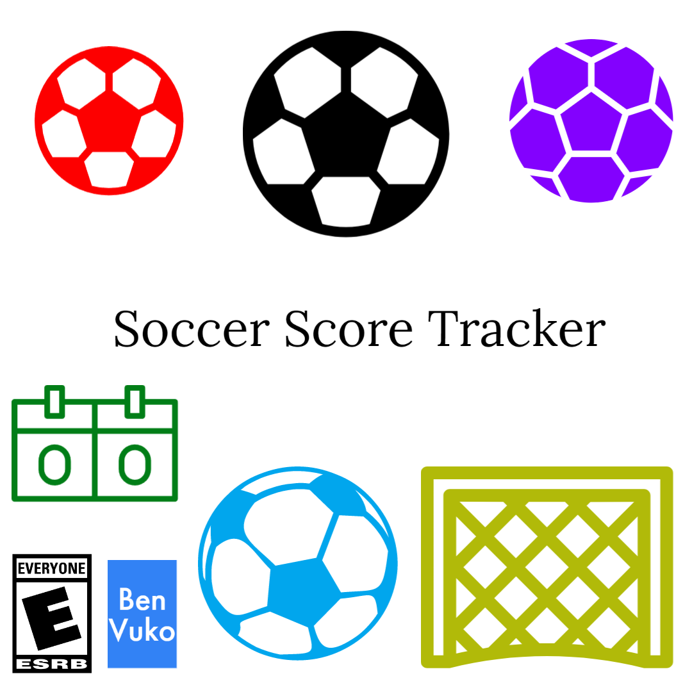

Ben Vuko

Intro to Software Development

Final Project

5/14/2023

Table of Contents

* Table Of Contents …. 1
* Introduction …. 2
* Purpose …. 2
* Requirements …. 3
* Installation …. 3
* Guide To Play …. 4
* Conclusion …. 5

**Introduction**

Soccer Score Tracker is programmed using Python and Tkinter. It is a program that allows users to track the score of a soccer match between two teams. The user manual gives instructions on how to play and how to get it installed as well as the requirements to play.

**Purpose**

The purpose of this program is to help track scores of soccer matches so you don't have to remember it in your head.

**Requirements**

1. Python Installed
2. Tkinter library Installed
3. Pillow Installed

**Installation**

Before, make sure you have installed Python and have all the requirements.

In the folder you found the manual, install the “soccerscoretracker.py”, “soccerball.jpg”, and “clock.jpg” files.

Or Download the Folder.

If you downloaded them separately make sure they are in the same folder or location on your computer.

That's all you need!!!!!

**Guide To Play**

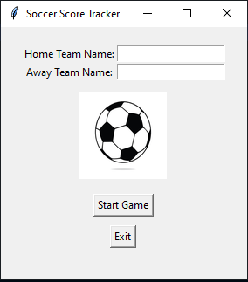To Start Playing, open the soccerscoretracker.py file in python

Run to start the program

A window will pop up: —--------→

Click the Home Team Box

Type the Name of the Home Team

Click the Away Team Box

Type the Name of the Away Team

Click the Start Game Box.

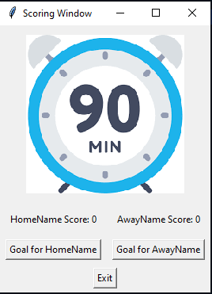The window will close and another will open

This is the start of score tracking —→

Whenever a team scores,

Click the Goal for button for that team

When the game is over,

It will have the score tracked

And all you have to do is click exit

At any moment you can hit exit to leave

**Conclusion**

This was Soccer Score Tracker

Thank You for Reading the Manual

Have fun with the soccer matches

And do a good job keeping score

Hopefully this program helps

