Bottom trawl survey age and length composition input sample sizes for stocks assessed with statistical catch-at-age assessment models at the Alaska Fisheries Science Center

by

Peter-John F. Hulson1,*, Benjamin C. Williams1, Matthew R. Siskey4, Meaghan D. Bryan2, and Jason Conner3

1 Auke Bay Laboratories, Alaska Fisheries Science Center, National Marine Fisheries Service, National Oceanic and Atmospheric Administration, 17109 Point Lena Loop Rd., Juneau, AK 99801  
2 Resource Ecology and Fisheries Management Division, Alaska Fisheries Science Center, National Marine Fisheries Service, National Oceanic and Atmospheric Administration, 7600 Sand Point Way NE, Seattle, WA 98115  
3 Resource Assessment and Conservation Engineering Division, Alaska Fisheries Science Center, National Marine Fisheries Service, National Oceanic and Atmospheric Administration, 7600 Sand Point Way NE, Seattle, WA 98115  
4 School of Aquatic and Fishery Sciences, University of Washington, Seattle, WA, USA

* Correspondence: [Peter-John F. Hulson <[pete.hulson@noaa.gov](mailto:pete.hulson@noaa.gov)>](mailto:pete.hulson@noaa.gov)

Month 2023

# ABSTRACT

At the Alaska Fisheries Science Center (AFSC) a number of fish stocks are assessed using statistical catch-at-age (SCA) models. SCA models integrate various sources of data to inform estimation of population dynamics and management quantities for fisheries that target these stocks. Two important information sources are age and length composition data, from fishery-independent (survey) and fishery-dependent sources. When used in statistical catch-at-age models, age and length composition data require determining *a priori* the ‘input sample size’ to weight their relative influence to other data sources fit within the assessment model. We developed an R-package that uses bootstrap methods to estimate input sample size for age and length composition data from bottom trawl surveys conducted by the AFSC in the eastern Bering Sea, Aleutian Islands, and Gulf of Alaska. Here we present annual input sample size estimates for length and age compositions (including sex-specific and sex combined compositions, and sub-regional compositions within the Gulf of Alaska) collected during Alaska bottom trawl surveys. These new input sample size estimates provide an objective method that follows the sampling design of the bottom trawl surveys for fishery stock assessments. We recommend that these input sample size estimates become a standard bottom trawl survey data product that are available to assessment authors for inclusion into AFSC fishery stock assessments.

# CONTENTS

Introduction

Materials and Methods

Survey Data

Expanding Length Frequency to Population Abundance-at-Length

Expanding Specimen Collections to Population Abundance-at-Age

Bootstrap Framework for Estimating Age and Length Composition Input Sample Size

Computing Effective and Input Sample Size

Results

Discussion

Acknowledgments

Citations

# INTRODUCTION

Under the North Pacific Fishery Management Council (NPFMC) Fishery Management Plan (FMP) for the Eastern Bering Sea, Aleutian Islands, and Gulf of Alaska, Tier 1–3 stocks use statistical catch-at-age assessment models to estimate population and management quantities (NPFMC 2020a, 2020b). While these models can vary in their specific implementation across stocks (i.e., due to differences in parameterization, error structures, or data availability), a critical and ubiquitous data component is age and length composition data. Age and length composition data are collected on both fishery-independent (e.g., bottom trawl or longline surveys) and fishery-dependent platforms, providing critical data to assessments in order to track population changes over time. The Alaska Fisheries Science Center (AFSC) operates fishery-independent bottom trawl surveys (Stauffer 2004), spanning most of the continental shelf for federal waters off of Alaska. These waters include the Bering Strait, including the eastern Bering Sea (EBS), the Aleutian Islands (AI), and the Gulf of Alaska (GOA) and provide age and length composition data for 26 stocks (or stock complexes) assessed with statistical catch-at-age models.

At the AFSC, age and length frequency sampling from bottom trawl surveys is used in stock assessment models in many ways to inform estimates of population abundance that are subsequently used to set management quantities. The most common use of length frequency sampling is to derive estimates of the population abundance-at-length that are used in conjunction with an age-length key to estimate population estimates at age, which are then converted to age composition estimates and fit in the model (e.g., Monnahan et al. 2021, Spencer and Ianelli 2022). Length frequency samples are also used in many assessments in a conditional-age-at-length framework (Rudd et al. 2021) that both fit the length compositions and enables estimation of growth internally to the assessment (e.g., McGilliard and Palsson 2017). In some cases, where age data is not available, length frequency samples which have been expanded to population abundance-at-length estimates are used directly as composition data within the assessment (e.g., McGilliard et al. 2019). Finally, recent developments have incorporated using length frequency samples in a model-based framework to estimate length and age composition estimates (Thorson and Haltuch 2019, Ianelli et al. 2021, Thompson et al. 2021).

Predominantly, the multinomial likelihood is used to fit age and length composition data at the AFSC (e.g., Bryan and Palsson 2021), while recently the Dirichlet-Multinomial has also been explored (e.g., Barbeaux et al. 2022). A common requirement, regardless of the likelihood employed, is a pre-determination of the input sample size that is used to ‘weight’ the particular year’s age or length composition data that subsequently influences the precision of the assessment model’s fit. Over the years, a variety of approaches have been used at AFSC to set the input sample size in stock assessments. These include selecting a constant value (e.g., Hulson et al. 2022), relating the input sample size to the number of hauls from which age or length composition data was collected (e.g., Spencer and Ianelli 2022), relating the input sample size to the nominal sample size (e.g., Hulson et al. 2021), or relating the input sample size to some combination of hauls and nominal sample size (e.g., Williams et al. 2022). Overall, there is no consensus method that is agreed upon at the AFSC to determine input sample size.

Stewart and Hamel (2014) introduced a method in which bootstrap techniques were used to resample age and length composition data that provides an estimate of the input sample size that can be used within assessment models. The primary advantage of this method is that it provides an objective framework from which estimates of input sample size are obtained that mimic the sampling design employed, either on a fishery-independent survey or on fishery-dependent platforms. Here, we apply the methods of Stewart and Hamel (2014) to obtain estimates of input sample size for age and length composition data obtained by the AFSC bottom trawl surveys in the EBS, AI, and GOA for all stocks assessed at AFSC with statistical catch-at-age assessment models. The main objectives of this technical memorandum are to 1) document methods used by AFSC for expanding length and age collections to population abundance estimates (which are subsequently used as composition data in stock assessments), 2) present stock-specific results of historical input samples size from AFSC bottom trawl surveys for Tier 1-3 stocks, and 3) record methods for estimating input sample sizes of survey-based age and length compositions using a two-stage bootstrapping approach.

# MATERIALS AND METHODS

## Survey Data

Data collection for each AFSC groundfish survey is described in respective NOAA Technical Memorandum (EBS: Lauth et al. 2019, AI: von Szalay et al. 2017, GOA: von Szalay and Raring 2018). Length frequency protocols and recent analysis of sex-specific length frequency data are further described in Hulson et al. (2023). To facilitate age estimation, individual fish are processed at sea to record sex, length and weight and to remove sagittal otoliths that are returned to the AFSC Age and Growth laboratory for age determination. Survey age sampling protocols are specific by fish species and follow 1 of 2 paradigms: 1) a stratified collection that is distributed over both the spatial frame of the stratification scheme and the expected size range of a species; or 2) a small subsample (3-6 fish, depending on species) collected randomly per trawl. The protocol for some species has changed over the time series, which has followed a trend of transitioning from protocol 1) to protocol 2). Species within each survey that are assessed with statistical catch-at-age models were selected to be included in this analysis (Tier 1-3 stock assessments, Table 1). Data from AFSC bottom trawl surveys conducted in the EBS shelf (1982 to present), EBS slope (2002, 2004, 2008, 2010, 2012, and 2016), AI (1991 to present), and GOA (1990 to present) were used to estimate input sample size for each of these stock assessments in this study.

## Expanding Length Frequency to Population Abundance-at-Length

Length frequency samples collected by the AFSC bottom trawl surveys are expanded by catch and stratum area to obtain estimates of population abundance-at-length (this approach is also detailed in Hulson et al. 2023, we include the description here to provide a source for both the length and age expansions). This is often referred to as the ‘first stage expansion’ and is a common method to obtain population estimates at length from area-swept survey data (Miller and Skalski,2006). Population abundance-at-length are computed for three sex categories: males, females, and unsexed at the stratum level, which are then summed across stratum to obtain the population abundance-at-length for the management-scale region (i.e., EBS, AI, or GOA), these can also be summed to any sub-region level.

In the first step of this process we compute the overall population numbers in year-*y* within stratum-*st* () with

where is the area of stratum-*st* (in km2), and is the average catch per unit effort of numbers captured across the hauls within a strata, given by

where is the number of hauls, is the catch per unit effort of numbers caught within a haul-*h*, is the catch (in numbers) in haul-*h*, and is the effort in haul-*h*, which is computed as the net width multiplied by the time on bottom, or, the area swept by the haul (in km2). Next, the ratio of catch per unit effort among hauls () is computed by

where is the catch per unit effort in numbers caught within a haul-*h*. We then compute the sex-specific ratio of the total number of lengths sampled within a haul by length () with

where is the length frequency sampled, in numbers, by sex-*sx* and length-*l*. In some cases there are hauls that have catch for a species but did not collect length frequency data, in this case (2) is applied in order to account for the unknown length frequency in these hauls, otherwise, if length frequency samples are obtained case (1) is applied. Finally, we estimate the sex-specific population abundance-at-length within strata-*st* with

and to obtain the sex-specific estimates of population abundance-at-length in a management area one would simply sum across strata.

## Expanding Specimen Collections to Population Abundance-at-Age

In the second stage expansion the sex-specific estimates of population abundance-at-length are used to estimate sex-specific population abundance-at-age. The annual specimen data collected during the survey, which includes observations of age at length, are first populated into sex-specific numbers at age and length (). Next, the sex-specific numbers at age and length are converted to sex-specific proportions of age at length with

The proportions of age at length are then expanded to population abundance-at-age with

where is the population abundance-at-length from (5) summed across strata. For specimen data with observations of sex (either female or male), the sex-specific specimen data are used, however, for specimen data without observations of sex the specimen data is pooled across all sexes and the unsexed population abundance-at-length is then applied to the pooled specimen data to estimate unsexed population abundance-at-age.

Two general categories of special cases for several stock assessments were also included in our analysis: 1) spatially-explicit assessments, and 2) assessments for species complexes. Age population estimates are computed at the management area scale (e.g., the entire GOA, AI, or EBS) for the majority of stocks assessed at AFSC; however, we note that there are two flatfish stock assessments that are spatially-explicit in the GOA (McGilliard and Palsson 2017, Bryan and Palsson 2021). While in the preceding equations we do not include a subscript for sub-region, population abundance-at-age can be estimated by sub-region through summing the population abundance-at-length in equation (5) across strata within the sub-region and applying equations (6) and (7) to specimen data that is subsetted to the sub-region. We have developed functions to estimate population abundance-at-age by sub-region, and by a combination of sub-regions within the GOA to allow for this flexibility in estimating population abundance-at-age. There are also assessments evaluating stocks at a complex level, where several species are included together in an assessment. There are two stock complexes at AFSC in which the species are combined and assessed within the same statistical catch-at-age model: blackspotted and rougheye rockfish in the GOA and AI (Spencer et al. 2020, Sullivan et al. 2021). Between the two management regions there are subtle differences in how the population abundance-at-age is estimated from the survey specimen data; we have developed functions that allow for these differences and estimate population abundance-at-age for these two stock complexes. In a similar case, while not assessed as a complex, over the historical bottom trawl survey in the GOA several species codes have been used for dusky rockfish. We have also developed a custom function that estimates population abundance-at-length and age for this case.

## Bootstrap Framework for Estimating Age and Length Composition Input Sample Size

To estimate the historical input sample sizes for age and length compositions of stocks assessed at AFSC we developed a bootstrap framework based on the methodology outlined in Stewart and Hamel (2014). The bootstrap framework is composed of a suite of nested resampling (with replacement) protocols. Functions to run the sampling protocols were developed in a compartmentalized manner to provide for flexibility in exploring desired resampling protocols. The order of operations (Figure 1) has the following schedule, with steps 1-3 being optional switches:

1. Resample hauls from the set of hauls with associated catch per unit effort (in numbers)
2. Within the resampled hauls from step 1, resample the observed length frequency data
3. Within the resampled hauls from step 1, resample the observed specimen data
4. From the resampled length frequency data in step 2, calculate sex-specific population abundance-at-length, using equations (1) - (5)
5. From the resampled specimen data in step 3 and the sex-specific population abundance-at-length in step 4, calculate sex-specific population abundance-at-age, using equations (6) - (7)

Steps 1-5 were repeated iteratively, providing sex-specific population abundance-at-length and age that was then compared to the observed sex-specific population abundance-at-length and age as from the bottom trawl surveys. We completed 500 iterations of the bootstrap-simulation, variability in the population abundance-at-length results stabilized at that point. The bootstrap-simulation was developed in R (R Core Team 2022) and is available via GitHub as an R package (<https://github.com/BenWilliams-NOAA/surveyISS> *still need to make this a package*).

## Computing Effective and Input Sample Size

Effective sample size (ESS), as introduced by McAllister and Ianelli (1997), is a statistic that can evaluate the level of intra-haul correlation in age or length composition samples that are collected on a survey. It is also a statistic that can evaluate the amount of uncertainty in an estimated composition compared to an observed composition. Effective sample size is given by

where is the estimated proportion for category-*c* (which can be either age or length or any other arbitrary category across which proportions are computed) and is the observed proportion. A higher ESS indicates less uncertainty in the composition estimates, while lower ESS indicates more uncertainty.

In this bootstrap-simulation, we used effective sample size to calculate uncertainty in length compositions for each simulation replicate where the underlying age and length compositions derived from the historical bottom trawl surveys was treated as the observed proportions in equation (8). For each iteration of the bootstrap we computed a sex-specific estimated proportion () that was then compared to the underlying historical sex-specific age and length composition (the effective sample size for the total age and length compositionwas also computed as the sum of population abundance-at-age and length). Thus, for each iteration of the simulation, we computed an effective sample size that quantifies the amount of uncertainty that resulted from each iteration of sub-sampling sexed length frequency data.

Input sample size (ISS) is defined as a metric of uncertainty used in data-weighting procedures for stock assessment models. An input sample size is usually assigned to annual length compositions in the model fitting process, but there are a variety of methods for calculation and are closely related to the information content of the data product in question. To summarize uncertainty across bootstrap replicates of ESS, we calculated ISS as the harmonic mean of effective sample size across bootstrap iterations

where is the annual input sample size, is the effective sample size for iteration-*i*, and *I* is the total number of iterations for which the bootstrap procedure is run. The harmonic mean has been shown to reduce bias in recovering the true sample size in simulations for a multinomial distribution. Due to this reduction in bias the harmonic mean has also been recommended to determine the *ISS* that is used in stock assessment models to fit compositional data (Stewart and Hamel 2014). Herein, when we use the term ‘effective sample size or ESS’ we are referring to the effective sample sizes that were computed for each iteration of the bootstrap-simulation from equation (8), when we use the term ‘input sample size or ISS’ we are referring to the harmonic mean of the iterated effective sample sizes from equation (9).

# RESULTS

Average age and length composition nominal sample sizes (rounded to the nearest 10s for age and 100s for length) for the bottom trawl surveys evaluated are shown in Tables 2 - 3. Across the surveys, average sex-specific length composition nominal sample size ranged from around 300 to upwards of 35,000 samples per year, where the total length composition nominal sample size (for all sexes combined) ranged from around 700 to upwards of 82,000 per year. The most frequently sampled species for length frequency within in eastern Bering Sea shelf survey were walleye pollock, yellowfin sole, northern rock sole, and arrowtooth flounder, and in the eastern Bering Sea slope survey were arrowtooth flounder, kamchatka flounder, and Pacific ocean perch (Table 2). The most frequently sampled species for length frequency within the Aleutian Islands bottom trawl survey were Pacific ocean perch, walleye pollock, and arrowtooth flounder and in the Gulf of Alaska bottom trawl survey were arrowtooth flounder, walleye pollock, and Pacific ocean perch (Table 3). Across the surveys, average sex-specific age composition nominal sample sizes ranged from around 130 to nearly 850 per year, where the total age composition nominal sample size (for all sexes combined) ranged from nearly 300 to over 1,500 per year. It was commonly the case that the most frequently sampled species in each survey for age composition were the most frequently sampled species for length composition.

The age and length composition ISS output of the surveyISS package is structured by year, species (using the AFSC survey species code), sex, and region (an example of the output is shown in Table 4). Using walleye pollock total (combined sex) age composition as an example, ISS is produced by year for each survey the stock is sampled from Figure (2). Sex specific, yellowfin sole age composition from the EBS shelf survey composition ISS is shown in Figure (3). For all species sampled in each survey, the range and median of total and sex-specific length composition ISS across survey years is shown in Figure 4, and age composition ISS is shown in Figure 5. Sub-regional ISS for age and length composition can also be estimated within the GOA survey, and is shown in Figures 6 - 7. These results show that the length composition ISS ranged from the hundreds to thousands, and were larger than the age composition ISS. Additionally, the sex-specific ISS for either length or age composition were smaller than the ISS for the total age compositions. For both the age and length compositions ISS the magnitude was species-specific, and was closely related to the overall sampling intensity for age and length observations from the surveys.

Whether for age or length compositions (including sex-specific composition data) the ISS was smaller than the nominal sample sizes (Figure 8, shown for age compositions) and there was a generally increasing trend between nominal sample size and input sample size. Comparing the age composition ISS to the number of hauls from which age samples were obtained did not result in a strong relationship for the flatfish and gadids sampled in the AFSC surveys, but there was an increasing trend for the rockfish species (Figure 9). There was an increasing trend between age composition ISS per sampled haul and the number of samples per sampled haul for most of the species sampled, this trend was most striking for the flatfish species (Figure 10). The ISS for age compositions sampled during AFSC surveys was 2.6 per sampled haul for flatfish, 1.7 per sampled haul for gadids, and 1.5 per sampled haul for rockfish. This translated to 0.36 ISS per age sample for flatfish, 0.22 ISS per age sample for gadids, and 0.26 ISS per age sample for rockfish.

# DISCUSSION

Here we have presented an application of the method outlined in Stewart and Hamel (2014) to produce annual age and length composition ISS for fishery stocks assessed by AFSC with statistical catch-at-age models for the bottom trawl surveys conducted in the EBS shelf, slope, AI and GOA by AFSC. This application produces total (combined sex) and sex-specific ISS, as well as sub-region ISS within the GOA bottom trawl survey. We find that the magnitude of age and length compositions can vary across stocks and years, where generally, age composition ISSs ranges from the tens to hundreds (with an average age ISS of around 100 across all years and species) and length composition ISSs ranges from the hundreds to thousands (with an average length ISS of around 1,000 across all years and species). This is not surprising, given that the magnitude of sampling for length frequency is much larger than sampling for ages. We also find that the sex-specific ISS is smaller than the total (combined sex) ISS, which again, is not surprising given the relatively smaller sampling intensity for sex-specific samples. We will note from this result that care and intentionality should be taken when developing and implementing sex-specific assessments given this increase in uncertainty in composition data.

At the AFSC, as noted previously, there are a myriad of approaches take to set ISS for age and length composition data used in assessments. There is no generally agreed upon approach, however, a common approach that has been implemented is to make ISS some function of the number of hauls. This follows from a result of Pennington et al. (2000) that found the age composition ISS to be one per sampled haul. Herein we find that the average age composition ISS per haul by species group (gadid, flatish, and rockfish) to be larger than one per sampled haul. We also find that there is no clear relationship between the number of sampled hauls and the magnitude of ISS, particularly for gadids and flatfish. There was, however, a stronger trend for rockfish. It is unclear as to the consequence of ISS misspecification in AFSC assessments that use the number of sampled hauls as a proxy for ISS, as ISS misspecification can lead to bias model results (Stewart and Monnahan 2017, Xu et al. 2020). We note that the results of the analysis conducted here does not strongly support the approach of using hauls as a proxy due to the large uncertainty and lack of correspondence when comparing ISS to the number of sampled hauls. The results of this analysis showed an increasing trend between the age composition ISS per haul and the number of ages sampled per haul. Therefore, we support increasing the number of hauls sampledrather than reducing the total number of hauls and increasing per haul sampling(e.g., Siskey et al. 2023).

A strength of the methodology presented by Stewart and Hamel (2014) is that it provides an objective method that produces estimates of ISS that follow from the sampling design employed. As such, this approach has been adopted in a number of assessments, both internationally and domestically. For example, this bootstrap approach has been applied to weight compositional data within the Pacific halibut stock assessment performed by the International Pacific Halibut Commission (Stewart and Allan 2022). If adopted within assessments conducted at AFSC, this approach would provide an objective and unifying method to set ISS when weighting compositional data. Further analysis to be developed and conducted includes constructing methods that apply the bootstrap approach to fishery-dependent age and length composition used in AFSC assessments. We recommend that the surveyISS package be adopted and further developed by assessment and survey programs at AFSC so that bootstrap derived ISS is a standard data product available to scientists conducting assessments with statistical catch-at-age models at AFSC.

# ACKNOWLEDGMENTS

We thank *reviewers* for their helpful reviews of this manuscript. All the staff who have spent time at sea and staring through microscopes to produce the data these analyses are based upon.

# CITATIONS

Ailloud, L.E., and Hoenig, J.M. 2019. A general theory of age-length keys: Combining the forward and inverse keys to estimate age composition from incomplete data. ICES Journal of Marine Science 76(6): 1515–1523.

Barbeaux, S.J., Barnett, L., Connor, J., Nielson, J., Shotwell, S.K., Siddon, E., and Spies, I. 2022. Assessment of the Pacific cod stock in the Eastern Bering Sea. *In* Stock Assessment and Fishery Evaluation Report for the Groundfish Resources of the Bering Sea and Aleutian Islands. North Pacific Fishery Management Council, 1007 West 3rd Ave., Suite 400, L92 Building, 4th floor, Anchorage, AK 99501.

Bryan, M.D., and Palsson, W. 2021. Assessment of the northern and southern rock sole (*Lepidopsetta polyxstra* and *bilineata*) stocks in the Gulf of Alaska. *In* Stock Assessment and Fishery Evaluation Report for the Groundfish Resources of the Gulf of Alaska. North Pacific Fishery Management Council, 1007 West 3rd Ave., Suite 400, L92 Building, 4th floor, Anchorage, AK 99501.

Hulson, P.-J.F., Barbeaux, S.J., Ferriss, B., McDermott, S., and Spies, I. 2022. Assessment of the Pacific cod stock in the Gulf of Alaska. *In* Stock Assessment and Fishery Evaluation Report for the Groundfish Resources of the Gulf of Alaska. North Pacific Fishery Management Council, 1007 West 3rd Ave., Suite 400, L92 Building, 4th floor, Anchorage, AK 99501.

Hulson, P.-J.F., Williams, B., Bryan, M., Conner, J., Siskey, M., Stockhausen, W., Mcdermott, S., and Long, C. 2023. Sub-sampling of length frequency to determine sex in Alaska Fishery Science Center bottom trawl surveys. U.S. Department of Commerce. NOAA Technical Memorandum NMFS-AFSC-464: 47 p.

Hulson, P.-J.F., Williams, B.C., Fissel, B.E., Ferriss, B.E., Hall, M., Yasumiishi, E.M., and Jones, D.T. 2021. Assessment of the Pacific ocean perch stock in the Gulf of Alaska. *In* Stock Assessment and Fishery Evaluation Report for the Groundfish Resources of the Gulf of Alaska. North Pacific Fishery Management Council, 1007 West 3rd Ave., Suite 400, L92 Building, 4th floor, Anchorage, AK 99501.

Ianelli, J.I., Fissel, B., Stienessen, S., Honkalehto, T., Siddon, E., and Allen-Akselrud, C. 2021. Assessment of the walleye pollock stock in the eastern Bering Sea. *In* Stock Assessment and Fishery Evaluation Report for the Groundfish Resources of the Bering Sea and Aleutian Islands. North Pacific Fishery Management Council, 1007 West 3rd Ave., Suite 400, L92 Building, 4th floor, Anchorage, AK 99501.

Lauth, R.R., Dawson, E.J., and Conner, J. 2019. Results of the 2017 eastern and northern Bering Sea continental shelf bottom trawl survey of groundfish and invertebrate fauna. U.S. Department of Commerce. NOAA Technical Memorandum NMFS-AFSC-396: 260 p.

McAllister, M.K., and Ianelli, J.N. 1997. Bayesian stock assessment using catch-age data and the sampling-importance resampling algorithm. Canadian Journal of Fisheries and Aquatic Sciences 54(2): 284–300.

McGilliard, C.R., and Palsson, W. 2017. Assessment of the rex sole stock in the Gulf of Alaska. *In* Stock Assessment and Fishery Evaluation Report for the Groundfish Resources of the Gulf of Alaska. North Pacific Fishery Management Council, 1007 West 3rd Ave., Suite 400, L92 Building, 4th floor, Anchorage, AK 99501.

McGilliard, C.R., Palsson, W., Havron, A., and Zador, S. 2019. Assessment of the Deepwater Flatfish stock complex in the Gulf of Alaska. *In* Stock Assessment and Fishery Evaluation Report for the Groundfish Resources of the Gulf of Alaska. North Pacific Fishery Management Council, 1007 West 3rd Ave., Suite 400, L92 Building, 4th floor, Anchorage, AK 99501.

Miller, T.J., and Skalski, J.R. 2006. Integrating design- and model-based inference to estimate length and age composition in north pacific longline catches. Canadian Journal of Fisheries and Aquatic Sciences 63(5): 1092–1114.

Monnahan, C.C., Dorn, M.W., Deary, A.L., Ferriss, B.E., Fissel, B.E., Honkalehto, T., Jones, D.T., Levine, M., Rogers, L., Shotwell, S.K., Tyrell, A., and Zador, S. 2021. Assessment of the walleye pollock stock in the Gulf of Alaska. *In* Stock Assessment and Fishery Evaluation Report for the Groundfish Resources of the Gulf of Alaska. North Pacific Fishery Management Council, 1007 West 3rd Ave., Suite 400, L92 Building, 4th floor, Anchorage, AK 99501.

NPFMC. 2020a. Fishery Management Plan for Groundfish of the Bering Sea and Aleutian Islands Management Area. North Pacific Fishery Management Council, 1007 West 3rd Ave., Suite 400, L92 Building, 4th floor, Anchorage, AK 99501.

NPFMC. 2020b. Fishery Management Plan for Groundfish of the Gulf of Alaska. North Pacific Fishery Management Council, 1007 West 3rd Ave., Suite 400, L92 Building, 4th floor, Anchorage, AK 99501.

Pennington, M., Burmeister, L.M., and Hjellvik, V. 2000. Assessing the precision of frequency distributions estimated from trawl-survey samples. Fishery Bulletin 100(1): 74–80.

R Core Team. 2022. R: A language and environment for statistical computing. R Foundation for Statistical Computing, Vienna, Austria. Available from <https://www.R-project.org/>.

Rudd, M.B., Cope, J.M., Wetzel, C.R., and Hastie, J. 2021. Catch and length models in the Stock Synthesis framework: expanded application to data-moderate stocks. Frontiers in Marine Science 8.

Siskey, M.R., Punt, A.E., Hulson, P.-J.F., Bryan, M.D., Ianelli, J.N., and Thorson, J.T. 2023. The estimated impact of changes to otolith field-sampling and ageing effort on stock assessment inputs, outputs, and catch advice. Canadian Journal of Fisheries and Aquatic Sciences 80(1): 115–131.

Spencer, P.D., and Ianelli, J.I. 2022. Assessment of the Pacific ocean perch stock in the Bering Sea/Aleutian Islands. *In* Stock Assessment and Fishery Evaluation Report for the Groundfish Resources of the Bering Sea and Aleutian Islands. North Pacific Fishery Management Council, 1007 West 3rd Ave., Suite 400, L92 Building, 4th floor, Anchorage, AK 99501.

Spencer, P.D., Ianelli, J.I., and Palsson, W.A. 2020. Assessment of the Blackspotted and Rougheye Rockfish stock complex in the Bering Sea/Aleutian Islands. *In* Stock Assessment and Fishery Evaluation Report for the Groundfish Resources of the Bering Sea and Aleutian Islands. North Pacific Fishery Management Council, 1007 West 3rd Ave., Suite 400, L92 Building, 4th floor, Anchorage, AK 99501.

Stauffer, G. 2004. NOAA Protocols for Groundfish Bottom Trawl Surveys of the Nation’s Fishery Resources. U.S. Department of Commerce. NOAA Technical Memorandum NMFS-F/SPO-65: 205 p.

Stewart, I.J., and Allan, H. 2022. Assessment of the Pacific halibut(*Hippoglossus stenolepis*) stock at the end of 2022. *In* IPHC-2023-SA-01. International Pacific Halibut Commission, 2320 W Commodore Way, Seattle, WA 98199.

Stewart, I.J., and Hamel, O.S. 2014. Bootstrapping of sample sizes for length-or age-composition data used in stock assessments. Canadian Journal of Fisheries and Aquatic Sciences 71(4): 581–588.

Stewart, I.J., and Monnahan, C.C. 2017. Implications of process error in selectivity for approaches to weighting compositional data in fisheries stock assessments. Fisheries Research 192: 126–134.

Sullivan, Jane Y, Shotwell, S.K., Hanselman, D.H., Hulson, P.-J.F., Williams, B.C., Yasumiishi, E.M., and Ferriss, B.E. 2021. Assessment of the Rougheye and Blackspotted Rockfish stock complex in the Gulf of Alaska. *In* Stock Assessment and Fishery Evaluation Report for the Groundfish Resources of the Gulf of Alaska. North Pacific Fishery Management Council, 1007 West 3rd Ave., Suite 400, L92 Building, 4th floor, Anchorage, AK 99501.

Thompson, G.G., Barbeaux, S., Connor, J., Fissel, B., Hurst, T., Laurel, B., O’Leary, C.A., Rogers, L., Shotwell, S.K., Siddon, E., Spies, I., Thorson, J.T., and Tyrell, A. 2021. Assessment of the Pacific cod stock in the eastern Bering Sea. *In* Stock Assessment and Fishery Evaluation Report for the Groundfish Resources of the Bering Sea and Aleutian Islands. North Pacific Fishery Management Council, 1007 West 3rd Ave., Suite 400, L92 Building, 4th floor, Anchorage, AK 99501.

Thorson, J.T., and Haltuch, M.A. 2019. Spatiotemporal analysis of compositional data: Increased precision and improved workflow using model-based inputs to stock assessment. Canadian Journal of Fisheries and Aquatic Sciences 76(3): 401–414.

von Szalay, P.G., and Raring, N.W. 2018. Data Report: 2017 Gulf of Alaska bottom trawl survey. U.S. Department of Commerce. NOAA Technical Memorandum NMFS-AFSC-374: 260 p.

von Szalay, P.G., Raring, N.W., Rooper, C.N., and A, L.E. 2017. Data Report: 2016 Aleutian Islands bottom trawl survey. U.S. Department of Commerce. NOAA Technical Memorandum NMFS-AFSC-349: 161 p.

Williams, B.C., Hulson, P.-J.F., Lunsford, C.R., and Ferriss, B. 2022. Assessment of the Northern rockfish stock in the Gulf of Alaska. *In* Stock Assessment and Fishery Evaluation Report for the Groundfish Resources of the Gulf of Alaska. North Pacific Fishery Management Council, 1007 West 3rd Ave., Suite 400, L92 Building, 4th floor, Anchorage, AK 99501.

Xu, H., Thorson, J.T., and Methot, R.D. 2020. Comparing the performance of three data-weighting methods when allowing for time-varying selectivity. Canadian Journal of Fisheries and Aquatic Sciences 77(2): 247–263.

Table 1. -- Species assessed at the Alaska Fisheries Science Center that were evaluated in the bootstrap analysis for bottom trawl survey length and age composition input sample size (AI - Aleutian Islands, EBS - Eastern Bering Sea, GOA - Gulf of Alaska)

| Stock | Scientific name | Survey evaluated |
| --- | --- | --- |
| Alaska plaice | *Pleuronectes quadrituberculatus* | EBS shelf |
| arrowtooth flounder | *Atheresthes stomias* | AI, EBS shelf, EBS slope, GOA |
| Atka mackerel | *Pleurogrammus monopterygius* | AI |
| Dover sole | *Microstomus pacificus* | GOA |
| Dusky rockfish | *Sebastes ciliatus* | GOA |
| flathead sole | *Hippoglossoides elassodon* | EBS shelf, GOA |
| Greenland turbot | *Reinhardtius hippoglossoides* | EBS shelf, EBS slope |
| Kamchatka flounder | *Atheresthes evermanni* | AI, EBS shelf, EBS slope |
| northern rock sole | *Lepidopsetta polyxystra* | EBS shelf, GOA |
| northern rockfish | *Sebastes polyspinis* | AI, GOA |
| Pacific cod | *Gadus macrocephalus* | AI, EBS shelf, GOA |
| Pacific ocean perch | *Sebastes alutus* | AI, EBS slope, GOA |
| REBS rockfish complex | *Sebastes aleutianus* | AI, GOA |
| rex sole | *Glyptocephalus* | GOA |
| sablefish | *Anoplopoma fimbria* | GOA |
| southern rock sole | *Lepidopsetta billineta* | GOA |
| walleye pollock | *Gadus chalcogrammus* | AI, EBS shelf, GOA |
| yellowfin sole | *Limanda aspera* | EBS shelf |

Table 2. -- Average age (a) and length (l) frequency samples for Female (F), Male (M), and Total (T, all sexes combined) collections from the Eastern Bering Sea shelf and slope bottom trawl surveys.

| Stock | Survey | F (a) | M (a) | T (a) | F (l) | M (l) | T (l) |
| --- | --- | --- | --- | --- | --- | --- | --- |
| Alaska plaice | Shelf | 250 | 160 | 410 | 5,200 | 5,100 | 10,800 |
| arrowtooth flounder | Shelf | 330 | 140 | 470 | 6,700 | 2,800 | 9,800 |
| flathead sole | Shelf | 310 | 250 | 560 | 8,100 | 8,000 | 17,200 |
| Greenland turbot | Shelf | 150 | 130 | 290 | 300 | 300 | 700 |
| Kamchatka flounder | Shelf | 260 | 220 | 480 | 900 | 900 | 1,800 |
| northern rock sole | Shelf | 260 | 190 | 460 | 14,100 | 14,300 | 29,100 |
| Pacific cod | Shelf | 540 | 520 | 1,060 | 6,000 | 6,200 | 13,300 |
| walleye pollock | Shelf | 740 | 680 | 1,530 | 28,700 | 29,400 | 82,500 |
| yellowfin sole | Shelf | 430 | 320 | 750 | 17,300 | 11,000 | 29,800 |
| arrowtooth flounder | Slope | 390 | 150 | 540 | 4,600 | 1,100 | 5,800 |
| Greenland turbot | Slope | 240 | 250 | 490 | 600 | 1,000 | 1,600 |
| Kamchatka flounder | Slope | 370 | 300 | 670 | 1,300 | 1,900 | 3,200 |
| Pacific ocean perch | Slope | 210 | 190 | 400 | 1,400 | 1,800 | 3,200 |

Table 3. -- Average age (a) and length (l) frequency samples for Female (F), Male (M), and Total (T, all sexes combined) collections from the Aleutian Islands (AI) and Gulf of Alaska (GOA) bottom trawl surveys.

| Stock | Survey | F (a) | M (a) | T (a) | F (l) | M (l) | T (l) |
| --- | --- | --- | --- | --- | --- | --- | --- |
| arrowtooth flounder | AI | 560 | 360 | 920 | 35,600 | 17,100 | 54,100 |
| Dover sole | AI | 210 | 190 | 390 | 2,500 | 3,200 | 6,100 |
| Dusky rockfish | AI | 230 | 200 | 430 | 1,000 | 900 | 2,000 |
| flathead sole | AI | 290 | 240 | 540 | 10,800 | 9,800 | 21,300 |
| northern rockfish | AI | 240 | 210 | 450 | 2,000 | 1,800 | 3,900 |
| Pacific cod | AI | 320 | 300 | 620 | 5,300 | 5,200 | 10,900 |
| Pacific ocean perch | AI | 550 | 550 | 1,100 | 9,000 | 10,200 | 20,500 |
| REBS rockfish complex | AI | 280 | 280 | 560 | 1,600 | 1,700 | 3,400 |
| walleye pollock | AI | 710 | 600 | 1,330 | 13,700 | 11,400 | 28,200 |
| arrowtooth flounder | GOA | 290 | 240 | 520 | 6,300 | 3,900 | 10,600 |
| Atka mackerel | GOA | 320 | 290 | 610 | 4,600 | 4,300 | 9,100 |
| Kamchatka flounder | GOA | 260 | 250 | 510 | 1,100 | 1,600 | 2,700 |
| northern rockfish | GOA | 300 | 240 | 540 | 5,600 | 3,600 | 9,300 |
| Pacific cod | GOA | 390 | 390 | 790 | 3,300 | 3,500 | 7,100 |
| Pacific ocean perch | GOA | 550 | 550 | 1,100 | 9,800 | 13,200 | 23,500 |
| REBS rockfish complex | GOA | 230 | 230 | 460 | 900 | 900 | 2,100 |
| walleye pollock | GOA | 850 | 700 | 1,550 | 7,800 | 6,300 | 14,500 |

Table 4. -- Example output for age (iss_age) and length (iss_length) input sample size from the surveyISS package.

| year | species_code | comp_type | iss_age | iss_length | region |
| --- | --- | --- | --- | --- | --- |
| 1990 | 10110 | female | 94 | 2633 | goa |
| 1990 | 10110 | male | 35 | 1625 | goa |
| 1990 | 10110 | total | 106 | 3532 | goa |
| 1990 | 10130 | female | 34 | 1101 | goa |
| 1990 | 10130 | male | 28 | 923 | goa |
| 1990 | 10130 | total | 68 | 1725 | goa |
| 1990 | 10180 | female | 42 | 536 | goa |
| 1990 | 10180 | male | 23 | 236 | goa |
| 1990 | 10180 | total | 64 | 615 | goa |
| 1990 | 21720 | female | 85 | 483 | goa |
| 1990 | 21720 | male | 63 | 416 | goa |
| 1990 | 21720 | total | 106 | 601 | goa |
| 1990 | 21740 | female | 100 | 657 | goa |
| 1990 | 21740 | male | 74 | 441 | goa |
| ⁝ | ⁝ | ⁝ | ⁝ | ⁝ | ⁝ |

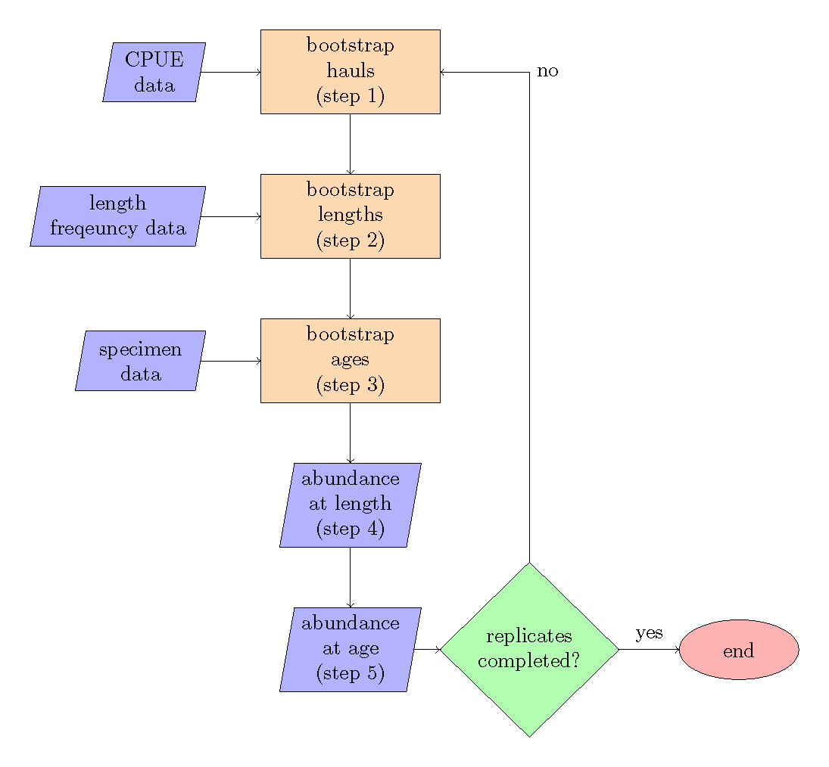

Figure 1. -- Bootstrap flow chart, the steps refer to the order of operations.

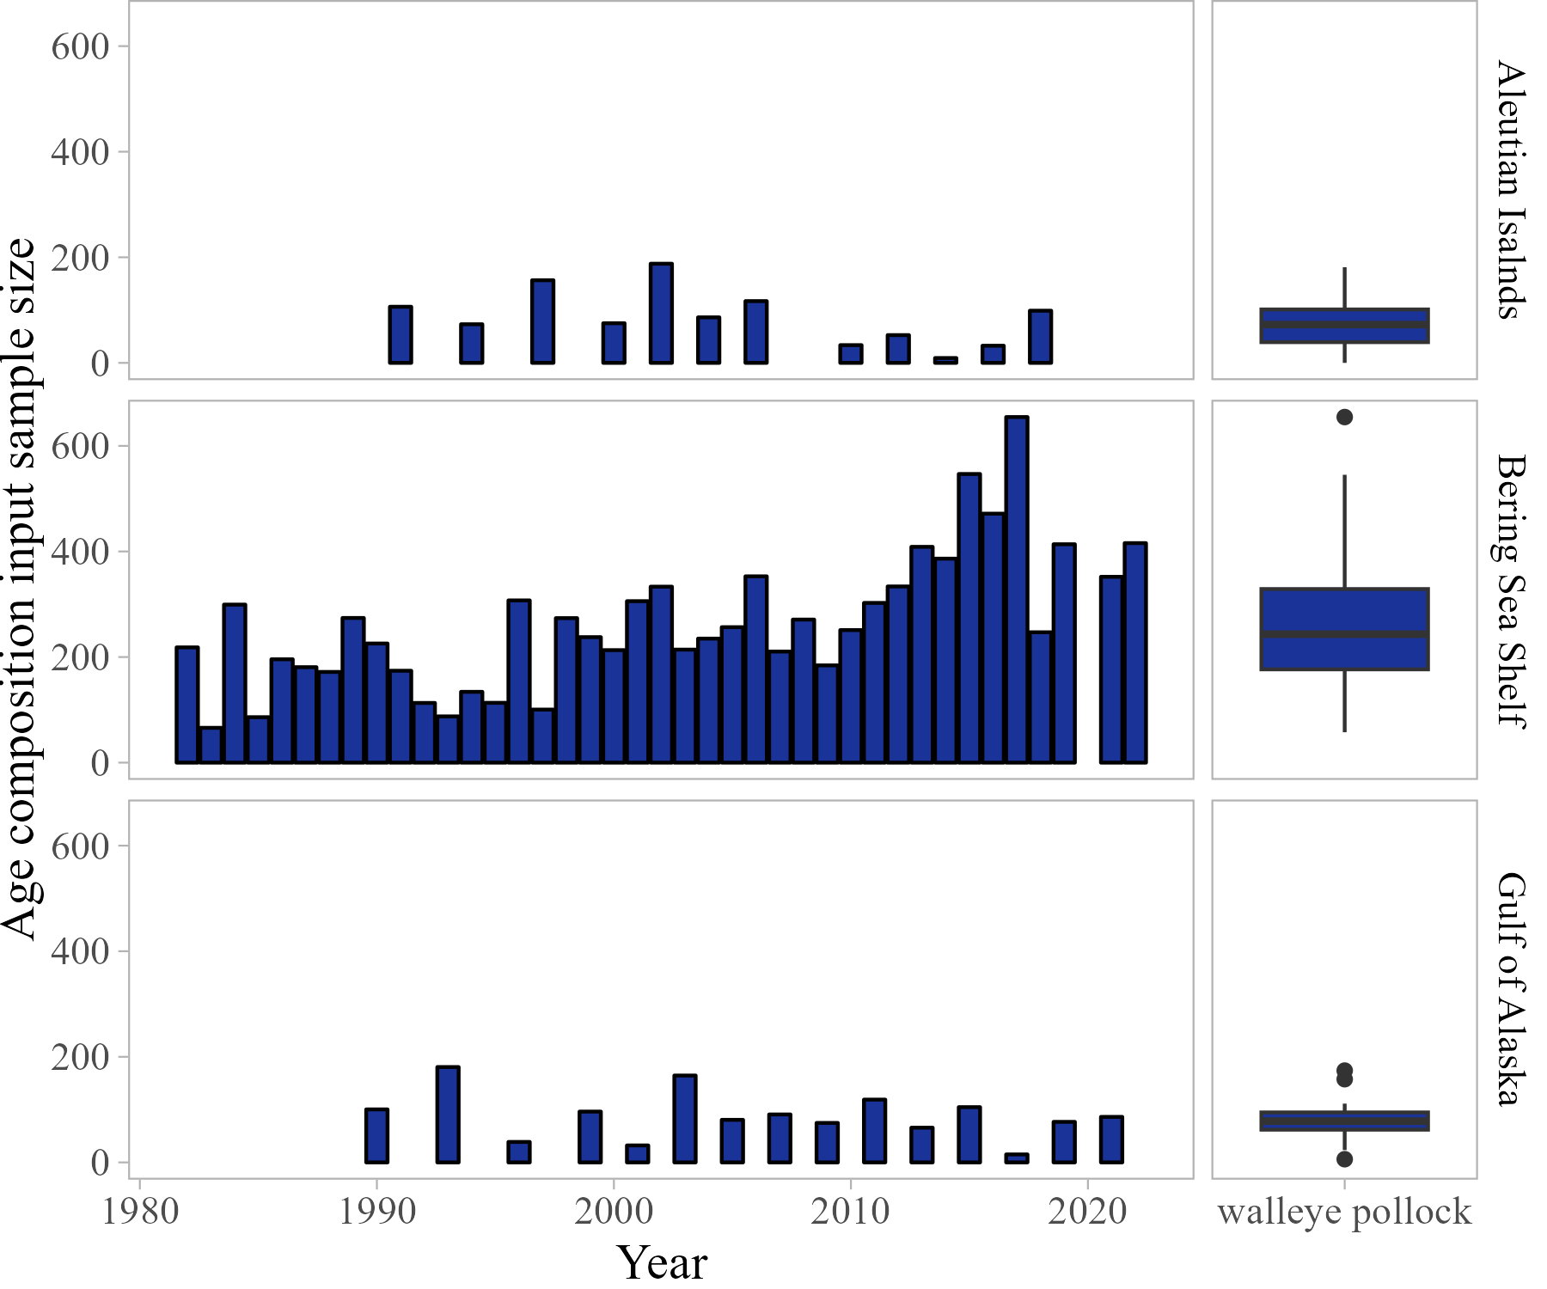

Figure 2. -- Walleye pollock total age composition input sample size by year and survey.

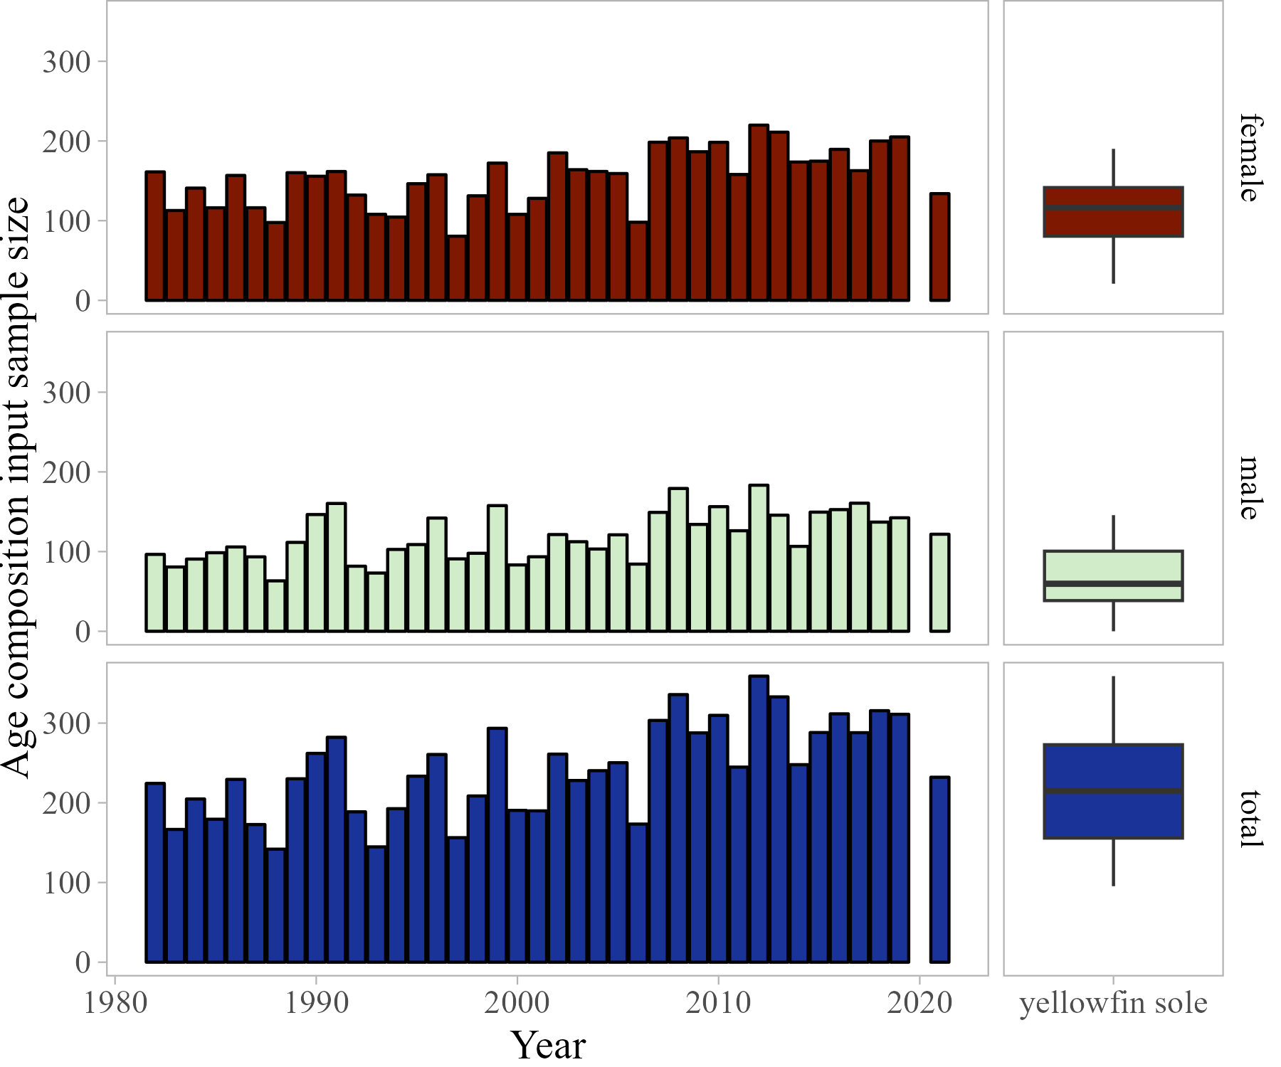

Figure 3. -- Eastern Bering Sea Yellowfin sole sex-specific age composition annual input sample size.

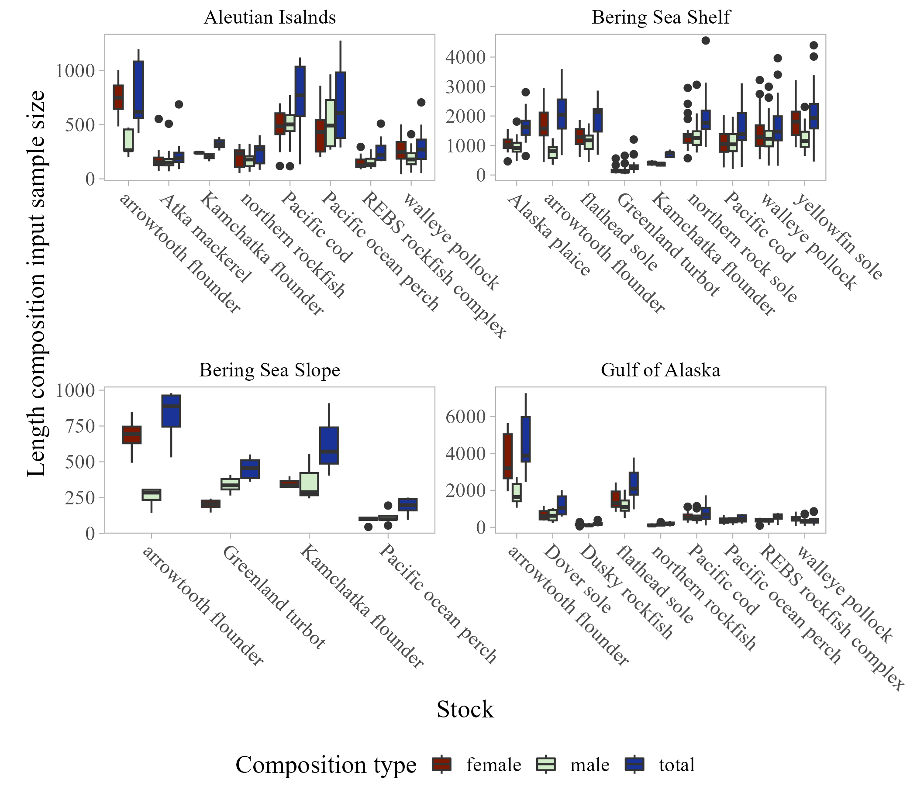

Figure 4. -- Length composition input sample size by species and survey.

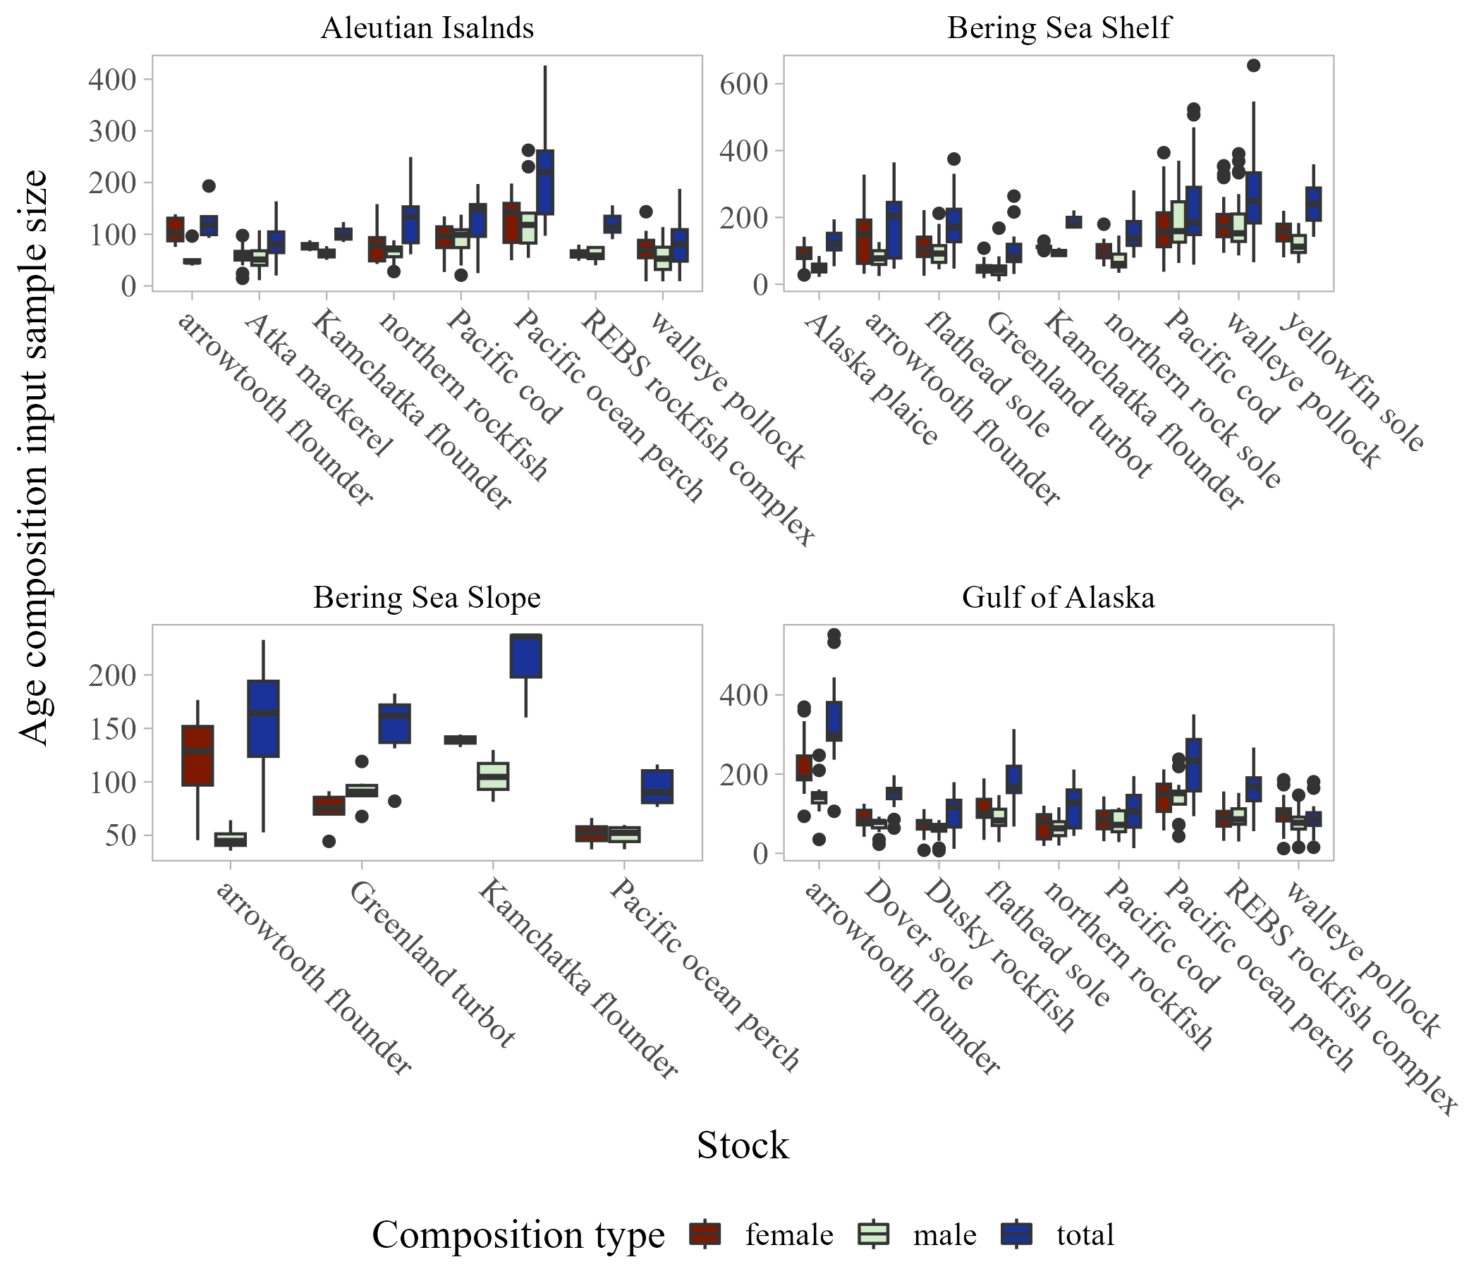

Figure 5. -- Age composition input sample size by species and survey.

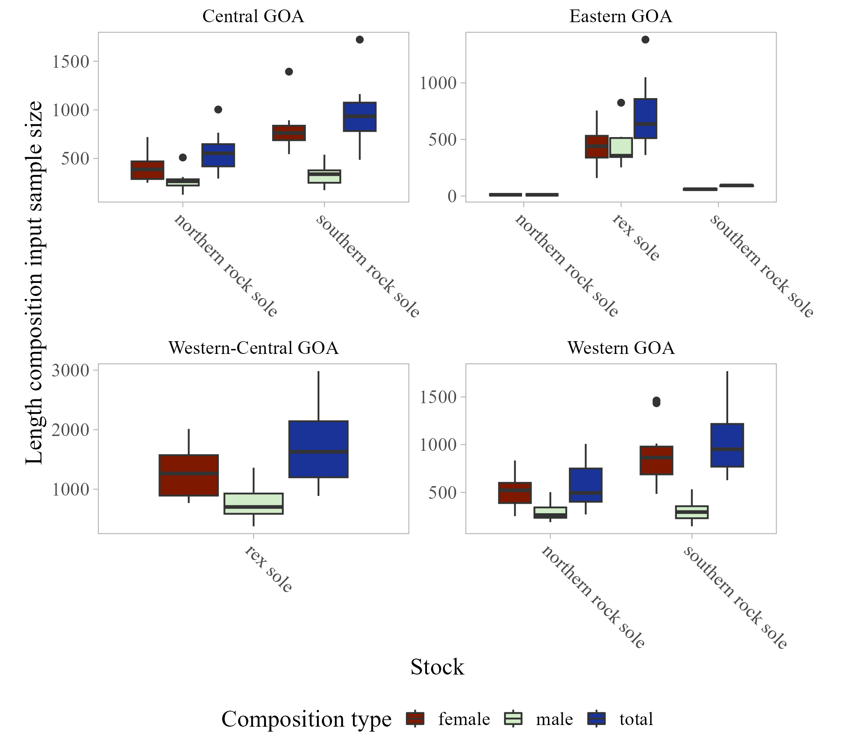

Figure 6. -- Sub-region length composition input sample size by species within the Gulf of Alaska survey.

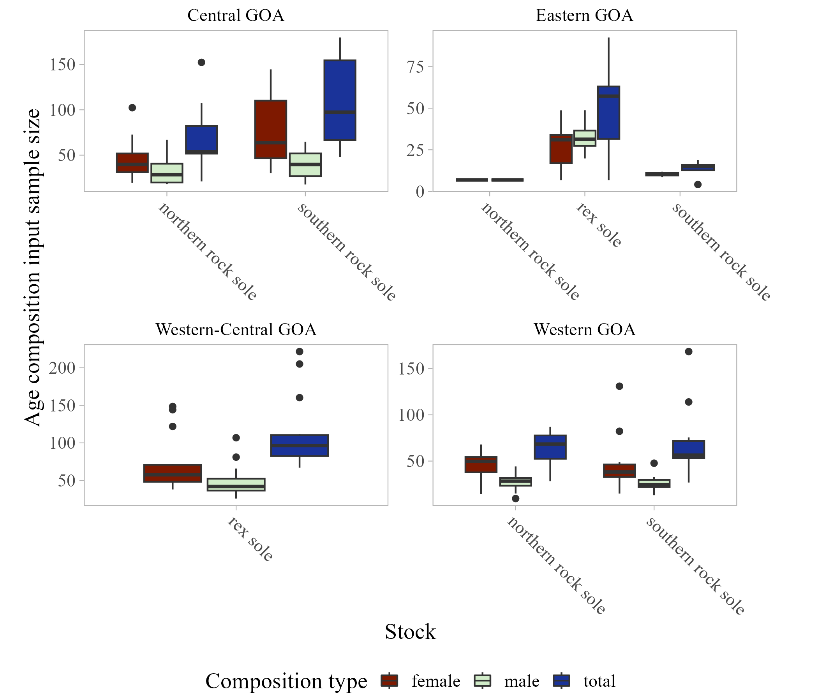

Figure 7. -- Sub-region age composition input sample size by species within the Gulf of Alaska survey.

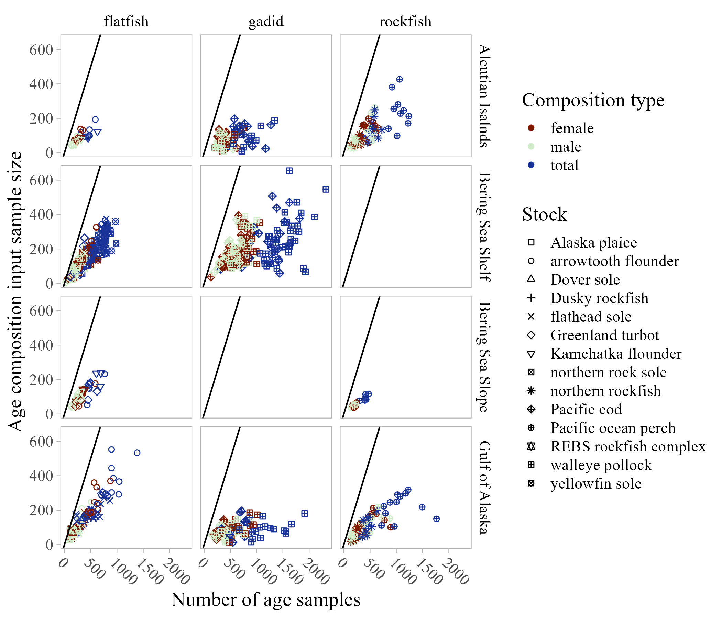

Figure 8. -- Number of fish aged and age composition input sample size by species group and survey (1-1 line shown in black for reference).

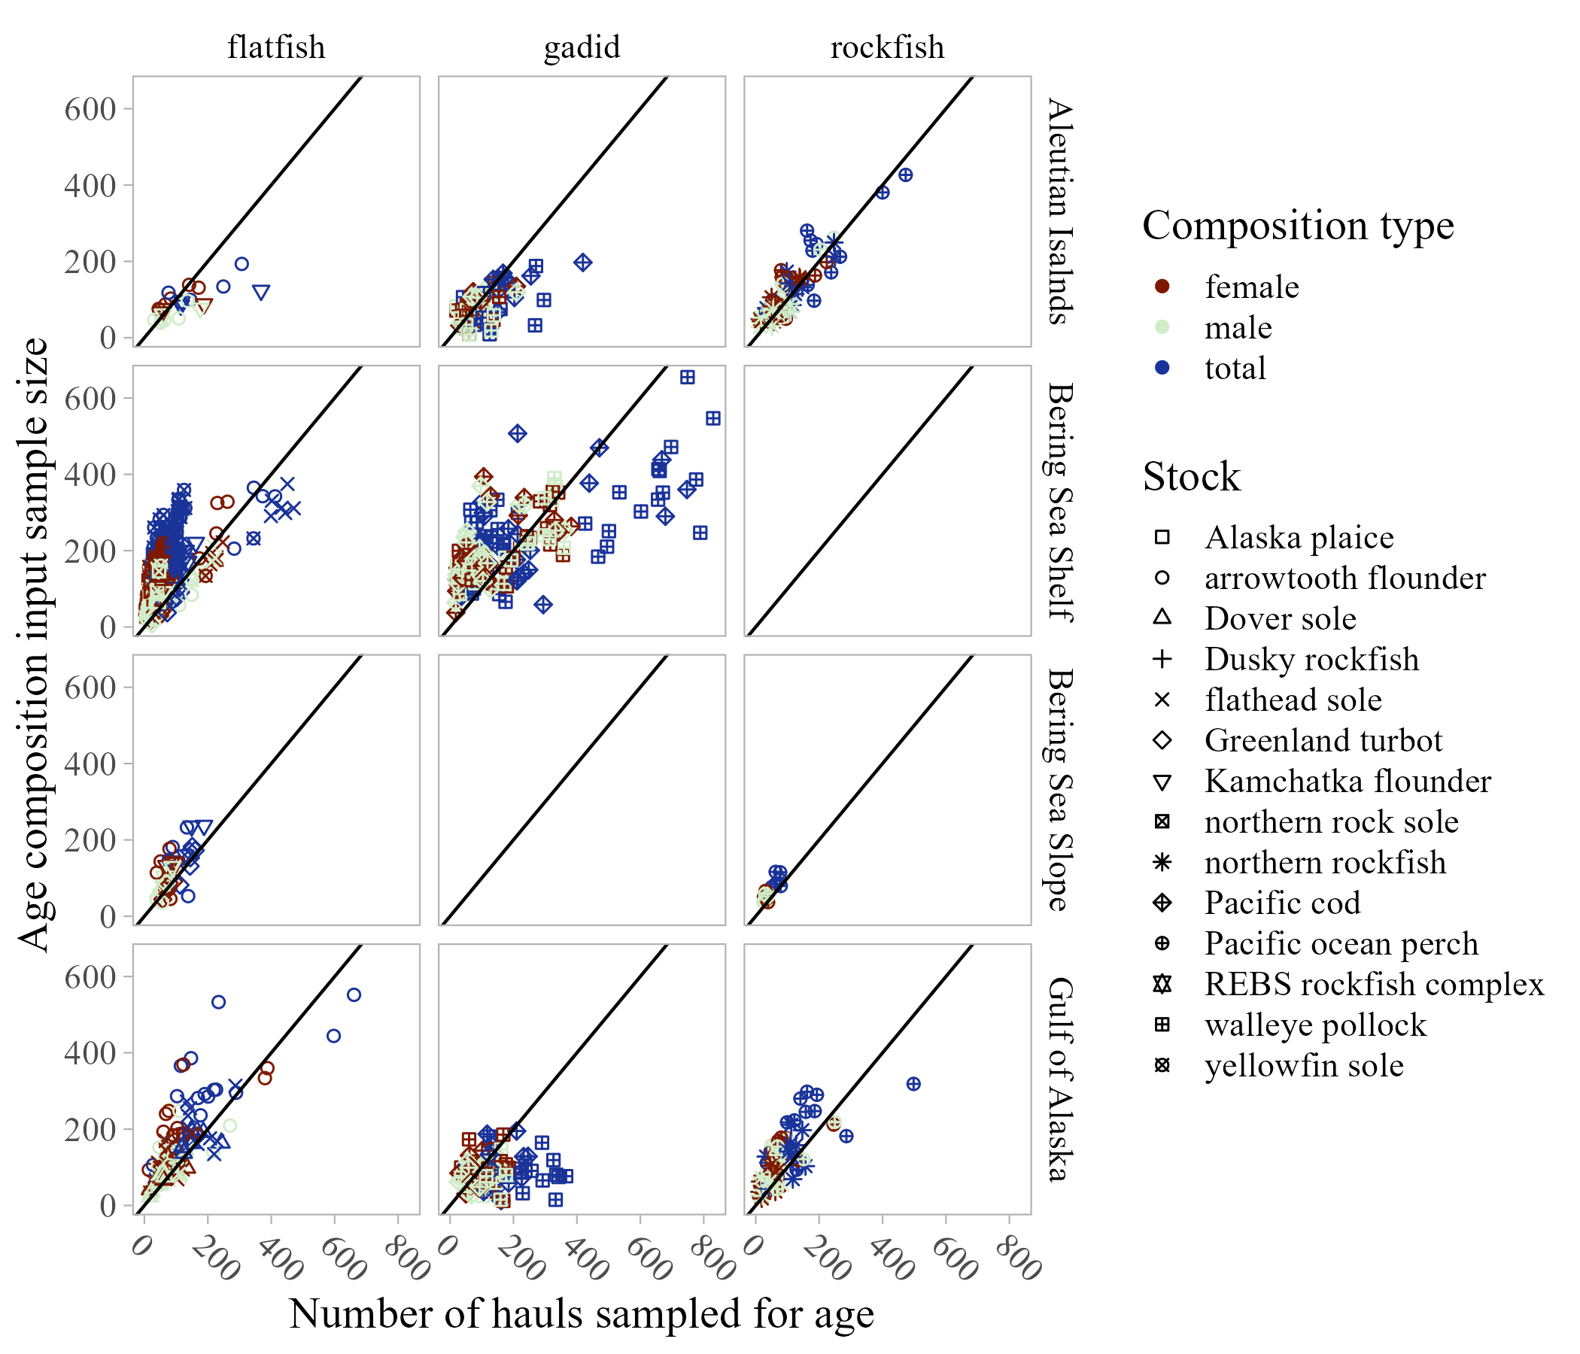

Figure 9. -- Number of sampled hauls compared to age composition input sample size by species group and survey (1-1 line shown in black for reference).

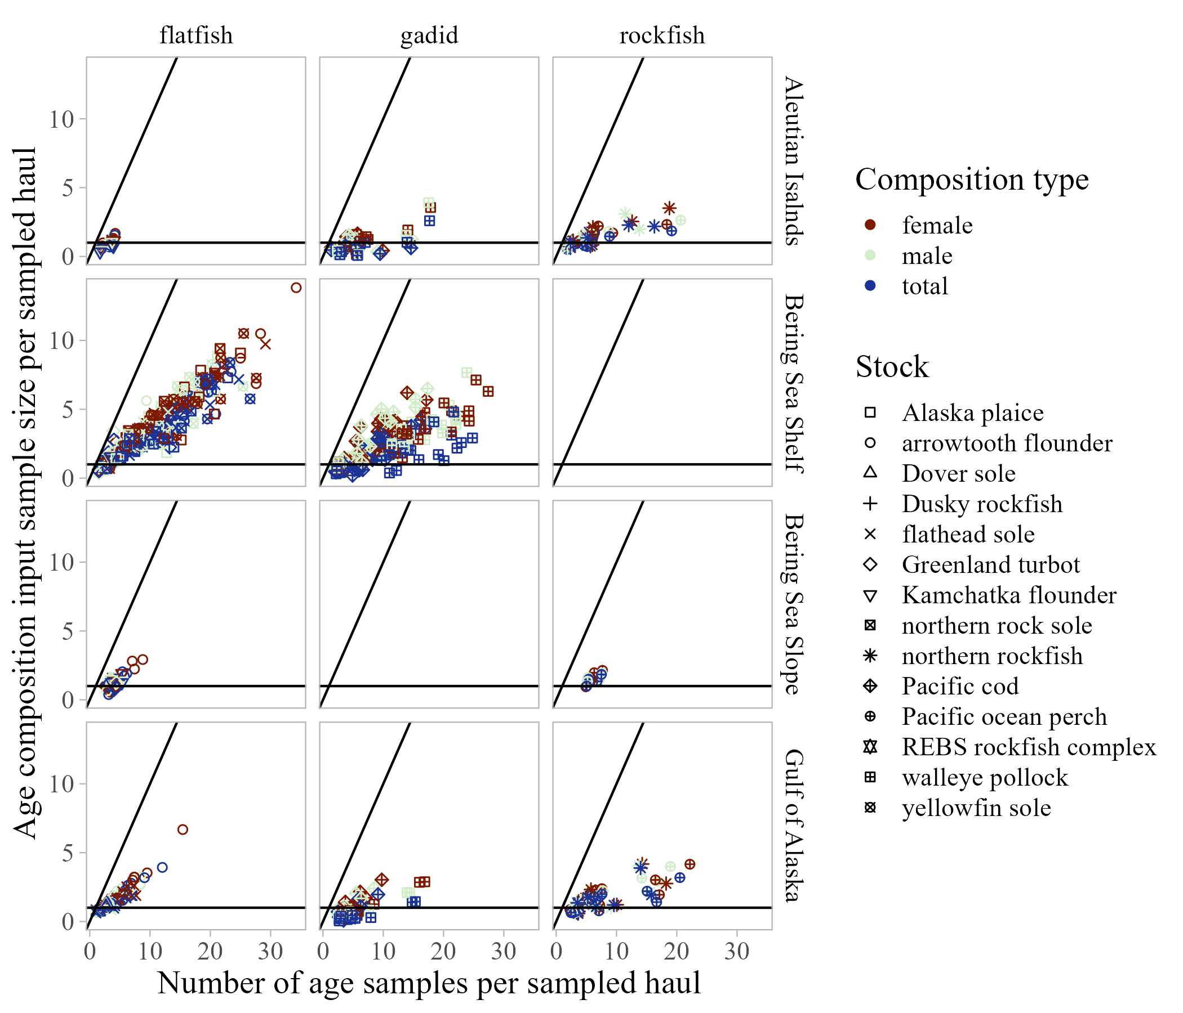

Figure 10. -- Number of age samples compared to age composition input sample size per sampled haul by species group and survey (1-1 line and the slope = 1 line (when all samples are identical in each haul) shown in black for reference).