Bootstrap age and length composition input sample sizes for stocks assessed with statistical catch-at-age models at the Alaska Fisheries Science Center

Meaghan Bryan2, Jason Conner3, Pete Hulson1,*, Matthew Siskey4, and Benjamin Williams1

1 Auke Bay Laboratories, Alaska Fisheries Science Center, National Marine Fisheries Service, National Oceanic and Atmospheric Administration, 17109 Point Lena Loop Rd., Juneau, AK 99801  
2 Resource Ecology and Fisheries Management Division, Alaska Fisheries Science Center, National Marine Fisheries Service, National Oceanic and Atmospheric Administration, 7600 Sand Point Way NE, Seattle, WA 98115  
3 Resource Assessment and Conservation Engineering Division, Alaska Fisheries Science Center, National Marine Fisheries Service, National Oceanic and Atmospheric Administration, 7600 Sand Point Way NE, Seattle, WA 98115  
4 School of Aquatic and Fishery Sciences, University of Washington, Seattle, WA, USA

* Correspondence: [Pete Hulson <[pete.hulson@noaa.gov](mailto:pete.hulson@noaa.gov)>](mailto:pete.hulson@noaa.gov)

# Abstract

[Pete and Matt]

* alpha order for now
* Abstract
* Introduction
* Materials and Methods
  + Survey data
  + Expanding length frequency to population abundance at length
  + Expanding specimen collections to population abundance at age
  + Bootstrap framework for estimating age and length composition input sample size
  + Computing effective and input sample size
* Results
* Discussion
* Acknowledgments
* Citations
* Tables
* Figures

# Introduction

Age-structured stock assessments (e.g., statistical catch-at-age models) conducted by the Alaska Fisheries Science Center (AFSC) offer valuable information for the management of marine fish stocks. Compositional information on age and length comprise important data products used in these assessments, as they facilitate the tracking of year classes and size-structure over time, thus improving our understanding of the population dynamics (Quinn and Deriso 1999). For stocks that depend on the periodic production of strong year-classes and subsequent recruitment into fisheries, sampling efforts for age and length data, scaling of these data to the population level (‘compositional expansion’), and the weight assigned to these data products in assessment models are highly important. Therefore, care must be taken in the design of sampling efforts as well as the development of quantitative methods used in the expansion process and estimation of weights.

The AFSC is responsible for the execution of several fisheries-independent bottom trawl surveys (Stauffer 2004), spanning most of the continental shelf in Alaskan waters south of the Bering Strait, including the eastern Bering Sea (EBS), the Aleutian Islands (AI), and the Gulf of Alaska (GOA). The quantitative time series of these surveys began in 1982 with the adoption of standardized trawling protocols (Lauth et al. 2019a), but trawl observations were made as early as 1955 (**zimmerman2009?**). Within the quantitative time series, AFSC scientists have routinely collected observations of fish size and age composition, consisting of complete or random subsamples of fish within each trawl. Large subsample observations (n > 200 per trawl sample) of sex-specific fish size are relatively inexpensive to obtain, however the indirect cost of workplace illness from repetitive length processing has been documented (Hulson et al. in prep). There is a significant fiscal cost to processing age composition data, in that the extraction of otoliths from individual fish and the subsequent analysis of these otoliths for age determination is labor intensive. To leverage the relative costs of size composition data to age composition data, estimated age-at-length is often applied to the estimated total population proportion for each length bin in a survey.

Since modern stock assessment models integrate multiple sources of data related to catch (e.g., fisheries catch-per-unit-effort, survey indices of abundance), life history (e.g., size-at-age, maturity-at-age, selectivity-at-age), and composition (e.g., length and age), it is imperative to consider the relative information content these data products provide to the model employed. This is often handled through the use of data-weighting methods, checking the fit of compositional data in the model, and ensuring a good match between the variance of the data and the variance implied by the model (Francis 2017). The weight assigned to annual compositions (the ‘input sample size’) can be calculated using myriad methods (e.g., fixed values, number of samples or tows sampled upon, bootstrapping compositions; Stewart and Hamel (2014)), as can the estimated sample size resulting from the fit of compositional data in the model (the ‘effective sample size’). Often, input sample sizes are used in an initial fit of the model, and then a tuning (or ‘re-weighting’) process is used to ensure the compositional data are appropriately weighted. This re-weighting process has various forms, but two common methods are to use the estimated effective sample size in a new fit of the model, or calculating a new weight based on expected vs. observed compositions applied to the original input sample size.

The main objectives of this technical memorandum are to (1) document methods used by AFSC for expanding length and age collections to population abundance estimates (which are subsequently used as composition data in stock assessments), (2) present species-specific results of historical input samples size for Tier $≥$ 3 stocks, and (3) record methods for estimating input sample sizes of survey-based age and length compositions using a two-stage bootstrapping approach.

# Materials and Methods

## Survey data

Data collection for each AFSC groundfish survey is described in respective NOAA Technical Memorandum (EBS: Lauth et al. 2019b, AI: von Szalay et al. 2017, GOA: von Szalay and Raring 2018). Length frequency protocols and recent analysis of historical data are further described in Hulson et al. (in prep).

To facilitate age estimation, individual fish are processed at sea to record sex, length and weight and to remove sagittal otoliths that are returned the AFSC Age and Growth laboratory for age determination. Survey age sampling protocols are specific by fish species and follow 1 of 2 paradigms: 1) a stratified collection that is distributed over both the spatial frame of the stratification scheme and the expected size range of a species; or 2) a small subsample (3-6 fish, depneding on species) collected randomly per trawl. The protocol for some species has changed over the time series, which has followed a trend of transitioning from protocol 1) to protocol 2). Age-length-keys (ALKs) generated from the age/length observations within a survey are then applied to estimated size compositions to provide an estimate of population age composition. Currently, no species age composition are estimated using stratified ALKs, rather, all observations are pooled for the entirety of the survey area each survey year. When there is no corresponding age observation for an observed length bin in a single survey, age-at-length observations for all years are pooled to assign ages to that length bin. This is different in AI/GOA, where the age obs are just dropped.

Species within each survey that are assessed with statistical catch-at-age models (Tier $≥$ 3 stock assessments, Table 1) were selected to be included in this analysis. The database (i.e., RACEBASE) was queried based on functions used in the sumfish package in Program R (<https://github.com/afsc-gap-products/sumfish>).

## Expanding length frequency to population abundance at length

Length frequency samples collected by the AFSC bottom trawl surveys are expanded by catch and stratum area to obtain estimates of population abundance at length (this approach is also detailed in Hulson et al. (in prep), we include the description here as well in order to provide a source for both the length and age expansions for reference). This is often referred to as the ‘first stage expansion’ and is a common method to obtain population estimates at length from area-swept survey data Miller and Skalski (2006). Population abundance at length are computed for three sex categories: males, females, and unsexed at the stratum level, which are then summed across stratum to obtain the population abundance at length for the management-scale region (i.e., EBS, AI, or GOA), these can also be summed to any sub-region level.

In the first step of this process we compute the overall population numbers in year-*y* within stratum-*st* (${\hat{N}}_{st,y}$) with:

$${\hat{N}}_{st,y}={\overline{CPUE}}_{st,y}⋅A_{st} \left(1\right)$$

where $A_{st}$ is the area of stratum-*st* (in km2), and is the average catch per unit effort of numbers captured across the hauls within a strata, given by:

$${\overline{CPUE}}_{st,y}=\frac{1}{H_{st,y}}\sum_{h=1}^{H_{st,y}}{C}PUE_{h,st,y}=\frac{1}{H_{st,y}}\sum_{h=1}^{H_{st,y}}{\frac{n_{h,st,y}}{E_{h,st,y}}} \left(2\right)$$

where $H_{st,y}$ is the number of hauls, $CPUE_{h,st,y}$ is the catch per unit effort of numbers caught within a haul-*h*, $n_{h,st,y}$ is the catch (in numbers) in haul-*h*, and $E_{h,st,y}$ is the effort in haul-*h*, which is computed as the net width multiplied by the time on bottom, or, the area swept by the haul (in km2). Next, the ratio of catch per unit effort among hauls (${\hat{p}}_{CPUE,h,st,y}$) is computed by:

$${\hat{p}}_{CPUE,h,st,y}=\frac{CPUE_{h,st,y}}{\sum_{h=1}^{H_{sy,y}}{C}PUE_{h,st,y}} \left(3\right)$$

where $CPUE_{h,st,y}$ is the catch per unit effort of numbers caught within a haul-*h*. We then compute the sex-specific ratio of the total number of lengths sampled within a haul by length (${\hat{p}}_{sx,l,h,st,y}$) with:

$${\hat{p}}_{sx,l,h,st,y}=\left\{\begin{matrix}\left(1\right)\frac{N_{sx,l,h,st,y}}{N_{h,st,y}} \\ \left(2\right)\frac{\sum_{h=1}^{H_{st,y}}{\left[N_{sx,l,h,st,y}/N_{h,st,y}\right]}}{\sum_{sx=1}^{3}{\sum_{l=1}^{L}{\sum_{h=1}^{H_{st,y}}{\left[N_{sx,l,h,st,y}/N_{h,st,y}\right]}}}}\end{matrix}\right. \left(4\right)$$

where $N_{sx,l,h,st,y}$ is the length frequency sampled, in numbers, by sex-*sx* and length-*l*. In some cases there are hauls that have catch for a species but did not collect length frequency data, in this case (2) is applied in order to account for the unknown length frequency in these hauls, otherwise, if length frequency samples are obtained case (1) is applied. Finally, we estimate the sex-specific population abundance at length within strata-st with:

$${\hat{N}}_{sx,l,st,y}={\hat{N}}_{st,y}⋅{\hat{p}}_{CPUE,h,st,y}⋅{\hat{p}}_{sx,l,h,st,y} \left(5\right)$$

and to obtain the sex-specific estimates of population abundance at length in a management area one would simply sum ${\hat{N}}_{sx,l,st,y}$ across strata.

## Expanding specimen collections to population abundance at age

In the second stage expansion the sex-specific estimates of population abundance at length are used to estimate sex-specific population abundance at age. The annual specimen data that is collected during the survey, which includes observations of age at length, are first populated into sex-specific numbers at age and length ($N_{sx,a,l,y}$). Next, the sex-specific numbers at age and length are converted to sex-specific proportions of age at length with:

$${\hat{p}}_{sx,a,l,y}=\frac{N_{sx,a,l,y}}{\sum_{a=1}^{A}{N_{sx,a,l,y}}} \left(6\right)$$

The proportions of age at length are then expanded to population abundance at age with:

$${\hat{N}}_{sx,a,y}=\sum_{l=1}^{L}{{\hat{p}}_{sx,a,l,y}}⋅{\hat{N}}_{sx,l,y} \left(7\right)$$

where ${\hat{N}}_{sx,l,y}$ is the population abundance at length from (5) summed across strata. For specimen data with observations of sex (either female or male), the sex-specific specimen data is used, however, for specimen data without observations of sex the specimen data is pooled across all sexes and the unsexed population abundance at length is then applied to the pooled specimen data to estimate unsexed population abundance at age.

For the majority of stocks assessed at AFSC age population estimates are computed at the management area scale (e.g., the entire GOA, AI, or EBS), however, we note that there are two flatfish stock assessments that are spatially-explicit in the GOA (McGilliard and Palsson 2017, Bryan and Palsson 2021). While in the preceding equations we do not include a subscript for sub-region, population abundance at age can be estimated by sub-region through summing the population abundance at length in equation (5) across strata within the sub-region and applying equations (6) and (7) to specimen data that is subsetted to the sub-region. We have developed functions to estimate population abundance at age by sub-region, and by a combination of sub-regions within the GOA to allow for this flexibility in estimating population abundance at age.

There are a handful of assessments conducted at AFSC that evaluate stocks at a complex level, where several species are included together in an assessment. There are two stock complexes at AFSC in which the species are combined and assessed within the same statistical catch-at-age model: blackspotted and rougheye rockfish in the GOA and AI (Spencer et al. 2020, Sullivan et al. 2021). Between the two management regions there are subtle differences in how the population abundance at age is estimated from the survey specimen data; we have developed functions that allow for these differences and estimate population abundance at age for these two stock complexes.

## Bootstrap framework for estimating age and length composition input sample size

To estimate the historical input sample sizes for age and length compositions of stocks assessed at AFSC we developed a bootstrap framework based on the methodology outlined in Stewart and Hamel (2014). The bootstrap framework is composed of a suite of nested resampling (with replacement) protocols. Functions to run the sampling protocols were developed in a compartmentalized manner to provide for substantial flexibility in exploring desired resampling protocols. The order of operations (Figure 1) has the following schedule, with steps 1-3 being optional switches:

1. Resample hauls from the set of hauls with associated catch per unit effort (in numbers)
2. Within the resampled hauls from step 1, resample the observed length frequency data
3. Within the resampled hauls from step 1, resample the observed specimen data
4. From the resampled length frequency data in step 2, calculate sex-specific population abundance at length, using equations (1) - (5)
5. From the resampled specimen data in step 3 and the sex-specific population abundance at length in step 4, calculate sex-specific population abundance at age, using equations (6) - (7)

The bootstrap framework then repeated steps 1-5 iteratively, providing iterated sex-specific population abundance at length and age that was then compared to the historical sex-specific population abundance at length and age determined by the bottom trawl surveys. We applied the bootstrap-simulation to stocks that are assessed in the EBS, AI, and GOA with statistical catch-at-age models (or are Tier $≥$ 3). We ran the bootstrap-simulation for 500 iterations, which was a level for which the variability in population abundance at length results had stabilized, and applied the bootstrap-simulation to all years of the respective bottom trawl surveys through the 2021 surveys (for species that had specimen data completed by the AFSC Age and Growth Program). The bootstrap-simulation was developed in R (R Core Team 2022) and is available via GitHub as an R package (<https://github.com/BenWilliams-NOAA/swo>).

## Computing effective and input sample size

Effective sample size, as introduced by McAllister and Ianelli (1997), is a statistic that can evaluate the level of intra-haul correlation in composition samples that are collected on a survey (whether from age or length frequency collections). It is also a statistic that can evaluate the amount of uncertainty in an estimated composition compared to an observed composition. Effective sample size is given by:

$$ESS=\frac{\sum_{c=1}^{C}{E_{c}}\left(1-E_{c}\right)}{\sum_{c=1}^{C}{{\left(E_{c}-O_{c}\right)}^{2}}} \left(8\right)$$

where $E_{c}$ is the estimated proportion for category-*c* (which can be either age or length or any other arbitrary category across which proportions are computed) and $O_{c}$ is the observed proportion.

In this bootstrap framework the underlying age and length compositions derived from the historical bottom trawl surveys was treated as the observed proportions $O_{c}$ in equation (8). For each iteration of the bootstrap we computed a sex-specific estimated proportion ($E_{c}$) that was then compared to the underlying historical sex-specific age and length composition (the effective sample size for the total age and length composition, as the sum of population abundance at age and length, was also computed). To summarize effective sample size across iterations we used the harmonic mean, which has been shown to reduce bias in recovering the true sample size in simulations for a multinomial distribution. Due to this reduction in bias the harmonic mean has also been recommended to determine the ‘input sample size’ that is used in stock assessment models to fit compositional data (Stewart and Hamel 2014). Herein, when we use the term ‘effective sample size’ we are referring to the effective sample sizes that were computed for each iteration of the bootstrap-simulation. When we use the term ‘input sample size’ we are referring to the harmonic mean of the iterated effective sample sizes, which has been recommended to be used to weight composition data in stock assessment models.

# Results

Average length composition nominal sample sizes and estimated input sample sizes for the bottom trawl surveys evaluated are shown in Tables 3 - 6. Across the surveys, average sex-specific length composition nominal sample size ranged from around 300 to upwards of 35,000 samples per year, where the total length composition nominal sample size (for all sexes combined) ranged from around 700 to upwards of 82,000 per year. The most frequently sampled species within in Eastern Bering Sea shelf survey were walleye pollock, yellowfin sole, northern rock sole, and arrowtooth flounder (Table 3), and in the Eastern Bering Sea slope survey were arrowtooth flounder, kamchatka flounder, and Pacific ocean perch (Table 4). The most frequently sampled species within the Aleutian Islands bottom trawl survey were Pacific ocean perch, walleye pollock, and arrowtooth flounder (Table 5). The most frequently sampled species in the Gulf of Aslaska bottom trawl survey were arrowtooth flounder, walleye pollock, flathead flounder, and Pacific ocean perch (Table 6). Estimated input sample sizes for length composition were smaller than the nominal sample sizes, as expected. It was generally the case that length composition input sample sizes ranged in the thousands for species that were more commonly sampled in the bottom trawl surveys, and were less than 1,000 for species that weren’t (Tables 3 - 6). Sex-specific length composition input sample size ranged from 35 to greater than 3,500, with a mean around 700. Total length composition (all sexes combined) input sample size ranged from around 100 to greater than 4,500 with a mean of just larger than 1,000.

Average age composition nominal sample sizes and estimated input sample sizes for the bottom trawl surveys evaluated are shown in Tables 7 - 10. Across the surveys, average sex-specific age composition nominal sample sizes ranged from around 130 to nearly 850 per year, where the total age composition nominal sample size (for all sexes combined) ranged from nearly 300 to over 1,500 per year. It was commonly the case that the most frequently sampled species in each survey for age composition were similar to the most frequently sampled species for length composition. Similar to the length composition results, estimated input sample sizes for age composition were smaller than the nominal sample sizes, as expected. Sex-specific age composition input sample size ranged from 20 to nearly 300, with a mean around 100. Total age composition (all sexes combined) input sample size ranged from around 50 to greater than 400 with a mean of just larger than 150. It was the case that for each species and sex combination the age composition input sample size was smaller than the length composition input sample size.

# Discussion

[General para on main take-home results - Pete]

[Para on use of input sample sizes used in assessment, with examples from other regions (e.g., west coast, iphc) - Matt]

[Para on different approaches used to weight comp data at AFSC]

[Conclusion para on where input sample size will be available to authors - Pete with input from all]

# Acknowledgments

We thank *reviewer1* and *reviewer2* for their helpful reviews of this manuscript.

# Citations

Ailloud, L.E., and Hoenig, J.M. 2019. A general theory of age-length keys: Combining the forward and inverse keys to estimate age composition from incomplete data. ICES Journal of Marine Science 76(6): 1515–1523.

Bryan, M.D., and Palsson, W. 2021. Assessment of the northern and southern rock sole (*Lepidopsetta polyxstra* and *bilineata*) stocks in the Gulf of Alaska. *In* Stock Assessment and Fishery Evaluation Report for the Groundfish Resources of the Gulf of Alaska. North Pacific Fishery Management Council, Anchorage, AK.

Francis, R.I.C.C. 2017. Revisting data weighting in fisheries stock assessment models. Fisheries Research 192: 5–15.

Hulson, P.-J.F., Williams, B., Bryan, M., Conner, J., Siskey, M., Stockhausen, W., Mcdermott, S., and Long, C. in prep. Sub-sampling of length frequency to determine sex in Alaska Fishery Science Center bottom trawl surveys. U.S. Department of Commerce. NOAA Technical Memorandum.

Lauth, R.R., Dawson, E.J., and Conner, J. 2019a. Results of the 2017 eastern and northern Bering Sea continental shelf bottom trawl survey of groundfish and invertebrate fauna. U.S. Dep. Commer.: 270.

Lauth, R.R., J, D.E., and J, C. 2019b. Results of the 2017 eastern and northern Bering Sea continental shelf bottom trawl survey of groundfish and invertebrate fauna. U.S. Department of Commerce. NOAA Technical Memorandum NMFS-AFSC-396: 260 p.

McAllister, M.K., and Ianelli, J.N. 1997. Bayesian stock assessment using catch-age data and the sampling-importance resampling algorithm. Canadian Journal of Fisheries and Aquatic Sciences 54(2): 284–300.

McGilliard, C.R., and Palsson, W. 2017. Assessment of the rex sole stock in the Gulf of Alaska. *In* Stock Assessment and Fishery Evaluation Report for the Groundfish Resources of the Gulf of Alaska. North Pacific Fishery Management Council, Anchorage, AK.

Miller, T.J., and Skalski, J.R. 2006. Integrating design- and model-based inference to estimate length and age composition in north pacific longline catches. Canadian Journal of Fisheries and Aquatic Sciences 63(5): 1092–1114.

Quinn, T., and Deriso, R. 1999. QUantitative fish dynamics. Oxford University Press, New York, NY.

R Core Team. 2022. R: A language and environment for statistical computing. R Foundation for Statistical Computing, Vienna, Austria. Available from <https://www.R-project.org/>.

Spencer, P.D., Ianelli, J.I., and Palsson, W.A. 2020. Assessment of the Blackspotted and Rougheye Rockfish stock complex in the Bering Sea/Aleutian Islands. *In* Stock Assessment and Fishery Evaluation Report for the Groundfish Resources of the Bering Sea and Aleutian Islands. North Pacific Fishery Management Council, Anchorage, AK.

Stauffer, G.D. 2004. Stauffer, G.D., 2004. NOAA protocols for groundfish bottom trawl surveys of the nation’s fishery resources, March 16, 2003.

Stewart, I.J., and Hamel, O.S. 2014. Bootstrapping of sample sizes for length-or age-composition data used in stock assessments. Canadian Journal of Fisheries and Aquatic Sciences 71(4): 581–588.

Sullivan, Jane Y, Shotwell, S.K., Hanselman, D.H., Hulson, P.-J.F., Williams, B.C., Yasumiishi, E.M., and Ferriss, B.E. 2021. Assessment of the Rougheye and Blackspotted Rockfish stock complex in the Gulf of Alaska. *In* Stock Assessment and Fishery Evaluation Report for the Groundfish Resources of the Gulf of Alaska. North Pacific Fishery Management Council, Anchorage, AK.

von Szalay, P.G., and Raring, N.W. 2018. Data Report: 2017 Gulf of Alaska bottom trawl survey. U.S. Department of Commerce. NOAA Technical Memorandum NMFS-AFSC-374: 260 p.

von Szalay, P.G., Raring, N.W., Rooper, C.N., and A, L.E. 2017. Data Report: 2016 Aleutian Islands bottom trawl survey. U.S. Department of Commerce. NOAA Technical Memorandum NMFS-AFSC-349: 161 p.

# Tables

Table 1: Species assessed at the Alaska Fisheries Science Center that were evaluated in the bootstrap analysis for bottom trawl survey length and age composition input sample size (AI - Aleutian Islands, EBS - Eastern Bering Sea, GOA - Gulf of Alaska)

| Stock | Scientific name | Survey evaluated |
| --- | --- | --- |
| Alaska plaice | Pleuronectes quadrituberculatus | EBS shelf |
| arrowtooth flounder | Atheresthes stomias | AI, EBS shelf, EBS slope, GOA |
| Atka mackerel | Pleurogrammus monopterygius | AI |
| Dover sole | Microstomus pacificus | GOA |
| Dusky rockfish | Sebastes ciliatus | GOA |
| flathead sole | Hippoglossoides elassodon | EBS shelf, GOA |
| Greenland turbot | Reinhardtius hippoglossoides | EBS shelf, EBS slope |
| Kamchatka flounder | Atheresthes evermanni | AI, EBS shelf, EBS slope |
| northern rock sole | Lepidopsetta polyxystra | EBS shelf, GOA |
| northern rockfish | Sebastes polyspinis | AI, GOA |
| Pacific cod | Gadus macrocephalus | AI, EBS shelf, GOA |
| Pacific ocean perch | Sebastes alutus | AI, EBS slope, GOA |
| REBS rockfish complex | Sebastes aleutianus | AI, GOA |
| rex sole | Glyptocephalus | GOA |
| sablefish | Anoplopoma fimbria | GOA |
| southern rock sole | Lepidopsetta billineta | GOA |
| walleye pollock | Gadus chalcogrammus | AI, EBS shelf, GOA |
| yellowfin sole | Limanda aspera | EBS shelf |

Table 2: Species assessed at the Alaska Fisheries Science Center that were evaluated in the bootstrap analysis by ‘flatfish,’ ‘rockfish’ and ‘roundfish’ groupings

| Flatfish | Rockfish | Roundfish |
| --- | --- | --- |
| Alaska plaice | Dusky rockfish | Atka mackerel |
| arrowtooth flounder | northern rockfish | Pacific cod |
| Dover sole | Pacific ocean perch | sablefish |
| flathead sole | REBS rockfish complex | walleye pollock |
| Greenland turbot | NA | NA |
| Kamchatka flounder | NA | NA |
| northern rock sole | NA | NA |
| rex sole | NA | NA |
| southern rock sole | NA | NA |
| yellowfin sole | NA | NA |

Table 3: Average length frequency samples (nominal) and average length composition input sample size (iss) from the Eastern Bering Sea shelf bottom trawl survey.

| Stock | Type | Female | Male | Total |
| --- | --- | --- | --- | --- |
| Alaska plaice | nominal | 5,209 | 5,135 | 10,800 |
| NA | iss | 1,122 | 1,079 | 1,685 |
| arrowtooth flounder | nominal | 6,715 | 2,806 | 9,779 |
| NA | iss | 1,989 | 999 | 2,565 |
| flathead sole | nominal | 8,145 | 7,994 | 17,193 |
| NA | iss | 1,538 | 1,298 | 2,302 |
| Greenland turbot | nominal | 301 | 316 | 720 |
| NA | iss | 78 | 35 | 115 |
| Kamchatka flounder | nominal | 875 | 882 | 1,776 |
| NA | iss | 383 | 355 | 679 |
| northern rock sole | nominal | 14,060 | 14,285 | 29,137 |
| NA | iss | 1,272 | 1,153 | 1,933 |
| Pacific cod | nominal | 6,032 | 6,210 | 13,320 |
| NA | iss | 1,693 | 1,631 | 2,655 |
| walleye pollock | nominal | 28,713 | 29,373 | 82,451 |
| NA | iss | 2,138 | 2,015 | 2,448 |
| yellowfin sole | nominal | 17,326 | 10,952 | 29,803 |
| NA | iss | 1,653 | 1,012 | 1,166 |

Table 4: Average length frequency samples (nominal) and average length composition input sample size (iss) from the Eastern Bering Sea slope bottom trawl survey.

| Stock | Type | Female | Male | Total |
| --- | --- | --- | --- | --- |
| arrowtooth flounder | nominal | 4,623 | 1,138 | 5,761 |
| NA | iss | HMMM | HMMM | HMMM |
| Greenland turbot | nominal | 578 | 1,017 | 1,595 |
| NA | iss | 172 | 232 | 335 |
| Kamchatka flounder | nominal | 1,345 | 1,915 | 3,260 |
| NA | iss | 382 | 403 | 698 |
| Pacific ocean perch | nominal | 1,378 | 1,759 | 3,191 |
| NA | iss | 74 | 81 | 137 |

Table 5: Average length frequency samples (nominal) and average length composition input sample size (iss) from the Aleutian Islands bottom trawl surveys.

| Stock | Type | Female | Male | Total |
| --- | --- | --- | --- | --- |
| arrowtooth flounder | nominal | 6,306 | 3,921 | 10,607 |
| NA | iss | 676 | 353 | 793 |
| Atka mackerel | nominal | 4,561 | 4,292 | 9,110 |
| NA | iss | 166 | 148 | 194 |
| Kamchatka flounder | nominal | 1,119 | 1,597 | 2,718 |
| NA | iss | 203 | 188 | 292 |
| northern rockfish | nominal | 5,607 | 3,553 | 9,290 |
| NA | iss | 183 | 161 | 224 |
| Pacific cod | nominal | 3,269 | 3,516 | 7,080 |
| NA | iss | 442 | 456 | 699 |
| Pacific ocean perch | nominal | 9,841 | 13,175 | 23,538 |
| NA | iss | 383 | 472 | 620 |
| REBS rockfish complex | nominal | 890 | 939 | 2,061 |
| NA | iss | 141 | 147 | 242 |
| walleye pollock | nominal | 7,778 | 6,257 | 14,529 |
| NA | iss | 296 | 220 | 288 |

Table 6: Average length frequency samples (nominal) and average length composition input sample size (iss) from the Gulf of Alaska bottom trawl surveys.

| Stock | Type | Female | Male | Total |
| --- | --- | --- | --- | --- |
| arrowtooth flounder | nominal | 35,553 | 17,117 | 54,108 |
| NA | iss | 3,637 | 1,860 | 4,581 |
| Dover sole | nominal | 2,523 | 3,209 | 6,084 |
| NA | iss | 601 | 623 | 1,089 |
| Dusky rockfish | nominal | 1,039 | 923 | 1,997 |
| NA | iss | 146 | 118 | 194 |
| flathead sole | nominal | 10,753 | 9,799 | 21,318 |
| NA | iss | 1,469 | 1,139 | 2,214 |
| northern rockfish | nominal | 1,971 | 1,827 | 3,913 |
| NA | iss | 125 | 144 | 212 |
| Pacific cod | nominal | 5,314 | 5,208 | 10,918 |
| NA | iss | 576 | 555 | 767 |
| Pacific ocean perch | nominal | 9,003 | 10,181 | 20,456 |
| NA | iss | 322 | 326 | 420 |
| REBS rockfish complex | nominal | 1,630 | 1,656 | 3,378 |
| NA | iss | 341 | 338 | 520 |
| sablefish | nominal | 2,829 | 3,735 | 6,908 |
| NA | iss | 468 | 620 | 854 |
| walleye pollock | nominal | 13,701 | 11,402 | 28,242 |
| NA | iss | 467 | 365 | 434 |

Table 7: Average age frequency samples (nominal) and average age composition input sample size (iss) from the Eastern Bering Sea shelf bottom trawl survey.

| Stock | Type | Female | Male | Total |
| --- | --- | --- | --- | --- |
| Alaska plaice | nominal | 246 | 161 | 407 |
| NA | iss | 117 | 61 | 152 |
| arrowtooth flounder | nominal | 326 | 141 | 467 |
| NA | iss | 248 | 87 | 294 |
| flathead sole | nominal | 305 | 247 | 558 |
| NA | iss | 180 | 177 | 319 |
| Greenland turbot | nominal | 147 | 134 | 293 |
| NA | iss | 35 | 19 | 55 |
| Kamchatka flounder | nominal | 259 | 218 | 477 |
| NA | iss | 113 | 87 | 183 |
| northern rock sole | nominal | 255 | 194 | 456 |
| NA | iss | 122 | 104 | 213 |
| Pacific cod | nominal | 535 | 515 | 1,062 |
| NA | iss | 265 | 272 | 349 |
| walleye pollock | nominal | 736 | 682 | 1,534 |
| NA | iss | 269 | 296 | 422 |
| yellowfin sole | nominal | 425 | 321 | 747 |
| NA | iss | 178 | 139 | 290 |

Table 8: Average age frequency samples (nominal) and average age composition input sample size (iss) from the Eastern Bering Sea slope bottom trawl survey.

| Stock | Type | Female | Male | Total |
| --- | --- | --- | --- | --- |
| arrowtooth flounder | nominal | 391 | 148 | 539 |
| NA | iss | HMMM | HMMM | HMMM |
| Greenland turbot | nominal | 239 | 254 | 493 |
| NA | iss | 62 | 78 | 114 |
| Kamchatka flounder | nominal | 365 | 296 | 661 |
| NA | iss | 141 | 114 | 223 |
| Pacific ocean perch | nominal | 207 | 192 | 404 |
| NA | iss | 51 | 53 | 93 |

Table 9: Average age frequency samples (nominal) and average age composition input sample size (iss) from the Aleutian Islands bottom trawl surveys.

| Stock | Type | Female | Male | Total |
| --- | --- | --- | --- | --- |
| arrowtooth flounder | nominal | 285 | 239 | 524 |
| NA | iss | 109 | 56 | 132 |
| Atka mackerel | nominal | 322 | 288 | 609 |
| NA | iss | 50 | 46 | 70 |
| Kamchatka flounder | nominal | 257 | 250 | 509 |
| NA | iss | 74 | 60 | 95 |
| northern rockfish | nominal | 295 | 239 | 536 |
| NA | iss | 74 | 57 | 119 |
| Pacific cod | nominal | 394 | 394 | 788 |
| NA | iss | 80 | 81 | 113 |
| Pacific ocean perch | nominal | 548 | 545 | 1,103 |
| NA | iss | 122 | 117 | 204 |
| REBS rockfish complex | nominal | 226 | 229 | 456 |
| NA | iss | 63 | 62 | 120 |
| walleye pollock | nominal | 848 | 698 | 1,549 |
| NA | iss | 71 | 56 | 84 |

Table 10: Average age frequency samples (nominal) and average age composition input sample size (iss) from the Gulf of Alaska bottom trawl surveys.

| Stock | Type | Female | Male | Total |
| --- | --- | --- | --- | --- |
| arrowtooth flounder | nominal | 560 | 359 | 920 |
| NA | iss | 230 | 151 | 337 |
| Dover sole | nominal | 207 | 187 | 394 |
| NA | iss | 85 | 71 | 145 |
| Dusky rockfish | nominal | 228 | 199 | 428 |
| NA | iss | 58 | 48 | 90 |
| flathead sole | nominal | 293 | 244 | 542 |
| NA | iss | 111 | 86 | 180 |
| northern rockfish | nominal | 237 | 208 | 445 |
| NA | iss | 67 | 60 | 116 |
| Pacific cod | nominal | 324 | 295 | 619 |
| NA | iss | 78 | 70 | 96 |
| Pacific ocean perch | nominal | 547 | 550 | 1,103 |
| NA | iss | 132 | 133 | 205 |
| REBS rockfish complex | nominal | 276 | 283 | 561 |
| NA | iss | 86 | 85 | 152 |
| sablefish | nominal | 274 | 270 | 544 |
| NA | iss | 52 | 55 | 77 |
| walleye pollock | nominal | 710 | 604 | 1,327 |
| NA | iss | 110 | 88 | 99 |

# Figures

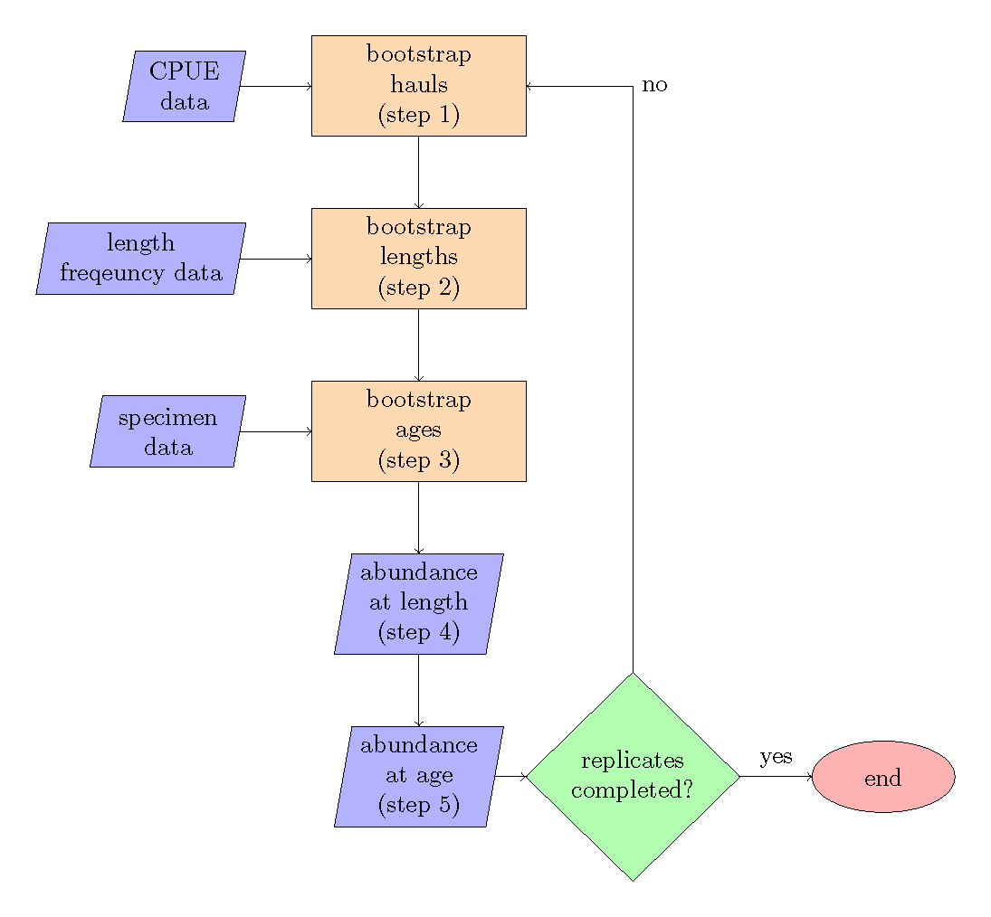

Figure 1: Bootstrap flow chart, the steps refer to the order of operations as described in the *Bootstrap framework for estimating age and length composition input sample size* section.

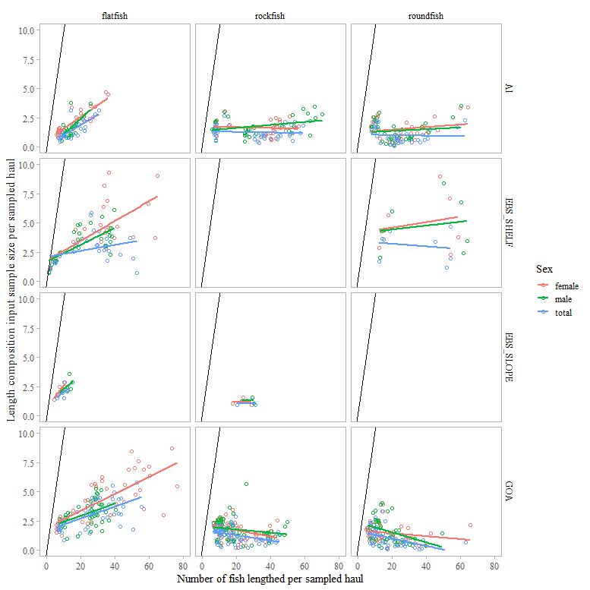

Figure 2: Number of fish lengthed and length composition input sample size per sampled haul by species group and survey.

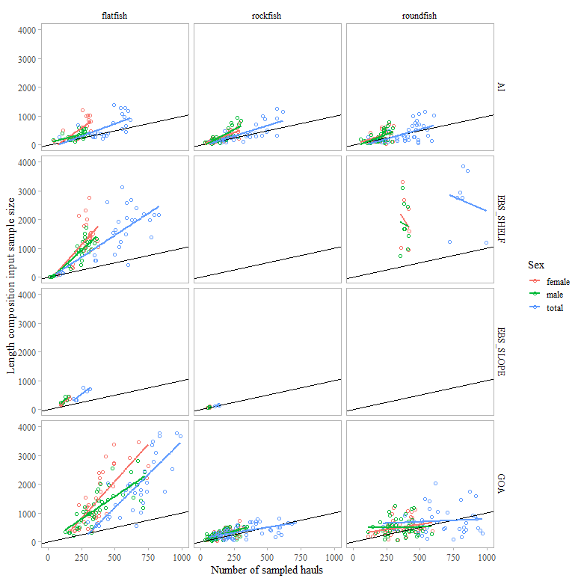

Figure 3: Number of sampled hauls compared to length compostion input sample size by species group and survey.

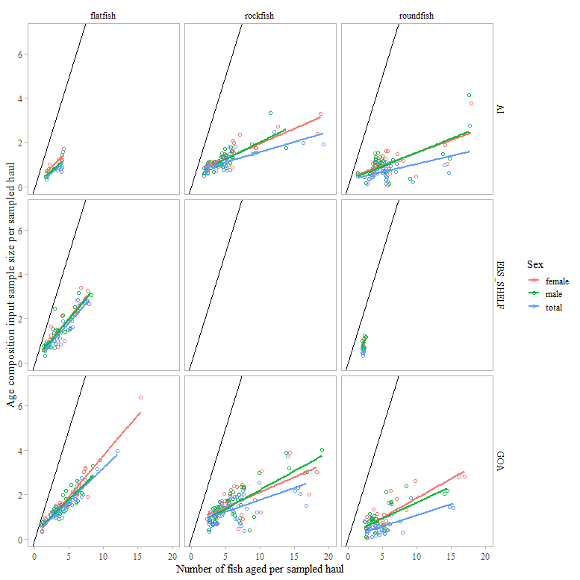

Figure 4: Number of fish aged and age composition input sample size per sampled haul by species group and survey.

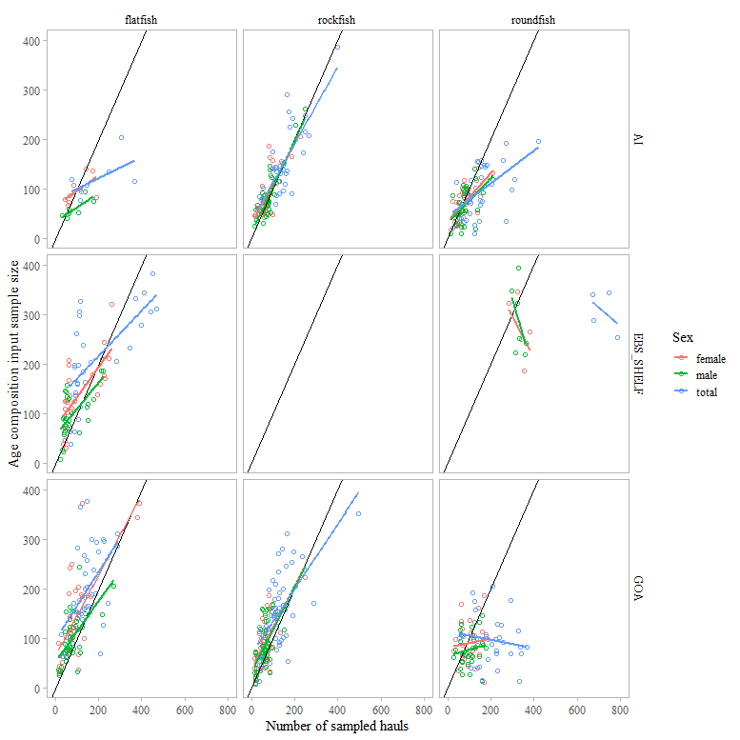

Figure 5: Number of sampled hauls compared to age compostion input sample size by species group and survey.