|  |
| --- |
| **Relative directories** |
|  |

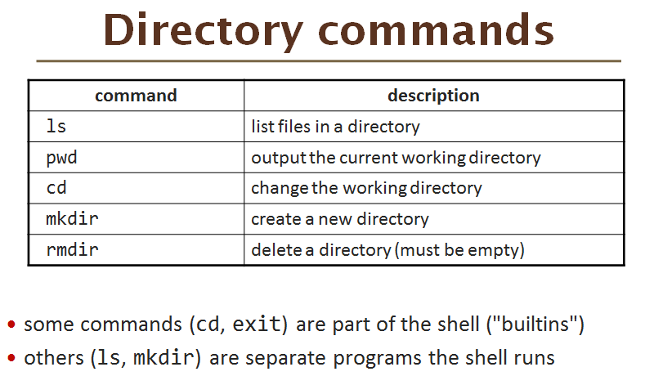

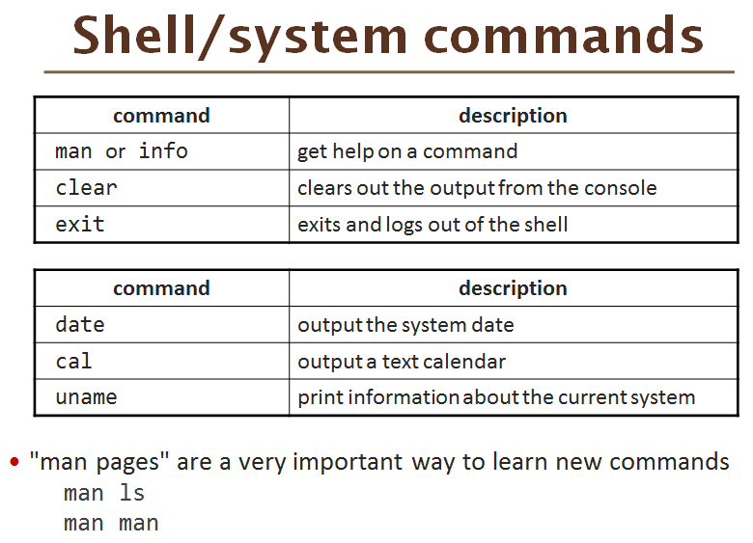

In GitHub Bash Shell,

Using:

1. **Help Help** like Unix Shell *man man*
2. **Ls –Help** like Unix Shell *man ls*

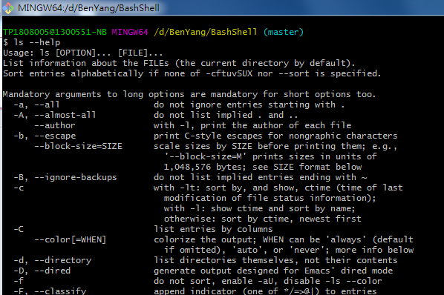

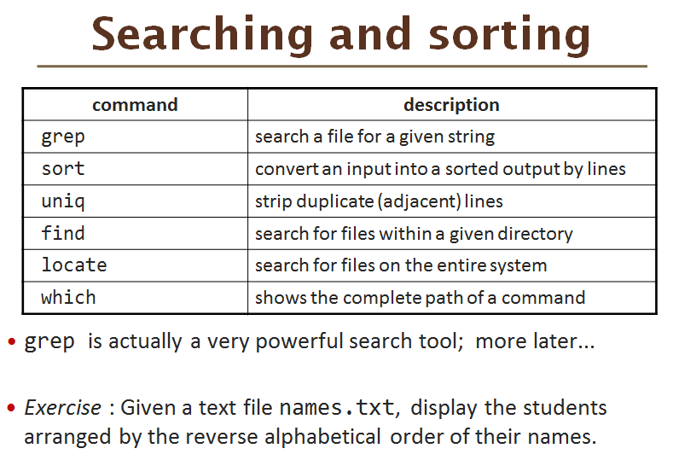

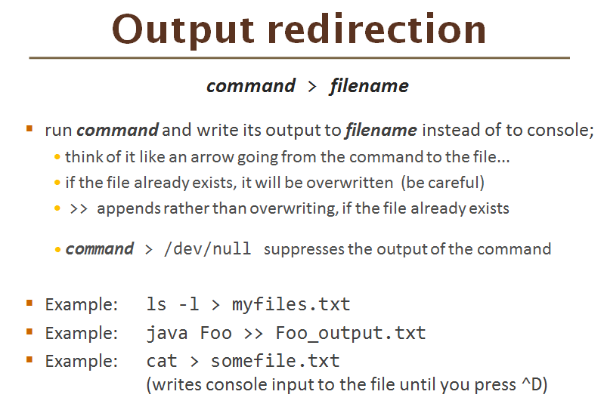

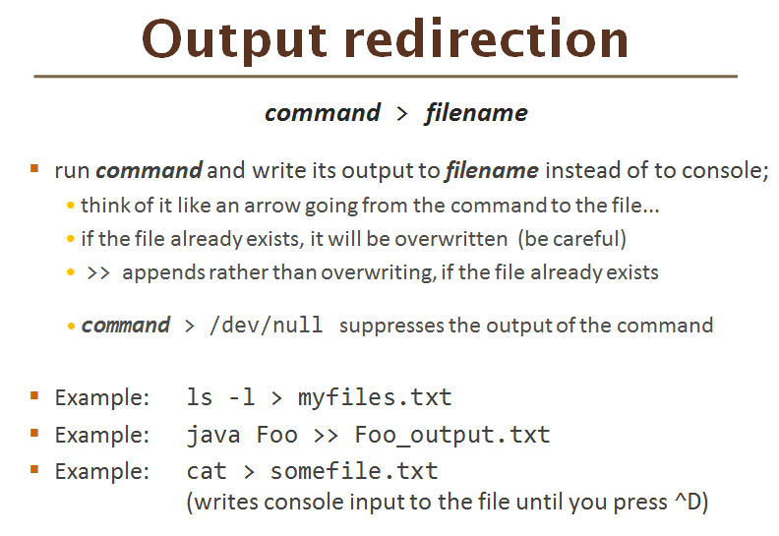

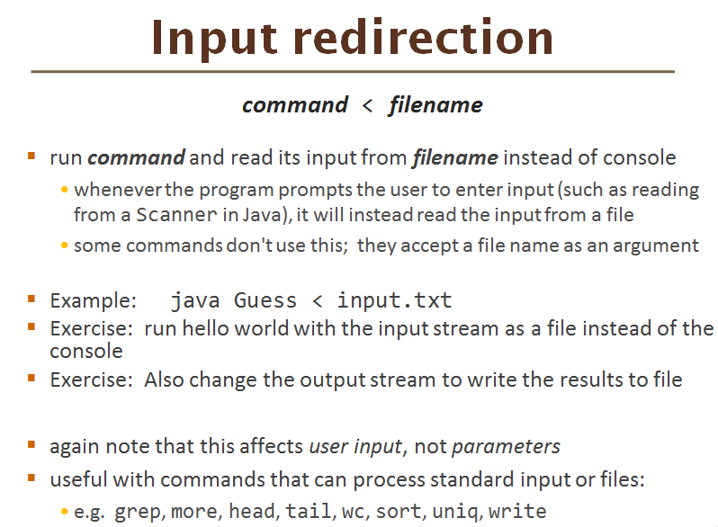

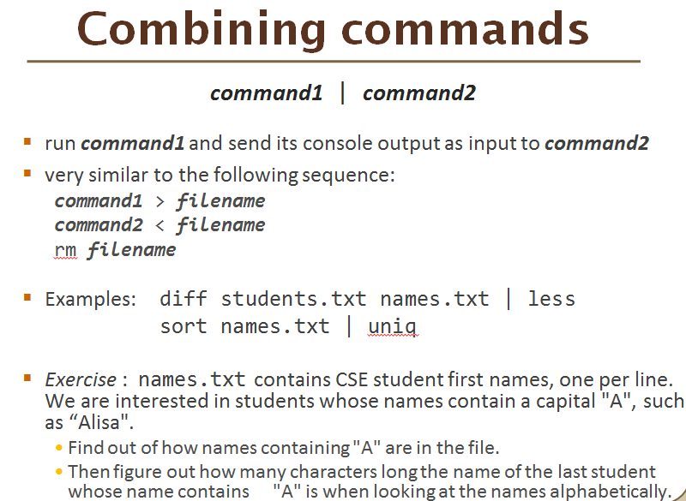

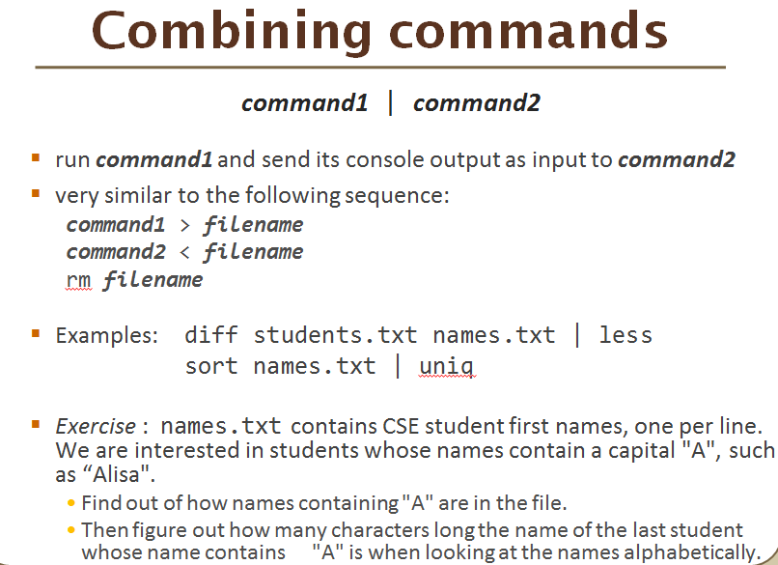

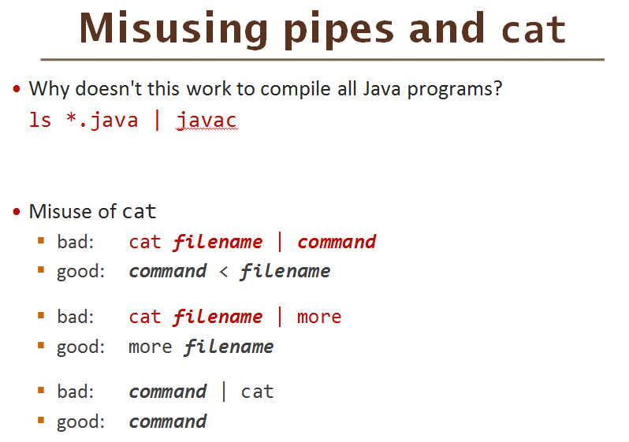

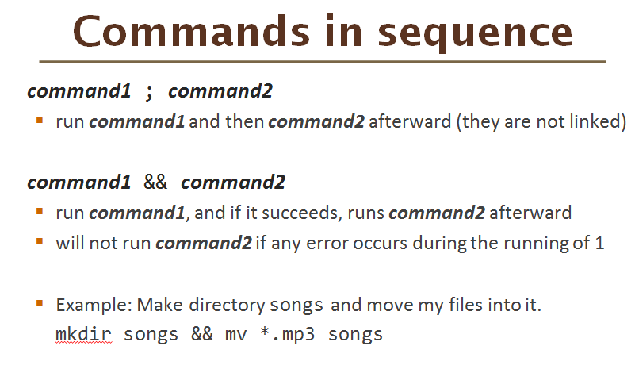

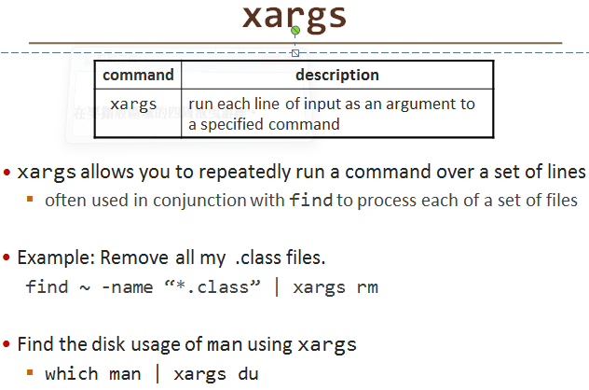

* Example: Remove all my .class files.
  + find ~ -name “*.class” | xargs rm
* Find the disk usage of man using xargs
  + which man | xargs du

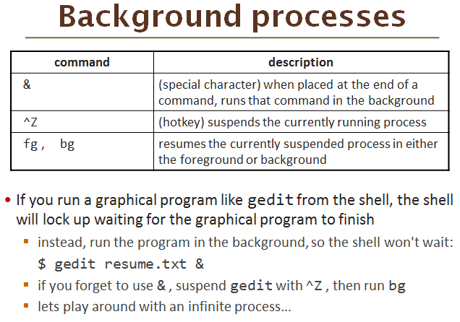

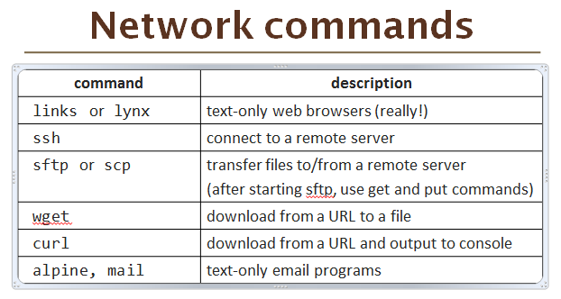

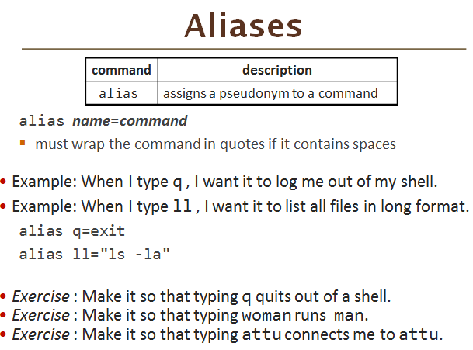

alias ***name***=***command***

* + must wrap the command in quotes if it contains spaces
* Example: When I type q , I want it to log me out of my shell.
* Example: When I type ll , I want it to list all files in long format.

alias q=exit

alias ll="ls -la"

* *Exercise* : Make it so that typing q quits out of a shell.
* *Exercise* : Make it so that typing woman runs man.
* *Exercise* : Make it so that typing attu connects me to attu.