**ML Unit 10 Seminar Preparation:**

Wang et al. (2021) created a visual examination which facilitates the understanding of Convolutional Neural Networks (CNNs). It shows how a CNN can be used for image classification. The different hyperparameters and activation functions of a CNN are explained which enhanced my understanding of this model. It is also explained how pooling layers are used and how they reduce the computation necessary to run the neural network. Then, it is shown that the flatten layer is used to comprise the output to one dimension again which is necessary when using the softmax function for the final classification. Overall, this is an interesting way of teaching a rather complex concept as CNNs. A mixture of plain text, a video tutorial and a clickable visualisation of the neural network enables to learn the concepts via multiple input channels. For me, this significantly helped create a better grasp of the technical basics of neural networks in genera and CNNs in particular.

Furthermore, the site enables to upload own images and this way test the model’s classification. I tested multiple images.

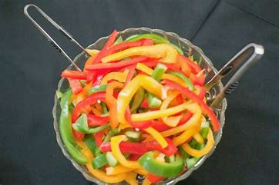

**Image 1: Sliced peppers**

The CNN has been trained on bell pepper. Uploading image 1, a picture of sliced peppers, I check whether it also classifies these correctly as pepper or whether it faces difficulties.

Ein Bild, das Text, Screenshot, Design enthält.

**Figure 1: Results for the slices pepper image delivered by the CNN**

As we see in figure 1, the CNN classifies the picture of sliced peppers as orange or pizza, with no signs of it being related to bell pepper at all. This is probably the case because the model was trained on full bell peppers and pepper in its sliced form looks completely different, rather associated to oranges or pizzas because they lay in a circular form.

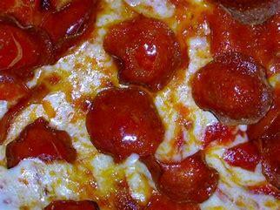

**Image 2: Close-up picture of pizza**

Continuing to challenge the model by picking images that match with one of the training classes but look slightly different than I expect the training data to look, I uploaded a close-up picture of a pizza without the circular form of it.

Ein Bild, das Text, Screenshot, Design enthält.

**Figure 2:** **Results for the close-up pizza image delivered by the CNN**

We now see that the classification once again is incorrect. The model classifies the close-up picture of a pizza as espresso, bell pepper or orange and only a very slight bit as pizza. Once again this is probably the case because the pizza pictures in the training dataset were photographed as whole, round pizzas, i.e., looking very differently to the picture of a pizza that I uploaded.

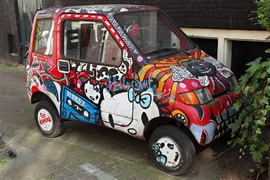

**Image 3: A car with graffiti sprayed on it**

Checking for the “car” class, I now use a car with graffiti on it. This way it also probably looks slightly different than the training images. However, as it is still much closer to a “normal” picture of a car than the two previous images, I expect the model to correctly classify it.

**Ein Bild, das Text, Screenshot, Design enthält.
**

**Figure 3: Results for the image of the car with graffiti sprayed on it delivered by the CNN**

Now we see that the model, as I predicted, correctly classifies the car, associating it to the “sport car” class.

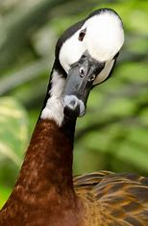

**Image 4: A duck**

Lastly, I want to check what happens when I upload an image that is completely unrelated to any of the classes the model was trained on. Thus, I upload a photo of a duck and check how the model classifies it and whether I can explain this classification somehow.

**Ein Bild, das Text, Screenshot, Design enthält.
**

**Figure 4: Results for the image of a duck delivered by the CNN**

We see that the CNN classifies the picture of a dock as ladybug, only with very small ticks for bell pepper and orange. I can not really explain this classification, the only idea I have is that these are rather small animals and objects and the duck on the photo does not take up much of the space on the picture. Other than that, the duck shares no similar features to a ladybug, a bell pepper or an orange.

Overall, clicking through the different layers of the CNN and uploading own images created a deeper understanding for the working of a CNN. While some of the wrong classifications I saw in my tests are explainable due to shared or similar features of different objects, some I cannot really explain. I especially do not understand why the picture of a duck gets classified as ladybug. This shows how a CNN evaluates these pictures differently as compared to our human view.

**References:**

Wang, J., Turko, R., Shaikh, O., Park, H., Das, N., Hohman, F., Kahng, M. & Chau, P. (2021) CNN Explainer: Learn Convolutional Neural Network (CNN) in your browser.