 | SBP-YOLO: REAL-TIME DETECTION OF SPEED BUMPS AND POTHOLES | 
A Project Report
U23ADS705 – MINI PROJECT
Submitted by

BENADICT INFANT A | (61782323110022)
ELANGOVAN S | (61782323110035)
in partial fulfillment for the award of the degree
of
BACHELOR OF TECHNOLOGY
in
ARTIFICIAL INTELLIGENCE AND DATA SCIENCE
SONA COLLEGE OF TECHNOLOGY (AUTONOMOUS), SALEM – 636005
ANNA UNIVERSITY: CHENNAI 600 025
OCTOBER 2026

SONA COLLEGE OF TECHNOLOGY (AUTONOMOUS)
ANNA UNIVERSITY: CHENNAI – 600 025
BONAFIDE CERTIFICATE
Certified that this project titled “SBP-YOLO: REAL-TIME DETECTION OF SPEED BUMPS AND POTHOLES” is the bonafide work of “BENADICT INFANT A (61782323110022), ELANGOVAN S (61782323110035)” who carried out the project work U23ADS705 – MINI PROJECT under my supervision.

Signature of the Supervisor | Head of the Department
Dr. P. SHANMUGARAJA | Dr. J. AKILANDESWARI
SUPERVISOR | HEAD OF THE DEPARTMENT
Assistant Professor, | Department of Information Technology,
Department of Information Technology, | Sona College of Technology,
Sona College of Technology, | Salem – 636005.
Salem – 636005.

Submitted for the Project Viva-Voce Examination held on ____________________

INTERNAL EXAMINER | EXTERNAL EXAMINER
Sona College of Technology
Department of Information Technology
U23ADS705 – MINI PROJECT – DECLARATION FORM
Declaration by the Student(s)
We hereby declare that the project titled “SBP-YOLO: Real-Time Detection of Speed Bumps and Potholes” is an original work carried out by us under the guidance of Dr. P. Shanmugaraja. This project has not been submitted elsewhere for the award of any degree.
We also affirm that all the data and information used in this project are genuine and properly acknowledged. This project work is carried out with reference to the United Nations Sustainable Development Goals Goal 3 – Good Health and Well-being, Goal 9 – Industry, Innovation and Infrastructure, and Goal 11 – Sustainable Cities and Communities.
S.No | Register Number | Name | Signature
1. | 61782323110022 | BENADICT INFANT A
2. | 61782323110035 | ELANGOVAN S

Date: ____________________
Place: Sona College of Technology
ACKNOWLEDGMENT
We would like to place on record our sincere thanks to the Management of Sona College of Technology, Salem, for providing the facilities and the academic environment in which this project was carried out.
We are grateful to our Principal for the encouragement given to students to take up project work that goes beyond the classroom.
We thank Dr. J. Akilandeswari, Head of the Department of Information Technology, for supporting this work and for making the department’s resources available to us whenever we needed them.
We express our deep gratitude to our project guide, Dr. P. Shanmugaraja, Assistant Professor, Department of Information Technology, for his guidance at every stage of this project. His questions about what each part of the model actually contributes pushed us to look past the headline numbers, and that shaped the final form of this work.
We also thank the project coordinators and all the faculty members of the department for their review comments, which helped us sharpen both the experiments and this report.
We acknowledge the authors of SBP-YOLO for releasing their code and trained weights publicly, which made this project possible.
Finally, we thank our parents and friends for their patience and support throughout the project.

BENADICT INFANT A
ELANGOVAN S
ABSTRACT
Speed bumps and potholes are the road anomalies that most often force a vehicle to slow down or swerve. On Indian roads many speed bumps are unpainted and poorly marked, so a driver often gets no visual warning until the suspension takes the impact. A camera that detects these anomalies early could warn the driver or let an active suspension prepare in advance, but only if the detector is accurate on small, distant targets and fast enough to run on an embedded board.
This project studies and implements SBP-YOLO, a lightweight real-time detector for speed bumps and potholes built on YOLOv11n. SBP-YOLO replaces costly convolutions with GhostConv and VoVGSCSPC blocks, adds a high-resolution P2 detection level for small targets, and uses a Lightweight Efficient Detection Head (LEDH) to hold down the extra cost. It is trained with the Normalized Wasserstein Distance (NWD) loss, weather augmentation and knowledge distillation. Its authors report 87.0% mAP@0.5 with 2.04 million parameters and 5.8 GFLOPs, and 139.5 frames per second on a Jetson AGX Xavier with TensorRT FP16.
We set up the official implementation, analysed each module, and ran the released SBP-YOLO weights on road images and video. To ground the comparison, we also trained seven stock detectors under one fixed protocol on a public 3,243-image dataset. The unmodified YOLO generations from YOLOv8n to YOLO12n ended within about 2.5 points of each other, a smaller spread than the 5.4-point gain SBP-YOLO’s authors report over YOLOv11n. Task-specific design therefore matters more here than switching to a newer generation.
Keywords: SBP-YOLO, speed bump detection, pothole detection, small object detection, lightweight detector, YOLOv11n, TensorRT, suspension preview control.
TABLE OF CONTENTS
TITLE PAGE NO.
ACKNOWLEDGMENT iv
ABSTRACT v
LIST OF FIGURES viii
LIST OF TABLES ix
LIST OF ABBREVIATIONS x
1. INTRODUCTION 1
1.1 Background of the Project 1
1.2 Problem Statement 1
1.3 Motivation 2
1.4 Objectives 2
1.5 Scope of the Project 2
2. LITERATURE REVIEW 4
2.1 Introduction 4
2.2 Review of Related Studies 4
2.3 Techniques and Technologies Used in Existing Systems 7
2.4 Research Gap 8
2.5 Summary 9
3. CHAPTER 1 – NEED FOR PROPOSED TECHNIQUE 10
3.1 Existing Techniques 10
3.2 Limitations of Existing Techniques 11
3.3 Proposed Technique 11
3.4 Objectives of the Proposed Technique 12
3.5 Advantages of the Proposed Technique 12
4. CHAPTER 2 – DESIGN OF PROPOSED SYSTEM AND ITS IMPLEMENTATION 13
4.1 Introduction 13
4.2 System Requirements 13
4.2.1 Hardware Requirements 13
4.2.2 Software Requirements 14
4.3 System Architecture 14
4.4 System Components/Modules 16
4.4.1 Data Acquisition and Augmentation Module 16
4.4.2 Lightweight Backbone and Neck Module 16
4.4.3 Small-Object Detection Head Module 17
4.4.4 Training and Distillation Module 17
4.4.5 Deployment and Inference Module 17
4.4.6 Baseline Benchmarking Module 17
4.5 Proposed Methodology 17
4.6 System Workflow 18
4.7 Algorithms/Techniques Used 18
4.8 Dataset/Data Collection 21
4.9 Data Preprocessing 22
4.10 Model/System Development 22
4.11 System Design Diagrams 24
4.12 Implementation 25
4.13 Coding/Program Implementation 26
4.14 User Interface / Application Screens 28
4.15 Chapter Summary 29
5. CHAPTER 3 – RESULTS AND DISCUSSION 30
5.1 Introduction 30
5.2 Experimental Setup 30
5.3 Evaluation Metrics 30
5.4 Experimental Results 31
5.4.1 Contribution of Each SBP-YOLO Module (Reported) 31
5.4.2 Effect of Knowledge Distillation (Reported) 32
5.4.3 Comparison with YOLO Baselines (Reported) 32
5.4.4 Embedded Deployment with TensorRT (Reported) 33
5.4.5 Baseline Benchmark on the Public Dataset (Measured) 34
5.4.6 Inference with the Released SBP-YOLO Weights 37
5.5 Comparison with Existing Techniques 37
5.6 Discussion of Results 37
5.7 Chapter Summary 39
6. CHAPTER 4 – CONCLUSION AND FUTURE SCOPE 40
6.1 Summary of the Project 40
6.2 Conclusion 41
6.3 Future Scope 41
SDG GOALS 43
PUBLICATIONS 44
REFERENCES 45
LIST OF FIGURES
FIGURE NO. TITLE PAGE NO.
Fig. 4.1 Overall system architecture 15
Fig. 4.2 Simplified structure of the SBP-YOLO network, after Liang et al. [23] 16
Fig. 4.3 Project workflow 18
Fig. 4.4 GhostConv and GSConv, the building blocks of SBP-YOLO’s backbone and neck 19
Fig. 4.5 A conventional decoupled head compared with LEDH 20
Fig. 4.6 Use case diagram 24
Fig. 4.7 Data flow diagram (level 1) 25
Fig. 4.8 SBP-YOLO detections on a road image 28
Fig. 4.9 SBP-YOLO detections on a frame from a dashcam clip 29
Fig. 5.1 Effect of each SBP-YOLO module on accuracy and computation (values reported by Liang et al. [23]) 31
Fig. 5.2 mAP@0.5 against GFLOPs on the SBP-YOLO dataset (values reported by Liang et al. [23]) 33
Fig. 5.3 Throughput on Jetson AGX Xavier at three precisions (values reported by Liang et al. [23]) 34
Fig. 5.4 Overall accuracy of the baseline detectors on the public test split (measured) 35
Fig. 5.5 Per-class AP@0.5 of the baseline detectors (measured) 36
Fig. 5.6 Baseline detections on two test images: (a) a distant unpainted bump, (b) a pothole cluster (measured) 36
LIST OF TABLES
TABLE NO. TITLE PAGE NO.
Table 2.1 Summary of representative prior work 6
Table 3.1 Comparison of existing techniques 11
Table 4.1 Hardware requirements 13
Table 4.2 Software requirements 14
Table 4.3 Feature pyramid levels for a 640 × 640 input 20
Table 4.4 Datasets used in this project 22
Table 4.5 SBP-YOLO design stages and released weights 23
Table 4.6 SBP-YOLO training configuration reported by its authors 23
Table 4.7 Baseline training configuration (our runs, identical across models) 24
Table 5.1 Ablation study of SBP-YOLO 31
Table 5.2 Effect of knowledge distillation 32
Table 5.3 Comparison of SBP-YOLO with YOLO baselines on the SBP-YOLO dataset 32
Table 5.4 TensorRT inference on NVIDIA Jetson AGX Xavier 33
Table 5.5 Baseline accuracy and cost on the public test split (measured) 34
Table 5.6 Per-class accuracy of the baselines on the public test split (measured, %) 35
Table 5.7 Comparison with existing techniques (as reported) 37
Table 6.1 Achievement of project objectives 41
LIST OF ABBREVIATIONS
ABBREVIATION EXPANSION
ADAS Advanced Driver Assistance System
AMP Automatic Mixed Precision
AP Average Precision
BCKD Bridging Cross-task Knowledge Distillation
CNN Convolutional Neural Network
COCO Common Objects in Context (dataset)
CWD Channel-Wise Distillation
DFD Data Flow Diagram
DFL Distribution Focal Loss
FN / FP / TP False Negative / False Positive / True Positive
FP16 / FP32 16-bit / 32-bit floating point
FPS Frames Per Second
GFLOPs Giga Floating-Point Operations
GPU Graphics Processing Unit
GSConv Group-Shuffle Convolution
INT8 8-bit integer precision
IoU Intersection over Union
ITS Intelligent Transportation Systems
KD Knowledge Distillation
LEDH Lightweight Efficient Detection Head
mAP mean Average Precision
NMS Non-Maximum Suppression
NWD Normalized Gaussian Wasserstein Distance
P2–P5 Feature pyramid levels at strides 4 to 32
RT-DETR Real-Time Detection Transformer
SBP-YOLO Speed Bump and Pothole YOLO
SDG Sustainable Development Goal
VoVGSCSPC VoV-style GSConv Cross-Stage Partial block
YOLO You Only Look Once

1. INTRODUCTION
1.1 Background of the Project
Road surfaces carry two kinds of anomalies that matter to a moving vehicle. Some are defects, such as potholes and cracks, which appear as the pavement wears out. Others are built on purpose, such as speed bumps and humps, which are placed near schools, hospitals, junctions and residential streets to force traffic to slow down. Both share the same problem for a driver: if they are not seen in time, the vehicle hits them at the wrong speed.
On Indian roads, speed bumps are among the least standardised features a driver meets. A large share are unpainted, many do not follow the height and profile that the Indian Roads Congress specifies, and a single stretch of road can carry several of them with no signboard at all. At night, in rain, or behind a larger vehicle, an unmarked bump is practically invisible until the suspension finds it. For two-wheelers, which carry most of the road users in Tamil Nadu, meeting one at speed can mean anything from discomfort to a loss of control [1], [39].
Early detection systems used accelerometers and gyroscopes to sense the jolt as a vehicle crossed a bump [7]. Later systems used cameras, first with hand-crafted image processing [8] and then with deep learning [10], [42]. A camera can see a bump before the vehicle reaches it, and this matters for more than driver warnings. Modern vehicles with semi-active or active suspension can adjust their damping in advance of an uneven surface, an idea called suspension preview control [35]. For that to work, the vehicle needs to know where the next bump or pothole is, early and reliably.
SBP-YOLO, proposed by Liang et al. [23], [25], was designed for exactly this setting. It is a lightweight version of the YOLOv11n detector, changed in four places to make small, distant road anomalies easier to detect while keeping the model small enough to run at high frame rates on an embedded board. This project studies that design in detail, sets up its official implementation [24] and uses its released weights, and places it in context with a set of stock detectors that we trained ourselves.
1.2 Problem Statement
A speed bump seen from a useful stopping distance is a thin, low-contrast band that may be only a dozen pixels tall in a 640-pixel frame. Potholes are similar: small, irregular and often clustered together. Standard detectors find most of their objects through feature maps that have been shrunk by a factor of 8 to 32, and at those scales a distant bump covers one feature cell or less. At the same time, a detector meant for a vehicle has to run on an embedded board in real time, which rules out simply making the model bigger.
The problem this project addresses is therefore how to detect speed bumps and potholes accurately at small scales while keeping the detector light enough for real-time embedded use, and how much a purpose-built lightweight design such as SBP-YOLO actually gains over the off-the-shelf detectors a developer would otherwise reach for.
1.3 Motivation
Unmarked bumps are a common sight on roads in and around Salem, as in most Indian towns, and most riders learn their positions only by repeatedly hitting them. A camera-based system would help in exactly the cases where a driver cannot see the hazard. We were drawn to SBP-YOLO because it does not stop at reporting a detection score: it targets a concrete use, suspension preview, and reports speed on real embedded hardware. Its authors also released their code and trained weights, so the design could be studied and run rather than only read about.
A second motivation came from our own experiments with general-purpose detectors. When we trained several stock YOLO generations on a public speed bump and pothole dataset, the newer versions improved only slightly on the older ones. That raised a natural question: if moving from YOLOv8 to YOLO12 changes little, does a design built specifically for this task do better? SBP-YOLO is a good case for answering it.
1.4 Objectives
The specific objectives of the project are:
- To review existing speed bump and pothole detection methods, with attention to small-object detection and lightweight design.
- To study the SBP-YOLO architecture in detail and explain what each of its modules contributes: GhostConv, VoVGSCSPC, the P2 detection level, LEDH, the NWD loss and knowledge distillation.
- To set up the official SBP-YOLO implementation and run the released trained weights on road images and video.
- To train stock real-time detectors on a public speed bump and pothole dataset under one fixed protocol, as a measured baseline.
- To analyse SBP-YOLO’s reported accuracy, model size and embedded speed against these baselines and against earlier work, and to identify what remains to be done before deployment.
1.5 Scope of the Project
The project covers the detection of two classes, speed bumps and potholes, in single road images using a monocular forward-facing camera. It includes the study and setup of SBP-YOLO, inference with its released weights, the training and evaluation of baseline detectors, and an analysis of the results.
Some things are deliberately outside the scope. We did not retrain SBP-YOLO from scratch; its accuracy and speed figures in this report are those published by its authors and are labelled as such wherever they appear. We did not build an in-vehicle device or connect the detector to a real suspension controller, and we did not measure latency on a Jetson board ourselves. Distance estimation and multi-frame tracking are also not part of this work. These items are listed as future work in Chapter 6.
2. LITERATURE REVIEW
2.1 Introduction
This chapter reviews earlier work on detecting speed bumps and potholes, and on the techniques that SBP-YOLO builds on. The aim is to understand which sensing approaches have been tried, which detection models have been used, how results have been reported, and what is still missing. The review is organised by sensing method first and detection model second, then covers the lightweight and small-object techniques that matter for this project, and ends with the research gap.
Two broad surveys give a useful starting map of the field. Saffarini et al. [33] grouped road anomaly detection into accelerometer-based and vision-based techniques and covered potholes, cracks and speed bumps together. Assemlali et al. [4] carried out a systematic review of 95 computer vision studies on road obstacles published between 2015 and 2024, and found that most relied on image input and that only about a third used public datasets. Both surveys note that comparisons across studies are difficult because datasets and evaluation settings differ.
2.2 Review of Related Studies
Sensor-based detection. The earliest practical systems did not use cameras at all. When a vehicle crosses a bump, its accelerometer and gyroscope record a clear vertical spike. Celaya-Padilla et al. [7] extracted accelerometric features from such signals and used a genetic algorithm to select the features that best separate bump events from normal driving. The method works in near real time and can be used to build maps of bump locations. Its limitation is structural: detection only happens after contact, so it helps the next vehicle rather than the current one. Darwiche and El-Hajj-Chehade [8] combined image processing with signal processing so that bumps could be detected without special sensors or GPS, an early move towards vision.
Stereo vision and distance estimation. A second camera lets a system estimate how far away a bump is. Varma et al. [42] used a ZED stereo camera with GPU-based deep learning to detect both marked and unmarked humps and estimate their distance in real time. Peralta-López et al. [31] also used a ZED camera, designed a lightweight network for potholes, and built a database that separates potholes from speed bumps. Vasisht et al. [43] combined YOLOv8x with a ZED stereo camera and reported 93.1% mAP@50 at about 30 FPS on a laptop GPU. Distance is valuable for suspension control, but a stereo camera together with a discrete GPU is too costly for a simple retrofit device.
Monocular deep learning for speed bumps. Dewangan and Sahu [10] built a CNN-based speed bump system that runs on a Raspberry Pi and reported 98.54% accuracy. That figure is for image-level classification rather than box-level detection, so it cannot be compared with mAP. Magdy et al. [26] compared Faster R-CNN, VGG-16, MobileNet-SSD and two YOLOv3 variants for combined lane and bump detection, with YOLOv3 Lite-MobileNet best at 89.17%. Aishwarya et al. [1] focused on Indian roads. They compared Faster R-CNN with YOLOv5, treated marked and unmarked bumps separately and dealt with confusion between bumps and pedestrian crossings, at 18.5 ms per frame on a Jetson board.
A second group of studies modifies a base detector, which is the approach SBP-YOLO takes. Xiang et al. [49] built CRSCCG-YOLOv5s to detect several types of speed bump defect and reported 96.4% mAP with 8.8 million parameters. Wang et al. [47] added FasterNet and Dynamic Snake Convolution to a YOLOv5-based network for connected vehicles, giving up a little accuracy for a large gain in speed. Hussein et al. [14] collected road images in Egypt and deployed their detector on a Jetson Nano at 81% mAP. Li et al. [22] added SE and EMA attention to YOLOv8n and improved mAP@0.5 by 8.9 points in low light and rain. Mao et al. [27] proposed SBD-YOLO, based on YOLOv9 with an Aggregated-MBConv module that cuts computation by 82.8% for suspension preview control. SBD-YOLO and SBP-YOLO share the same target application, which shows that suspension preview has become an active driver for this line of work.
SBP-YOLO. Liang et al. [23], [25] start from YOLOv11n and make four changes: GhostConv and VoVGSCSPC blocks in the backbone and neck to reduce computation, a P2 detection branch for small objects, a Lightweight Efficient Detection Head (LEDH) to offset the cost of that branch, and a training recipe that adds the NWD loss, weather augmentation and knowledge distillation. On their 7,500-image dataset they report 86.6% mAP@0.5 for the base model and 87.0% after distillation, against 81.2% for YOLOv11n, with 2.04 million parameters and 5.8 GFLOPs. After TensorRT FP16 quantisation the model runs at 139.5 FPS on a Jetson AGX Xavier. The code, dataset links and a set of trained weights for each design step are public [24]. This is the model studied in this project, and Chapters 3 and 4 describe it in detail.
Studies on Indian roads. Only a few studies work with Indian road conditions directly. Dharneeshkar et al. [11] built a pothole dataset from Indian roads and trained YOLO models on it. Aishwarya et al. [1] reported that unpainted bumps and pedestrian crossings that look like painted bumps were the main sources of error. The Towards Safer Roads review [39] also uses an unmarked Indian speed bump as an example of a hazard that conventional mapping systems miss. These studies agree that unmarked bumps are the hardest and most important case.
Detection for suspension preview control. A growing part of this literature is aimed not at drivers but at the suspension itself. Shen et al. [35] describe the usual structure of a vision-based preview system: a camera module, an image processing module, a detection module, and a control module that adjusts damping before the wheel reaches the anomaly. They point out that the detection module has to finish within the time budget of the control loop, which is why frame rate on embedded hardware matters as much as accuracy. SBD-YOLO [27] and SBP-YOLO [23] were both designed for this module. They differ in their starting points, YOLOv9 for SBD-YOLO and YOLOv11n for SBP-YOLO, and in their priorities: SBD-YOLO cuts computation as far as possible, while SBP-YOLO spends part of its savings on a P2 level for small targets. Varma et al. [42] and Peralta-López et al. [31] approach the same application from the stereo side, adding distance to the detection.
Pothole detection and comparative studies. Pothole detection has been studied far more than speed bump detection. Park et al. [30] compared YOLOv4, YOLOv4-tiny and YOLOv5s and found the tiny model best once speed was taken into account. Mohan Prakash and Sriharipriya [28] tested YOLOX for potholes and found that the YOLOX-Nano model gave high accuracy at low computational cost. Wang et al. [48] improved a YOLOv3-based network with a ResNet backbone and tested robustness to adversarial inputs. Asad et al. [3] compared YOLOv1 to YOLOv5 and SSD-MobileNetV2 on OAK-D and Raspberry Pi hardware, one of the few studies to treat edge hardware as part of the experiment.
Jakubec et al. [15] compared YOLO and R-CNN models under rain, night and sunset conditions. Tamagusko et al. [37] compared YOLOv3, YOLOv4 and YOLOv5 on a fixed 665-image dataset. Bhavana et al. [5] added Sobel edge preprocessing to YOLOv8 and reported 99.1% accuracy. Khan et al. [17] applied YOLOv8 to pothole detection for autonomous vehicles and studied the effect of data augmentation. Aquib et al. [2] compared YOLOv5 to YOLOv8, Kothari et al. [19] compared YOLO11 and YOLO12 at three scales on real road photographs taken in different weather, and Pham et al. [32] compared YOLOv7 to YOLOv10 for general road damage. None of these comparative studies includes speed bumps.
Reviews of the area. Safyari et al. [34] reviewed vision-based pothole detection and concluded that hybrid methods combining image processing with machine learning gave the highest accuracy in the studies they examined. The Towards Safer Roads review [39] is the only review we found that focuses on speed bumps specifically, covering vision-based, sensor-based and hybrid approaches published between 2017 and 2024. Shen et al. [35] reviewed road surface perception for suspension preview control and stressed the need for information about bump height and pothole depth, not only position. Table 2.1 summarises the main studies discussed in this section.
Table 2.1 Summary of representative prior work
Ref. | Method | Target | Reported outcome
[7] | Accelerometer features + genetic algorithm | Speed bumps | Post-contact detection
[42] | ZED stereo camera + GPU | Humps, distance | Real-time with ranging
[10] | CNN on Raspberry Pi | Speed bumps | 98.54% classification accuracy
[26] | YOLOv3 Lite-MobileNet | Lanes and bumps | 89.17%
[1] | Faster R-CNN vs YOLOv5 | Indian speed bumps | 18.5 ms per frame (Jetson)
[49] | CRSCCG-YOLOv5s | Bump defects | 96.4% mAP, 8.8 M parameters
[47] | YOLOv5-FPNet | Speed bumps | Large FPS gain
[14] | YOLO on Jetson Nano | Speed bumps (Egypt) | 81% mAP
[22] | YOLOv8n + SE/EMA | Low-light speed bumps | +8.9 mAP@0.5
[27] | SBD-YOLO (YOLOv9) | Speed bumps | 82.8% less computation
[43] | YOLOv8x + stereo camera | Bumps and rumblers | 93.1% mAP@50, 30 FPS
[23] | SBP-YOLO (YOLOv11n) | Bumps and potholes | 87.0% mAP@0.5, 139.5 FPS
[30] | YOLOv4 / v4-tiny / v5s | Potholes | Tiny variant best
[3] | YOLOv1–v5, SSD | Potholes (edge) | OAK-D, Raspberry Pi
[15] | YOLO vs R-CNN | Potholes, weather | Condition-wise results
[19] | YOLO11 vs YOLO12 | Potholes | Multi-weather comparison
[5] | POT-YOLO (YOLOv8 + Sobel) | Potholes | 99.1% accuracy
Note: Metrics are as reported by the respective authors on their own datasets and hardware, and are not directly comparable across rows.
2.3 Techniques and Technologies Used in Existing Systems
One-stage detectors and the YOLO lineage. One-stage detectors such as SSD and YOLO predict boxes and classes in a single pass, which makes them the usual choice for real-time work on vehicles [1], [26]. YOLOv8 [16] introduced an anchor-free head and remains the most widely used baseline in road anomaly work. YOLOv9 [45] added programmable gradient information, YOLOv10 [44] trained a one-to-one head so that inference no longer needs Non-Maximum Suppression, and YOLO11 [18], the base of SBP-YOLO, refined the backbone and neck blocks. YOLO12 [38] replaced much of the convolutional backbone with area attention, and YOLO26 [40], [41] removed Distribution Focal Loss and added small-target-aware label assignment. RT-DETR [51] brought transformer-based detection to real-time speeds.
Cheap convolutions. GhostNet [12] observed that many feature maps inside a CNN are near-copies of each other, and proposed generating part of them with cheap depthwise operations instead of full convolutions. The resulting GhostConv module produces the same number of output channels at roughly half the cost. GSConv, introduced in the slim-neck design of Li et al. [21], mixes a standard convolution with a depthwise convolution and then shuffles the channels, so that the cheap half still receives information from the dense half. VoVNet [20] showed that one-shot aggregation of intermediate features is more efficient on GPUs than repeated dense connections, and VoVGSCSPC combines that idea with GSConv.
Small-object techniques. Because a distant bump occupies very few pixels, detectors for this task add features designed for small objects. Adding a detection level at stride 4 (P2) gives the head a feature map with four times the area of the usual smallest level. Li et al. [22] instead add attention to recover faint targets in poor lighting. On the loss side, Wang et al. [46] proposed the Normalized Gaussian Wasserstein Distance (NWD), which models each box as a two-dimensional Gaussian and measures the distance between them. Unlike IoU, NWD changes smoothly when a small predicted box is shifted by a few pixels, so it gives a more useful training signal for tiny objects.
Knowledge distillation and augmentation. Knowledge distillation trains a small student network to imitate a larger teacher [13]. For dense detection, Channel-Wise Distillation (CWD) [36] aligns the channel activations of intermediate feature maps, and BCKD [50] handles the mismatch between classification and localisation outputs when distilling detector heads. Albumentations [6] is a widely used library for image augmentation, including synthetic rain, snow, blur and lighting changes.
How results are reported. The way results are reported varies a great deal across the field. Some studies report image classification accuracy [5], [10], some report mAP at an IoU threshold of 0.5, and only a few report the stricter mAP@0.5:0.95. Speeds are reported on Raspberry Pi boards, Jetson modules and laptop GPUs, with and without TensorRT optimisation [3], [23], [43]. Datasets differ too: many speed bump studies use private collections, while others use public datasets hosted on Roboflow Universe [9]. Assemlali et al. [4] found that only about a third of the computer vision studies they reviewed used public datasets. This variety is the main reason results from different papers cannot be placed side by side, and it is why this report keeps reported and measured results clearly apart.
Hardware and deployment. Studies have deployed detectors on Raspberry Pi boards [3], [10], Jetson Nano and Jetson AGX Xavier modules [14], [23] and laptop GPUs [43]. Speed-ups usually come from NVIDIA TensorRT [29], which compiles a trained network into an optimised engine for a specific GPU and supports reduced-precision inference in FP16 and INT8.
2.4 Research Gap
Reading these studies together reveals four gaps that motivate this project.
- Most speed bump and pothole detectors are general-purpose models applied to road images. Few are designed around the small size of distant targets, which is the case that matters most for early warning.
- Detectors that add small-object features usually become heavier, and lightweight detectors usually lose small-object accuracy. Studies that address both together, at embedded speeds, are rare; SBP-YOLO is one of the few.
- Embedded speed is often reported for one proposed model only, and frequently on laptop or desktop GPUs rather than the boards used in vehicles.
- Results are reported on different, often private datasets, so it is hard to tell how much a proposed model gains over simply choosing a newer stock detector.
2.5 Summary
The literature shows a clear move from sensor-based detection to camera-based one-stage detectors, and from general road damage towards specific targets and specific uses such as suspension preview. It also shows that small-object accuracy and lightweight design pull in opposite directions. SBP-YOLO attempts to reconcile the two. Chapter 3 explains how it does this, and what the rest of this project adds around it.
3. CHAPTER 1 – NEED FOR PROPOSED TECHNIQUE
3.1 Existing Techniques
This section describes the main existing techniques in terms of how they work, along with their advantages and disadvantages.
(a) Vibration and inertial sensing. An accelerometer and gyroscope, either built into the vehicle or inside a smartphone fixed to the dashboard, record vertical acceleration. A bump produces a characteristic spike that thresholds or classifiers can pick out [7]. The method is cheap and good for mapping, but the vehicle must already have hit the bump, and the signal changes with sensor mounting and suspension type.
(b) Classical image processing. Early camera systems used colour thresholds, edge detection and morphological operations to find the painted stripes of a bump [8]. These methods need no training data and run quickly, but they depend on paint and good lighting, and fail on unpainted bumps and in shadows.
(c) Stereo vision with deep learning. A stereo camera gives depth as well as appearance, so the system can estimate the distance to a bump [31], [42], [43]. The cost and calibration needs of a stereo rig, together with the GPU needed to run it, make it hard to fit into low-cost vehicles.
(d) General-purpose monocular detectors. Stock YOLO, SSD or Faster R-CNN models are trained on road images [1], [19], [30]. They are easy to train and deploy. However, their smallest detection level works on feature maps shrunk eight times, which loses distant bumps, and the larger variants that recover some of this accuracy are too slow for embedded boards.
(e) Modified lightweight detectors. Several studies add attention, lighter convolutions or extra branches to a YOLO model [22], [27], [47], [49]. These run in real time on embedded boards, but most target either speed or small objects, not both, and most are not publicly released, so they cannot be checked or reused. Table 3.1 summarises these techniques.
Table 3.1 Comparison of existing techniques
Technique | Advantages | Disadvantages
Vibration / inertial sensing | Low cost; no camera needed; good for mapping | Detects only after contact; depends on vehicle and mounting
Classical image processing | No training data; fast | Needs paint and good light; fails on unpainted bumps and shadows
Stereo vision + deep learning | Gives distance to the bump | Costly hardware; needs calibration and a GPU
General-purpose detectors | Easy to train and deploy | Weak on small, distant targets; larger variants too slow
Modified lightweight detectors | Real-time on embedded boards | Usually trade small-object accuracy for speed; often not released

3.2 Limitations of Existing Techniques
The major limitations identified from the existing techniques can be stated together:
- Sensor-based methods react only after the vehicle crosses the bump, so they cannot warn the current driver or prepare the suspension.
- Hand-crafted vision methods depend on paint and lighting and do not generalise to unpainted bumps.
- Stereo systems are accurate but too costly for a simple retrofit device.
- General-purpose detectors lose small, distant targets at their coarse feature scales.
- Adding small-object features usually increases computation, which conflicts with embedded real-time use.
- Most modified detectors are not publicly released, so their reported gains cannot be checked.
3.3 Proposed Technique
The technique adopted in this project is SBP-YOLO [23], [25], a lightweight real-time detector for speed bumps and potholes published by Liang et al. with its code and trained weights [24]. We did not design SBP-YOLO; our work consists of studying it, setting it up, running it, and placing it in context with detectors we trained ourselves.
SBP-YOLO starts from YOLOv11n and changes it in four ways. First, deeper convolutions in the backbone are replaced by GhostConv, and the C3k2 blocks of the backbone and neck are replaced by VoVGSCSPC blocks built from GSConv, which lowers computation. Second, a fourth detection level, P2, is added at stride 4, giving the head a 160 × 160 feature map in which a distant bump covers several cells instead of a fraction of one. Third, every detection level uses a Lightweight Efficient Detection Head (LEDH) whose grouped, shared convolutions offset most of the cost of the extra P2 level. Fourth, training adds the NWD loss for small boxes, synthetic rain and snow augmentation for robustness, and knowledge distillation from a larger teacher.
Around this, the project adds a measured baseline. Seven stock detectors, including YOLO11n, the base SBP-YOLO was built on, were trained on a public speed bump and pothole dataset under one fixed protocol, so that the size of SBP-YOLO’s reported gain can be judged against what a newer stock model alone achieves.
3.4 Objectives of the Proposed Technique
SBP-YOLO addresses the limitations listed in Section 3.2 as follows:
- The P2 detection level and the NWD loss target the small, distant bumps and potholes that general-purpose detectors lose.
- GhostConv, VoVGSCSPC and LEDH reduce computation so that the extra P2 level does not push the model out of the embedded budget.
- Weather augmentation improves robustness to rain and snow, conditions in which camera-based detection usually degrades.
- Knowledge distillation lets the small model learn from a larger one without adding any cost at inference time.
- TensorRT export with FP16 or INT8 precision makes real-time inference on a Jetson-class board practical.
- Because the implementation and weights are public, the design can be checked and reused, which this project does.
3.5 Advantages of the Proposed Technique
- Small-object accuracy: SBP-YOLO’s reported mAP@0.5 is 5.4 points above YOLOv11n before distillation and 5.8 points after [23].
- Lower cost than its base: 2.04 million parameters and 5.8 GFLOPs, against 2.58 million and 6.3 GFLOPs for YOLOv11n.
- Embedded speed: a reported 139.5 FPS on a Jetson AGX Xavier with TensorRT FP16, fast enough for preview control.
- Early warning: a single camera sees the bump before contact, unlike vibration-based methods, and without stereo hardware.
- Open and reusable: the code and trained weights are public, so the model can be run, checked and extended.
4. CHAPTER 2 – DESIGN OF PROPOSED SYSTEM AND ITS IMPLEMENTATION
4.1 Introduction
This chapter describes the design of the SBP-YOLO system and how we implemented the project around it. It covers the hardware and software, the overall architecture, the modules, the methodology and workflow, the algorithms inside SBP-YOLO, the datasets, preprocessing, model development, design diagrams and the code. Two kinds of work are described side by side. The first is SBP-YOLO itself, which we set up and ran using the authors’ implementation and released weights. The second is the baseline benchmark, which we trained and evaluated ourselves. Where a figure comes from the SBP-YOLO authors rather than from our own runs, the text and table notes say so.
4.2 System Requirements
The requirements below separate the setup reported by the SBP-YOLO authors, the setup we used, and the deployment target.
4.2.1 Hardware Requirements
Table 4.1 Hardware requirements
Component | Specification | Purpose
Training GPU (SBP-YOLO authors) | NVIDIA Tesla V100, 16 GB [23] | Training SBP-YOLO and its teacher
GPU used in this project | NVIDIA Tesla T4, 16 GB (Kaggle) | Baseline training and evaluation; inference with released weights
Deployment target | NVIDIA Jetson AGX Xavier | Real-time TensorRT inference in the vehicle
Camera | Forward-facing vehicle or dashboard camera | Capturing road frames and video
Local machine | Laptop or desktop with a web browser | Code, notebooks, analysis and reporting

4.2.2 Software Requirements
Table 4.2 Software requirements
Software | Version / detail | Purpose
Python | 3.12 (our runs) | Programming language
PyTorch | 2.10 (our runs); 1.13.1 (SBP-YOLO authors) | Deep learning framework
SBP-YOLO repository | ultralytics-yolo11 and ultralytics-distill | SBP-YOLO modules, training and distillation
Ultralytics | 8.4.156 (our baseline runs) | Training and evaluation of stock detectors
CUDA | 11.7 (authors); Kaggle default (ours) | GPU acceleration
TensorRT | NVIDIA TensorRT | FP16 / INT8 engine for the Jetson
Albumentations | Latest release | Rain, snow, blur and lighting augmentation
OpenCV, NumPy, Matplotlib | Standard releases | Video frames, result tables and plots
Operating system | Linux | Execution environment

4.3 System Architecture
The overall architecture of the system is shown in Fig. 4.1. It has four layers. The data layer collects road images of speed bumps and potholes, applies weather and lighting augmentation, and resizes them to 640 × 640. The training layer builds the SBP-YOLO network, trains it with the combined NWD and IoU box loss, and refines it with distillation from a larger teacher. The deployment layer takes the trained weights, exports them to a TensorRT engine in FP16 or INT8 precision, and loads that engine on the Jetson board in the vehicle.
The application layer is what runs while the vehicle moves. Each frame from the forward camera passes through the SBP-YOLO engine, Non-Maximum Suppression removes duplicate boxes, and the remaining detections are passed to the suspension controller or shown as a warning. In this project the data, training and deployment layers follow the SBP-YOLO authors’ design [23], and the application layer was exercised by running the released weights on road images and video; a physical in-vehicle setup is future work.
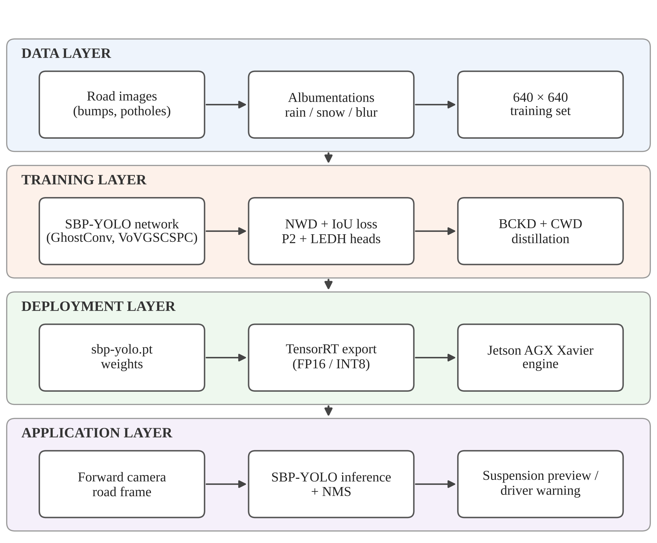
Fig. 4.1 Overall system architecture
The network itself is shown in Fig. 4.2. The backbone extracts features at four scales. Its deeper downsampling convolutions are GhostConv layers and its feature blocks are VoVGSCSPC blocks. The neck fuses these features top-down, so that the high-resolution P2 map also receives semantic information from deeper levels. The head applies an LEDH at each of the four levels, from the 160 × 160 P2 grid down to the 20 × 20 P5 grid, and NMS merges their predictions.
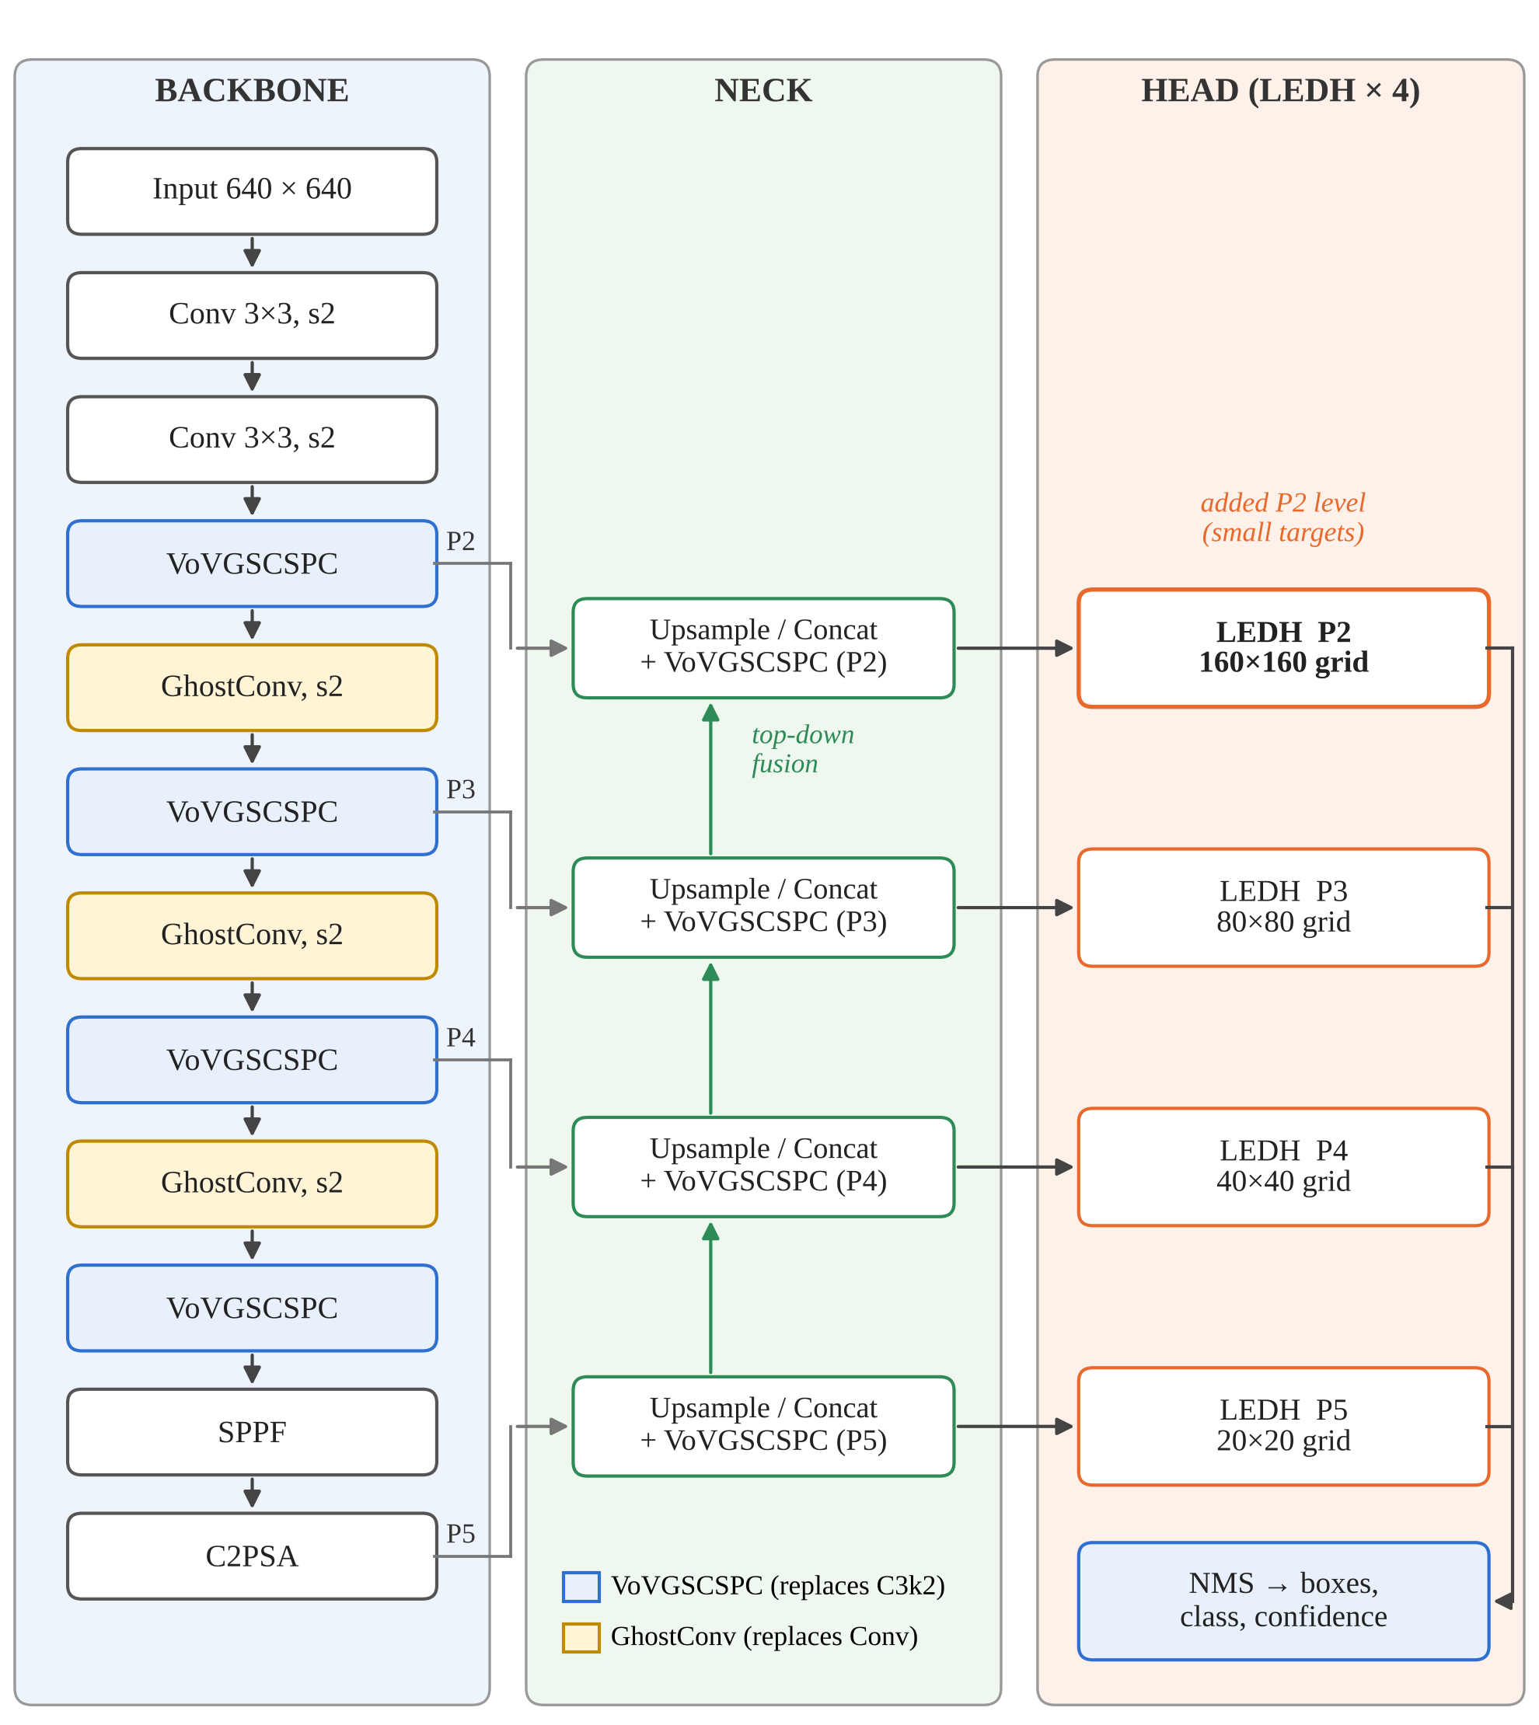
Fig. 4.2 Simplified structure of the SBP-YOLO network, after Liang et al. [23]
4.4 System Components/Modules
The system is divided into six modules.
4.4.1 Data Acquisition and Augmentation Module
This module gathers labelled road images and prepares them for training. The SBP-YOLO authors combined public benchmarks with images from Kaggle and Roboflow Universe [23]. Images are resized to 640 × 640, and the training set is expanded with synthetic rain and snow, random flips, motion blur and changes in brightness, contrast and saturation [6].
4.4.2 Lightweight Backbone and Neck Module
This module extracts and fuses multi-scale features at low cost. GhostConv replaces standard convolutions in the deeper stages of the backbone, and VoVGSCSPC replaces the C3k2 blocks in both the backbone and the neck. Together they bring the parameter count down from 2.37 million to 2.04 million in the authors’ ablation [23].
4.4.3 Small-Object Detection Head Module
This module produces the boxes and class scores. It adds the P2 level at stride 4 to the usual P3, P4 and P5 levels, and uses an LEDH at each level. The LEDH uses two shared 3 × 3 grouped convolutions followed by two parallel 1 × 1 convolutions, one for box regression and one for classification.
4.4.4 Training and Distillation Module
This module trains the network. The box loss combines NWD with IoU so that small boxes receive a useful gradient. After the base model converges, a larger teacher with the same architecture at a bigger scale (7.42 million parameters, 20.6 GFLOPs) passes its knowledge to the student through BCKD on the outputs and CWD on intermediate feature maps [23].
4.4.5 Deployment and Inference Module
This module turns trained weights into a working detector. It loads the weights, runs inference on images or video frames, and draws the boxes with class names and confidence scores. For the vehicle, it exports the model to a TensorRT engine. In this project we used it to run the released SBP-YOLO weights on road images and video.
4.4.6 Baseline Benchmarking Module
This module trains and evaluates stock detectors under one fixed protocol on a public dataset, so that SBP-YOLO’s improvements can be judged against what an unmodified detector achieves. It records overall and per-class accuracy, model size, computation and latency for each model.
4.5 Proposed Methodology
The methodology followed in this project has these steps:
- Literature study: review existing speed bump and pothole detection and the techniques SBP-YOLO builds on (Chapter 2).
- Model study: study the SBP-YOLO paper and code, and work out what each module changes and why.
- Setup: clone the official repository, install its two Ultralytics-based code bases, and download the released weights for each stage of the design.
- Inference: run the released SBP-YOLO weights on road images and video clips and inspect the detections.
- Baseline training: train seven stock detectors on a public speed bump and pothole dataset with one fixed configuration.
- Baseline evaluation: score each baseline once on the held-out test split, overall and per class, and record size, computation and latency.
- Analysis: compare the baselines with SBP-YOLO’s reported results, examine the contribution of each SBP-YOLO module, and identify failure cases and deployment costs.
4.6 System Workflow
Fig. 4.3 shows the overall workflow of the project as a flowchart. The SBP-YOLO branch (study, setup, inference) and the baseline branch (training and evaluation) meet at the comparison and analysis steps.
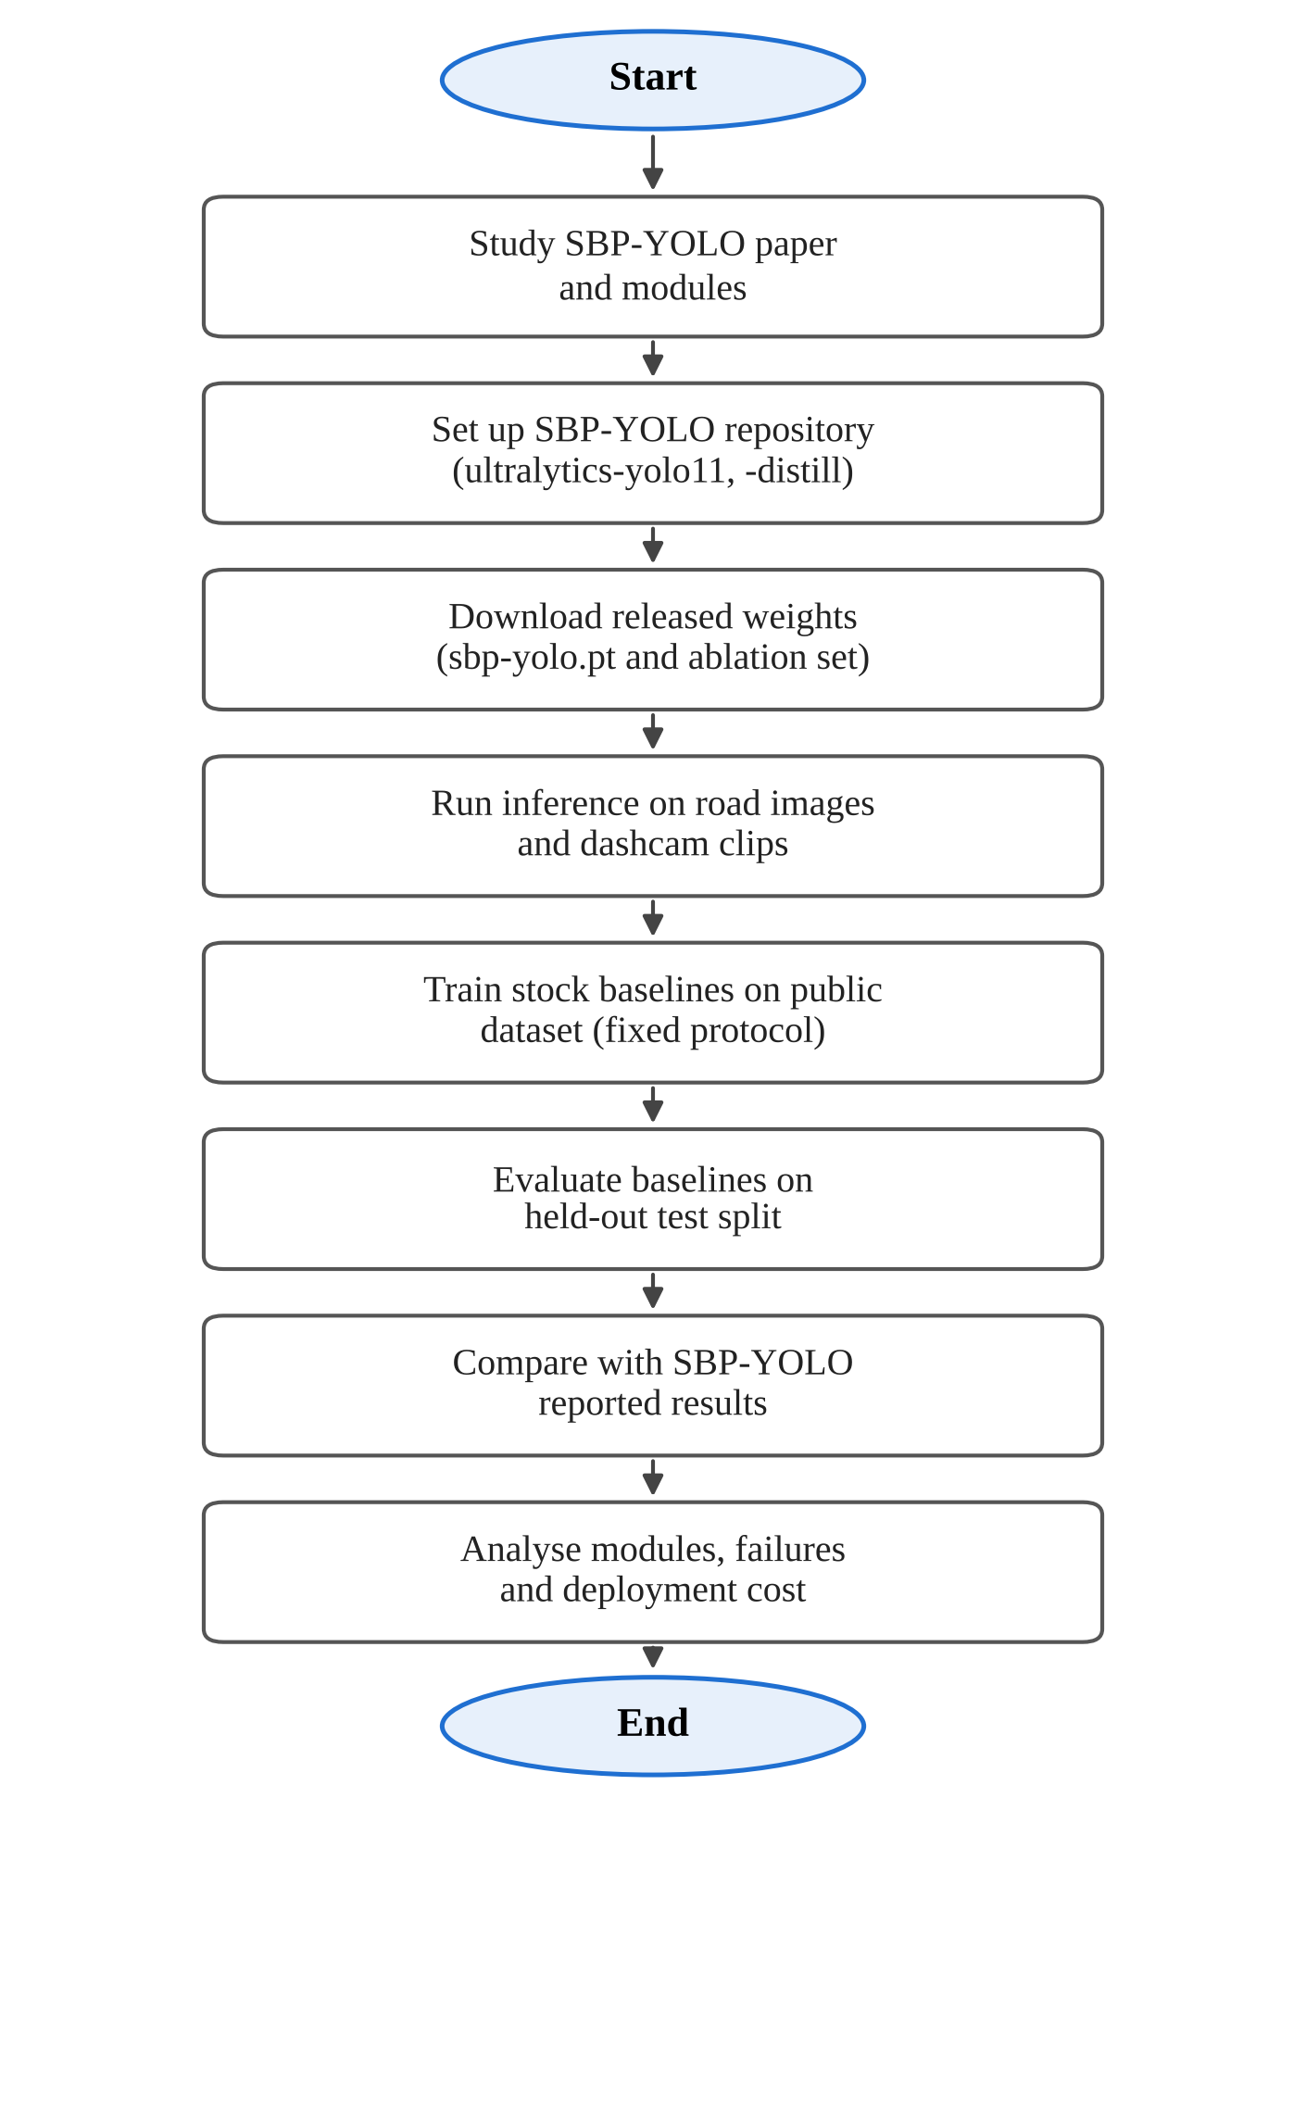
Fig. 4.3 Project workflow
4.7 Algorithms/Techniques Used
GhostConv. A standard convolution with C₂ output channels computes every output channel from all input channels. GhostConv computes only half of them this way, the intrinsic features, and produces the other half by applying a cheap 5 × 5 depthwise convolution to the intrinsic features [12]. The two halves are concatenated, as in Fig. 4.4(a). With a ratio of two, the cost is roughly halved, which is consistent with the 48% to 55% of standard convolution cost reported for SBP-YOLO [23].
Cost(GhostConv) ≈ Cost(Conv) / s, with s = 2 (4.1)
GSConv and VoVGSCSPC. GSConv applies a standard convolution to produce half of the output channels, a depthwise convolution to produce the other half, concatenates them and shuffles the channels [21], as in Fig. 4.4(b). The shuffle mixes the dense and cheap features so that information is not trapped in one half. VoVGSCSPC is a cross-stage partial block built from GSConv bottlenecks with one-shot aggregation in the style of VoVNet [20]. It replaces the C3k2 block of YOLOv11n.
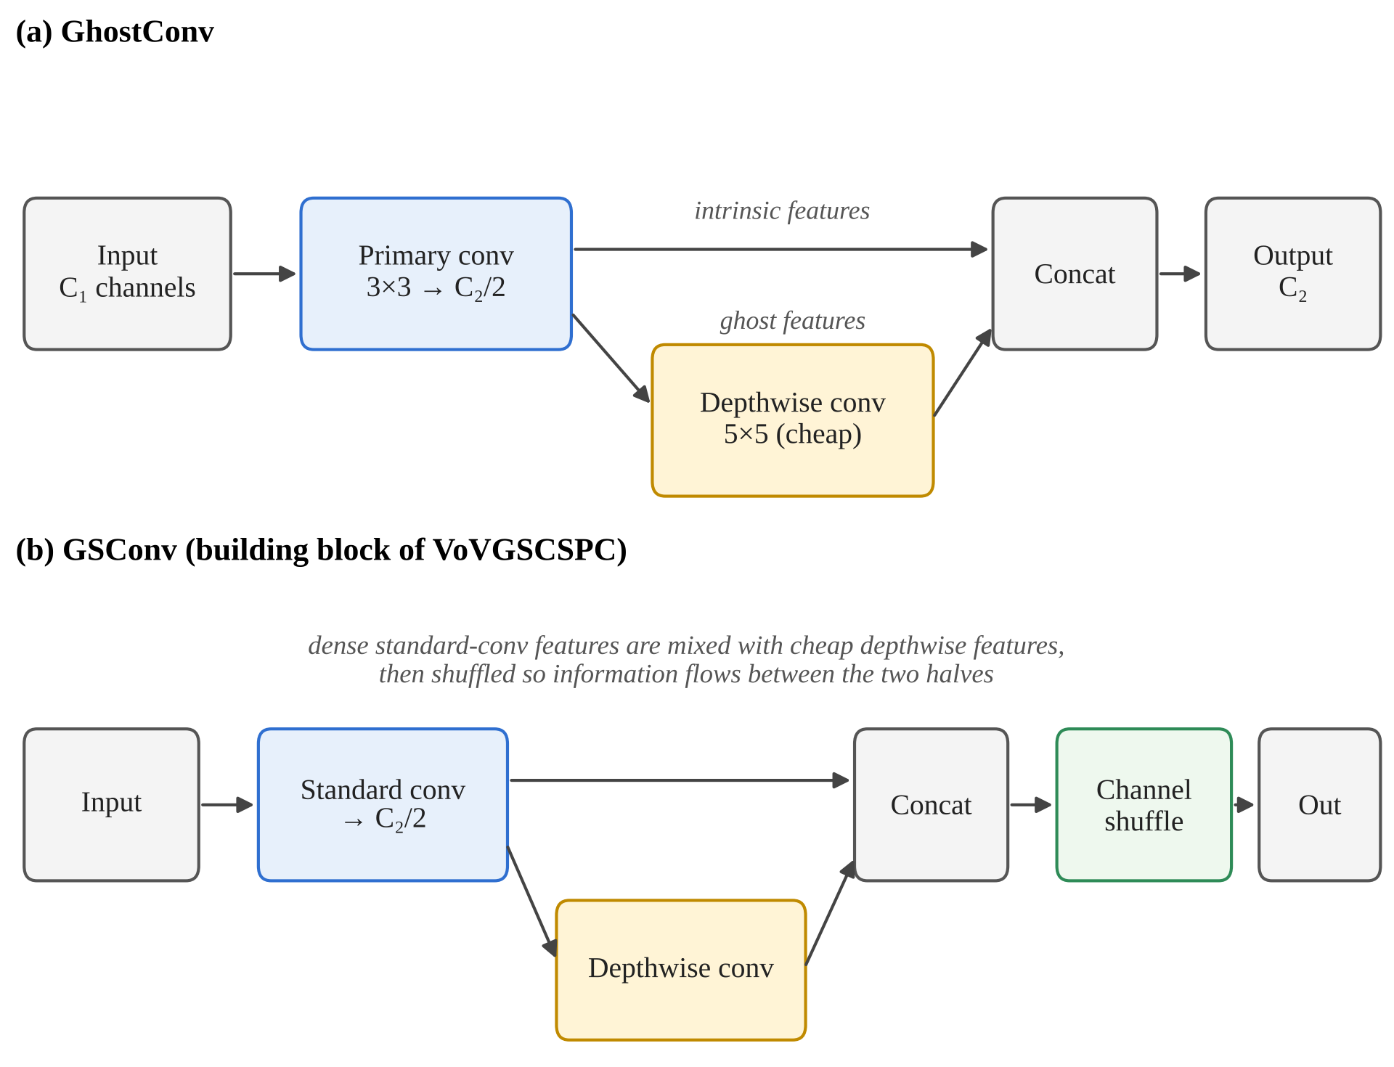
Fig. 4.4 GhostConv and GSConv, the building blocks of SBP-YOLO’s backbone and neck
The P2 detection level. Each detection level sees the image through a grid whose cells are as wide as the level’s stride. Table 4.3 shows what this means for a bump 16 pixels tall in a 640-pixel frame. At P3, the smallest level of a standard YOLO head, the bump covers two cells; at P5 it covers half a cell. The P2 level gives it four cells, which leaves enough spatial detail for the head to locate it.
Table 4.3 Feature pyramid levels for a 640 × 640 input
Level | Stride | Grid size | Cells covering a 16-pixel-tall bump | In YOLOv11n
P2 | 4 | 160 × 160 | 4 | No (added by SBP-YOLO)
P3 | 8 | 80 × 80 | 2 | Yes
P4 | 16 | 40 × 40 | 1 | Yes
P5 | 32 | 20 × 20 | 0.5 | Yes

LEDH. A conventional decoupled head runs two separate stacks of convolutions at each level, one for the box and one for the class. Adding a 160 × 160 level makes this expensive: in the authors’ ablation, adding P2 to YOLOv11n raised the cost from 6.3 to 10.3 GFLOPs [23]. LEDH, shown in Fig. 4.5, shares two 3 × 3 grouped convolutions between the two outputs, using c/16 groups so that each filter sees only a slice of the channels. Two 1 × 1 convolutions then produce the box and class outputs. This brought the cost back to 6.7 GFLOPs while keeping the P2 level.
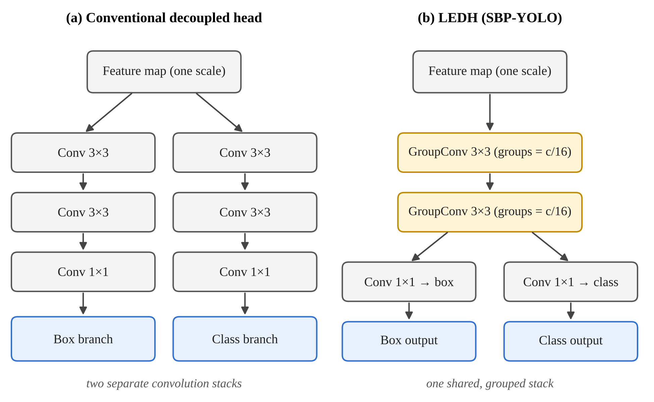
Fig. 4.5 A conventional decoupled head compared with LEDH
Normalized Gaussian Wasserstein Distance. IoU is very sensitive for small boxes: shifting a 10-pixel box by 3 pixels cuts its IoU sharply, and two small boxes that do not overlap have an IoU of zero no matter how close they are. NWD avoids this by modelling each box (cx, cy, w, h) as a two-dimensional Gaussian and measuring the second-order Wasserstein distance between the two Gaussians [46]:
W₂²(N_{a}, N_{b}) = ‖ [cx_{a}, cy_{a}, w_{a}/2, h_{a}/2] − [cx_{b}, cy_{b}, w_{b}/2, h_{b}/2] ‖² (4.2)
NWD(N_{a}, N_{b}) = exp( −√(W₂²(N_{a}, N_{b})) / C ) (4.3)
Here C is a normalising constant related to typical object size. SBP-YOLO combines NWD with IoU in the box loss, with a weighting factor α between 0 and 1 [23]:
L_{box} = (1 − α) · (1 − NWD) + α · L_{IoU} (4.4)
Knowledge distillation. The student (SBP-YOLO) learns from a teacher of the same architecture at a larger scale. Two terms are added to the normal detection loss: a BCKD term that aligns the student’s classification and localisation outputs with the teacher’s [50], and a CWD term that aligns the channel activations of six intermediate feature maps [36]. Both are weighted by 0.5 [23]:
L = L_{det} + 0.5 · L_{BCKD} + 0.5 · L_{CWD} (4.5)
Distillation adds nothing at inference time, because the teacher is only used during training.
Intersection over Union and NMS. A prediction is counted as correct when its IoU with a ground-truth box of the same class is above a threshold such as 0.5. Non-Maximum Suppression removes duplicate predictions by keeping the highest-scoring box of a class and discarding any other box whose IoU with it exceeds a threshold, then repeating with the next box.
IoU = Area(A ∩ B) / Area(A ∪ B) (4.6)
TensorRT quantisation. TensorRT fuses layers, selects GPU kernels for the target board, and can store weights and activations in FP16 or INT8 instead of FP32 [29]. Lower precision cuts memory traffic and lets the Jetson’s tensor cores run more operations per cycle, at a small risk to accuracy.
4.8 Dataset/Data Collection
Two datasets appear in this project. The first is the dataset the SBP-YOLO authors trained and tested on, which is the source of all SBP-YOLO accuracy figures in Chapter 5. It contains 7,500 images of speed bumps and potholes gathered from public benchmarks and from Kaggle and Roboflow Universe, split into 5,250 training, 1,125 validation and 1,125 test images [23]. The authors provide download links for it in their repository [24].
The second is the dataset we used for our own baseline runs: the public Humps/Bumps and Potholes Detection dataset [9], version 8, released through Roboflow Universe under a CC BY 4.0 licence. It contains 3,243 images with bounding-box labels in YOLO format for the same two classes. We used it exactly as distributed, with its official splits. Table 4.4 compares the two.
Table 4.4 Datasets used in this project
Property | SBP-YOLO dataset [23] | Baseline dataset (ours) [9]
Classes | Speed bump, pothole | Speed bump, pothole
Total images | 7,500 | 3,243
Training / validation / test | 5,250 / 1,125 / 1,125 | 2,560 / 475 / 208
Sources | Public benchmarks, Kaggle, Roboflow Universe | Roboflow Universe (single public release)
Input size | 640 × 640 | 640 × 640
Used for | All SBP-YOLO results (reported) | Baseline results (measured by us)
Note: The two datasets differ in size and content, so accuracy figures obtained on one cannot be compared directly with figures obtained on the other.
The test split of our baseline dataset contains 457 instances: 386 potholes in 140 images and 71 speed bumps in 70 images. Speed bump boxes usually cover the full width of the bump, very distant bumps are often unlabelled, and each pothole in a cluster is boxed separately. These conventions affect the baseline scores, especially for potholes at strict IoU thresholds.
4.9 Data Preprocessing
Preprocessing differs slightly between the SBP-YOLO pipeline and our baseline runs:
- Resizing: in both, each image is letterboxed to 640 × 640 and pixel values are scaled to the range 0 to 1.
- Weather augmentation (SBP-YOLO): synthetic rain and snow are added with Albumentations-style transforms so that the model sees adverse weather during training [6], [23].
- Photometric and geometric augmentation (SBP-YOLO): random flips and changes in brightness, contrast and saturation, with motion blur and illumination changes.
- Baseline augmentation (ours): the default Ultralytics recipe, with HSV jitter, scaling, translation, horizontal flip and mosaic, mosaic switched off for the final ten epochs and vertical flip off. It was applied identically to every baseline model and not tuned.
- Label format: YOLO format in both, with one line per object giving the class index and the normalised box centre, width and height.
4.10 Model/System Development
SBP-YOLO was built in steps from YOLOv11n, and the authors released weights for each step [24]. Table 4.5 lists them. These released files let anyone reproduce the ablation in Chapter 5 by loading each stage in turn.
Table 4.5 SBP-YOLO design stages and released weights
Stage | Change | Released weights
1 | YOLOv11n baseline | yolo11.pt
2 | Add P2 detection level | yolo11-p2.pt
3 | Replace head with LEDH | yolo11-p2-ledh.pt
4 | Add GhostConv | yolo11-ledh-ghostconv.pt
5 | Add VoVGSCSPC (full architecture) | sbp-yolo.pt
6 | Train with NWD loss | sbp-yolo-nwdloss.pt
Note: File names as listed in the official repository. The distilled model is produced with the ultralytics-distill code base.
The SBP-YOLO authors trained the network with the settings in Table 4.6. The base model was trained for up to 300 epochs; the distillation stage used a separate run of 500 epochs with SGD and batch size 32.
Table 4.6 SBP-YOLO training configuration reported by its authors
Parameter | Value
Input resolution | 640 × 640
Epochs | 300, early stopping after 30 epochs without improvement
Batch size | 16
Optimiser / initial learning rate | Adam / 0.001
Box loss | NWD combined with IoU (equation 4.4)
Distillation run | 500 epochs, batch 32, SGD; BCKD 0.5 + CWD 0.5
Teacher | Same architecture at S scale (7.42 M parameters, 20.6 GFLOPs)
Hardware | NVIDIA Tesla V100 16 GB, Intel Xeon E5-2680
Framework | PyTorch 1.13.1, CUDA 11.7
Note: Values as reported by Liang et al. [23]; they were not reproduced in this project.
For our baselines we trained seven stock detectors at their smallest scale: YOLOv8n, YOLOv9t, YOLOv10n, YOLO11n, YOLO12n, YOLO26n and RT-DETR-L [16], [18], [38], [40], [44], [45], [51]. All used the same configuration, shown in Table 4.7, so that only the architecture changed between runs.
Table 4.7 Baseline training configuration (our runs, identical across models)
Parameter | Value
Input resolution | 640 × 640, letterboxed
Epochs | 50, early stopping patience 15
Batch size | 16 (8 for RT-DETR-L)
Optimiser | AdamW (auto-selected), learning rate 1.67e-3, momentum 0.9
Weight initialisation | COCO-pretrained, per architecture
Mixed precision | AMP enabled
Framework | Ultralytics 8.4.156, PyTorch 2.10, Python 3.12
Hardware | NVIDIA Tesla T4, 16 GB (Kaggle)
Random seed | 42, deterministic

4.11 System Design Diagrams
The use case diagram in Fig. 4.6 shows the two actors. The researcher or developer prepares data, trains or loads SBP-YOLO, evaluates it and exports it for the vehicle. The driver or vehicle system uses the deployed detector and receives warnings or a suspension preview signal.
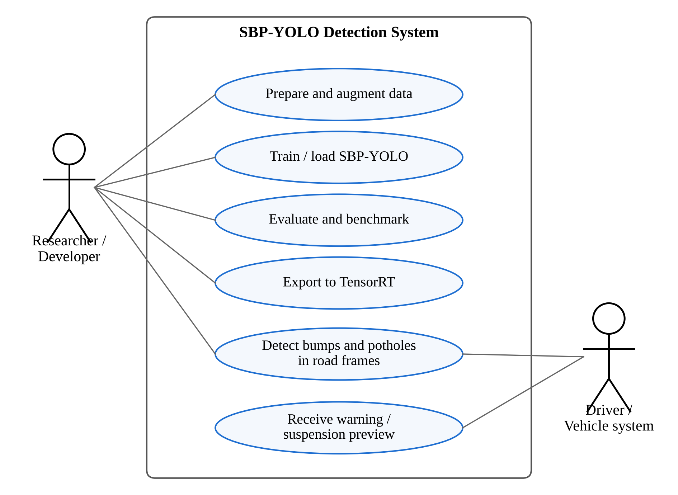
Fig. 4.6 Use case diagram
The data flow diagram in Fig. 4.7 shows how data moves through the system. Images and labels are prepared and stored (D1), training produces weights (D2), evaluation writes metrics and logs (D3), and the weights are exported to a TensorRT engine. At run time, camera frames flow into the real-time inference process, which sends alerts to the vehicle or driver.
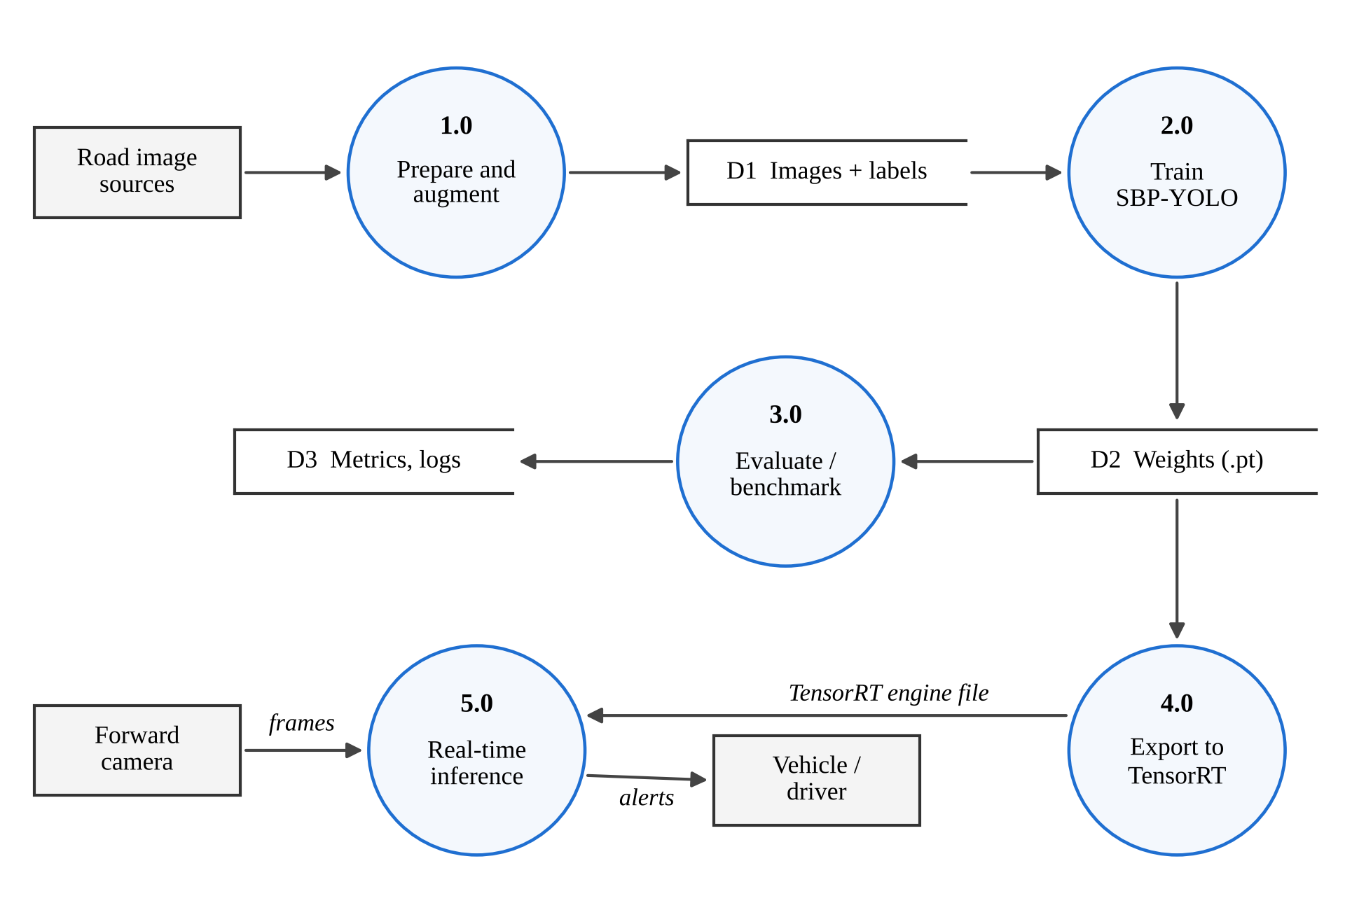
Fig. 4.7 Data flow diagram (level 1)
4.12 Implementation
We cloned the official SBP-YOLO repository [24] and kept our own fork of it for this project. The repository contains two code bases built on Ultralytics: ultralytics-yolo11, which holds the SBP-YOLO modules (GhostConv, VoVGSCSPC, LEDH and the NWD loss) and is used for training and inference, and ultralytics-distill, which holds the distillation code. Because SBP-YOLO’s custom modules live in the first of these, its weights must be loaded through that code base rather than through the standard Ultralytics package.
We downloaded the released weights listed in Table 4.5 and ran the final SBP-YOLO model on road images and video clips, saving the annotated outputs. This confirmed that the released model loads and produces speed bump and pothole detections on images outside the authors’ dataset. We did not have ground-truth labels in the authors’ class format for this footage, so this part of the work is qualitative; Section 4.14 shows example outputs.
The baseline benchmark was run on Kaggle notebooks with a Tesla T4 GPU. Each detector was trained in its own run using one script, evaluated once on the held-out test split with the Ultralytics validator (confidence threshold 0.001, IoU threshold 0.7 for NMS), and timed over 100 single-image predictions after 10 warm-up images.
4.13 Coding/Program Implementation
GitHub repository: https://github.com/<username>/SBP-YOLO
The project code is kept in our fork of the official SBP-YOLO repository. Its structure is shown below. The two Ultralytics code bases come from the original repository; the pre_trained_weights and results folders hold the released weights and our own outputs.
SBP-YOLO/
├── README.md Overview, dataset and weight links
├── LICENSE GPL-3.0
├── ultralytics-yolo11/ YOLOv11 code with SBP-YOLO modules
│ (GhostConv, VoVGSCSPC, LEDH, NWD loss)
├── ultralytics-distill/ Knowledge distillation (BCKD + CWD)
├── pre_trained_weights/ Released weights for each design stage
│ ├── sbp-yolo.pt
│ ├── sbp-yolo-nwdloss.pt
│ └── yolo11*.pt Ablation stages
└── results/ Our detections and baseline metrics

GhostConv module. This is the GhostConv layer as implemented in the Ultralytics code base that SBP-YOLO extends. The first convolution produces half of the output channels; the second is a depthwise 5 × 5 convolution (groups equal to channels) that generates the cheap ghost features.
class GhostConv(nn.Module):
def __init__(self, c1, c2, k=1, s=1, g=1, act=True):
super().__init__()
c_ = c2 // 2 # intrinsic channels
self.cv1 = Conv(c1, c_, k, s, None, g, act=act)
self.cv2 = Conv(c_, c_, 5, 1, None, c_, act=act) # depthwise

def forward(self, x):
y = self.cv1(x)
return torch.cat((y, self.cv2(y)), 1)

NWD similarity. The function below implements equations (4.2) and (4.3) for boxes given as (cx, cy, w, h). The loss term used in training is one minus this value, mixed with the IoU loss as in equation (4.4).
def nwd(pred, target, C=12.8, eps=1e-7):
# pred, target: (N, 4) tensors of (cx, cy, w, h)
d_center = ((pred[:, :2] - target[:, :2]) ** 2).sum(dim=1)
d_size = (((pred[:, 2:] - target[:, 2:]) / 2) ** 2).sum(dim=1)
w2 = d_center + d_size + eps # squared Wasserstein-2 distance
return torch.exp(-torch.sqrt(w2) / C)

Inference with the released weights. Because SBP-YOLO’s modules are defined in the repository’s own Ultralytics copy, that folder is placed first on the Python path before importing. The model is then used like any Ultralytics detector.
import sys
sys.path.insert(0, "ultralytics-yolo11") # SBP-YOLO modules
from ultralytics import YOLO

model = YOLO("pre_trained_weights/sbp-yolo.pt")
results = model.predict(source="samples/", imgsz=640, conf=0.25,
save=True, project="results", name="sbp_images")
for r in results:
for box in r.boxes:
print(r.names[int(box.cls)], round(float(box.conf), 2))

Video inference. For dashcam clips, frames are read with OpenCV, passed through the model, and the annotated frames are written to a new video.
import cv2
cap = cv2.VideoCapture("clips/road.mp4")
fps = cap.get(cv2.CAP_PROP_FPS)
w, h = int(cap.get(3)), int(cap.get(4))
out = cv2.VideoWriter("results/road_sbp.mp4",
cv2.VideoWriter_fourcc(*"mp4v"), fps, (w, h))
while True:
ok, frame = cap.read()
if not ok:
break
r = model.predict(frame, imgsz=640, conf=0.25, verbose=False)[0]
out.write(r.plot())
cap.release(); out.release()

TensorRT export. On the Jetson, the trained model is exported to a TensorRT engine in half precision. The resulting .engine file is loaded the same way as the .pt file.
model = YOLO("pre_trained_weights/sbp-yolo.pt")
model.export(format="engine", half=True, imgsz=640, device=0)
trt_model = YOLO("pre_trained_weights/sbp-yolo.engine")

Baseline training. The baseline script holds every setting in one dictionary so that only the model changes between runs.
from ultralytics import YOLO, RTDETR

MODELS = {"YOLOv8n": "yolov8n.pt", "YOLOv9t": "yolov9t.pt",
"YOLOv10n": "yolov10n.pt", "YOLO11n": "yolo11n.pt",
"YOLO12n": "yolo12n.pt", "YOLO26n": "yolo26n.pt",
"RT-DETR-L": "rtdetr-l.pt"}
COMMON = dict(data="data/data.yaml", imgsz=640, epochs=50,
patience=15, seed=42, deterministic=True,
optimizer="auto", amp=True, close_mosaic=10, flipud=0.0)

for name, ckpt in MODELS.items():
is_detr = name.startswith("RT-DETR")
model = RTDETR(ckpt) if is_detr else YOLO(ckpt)
model.train(batch=8 if is_detr else 16, name=name, **COMMON)

4.14 User Interface / Application Screens
The system was run from Python scripts and notebooks and does not have a separate graphical interface. Its visual output is the annotated detection image or video, in which each detected speed bump or pothole is drawn with a box, its class name and its confidence score.
Fig. 4.8 and Fig. 4.9 show outputs of the released SBP-YOLO model on a road image and on a frame from a dashcam clip, produced with the inference scripts in Section 4.13 at a confidence threshold of 0.25.
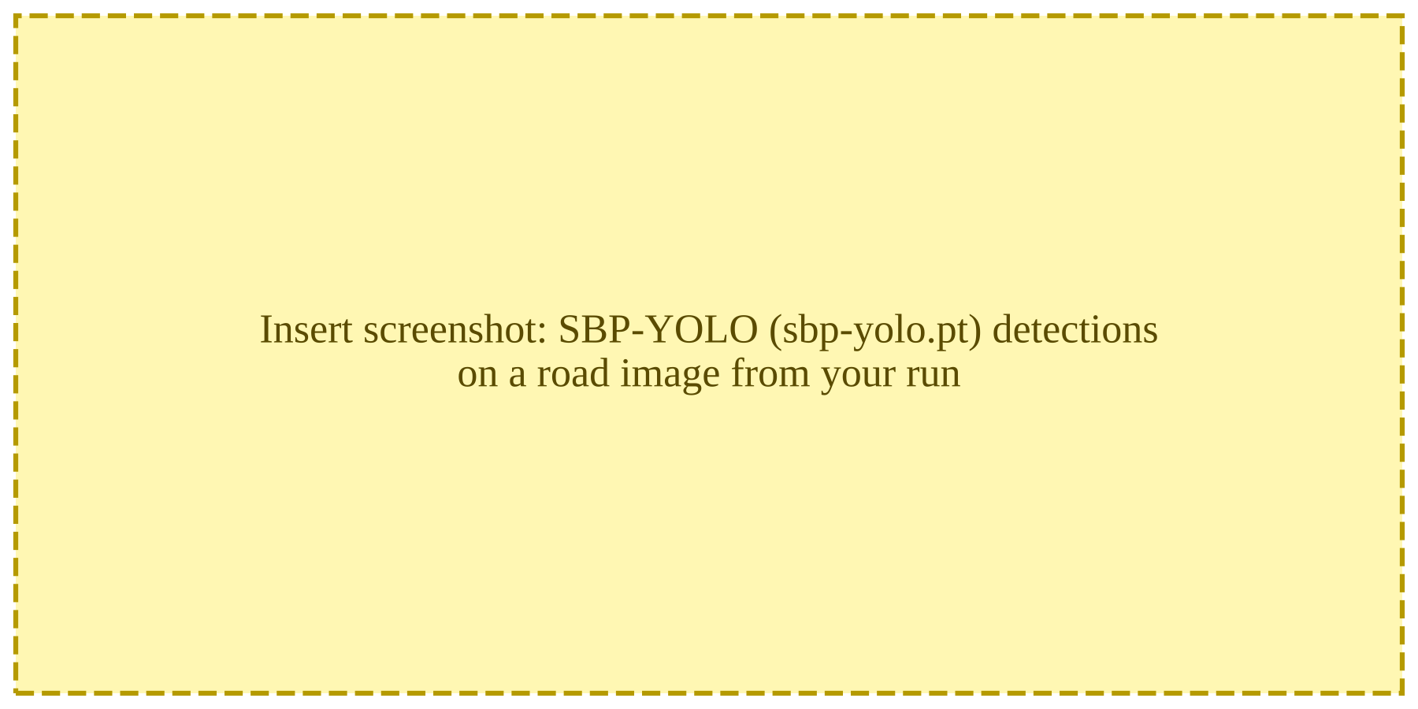
Fig. 4.8 SBP-YOLO detections on a road image
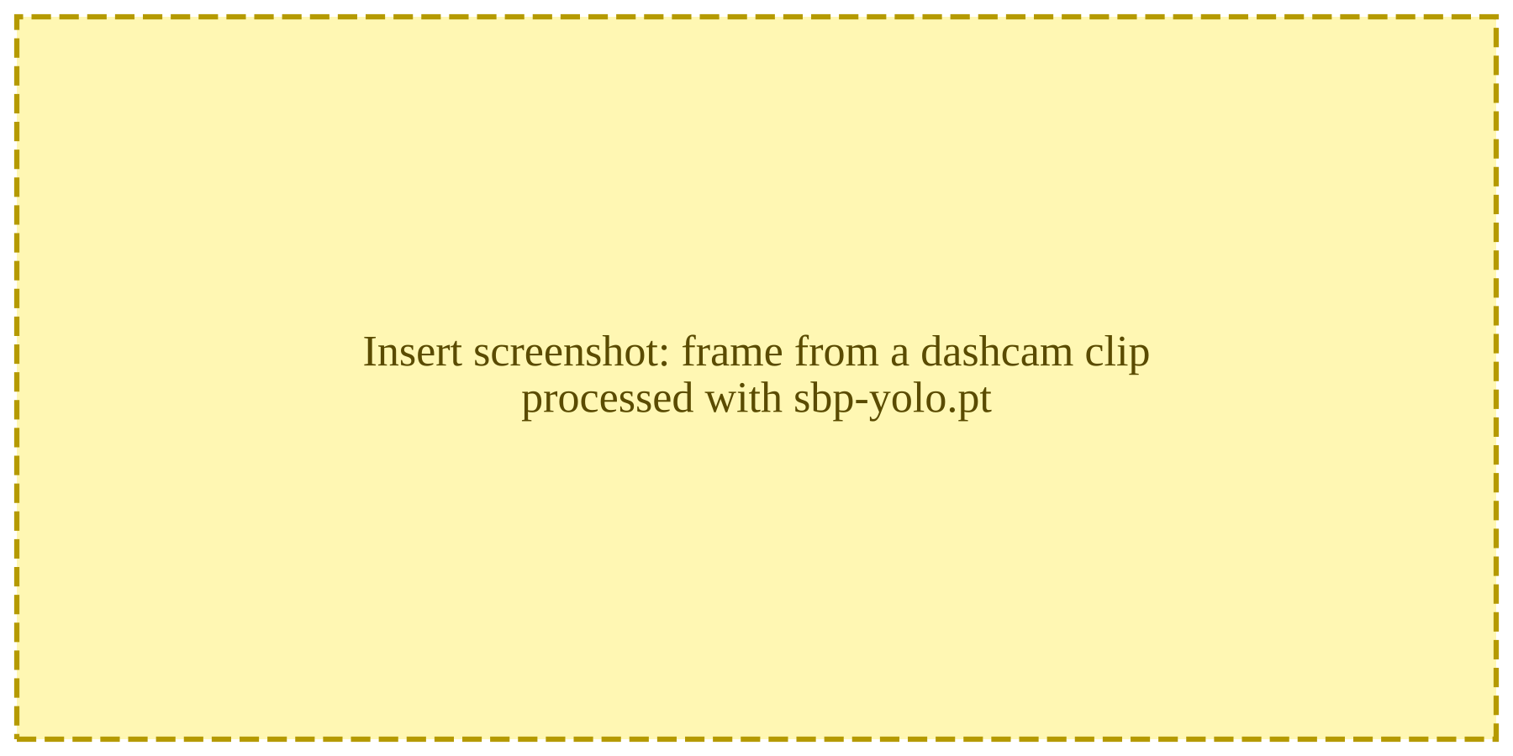
Fig. 4.9 SBP-YOLO detections on a frame from a dashcam clip
4.15 Chapter Summary
This chapter described the SBP-YOLO system and its implementation in this project. The network replaces costly convolutions with GhostConv and VoVGSCSPC, adds a P2 detection level for small targets, and offsets its cost with LEDH, while the training recipe adds the NWD loss, weather augmentation and distillation. We set up the official implementation, ran its released weights on road images and video, and trained seven stock detectors on a public dataset as a measured baseline. The next chapter presents the results.
5. CHAPTER 3 – RESULTS AND DISCUSSION
5.1 Introduction
This chapter presents two sets of results, and it is important to keep them apart. The first set is SBP-YOLO’s accuracy, size and embedded speed, as reported by its authors on their 7,500-image dataset [23]. We did not retrain SBP-YOLO, so these numbers are quoted, not measured; every table that contains them says so. The second set is our own baseline benchmark: seven stock detectors trained and tested by us on a different, public dataset. The chapter then compares SBP-YOLO with earlier work and discusses what the two sets of results mean together.
5.2 Experimental Setup
SBP-YOLO (reported). The authors trained SBP-YOLO on a Tesla V100 GPU with the configuration in Table 4.6, evaluated it on their 1,125-image test split, and measured embedded speed on an NVIDIA Jetson AGX Xavier with TensorRT at FP32, FP16 and INT8 precision [23].
Released weights (ours). We ran sbp-yolo.pt from the official repository on road images and video clips with a confidence threshold of 0.25, as described in Section 4.12.
Baselines (ours). We trained seven stock detectors on the 2,560 training images of the public Humps/Bumps and Potholes dataset with the configuration in Table 4.7, selected the best checkpoint on the validation split, and evaluated it once on the 208-image test split. Latency was measured on the same Tesla T4 GPU as the end-to-end time of a single-image prediction, averaged over 100 test images.
5.3 Evaluation Metrics
TP, FP and FN denote true positives, false positives and false negatives at a given IoU threshold.
Precision is the fraction of predicted boxes that are correct, and recall is the fraction of actual objects that are detected:
Precision = TP / (TP + FP) (5.1)
Recall = TP / (TP + FN) (5.2)
Average Precision (AP) is the area under the precision-recall curve for one class, and mAP is the mean of AP over the N classes:
mAP = (1 / N) × Σ AP_{i}, i = 1, …, N (5.3)
mAP@0.5 uses an IoU threshold of 0.5. mAP@0.5:0.95 averages mAP over ten IoU thresholds from 0.5 to 0.95, so it rewards tighter boxes. Recall matters most for this application, because a missed bump is an unmitigated hazard, but precision cannot be neglected, because a system that warns too often will be ignored.
Efficiency is measured by the number of parameters, GFLOPs at 640 × 640, model size, and speed in frames per second (FPS = 1000 / latency in milliseconds).
5.4 Experimental Results
5.4.1 Contribution of Each SBP-YOLO Module (Reported)
Table 5.1 and Fig. 5.1 show the authors’ ablation study, in which the modules were added to YOLOv11n one at a time. Adding the P2 level alone raised mAP@0.5 from 81.2% to 83.9%, but pushed computation from 6.3 to 10.3 GFLOPs and cut speed from 71.2 to 53.5 FPS. Replacing the head with LEDH recovered almost all of that cost (6.7 GFLOPs, 69.6 FPS) and slightly improved accuracy to 84.5%. GhostConv then cut the parameters from 2.37 to 2.09 million with no change in mAP@0.5, and VoVGSCSPC brought computation down to 5.8 GFLOPs, below the original baseline. Finally, the NWD loss added 2.0 points of mAP@0.5 at no computational cost.
Table 5.1 Ablation study of SBP-YOLO
Configuration | P (%) | R (%) | mAP@​0.5 | mAP@​0.5:​0.95 | GFLOPs | Params (M) | FPS
YOLOv11n baseline | 85.0 | 75.0 | 81.2 | 47.7 | 6.3 | 2.58 | 71.2
+ P2 head | 84.8 | 76.5 | 83.9 | 49.8 | 10.3 | 2.67 | 53.5
+ LEDH | 86.6 | 77.6 | 84.5 | 50.1 | 6.7 | 2.37 | 69.6
+ GhostConv | 86.3 | 78.1 | 84.5 | 49.8 | 6.2 | 2.09 | 66.5
+ VoVGSCSPC | 87.5 | 79.2 | 84.6 | 49.9 | 5.8 | 2.04 | 63.7
+ NWD loss (SBP-YOLO) | 89.0 | 79.4 | 86.6 | 51.1 | 5.8 | 2.04 | 63.7
Note: Values as reported by Liang et al. [23]; they were not reproduced in this project. FPS at batch size 1.
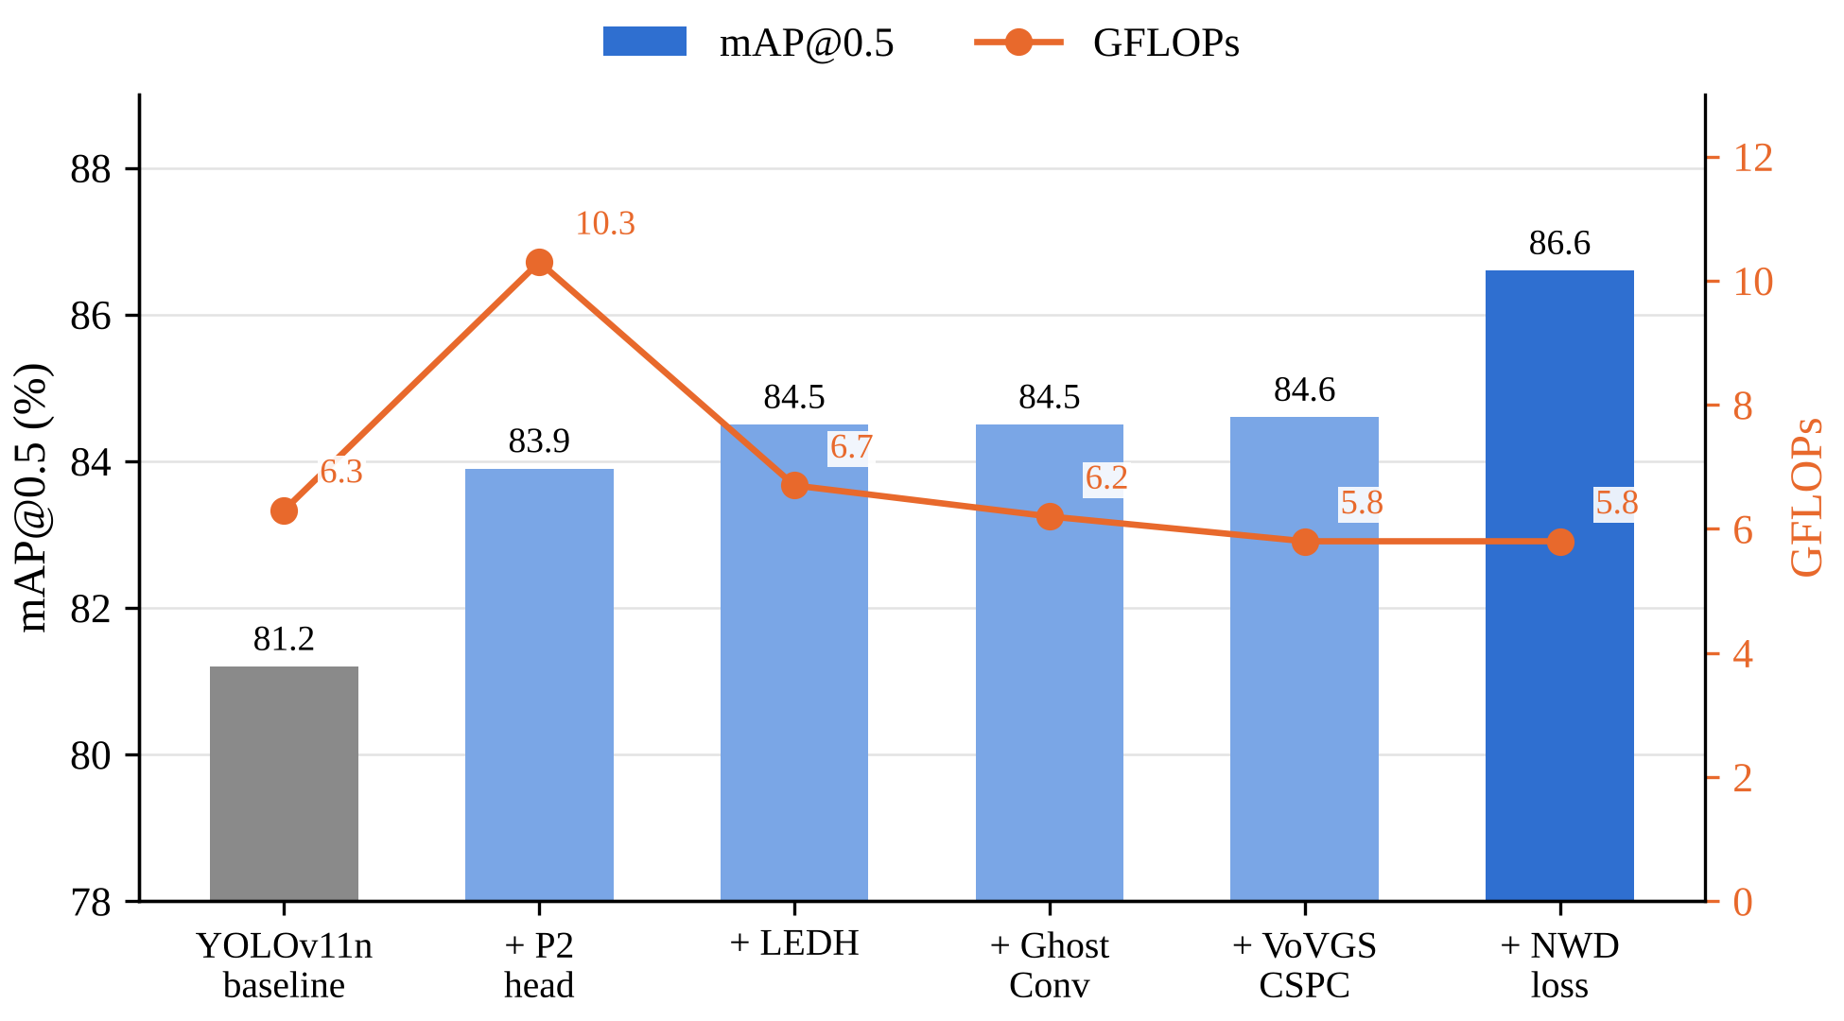
Fig. 5.1 Effect of each SBP-YOLO module on accuracy and computation (values reported by Liang et al. [23])
5.4.2 Effect of Knowledge Distillation (Reported)
Table 5.2 shows the effect of distillation. On the test split, the distilled model reached 87.7% mAP@0.5 and 54.9% mAP@0.5:0.95, against 86.3% and 51.5% for the undistilled student. It came within 0.1 points of the teacher on mAP@0.5 and exceeded it on mAP@0.5:0.95, while using about 3.6 times fewer parameters and 3.6 times less computation.
Table 5.2 Effect of knowledge distillation
Model | Val mAP@​0.5 | Val mAP@​0.5:​0.95 | Test mAP@​0.5 | Test mAP@​0.5:​0.95
Student (SBP-YOLO) | 86.6 | 51.1 | 86.3 | 51.5
Distilled student | 87.0 | 54.6 | 87.7 | 54.9
Teacher (S scale) | 87.4 | 53.8 | 87.8 | 54.1
Note: Values as reported by Liang et al. [23]; they were not reproduced in this project.
5.4.3 Comparison with YOLO Baselines (Reported)
Table 5.3 and Fig. 5.2 give the authors’ comparison with seven YOLO models trained on the same 7,500-image dataset. SBP-YOLO has the highest precision, recall and mAP of all of them, and its cost is the joint lowest at 5.8 GFLOPs. Only YOLOv9t has fewer parameters. The best stock model, YOLOv8n, reaches 82.4% mAP@0.5, which is 4.2 points below SBP-YOLO and 4.6 points below the distilled version. The stock models from YOLOv5n to YOLOv12n span only 3.1 points of mAP@0.5 among themselves.
Table 5.3 Comparison of SBP-YOLO with YOLO baselines on the SBP-YOLO dataset
Model | P (%) | R (%) | mAP@​0.5 | mAP@​0.5:​0.95 | Params (M) | GFLOPs | Size (MB)
YOLOv5n | 83.4 | 74.5 | 80.6 | 46.1 | 2.18 | 5.8 | 4.43
YOLOv6n | 83.8 | 72.0 | 79.3 | 45.9 | 4.16 | 11.5 | 8.15
YOLOv8n | 88.2 | 73.5 | 82.4 | 48.3 | 2.68 | 6.8 | 5.36
YOLOv9t | 84.7 | 75.3 | 81.5 | 48.3 | 1.76 | 6.6 | 3.95
YOLOv10n | 84.8 | 72.5 | 82.0 | 48.3 | 2.27 | 6.5 | 5.48
YOLOv11n | 85.0 | 75.0 | 81.2 | 47.7 | 2.58 | 6.3 | 5.21
YOLOv12n | 84.1 | 74.2 | 80.9 | 47.5 | 2.56 | 6.3 | 5.25
SBP-YOLO | 89.0 | 79.4 | 86.6 | 51.1 | 2.04 | 5.8 | 4.28
SBP-YOLO (distilled) | 90.2 | 80.7 | 87.0 | 54.6 | 2.04 | 5.8 | 4.28
Note: Values as reported by Liang et al. [23]; they were not reproduced in this project.
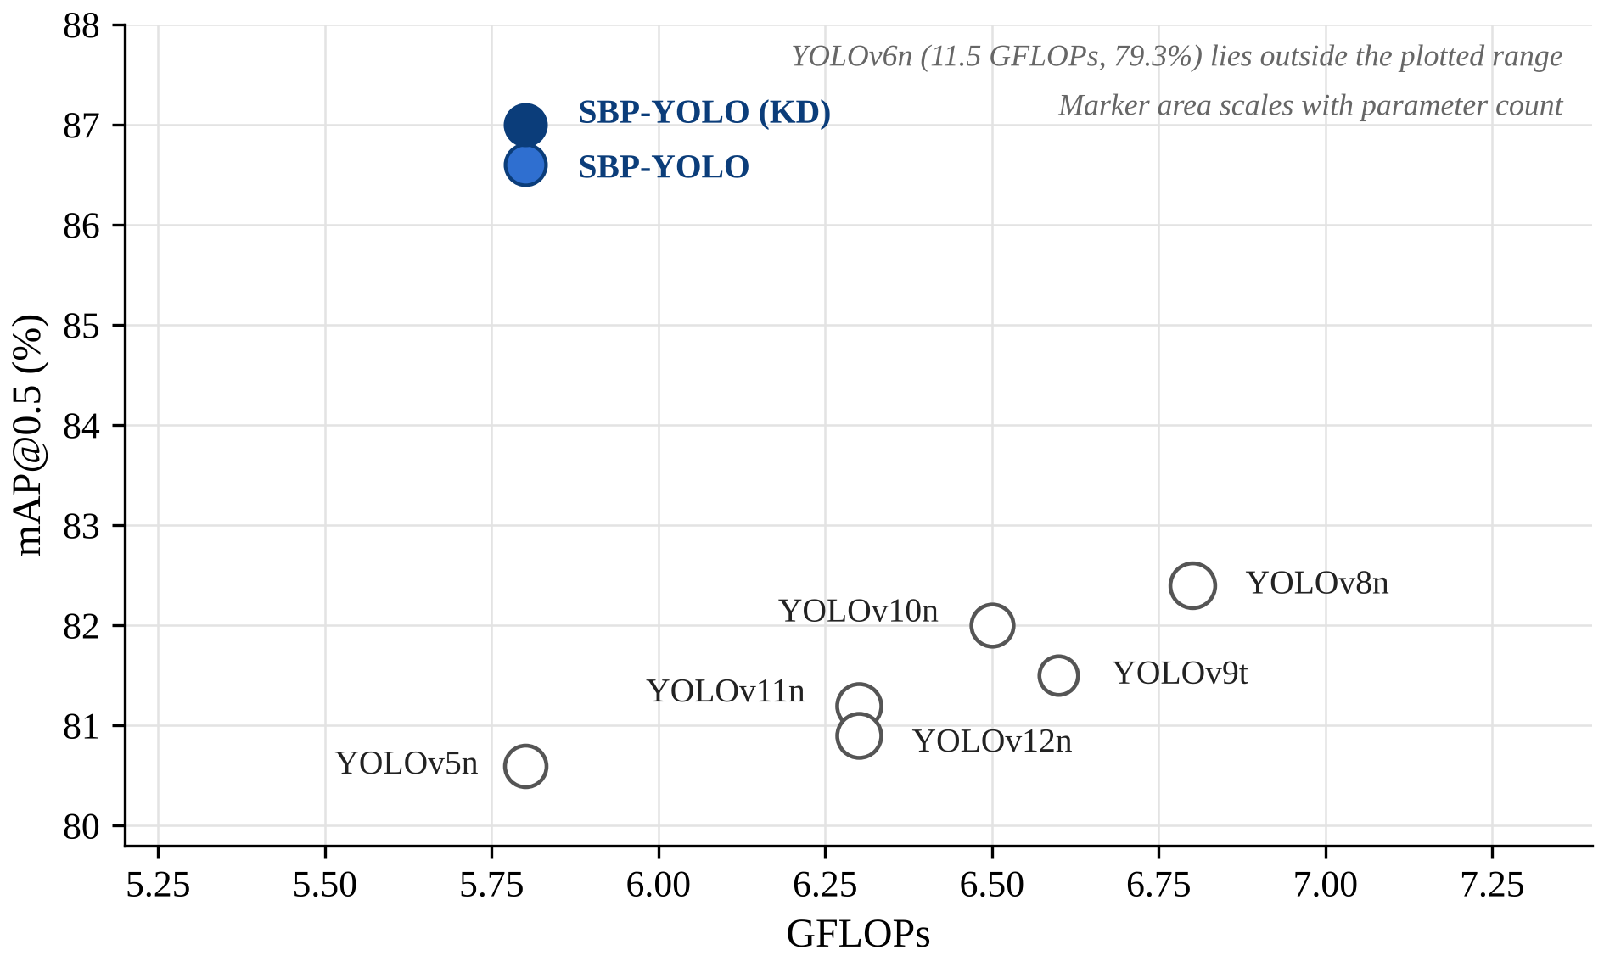
Fig. 5.2 mAP@0.5 against GFLOPs on the SBP-YOLO dataset (values reported by Liang et al. [23])
5.4.4 Embedded Deployment with TensorRT (Reported)
Table 5.4 and Fig. 5.3 show speed on a Jetson AGX Xavier after TensorRT conversion. In FP16, SBP-YOLO runs at 139.5 FPS (7.17 ms per frame), 12.4% faster than the P2-enhanced YOLOv11n reference at 124.1 FPS. INT8 raises this to 155.8 FPS with a 5.24 MB engine. Even the slowest setting, FP32, gives 84.1 FPS, well above the frame rate of a typical vehicle camera.
Table 5.4 TensorRT inference on NVIDIA Jetson AGX Xavier
Model | Precision | Inference time (ms) | FPS | Engine size (MB)
YOLOv11n reference (P2) | FP32 | 14.18 | 70.54 | 14.35
YOLOv11n reference (P2) | FP16 | 8.06 | 124.11 | 7.42
YOLOv11n reference (P2) | INT8 | 6.514 | 152.9 | 5.53
SBP-YOLO | FP32 | 11.90 | 84.06 | 9.63
SBP-YOLO | FP16 | 7.17 | 139.50 | 6.18
SBP-YOLO | INT8 | 6.42 | 155.78 | 5.24
Note: Values as reported by Liang et al. [23]; they were not reproduced in this project. The reference row is labelled YOLOv11n in the source table; the text of the paper describes the comparison as against the P2-enhanced YOLOv11n.
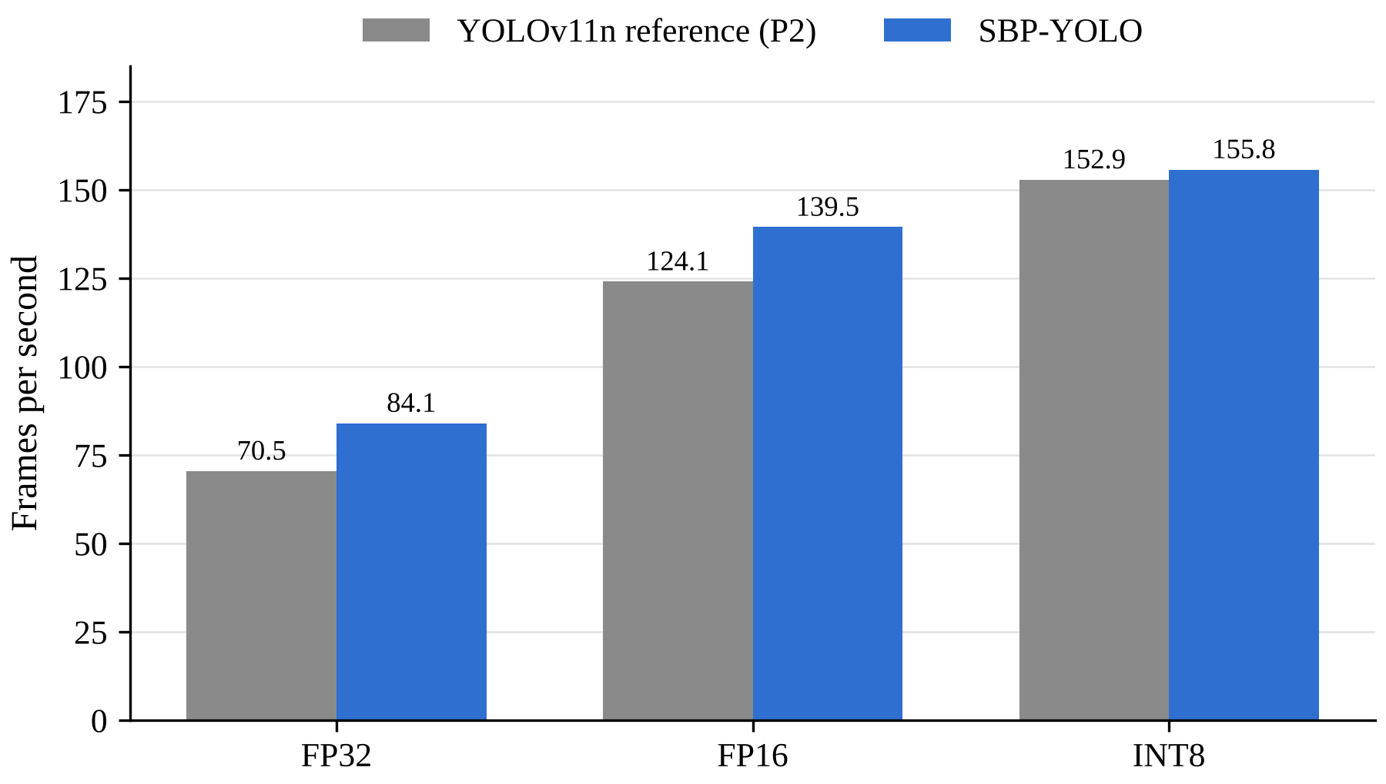
Fig. 5.3 Throughput on Jetson AGX Xavier at three precisions (values reported by Liang et al. [23])
The authors also report robustness in simulated rain, where SBP-YOLO kept a detection accuracy of 0.64 against 0.47 for the baseline [23].
5.4.5 Baseline Benchmark on the Public Dataset (Measured)
The results in this section were measured by us. Table 5.5 and Fig. 5.4 give the overall accuracy of the seven stock detectors on the 208-image test split of the public dataset. YOLO11n, the model SBP-YOLO was built from, reached 73.9% mAP@0.5 and 33.3% mAP@0.5:0.95. The five YOLO generations from YOLOv8n to YOLO12n ended between 71.4% and 73.9% mAP@0.5, a spread of 2.5 points. YOLO26n was best on every metric at 74.8% mAP@0.5 and the lowest computation at 5.3 GFLOPs. RT-DETR-L, a transformer with about 32 million parameters, was last at 67.5% and ran at 12.2 FPS against 25 to 31 FPS for the YOLO models.
Table 5.5 Baseline accuracy and cost on the public test split (measured)
Model | P (%) | R (%) | mAP@​0.5 | mAP@​0.5:​0.95 | Params (M) | GFLOPs | FPS (T4)
YOLOv8n | 73.9 | 67.7 | 73.5 | 34.6 | 3.01 | 8.1 | 30.2
YOLOv9t | 73.0 | 67.1 | 71.4 | 35.3 | 1.97 | 7.6 | 25.2
YOLOv10n | 79.3 | 66.1 | 72.8 | 34.7 | 2.27 | 6.6 | 30.8
YOLO11n | 78.8 | 64.9 | 73.9 | 33.3 | 2.58 | 6.4 | 30.6
YOLO12n | 73.1 | 66.6 | 73.7 | 34.0 | 2.56 | 7.3 | 26.7
YOLO26n | 82.3 | 68.1 | 74.8 | 35.5 | 2.38 | 5.3 | 29.3
RT-DETR-L | 66.6 | 65.8 | 67.5 | 30.6 | 31.99 | 105.3 | 12.2
Note: Measured in this project. Test split: 208 images, 457 instances. FPS is end-to-end single-image throughput on a Tesla T4.
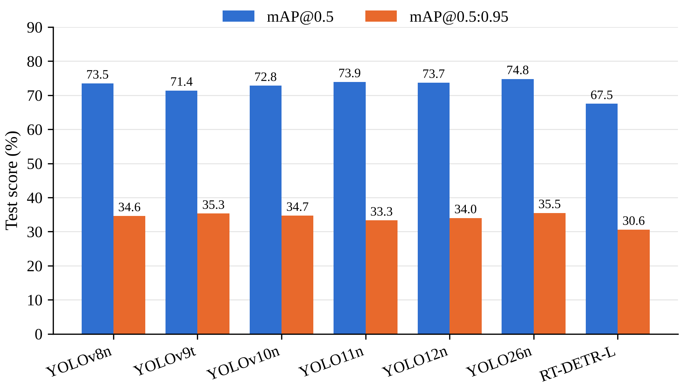
Fig. 5.4 Overall accuracy of the baseline detectors on the public test split (measured)
Table 5.6 and Fig. 5.5 split the measured results by class. Every YOLO model found speed bumps well, with AP@0.5 between 87.2% and 93.5%, while pothole AP@0.5 stayed between 55.3% and 56.9% for all six YOLO models. Potholes in this dataset are small, crowded and irregular, and each one in a cluster is labelled separately, which makes them much harder to box precisely.
Table 5.6 Per-class accuracy of the baselines on the public test split (measured, %)
Model | Pothole AP@​0.5 | Pothole AP@​0.5:​0.95 | Speed bump AP@​0.5 | Speed bump AP@​0.5:​0.95
YOLOv8n | 55.5 | 22.6 | 91.4 | 46.7
YOLOv9t | 55.5 | 24.6 | 87.2 | 45.9
YOLOv10n | 55.3 | 23.9 | 90.4 | 45.5
YOLO11n | 56.9 | 24.2 | 90.9 | 42.4
YOLO12n | 56.6 | 24.3 | 90.7 | 43.7
YOLO26n | 56.1 | 24.0 | 93.5 | 46.9
RT-DETR-L | 59.1 | 24.6 | 75.9 | 36.7
Note: Measured in this project. Test split: 386 pothole instances in 140 images and 71 speed bump instances in 70 images.
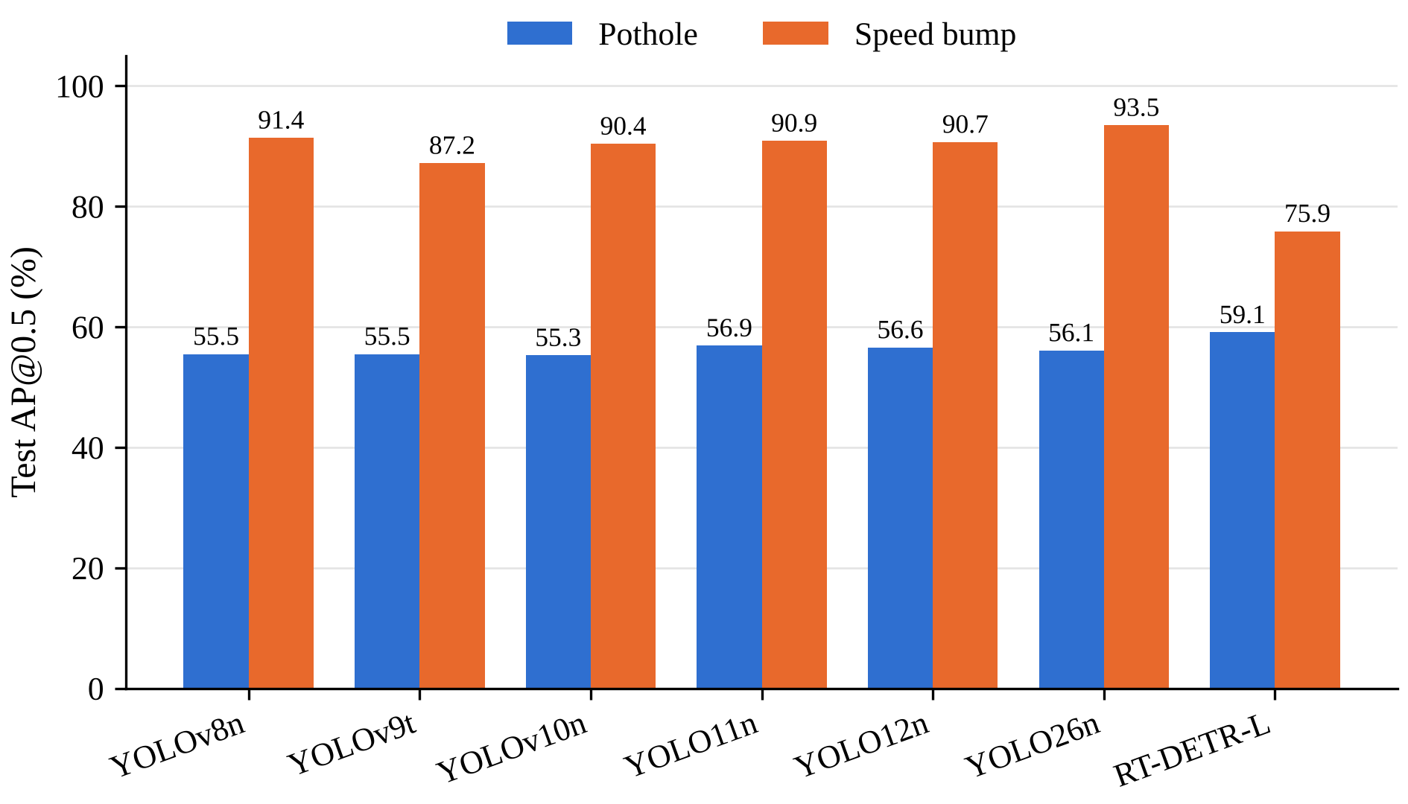
Fig. 5.5 Per-class AP@0.5 of the baseline detectors (measured)
Fig. 5.6 shows example baseline detections. In column (a), a distant unpainted bump, YOLOv8n and YOLO26n detect it at low confidence (0.34 and 0.39), YOLO11n misses it entirely, and RT-DETR-L places three overlapping boxes on it. This is exactly the small, distant case that SBP-YOLO’s P2 level and NWD loss were designed for.
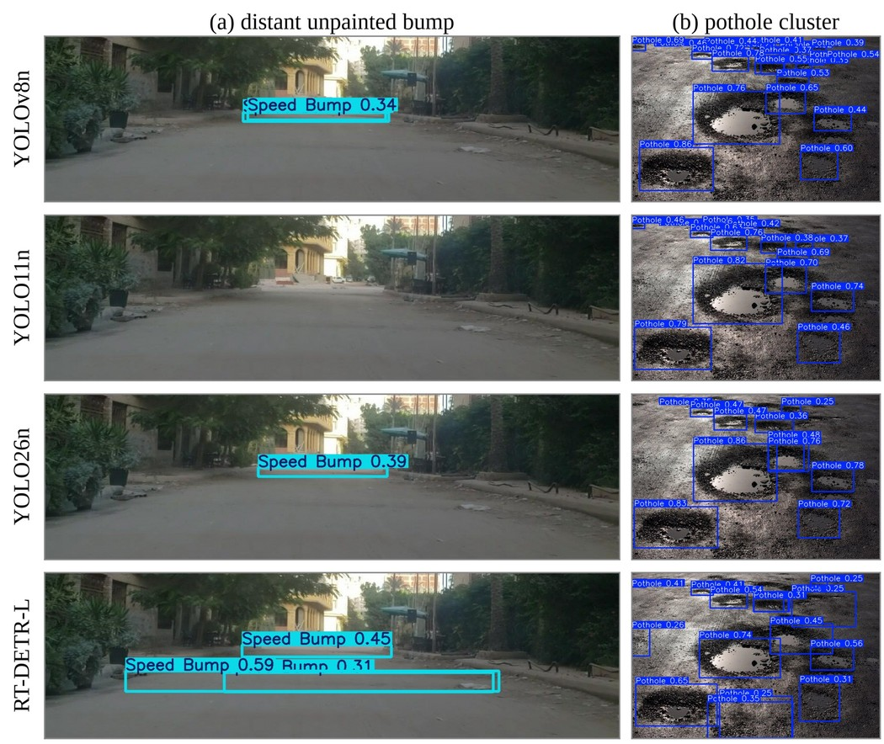
Fig. 5.6 Baseline detections on two test images: (a) a distant unpainted bump, (b) a pothole cluster (measured)
5.4.6 Inference with the Released SBP-YOLO Weights
Running the released sbp-yolo.pt weights confirmed that the model loads through the repository’s code base and detects speed bumps and potholes on road images and video that were not part of its training data, as shown in Fig. 4.8 and Fig. 4.9. Because this footage has no ground-truth labels, these runs show that the model works; they do not measure how accurately it works. A quantitative evaluation of the released weights on a labelled test split is the first item of future work in Chapter 6.
5.5 Comparison with Existing Techniques
Table 5.7 places SBP-YOLO beside earlier speed bump and pothole detectors. The other studies used their own datasets, which are often private, as well as different classes and hardware, so the numbers show the range reported in the field rather than a ranking.
Table 5.7 Comparison with existing techniques (as reported)
Work | Model | Classes | Accuracy | Embedded speed
[10] | CNN | Speed bump | 98.54% (classification) | Raspberry Pi
[1] | YOLOv5 | Speed bump | — | 18.5 ms per frame (Jetson)
[14] | YOLO | Speed bump | 81% mAP | Jetson Nano
[43] | YOLOv8x + stereo | Bumps, rumblers | 93.1% mAP@0.5 | 30 FPS (laptop GPU)
[49] | CRSCCG-YOLOv5s | Bump defects | 96.4% mAP | —
[27] | SBD-YOLO (YOLOv9) | Speed bump | — | 82.8% less computation
[23] | SBP-YOLO (YOLOv11n) | Bump, pothole | 87.0% mAP@0.5 | 139.5 FPS (Jetson AGX Xavier, FP16)
Note: All values as reported by the respective authors on different datasets and hardware; they are not directly comparable.
Three things stand out. SBP-YOLO is one of the few detectors that covers both speed bumps and potholes, the two anomalies a suspension controller must react to. It is the only one in the table that reports embedded speed on a vehicle-grade board in all three precisions. And it is publicly released, which is what made it possible to run and examine it in this project.
5.6 Discussion of Results
Where SBP-YOLO’s gain comes from. The ablation shows that the accuracy gain comes from two places: the P2 level (+2.7 points of mAP@0.5) and the NWD loss (+2.0 points). Both target small objects, one through the architecture and one through the training signal. The other three modules, LEDH, GhostConv and VoVGSCSPC, change accuracy by less than one point; their job is to pay for the P2 level. Without them, P2 would cost 63% more computation. With them, the final model is cheaper than the YOLOv11n it started from.
A cost the headline numbers hide. In the authors’ PyTorch measurement at batch size 1, SBP-YOLO ran at 63.7 FPS against 71.2 FPS for plain YOLOv11n, about 10.5% slower, even though it needs fewer FLOPs. The reason is the P2 level: a 160 × 160 feature map means more memory traffic, which FLOP counts do not capture. The 12.4% speed-up quoted in the paper is against the P2-enhanced YOLOv11n, not the plain one. After TensorRT conversion SBP-YOLO is fast enough that this hardly matters for a camera running at 30 frames per second, but it is worth knowing when comparing models by FLOPs alone.
Distillation is almost free accuracy. The distilled student nearly matched a teacher with 3.6 times its size, and the gain appears only at training time. The strongest improvement was in mAP@0.5:0.95 (+3.5 points on the validation split), meaning the distilled model places its boxes more tightly, which matters for estimating where a bump starts.
What our baselines add. Our benchmark was run on a different dataset, so its numbers cannot be placed beside SBP-YOLO’s. Its pattern can, though. In the authors’ comparison, the stock YOLO models span 3.1 points of mAP@0.5; in ours, YOLOv8n to YOLO12n span 2.5 points. Two independent datasets tell the same story: moving to a newer YOLO generation changes accuracy on this task by only a couple of points. SBP-YOLO’s reported gain of 5.4 points over YOLOv11n before distillation is larger than either spread, which supports the case for task-specific design over simply switching generations. Our results also show that YOLO26n, released after SBP-YOLO, led the stock models in our tests and is the cheapest of them, which makes it a natural candidate for a future SBP-YOLO built on a newer base.
Relation to the limitations identified earlier. SBP-YOLO addresses the main limitations listed in Section 3.2: it targets small distant objects, keeps the cost below its base model, runs in real time on a vehicle-grade board, and is publicly available. Our baseline results show that the small-object problem is real on public data too: in Fig. 5.6, the distant unpainted bump was missed or found at low confidence by every stock model.
Limitations of this study. The most important limitation is that we did not retrain SBP-YOLO or evaluate its released weights on a labelled test set, so every SBP-YOLO accuracy and speed figure in this report is the authors’ own. Our runs with the released weights are qualitative. Our baselines were trained once each with one seed for 50 epochs, which left them short of full convergence; differences of under about one point between them should not be read as real. The two datasets differ in size and content, so cross-dataset comparisons are limited to patterns rather than numbers. Finally, neither dataset is documented as representing Indian roads specifically.
5.7 Chapter Summary
As reported by its authors, SBP-YOLO reaches 86.6% mAP@0.5 (87.0% after distillation) with 2.04 million parameters and 5.8 GFLOPs, and runs at 139.5 FPS on a Jetson AGX Xavier in FP16. Its accuracy gain comes mainly from the P2 level and the NWD loss, while LEDH, GhostConv and VoVGSCSPC keep the cost below that of YOLOv11n. Our own benchmark of seven stock detectors on a public dataset showed that newer YOLO generations move accuracy by only about 2.5 points, which puts SBP-YOLO’s task-specific gain in perspective. The released SBP-YOLO weights ran successfully on road images and video, though their accuracy on such footage remains to be measured.
6. CHAPTER 4 – CONCLUSION AND FUTURE SCOPE
6.1 Summary of the Project
This project set out to understand how a camera-based detector can find small, distant speed bumps and potholes accurately while staying light enough for real-time embedded use, the requirement behind suspension preview control. The literature review showed that small-object accuracy and lightweight design usually pull against each other, and that SBP-YOLO is one of the few public designs that tackles both.
We studied SBP-YOLO module by module, set up its official implementation, and ran its released weights on road images and video. To put its reported gains in context, we trained and evaluated seven stock detectors on a public dataset under a single fixed protocol.
The important outcomes of the project are:
- SBP-YOLO’s reported accuracy gain over YOLOv11n comes mainly from the P2 detection level (+2.7 points) and the NWD loss (+2.0 points).
- LEDH, GhostConv and VoVGSCSPC offset the cost of the P2 level, giving 2.04 million parameters and 5.8 GFLOPs against 2.58 million and 6.3 GFLOPs for YOLOv11n.
- Reported embedded speed is 139.5 FPS in FP16 and 155.8 FPS in INT8 on a Jetson AGX Xavier.
- In PyTorch at batch size 1, SBP-YOLO is about 10% slower than plain YOLOv11n despite fewer FLOPs, because of the high-resolution P2 map.
- In our measured benchmark, stock YOLO generations from YOLOv8n to YOLO12n differed by only 2.5 points of mAP@0.5, and YOLO26n was best at 74.8% with the lowest cost.
- The released SBP-YOLO weights ran successfully on road images and video outside the authors’ dataset.
Table 6.1 shows how the project met each of its objectives.
Table 6.1 Achievement of project objectives
Objective | How it was met
Review existing methods, small-object and lightweight techniques | Chapter 2 reviewed over 40 sources and identified four gaps
Study SBP-YOLO and explain each module | Chapter 4 explained GhostConv, VoVGSCSPC, P2, LEDH, NWD and distillation; Chapter 5 analysed their reported effects
Set up the implementation and run released weights | Official repository set up; sbp-yolo.pt run on road images and video
Train stock detectors as a measured baseline | Seven detectors trained and evaluated under one protocol
Analyse accuracy, size and speed; identify remaining work | Reported and measured results analysed; limitations and future work identified

6.2 Conclusion
SBP-YOLO shows that detecting small road anomalies and running in real time on an embedded board do not have to be traded against each other. Its designers bought small-object accuracy with a high-resolution detection level and a better box loss, and then paid for that level with cheaper convolutions and a lighter head, ending with a model smaller than the one they started from. Our own experiments point the same way from the other side: on a public dataset, four years of general YOLO development moved accuracy by only a couple of points, which suggests that the remaining gains on this task come from design choices aimed at the problem rather than from newer general-purpose models.
The work also made clear what is still missing before such a detector can go into a vehicle. Its accuracy needs to be confirmed on independent, labelled road data, ideally from Indian roads, and its speed needs to be measured on the board it will actually run on. The released code and weights make both of these steps practical, and they are where this project goes next.
6.3 Future Scope
- Measure the released weights: evaluate sbp-yolo.pt on the labelled test split of the public dataset, after matching its class names and order, to turn the qualitative results of this project into numbers.
- Retrain SBP-YOLO: train SBP-YOLO under the same protocol as our baselines, so that it can be compared with them directly on one dataset.
- SBP-YOLO on a newer base: port the P2 level, LEDH and NWD loss onto YOLO26n, the best and cheapest stock model in our benchmark.
- Embedded measurement: export the model to TensorRT and measure latency on a Jetson board ourselves, split into preprocessing, inference and post-processing.
- Indian road dataset: collect and label speed bumps and potholes from Tamil Nadu roads, with tags for lighting, weather and marking.
- Distance estimation: estimate the distance to a detected bump from a single camera, to give a suspension controller the time-to-contact it needs [35].
- Temporal consistency: combine detections across consecutive frames to suppress one-off false alarms from shadows and pedestrian crossings.
SDG GOALS
This project is carried out with reference to the following United Nations Sustainable Development Goals.
Goal 3 – Good Health and Well-being. Target 3.6 aims to reduce deaths and injuries from road traffic accidents. Unmarked speed bumps and potholes cause sudden braking, loss of control and falls, especially for two-wheeler riders. A camera-based detector such as SBP-YOLO, which finds these hazards before the vehicle reaches them, can warn the driver or prepare the suspension in time.
Goal 9 – Industry, Innovation and Infrastructure. Target 9.1 calls for quality, reliable and resilient infrastructure, and Target 9.5 calls for stronger scientific research and technological capability. Detected potholes can be logged with their locations and passed to road maintenance agencies, helping them plan repairs. The project also studies and builds on openly released research code, adding a measured baseline that other students and researchers can repeat.
Goal 11 – Sustainable Cities and Communities. Target 11.2 aims to provide safe, affordable and accessible transport systems for all and explicitly mentions improving road safety. SBP-YOLO needs only a single camera and a small embedded board, so it can be fitted to ordinary vehicles, including two-wheelers and public transport, rather than only to premium cars with advanced driver assistance.
Relevance to Indian roads. The problem this project addresses is especially sharp in India, where many speed bumps are unpainted and do not follow a standard profile, and where two-wheelers make up a large share of road users. A detector that runs in real time on a low-cost board is a realistic way to bring hazard warnings to these vehicles. Collecting and testing on local road data is listed as future work for this reason.
How the outcomes map to the targets. Under Target 3.6, SBP-YOLO’s focus on small, distant targets matters because the bump that is seen late is the one that causes injury. Under Targets 9.1 and 9.5, the project contributes a documented setup and a repeatable baseline benchmark. Under Target 11.2, the model’s small size, 2.04 million parameters and 5.8 GFLOPs as reported, keeps the cost of a deployed system low enough for wide use.
Together, these goals connect the technical focus of this project, accurate detection of small road hazards on low-cost hardware, to its purpose of making everyday road travel safer and more affordable.
PUBLICATIONS
Benadict Infant A, Elangovan S and Dr. P. Shanmugaraja, ‘Comparative Evaluation of YOLOv8 to YOLO26 and RT-DETR for Speed Bump and Pothole Detection’, [Conference name – status: communicated / accepted].
This paper reports the baseline benchmark described in Section 5.4.5 of this report.
REFERENCES

- Aishwarya, R et al. 2023, ‘Robust deep learning based speed bump detection for autonomous vehicles in Indian scenarios’.
- Aquib, M et al. 2026, ‘YOLO models for accurate pothole detection: A comparative study’.
- Asad, MH, Khaliq, S, Yousaf, MH, Ullah, MO & Ahmad, A 2022, ‘Pothole detection using deep learning: A real-time and AI-on-the-edge perspective’, Advances in Civil Engineering, vol. 2022, Article ID 9221211.
- Assemlali, H, Bouhsissin, S & Sael, N 2025, ‘Computer vision-based detection and classification of road obstacles: Systematic literature review’, IEEE Access, doi: 10.1109/ACCESS.2025.3588668.
- Bhavana, B et al. 2024, ‘POT-YOLO: Real-time road potholes detection using edge segmentation-based YOLOv8’, IEEE Access.
- Buslaev, A, Iglovikov, VI, Khvedchenya, E, Parinov, A, Druzhinin, M & Kalinin, AA 2020, ‘Albumentations: Fast and flexible image augmentations’, Information, vol. 11, no. 2, p. 125.
- Celaya-Padilla, JM, Galván-Tejada, CE, López-Monteagudo, FE et al. 2018, ‘Speed bump detection using accelerometric features: A genetic algorithm approach’, Sensors, vol. 18, no. 2, p. 443.
- Darwiche, M & El-Hajj-Chehade, W 2019, ‘Speed bump detection for autonomous vehicles using signal-processing techniques’, BAU Journal – Science and Technology, vol. 1, no. 1, Article 5.
- detection-system 2023, Humps/Bumps & Potholes Detection Dataset, version 8, Roboflow Universe, CC BY 4.0, Available from: https://universe.roboflow.com/detection-system/humps-bumps-potholes-detection/dataset/8 [Accessed 22 Sep 2026].
- Dewangan, DK & Sahu, SP 2021, ‘Deep learning-based speed bump detection model for intelligent vehicle system using Raspberry Pi’, IEEE Sensors Journal, vol. 21, no. 3, pp. 3570–3578.
- Dharneeshkar, J, Soban Dhakshana, V, Aniruthan, SA, Karthika, R & Parameswaran, L 2020, ‘Deep learning based detection of potholes in Indian roads using YOLO’, Proceedings of the International Conference on Inventive Computation Technologies (ICICT).
- Han, K, Wang, Y, Tian, Q, Guo, J, Xu, C & Xu, C 2020, ‘GhostNet: More features from cheap operations’, Proceedings of the IEEE/CVF Conference on Computer Vision and Pattern Recognition (CVPR), pp. 1580–1589.
- Hinton, G, Vinyals, O & Dean, J 2015, ‘Distilling the knowledge in a neural network’, arXiv preprint arXiv:1503.02531.
- Hussein, M et al. 2024, ‘An intelligent approach for speed bump detection’.
- Jakubec, M et al. 2023, ‘Comparison of CNN-based models for pothole detection in real-world adverse conditions’, Sensors.
- Jocher, G, Chaurasia, A & Qiu, J 2023, Ultralytics YOLOv8, Available from: https://github.com/ultralytics/ultralytics [Accessed 22 Sep 2026].
- Khan, M, Raza, MA, Abbas, G, Othmen, S, Yousef, A & Jumani, TA 2024, ‘Pothole detection for autonomous vehicles using deep learning: A robust and efficient solution’, Frontiers in Built Environment, vol. 9, doi: 10.3389/fbuil.2023.1323792.
- Khanam, R & Hussain, M 2024, ‘YOLOv11: An overview of the key architectural enhancements’, arXiv preprint arXiv:2410.17725.
- Kothari, A et al. 2025, ‘Enhancing pothole detection: Comparing YOLO variants with validation on multi-weather images’.
- Lee, Y, Hwang, J, Lee, S, Bae, Y & Park, J 2019, ‘An energy and GPU-computation efficient backbone network for real-time object detection’, Proceedings of the IEEE/CVF Conference on Computer Vision and Pattern Recognition Workshops (CVPRW).
- Li, H, Li, J, Wei, H, Liu, Z, Zhan, Z & Ren, Q 2024, ‘Slim-neck by GSConv: A lightweight-design for real-time detector architectures’, Journal of Real-Time Image Processing, vol. 21, Article 62.
- Li, H et al. 2026, ‘Research on low-light speed bump detection algorithm based on improved YOLOv8n’.
- Liang, C, Fu, J, Yu, M & Luo, L 2025a, ‘SBP-YOLO: A lightweight real-time model for detecting speed bumps and potholes toward intelligent vehicle suspension systems’, arXiv preprint arXiv:2508.01339.
- Liang, C 2025b, SBP-YOLO: Official implementation, GitHub repository, GPL-3.0, Available from: https://github.com/chuanqi1997/SBP-YOLO [Accessed 8 Oct 2026].
- Liang, C et al. 2026, ‘SBP-YOLO: A lightweight real-time model for detecting speed bumps and potholes toward intelligent vehicle suspension systems’, Journal of Real-Time Image Processing, vol. 23, doi: 10.1007/s11554-025-01849-x.
- Magdy, A et al. 2023, ‘Lane and bump detection based on computer vision and deep learning methods’.
- Mao, Y et al. 2026, ‘SBD-YOLO: An efficient speed bump detector for active suspension preview control’.
- Mohan Prakash, B & Sriharipriya, KC 2022, ‘Enhanced pothole detection system using YOLOX algorithm’, Autonomous Intelligent Systems, vol. 2, no. 1, Article 22.
- NVIDIA 2026, NVIDIA TensorRT Documentation, Available from: https://docs.nvidia.com/deeplearning/tensorrt/ [Accessed 8 Oct 2026].
- Park, SS, Tran, VT & Lee, DE 2021, ‘Application of various YOLO models for computer vision-based real-time pothole detection’, Applied Sciences, vol. 11, no. 23, p. 11229.
- Peralta-López, JE, Morales-Viscaya, JA, Lázaro-Mata, D et al. 2023, ‘Speed bump and pothole detection using deep neural network with images captured through ZED camera’, Applied Sciences, vol. 13, no. 14, p. 8349.
- Pham, V, Ngoc, LDT & Bui, DL 2024, ‘Optimizing YOLO architectures for optimal road damage detection and classification: A comparative study from YOLOv7 to YOLOv10’, IEEE BigData 2024 Optimized Road Damage Detection Challenge, arXiv:2410.08409.
- Saffarini, R, Khamayseh, F, Daraghmi, YA, Elyan, D & Sabha, M 2023, ‘Survey of road anomalies detection methods’, International Journal of Intelligent Systems Technologies and Applications, vol. 21, no. 3.
- Safyari, M et al. 2024, ‘A review of vision-based pothole detection methods using computer vision and machine learning’, Sensors.
- Shen, Y, Jing, K, Sun, K, Liu, C, Yang, Y & Liu, Y 2025, ‘Review of uneven road surface information perception methods for suspension preview control’, Sensors, vol. 25, Article 5884.
- Shu, C, Liu, Y, Gao, J, Yan, Z & Shen, C 2021, ‘Channel-wise knowledge distillation for dense prediction’, Proceedings of the IEEE/CVF International Conference on Computer Vision (ICCV), pp. 5311–5320.
- Tamagusko, T et al. 2023, ‘Optimizing pothole detection in pavements: A comparative analysis of deep learning models’.
- Tian, Y, Ye, Q & Doermann, D 2025, ‘YOLOv12: Attention-centric real-time object detectors’, Advances in Neural Information Processing Systems (NeurIPS 2025), arXiv:2502.12524.
- ‘Towards safer roads: A review of hybrid machine learning and vision-based approaches for speed bump detection in intelligent transportation systems’ 2025, International Journal of Safety and Security Engineering.
- Ultralytics 2026a, ‘Ultralytics YOLO26: Unified real-time end-to-end vision models’, arXiv preprint arXiv:2606.03748.
- Ultralytics 2026b, YOLO26 Model Documentation, Available from: https://docs.ultralytics.com/models/yolo26 [Accessed 22 Sep 2026].
- Varma, VSKP, Adarsh, S, Ramachandran, KI & Nair, BB 2018, ‘Real time detection of speed hump/bump and distance estimation with deep learning using GPU and ZED stereo camera’, Procedia Computer Science, vol. 143, pp. 988–997.
- Vasisht, S et al. 2026, ‘Real-time detection of speed breakers and rumblers using advanced deep learning algorithms’.
- Wang, A et al. 2024, ‘YOLOv10: Real-time end-to-end object detection’, Advances in Neural Information Processing Systems (NeurIPS 2024).
- Wang, CY, Yeh, IH & Liao, HYM 2024, ‘YOLOv9: Learning what you want to learn using programmable gradient information’, Proceedings of the European Conference on Computer Vision (ECCV), arXiv:2402.13616.
- Wang, J, Xu, C, Yang, W & Yu, L 2021, ‘A normalized Gaussian Wasserstein distance for tiny object detection’, arXiv preprint arXiv:2110.13389.
- Wang, J et al. 2024, ‘Research on visual perception of speed bumps for intelligent connected vehicles based on lightweight FPNet’, Sensors.
- Wang, Y et al. 2022, ‘Automatic detection of pothole distress in asphalt pavement using improved convolutional neural networks’.
- Xiang, Q et al. 2024, ‘Research on detection of multiple types of speed bump defects based on CRSCCG-YOLOv5s’.
- Yang, L et al. 2023, ‘Bridging cross-task protocol inconsistency for distillation in dense object detection’, Proceedings of the IEEE/CVF International Conference on Computer Vision (ICCV).
- Zhao, Y et al. 2024, ‘DETRs beat YOLOs on real-time object detection’, Proceedings of the IEEE/CVF Conference on Computer Vision and Pattern Recognition (CVPR), pp. 16965–16974.

