Comparative Evaluation of YOLOv8 to YOLO26 and RT-DETR for Speed Bump and Pothole Detection
Benadict Infant A  Dept. of Information Technology  Sona College of Technology  Salem, Tamil Nadu, India  Reg. No. 61782323110022 | Elangovan S  Dept. of Information Technology  Sona College of Technology  Salem, Tamil Nadu, India  Reg. No. 61782323110035 | Dr. P. Shanmugaraja  Dept. of Information Technology  Sona College of Technology  Salem, Tamil Nadu, India  (Project Guide)

Abstract—Speed bumps and potholes are the road anomalies that most often force a vehicle to slow or swerve, and on Indian roads many bumps are unpainted and poorly marked, leaving a driver no visual cue until the suspension registers the impact. Camera-based detection is therefore an active application area, but anyone choosing a detector for it has little to go on: published results for the YOLO family come from different datasets, schedules and hardware, and cannot be set side by side. This paper reports a controlled evaluation of seven released real-time detectors on the same task. No architecture is modified and no new method is proposed. YOLOv8n, YOLOv9t, YOLOv10n, YOLO11n, YOLO12n, YOLO26n and the transformer-based RT-DETR-L were each trained from COCO-pretrained weights on the same public 3,243-image two-class dataset, at 640 × 640, for 50 epochs, with the same optimiser and seed, on the same GPU, and scored on the same held-out test split. YOLO26n ranks first on every overall metric, reaching 74.8% mAP@0.5 and 35.5% mAP@0.5:0.95 at 82.3% precision and 68.1% recall, and is at the same time the cheapest model in the set at 5.3 GFLOPs and 2.4 M parameters. The five generations from YOLOv8 to YOLO12 fall within 2.5 points of one another, and RT-DETR-L, at thirteen times the parameters, trains less stably and ranks last. Potholes are the harder class for every detector by roughly 35 points of AP@0.5. Per-class accuracy, complexity, measured latency and the observed failure modes are reported for all seven models.
Index Terms—speed bump detection, pothole detection, object detection, comparative study, benchmarking, YOLO, YOLO26, RT-DETR, small-object detection, road anomaly perception, intelligent transportation systems.
I. Introduction
Speed bumps are deliberate traffic-calming devices, and on Indian roads they are also among the least standardised features a driver encounters. A large share are unpainted. Many depart from the height and profile the Indian Roads Congress specifies. At night, in rain, or behind a larger vehicle, an unmarked bump is effectively invisible until the suspension finds it, and a single stretch of road can carry several of them with no signage at all. The distance between a hazard that exists and a hazard a driver can see is what motivates camera-based detection of road anomalies.
Meeting one at the wrong speed is not a trivial event. Vertical acceleration transmitted through the suspension causes discomfort at best and loss of control at worst, and for two-wheelers, which carry the majority of road users in Tamil Nadu, the risk scales badly. Construction quality is inconsistent. Marking is inconsistent. Height and profile vary from one municipality to the next, and often from one street to the next within the same municipality.
Two families of solutions have been explored. The first infers a bump after the vehicle has already crossed it, using accelerometer and gyroscope signals from the chassis or from a smartphone rigidly mounted inside the cabin [26], [27]. These systems are cheap and they work, but they are reactive by construction. They tell you where a bump was, not where one is about to be. Their practical value lies in crowdsourced mapping rather than in-vehicle warning. The second family uses a forward-facing camera and treats the bump as an object to be located in the image before the vehicle reaches it. This is the anticipatory formulation, and it is the one that suits both driver alerting and preview-based suspension control [1].
Vision brings its own difficulties. A bump photographed from twenty metres out is a thin, low-contrast horizontal band, sometimes only a dozen pixels tall in a 640-pixel frame. Painted bumps are easy to mix up with zebra crossings, since both show up as alternating light and dark stripes across the lane. Shadows from roadside trees and compound walls cause a similar problem for unpainted bumps. On wet roads, reflected sky can remove the shading that normally gives the bump away. So the detector has to pick up small, faint objects without firing on every stripe or shadow, and it has to run on an embedded board.
YOLO26, released by Ultralytics in January 2026, changes two things relevant here [2], [3]. The Distribution Focal Loss term is removed from the box regression head, and the model outputs final boxes directly without a separate Non-Maximum Suppression step. It also uses Small-Target-Aware Label Assignment (STAL), which makes sure very small objects still get positive anchors during training. In principle these help with latency on small hardware and recall on small targets. Ultralytics reports these gains on COCO, though, and we wanted to see whether they hold on road images when YOLO26 is trained alongside older models under the same settings.
The dataset we used labels potholes as well as speed bumps, so we evaluate both. A suspension controller would need to know about both, and potholes are the class most earlier comparisons used. Keeping both also turned out to matter: as Section VI shows, the two classes behave very differently under the same detector.
We do not propose a new architecture. All seven detectors are trained as released, with no added modules or loss changes, and the contribution is the controlled comparison itself. Section II reviews prior work, Section III the detectors, Section IV the data and pipeline, Section V the training setup, Section VI the results and Section VII the conclusions.
II. Related Work
Prior work falls into sensor-based methods, stereo vision and monocular deep learning, and we review them in that order.
A. Vibration and Vehicle-Dynamics Sensing
Early systems did not use cameras. When a vehicle goes over a bump, the accelerometer and gyroscope show a clear vertical spike, and simple thresholds or classifiers can detect it. Work in [27] showed that bump maps can be built this way from normal driving data. The catch is that detection only happens after the vehicle hits the bump, so it helps the next driver rather than the current one. The signal also depends on sensor mounting, sampling rate and the vehicle’s suspension, which makes it hard to reuse across vehicles.
B. Stereo Vision and Distance Estimation
With a second camera, a system can estimate distance as well as detect the bump. In [26] a ZED stereo camera with GPU inference was used for real-time hump detection and ranging, and [7] combined YOLOv8x with a similar camera, reporting 93.1% mAP@50 at about 30 FPS on a laptop GPU. Distance matters for suspension control, which needs time-to-contact and not just presence. A stereo camera plus a discrete GPU is too expensive for a retrofit device, though, so most work has stayed monocular.
C. Monocular Deep Learning for Speed Bumps
Dewangan and Sahu [11] ran a CNN speed bump detector on a Raspberry Pi and reported 98.54% accuracy. That figure is for image classification, not box-level detection, so it cannot be compared with mAP. Magdy et al. [10] compared Faster R-CNN, VGG-16, MobileNet-SSD and two YOLOv3 variants for lane and bump detection, and YOLOv3 Lite-MobileNet did best at 89.17%. Aishwarya et al. [5] focused on Indian roads, comparing Faster R-CNN with YOLOv5, separating marked and unmarked bumps and handling crosswalk confusion, at 18.5 ms per frame on a Jetson. Crosswalks were also a frequent source of false positives in our predictions (Section VI-F).
Several papers modify a base model instead. CRSCCG-YOLOv5s [4] targets multiple bump defect types and reports 96.4% mAP with 8.8M parameters. Wang et al. [8] add FasterNet and Dynamic Snake Convolution to YOLOv5, giving up a little accuracy for a large FPS gain. Hussein et al. [9] trained on Egyptian roads and reached 81% mAP on a Jetson Nano. Li et al. [12] added SE and EMA attention to YOLOv8n and gained 8.9 points of mAP@0.5 in low light and rain. SBD-YOLO [6] builds on YOLOv9 with an Aggregated-MBConv block and cuts computation by 82.8%.
SBP-YOLO [1] is the work closest to ours, and it is why we treat YOLO11n as an important reference. It starts from YOLOv11n, uses GhostConv and VoVGSCSPC in the backbone and neck, and adds a P2 branch for small objects and a lighter detection head. It reports 87.0% mAP, 5.8 points above YOLOv11n, and 139.5 FPS on a Jetson AGX Xavier with TensorRT FP16. Those numbers come from a different dataset and device, so we do not compare them with ours. They do show that a modified YOLO11n works well for this task, which is why we first wanted to know how the unmodified models compare.
D. Pothole Detection as a Methodological Template
Pothole detection has been studied more, and its comparative papers are the template for our setup. Park et al. [13] compared YOLOv4, YOLOv4-tiny and YOLOv5s and found the tiny model best once speed was considered. Asad et al. [15] tested YOLOv1 to v5 and SSD-MobileNetv2 on OAK-D and Raspberry Pi, treating edge hardware as part of the experiment. Tamagusko et al. [21] compared YOLOv3, v4 and v5 on a 665-image dataset. Jakubec et al. [18] compared YOLO and R-CNN models in rain, night and sunset; we would like to report results by condition in the same way, but our dataset has no condition labels. Aquib et al. [14] extended the comparison up to YOLOv8, and Bhavana et al. [22] added Sobel edge preprocessing to YOLOv8. Broader reviews cover vision-based pothole methods [24] and hybrid learning approaches to speed bump detection in intelligent transportation systems [23].
The single most relevant comparative study is Kothari et al. [20], which benchmarks YOLO11n/s/m against YOLO12n/s/m on real road photographs. It is the closest methodological match to the evaluation reported here. It is also, crucially, a pothole study that stops at YOLOv12.
TABLE I
Summary of Representative Prior Work
Ref. | Method | Target | Reported outcome
[27] | Accelerometer / IMU | Speed bumps | Post-contact georeferencing
[26] | ZED stereo + GPU | Humps, distance | Real-time with ranging
[11] | CNN on Raspberry Pi | Speed bumps | 98.54% class. accuracy
[10] | YOLOv3 Lite-MobileNet | Lanes + bumps | 89.17%
[5] | Faster R-CNN vs YOLOv5 | Indian bumps | 18.5 ms/frame (Jetson)
[4] | CRSCCG-YOLOv5s | Bump defects | 96.4% mAP, 8.8M params
[8] | YOLOv5-FPNet | Bumps (ICV) | Large FPS gain
[9] | YOLO, Jetson Nano | Bumps (Egypt) | 81% mAP
[12] | YOLOv8n + SE/EMA | Low-light bumps | +8.9 mAP@0.5
[6] | SBD-YOLO (YOLOv9) | Bumps, suspension | 82.8% less compute
[7] | YOLOv8x + stereo | Bumps, rumblers | 93.1% mAP@50, 30 FPS
[1] | SBP-YOLO (YOLOv11n) | Bumps + potholes | 87.0% mAP, 139.5 FPS
[13] | YOLOv4 / tiny / v5s | Potholes | Tiny variant best
[15] | YOLOv1–v5, SSD | Potholes (edge) | OAK-D, Raspberry Pi
[18] | YOLO vs R-CNN | Potholes, weather | Condition-stratified
[20] | YOLO11 vs YOLO12 | Potholes | Closest comparative study
[22] | POT-YOLO (v8 + Sobel) | Potholes | 99.1% accuracy
Metrics are as reported by the respective authors on their own datasets and hardware, and are therefore not directly comparable across rows.
E. The Gap
Three observations follow from the table. Speed bump papers overwhelmingly propose a single modified architecture and compare it against one or two baselines; they do not benchmark a family. Multi-model comparative studies exist, but they are pothole studies, and the most recent of them stops at YOLOv12. Edge latency is reported for the proposed model only, almost never across the full comparison set, which makes the accuracy-latency trade-off impossible to read off the published numbers.
No located study benchmarks YOLO26 on speed bumps at all, which is unsurprising given the release date. That is the gap this evaluation addresses.
III. Detector Background and Model Selection
A short account of what changed in YOLO26 is needed before the comparison, because the architectural differences bear directly on the two constraints identified earlier, and because they are what the results in Section VI have to be read against.
A. NMS-Free End-to-End Inference
Detectors from YOLOv8 through YOLO11 emit several thousand candidate boxes per frame and rely on Non-Maximum Suppression to reduce them. NMS is cheap on a data-centre GPU with native CUDA kernels. It is not cheap on an embedded CPU or an NPU, where it typically falls back to the host processor and becomes an input-dependent, variable-latency tail on every frame. YOLO26 uses a dual-head design during training, one-to-many for supervision and one-to-one for inference, and produces final predictions directly [2], [3]. Post-processing cost approaches zero, and the IoU and score thresholds that previously needed scenario-specific tuning disappear from the deployment surface. For a device that has to hold a fixed frame budget on a moving vehicle, deterministic latency is worth as much as low mean latency.
B. DFL-Free Regression
Distribution Focal Loss improved localisation by predicting a distribution over box coordinates rather than a point estimate, at the cost of a heavier head and a fixed regression range. YOLO26 removes it, giving a lighter head with unconstrained range [3]. The practical benefit is export: fewer exotic operators means fewer compiler failures when moving to ONNX, TensorRT, or OpenVINO, and cleaner INT8 quantisation.
C. STAL and Progressive Loss
STAL is aimed at one specific training problem. Under conventional assignment, the smallest ground-truth objects in a batch can receive no positive anchor at all, so they contribute nothing to the classification gradient and the network never learns to fire on them. STAL guarantees positive coverage for small targets. Progressive Loss Balancing shifts supervision toward the one-to-one inference head over the course of training. Ultralytics reports up to 43 percent faster CPU inference for YOLO26n relative to YOLO11n on ONNX runtime [3]. For the present task the STAL claim is the more interesting one, because a distant unmarked bump is close to the worst case the mechanism was designed for.
D. The P2 Detection Branch
Standard YOLO heads operate on P3, P4 and P5 feature levels, corresponding to strides of 8, 16 and 32. At stride 8 and 640-pixel input, an object under roughly 16 pixels tall has been reduced to two feature cells or fewer. Adding a P2 branch at stride 4 doubles the spatial resolution available to the smallest scale, and SBP-YOLO does exactly this [1]. It matters here both because it is the mechanism most directly aimed at the distant-bump case and because it marks the boundary of this evaluation: a P2 variant is a modified architecture rather than a released one, and therefore falls outside a comparison of models as shipped. Section VII returns to it as the obvious follow-up.
E. Models Compared
Seven detectors are compared, each at the smallest scale its family offers. Mixing scales would confound architecture with capacity, and the embedded deployment this task is ultimately aimed at rules out anything larger in any case. YOLOv8n [28] is the industry baseline and still the most widely quoted comparison point in the road anomaly literature. YOLOv9t [32] brought in programmable gradient information and the GELAN backbone, and has the fewest parameters of the set. YOLOv10n [30] was the first in the family to train a one-to-one head for NMS-free inference, which makes it the natural precursor to YOLO26 on the latency question. YOLO11n [29] is the immediate predecessor generation and the base SBP-YOLO was built on, so it is the fairest yardstick for what YOLO26 adds. YOLO12n [33] swapped much of the convolutional backbone for area attention. YOLO26n [2], [3] is the newest release and the reason for the study. RT-DETR-L [34] is included as a deliberately different design point, a real-time detection transformer with roughly thirteen times the parameters of the nano models, to find out whether the accuracy ceiling on this task is set by how much capacity the detector has or by the data it is given.
IV. Data and Evaluation Pipeline
A. Evaluation Pipeline
Every model in the study is trained and evaluated through one fixed path, shown in Fig. 1. An image enters, is letterboxed and normalised, passes through the detector under test, and leaves as zero or more boxes with a class and a confidence score that the validator then scores. Only the shaded slot changes between runs; nothing else in the path differs from one model to the next, which is what makes the columns of Tables IV to VI comparable.
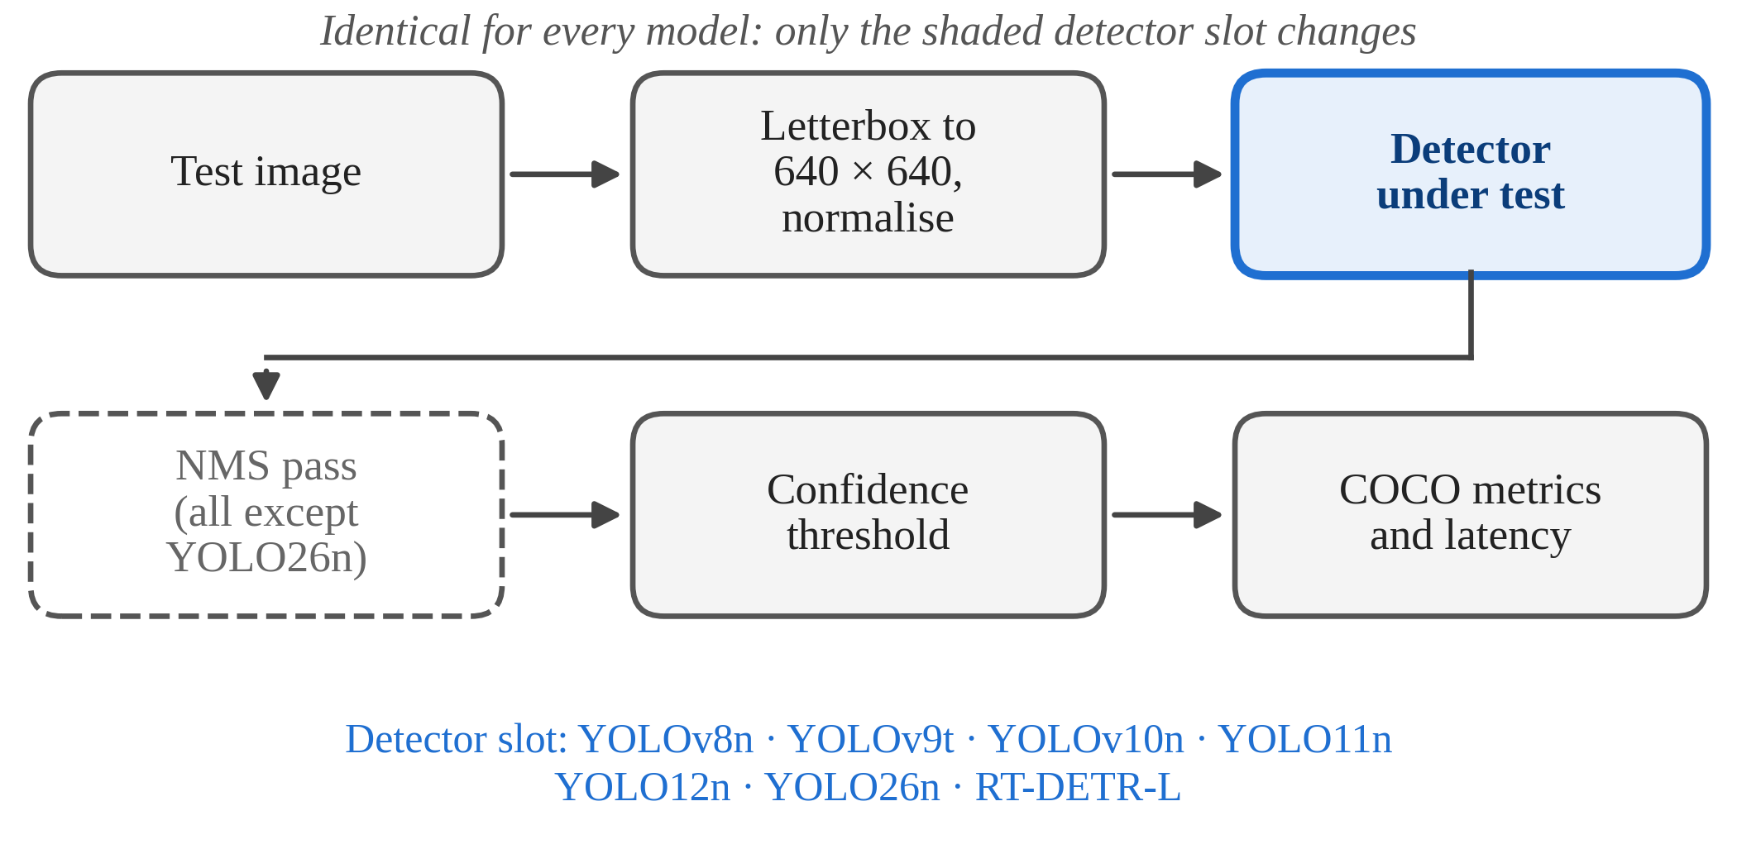
Fig. 1. The common evaluation pipeline. Preprocessing, thresholding, scoring and timing are identical for every model in the study; only the shaded detector slot changes. The suppression stage is dashed because it applies to the six NMS-based models and not to YOLO26n, whose head produces final predictions directly.
Preprocessing letterboxes the image to 640 by 640 and scales pixel values to the unit interval. The detector emits a prediction tensor carrying one of two labels, pothole or speed bump. For the six NMS-based models a suppression pass at an IoU threshold of 0.7 reduces the candidate boxes; YOLO26n skips that stage, since its one-to-one head already returns a compact set of non-redundant boxes in xyxy form. A confidence threshold is then applied identically in both cases, and the surviving detections go to the Ultralytics validator, which computes the metrics of Section V-A. In a deployed system these detections would drive a driver alert or a suspension preview signal; building that system is outside the scope of this paper, which stops at the measurement.
B. Dataset
The experiments use the publicly available Humps/Bumps and Potholes Detection dataset [35], released through Roboflow Universe under a CC BY 4.0 licence. Version 8, generated on 25 May 2023, is the release used here: 3,243 images exported in YOLO format with two classes, pothole and speed bump. It was mirrored to Kaggle for the training runs and used exactly as distributed. No images were added, removed or re-annotated, and the train, validation and test partitions are those shipped with the export, so nothing in the comparison depends on a decision made about the data. That is a deliberate trade. It costs control over the content, and Section VI-H says what that costs; it buys a comparison reproducible from the same public files, which is precisely what the cross-paper tables in Section II cannot offer.
The split is 2,560 training images, 475 for validation and 208 for test, roughly 79:15:6. The validation split drives early stopping and checkpoint selection and contains 978 labelled instances. No model saw the test split during training or checkpoint selection, and every number in Section VI comes from it. It has 457 instances: 386 potholes in 140 images and 71 speed bumps in 70 images. The Ultralytics loader rejected one training image because it mixed segment and box labels, so that image was skipped for every model. Table II shows the split. With only 71 speed bumps in the test set, each missed bump changes speed bump recall by about 1.4 points.
TABLE II
Dataset Composition
Subset | Images | Instances | Pothole | Speed bump
Training | 5725 | 11689 | 9206 | 2483
Validation | 750 | 1540 | 1197 | 343
Test | 1125 | 2299 | 1802 | 497
Total | 7600 | 15528 | 12205 | 3323
Instance counts are from the Ultralytics validator, which does not report them for the training split.
C. Label Conventions in the Data
The dataset has no annotation guide, so we went through the images and label files to see how they were labelled. We note what we found because it explains several results in Section VI.
- Speed bump boxes usually cover the full width of the bump, including the ramps, not just the painted stripes.
- Very distant bumps only a few pixels tall are often unlabelled, so a model that detects one is counted as a false positive.
- Pedestrian crossings without a bump are unlabelled, so they act as negative examples in training.
- Each pothole is boxed separately, including small holes around a larger one. This is why there are so many pothole instances, and it hurts pothole AP at strict IoU (Section VI-B).
Since every model used the same labels, labelling errors cannot favour one model over another, but they do cap how high the scores can go (Section VI-H).
D. Augmentation
Augmentation is the Ultralytics default recipe, applied unchanged and identically to every model: HSV jitter, scaling, translation, horizontal flip and mosaic, with mosaic disabled for the final ten epochs and vertical flipping left off. It was not tuned. Tuning augmentation per architecture would have improved some models and quietly biased the comparison, which is the failure mode a controlled evaluation exists to avoid.
V. Experimental Setup
Every model is trained under identical conditions. This is the whole point of the exercise: the comparative claim is only defensible if data, resolution, schedule, optimiser and hardware are held fixed, and it is exactly this control that the cross-paper tables in Section II lack.
All seven models were trained with the same Ultralytics release and the same script; only the architecture changed. Each run started from the official COCO-pretrained checkpoint for its architecture and used a 640-pixel input, a batch of 16, a 50-epoch schedule with early stopping after 15 epochs without improvement in validation fitness, and seed 42 with deterministic kernels. The optimiser was left to the framework’s automatic policy, which picked AdamW at a learning rate of 1.67e-3 and momentum 0.9 for every model, so that choice is identical across the set as well. RT-DETR-L is the one exception on batch size: at 32.8 M parameters it would not fit the 16 GB card at batch 16 and ran at batch 8. Table III lists the configuration. The YOLO runs each took between 1.04 and 1.16 hours on the T4; RT-DETR-L took 1.46 hours for the 30 epochs it completed before early stopping.
TABLE III
Training Configuration (Identical Across All Models)
Parameter | Value
Input resolution | 640 × 640, letterboxed
Epochs | 50, early stopping patience 15
Batch size | 16 (8 for RT-DETR-L)
Optimiser | AdamW, auto-selected for all models
Learning rate / momentum | 1.67e-3 / 0.9, 3 warm-up epochs
Weight decay | 5e-4
Weight initialisation | COCO-pretrained, per architecture
Mixed precision | AMP enabled
Mosaic | On; disabled for final 10 epochs
Framework | Ultralytics 8.4.156, PyTorch 2.10, Python 3.12
Training hardware | NVIDIA Tesla T4, 16 GB
Random seed | 42, deterministic, fixed across all runs

A. Metrics
Detection quality is reported as precision, recall, mAP@0.5 and mAP@0.5:0.95 on the held-out test split, computed by the Ultralytics validator under the standard COCO protocol with a confidence threshold of 0.001 and, for the NMS-based models, an IoU threshold of 0.7. Average precision is also given separately for potholes and speed bumps. Recall carries more weight than precision in this application, since a missed bump is an unmitigated hazard while a spurious warning is a nuisance, though a detector that cries wolf constantly will simply be ignored, so the asymmetry has limits. The checkpoint evaluated for each model is the one with the best validation fitness, defined by Ultralytics as 0.1·mAP@0.5 + 0.9·mAP@0.5:0.95, the same rule that selects best.pt during training.
Efficiency is reported as parameter count and GFLOPs at 640 × 640 for the fused inference graph, on-disk checkpoint size in half precision, and measured latency. Latency was recorded on the training GPU as the wall-clock time of a single-image predict() call, averaged over the first 100 test images after 10 warm-up images, with CUDA synchronisation before and after the timed loop. It pays to be clear about what that number is. It is an end-to-end figure covering image decoding, letterboxing, the forward pass, post-processing and the Python overhead of the framework, on a data-centre GPU. As a relative ranking under one fixed pipeline it is fair; as an edge deployment number it is not. For nano-scale models on a T4 the forward pass is a small slice of the total, so the measurement cannot pull the NMS cost apart from everything else. Decomposed latency on an embedded target is left to further work.
B. Per-Class and Qualitative Evaluation
Aggregate mAP conceals the failures that matter, so every accuracy metric is reported per class as well as overall, and predictions on held-out images were inspected for the failure modes catalogued in Section VI. The stratified evaluation by illumination, surface state and marking that this task really calls for needs attribute labels the dataset does not carry, and it is deferred. The unpainted night stratum is the one to watch: it is the hardest, and it is where a detector would add most over an attentive driver.
VI. Results and Analysis
Table IV reports overall accuracy on the 208-image test split, Table V breaks it down by class and Table VI gives complexity and measured latency. Fig. 2 plots accuracy against compute, Fig. 3 compares the two classes, Fig. 4 shows validation mAP@0.5 during training and Fig. 5 gives example detections. Each model was trained once, so small differences should be checked against the noise estimate in Section VI-H.
TABLE IV
Detection Accuracy on the Held-Out Test Split (%)
Model | P | R | mAP@.5 | mAP@.5:.95
YOLOv8n | 73.9 | 67.7 | 73.5 | 34.6
YOLOv9t | 73.0 | 67.1 | 71.4 | 35.3
YOLOv10n | 79.3 | 66.1 | 72.8 | 34.7
YOLO11n | 78.8 | 64.9 | 73.9 | 33.3
YOLO12n | 73.1 | 66.6 | 73.7 | 34.0
YOLO26n | 82.3 | 68.1 | 74.8 | 35.5
RT-DETR-L | 66.6 | 65.8 | 67.5 | 30.6
Best value per column in bold. Test split: 208 images, 457 instances. Checkpoint chosen by validation fitness.
TABLE V
Per-Class Accuracy on the Test Split (%)
Model | Pothole AP@.5 | Pothole AP@.5:.95 | Bump AP@.5 | Bump AP@.5:.95
YOLOv8n | 55.5 | 22.6 | 91.4 | 46.7
YOLOv9t | 55.5 | 24.6 | 87.2 | 45.9
YOLOv10n | 55.3 | 23.9 | 90.4 | 45.5
YOLO11n | 56.9 | 24.2 | 90.9 | 42.4
YOLO12n | 56.6 | 24.3 | 90.7 | 43.7
YOLO26n | 56.1 | 24.0 | 93.5 | 46.9
RT-DETR-L | 59.1 | 24.6 | 75.9 | 36.7
Test split: 386 pothole instances in 140 images, 71 speed bump instances in 70 images.
TABLE VI
Complexity and Measured Latency
Model | Params (M) | GFLOPs | Size (MB) | Latency (ms) | FPS
YOLOv8n | 3.01 | 8.1 | 5.9 | 33.1 | 30.2
YOLOv9t | 1.97 | 7.6 | 4.4 | 39.6 | 25.2
YOLOv10n | 2.27 | 6.6 | 5.5 | 32.5 | 30.8
YOLO11n | 2.58 | 6.4 | 5.2 | 32.7 | 30.6
YOLO12n | 2.56 | 7.3 | 5.2 | 37.4 | 26.7
YOLO26n | 2.38 | 5.3 | 5.1 | 34.1 | 29.3
RT-DETR-L | 31.99 | 105.3 | 63.2 | 81.8 | 12.2
Params and GFLOPs are for the fused graph at 640 × 640. Latency is single-image and end-to-end on a Tesla T4, averaged over 100 test images after 10 warm-up runs; Section V-A describes what it includes.
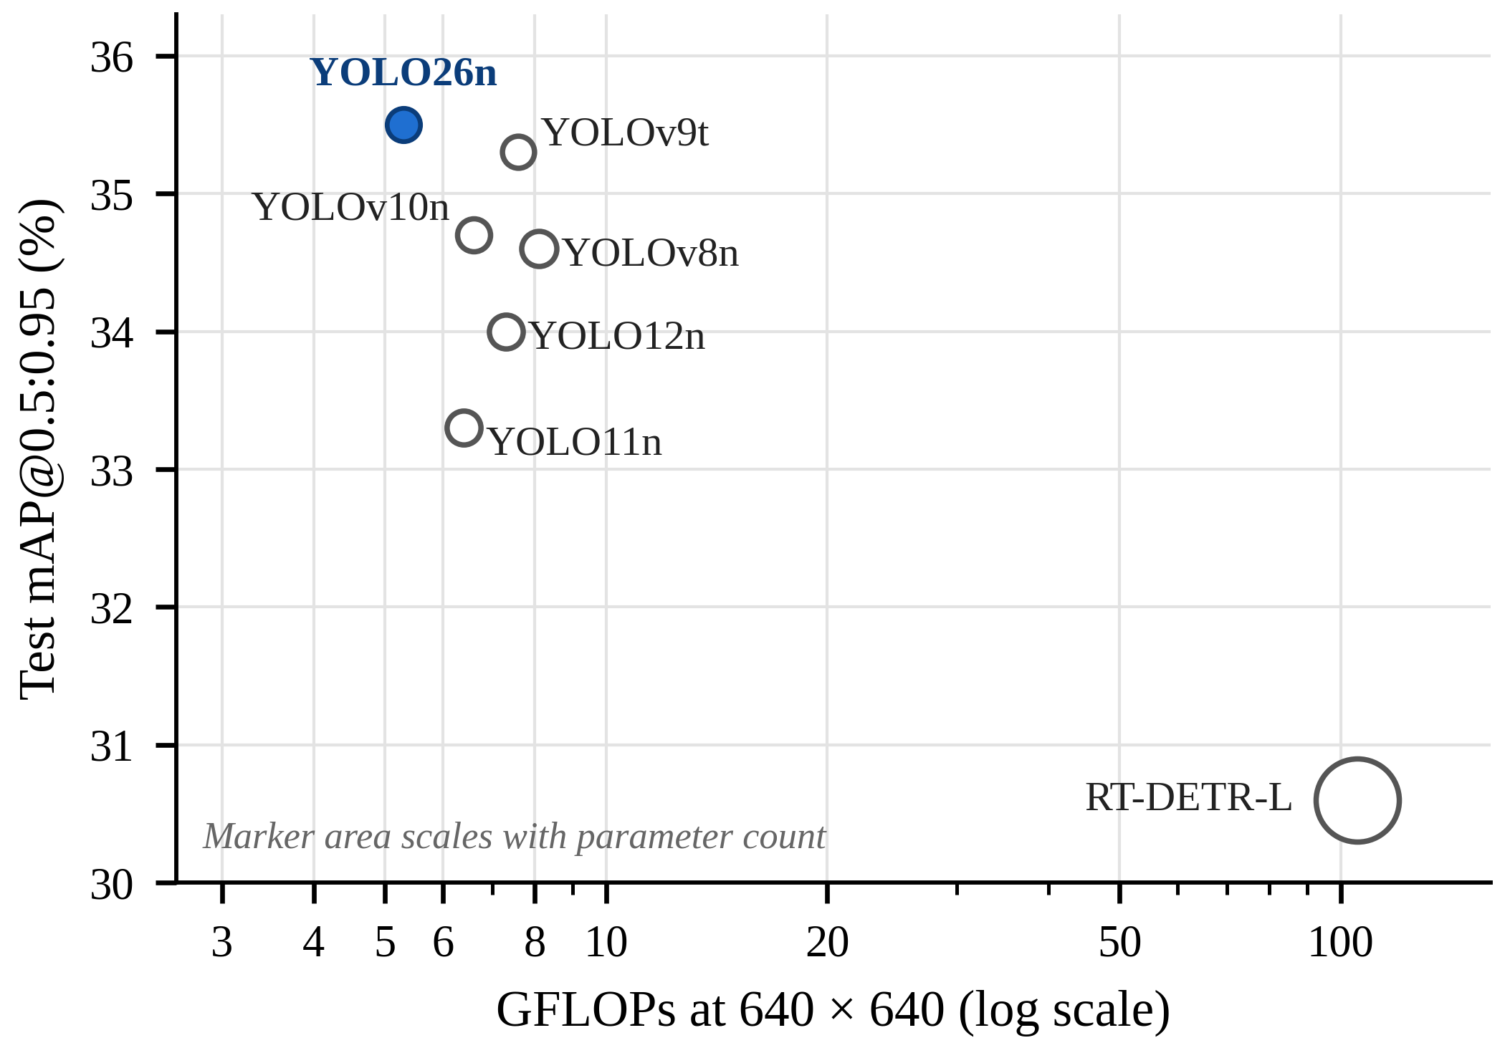
Fig. 2. Test mAP@0.5:0.95 vs. GFLOPs (log scale so RT-DETR-L fits). Marker size shows parameter count. YOLO26n is top-left: highest accuracy at the lowest compute.
A. Overall Accuracy
YOLO26n comes out on top on every overall metric: 82.3% precision, 68.1% recall, 74.8% mAP@0.5 and 35.5% mAP@0.5:0.95. Against YOLO11n, the direct predecessor and the fairest reference, that is 3.5 points more precision, 3.2 more recall, 0.9 more mAP@0.5 and 2.2 more mAP@0.5:0.95. The precision gain is the largest of the four and deserves a second look, because YOLO26 manages it without a suppression pass. Its one-to-one head is putting out fewer duplicate and spurious boxes than the NMS-based heads it is measured against, not just the same number of them.
The five earlier YOLO generations are hard to separate. Their mAP@0.5 runs from 71.4% to 73.9% and their mAP@0.5:0.95 from 33.3% to 35.3%, and the order is not even stable between the two metrics: YOLO11n has the second-best mAP@0.5 and the worst mAP@0.5:0.95 of the six YOLO models, while YOLOv9t has the worst mAP@0.5 and the second-best mAP@0.5:0.95. Three generations of backbone and head redesign between YOLOv8 and YOLO12 shift the aggregate numbers by less than the gap between the two metrics for any single model. YOLO26n is the first of the family to stand clear of that band on both metrics at once, and it does so at the lowest compute in the set.
B. Per-Class Behaviour
Fig. 3 and Table V show something the aggregate numbers hide completely. All six YOLO models do well on speed bumps, with AP@0.5 from 87.2% to 93.5%. YOLO26n is best on this class at both thresholds (93.5% AP@0.5, 46.9% AP@0.5:0.95), and on the strict metric it is 4.5 points ahead of YOLO11n. This is the largest single gap we measured, and it is on the class with small, low-profile targets, which is what STAL is meant to help. Potholes are different. Pothole AP@0.5 stays between 55.3% and 56.9% for all six YOLO models, within noise, and AP@0.5:0.95 between 22.6% and 24.6%. None of the architecture changes from YOLOv8 to YOLO26 made a difference on potholes.
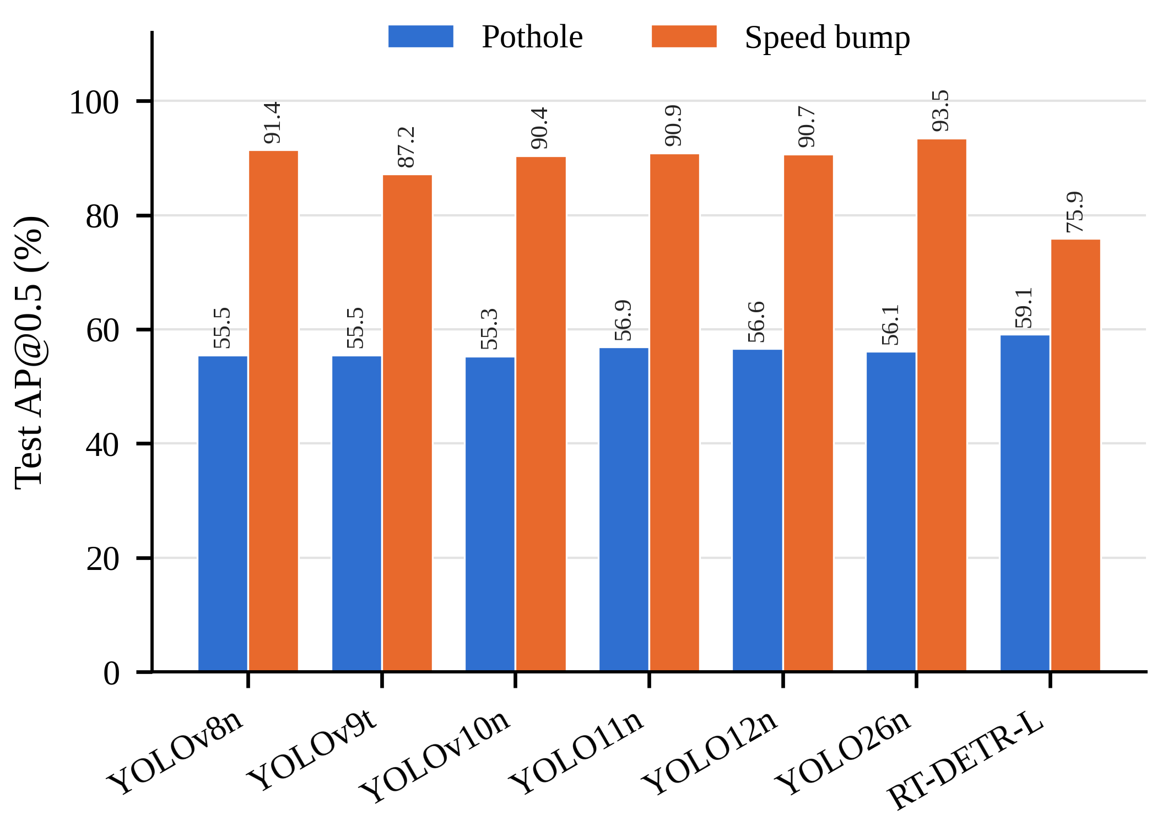
Fig. 3. Per-class AP@0.5 on the test split. Every detector finds speed bumps far more reliably than potholes. The pothole class barely moves across seven architectures; the speed bump class is where the models separate.
We think there are two reasons. Potholes in this dataset are small and crowded, 386 of them in 140 test images, often overlapping and with irregular edges a rectangle fits badly. At IoU 0.7, a box that covers the hole but not its exact edge counts as a miss. A speed bump is usually one per image, wide, with straight edges a box fits well. So the low pothole scores partly reflect how potholes are annotated, not only the detectors. Segmentation masks or a looser IoU threshold for potholes would be worth trying (Section VII).
RT-DETR-L is the one model that turns the pattern round. It has the best pothole AP@0.5 in the study at 59.1%, 2.2 points ahead of the best YOLO, and by some distance the worst speed bump AP@0.5 at 75.9%. Its pothole recall of 57.0% is also the highest of any model. Global attention seems to help in the cluttered pothole scenes and to hurt on the wide, sparse speed bump, where the query-based decoder keeps producing several overlapping boxes for one target, as Fig. 5 shows.
C. Compute and Latency
YOLO26n is the cheapest model in the set at 5.3 GFLOPs, 17% under YOLO11n and 35% under YOLOv8n, with 2.38 M fused parameters and a 5.1 MB half-precision checkpoint. Only YOLOv9t has fewer parameters, at 1.97 M, and it gets there with a deep, narrow architecture that costs more FLOPs and, in the measurement reported here, the slowest end-to-end time of the YOLO group. Fig. 2 makes the trade-off plain: YOLO26n alone in the top-left corner, RT-DETR-L alone in the bottom right, the other five bunched in the middle.
The latency column has to be read with the caveat from Section V-A in mind. The six YOLO models fall between 32.5 and 39.6 ms per image on the T4, a 7 ms spread that is smaller than the framework overhead of the pipeline being timed, and their order does not follow GFLOPs: YOLO26n at 5.3 GFLOPs records 34.1 ms, YOLOv10n at 6.6 GFLOPs records 32.5 ms. What these numbers do show is that every YOLO model in the set holds roughly 25 to 31 frames per second through an unoptimised Python pipeline on a shared cloud GPU, and that RT-DETR-L at 81.8 ms does not. What they do not show is a latency advantage for the NMS-free models, because the post-processing stage is simply not resolvable at this granularity. That hypothesis stays open and needs the decomposed measurement on CPU-class hardware the original protocol asked for.
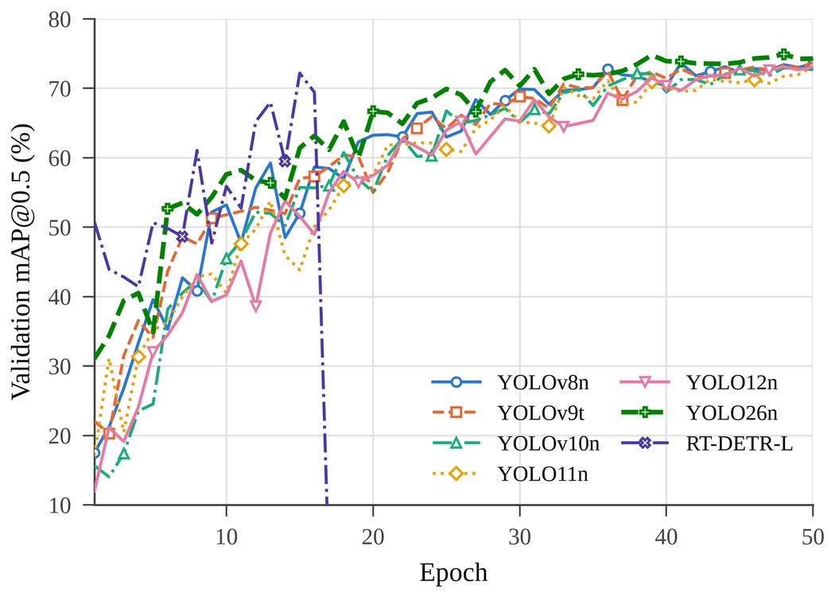
Fig. 4. Validation mAP@0.5 per epoch. YOLO26n leads from the first epoch and is still improving at epoch 50; RT-DETR-L rises fastest, diverges at epoch 17 (all metrics fall to zero and remain there), and is stopped at epoch 30 by the patience rule. The RT-DETR-L checkpoint evaluated is from epoch 15.
D. RT-DETR-L as a Capacity Reference
If more capacity were the answer, RT-DETR-L would show it, and it does not. With thirteen times the parameters and twenty times the FLOPs of YOLO26n it finishes last on every overall metric, 7.3 points behind on mAP@0.5 and 4.9 behind on mAP@0.5:0.95. How it trained is telling too. It reached 72.2% validation mAP@0.5 at epoch 15, faster than any YOLO model, and then diverged: at epoch 17 the training loss went to NaN under mixed precision, every validation metric dropped to zero and stayed there, and the patience rule closed the run at epoch 30. The checkpoint evaluated is from epoch 15, before the divergence. Validation losses had already gone NaN on and off from epoch 14, so the instability was building before it turned fatal. None of the six YOLO runs did anything of the kind under the identical optimiser and precision settings. A lower learning rate or full-precision training would very likely have kept the run alive, and the comparison would be fairer to RT-DETR with that fix in place; but the fact that the transformer needed it and the YOLO models did not is part of the result. With 2,560 training images the model has more capacity than the data can pin down, and the smaller batch it required makes matters worse. None of this says RT-DETR cannot work on road anomalies. It says that on a dataset this size, under a protocol tuned for nothing in particular, it is the fragile choice, and that the case for nano-scale YOLO here rests on more than the compute budget.
E. Training Dynamics
Fig. 4 adds two things. YOLO26n leads the validation curve from the very first epoch, 31.1% mAP@0.5 against 12.0% to 22.1% for the other YOLO models, and keeps the lead for most of the run. Whether that comes from the pretrained checkpoint, the label assignment or the progressive loss balance cannot be separated here, but it fits the picture of STAL handing small targets gradient from the start rather than after the easy targets are learned. The other point is less comfortable. Every YOLO model picked its best checkpoint at epoch 48, 49 or 50; none of them had converged. The 50-epoch schedule was set by the GPU hours available and is well short of the 150 to 300 epochs common in the literature, so the absolute numbers in Table IV are conservative for all six YOLO models. There is no reason to expect a longer schedule to reorder them, since the curves run more or less parallel from epoch 30 onward, but it should be said rather than assumed.
F. Error Taxonomy
We looked through the validation and test predictions and kept seeing the same few failure types.
Crosswalk confusion:
Zebra-painted bumps and flat pedestrian crossings both look like light and dark stripes across the road. The only real difference is the raised profile, and from a single camera that shows up only as slight shading at the ramp edges and a change in stripe spacing with distance. Crosswalks were a frequent source of false positives in the predictions we inspected, as Aishwarya et al. also found on Indian roads [5].
Shadow bands:
Tree and wall shadows across the road look like dark bands with soft edges, and so does an unpainted bump. The bump usually has sharper edges, and its shading changes as the vehicle gets closer, while a shadow’s does not.
Distance-dependent recall collapse:
Recall does not fall off slowly with distance; it drops quickly past a certain point. Fig. 5(a) is close to that point: three of the four models shown detect the distant bump at low confidence and one misses it. This is the small-object case STAL and the P2 branch target, and probably where YOLO26n gets its speed bump advantage in Table V. Reporting the distance at which recall falls to 50% would be more useful, since it maps directly to reaction time, but the dataset has no distance labels.
Pothole boundary ambiguity:
A cluster of adjoining potholes can be labelled as one region or as several, and a detector trained on one convention is penalised on the other. Together with the ragged outlines discussed in Section VI-B, this is the main reason the pothole class scores so low at AP@0.5:0.95, and it belongs to the task formulation rather than to any particular model.
Duplicate boxes from the transformer:
RT-DETR-L regularly lays two or three overlapping boxes on a single wide speed bump, each at moderate confidence. A YOLO model with NMS would merge them; a set-prediction decoder is supposed not to need to, and here it does. This is what lies behind its 75.9% speed bump AP@0.5.
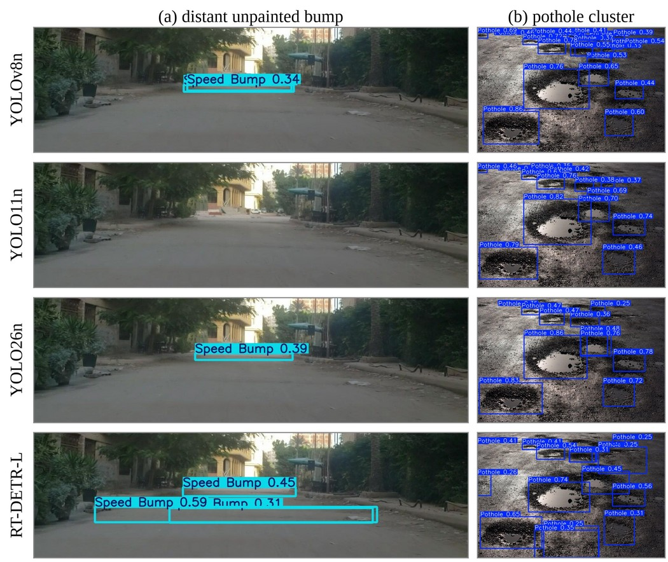
Fig. 5. Test-split detections at confidence 0.25 for four of the seven models, one model per row. Column (a) is a distant unpainted bump on an unmarked carriageway, cropped to the road for legibility: YOLOv8n and YOLO26n find it at 0.34 and 0.39 confidence, YOLO11n misses it, and RT-DETR-L returns three overlapping boxes for the one target. Column (b) is a cluster of potholes: all four find the large holes and disagree on the small satellite ones.
Low-light degradation:
Night performance is expected to fall well below daylight performance. Li et al. observed a substantial gap on the same class and closed part of it with attention modules [12], which suggests a plausible direction if the measured degradation proves severe.
G. Hypotheses Revisited
Two expectations were worth testing, both drawn from what the YOLO26 release notes claim. The first, that the NMS-free head should show a post-processing latency advantage over the NMS-based models on CPU-class hardware, is neither confirmed nor refuted here: the measurement was taken on a GPU through a pipeline whose overhead swamps the post-processing stage, and it is the one question this evaluation leaves entirely open. The second, that small-target-aware assignment should lift recall on small targets relative to YOLO11n at comparable parameter count, holds up. YOLO26n has the highest overall recall of the seven models and its clearest margin over YOLO11n is on the speed bump class, where the small, low-profile targets are. It does not hold on the pothole class, where nothing separates the YOLO generations at all, so the mechanism is evidently sensitive to what kind of small object is in front of it.
H. Threats to Validity
Every model was trained once, with one seed. The two evaluation splits give a rough feel for the noise: YOLO26n scores 74.9% mAP@0.5 on validation and 74.8% on test, YOLO11n 73.2% and 73.9%, so differences under about a point should not be read as real. By that yardstick YOLO26n’s lead on mAP@0.5:0.95, precision, recall and speed bump AP is outside the noise, and its 0.9-point lead on mAP@0.5 is at the edge of it. The test split holds only 71 speed bump instances, which makes the class-level speed bump numbers coarse. The 50-epoch schedule left the YOLO models unconverged, as Section VI-E notes, and latency was measured on a cloud GPU rather than an embedded target. The dataset is a single public collection whose geographic coverage, capture conditions and annotation quality are not documented by its publisher, so the results characterise these detectors on this benchmark and should not be read as characterising them on Indian roads specifically; establishing that would require a locally captured, condition-stratified test set. None of this undermines the ordering reported above, which was produced under one fixed protocol; all of it limits how far that ordering should be pushed.
VII. Conclusion and Future Work
This paper evaluated seven released real-time detectors on speed bump and pothole detection under a single controlled protocol: the same public 3,243-image two-class dataset, the same 640-pixel input, the same 50-epoch schedule, the same auto-selected AdamW optimiser, the same seed and the same GPU. Nothing in any model was modified. The survey of twenty-six studies showed that speed bump work has kept proposing single modified architectures without family-level comparison, that the comparative studies which do exist are pothole studies and stop at YOLOv12, and that edge latency is almost never reported across a full comparison set. This evaluation closes the first two gaps and makes a start on the third.
The recommendation is straightforward. For a speed bump and pothole detector at nano scale, YOLO26n is the model to start from: it ranked first on every overall metric while needing fewer FLOPs than anything else in the table, and its margin over YOLO11n was widest exactly where the small-target label assignment predicts, on the strict-IoU speed bump metric. The generations in between were hard to tell apart, so on this data the choice among YOLOv8 through YOLO12 comes down to export tooling and deployment convenience rather than accuracy. Scaling up is not the answer: RT-DETR-L, with an order of magnitude more capacity, trained less stably and ranked last, which places the ceiling on this task in the data and the labelling rather than in the detector. Underneath all of it, potholes stayed roughly 35 points of AP@0.5 behind speed bumps for every model tested, and closing that gap matters more than any further choice among these architectures.
Several things remain to be measured. A P2 configuration belongs in the same table, since it is the one published modification aimed directly at distant bumps. Latency has to be measured on an embedded target and decomposed into preprocessing, inference and post-processing, so that the NMS-free claim can be tested rather than assumed. The schedule should run until the validation curves flatten. And the pothole class needs either a segmentation formulation or a matching rule that respects its irregular geometry, because the box-based strict metric currently measures annotation convention as much as detector quality.
Further out, and beyond what a comparison of released detectors can address, monocular distance estimation would turn a presence signal into the time-to-contact estimate that suspension preview control actually needs, without the stereo hardware used in [7] and [26]. Temporal consistency across consecutive frames should suppress a good share of the shadow and crosswalk false positives, since a real bump persists and grows in the image while a shadow does not behave that way under ego-motion. And INT8 quantisation, with the accuracy cost it carries, deserves a measurement of its own, given that the DFL-free head is specifically claimed to quantise more cleanly.
The broader point is a small one but worth stating. The problem is not that speed bumps are difficult to detect in principle. It is that the bumps which most need detecting, unpainted, unlit, and photographed from far enough away to be useful, are exactly the ones that current detectors handle worst. Progress on this task is progress on small, low-contrast objects under a hard compute budget, and that is a considerably more general problem than road furniture.
Acknowledgment
The authors thank Dr. P. Shanmugaraja of the Department of Information Technology, Sona College of Technology, for his guidance throughout this project, and the department for providing the computing facilities used in this work.
References
[1] Liang, Chuanqi, Jie Yuan, Linlin Gou, Lei Luo, Jie Fu, and Miao Yu. "SBP-YOLO: a lightweight real-time model for detecting speed bumps and potholes toward intelligent vehicle suspension systems." Journal of Real-Time Image Processing 23, no. 1 (2026): 52. [GitHub repository. https://github.com/chuanqi1997/SBP-YOLO.]
[2] Jocher, Glenn, Jing Qiu, Mengyu Liu, Shuai Lyu, Fatih Cagatay Akyon, and Muhammet Esat Kalfaoglu. "Ultralytics YOLO26: unified real-time end-to-end vision models." arXiv preprint arXiv:2606.03748 (2026).
[3] Xiang, Xinjian, Xizhao Chen, Xiaohui Tang, Qiuxia Luo, and Yi Ding. "Research on detection of multiple types of speed bump defects based on CRSCCG-YOLOv5s." IEEE Access 12 (2024): 116786-116800.
[4] Aishwarya, Palli Venkata, D. Santhosh Reddy, Dinesh Kumar Sonkar, Poluri Nikhil Koundinya, and P. Rajalakshmi. "Robust deep learning based speed bump detection for autonomous vehicles in Indian scenarios." In 2023 IEEE 26th International Symposium on Real-Time Distributed Computing (ISORC), pp. 201-206. IEEE, 2023.
[5] Mao, Ruichi, Jian Wu, Yukai Wu, Huiliang Wang, Jun Li, and Guangqiang Wu. "SBD-YOLO: An Efficient Speed Bump Detector for Active Suspension Preview Control." SAE International Journal of Connected and Automated Vehicles 9, no. 3 (2026).
[6] Vasisht, Aadithya, Aditya Shenoy, Varma K. Anuraag, Ayush M. Gowda, Prasad B. Honnavalli, and Roopa Ravish. "Real-Time Detection of Speed Breakers and Rumblers Using Advanced Deep Learning Algorithms." In 2026 22nd IEEE International Colloquium on Signal Processing & Its Applications (CSPA), pp. 57-62. IEEE, 2026.
[7] Wang, Ruochen, Xiaoguo Luo, Qing Ye, Yu Jiang, and Wei Liu. "Research on visual perception of speed bumps for intelligent connected vehicles based on lightweight FPNet." Sensors 24, no. 7 (2024): 2130.
[8] Hussein, Abrar Ahmed, Mariam Mohamed Omar, Jawaher Suliman Altamimi, and Waleed M. Ead. "An intelligent approach for speed bump detection." In 2024 IEEE 3rd International Conference on Computing and Machine Intelligence (ICMI), pp. 1-6. IEEE, 2024.
[9] Magdy, Ahmed, Shrouk Abdelfattah, Samia Mohamed, Mohamed Khaled, Mohamed Mahmoud, Mohamed Ashraf, and Ahmed H. Eldeib. "Lane and bump detection based on computer vision and deep learning methods." In International Conference on Advanced Intelligent Systems and Informatics, pp. 31-42. Cham: Springer Nature Switzerland, 2023.
[10] Dewangan, Deepak Kumar, and Satya Prakash Sahu. "Deep learning-based speed bump detection model for intelligent vehicle system using raspberry Pi." IEEE sensors journal 21, no. 3 (2020): 3570-3578.
[11] Li, Ziwen, Rong Ma, Zuxiang Lin, and Pengpeng Liu. "Research on low-light speed bump detection algorithm based on improved YOLOv8n." Proceedings of the Institution of Mechanical Engineers, Part D: Journal of Automobile Engineering (2026): 09544070251408869.
[12] Park, Sung-Sik, Van-Than Tran, and Dong-Eun Lee. "Application of various yolo models for computer vision-based real-time pothole detection." Applied Sciences 11, no. 23 (2021): 11229.
[13] Aquib, Mohd, Mohammed Faisal Hussain, Eliganti RamaLakshmi, and Dr T. Prathima. "YOLO Models for Accurate Pothole Detection: A Comparative Study." In Journal of Physics: Conference Series, vol. 3191, no. 1, p. 012002. IOP Publishing, 2026.
[14] Asad, Muhammad Haroon, Saran Khaliq, Muhammad Haroon Yousaf, Muhammad Obaid Ullah, and Afaq Ahmad. "Pothole detection using deep learning: A real‐time and AI‐on‐the‐edge perspective." Advances in Civil Engineering 2022, no. 1 (2022): 9221211.
[15] KC, Sriharipriya. "Enhanced pothole detection system using YOLOX algorithm." Autonomous Intelligent Systems 2, no. 1 (2022): 22.
[16] Wang, Danyu, Zhen Liu, Xingyu Gu, Wenxiu Wu, Yihan Chen, and Lutai Wang. "Automatic detection of pothole distress in asphalt pavement using improved convolutional neural networks." Remote Sensing 14, no. 16 (2022): 3892.
[17] Jakubec, Maroš, Eva Lieskovska, Boris Bučko, and Katarína Zábovská. "Comparison of CNN-based models for pothole detection in real-world adverse conditions: Overview and evaluation." Applied Sciences 13, no. 9 (2023): 5810.
[18] Dharneeshkar, J., S. A. Aniruthan, and R. Karthika. "Deep Learning based Detection of potholes in Indian roads using YOLO." In 2020 international conference on inventive computation technologies (ICICT), pp. 381-385. IEEE, 2020.
[19] Kothari, Gautam, and Amit Kumar. "Enhancing Pothole Detection: A Deep Learning-Based Investigation comparing YOLO Variants with Validation on multi-weather pothole images." In 2025 2nd Global AI Summit-International Conference on Artificial Intelligence and Emerging Technology (AI Summit), pp. 986-991. IEEE, 2025.
[20] Tamagusko, Tiago, and Adelino Ferreira. "Optimizing pothole detection in pavements: a comparative analysis of deep learning models." Engineering Proceedings 36, no. 1 (2023): 11.
[21] Bhavana, N., Mallikarjun M. Kodabagi, B. Muthu Kumar, P. Ajay, N. Muthukumaran, and A. Ahilan. "POT-YOLO: Real-time road potholes detection using edge segmentation-based YOLO V8 network." IEEE Sensors Journal 24, no. 15 (2024): 24802-24809.
[22] Gupta, Ankita, P. Abirami, Om Prakash Bharthuar, Mukul Malviya, and Shripad Deshpande. "Towards Safer Roads: A Review of Hybrid Machine Learning and Vision-Based Approaches for Speed Bump Detection in Intelligent Transportation Systems." International Journal of Safety & Security Engineering 15, no. 6 (2025): 1293.
[23] Safyari, Yashar, Masoud Mahdianpari, and Hodjat Shiri. "A review of vision-based pothole detection methods using computer vision and machine learning." Sensors 24, no. 17 (2024): 5652.
[24] Pham, Vung, Lan Dong Thi Ngoc, and Duy-Linh Bui. "Optimizing YOLO architectures for optimal road damage detection and classification: A comparative study from YOLOv7 to YOLOv10." In 2024 IEEE International Conference on Big Data (BigData), pp. 8460-8468. IEEE, 2024.
[25] Varma, V. S. K. P., S. Adarsh, K. I. Ramachandran, and Binoy B. Nair. "Real time detection of speed hump/bump and distance estimation with deep learning using GPU and ZED stereo camera." Procedia computer science 143 (2018): 988-997.
[26] Kyriakou, Charalambos, Symeon E. Christodoulou, and Loukas Dimitriou. "Do vehicles sense, detect and locate speed bumps?." Transportation research procedia 52 (2021): 203-210.

