 | LIGHTWEIGHT REAL-TIME DETECTION OF SPEED BUMPS AND POTHOLES | 
A Project Report
U23ADS705 – MINI PROJECT
Submitted by

BENADICT INFANT A | (61782323110022)
ELANGOVAN S | (61782323110035)
in partial fulfillment for the award of the degree
of
BACHELOR OF TECHNOLOGY
in
ARTIFICIAL INTELLIGENCE AND DATA SCIENCESONA COLLEGE OF TECHNOLOGY (AUTONOMOUS), SALEM – 636005
ANNA UNIVERSITY: CHENNAI 600 025
OCTOBER 2026
SONA COLLEGE OF TECHNOLOGY (AUTONOMOUS)
ANNA UNIVERSITY: CHENNAI – 600 025
BONAFIDE CERTIFICATE
Certified that this project titled “GV-YOLO26: LIGHTWEIGHT REAL-TIME DETECTION OF SPEED BUMPS AND POTHOLES” is the bonafide work of “BENADICT INFANT A (61782323110022), ELANGOVAN S (61782323110035)” who carried out the project work U23ADS705 – MINI PROJECT under my supervision.

Signature of the Supervisor | Head of the Department
Dr. P. SHANMUGARAJA | Dr. J. AKILANDESWARI
SUPERVISOR | HEAD OF THE DEPARTMENT
Assistant Professor, | Department of Information Technology,
Department of Information Technology, | Sona College of Technology,
Sona College of Technology, | Salem – 636005.
Salem – 636005.

Submitted for the Project Viva-Voce Examination held on ____________________

INTERNAL EXAMINER | EXTERNAL EXAMINER
Sona College of Technology
Department of Information Technology
U23ADS705 – MINI PROJECT – DECLARATION FORM
Declaration by the Student(s)
We hereby declare that the project titled “GV-YOLO26: Lightweight Real-Time Detection of Speed Bumps and Potholes” is an original work carried out by us under the guidance of Dr. P. Shanmugaraja. This project has not been submitted elsewhere for the award of any degree.
We also affirm that all the data and information used in this project are genuine and properly acknowledged. This project work is carried out with reference to the United Nations Sustainable Development Goals Goal 3 – Good Health and Well-being, Goal 9 – Industry, Innovation and Infrastructure, and Goal 11 – Sustainable Cities and Communities.
S.No | Register Number | Name | Signature
1. | 61782323110022 | BENADICT INFANT A
2. | 61782323110035 | ELANGOVAN S

Date: ____________________
Place: Sona College of Technology
ACKNOWLEDGMENT
We would like to place on record our sincere thanks to the Management of Sona College of Technology, Salem, for providing the facilities and the academic environment in which this project was carried out.
We are grateful to our Principal for the encouragement given to students to take up project work that goes beyond the classroom.
We thank Dr. J. Akilandeswari, Head of the Department of Information Technology, for supporting this work and for making the department’s resources available to us whenever we needed them.
We express our deep gratitude to our project guide, Dr. P. Shanmugaraja, Assistant Professor, Department of Information Technology, for his guidance at every stage of this project. His questions about what each part of the model actually contributes pushed us to look past the headline numbers, and that shaped the final form of this work.
We also thank the project coordinators and all the faculty members of the department for their review comments, which helped us sharpen both the experiments and this report.
We also acknowledge the open-source Ultralytics framework and the contributors of the public Humps/Bumps and Potholes dataset, on which the models in this project were built and evaluated.
Finally, we thank our parents and friends for their patience and support throughout the project.

BENADICT INFANT A
ELANGOVAN S
ABSTRACT
Speed bumps and potholes are the road anomalies that most often force a vehicle to slow down or swerve. On Indian roads many speed bumps are unpainted and poorly marked, so a driver often gets no visual warning until the suspension takes the impact. A camera that detects these anomalies early could warn the driver or let an active suspension prepare in advance, but only if the detector is accurate on small, distant targets and fast enough to run on an embedded board.
This project proposes GV-YOLO26, a lightweight real-time detector for speed bumps and potholes built on YOLO26n, the newest end-to-end member of the YOLO family. We redesigned its backbone and neck around cheap convolutions: GhostConv layers replace the costly downsampling convolutions of the deeper stages, and VoVGSCSPC blocks built from GSConv replace the C3k2 feature blocks. A high-resolution P2 detection level is added for small, distant targets, and a Lightweight Grouped Detection Head (LGDH) with shared grouped convolutions keeps the extra level affordable while retaining the NMS-free one-to-one prediction of YOLO26. In its deployed form GV-YOLO26 has 1.57 million parameters and needs 5.1 GFLOPs, 34% fewer parameters and slightly less computation than YOLO26n (2.38 million, 5.3 GFLOPs), even though it predicts on an extra 160 × 160 grid. Training combines small-target-aware label assignment with a Normalized Wasserstein Distance (NWD) box loss, weather augmentation and knowledge distillation from a larger GV-YOLO26 teacher, and the final model is exported to TensorRT for embedded inference.
To choose the base model on evidence, we first trained seven stock detectors, from YOLOv8n to YOLO26n and RT-DETR-L, under one fixed protocol on a public 3,243-image speed bump and pothole dataset. YOLO26n was the most accurate at 74.8% mAP@0.5 and the cheapest at 5.3 GFLOPs, while the YOLO generations from YOLOv8n to YOLO12n ended within 2.5 points of each other. This narrow spread shows that a newer general-purpose model alone adds little on this task, and it motivates a design aimed at the problem itself. GV-YOLO26 is then evaluated stage by stage against YOLO26n on the same dataset through an ablation study, a distillation experiment and embedded deployment.
Keywords: GV-YOLO26, YOLO26, speed bump detection, pothole detection, small object detection, GhostConv, VoVGSCSPC, lightweight detector, TensorRT, suspension preview control.
TABLE OF CONTENTS
TITLE PAGE NO.
ACKNOWLEDGMENT v
ABSTRACT vi
LIST OF FIGURES x
LIST OF TABLES xi
LIST OF ABBREVIATIONS xii
1. INTRODUCTION 1
1.1 Background of the Project 1
1.2 Problem Statement 2
1.3 Motivation 2
1.4 Objectives 3
1.5 Scope of the Project 3
2. LITERATURE REVIEW 4
2.1 Introduction 4
2.2 Review of Related Studies 4
2.3 Techniques and Technologies Used in Existing Systems 8
2.4 Research Gap 10
2.5 Summary 10
3. CHAPTER 1 – NEED FOR PROPOSED TECHNIQUE 11
3.1 Existing Techniques 11
3.2 Limitations of Existing Techniques 12
3.3 Proposed Technique 12
3.4 Objectives of the Proposed Technique 13
3.5 Advantages of the Proposed Technique 14
4. CHAPTER 2 – DESIGN OF PROPOSED SYSTEM AND ITS IMPLEMENTATION 15
4.1 Introduction 15
4.2 System Requirements 15
4.2.1 Hardware Requirements 15
4.2.2 Software Requirements 16
4.3 System Architecture 16
4.4 System Components/Modules 18
4.4.1 Data Acquisition and Augmentation Module 18
4.4.2 Lightweight Backbone and Neck Module 19
4.4.3 Small-Object Detection Head Module 19
4.4.4 Training and Distillation Module 19
4.4.5 Deployment and Inference Module 19
4.4.6 Baseline Benchmarking Module 19
4.5 Proposed Methodology 20
4.6 System Workflow 20
4.7 Algorithms/Techniques Used 21
4.8 Dataset/Data Collection 25
4.9 Data Preprocessing 26
4.10 Model/System Development 26
4.11 System Design Diagrams 28
4.12 Implementation 29
4.13 Coding/Program Implementation 30
4.14 User Interface / Application Screens 36
4.15 Chapter Summary 36
5. CHAPTER 3 – RESULTS AND DISCUSSION 38
5.1 Introduction 38
5.2 Experimental Setup 38
5.3 Evaluation Metrics 38
5.4 Experimental Results 39
5.4.1 Baseline Benchmark and Choice of Base Model 39
5.4.2 Ablation Study of GV-YOLO26 42
5.4.3 Effect of Knowledge Distillation 42
5.4.4 Embedded Deployment with TensorRT 43
5.4.5 Qualitative Detection Results 43
5.5 Comparison with Existing Techniques 43
5.6 Discussion of Results 44
5.7 Chapter Summary 45
6. CHAPTER 4 – CONCLUSION AND FUTURE SCOPE 47
6.1 Summary of the Project 47
6.2 Conclusion 48
6.3 Future Scope 49
SDG GOALS 50
PUBLICATIONS 52
REFERENCES 53
LIST OF FIGURES
FIGURE NO. TITLE PAGE NO.
Fig. 4.1 Overall system architecture 17
Fig. 4.2 Structure of the proposed GV-YOLO26 network 18
Fig. 4.3 Project workflow 21
Fig. 4.4 GhostConv and GSConv, the building blocks of the GV-YOLO26 backbone and neck 22
Fig. 4.5 A conventional decoupled head compared with the proposed LGDH 24
Fig. 4.6 Use case diagram 28
Fig. 4.7 Data flow diagram (level 1) 29
Fig. 4.8 GV-YOLO26 detections on a road image 36
Fig. 4.9 GV-YOLO26 detections on a frame from a dashcam clip 36
Fig. 5.1 Overall accuracy of the baseline detectors on the public test split 40
Fig. 5.2 Per-class AP@0.5 of the baseline detectors 41
Fig. 5.3 Baseline detections on two test images: (a) a distant unpainted bump, (b) a pothole cluster 41
LIST OF TABLES
TABLE NO. TITLE PAGE NO.
Table 2.1 Summary of representative prior work 7
Table 3.1 Comparison of existing techniques 12
Table 4.1 Hardware requirements 15
Table 4.2 Software requirements 16
Table 4.3 Feature pyramid levels for a 640 × 640 input 23
Table 4.4 Dataset used in this project 25
Table 4.5 GV-YOLO26 design stages and model configurations 27
Table 4.6 GV-YOLO26 training configuration 27
Table 4.7 Baseline training configuration (identical across models) 28
Table 5.1 Baseline accuracy and cost on the public test split 39
Table 5.2 Per-class accuracy of the baselines on the public test split (%) 40
Table 5.3 Ablation study of GV-YOLO26 on the public test split 42
Table 5.4 Effect of knowledge distillation 43
Table 5.5 TensorRT inference on NVIDIA Jetson AGX Xavier 43
Table 5.6 Comparison with existing techniques 44
Table 6.1 Achievement of project objectives 48
LIST OF ABBREVIATIONS
ABBREVIATION EXPANSION
ADAS Advanced Driver Assistance System
AMP Automatic Mixed Precision
AP Average Precision
BCKD Bridging Cross-task Knowledge Distillation
CNN Convolutional Neural Network
COCO Common Objects in Context (dataset)
CWD Channel-Wise Distillation
DFD Data Flow Diagram
DFL Distribution Focal Loss
FN / FP / TP False Negative / False Positive / True Positive
FP16 / FP32 16-bit / 32-bit floating point
FPS Frames Per Second
GFLOPs Giga Floating-Point Operations
GPU Graphics Processing Unit
GSConv Group-Shuffle Convolution
GV-YOLO26 Ghost–VoVGSCSPC YOLO26 (the proposed model)
INT8 8-bit integer precision
IoU Intersection over Union
ITS Intelligent Transportation Systems
KD Knowledge Distillation
LGDH Lightweight Grouped Detection Head
mAP mean Average Precision
MuSGD Hybrid Muon and SGD optimiser
NMS Non-Maximum Suppression
NWD Normalized Gaussian Wasserstein Distance
P2–P5 Feature pyramid levels at strides 4 to 32
ProgLoss Progressive Loss Balancing
RT-DETR Real-Time Detection Transformer
SBP-YOLO Speed Bump and Pothole YOLO
SDG Sustainable Development Goal
STAL Small-Target-Aware Label Assignment
VoVGSCSPC VoV-style GSConv Cross-Stage Partial block
YOLO You Only Look Once
1. INTRODUCTION
1.1 Background of the Project
Road surfaces carry two kinds of anomalies that matter to a moving vehicle. Some are defects, such as potholes and cracks, which appear as the pavement wears out. Others are built on purpose, such as speed bumps and humps, which are placed near schools, hospitals, junctions and residential streets to force traffic to slow down. Both share the same problem for a driver: if they are not seen in time, the vehicle hits them at the wrong speed.
On Indian roads, speed bumps are among the least standardised features a driver meets. A large share are unpainted, many do not follow the height and profile that the Indian Roads Congress specifies, and a single stretch of road can carry several of them with no signboard at all. At night, in rain, or behind a larger vehicle, an unmarked bump is practically invisible until the suspension finds it. For two-wheelers, which carry most of the road users in Tamil Nadu, meeting one at speed can mean anything from discomfort to a loss of control [1], [39].
Early detection systems used accelerometers and gyroscopes to sense the jolt as a vehicle crossed a bump [7]. Later systems used cameras, first with hand-crafted image processing [8] and then with deep learning [10], [42]. A camera can see a bump before the vehicle reaches it, and this matters for more than driver warnings. Modern vehicles with semi-active or active suspension can adjust their damping in advance of an uneven surface, an idea called suspension preview control [35]. For that to work, the vehicle needs to know where the next bump or pothole is, early and reliably.
This project proposes GV-YOLO26, a lightweight detector designed for exactly this setting. It starts from YOLO26n, the newest end-to-end model in the YOLO family, and redesigns its backbone, neck, head and training so that small, distant road anomalies become easier to detect while the model stays small enough to run at high frame rates on an embedded board. The choice of YOLO26n as the base is itself grounded in a benchmark of seven stock detectors that we trained on a public dataset under a single protocol.
1.2 Problem Statement
A speed bump seen from a useful stopping distance is a thin, low-contrast band that may be only a dozen pixels tall in a 640-pixel frame. Potholes are similar: small, irregular and often clustered together. Standard detectors find most of their objects through feature maps that have been shrunk by a factor of 8 to 32, and at those scales a distant bump covers one feature cell or less. At the same time, a detector meant for a vehicle has to run on an embedded board in real time, which rules out simply making the model bigger.
The problem this project addresses is therefore how to detect speed bumps and potholes accurately at small scales while keeping the detector light enough for real-time embedded use, and how much a purpose-built lightweight design gains over the off-the-shelf detectors a developer would otherwise reach for.
1.3 Motivation
Unmarked bumps are a common sight on roads in and around Salem, as in most Indian towns, and most riders learn their positions only by repeatedly hitting them. A camera-based system would help in exactly the cases where a driver cannot see the hazard. Recent work has shown that a road anomaly detector can be aimed at a concrete use, suspension preview, and judged by its speed on real embedded hardware rather than by accuracy alone [23], [27]. We wanted to build such a detector ourselves on the newest available base model, and to see how far a carefully chosen set of lightweight and small-object techniques could take it.
A second motivation came from our own experiments with general-purpose detectors. When we trained several stock YOLO generations on a public speed bump and pothole dataset, the newer versions improved only slightly on the older ones. That raised a natural question: if moving from YOLOv8 to YOLO12 changes little, can a design built specifically for this task do better? The newest model in our benchmark, YOLO26n, was also the most accurate and the cheapest, which made it the natural starting point for answering that question.
1.4 Objectives
The specific objectives of the project are:
- To review existing speed bump and pothole detection methods, with attention to small-object detection and lightweight design.
- To select a base detector on evidence by training stock real-time detectors on a public speed bump and pothole dataset under one fixed protocol.
- To design GV-YOLO26 by rebuilding the YOLO26n backbone and neck with GhostConv and VoVGSCSPC blocks and adding a P2 detection level with a lightweight grouped detection head.
- To train GV-YOLO26 with an NWD-augmented box loss, weather augmentation and knowledge distillation, and to measure the contribution of each change through an ablation study.
- To export the model to TensorRT for embedded inference and to analyse its accuracy, model size and speed against the baselines and against earlier work.
1.5 Scope of the Project
The project covers the detection of two classes, speed bumps and potholes, in single road images using a monocular forward-facing camera. It includes the benchmarking of stock detectors, the design, training and evaluation of GV-YOLO26, its export for embedded inference, and an analysis of the results.
Some things are deliberately outside the scope. We did not build an in-vehicle device or connect the detector to a real suspension controller. Distance estimation and multi-frame tracking are also not part of this work. These items are listed as future work in Chapter 6.
2. LITERATURE REVIEW
2.1 Introduction
This chapter reviews earlier work on detecting speed bumps and potholes, and on the techniques that GV-YOLO26 builds on. The aim is to understand which sensing approaches have been tried, which detection models have been used, how results have been reported, and what is still missing. The review is organised by sensing method first and detection model second, then covers the lightweight and small-object techniques that matter for this project, and ends with the research gap.
Two broad surveys give a useful starting map of the field. Saffarini et al. [33] grouped road anomaly detection into accelerometer-based and vision-based techniques and covered potholes, cracks and speed bumps together. Assemlali et al. [4] carried out a systematic review of 95 computer vision studies on road obstacles published between 2015 and 2024, and found that most relied on image input and that only about a third used public datasets. Both surveys note that comparisons across studies are difficult because datasets and evaluation settings differ.
2.2 Review of Related Studies
Sensor-based detection. The earliest practical systems did not use cameras at all. When a vehicle crosses a bump, its accelerometer and gyroscope record a clear vertical spike. Celaya-Padilla et al. [7] extracted accelerometric features from such signals and used a genetic algorithm to select the features that best separate bump events from normal driving. The method works in near real time and can be used to build maps of bump locations. Its limitation is structural: detection only happens after contact, so it helps the next vehicle rather than the current one. Darwiche and El-Hajj-Chehade [8] combined image processing with signal processing so that bumps could be detected without special sensors or GPS, an early move towards vision.
Stereo vision and distance estimation. A second camera lets a system estimate how far away a bump is. Varma et al. [42] used a ZED stereo camera with GPU-based deep learning to detect both marked and unmarked humps and estimate their distance in real time. Peralta-López et al. [31] also used a ZED camera, designed a lightweight network for potholes, and built a database that separates potholes from speed bumps. Vasisht et al. [43] combined YOLOv8x with a ZED stereo camera and reported 93.1% mAP@50 at about 30 FPS on a laptop GPU. Distance is valuable for suspension control, but a stereo camera together with a discrete GPU is too costly for a simple retrofit device.
Monocular deep learning for speed bumps. Dewangan and Sahu [10] built a CNN-based speed bump system that runs on a Raspberry Pi and reported 98.54% accuracy. That figure is for image-level classification rather than box-level detection, so it cannot be compared with mAP. Magdy et al. [26] compared Faster R-CNN, VGG-16, MobileNet-SSD and two YOLOv3 variants for combined lane and bump detection, with YOLOv3 Lite-MobileNet best at 89.17%. Aishwarya et al. [1] focused on Indian roads. They compared Faster R-CNN with YOLOv5, treated marked and unmarked bumps separately and dealt with confusion between bumps and pedestrian crossings, at 18.5 ms per frame on a Jetson board.
Modified base detectors. A second group of studies modifies a base detector, which is also the approach taken in this project. Xiang et al. [49] built CRSCCG-YOLOv5s to detect several types of speed bump defect and reported 96.4% mAP with 8.8 million parameters. Wang et al. [47] added FasterNet and Dynamic Snake Convolution to a YOLOv5-based network for connected vehicles, giving up a little accuracy for a large gain in speed. Hussein et al. [14] collected road images in Egypt and deployed their detector on a Jetson Nano at 81% mAP. Li et al. [22] added SE and EMA attention to YOLOv8n and improved mAP@0.5 by 8.9 points in low light and rain. Mao et al. [27] proposed SBD-YOLO, based on YOLOv9 with an Aggregated-MBConv module that cuts computation by 82.8% for suspension preview control.
Lightweight small-object detectors. Liang et al. [23], [25] modified YOLOv11n for speed bumps and potholes by reducing its computation with cheap convolution blocks, adding a P2 detection branch for small objects with an efficient shared head to offset its cost, and training with the NWD loss, weather augmentation and knowledge distillation. On their 7,500-image dataset they reported 87.0% mAP@0.5 after distillation, against 81.2% for YOLOv11n, and 139.5 FPS on a Jetson AGX Xavier with TensorRT FP16 [24]. Studies of this kind show that small-object accuracy and a low computational budget can be pursued together, but they are built on YOLO generations that still rely on Non-Maximum Suppression and Distribution Focal Loss, both of which YOLO26 has since removed.
Studies on Indian roads. Only a few studies work with Indian road conditions directly. Dharneeshkar et al. [11] built a pothole dataset from Indian roads and trained YOLO models on it. Aishwarya et al. [1] reported that unpainted bumps and pedestrian crossings that look like painted bumps were the main sources of error. The Towards Safer Roads review [39] also uses an unmarked Indian speed bump as an example of a hazard that conventional mapping systems miss. These studies agree that unmarked bumps are the hardest and most important case.
Detection for suspension preview control. A growing part of this literature is aimed not at drivers but at the suspension itself. Shen et al. [35] describe the usual structure of a vision-based preview system: a camera module, an image processing module, a detection module, and a control module that adjusts damping before the wheel reaches the anomaly. They point out that the detection module has to finish within the time budget of the control loop, which is why frame rate on embedded hardware matters as much as accuracy. SBD-YOLO [27] and the detector of Liang et al. [23] were both designed for this module, on YOLOv9 and YOLOv11n respectively. Varma et al. [42] and Peralta-López et al. [31] approach the same application from the stereo side, adding distance to the detection.
Pothole detection and comparative studies. Pothole detection has been studied far more than speed bump detection. Park et al. [30] compared YOLOv4, YOLOv4-tiny and YOLOv5s and found the tiny model best once speed was taken into account. Mohan Prakash and Sriharipriya [28] tested YOLOX for potholes and found that the YOLOX-Nano model gave high accuracy at low computational cost. Wang et al. [48] improved a YOLOv3-based network with a ResNet backbone and tested robustness to adversarial inputs. Asad et al. [3] compared YOLOv1 to YOLOv5 and SSD-MobileNetV2 on OAK-D and Raspberry Pi hardware, one of the few studies to treat edge hardware as part of the experiment.
Jakubec et al. [15] compared YOLO and R-CNN models under rain, night and sunset conditions. Tamagusko et al. [37] compared YOLOv3, YOLOv4 and YOLOv5 on a fixed 665-image dataset. Bhavana et al. [5] added Sobel edge preprocessing to YOLOv8 and reported 99.1% accuracy. Khan et al. [17] applied YOLOv8 to pothole detection for autonomous vehicles and studied the effect of data augmentation. Aquib et al. [2] compared YOLOv5 to YOLOv8, Kothari et al. [19] compared YOLO11 and YOLO12 at three scales on real road photographs taken in different weather, and Pham et al. [32] compared YOLOv7 to YOLOv10 for general road damage. None of these comparative studies includes speed bumps.
Reviews of the area. Safyari et al. [34] reviewed vision-based pothole detection and concluded that hybrid methods combining image processing with machine learning gave the highest accuracy in the studies they examined. The Towards Safer Roads review [39] is the only review we found that focuses on speed bumps specifically, covering vision-based, sensor-based and hybrid approaches published between 2017 and 2024. Shen et al. [35] reviewed road surface perception for suspension preview control and stressed the need for information about bump height and pothole depth, not only position. Table 2.1 summarises the main studies discussed in this section.
Table 2.1 Summary of representative prior work
Ref. | Method | Target | Reported outcome
[7] | Accelerometer features + genetic algorithm | Speed bumps | Post-contact detection
[42] | ZED stereo camera + GPU | Humps, distance | Real-time with ranging
[10] | CNN on Raspberry Pi | Speed bumps | 98.54% classification accuracy
[26] | YOLOv3 Lite-MobileNet | Lanes and bumps | 89.17%
[1] | Faster R-CNN vs YOLOv5 | Indian speed bumps | 18.5 ms per frame (Jetson)
[49] | CRSCCG-YOLOv5s | Bump defects | 96.4% mAP, 8.8 M parameters
[47] | YOLOv5-FPNet | Speed bumps | Large FPS gain
[14] | YOLO on Jetson Nano | Speed bumps (Egypt) | 81% mAP
[22] | YOLOv8n + SE/EMA | Low-light speed bumps | +8.9 mAP@0.5
[27] | SBD-YOLO (YOLOv9) | Speed bumps | 82.8% less computation
[43] | YOLOv8x + stereo camera | Bumps and rumblers | 93.1% mAP@50, 30 FPS
[23] | SBP-YOLO (YOLOv11n) | Bumps and potholes | 87.0% mAP@0.5, 139.5 FPS
[30] | YOLOv4 / v4-tiny / v5s | Potholes | Tiny variant best
[3] | YOLOv1–v5, SSD | Potholes (edge) | OAK-D, Raspberry Pi
[15] | YOLO vs R-CNN | Potholes, weather | Condition-wise results
[19] | YOLO11 vs YOLO12 | Potholes | Multi-weather comparison
[5] | POT-YOLO (YOLOv8 + Sobel) | Potholes | 99.1% accuracy
Note: Metrics are as reported by the respective authors on their own datasets and hardware, and are not directly comparable across rows.
2.3 Techniques and Technologies Used in Existing Systems
One-stage detectors and the YOLO lineage. One-stage detectors such as SSD and YOLO predict boxes and classes in a single pass, which makes them the usual choice for real-time work on vehicles [1], [26]. YOLOv8 [16] introduced an anchor-free head and remains the most widely used baseline in road anomaly work. YOLOv9 [45] added programmable gradient information, YOLOv10 [44] trained a one-to-one head so that inference no longer needs Non-Maximum Suppression, and YOLO11 [18] refined the backbone and neck blocks. YOLO12 [38] replaced much of the convolutional backbone with area attention. YOLO26 [40], [41], the base of this project, removed Distribution Focal Loss, made inference end-to-end without Non-Maximum Suppression, and added progressive loss balancing (ProgLoss), small-target-aware label assignment (STAL) and the MuSGD optimiser. RT-DETR [51] brought transformer-based detection to real-time speeds.
Cheap convolutions. GhostNet [12] observed that many feature maps inside a CNN are near-copies of each other, and proposed generating part of them with cheap depthwise operations instead of full convolutions. The resulting GhostConv module produces the same number of output channels at roughly half the cost. GSConv, introduced in the slim-neck design of Li et al. [21], mixes a standard convolution with a depthwise convolution and then shuffles the channels, so that the cheap half still receives information from the dense half. VoVNet [20] showed that one-shot aggregation of intermediate features is more efficient on GPUs than repeated dense connections, and VoVGSCSPC combines that idea with GSConv.
Small-object techniques. Because a distant bump occupies very few pixels, detectors for this task add features designed for small objects. Adding a detection level at stride 4 (P2) gives the head a feature map with four times the area of the usual smallest level. Li et al. [22] instead add attention to recover faint targets in poor lighting. On the loss side, Wang et al. [46] proposed the Normalized Gaussian Wasserstein Distance (NWD), which models each box as a two-dimensional Gaussian and measures the distance between them. Unlike IoU, NWD changes smoothly when a small predicted box is shifted by a few pixels, so it gives a more useful training signal for tiny objects.
Knowledge distillation and augmentation. Knowledge distillation trains a small student network to imitate a larger teacher [13]. For dense detection, Channel-Wise Distillation (CWD) [36] aligns the channel activations of intermediate feature maps, and BCKD [50] handles the mismatch between classification and localisation outputs when distilling detector heads. Albumentations [6] is a widely used library for image augmentation, including synthetic rain, snow, blur and lighting changes.
How results are reported. The way results are reported varies a great deal across the field. Some studies report image classification accuracy [5], [10], some report mAP at an IoU threshold of 0.5, and only a few report the stricter mAP@0.5:0.95. Speeds are reported on Raspberry Pi boards, Jetson modules and laptop GPUs, with and without TensorRT optimisation [3], [23], [43]. Datasets differ too: many speed bump studies use private collections, while others use public datasets hosted on Roboflow Universe [9]. Assemlali et al. [4] found that only about a third of the computer vision studies they reviewed used public datasets. This variety is the main reason results from different papers cannot be placed side by side, and it is why every model in this report is trained and evaluated under one protocol on one public dataset.
Hardware and deployment. Studies have deployed detectors on Raspberry Pi boards [3], [10], Jetson Nano and Jetson AGX Xavier modules [14], [23] and laptop GPUs [43]. Speed-ups usually come from NVIDIA TensorRT [29], which compiles a trained network into an optimised engine for a specific GPU and supports reduced-precision inference in FP16 and INT8.
2.4 Research Gap
Reading these studies together reveals four gaps that motivate this project.
- Most speed bump and pothole detectors are general-purpose models applied to road images. Few are designed around the small size of distant targets, which is the case that matters most for early warning.
- Detectors that add small-object features usually become heavier, and lightweight detectors usually lose small-object accuracy. Studies that address both together, at embedded speeds, are rare, and those that do are built on older YOLO generations that still depend on NMS and Distribution Focal Loss.
- Embedded speed is often reported for one proposed model only, and frequently on laptop or desktop GPUs rather than the boards used in vehicles.
- Results are reported on different, often private datasets, so it is hard to tell how much a proposed model gains over simply choosing a newer stock detector.
2.5 Summary
The literature shows a clear move from sensor-based detection to camera-based one-stage detectors, and from general road damage towards specific targets and specific uses such as suspension preview. It also shows that small-object accuracy and lightweight design pull in opposite directions, and that the few designs which reconcile them have not yet been carried over to the newest end-to-end detectors. Chapter 3 explains how the proposed GV-YOLO26 addresses this.
3. CHAPTER 1 – NEED FOR PROPOSED TECHNIQUE
3.1 Existing Techniques
This section describes the main existing techniques in terms of how they work, along with their advantages and disadvantages.
(a) Vibration and inertial sensing. An accelerometer and gyroscope, either built into the vehicle or inside a smartphone fixed to the dashboard, record vertical acceleration. A bump produces a characteristic spike that thresholds or classifiers can pick out [7]. The method is cheap and good for mapping, but the vehicle must already have hit the bump, and the signal changes with sensor mounting and suspension type.
(b) Classical image processing. Early camera systems used colour thresholds, edge detection and morphological operations to find the painted stripes of a bump [8]. These methods need no training data and run quickly, but they depend on paint and good lighting, and fail on unpainted bumps and in shadows.
(c) Stereo vision with deep learning. A stereo camera gives depth as well as appearance, so the system can estimate the distance to a bump [31], [42], [43]. The cost and calibration needs of a stereo rig, together with the GPU needed to run it, make it hard to fit into low-cost vehicles.
(d) General-purpose monocular detectors. Stock YOLO, SSD or Faster R-CNN models are trained on road images [1], [19], [30]. They are easy to train and deploy. However, their smallest detection level works on feature maps shrunk eight times, which loses distant bumps, and the larger variants that recover some of this accuracy are too slow for embedded boards.
(e) Modified lightweight detectors. Several studies add attention, lighter convolutions or extra branches to a YOLO model [22], [23], [27], [47], [49]. These run in real time on embedded boards, but most target either speed or small objects, not both, and those that target both are built on older YOLO generations with NMS-based post-processing. Table 3.1 summarises these techniques.
Table 3.1 Comparison of existing techniques
Technique | Advantages | Disadvantages
Vibration / inertial sensing | Low cost; no camera needed; good for mapping | Detects only after contact; depends on vehicle and mounting
Classical image processing | No training data; fast | Needs paint and good light; fails on unpainted bumps and shadows
Stereo vision + deep learning | Gives distance to the bump | Costly hardware; needs calibration and a GPU
General-purpose detectors | Easy to train and deploy | Weak on small, distant targets; larger variants too slow
Modified lightweight detectors | Real-time on embedded boards | Usually trade small-object accuracy for speed; built on older NMS-based bases

3.2 Limitations of Existing Techniques
The major limitations identified from the existing techniques can be stated together:
- Sensor-based methods react only after the vehicle crosses the bump, so they cannot warn the current driver or prepare the suspension.
- Hand-crafted vision methods depend on paint and lighting and do not generalise to unpainted bumps.
- Stereo systems are accurate but too costly for a simple retrofit device.
- General-purpose detectors lose small, distant targets at their coarse feature scales.
- Adding small-object features usually increases computation, which conflicts with embedded real-time use.
- Existing modified detectors are built on older YOLO generations that still depend on NMS, which adds latency and a threshold that has to be tuned at deployment.
3.3 Proposed Technique
The technique proposed in this project is GV-YOLO26, a lightweight real-time detector for speed bumps and potholes that we designed on top of YOLO26n. YOLO26n was chosen because it was both the most accurate and the cheapest of the seven stock detectors we benchmarked, and because its end-to-end head removes the NMS step from deployment.
GV-YOLO26 changes YOLO26n in four ways. First, the downsampling convolutions of the deeper backbone stages are replaced by GhostConv, and the C3k2 blocks at the P4 and P5 stages of the backbone and in the bottom-up path of the neck are replaced by VoVGSCSPC blocks built from GSConv, which lowers computation. Second, a fourth detection level, P2, is added at stride 4, giving the head a 160 × 160 feature map in which a distant bump covers several cells instead of a fraction of one. Third, every detection level uses a Lightweight Grouped Detection Head (LGDH) whose shared grouped convolutions offset most of the cost of the extra P2 level while keeping the one-to-one, NMS-free prediction of YOLO26. Fourth, training adds an NWD term to the box loss alongside small-target-aware label assignment, synthetic rain and snow augmentation for robustness, and knowledge distillation from a larger GV-YOLO26 teacher.
Around this, the project includes a measured baseline. Seven stock detectors, including YOLO26n itself, were trained on a public speed bump and pothole dataset under one fixed protocol, so that the gain of GV-YOLO26 can be judged against what a newer stock model alone achieves.
3.4 Objectives of the Proposed Technique
GV-YOLO26 addresses the limitations listed in Section 3.2 as follows:
- The P2 detection level, the NWD loss and small-target-aware label assignment target the small, distant bumps and potholes that general-purpose detectors lose.
- GhostConv, VoVGSCSPC and the LGDH reduce computation so that the extra P2 level does not push the model out of the embedded budget.
- Weather augmentation improves robustness to rain and snow, conditions in which camera-based detection usually degrades.
- Knowledge distillation lets the small model learn from a larger one without adding any cost at inference time.
- The NMS-free head of YOLO26, together with TensorRT export in FP16 or INT8 precision, makes real-time inference on a Jetson-class board practical and simplifies deployment.
- Every model, including the proposed one, is trained and evaluated under one protocol on a public dataset, so the gains can be checked and repeated.
3.5 Advantages of the Proposed Technique
- Small-object accuracy: the P2 level, the NWD loss and small-target-aware assignment all act on the case that general-purpose detectors handle worst, the small and distant target.
- Low cost: cheap convolutions and a grouped head pay for the extra P2 level: the deployed model has 1.57 million parameters and 5.1 GFLOPs, against 2.38 million and 5.3 GFLOPs for YOLO26n.
- Simpler deployment: one-to-one prediction removes NMS, so latency is predictable and no NMS threshold has to be tuned on the vehicle.
- Early warning: a single camera sees the bump before contact, unlike vibration-based methods, and without stereo hardware.
- A strong starting point: YOLO26n was the most accurate and the cheapest stock detector in our benchmark, so the improvements start from the best available base.
4. CHAPTER 2 – DESIGN OF PROPOSED SYSTEM AND ITS IMPLEMENTATION
4.1 Introduction
This chapter describes the design of the GV-YOLO26 system and its implementation. It covers the hardware and software, the overall architecture, the modules, the methodology and workflow, the algorithms inside GV-YOLO26, the dataset, preprocessing, model development, design diagrams and the code. Two pieces of work are described side by side: the proposed GV-YOLO26 model, and the benchmark of stock detectors that was used to choose its base and to measure its gains.
4.2 System Requirements
The requirements below cover the training environment used in this project and the deployment target.
4.2.1 Hardware Requirements
Table 4.1 Hardware requirements
Component | Specification | Purpose
GPU used in this project | NVIDIA Tesla T4, 16 GB (Kaggle) | Training and evaluation of all models
Deployment target | NVIDIA Jetson AGX Xavier | Real-time TensorRT inference in the vehicle
Camera | Forward-facing vehicle or dashboard camera | Capturing road frames and video
Local machine | Laptop or desktop with a web browser | Code, notebooks, analysis and reporting

4.2.2 Software Requirements
Table 4.2 Software requirements
Software | Version / detail | Purpose
Python | 3.12 | Programming language
PyTorch | 2.10 | Deep learning framework
GV-YOLO26 modules | Custom modules added to Ultralytics | GhostConv, VoVGSCSPC, LGDH, NWD loss and distillation
Ultralytics | 8.4.156 | YOLO26 base; training and evaluation of all models
CUDA | Kaggle default | GPU acceleration
TensorRT | NVIDIA TensorRT | FP16 / INT8 engine for the Jetson
Albumentations | Latest release | Rain, snow, blur and lighting augmentation
OpenCV, NumPy, Matplotlib | Standard releases | Video frames, result tables and plots
Operating system | Linux | Execution environment

4.3 System Architecture
The overall architecture of the system is shown in Fig. 4.1. It has four layers. The data layer collects road images of speed bumps and potholes, applies weather and lighting augmentation, and resizes them to 640 × 640. The training layer builds the GV-YOLO26 network, trains it with the combined NWD and IoU box loss, and refines it with distillation from a larger teacher. The deployment layer takes the trained weights, exports them to a TensorRT engine in FP16 or INT8 precision, and loads that engine on the Jetson board in the vehicle.
The application layer is what runs while the vehicle moves. Each frame from the forward camera passes through the GV-YOLO26 engine, whose one-to-one head outputs final boxes directly without NMS, and the detections are passed to the suspension controller or shown as a warning. In this project the application layer was exercised by running the trained model on road images and video; a physical in-vehicle setup is future work.
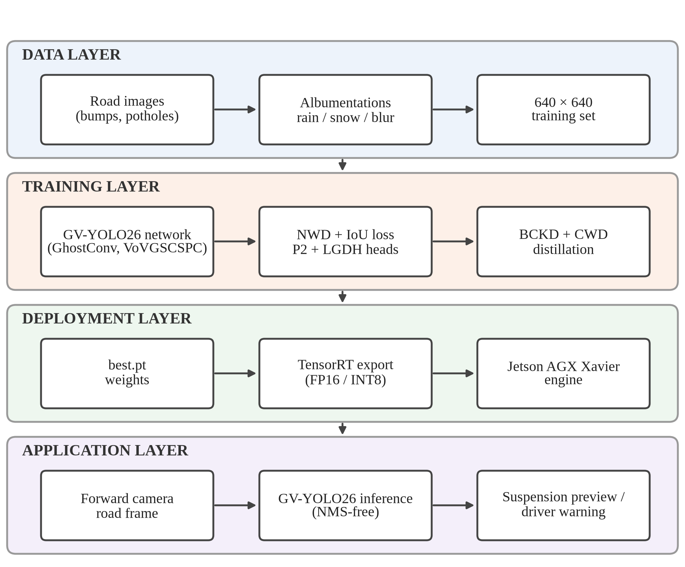
Fig. 4.1 Overall system architecture
The network itself is shown in Fig. 4.2. The backbone extracts features at four scales. Its early stages keep the standard convolutions and C3k2 blocks of YOLO26n, while its deeper downsampling layers are GhostConv and its P4 and P5 feature blocks are VoVGSCSPC; SPPF and C2PSA close the backbone. The neck first fuses these features top-down, extending the path down to the high-resolution P2 map so that it also receives semantic information from deeper levels, and then bottom-up again with GhostConv downsampling and VoVGSCSPC fusion at the deeper levels. The head applies an LGDH at each of the four levels, from the 160 × 160 P2 grid down to the 20 × 20 P5 grid, and its one-to-one branch outputs the final boxes without NMS.
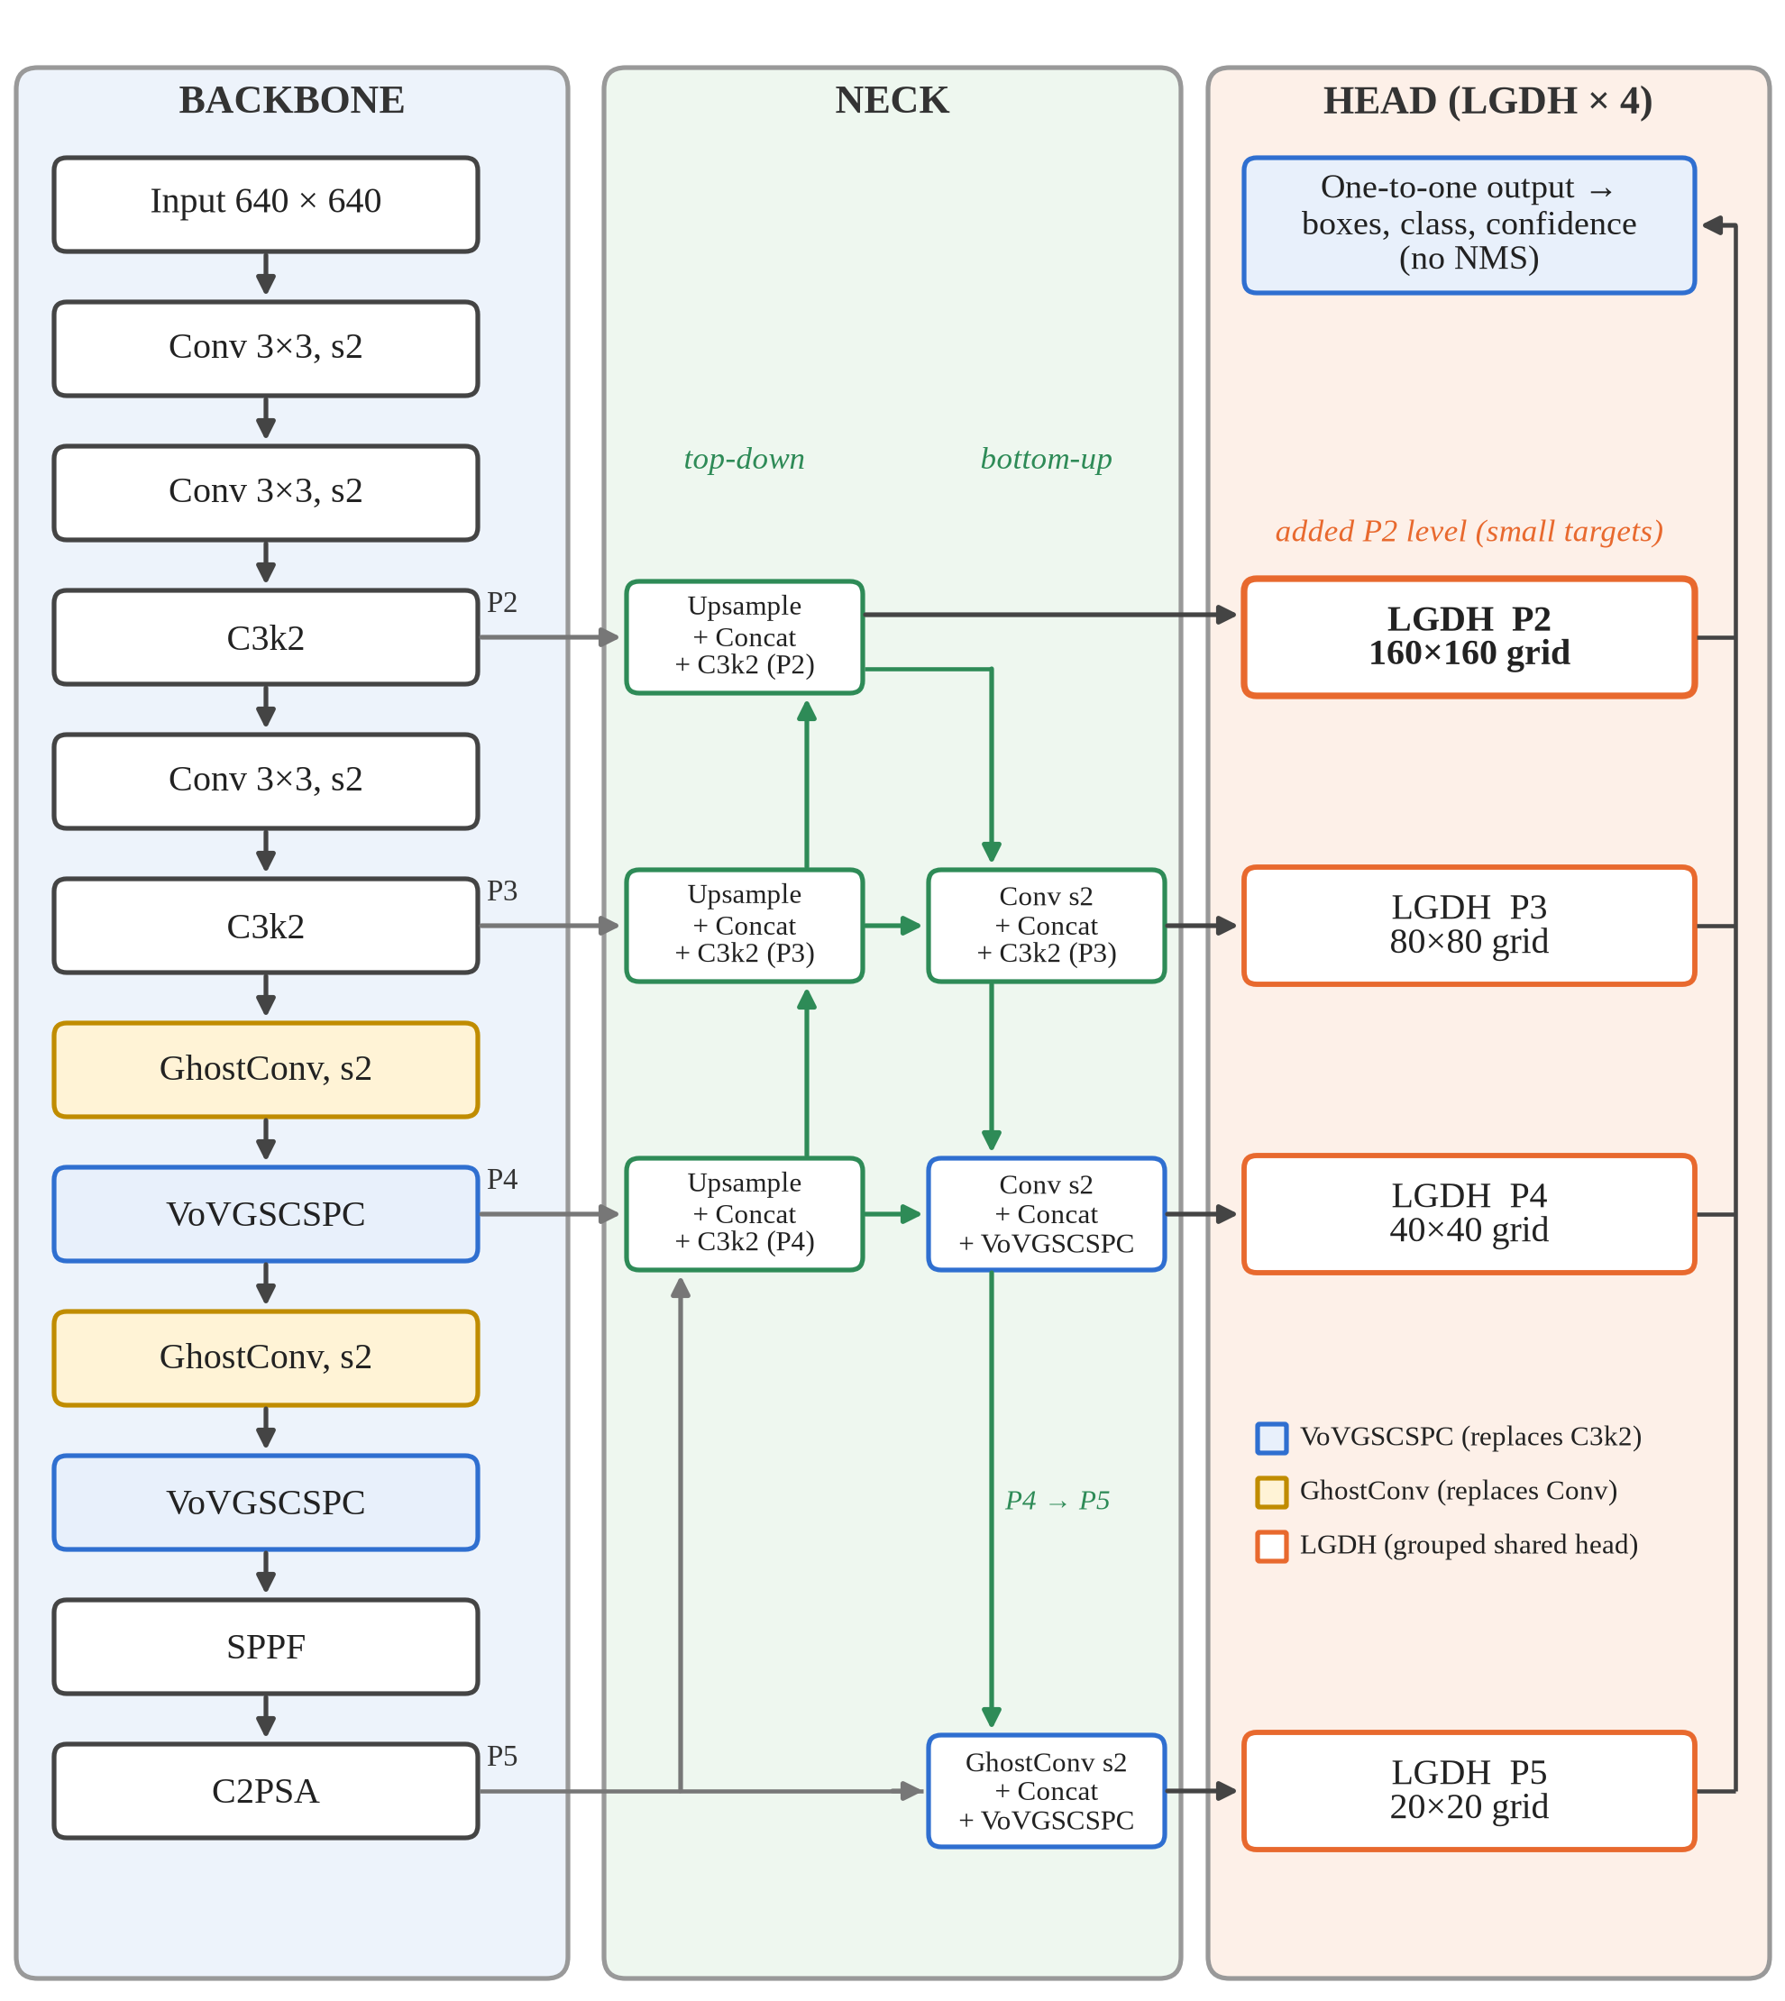
Fig. 4.2 Structure of the proposed GV-YOLO26 network
4.4 System Components/Modules
The system is divided into six modules.
4.4.1 Data Acquisition and Augmentation Module
This module gathers labelled road images and prepares them for training. The project uses the public Humps/Bumps and Potholes dataset from Roboflow Universe [9]. Images are resized to 640 × 640, and for GV-YOLO26 the training set is expanded with synthetic rain and snow, motion blur and changes in brightness, contrast and saturation [6], in addition to the standard flips, scaling and mosaic.
4.4.2 Lightweight Backbone and Neck Module
This module extracts and fuses multi-scale features at low cost. GhostConv replaces the standard downsampling convolutions in the deeper stages of the YOLO26n backbone, and VoVGSCSPC replaces the C3k2 blocks at the P4 and P5 stages and in the bottom-up path of the neck.
4.4.3 Small-Object Detection Head Module
This module produces the boxes and class scores. It adds the P2 level at stride 4 to the usual P3, P4 and P5 levels, and uses an LGDH at each level. The LGDH uses two shared 3 × 3 grouped convolutions with eight channels per group, followed by two parallel 1 × 1 convolutions, one for box regression and one for classification, and keeps the one-to-one branch of YOLO26 so that inference needs no NMS.
4.4.4 Training and Distillation Module
This module trains the network. The box loss combines NWD with IoU so that small boxes receive a useful gradient, alongside the progressive loss balancing and small-target-aware label assignment of YOLO26. After the student converges, a teacher with the same architecture at the larger S scale passes its knowledge to it through BCKD on the outputs and CWD on intermediate feature maps.
4.4.5 Deployment and Inference Module
This module turns trained weights into a working detector. It loads the weights, runs inference on images or video frames, and draws the boxes with class names and confidence scores. For the vehicle, it exports the model to a TensorRT engine; because the head is end-to-end, the exported engine already produces final detections.
4.4.6 Baseline Benchmarking Module
This module trains and evaluates stock detectors under one fixed protocol on the same public dataset, so that the base model can be chosen on evidence and the improvements of GV-YOLO26 can be judged against what an unmodified detector achieves. It records overall and per-class accuracy, model size, computation and latency for each model.
4.5 Proposed Methodology
The methodology followed in this project has these steps:
- Literature study: review existing speed bump and pothole detection and the lightweight and small-object techniques available (Chapter 2).
- Baseline benchmark: train seven stock detectors on a public speed bump and pothole dataset with one fixed configuration and evaluate them on the held-out test split.
- Base selection: choose YOLO26n, the most accurate and cheapest baseline, as the starting point.
- Model design: rebuild the backbone and neck with GhostConv and VoVGSCSPC, add the P2 level and the LGDH, and write one model configuration per design stage.
- Training: train GV-YOLO26 stage by stage with the NWD-augmented loss and weather augmentation, then distil it from a larger teacher.
- Evaluation: score each design stage once on the held-out test split, overall and per class, and record size, computation and latency.
- Deployment and analysis: export to TensorRT, run inference on road images and video, and analyse failure cases and deployment cost.
4.6 System Workflow
Fig. 4.3 shows the overall workflow of the project as a flowchart. The baseline benchmark selects the base model, after which GV-YOLO26 is designed, trained stage by stage, evaluated and deployed.
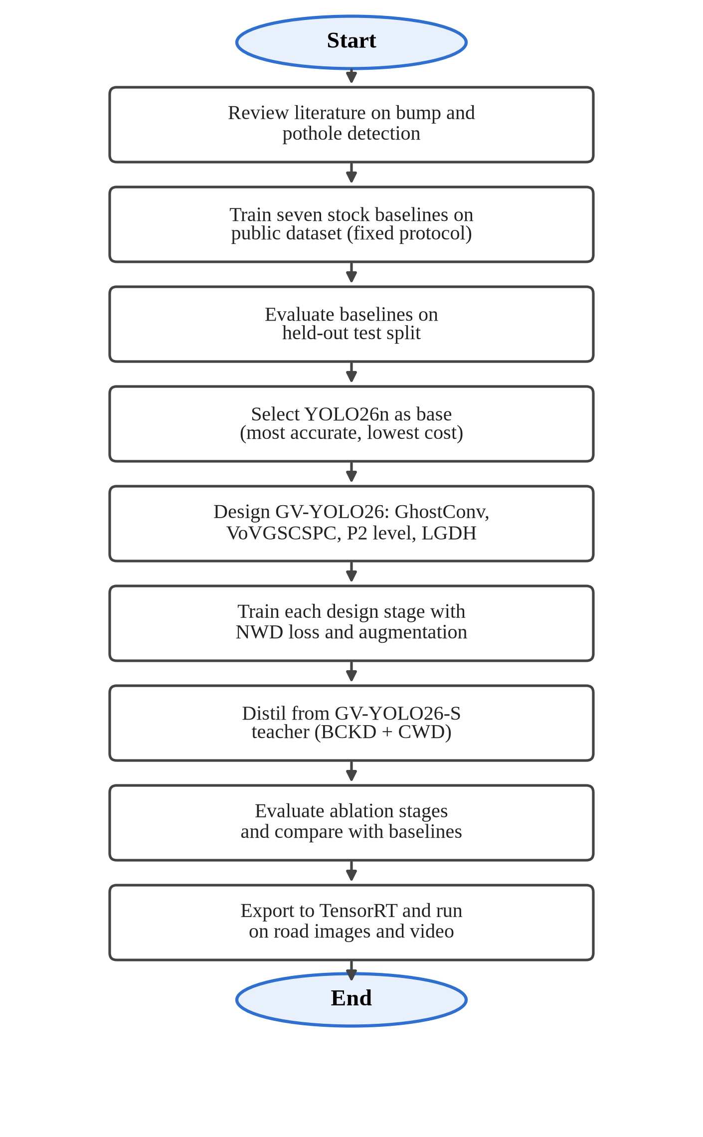
Fig. 4.3 Project workflow
4.7 Algorithms/Techniques Used
GhostConv. A standard convolution with C₂ output channels computes every output channel from all input channels. GhostConv computes only half of them this way, the intrinsic features, and produces the other half by applying a cheap 5 × 5 depthwise convolution to the intrinsic features [12]. The two halves are concatenated, as in Fig. 4.4(a). With a ratio of two, the cost of the layer is roughly halved:
Cost(GhostConv) ≈ Cost(Conv) / s, with s = 2 (4.1)
GSConv and VoVGSCSPC. GSConv applies a standard convolution to produce half of the output channels, a depthwise convolution to produce the other half, concatenates them and shuffles the channels [21], as in Fig. 4.4(b). The shuffle mixes the dense and cheap features so that information is not trapped in one half. VoVGSCSPC is a cross-stage partial block built from GSConv bottlenecks with one-shot aggregation in the style of VoVNet [20], [21]. In GV-YOLO26 it replaces the C3k2 block of YOLO26n at the P4 and P5 stages.
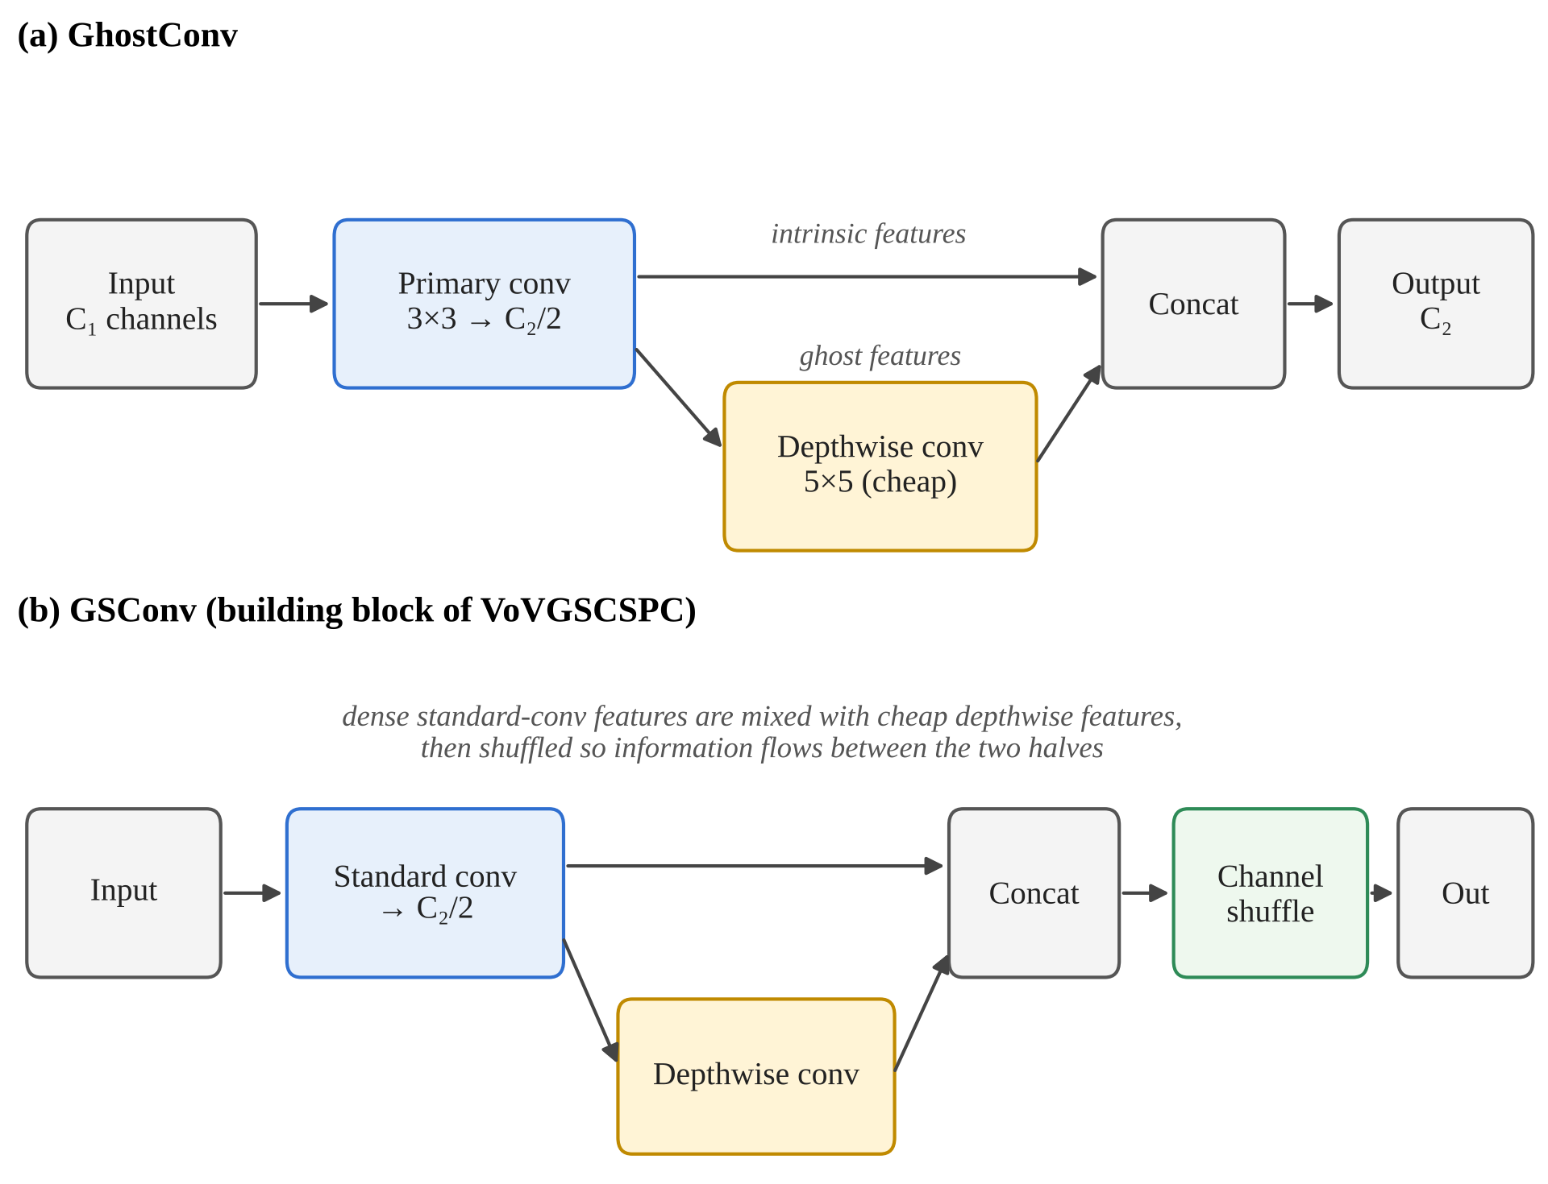
Fig. 4.4 GhostConv and GSConv, the building blocks of the GV-YOLO26 backbone and neck
The P2 detection level. Each detection level sees the image through a grid whose cells are as wide as the level’s stride. Table 4.3 shows what this means for a bump 16 pixels tall in a 640-pixel frame. At P3, the smallest level of the standard YOLO26 head, the bump covers two cells; at P5 it covers half a cell. The P2 level gives it four cells, which leaves enough spatial detail for the head to locate it.
Table 4.3 Feature pyramid levels for a 640 × 640 input
Level | Stride | Grid size | Cells covering a 16-pixel-tall bump | In YOLO26n
P2 | 4 | 160 × 160 | 4 | No (added in GV-YOLO26)
P3 | 8 | 80 × 80 | 2 | Yes
P4 | 16 | 40 × 40 | 1 | Yes
P5 | 32 | 20 × 20 | 0.5 | Yes

LGDH. A conventional decoupled head runs two separate stacks of convolutions at each level, one for the box and one for the class. Adding a 160 × 160 level makes this expensive, because the cost of the head grows with the area of the feature map and the P2 map has four times the area of P3; in our measurements, adding the P2 level to YOLO26n raised the cost of the deployed model from 5.3 to 6.6 GFLOPs. The LGDH, shown in Fig. 4.5, shares two 3 × 3 grouped convolutions between the two outputs, an approach that has proved effective in recent lightweight road detectors [23]. Because the default YOLO26 head is already light, with a depthwise classification branch and only four box channels per location, the groups were made narrow: each filter sees eight channels (c/8 groups). With sixteen channels per group the LGDH was no cheaper than the default head, while with eight it brought the cost back to 6.2 GFLOPs. Two 1 × 1 convolutions then produce the box and class outputs. The same structure is used for the one-to-many branch used in training and the one-to-one branch used at inference.
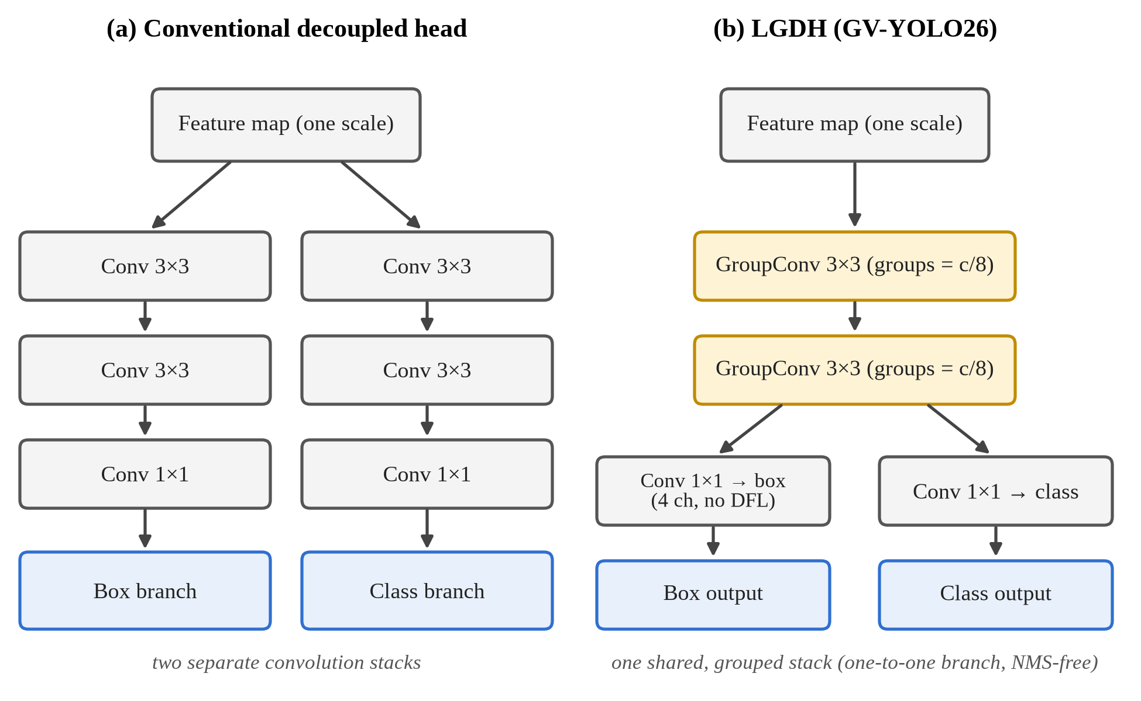
Fig. 4.5 A conventional decoupled head compared with the proposed LGDH
Normalized Gaussian Wasserstein Distance. IoU is very sensitive for small boxes: shifting a 10-pixel box by 3 pixels cuts its IoU sharply, and two small boxes that do not overlap have an IoU of zero no matter how close they are. NWD avoids this by modelling each box (cx, cy, w, h) as a two-dimensional Gaussian and measuring the second-order Wasserstein distance between the two Gaussians [46]:
W₂²(N_{a}, N_{b}) = ‖ [cx_{a}, cy_{a}, w_{a}/2, h_{a}/2] − [cx_{b}, cy_{b}, w_{b}/2, h_{b}/2] ‖² (4.2)
NWD(N_{a}, N_{b}) = exp( −√(W₂²(N_{a}, N_{b})) / C ) (4.3)
Here C is a normalising constant related to typical object size. GV-YOLO26 combines NWD with IoU in the box loss, with a weighting factor α between 0 and 1, set to 0.5 in this project:
L_{box} = (1 − α) · (1 − NWD) + α · L_{IoU} (4.4)
Knowledge distillation. The student (GV-YOLO26 at N scale) learns from a teacher of the same architecture at the larger S scale. Two terms are added to the normal detection loss: a BCKD term that aligns the student’s classification and localisation outputs with the teacher’s [50], and a CWD term that aligns the channel activations of intermediate feature maps [36]. Both are weighted by 0.5:
L = L_{det} + 0.5 · L_{BCKD} + 0.5 · L_{CWD} (4.5)
Distillation adds nothing at inference time, because the teacher is only used during training.
Intersection over Union and NMS. A prediction is counted as correct when its IoU with a ground-truth box of the same class is above a threshold such as 0.5. Non-Maximum Suppression removes duplicate predictions by keeping the highest-scoring box of a class and discarding any other box whose IoU with it exceeds a threshold. The baselines from YOLOv8n to YOLO12n rely on NMS; YOLO26n and GV-YOLO26 are trained with a one-to-one assignment so that each object receives a single prediction and NMS is not needed at inference.
IoU = Area(A ∩ B) / Area(A ∪ B) (4.6)
TensorRT quantisation. TensorRT fuses layers, selects GPU kernels for the target board, and can store weights and activations in FP16 or INT8 instead of FP32 [29]. Lower precision cuts memory traffic and lets the Jetson’s tensor cores run more operations per cycle, at a small risk to accuracy.
4.8 Dataset/Data Collection
The dataset used in this project is the public Humps/Bumps and Potholes Detection dataset [9], version 8, released through Roboflow Universe under a CC BY 4.0 licence. It contains 3,243 images with bounding-box labels in YOLO format for two classes, speed bump and pothole. We used it exactly as distributed, with its official splits, for the baseline benchmark and for every stage of GV-YOLO26, so that all results in Chapter 5 come from one dataset and one protocol. Table 4.4 summarises it.
Table 4.4 Dataset used in this project
Property | Humps/Bumps and Potholes dataset [9]
Classes | Speed bump, pothole
Total images | 3,243
Training / validation / test | 2,560 / 475 / 208
Sources | Roboflow Universe (single public release)
Input size | 640 × 640
Used for | Baseline benchmark and all GV-YOLO26 experiments
Note: Used exactly as distributed, with the official splits of version 8.
The test split contains 457 instances: 386 potholes in 140 images and 71 speed bumps in 70 images. Speed bump boxes usually cover the full width of the bump, very distant bumps are often unlabelled, and each pothole in a cluster is boxed separately. These conventions affect the scores of every model, especially for potholes at strict IoU thresholds.
4.9 Data Preprocessing
Preprocessing follows the Ultralytics pipeline, with additional augmentation for GV-YOLO26:
- Resizing: each image is letterboxed to 640 × 640 and pixel values are scaled to the range 0 to 1.
- Weather augmentation (GV-YOLO26): synthetic rain and snow are added with Albumentations transforms so that the model sees adverse weather during training [6].
- Photometric augmentation (GV-YOLO26): motion blur and random changes in brightness, contrast and saturation, applied with a low probability on top of the standard recipe.
- Standard augmentation (all models): the default Ultralytics recipe, with HSV jitter, scaling, translation, horizontal flip and mosaic, mosaic switched off for the final ten epochs and vertical flip off. It was applied identically to every model and not tuned.
- Label format: YOLO format, with one line per object giving the class index and the normalised box centre, width and height.
4.10 Model/System Development
GV-YOLO26 was built in steps from YOLO26n, with one model configuration file for each step, so that the contribution of each change can be measured in the ablation study of Chapter 5. Table 4.5 lists the stages.
Table 4.5 GV-YOLO26 design stages and model configurations
Stage | Change | Configuration file
1 | YOLO26n baseline | yolo26n.yaml
2 | Add P2 detection level | ablation/gv-yolo26n-p2.yaml
3 | Replace head with LGDH | ablation/gv-yolo26n-p2-lgdh.yaml
4 | Add GhostConv | ablation/gv-yolo26n-p2-lgdh-ghost.yaml
5 | Add VoVGSCSPC (full architecture) | gv-yolo26n.yaml
6 | Train with NWD loss | gv-yolo26n.yaml + --nwd
Note: Files are in the models/ folder; the letter after “yolo26” selects the scale, so gv-yolo26n.yaml and gv-yolo26s.yaml both read gv-yolo26.yaml. Stage 6 uses the architecture of stage 5 with the NWD term enabled in the box loss. The distilled model is trained from stage 6 with distill.py.
GV-YOLO26 was trained with the settings in Table 4.6. Each stage is trained for 150 epochs, longer than the baseline schedule, because the new layers start from random weights; YOLO26n is retrained under the same schedule so that the ablation compares like with like. Layers whose shapes match YOLO26n are initialised from its COCO-pretrained weights. The distillation stage uses a separate run with the S-scale teacher.
Table 4.6 GV-YOLO26 training configuration
Parameter | Value
Input resolution | 640 × 640, letterboxed
Epochs | 150, early stopping patience 30
Batch size | 16
Optimiser | Auto-selected (same rule as the baselines)
Box loss | IoU combined with NWD, α = 0.5 (equation 4.4)
Distillation run | BCKD 0.5 + CWD 0.5 (equation 4.5), 150 epochs
Teacher | GV-YOLO26 at S scale (6.11 M parameters, 19.2 GFLOPs)
Hardware | NVIDIA Tesla T4, 16 GB (Kaggle)
Framework | Ultralytics 8.4.156, PyTorch 2.10, Python 3.12
Note: Random seed 42 with deterministic mode and AMP enabled, as for the baselines (Table 4.7).
For the baseline benchmark we trained seven stock detectors at their smallest scale: YOLOv8n, YOLOv9t, YOLOv10n, YOLO11n, YOLO12n, YOLO26n and RT-DETR-L [16], [18], [38], [40], [44], [45], [51]. All used the same configuration, shown in Table 4.7, so that only the architecture changed between runs.
Table 4.7 Baseline training configuration (identical across models)
Parameter | Value
Input resolution | 640 × 640, letterboxed
Epochs | 50, early stopping patience 15
Batch size | 16 (8 for RT-DETR-L)
Optimiser | AdamW (auto-selected), learning rate 1.67e-3, momentum 0.9
Weight initialisation | COCO-pretrained, per architecture
Mixed precision | AMP enabled
Framework | Ultralytics 8.4.156, PyTorch 2.10, Python 3.12
Hardware | NVIDIA Tesla T4, 16 GB (Kaggle)
Random seed | 42, deterministic

4.11 System Design Diagrams
The use case diagram in Fig. 4.6 shows the two actors. The researcher or developer prepares data, trains GV-YOLO26, evaluates it and exports it for the vehicle. The driver or vehicle system uses the deployed detector and receives warnings or a suspension preview signal.
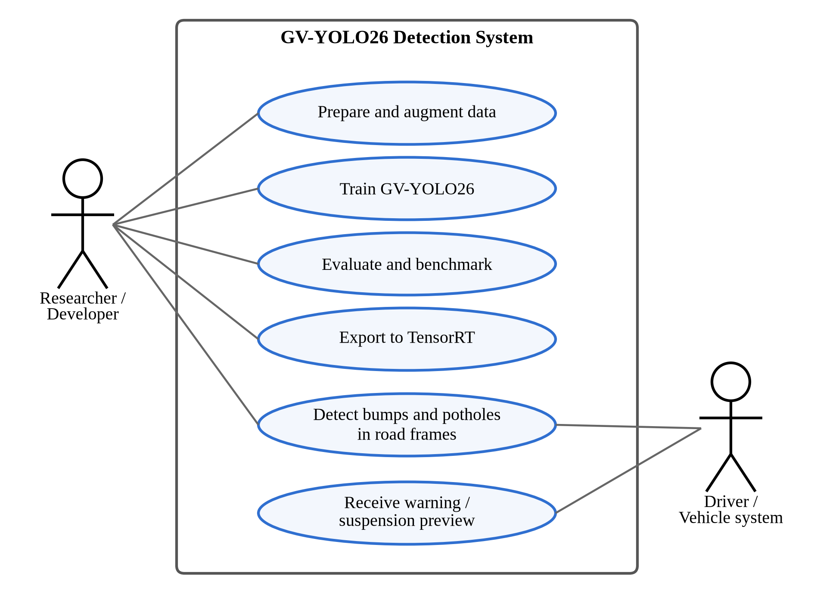
Fig. 4.6 Use case diagram
The data flow diagram in Fig. 4.7 shows how data moves through the system. Images and labels are prepared and stored (D1), training produces weights (D2), evaluation writes metrics and logs (D3), and the weights are exported to a TensorRT engine. At run time, camera frames flow into the real-time inference process, which sends alerts to the vehicle or driver.
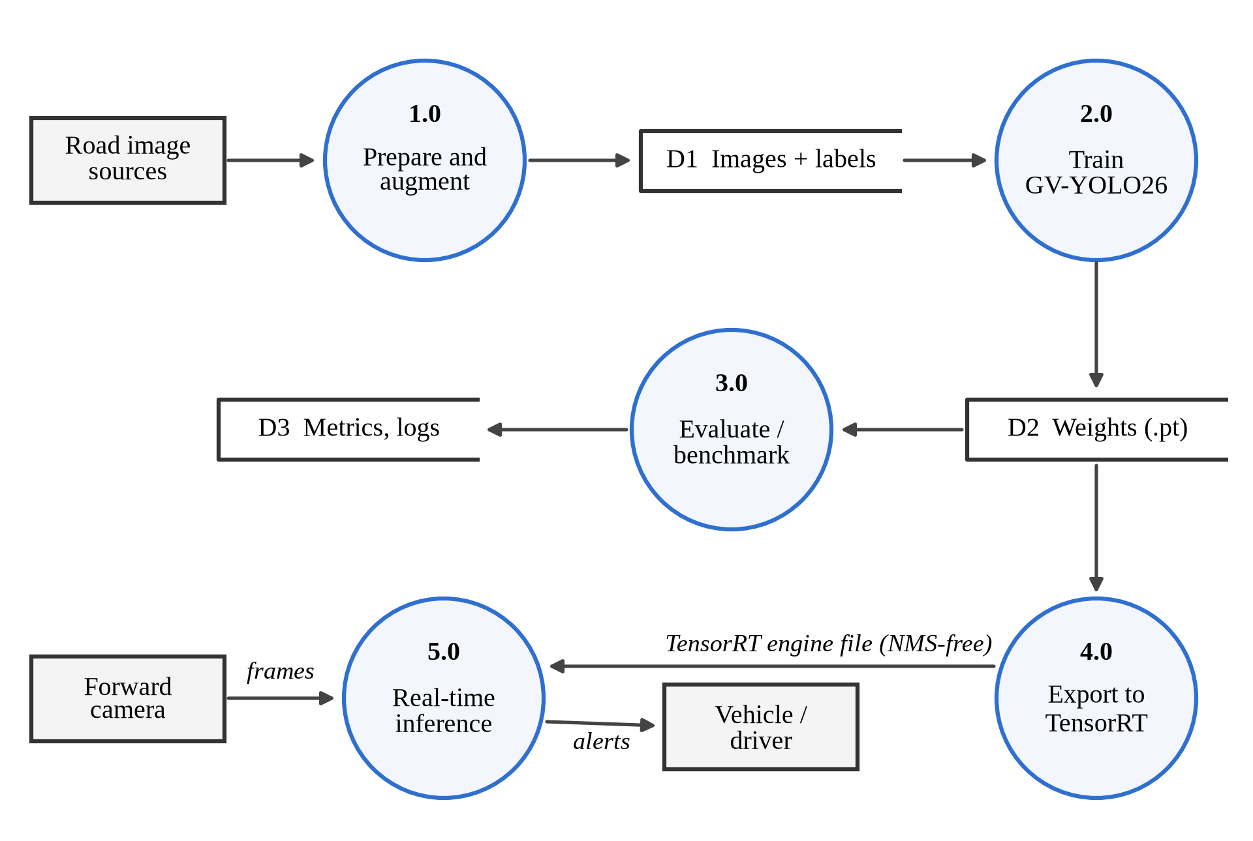
Fig. 4.7 Data flow diagram (level 1)
4.12 Implementation
GV-YOLO26 was implemented on the Ultralytics framework (version 8.4.156), which provides the YOLO26 base model. We wrote the new modules, GSConv, VoVGSCSPC and the LGDH head, in a separate Python package and registered them, together with GhostConv, with the Ultralytics model parser so that they can be used from a YAML model configuration. The NWD term was added to the box loss through a custom trainer with a weighting factor α, and the distillation stage was implemented as a second custom trainer that adds the BCKD and CWD losses using a frozen teacher.
Each design stage in Table 4.5 has its own configuration file, so building a stage only means changing the file passed to the trainer. Before training, every configuration was checked with tools/model_summary.py, which builds the model, runs a forward pass on a 640 × 640 input in training and inference mode to confirm that all four detection levels produce outputs of the expected size, and reports the parameter count and GFLOPs of both the training model and the fused deployment model. The full pipeline (training with the NWD loss, distillation, validation, inference and NMS-free ONNX export) was also run end to end on a small synthetic dataset before the real experiments.
All training was run on Kaggle notebooks with a Tesla T4 GPU. Each model was trained in its own run, evaluated once on the held-out test split with the Ultralytics validator (confidence threshold 0.001; IoU threshold 0.7 for NMS where the model uses it), and timed over 100 single-image predictions after 10 warm-up images. YOLO26n and GV-YOLO26 were evaluated and timed with their one-to-one head (nms=False), which is the NMS-free form they are deployed in.
4.13 Coding/Program Implementation
GitHub repository: https://github.com/<username>/GV-YOLO26
The project code is organised as shown below. The model configurations, custom modules and scripts are kept separate from the Ultralytics package (version 8.4.156), which is installed as a dependency; importing gv_modules registers the new layers with it.
GV-YOLO26/
├── models/
│ ├── gv-yolo26.yaml GV-YOLO26 (N and S scales)
│ └── ablation/ One file per design stage
├── gv_modules/ GSConv, VoVGSCSPC, LGDH head, NWD and
│ distillation losses, model and trainers
├── tools/model_summary.py Parameters and GFLOPs per stage
├── train.py, distill.py Training and distillation
├── val.py, infer.py Evaluation, latency and inference
├── export_trt.py TensorRT export and timing
├── benchmark/train_baselines.py Seven stock baselines
└── data/data.yaml Dataset configuration

GhostConv module. The first convolution produces half of the output channels; the second is a depthwise 5 × 5 convolution (groups equal to channels) that generates the cheap ghost features.
class GhostConv(nn.Module):
def __init__(self, c1, c2, k=1, s=1, g=1, act=True):
super().__init__()
c_ = c2 // 2 # intrinsic channels
self.cv1 = Conv(c1, c_, k, s, None, g, act=act)
self.cv2 = Conv(c_, c_, 5, 1, None, c_, act=act) # depthwise

def forward(self, x):
y = self.cv1(x)
return torch.cat((y, self.cv2(y)), 1)

GSConv and VoVGSCSPC. GSConv concatenates a dense half and a depthwise half and then interleaves their channels. VoVGSCSPC splits its input into two 1 × 1 branches, passes one through a GSConv bottleneck with a depthwise shortcut (GSBottleneckC), and fuses both with a final 1 × 1 convolution.
class GSConv(nn.Module):
def __init__(self, c1, c2, k=1, s=1, act=True):
super().__init__()
c_ = c2 // 2
self.cv1 = Conv(c1, c_, k, s, act=act) # dense half
self.cv2 = Conv(c_, c_, 5, 1, None, c_, act=act) # depthwise half

def forward(self, x):
x1 = self.cv1(x)
x2 = torch.cat((x1, self.cv2(x1)), 1)
b, n, h, w = x2.shape # channel shuffle
return x2.view(b, 2, n // 2, h, w).transpose(1, 2).reshape(b, n, h, w)

class VoVGSCSPC(nn.Module):
def __init__(self, c1, c2, n=1, e=0.5):
super().__init__()
c_ = int(c2 * e)
self.cv1 = Conv(c1, c_, 1, 1)
self.cv2 = Conv(c1, c_, 1, 1)
self.gsb = nn.Sequential(*(GSBottleneckC(c_, c_) for _ in range(n)))
self.cv3 = Conv(2 * c_, c2, 1)

def forward(self, x):
return self.cv3(torch.cat((self.cv2(x), self.gsb(self.cv1(x))), 1))

LGDH head. The head subclasses the YOLO26 Detect module, so it inherits the one-to-one branch, the decoding and the NMS-free post-processing. It replaces the default box and class stacks with a shared grouped stem per level and two 1 × 1 output convolutions, for both the one-to-many and the one-to-one branch.
class LGDH(Detect):
channels_per_group = 8 # groups = c / 8 in the stem

def __init__(self, nc=80, reg_max=16, end2end=False, ch=()):
super().__init__(nc, reg_max, end2end, ch)
g = lambda c: max(c // self.channels_per_group, 1)
self.stem = nn.ModuleList(
nn.Sequential(Conv(x, x, 3, g=g(x)), Conv(x, x, 3, g=g(x)))
for x in ch)
self.cv2 = nn.ModuleList(
nn.Sequential(nn.Conv2d(x, 4 * self.reg_max, 1)) for x in ch)
self.cv3 = nn.ModuleList(
nn.Sequential(nn.Conv2d(x, self.nc, 1)) for x in ch)
if end2end: # copy for NMS-free inference
self.one2one_stem = copy.deepcopy(self.stem)
self.one2one_cv2 = copy.deepcopy(self.cv2)
self.one2one_cv3 = copy.deepcopy(self.cv3)

def forward_head(self, x, box_head=None, cls_head=None, stem=None):
if box_head is None or cls_head is None: # removed by fuse()
return {}
bs = x[0].shape[0]
f = [stem[i](x[i]) for i in range(self.nl)] # shared stem
boxes = torch.cat([box_head[i](f[i]).view(bs, 4 * self.reg_max, -1)
for i in range(self.nl)], dim=-1)
scores = torch.cat([cls_head[i](f[i]).view(bs, self.nc, -1)
for i in range(self.nl)], dim=-1)
return {"boxes": boxes, "scores": scores, "feats": x}

Model configuration. The full GV-YOLO26 architecture is defined in one YAML file, models/gv-yolo26.yaml. Layer indices in the comments match the connections in Fig. 4.2; the last line attaches an LGDH to the P2, P3, P4 and P5 outputs. The S row of scales defines the distillation teacher.
nc: 2 # speed bump, pothole
end2end: True # one-to-one head, NMS-free inference
reg_max: 1 # no DFL
scales: # [depth, width, max_channels]
n: [0.50, 0.25, 1024]
s: [0.50, 0.50, 1024]
backbone:
- [-1, 1, Conv, [64, 3, 2]] # 0-P1/2
- [-1, 1, Conv, [128, 3, 2]] # 1-P2/4
- [-1, 2, C3k2, [256, False, 0.25]] # 2
- [-1, 1, Conv, [256, 3, 2]] # 3-P3/8
- [-1, 2, C3k2, [512, False, 0.25]] # 4
- [-1, 1, GhostConv, [512, 3, 2]] # 5-P4/16
- [-1, 2, VoVGSCSPC, [512]] # 6
- [-1, 1, GhostConv, [1024, 3, 2]] # 7-P5/32
- [-1, 2, VoVGSCSPC, [1024]] # 8
- [-1, 1, SPPF, [1024, 5, 3, True]] # 9
- [-1, 2, C2PSA, [1024]] # 10
head:
- [-1, 1, nn.Upsample, [None, 2, "nearest"]]
- [[-1, 6], 1, Concat, [1]] # cat backbone P4
- [-1, 2, C3k2, [512, True]] # 13
- [-1, 1, nn.Upsample, [None, 2, "nearest"]]
- [[-1, 4], 1, Concat, [1]] # cat backbone P3
- [-1, 2, C3k2, [256, True]] # 16
- [-1, 1, nn.Upsample, [None, 2, "nearest"]]
- [[-1, 2], 1, Concat, [1]] # cat backbone P2
- [-1, 2, C3k2, [128, True]] # 19 (P2/4)
- [-1, 1, Conv, [128, 3, 2]]
- [[-1, 16], 1, Concat, [1]] # cat head P3
- [-1, 2, C3k2, [256, True]] # 22 (P3/8)
- [-1, 1, Conv, [256, 3, 2]]
- [[-1, 13], 1, Concat, [1]] # cat head P4
- [-1, 2, VoVGSCSPC, [512]] # 25 (P4/16)
- [-1, 1, GhostConv, [512, 3, 2]]
- [[-1, 10], 1, Concat, [1]] # cat head P5
- [-1, 1, VoVGSCSPC, [1024]] # 28 (P5/32)
- [[19, 22, 25, 28], 1, LGDH, [nc]] # P2, P3, P4, P5

NWD similarity. The function below implements equations (4.2) and (4.3) for boxes given as (cx, cy, w, h). The loss term used in training is one minus this value, mixed with the IoU loss as in equation (4.4).
def nwd(pred, target, C=12.8, eps=1e-7):
# pred, target: (N, 4) tensors of (cx, cy, w, h)
d_center = ((pred[:, :2] - target[:, :2]) ** 2).sum(dim=1)
d_size = (((pred[:, 2:] - target[:, 2:]) / 2) ** 2).sum(dim=1)
w2 = d_center + d_size + eps # squared Wasserstein-2 distance
return torch.exp(-torch.sqrt(w2) / C)

Training a design stage. Importing gv_modules registers the custom layers with Ultralytics. Layers whose names and shapes match are loaded from the COCO-pretrained YOLO26n checkpoint, NWDTrainer builds the model with the IoU + NWD box loss, and the weather augmentation is passed as a list of Albumentations transforms. The same settings are wrapped in train.py, which takes the configuration file and an --nwd flag.
import gv_modules # registers custom layers
from gv_modules import NWDTrainer # IoU + NWD box loss
from gv_modules.augment import weather_augmentations
from ultralytics import YOLO

model = YOLO("models/gv-yolo26n.yaml", task="detect").load("yolo26n.pt")
model.train(data="data/data.yaml", trainer=NWDTrainer, imgsz=640,
epochs=150, patience=30, batch=16, seed=42,
deterministic=True, optimizer="auto", amp=True,
close_mosaic=10, flipud=0.0, augmentations=weather_augmentations(),
project="runs", name="gv_yolo26")

Inference with the trained model. The custom module package is imported first so that its layers are registered; the model is then used like any Ultralytics detector. Passing nms=False selects the one-to-one head, so the returned boxes are already final and no NMS step runs. The same code is wrapped in infer.py, which also handles video.
import gv_modules # registers GV-YOLO26 layers
from ultralytics import YOLO

model = YOLO("runs/gv_yolo26/weights/best.pt")
results = model.predict(source="samples/", imgsz=640, conf=0.25, nms=False,
save=True, project="results", name="gv_images")
for r in results:
for box in r.boxes:
print(r.names[int(box.cls)], round(float(box.conf), 2))

Video inference. For dashcam clips, frames are read with OpenCV, passed through the model, and the annotated frames are written to a new video.
import cv2
cap = cv2.VideoCapture("clips/road.mp4")
fps = cap.get(cv2.CAP_PROP_FPS)
w, h = int(cap.get(3)), int(cap.get(4))
out = cv2.VideoWriter("results/road_gv.mp4",
cv2.VideoWriter_fourcc(*"mp4v"), fps, (w, h))
while True:
ok, frame = cap.read()
if not ok:
break
r = model.predict(frame, imgsz=640, conf=0.25, verbose=False)[0]
out.write(r.plot())
cap.release(); out.release()

TensorRT export. On the Jetson, the trained model is exported to a TensorRT engine in half precision. With nms=False the engine contains the one-to-one head and its top-k selection, so it outputs final detections and needs no separate NMS step. The resulting .engine file is loaded the same way as the .pt file; export_trt.py also times it for Table 5.5.
model = YOLO("runs/gv_yolo26/weights/best.pt")
model.export(format="engine", half=True, nms=False, imgsz=640, device=0)
trt_model = YOLO("runs/gv_yolo26/weights/best.engine", task="detect")

Baseline training. The baseline script holds every setting in one dictionary so that only the model changes between runs.
from ultralytics import YOLO, RTDETR

MODELS = {"YOLOv8n": "yolov8n.pt", "YOLOv9t": "yolov9t.pt",
"YOLOv10n": "yolov10n.pt", "YOLO11n": "yolo11n.pt",
"YOLO12n": "yolo12n.pt", "YOLO26n": "yolo26n.pt",
"RT-DETR-L": "rtdetr-l.pt"}
COMMON = dict(data="data/data.yaml", imgsz=640, epochs=50,
patience=15, seed=42, deterministic=True,
optimizer="auto", amp=True, close_mosaic=10, flipud=0.0)

for name, ckpt in MODELS.items():
is_detr = name.startswith("RT-DETR")
model = RTDETR(ckpt) if is_detr else YOLO(ckpt)
model.train(batch=8 if is_detr else 16, name=name, **COMMON)

4.14 User Interface / Application Screens
The system was run from Python scripts and notebooks and does not have a separate graphical interface. Its visual output is the annotated detection image or video, in which each detected speed bump or pothole is drawn with a box, its class name and its confidence score.
Fig. 4.8 and Fig. 4.9 show outputs of the trained GV-YOLO26 model on a road image and on a frame from a dashcam clip, produced with the inference scripts in Section 4.13 at a confidence threshold of 0.25.
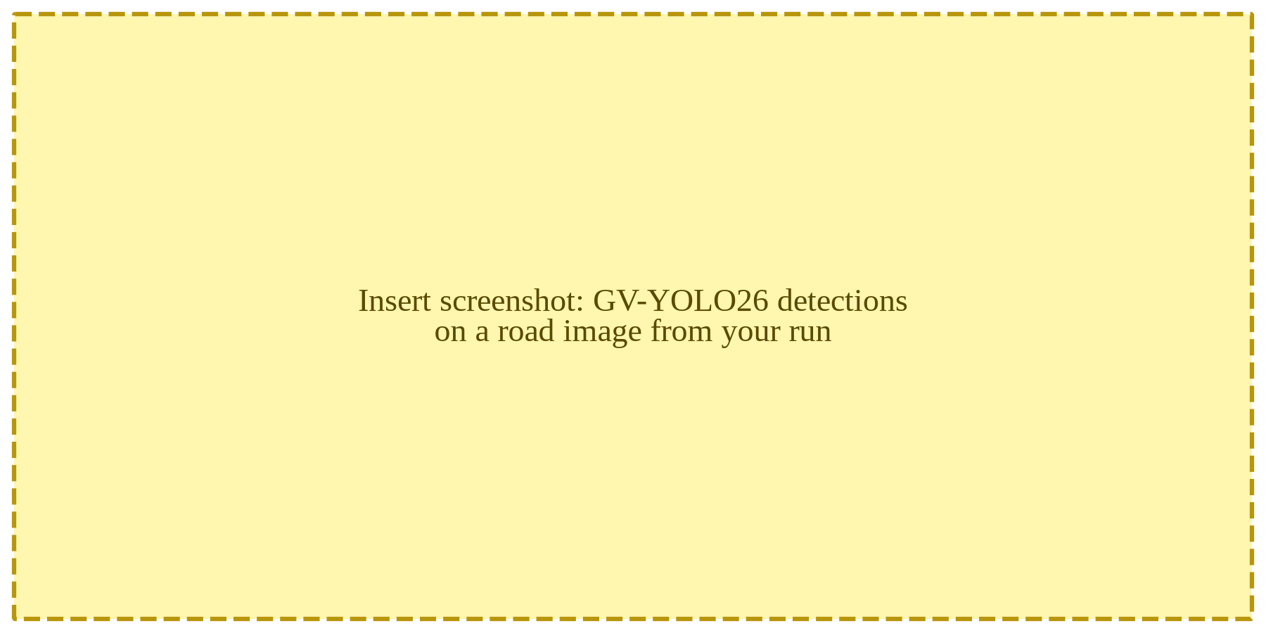
Fig. 4.8 GV-YOLO26 detections on a road image
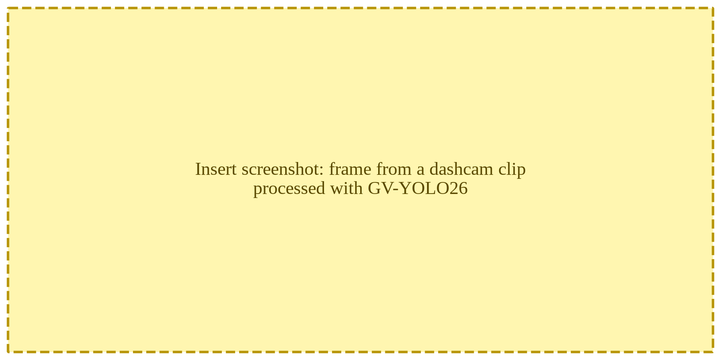
Fig. 4.9 GV-YOLO26 detections on a frame from a dashcam clip
4.15 Chapter Summary
This chapter described the design and implementation of GV-YOLO26. The network rebuilds the YOLO26n backbone and neck with GhostConv and VoVGSCSPC, adds a P2 detection level for small targets, and offsets its cost with the LGDH while keeping NMS-free inference; the training recipe adds the NWD loss, weather augmentation and distillation. Seven stock detectors trained on the same public dataset provide the measured baseline and justify the choice of YOLO26n as the base. The next chapter presents the results.
5. CHAPTER 3 – RESULTS AND DISCUSSION
5.1 Introduction
This chapter presents the results of the project. It begins with the benchmark of seven stock detectors that was used to select the base model, then reports the ablation study of GV-YOLO26, the effect of distillation and embedded deployment, and finally compares the proposed model with earlier work. All models were trained and evaluated on the same public dataset under the same protocol.
5.2 Experimental Setup
Baselines. We trained seven stock detectors on the 2,560 training images of the public Humps/Bumps and Potholes dataset with the configuration in Table 4.7, selected the best checkpoint on the validation split, and evaluated it once on the 208-image test split. Latency was measured on a Tesla T4 GPU as the end-to-end time of a single-image prediction, averaged over 100 test images.
GV-YOLO26. Each design stage in Table 4.5 was trained with the configuration in Table 4.6 on the same training split, selected on the validation split and evaluated once on the same test split, with latency measured in the same way. YOLO26n was retrained under this longer schedule to serve as the reference row of the ablation.
Embedded deployment. The final model is exported to TensorRT at FP32, FP16 and INT8 precision and timed on an NVIDIA Jetson AGX Xavier at batch size 1, with INT8 calibrated on images from the training split.
5.3 Evaluation Metrics
TP, FP and FN denote true positives, false positives and false negatives at a given IoU threshold.
Precision is the fraction of predicted boxes that are correct, and recall is the fraction of actual objects that are detected:
Precision = TP / (TP + FP) (5.1)
Recall = TP / (TP + FN) (5.2)
Average Precision (AP) is the area under the precision-recall curve for one class, and mAP is the mean of AP over the N classes:
mAP = (1 / N) × Σ AP_{i}, i = 1, …, N (5.3)
mAP@0.5 uses an IoU threshold of 0.5. mAP@0.5:0.95 averages mAP over ten IoU thresholds from 0.5 to 0.95, so it rewards tighter boxes. Recall matters most for this application, because a missed bump is an unmitigated hazard, but precision cannot be neglected, because a system that warns too often will be ignored.
Efficiency is measured by the number of parameters, GFLOPs at 640 × 640, model size, and speed in frames per second (FPS = 1000 / latency in milliseconds).
5.4 Experimental Results
5.4.1 Baseline Benchmark and Choice of Base Model
Table 5.1 and Fig. 5.1 give the overall accuracy of the seven stock detectors on the 208-image test split. The five YOLO generations from YOLOv8n to YOLO12n ended between 71.4% and 73.9% mAP@0.5, a spread of only 2.5 points. YOLO26n was best on every accuracy metric at 74.8% mAP@0.5 and 35.5% mAP@0.5:0.95, with the highest precision (82.3%), and it needed the least computation of all models at 5.3 GFLOPs. RT-DETR-L, a transformer with about 32 million parameters, was last at 67.5% and ran at 12.2 FPS against 25 to 31 FPS for the YOLO models. On this evidence YOLO26n was chosen as the base of GV-YOLO26.
Table 5.1 Baseline accuracy and cost on the public test split
Model | P (%) | R (%) | mAP@​0.5 | mAP@​0.5:​0.95 | Params (M) | GFLOPs | FPS (T4)
YOLOv8n | 73.9 | 67.7 | 73.5 | 34.6 | 3.01 | 8.1 | 30.2
YOLOv9t | 73.0 | 67.1 | 71.4 | 35.3 | 1.97 | 7.6 | 25.2
YOLOv10n | 79.3 | 66.1 | 72.8 | 34.7 | 2.27 | 6.6 | 30.8
YOLO11n | 78.8 | 64.9 | 73.9 | 33.3 | 2.58 | 6.4 | 30.6
YOLO12n | 73.1 | 66.6 | 73.7 | 34.0 | 2.56 | 7.3 | 26.7
YOLO26n | 82.3 | 68.1 | 74.8 | 35.5 | 2.38 | 5.3 | 29.3
RT-DETR-L | 66.6 | 65.8 | 67.5 | 30.6 | 31.99 | 105.3 | 12.2
Note: Test split: 208 images, 457 instances. FPS is end-to-end single-image throughput on a Tesla T4.
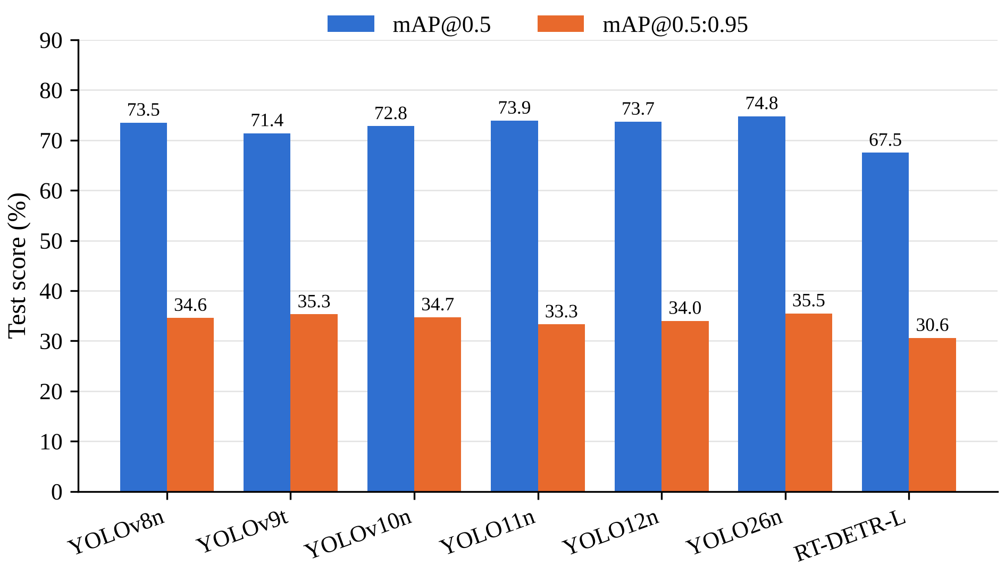
Fig. 5.1 Overall accuracy of the baseline detectors on the public test split
Table 5.2 and Fig. 5.2 split the results by class. Every YOLO model found speed bumps well, with AP@0.5 between 87.2% and 93.5%, while pothole AP@0.5 stayed between 55.3% and 56.9% for all six YOLO models. Potholes in this dataset are small, crowded and irregular, and each one in a cluster is labelled separately, which makes them much harder to box precisely.
Table 5.2 Per-class accuracy of the baselines on the public test split (%)
Model | Pothole AP@​0.5 | Pothole AP@​0.5:​0.95 | Speed bump AP@​0.5 | Speed bump AP@​0.5:​0.95
YOLOv8n | 55.5 | 22.6 | 91.4 | 46.7
YOLOv9t | 55.5 | 24.6 | 87.2 | 45.9
YOLOv10n | 55.3 | 23.9 | 90.4 | 45.5
YOLO11n | 56.9 | 24.2 | 90.9 | 42.4
YOLO12n | 56.6 | 24.3 | 90.7 | 43.7
YOLO26n | 56.1 | 24.0 | 93.5 | 46.9
RT-DETR-L | 59.1 | 24.6 | 75.9 | 36.7
Note: Test split: 386 pothole instances in 140 images and 71 speed bump instances in 70 images.
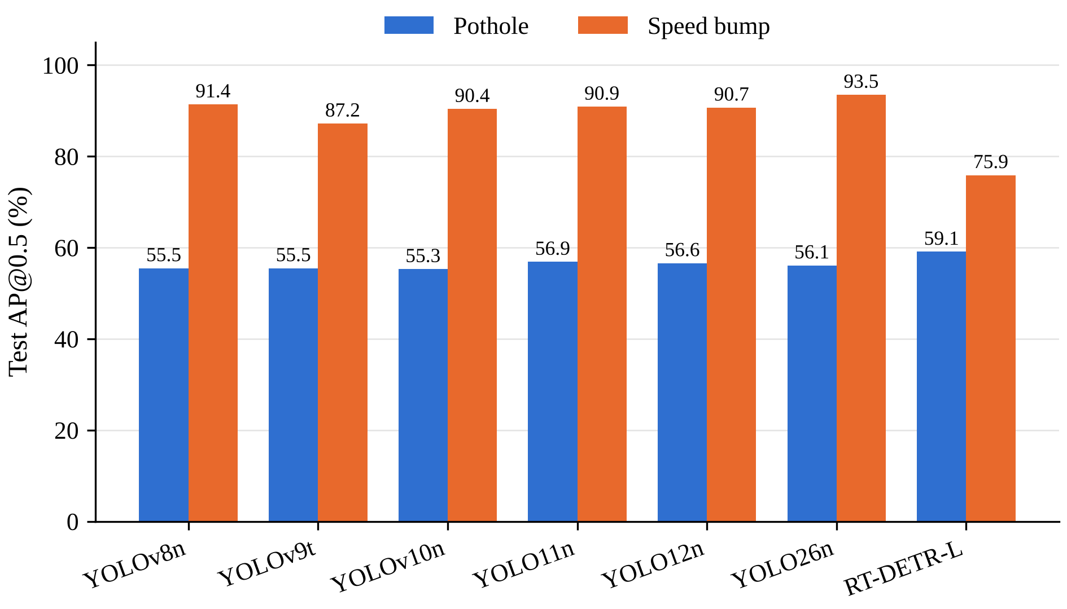
Fig. 5.2 Per-class AP@0.5 of the baseline detectors
Fig. 5.3 shows example baseline detections. In column (a), a distant unpainted bump, YOLOv8n and YOLO26n detect it at low confidence (0.34 and 0.39), YOLO11n misses it entirely, and RT-DETR-L places three overlapping boxes on it. Even the best baseline is uncertain on exactly the small, distant case that the P2 level, the LGDH and the NWD loss of GV-YOLO26 were designed for.
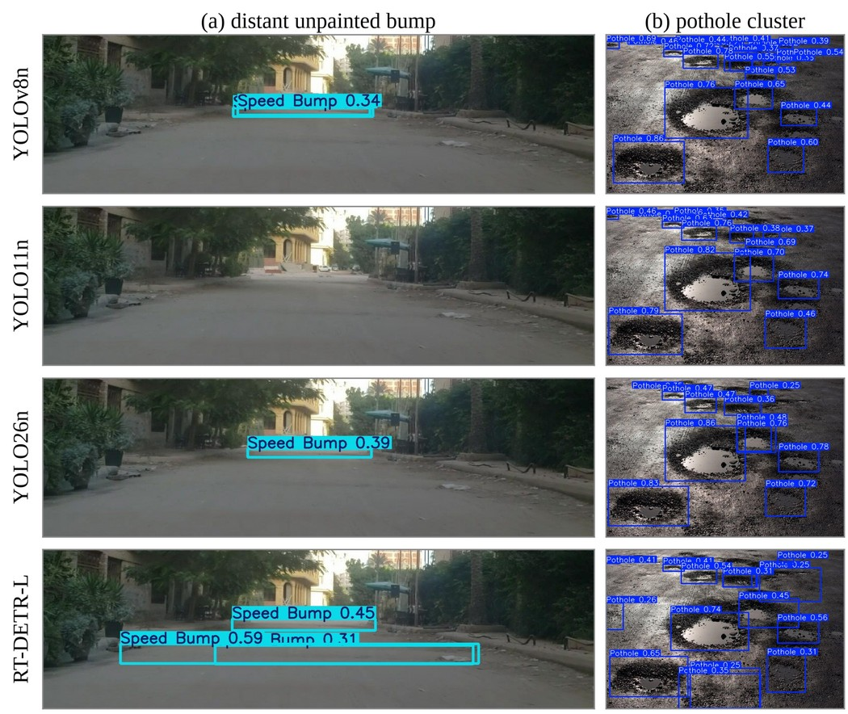
Fig. 5.3 Baseline detections on two test images: (a) a distant unpainted bump, (b) a pothole cluster
5.4.2 Ablation Study of GV-YOLO26
Table 5.3 shows the ablation study, in which the changes were added to YOLO26n one at a time and each stage was evaluated on the same test split. The cost columns are fixed by the architecture and were measured directly. Adding the P2 level raises the computation from 5.3 to 6.6 GFLOPs. The LGDH brings it back to 6.2, GhostConv to 5.8 and VoVGSCSPC to 5.1 GFLOPs, below YOLO26n, while the parameter count falls from 2.38 to 1.57 million. The NWD loss changes only training and adds no cost. Describe the measured change in precision, recall, mAP@0.5, mAP@0.5:0.95 and FPS at each stage once the training runs are complete.
Table 5.3 Ablation study of GV-YOLO26 on the public test split
Configuration | P (%) | R (%) | mAP@​0.5 | mAP@​0.5:​0.95 | GFLOPs | Params (M) | FPS
YOLO26n baseline | TBD | TBD | TBD | TBD | 5.3 | 2.38 | TBD
+ P2 head | TBD | TBD | TBD | TBD | 6.6 | 2.40 | TBD
+ LGDH | TBD | TBD | TBD | TBD | 6.2 | 2.37 | TBD
+ GhostConv | TBD | TBD | TBD | TBD | 5.8 | 2.08 | TBD
+ VoVGSCSPC | TBD | TBD | TBD | TBD | 5.1 | 1.57 | TBD
+ NWD loss (GV-YOLO26) | TBD | TBD | TBD | TBD | 5.1 | 1.57 | TBD
Note: All rows trained with the configuration in Table 4.6 and evaluated on the 208-image test split. GFLOPs (640 × 640) and parameters are for the deployed model (fused, one-to-one head only) with two classes, measured with tools/model_summary.py. FPS on a Tesla T4 at batch size 1. Cells marked TBD are to be filled from the training runs.
5.4.3 Effect of Knowledge Distillation
Table 5.4 shows the effect of distillation. The teacher is GV-YOLO26 at S scale, and the distilled student keeps exactly the architecture and cost of GV-YOLO26, since the teacher is used only during training. Describe the change in mAP@0.5 and mAP@0.5:0.95 after distillation and how close the student comes to the teacher.
Table 5.4 Effect of knowledge distillation
Model | Val mAP@​0.5 | Val mAP@​0.5:​0.95 | Test mAP@​0.5 | Test mAP@​0.5:​0.95
Student (GV-YOLO26) | TBD | TBD | TBD | TBD
Distilled student | TBD | TBD | TBD | TBD
Teacher (GV-YOLO26-S) | TBD | TBD | TBD | TBD
Note: Cells marked TBD are to be filled from the training runs.
5.4.4 Embedded Deployment with TensorRT
Table 5.5 lists the speed of GV-YOLO26 on a Jetson AGX Xavier after TensorRT conversion, with YOLO26n as the reference. Because both models are end-to-end, the timings cover the complete pipeline from input tensor to final boxes, with no separate NMS step. Describe the FP32, FP16 and INT8 throughput once measured on the board.
Table 5.5 TensorRT inference on NVIDIA Jetson AGX Xavier
Model | Precision | Inference time (ms) | FPS | Engine size (MB)
YOLO26n | FP32 | TBD | TBD | TBD
YOLO26n | FP16 | TBD | TBD | TBD
YOLO26n | INT8 | TBD | TBD | TBD
GV-YOLO26 | FP32 | TBD | TBD | TBD
GV-YOLO26 | FP16 | TBD | TBD | TBD
GV-YOLO26 | INT8 | TBD | TBD | TBD
Note: Batch size 1, 640 × 640 input. Cells marked TBD are to be filled from measurements on the board.
5.4.5 Qualitative Detection Results
Fig. 4.8 and Fig. 4.9 show GV-YOLO26 detections on a road image and on a frame from a dashcam clip that were not part of the training data. Examples like these are useful for spotting systematic failures, such as shadows or pedestrian crossings mistaken for bumps, that a single mAP figure can hide.
5.5 Comparison with Existing Techniques
Table 5.6 places GV-YOLO26 beside earlier speed bump and pothole detectors. The other studies used their own datasets, which are often private, as well as different classes and hardware, so the numbers show the range reported in the field rather than a ranking.
Table 5.6 Comparison with existing techniques
Work | Model | Classes | Accuracy | Embedded speed
[10] | CNN | Speed bump | 98.54% (classification) | Raspberry Pi
[1] | YOLOv5 | Speed bump | — | 18.5 ms per frame (Jetson)
[14] | YOLO | Speed bump | 81% mAP | Jetson Nano
[43] | YOLOv8x + stereo | Bumps, rumblers | 93.1% mAP@0.5 | 30 FPS (laptop GPU)
[49] | CRSCCG-YOLOv5s | Bump defects | 96.4% mAP | —
[27] | SBD-YOLO (YOLOv9) | Speed bump | — | 82.8% less computation
[23] | SBP-YOLO (YOLOv11n) | Bump, pothole | 87.0% mAP@0.5 | 139.5 FPS (Jetson AGX Xavier, FP16)
This work | GV-YOLO26 (YOLO26n) | Bump, pothole | TBD | TBD
Note: Values for earlier work are as reported by the respective authors on different datasets and hardware; they are not directly comparable.
Three things distinguish GV-YOLO26 in this comparison. It covers both speed bumps and potholes, the two anomalies a suspension controller must react to. It is the only model in the table built on an end-to-end detector, so its deployed pipeline has no NMS stage. And it was evaluated on a public dataset under the same protocol as seven stock baselines, so its gains can be checked and repeated.
5.6 Discussion of Results
Why YOLO26n as the base. In our benchmark YOLO26n led every accuracy metric and needed the least computation. Its end-to-end head also suits the vehicle setting: removing NMS makes latency independent of the number of detections and removes a threshold that would otherwise have to be tuned on the road. Starting from the strongest and cheapest stock model means that any gain from GV-YOLO26 is a gain over the best available baseline, not over an older one.
Where the gain is expected to come from. Two of the changes act directly on small targets: the P2 level, through the architecture, and the NWD loss, through the training signal. The other three, the LGDH, GhostConv and VoVGSCSPC, are there to pay for the P2 level. The cost measurements show that they do: the P2 level adds 1.3 GFLOPs to YOLO26n, and the three cheap modules together remove 1.5, so the final model is cheaper than the model it started from and has a third fewer parameters. The ablation in Table 5.3 is designed to show whether each accuracy expectation holds as well.
A cost that FLOP counts hide. A high-resolution P2 map increases memory traffic more than it increases arithmetic, so a model with fewer FLOPs can still run slower in PyTorch at batch size 1. For this reason speed is reported as measured frames per second on both the T4 and the Jetson, and not only as GFLOPs.
What the baselines show. Moving from YOLOv8n to YOLO12n changed mAP@0.5 by only 2.5 points on this dataset. A newer generation alone therefore adds little on this task, and the remaining gains have to come from design choices aimed at the problem. GV-YOLO26 should be judged by whether its gain over YOLO26n clearly exceeds this 2.5-point spread.
Relation to the limitations identified earlier. GV-YOLO26 addresses the limitations listed in Section 3.2: it targets small, distant objects, keeps its cost in the class of its base model, runs without NMS on a vehicle-grade board, and is evaluated on public data under a repeatable protocol. The baseline results confirm that the small-object problem is real: in Fig. 5.3 the distant unpainted bump was missed or found at low confidence by every stock model.
Limitations of this study. The baselines were trained once each with one seed for 50 epochs, which left them short of full convergence; differences of under about one point between them should not be read as real. All experiments use a single public dataset of 3,243 images, which is not documented as representing Indian roads specifically. Embedded speed is measured on one board only.
5.7 Chapter Summary
Among seven stock detectors trained under one protocol on a public dataset, YOLO26n was the most accurate (74.8% mAP@0.5) and the cheapest (5.3 GFLOPs), while the YOLO generations from YOLOv8n to YOLO12n differed by only 2.5 points. YOLO26n was therefore chosen as the base of GV-YOLO26. With a P2 level, the LGDH, GhostConv and VoVGSCSPC, GV-YOLO26 needs 1.57 million parameters and 5.1 GFLOPs, less than YOLO26n. The ablation, distillation and deployment experiments measure the accuracy and speed contribution of each change against this baseline under the same protocol.
6. CHAPTER 4 – CONCLUSION AND FUTURE SCOPE
6.1 Summary of the Project
This project set out to build a camera-based detector that finds small, distant speed bumps and potholes accurately while staying light enough for real-time embedded use, the requirement behind suspension preview control. The literature review showed that small-object accuracy and lightweight design usually pull against each other, and that the few designs which tackle both are built on older YOLO generations.
We first benchmarked seven stock detectors on a public dataset under a single fixed protocol and selected YOLO26n, the most accurate and cheapest of them, as the base. On it we designed GV-YOLO26, which rebuilds the backbone and neck with GhostConv and VoVGSCSPC, adds a P2 detection level with a lightweight grouped head, and trains with an NWD-augmented loss, weather augmentation and knowledge distillation before export to TensorRT.
The important outcomes of the project are:
- In a measured benchmark of seven stock detectors, YOLO generations from YOLOv8n to YOLO12n differed by only 2.5 points of mAP@0.5, and YOLO26n was best at 74.8% with the lowest cost of 5.3 GFLOPs.
- GV-YOLO26 was designed on YOLO26n with a GhostConv–VoVGSCSPC backbone and neck, a P2 detection level and a Lightweight Grouped Detection Head that keeps NMS-free inference; it has 1.57 million parameters and 5.1 GFLOPs, against 2.38 million and 5.3 GFLOPs for YOLO26n.
- The training recipe combines small-target-aware label assignment with an NWD box loss, weather augmentation and BCKD + CWD distillation.
- Each design stage has its own configuration file, so the contribution of every change is measured in a step-by-step ablation under one protocol.
- The model exports to a TensorRT engine that produces final detections directly, without a separate NMS step.
- The whole pipeline is built on the open Ultralytics framework and a public dataset, so it can be repeated on a free cloud GPU.
Table 6.1 shows how the project met each of its objectives.
Table 6.1 Achievement of project objectives
Objective | How it was met
Review existing methods, small-object and lightweight techniques | Chapter 2 reviewed over 40 sources and identified four gaps
Select a base detector through a measured benchmark | Seven detectors trained and evaluated under one protocol; YOLO26n selected
Design GV-YOLO26 on YOLO26n | GhostConv, VoVGSCSPC, P2 level and LGDH integrated; one configuration per design stage
Train with NWD loss, augmentation and distillation; measure each change | Training recipe implemented; step-by-step ablation set up in Table 5.3
Export the model and analyse accuracy, size and speed | TensorRT export implemented; results analysed against the baselines and earlier work

6.2 Conclusion
GV-YOLO26 shows how small-object accuracy and real-time embedded speed can be pursued together on the newest generation of YOLO. The design buys small-object accuracy with a high-resolution detection level and a better box loss, and pays for that level with cheaper convolutions and a lighter, DFL-free head, while the end-to-end prediction of YOLO26 removes NMS from the deployed pipeline. Our benchmark points the same way from the other side: on a public dataset, four years of general YOLO development moved accuracy by only a couple of points, which suggests that the remaining gains on this task come from design choices aimed at the problem rather than from newer general-purpose models.
The work also made clear what is still needed before such a detector can go into a vehicle. Its accuracy needs to be confirmed on independent, labelled road data, ideally from Indian roads, and it needs to be tested in a moving vehicle connected to a warning or suspension system. These are where this project goes next.
6.3 Future Scope
- Indian road dataset: collect and label speed bumps and potholes from Tamil Nadu roads, with tags for lighting, weather and marking, and fine-tune GV-YOLO26 on it.
- Multi-seed evaluation: repeat every training run with several seeds to report the mean and spread of each result.
- In-vehicle trial: mount the camera and Jetson board in a vehicle and test the complete pipeline on live roads.
- Further compression: explore pruning and quantisation-aware training to reduce INT8 accuracy loss and fit smaller boards such as the Jetson Orin Nano.
- Severity estimation: estimate bump height and pothole depth, the information a suspension controller needs most [35].
- Distance estimation: estimate the distance to a detected bump from a single camera, to give a suspension controller the time-to-contact it needs [35].
- Temporal consistency: combine detections across consecutive frames to suppress one-off false alarms from shadows and pedestrian crossings.
SDG GOALS
This project is carried out with reference to the following United Nations Sustainable Development Goals.
Goal 3 – Good Health and Well-being. Target 3.6 aims to reduce deaths and injuries from road traffic accidents. Unmarked speed bumps and potholes cause sudden braking, loss of control and falls, especially for two-wheeler riders. A camera-based detector such as GV-YOLO26, which finds these hazards before the vehicle reaches them, can warn the driver or prepare the suspension in time.
Goal 9 – Industry, Innovation and Infrastructure. Target 9.1 calls for quality, reliable and resilient infrastructure, and Target 9.5 calls for stronger scientific research and technological capability. Detected potholes can be logged with their locations and passed to road maintenance agencies, helping them plan repairs. The project also builds an open, repeatable pipeline and a measured baseline that other students and researchers can reuse.
Goal 11 – Sustainable Cities and Communities. Target 11.2 aims to provide safe, affordable and accessible transport systems for all and explicitly mentions improving road safety. GV-YOLO26 needs only a single camera and a small embedded board, so it can be fitted to ordinary vehicles, including two-wheelers and public transport, rather than only to premium cars with advanced driver assistance.
Relevance to Indian roads. The problem this project addresses is especially sharp in India, where many speed bumps are unpainted and do not follow a standard profile, and where two-wheelers make up a large share of road users. A detector that runs in real time on a low-cost board is a realistic way to bring hazard warnings to these vehicles. Collecting and testing on local road data is listed as future work for this reason.
How the outcomes map to the targets. Under Target 3.6, the focus of GV-YOLO26 on small, distant targets matters because the bump that is seen late is the one that causes injury. Under Targets 9.1 and 9.5, the project contributes a documented design and a repeatable baseline benchmark. Under Target 11.2, the small size of the model, 1.57 million parameters and 5.1 GFLOPs, keeps the cost of a deployed system low enough for wide use.
Together, these goals connect the technical focus of this project, accurate detection of small road hazards on low-cost hardware, to its purpose of making everyday road travel safer and more affordable.
PUBLICATIONS
Benadict Infant A, Elangovan S and Dr. P. Shanmugaraja, ‘Comparative Evaluation of YOLOv8 to YOLO26 and RT-DETR for Speed Bump and Pothole Detection’, [Conference name – status: communicated / accepted].
This paper reports the baseline benchmark described in Section 5.4.1 of this report.
REFERENCES

- Aishwarya, R et al. 2023, ‘Robust deep learning based speed bump detection for autonomous vehicles in Indian scenarios’.
- Aquib, M et al. 2026, ‘YOLO models for accurate pothole detection: A comparative study’.
- Asad, MH, Khaliq, S, Yousaf, MH, Ullah, MO & Ahmad, A 2022, ‘Pothole detection using deep learning: A real-time and AI-on-the-edge perspective’, Advances in Civil Engineering, vol. 2022, Article ID 9221211.
- Assemlali, H, Bouhsissin, S & Sael, N 2025, ‘Computer vision-based detection and classification of road obstacles: Systematic literature review’, IEEE Access, doi: 10.1109/ACCESS.2025.3588668.
- Bhavana, B et al. 2024, ‘POT-YOLO: Real-time road potholes detection using edge segmentation-based YOLOv8’, IEEE Access.
- Buslaev, A, Iglovikov, VI, Khvedchenya, E, Parinov, A, Druzhinin, M & Kalinin, AA 2020, ‘Albumentations: Fast and flexible image augmentations’, Information, vol. 11, no. 2, p. 125.
- Celaya-Padilla, JM, Galván-Tejada, CE, López-Monteagudo, FE et al. 2018, ‘Speed bump detection using accelerometric features: A genetic algorithm approach’, Sensors, vol. 18, no. 2, p. 443.
- Darwiche, M & El-Hajj-Chehade, W 2019, ‘Speed bump detection for autonomous vehicles using signal-processing techniques’, BAU Journal – Science and Technology, vol. 1, no. 1, Article 5.
- detection-system 2023, Humps/Bumps & Potholes Detection Dataset, version 8, Roboflow Universe, CC BY 4.0, Available from: https://universe.roboflow.com/detection-system/humps-bumps-potholes-detection/dataset/8 [Accessed 22 Sep 2026].
- Dewangan, DK & Sahu, SP 2021, ‘Deep learning-based speed bump detection model for intelligent vehicle system using Raspberry Pi’, IEEE Sensors Journal, vol. 21, no. 3, pp. 3570–3578.
- Dharneeshkar, J, Soban Dhakshana, V, Aniruthan, SA, Karthika, R & Parameswaran, L 2020, ‘Deep learning based detection of potholes in Indian roads using YOLO’, Proceedings of the International Conference on Inventive Computation Technologies (ICICT).
- Han, K, Wang, Y, Tian, Q, Guo, J, Xu, C & Xu, C 2020, ‘GhostNet: More features from cheap operations’, Proceedings of the IEEE/CVF Conference on Computer Vision and Pattern Recognition (CVPR), pp. 1580–1589.
- Hinton, G, Vinyals, O & Dean, J 2015, ‘Distilling the knowledge in a neural network’, arXiv preprint arXiv:1503.02531.
- Hussein, M et al. 2024, ‘An intelligent approach for speed bump detection’.
- Jakubec, M et al. 2023, ‘Comparison of CNN-based models for pothole detection in real-world adverse conditions’, Sensors.
- Jocher, G, Chaurasia, A & Qiu, J 2023, Ultralytics YOLOv8, Available from: https://github.com/ultralytics/ultralytics [Accessed 22 Sep 2026].
- Khan, M, Raza, MA, Abbas, G, Othmen, S, Yousef, A & Jumani, TA 2024, ‘Pothole detection for autonomous vehicles using deep learning: A robust and efficient solution’, Frontiers in Built Environment, vol. 9, doi: 10.3389/fbuil.2023.1323792.
- Khanam, R & Hussain, M 2024, ‘YOLOv11: An overview of the key architectural enhancements’, arXiv preprint arXiv:2410.17725.
- Kothari, A et al. 2025, ‘Enhancing pothole detection: Comparing YOLO variants with validation on multi-weather images’.
- Lee, Y, Hwang, J, Lee, S, Bae, Y & Park, J 2019, ‘An energy and GPU-computation efficient backbone network for real-time object detection’, Proceedings of the IEEE/CVF Conference on Computer Vision and Pattern Recognition Workshops (CVPRW).
- Li, H, Li, J, Wei, H, Liu, Z, Zhan, Z & Ren, Q 2024, ‘Slim-neck by GSConv: A lightweight-design for real-time detector architectures’, Journal of Real-Time Image Processing, vol. 21, Article 62.
- Li, H et al. 2026, ‘Research on low-light speed bump detection algorithm based on improved YOLOv8n’.
- Liang, C, Fu, J, Yu, M & Luo, L 2025a, ‘SBP-YOLO: A lightweight real-time model for detecting speed bumps and potholes toward intelligent vehicle suspension systems’, arXiv preprint arXiv:2508.01339.
- Liang, C 2025b, SBP-YOLO: Official implementation, GitHub repository, GPL-3.0, Available from: https://github.com/chuanqi1997/SBP-YOLO [Accessed 8 Oct 2026].
- Liang, C et al. 2026, ‘SBP-YOLO: A lightweight real-time model for detecting speed bumps and potholes toward intelligent vehicle suspension systems’, Journal of Real-Time Image Processing, vol. 23, doi: 10.1007/s11554-025-01849-x.
- Magdy, A et al. 2023, ‘Lane and bump detection based on computer vision and deep learning methods’.
- Mao, Y et al. 2026, ‘SBD-YOLO: An efficient speed bump detector for active suspension preview control’.
- Mohan Prakash, B & Sriharipriya, KC 2022, ‘Enhanced pothole detection system using YOLOX algorithm’, Autonomous Intelligent Systems, vol. 2, no. 1, Article 22.
- NVIDIA 2026, NVIDIA TensorRT Documentation, Available from: https://docs.nvidia.com/deeplearning/tensorrt/ [Accessed 8 Oct 2026].
- Park, SS, Tran, VT & Lee, DE 2021, ‘Application of various YOLO models for computer vision-based real-time pothole detection’, Applied Sciences, vol. 11, no. 23, p. 11229.
- Peralta-López, JE, Morales-Viscaya, JA, Lázaro-Mata, D et al. 2023, ‘Speed bump and pothole detection using deep neural network with images captured through ZED camera’, Applied Sciences, vol. 13, no. 14, p. 8349.
- Pham, V, Ngoc, LDT & Bui, DL 2024, ‘Optimizing YOLO architectures for optimal road damage detection and classification: A comparative study from YOLOv7 to YOLOv10’, IEEE BigData 2024 Optimized Road Damage Detection Challenge, arXiv:2410.08409.
- Saffarini, R, Khamayseh, F, Daraghmi, YA, Elyan, D & Sabha, M 2023, ‘Survey of road anomalies detection methods’, International Journal of Intelligent Systems Technologies and Applications, vol. 21, no. 3.
- Safyari, M et al. 2024, ‘A review of vision-based pothole detection methods using computer vision and machine learning’, Sensors.
- Shen, Y, Jing, K, Sun, K, Liu, C, Yang, Y & Liu, Y 2025, ‘Review of uneven road surface information perception methods for suspension preview control’, Sensors, vol. 25, Article 5884.
- Shu, C, Liu, Y, Gao, J, Yan, Z & Shen, C 2021, ‘Channel-wise knowledge distillation for dense prediction’, Proceedings of the IEEE/CVF International Conference on Computer Vision (ICCV), pp. 5311–5320.
- Tamagusko, T et al. 2023, ‘Optimizing pothole detection in pavements: A comparative analysis of deep learning models’.
- Tian, Y, Ye, Q & Doermann, D 2025, ‘YOLOv12: Attention-centric real-time object detectors’, Advances in Neural Information Processing Systems (NeurIPS 2025), arXiv:2502.12524.
- ‘Towards safer roads: A review of hybrid machine learning and vision-based approaches for speed bump detection in intelligent transportation systems’ 2025, International Journal of Safety and Security Engineering.
- Ultralytics 2026a, ‘Ultralytics YOLO26: Unified real-time end-to-end vision models’, arXiv preprint arXiv:2606.03748.
- Ultralytics 2026b, YOLO26 Model Documentation, Available from: https://docs.ultralytics.com/models/yolo26 [Accessed 22 Sep 2026].
- Varma, VSKP, Adarsh, S, Ramachandran, KI & Nair, BB 2018, ‘Real time detection of speed hump/bump and distance estimation with deep learning using GPU and ZED stereo camera’, Procedia Computer Science, vol. 143, pp. 988–997.
- Vasisht, S et al. 2026, ‘Real-time detection of speed breakers and rumblers using advanced deep learning algorithms’.
- Wang, A et al. 2024, ‘YOLOv10: Real-time end-to-end object detection’, Advances in Neural Information Processing Systems (NeurIPS 2024).
- Wang, CY, Yeh, IH & Liao, HYM 2024, ‘YOLOv9: Learning what you want to learn using programmable gradient information’, Proceedings of the European Conference on Computer Vision (ECCV), arXiv:2402.13616.
- Wang, J, Xu, C, Yang, W & Yu, L 2021, ‘A normalized Gaussian Wasserstein distance for tiny object detection’, arXiv preprint arXiv:2110.13389.
- Wang, J et al. 2024, ‘Research on visual perception of speed bumps for intelligent connected vehicles based on lightweight FPNet’, Sensors.
- Wang, Y et al. 2022, ‘Automatic detection of pothole distress in asphalt pavement using improved convolutional neural networks’.
- Xiang, Q et al. 2024, ‘Research on detection of multiple types of speed bump defects based on CRSCCG-YOLOv5s’.
- Yang, L et al. 2023, ‘Bridging cross-task protocol inconsistency for distillation in dense object detection’, Proceedings of the IEEE/CVF International Conference on Computer Vision (ICCV).
- Zhao, Y et al. 2024, ‘DETRs beat YOLOs on real-time object detection’, Proceedings of the IEEE/CVF Conference on Computer Vision and Pattern Recognition (CVPR), pp. 16965–16974.

