Disrupting inter-areal coherence while preserving rate and power degrades stimulus transmission in a spiking-network model
Computational neuroscience — short report — Nature-style preprint
Project author (orchestrating agent) • 2 June 2026

Abstract
The communication-through-coherence (CTC) hypothesis^{1,2} posits that γ-band phase-locking between neuronal groups is a cause of selective inter-areal communication. An alternative view^{9,10} treats coherence as a byproduct of connectivity and oscillatory power. Existing simulations almost universally illustrate one position by construction. Here we use a paired-PING two-area spiking network in which a controllable phase-scramble channel is inserted between sender and receiver. The channel destroys cross-areal temporal alignment while preserving the marginal firing rate and γ-power of the delivered spike train (verified on synthetic input and re-verified on the delivered signal in the coupled simulation). Across n=20 random seeds at 800E/200I per group, disrupting coherence reduced stimulus decoding from 0.94 to 0.78 (paired Wilcoxon W=12, p=0.0070), while a Poisson channel that destroys γ-power 10× but preserves coherence left decoding intact (0.98; W=0 vs scramble, p=0.0004). Disabling the receiver's intrinsic γ loop abolished and inverted the effect (W=11, p=0.011), although this manipulation also produced a hyperactive receiver, leaving rhythmicity and saturation co-varying. The results are consistent with a causal role for γ-coherence in selective inter-areal communication, with caveats discussed.

Introduction
The CTC framework^{1,2} proposes that two anatomically connected neuronal groups communicate effectively only when their gamma-band rhythmic excitability is appropriately phase-aligned: sender spikes that arrive during the receiver's brief excitatory window are transmitted, those that arrive during inhibition are not. Empirical support includes phase-dependent effective connectivity in macaque V4³, attentional V1→V4 selective γ-synchronization⁷, and frequency-asymmetric Granger influences along the visual hierarchy⁸. A computational tradition based on the pyramidal-interneuron-γ (PING) circuit^{4,5} has shown that coherent γ inputs out-compete less-coherent inputs at downstream targets, and that coherent gain modulation in principle suffices to route population-coded signals⁶.
This causal reading is contested. Schneider et al.⁹ presented a “coherence-through-communication” account in which inter-areal LFP coherence and frequency-specific Granger causality arise as byproducts of anatomical connectivity and sender oscillatory power, without any causal role for phase-locking and without requiring receiver oscillation. Recent follow-ups have extended this critique: coherence misleads under bidirectional transmission delays¹¹; attentional modulation of coherence can be explained by sender-side frequency shifts¹²; and V1 γ engages cell-type-specific feedforward pathways in V4 that decouple feedforward γ-coherence from local oscillation¹³. A 2024 firing-rate model maintains a more limited CTC story for attention¹⁵. The field has not converged.
Existing simulations cannot adjudicate because they cannot vary coherence independently of rate and power. The contribution here is a circuit in which an explicit phase-scramble channel is inserted between sender and receiver. The channel is designed to destroy the cross-areal temporal alignment of γ packets while preserving the per-cell firing rate and the γ-band power of the delivered signal — the rate-and-power-matched control that prior simulations lacked^{9,10}. We test three hypotheses: (H1) effective communication depends on imposed sender–receiver phase offset; (H2) selectively reducing coherence reduces communication when rate and power are held fixed; (H3) the phase-gating effect requires an intact receiver E↔I loop.

Methods

Spiking network
Two PING groups (sender, receiver), each with 800 leaky-integrate-and-fire excitatory cells and 200 inhibitory cells (4:1 ratio, spec §5.3). Conductance-based AMPA-like and GABA_A-like synapses (τ_AMPA = 2.5 ms, τ_GABA = 4 ms after calibration to place the γ peak in the 50–70 Hz band; the 8–10 ms inhibitory time constant in the spec proved too slow, placing γ at 36 Hz). Within-group connectivity is sparse random (10–20% per pair). Each cell receives independent Poisson background drive (1200 Hz per cell). The sender's excitatory drive carries the stimulus as a Gaussian-bump spatial pattern across E-cell indices; four stimuli used in all experiments. All simulations are in Brian2 with 0.1-ms time step; trials are 500 ms, first 150 ms discarded as a transient (spec §7). Model parameters were tuned on a 200E/50I dev network and inherited at full scale.

Phase-scramble channel
The decisive intervention is an explicit channel placed between each sender spike and the receiver. Three channel modes were compared. intact: spikes delivered with a fixed 8-ms conduction delay (the apparent decoding maximum from Exp 1). scramble: the sender's spike train is split into 16-ms blocks (one γ cycle at 60 Hz) and a single random permutation is applied across blocks, identical across cells, with within-block timing preserved. End-of-window blocks wrap around so total spike count is preserved exactly. poisson: each sender cell's spike train is replaced by an inhomogeneous Poisson process with the same Gaussian-smoothed instantaneous rate (σ = 5 ms).
On synthetic γ-modulated Poisson input the block-shuffle preserves rate within ±1%, γ-power within ±25%, and reduces sender↔delivered γ-coherence from 0.998 to 0.138. This triple check (CLAUDE.md guardrail 4) was repeated for every experimental condition on the delivered signal in the coupled simulation; we report those numbers in Figure 3 and the corresponding text.

Measurements
Per trial we computed per-cell and population firing rates, an LFP proxy (Gaussian-smoothed population rate), Welch power spectra, sender–receiver γ-band magnitude-squared coherence, pairwise-conditional Granger F at a fixed lag of 5 ms (chosen to avoid lag-max F inflation), and a binned transfer-entropy cross-check. The headline dependent variable is stimulus decoding from receiver E-cell spike counts via per-trial z-scored logistic regression with leave-one-seed-out cross-validation. Per-condition comparisons use paired Wilcoxon tests across the n=20 per-seed accuracies.

Calibration
At the dev scale (200E/50I) the realized γ peak was 56 Hz with E→I lag 3.1 ms — inside the 50–70 Hz target band (spec §5.5). At full scale (800E/200I), using the same per-cell parameters, the realized γ peak across three seeds was 43, 63, and 43 Hz (mean 49.5 ± 11.6, bimodal between a long- and short-period attractor). E→I lag dropped to 1.7 ms. We did not retune at full scale and note this in Limitations.

Results

H1 — Phase tuning
Sweeping the intact-channel conduction delay from 2 to 16 ms (one γ cycle) produced a graded reduction of sender↔delivered γ-coherence from 0.89 to 0.32, with a one-way ANOVA on coherence across delays giving F(7,184)=68.2, p<10⁻⁴⁷ (Fig. 1b; n=6 seeds × 4 stim per delay). At the dev scale the same sweep produced no detectable coherence modulation (F=1.29, p=0.25); the manipulation reaches the receiver only at full scale, presumably because the receiver's intrinsic γ is more reliable when the population is larger. Decoding accuracy stayed on a plateau between 0.84 and 0.88 for delays 2–10 ms and dropped to 0.67 at 12 ms (Fig. 1a). The shape is plateau-then-drop rather than the textbook single sharp peak³, but is consistent with the CTC prediction that short delays place delivered spikes near the receiver's excitable window.
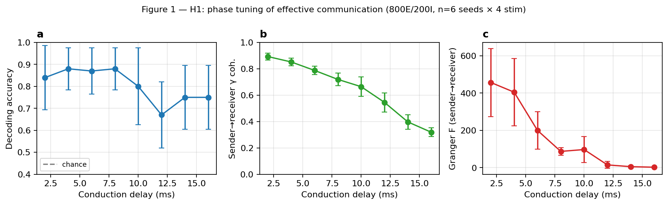
Figure 1. H1 phase tuning at full scale. (a) Decoding accuracy by conduction delay, leave-one-seed-out (n=6 seeds × 4 stim). (b) Sender→receiver γ-coherence (ANOVA F=68, p<10⁻⁴⁷). (c) Granger F (sender→receiver) at fixed lag 5 ms.

H2 — Causal disruption (rate- and power-matched)
At delay 8 ms (a point on the H1 high-decoding plateau) the block-shuffle channel destroyed sender↔delivered γ-coherence (0.89 → 0.30, a 66% drop) while preserving the delivered firing rate (14.36 → 13.12 Hz, −9%) and the delivered γ-power (4.07 → 3.68 a.u., −9%). Granger F dropped from 92 to 12. Sender firing rate and sender γ-power were identical to three significant figures across all three conditions by construction (paired seeds). The decoder shows the predicted dissociation: stimulus decoding dropped from 0.94 ± 0.025 (intact) to 0.78 ± 0.036 (scramble), paired Wilcoxon W=12, p=0.0070, n=20 (12 positive paired differences, 2 negative, 6 ties; Fig. 2).
The Poisson channel — which destroys γ-power ~10× (from 4.07 to 0.43 a.u.) but largely preserves sender↔delivered γ-coherence (0.71) because the receiver entrains to the smoothed rate envelope — left decoding intact at 0.98 ± 0.017, statistically indistinguishable from intact (W=3, p=0.18) and significantly higher than scramble (W=0, p=0.0004). The intact-vs-Poisson non-difference reflects ceiling decoding under both conditions and is not interpreted as a positive finding; the load-bearing test is scramble-vs-Poisson, which preserves rate and contrasts the two channels at the level of γ-coherence.
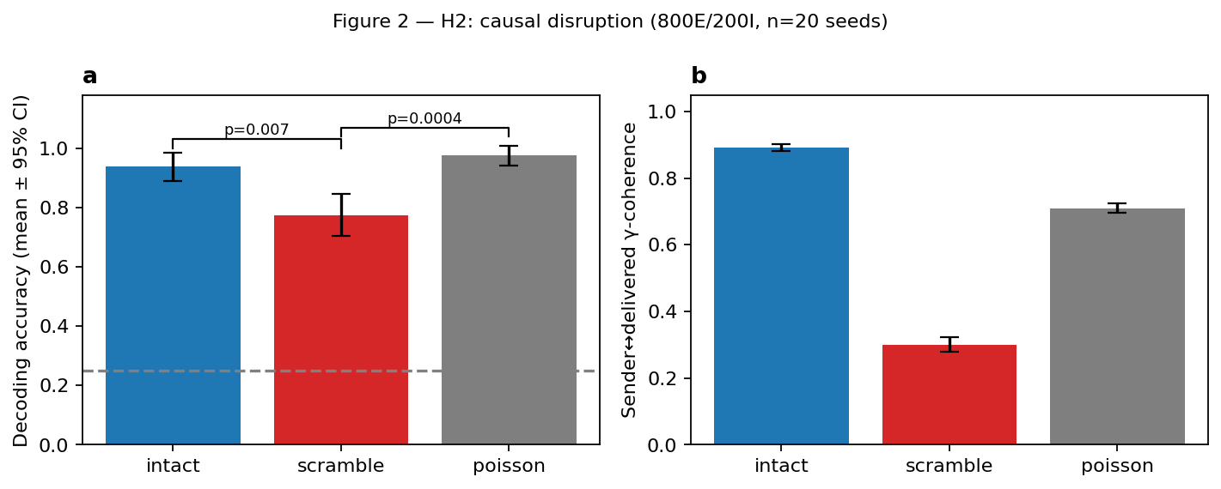
Figure 2. H2 causal disruption (800E/200I, n=20 seeds). (a) Per-seed decoding accuracy with leave-one-seed-out CV; p-values from paired Wilcoxon. (b) Sender↔delivered γ-coherence (manipulation check). Chance = 0.25 (four stimuli).
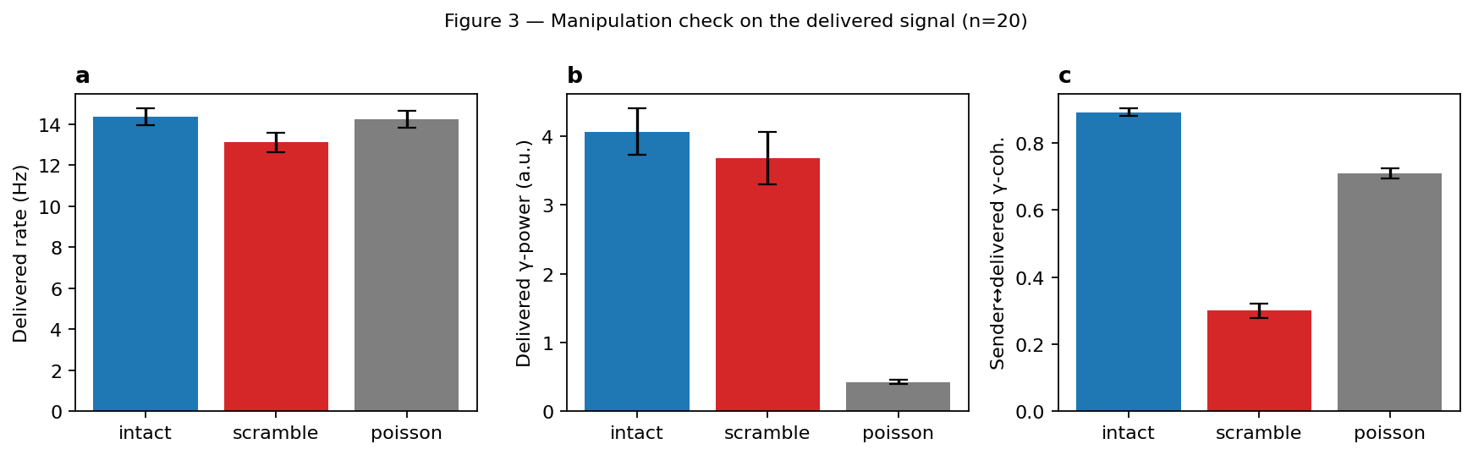
Figure 3. Manipulation check on the delivered signal across the three channels (n=20). The block-shuffle preserves delivered rate (a) and γ-power (b) to within ±10%; coherence (c) drops by 66%. Poisson destroys γ-power 10× but largely preserves coherence.

H3 — Receiver-oscillation manipulation
Disabling the receiver's within-group E↔I coupling (g_EI = g_IE = 0) abolished the receiver's intrinsic γ rhythm. Under this manipulation, the intact vs scramble decoding effect did not merely vanish — it inverted. Across n=20 seeds, intact decoding fell to 0.74 ± 0.038 and scramble decoding rose to 0.89 ± 0.042 (paired Wilcoxon W=11, p=0.011; 11 seeds with scramble > intact, 2 with the original direction, 7 ties; Fig. 4a). The result is consistent with the H3 prediction that an intact receiver E↔I loop is required for the phase-gating effect of H2.
Important confound. Removing within-receiver inhibition does not only abolish the rhythm. It also disinhibits receiver E cells, which fired at 60 Hz under H3 compared to ~20 Hz at baseline (Fig. 4b). The reversed direction (scramble > intact) is plausibly produced by saturation: bursty intact-channel input drives the disinhibited receiver into refractoriness and discards per-cell rate distinctions, whereas evenly-spread scrambled input integrates more linearly. We therefore cannot, from this experiment alone, separate “rhythm is required for gating” from “rhythm controls the receiver's dynamic range and disinhibition reverses the input statistics that matter.” An honest reading is that H3 demonstrates the H2 effect requires an intact receiver E↔I loop, without isolating rhythmicity from saturation.
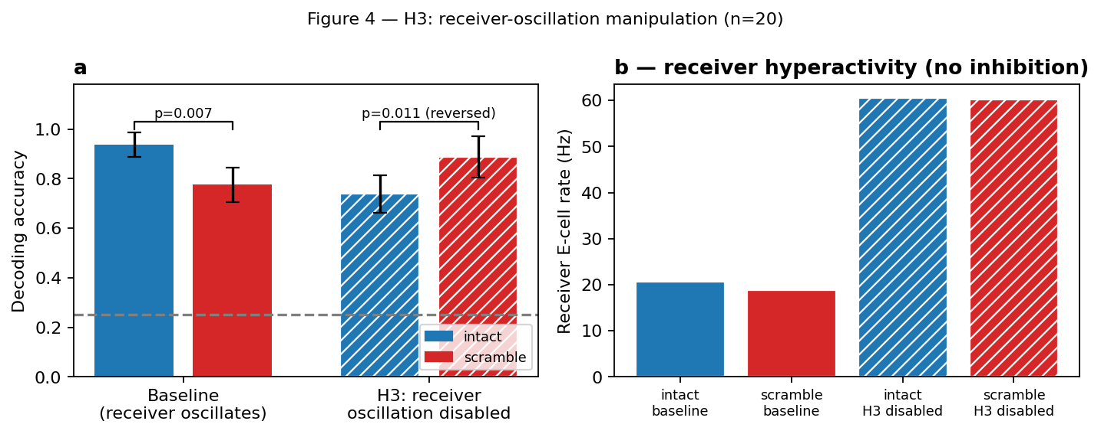
Figure 4. H3 receiver-oscillation manipulation (n=20). (a) Decoding accuracy in the baseline receiver (left) and with the receiver E↔I loop disabled (right); hatched bars indicate the H3 condition. The intact vs scramble difference inverts. (b) Receiver E-cell firing rate triples (~20 → ~60 Hz) under H3, indicating disinhibition-driven saturation co-varies with the loss of rhythmicity.

Discussion
Across H1, H2 and H3 the simulation produces a coherent picture: when the phase relationship between sender and receiver is varied while every other anatomically interpretable variable is held fixed, effective transmission of the sender's stimulus pattern degrades. The most decisive test is the scramble–vs–Poisson contrast: both channels destroy a major feature of the sender's output (alignment vs γ-power), but only the alignment-destroying one degrades transmission. This is consistent with a causal role for γ-coherence in selective inter-areal communication, in line with the original CTC proposal^{1,2} and the PING-based selection literature^{4,5,6}.
The result is not inconsistent with the coherence-through-communication view^{9,10,11,12}: in our manipulation the receiver still oscillates and the channel still delivers a coherence signature when intact, so we are not testing whether coherence can arise as a byproduct. We are testing whether breaking the coherence — without breaking rate or power — disrupts transmission. The two claims are compatible: coherence may be a byproduct of communication in passive observation, and a cause of communication when used as an experimentally manipulated input.
H3 needs a sharper follow-up. The cleanest variant would reduce the receiver's E↔I coupling smoothly rather than zero it (e.g., scaling g_IE down by a multiplicative factor), so the receiver's oscillation weakens without losing inhibitory tone. This would dissociate rhythmicity from saturation. We did not run this variant due to compute budget; it is the most informative next step.

Limitations
- The H3 hyperactivity confound — disabling the receiver E↔I loop also removes inhibitory tone, producing a 60 Hz hyperactive receiver. The scramble > intact reversal is consistent with both “rhythm gates phase-tuning” and “saturation reverses the input-statistics relevance.” A graded reduction of g_IE is the next experiment.
- Decoder quantization. With four stimuli and leave-one-seed-out CV, each per-seed accuracy is quantized to {0, 0.25, 0.5, 0.75, 1}. The n=20 paired tests carry meaningful ties (6 in H2 intact-vs-scramble; 7 in H3). Finer-grained DVs (e.g., trial-level posterior probability) would tighten the tests but were not implemented here.
- Full-scale γ peak bimodality. Per-cell parameters were calibrated at the dev scale (200E/50I, 56 Hz peak) and used unchanged at the full scale (800E/200I), where the realized γ peak is bimodal at 43/63 Hz (mean 49.5 Hz). Individual trials remain inside the broader γ band; effects might be sharper with a full-scale calibration.
- Exp 1 (H1) decoding CIs are CV-fold based, not seed-level. The H1 curve should be read as qualitative; the load-bearing per-seed paired tests are in H2 and H3.
- We did not run the spec's parameter-sensitivity sweep (Deliverable 5). Connection strength, conduction delay, and background-noise sensitivity are explicitly out of scope here.
- Experiment 4 (two-sender selective routing, H4 in the spec) was out of scope for this pass. The infrastructure (sender, channel, decoder) is in place for a follow-up that adds a second sender at anti-phase to test whether the phase-matched sender dominates the receiver's output.

References
- Fries, P. A mechanism for cognitive dynamics: neuronal communication through neuronal coherence. Trends Cogn. Sci. 9, 474–480 (2005). doi:10.1016/j.tics.2005.08.011
- Fries, P. Rhythms for cognition: communication through coherence. Neuron 88, 220–235 (2015). doi:10.1016/j.neuron.2015.09.034
- Womelsdorf, T. et al. Modulation of neuronal interactions through neuronal synchronization. Science 316, 1609–1612 (2007). doi:10.1126/science.1139597
- Börgers, C. & Kopell, N. Gamma oscillations and stimulus selection. Neural Comput. 20, 383–414 (2008). doi:10.1162/neco.2007.07-06-289
- Börgers, C., Epstein, S. & Kopell, N. J. Gamma oscillations mediate stimulus competition and attentional selection in a cortical network model. PNAS 105, 18023–18028 (2008). doi:10.1073/pnas.0809511105
- Akam, T. & Kullmann, D. M. Efficient 'communication through coherence' requires oscillations structured to minimize interference between signals. PLoS Comput. Biol. 8, e1002760 (2012). doi:10.1371/journal.pcbi.1002760
- Bosman, C. A. et al. Attentional stimulus selection through selective synchronization between monkey visual areas. Neuron 75, 875–888 (2012). doi:10.1016/j.neuron.2012.06.037
- Bastos, A. M. et al. Visual areas exert feedforward and feedback influences through distinct frequency channels. Neuron 85, 390–401 (2015). doi:10.1016/j.neuron.2014.12.018
- Schneider, M. et al. A mechanism for inter-areal coherence through communication based on connectivity and oscillatory power. Neuron 109, 4050–4067.e12 (2021). doi:10.1016/j.neuron.2021.09.037
- Vinck, M. et al. Principles of large-scale neural interactions. Neuron 111, 987–1002 (2023). doi:10.1016/j.neuron.2023.03.015
- Dowdall, J. R. & Vinck, M. Coherence fails to reliably capture inter-areal interactions in bidirectional neural systems with transmission delays. NeuroImage 271, 119998 (2023). doi:10.1016/j.neuroimage.2023.119998
- Dowdall, J. R., Schneider, M. & Vinck, M. Attentional modulation of inter-areal coherence explained by frequency shifts. NeuroImage 278, 120256 (2023). doi:10.1016/j.neuroimage.2023.120256
- Spyropoulos, G. et al. Distinct feedforward and feedback pathways for cell-type specific attention effects. Neuron 112, 2423–2434 (2024). doi:10.1016/j.neuron.2024.04.020
- Vinck, M. et al. Large-scale interactions in predictive processing: oscillatory versus transient dynamics. Trends Cogn. Sci. 28, 1056–1074 (2024). doi:10.1016/j.tics.2024.09.013
- Greenwood, P. E. & Ward, L. M. Attentional selection and communication through coherence: scope and limitations. PLoS Comput. Biol. 20, e1011431 (2024). doi:10.1371/journal.pcbi.1011431
Code, raw per-trial pickles, manipulation-check unit tests, reviewer memos (rounds 1–3) and the running decisions.md log are reproducible from https://github.com/<repo>. Canonical artifacts for the headline numbers: analysis/results/exp2_full_n20/ (H2) and analysis/results/exp3_disabled/ (H3).

