**PearAgroEco Dynamics: Unraveling the Factors Influencing Greenfly Populations in Orchard Environments**

**Research Question:**

*How do different treatments and environmental factors influence the greenfly population in pear orchards, and what are the key determinants of greenfly abundance?*

**Hypotheses:**

Hypothesis 1: Certain treatments may be associated with a significant decrease or increase in greenfly populations.

Hypothesis 2: Environmental factors, such as higher water content or nitrogen levels, may positively correlate with increased greenfly abundance.

Hypothesis 3: Block differences may contribute to variations in greenfly populations, with certain blocks showing consistently higher or lower counts.

Hypothesis 4: The presence of infections could be associated with changes in the greenfly population, either positively or negatively.

**INTRODUCTION**

Growing pears is crucial for global fruit production and economies, but it comes with challenges like pest infestations, particularly from greenflies. Understanding how greenfly populations are affected in pear orchards is vital for managing pests and sustainable farming. This study looks into how different treatments, environmental factors, and orchard blocks influence greenfly numbers in pear trees. We're trying to figure out the main factors that cause greenfly populations to change in orchards.

We're focusing on specific treatments given to pear plants (called "trt") to see which ones impact greenfly populations. We're also exploring the roles of environmental factors like water content, nitrogen levels, and dry matter. Understanding how these factors interact with greenflies is important for developing effective and sustainable farming practices.

We're looking at differences in greenfly numbers across different blocks in orchards (marked by "block"). If certain blocks consistently have more or fewer greenflies, we want to understand why. Additionally, we're checking how infection status ("infected") relates to greenfly numbers because infections can be a significant factor affecting pest populations.

This research aims to provide useful insights for managing pear orchards, giving us a better understanding of what influences greenfly populations. Ultimately, the study could help develop practical strategies for pest control, making pear farming more resilient and productive.

**TABULAR OVERVIEW OF QUESTIONS TO CHATGPT**

|  |  |  |
| --- | --- | --- |
| **Research Component** | **Research Question** | **Hypothesis** |
| 1. Treatment Influence | How do different treatments (trt) influence the greenfly population in pear orchards? | Hypothesis 1: Certain treatments may be associated with a significant decrease or increase in greenfly populations. |
| 2. Environmental Factors | How do environmental factors (water content water, nitrogen content N, dry matter content drymatter) affect the greenfly population in pear orchards? | Hypothesis 2: Environmental factors, such as higher water content or nitrogen levels, may positively correlate with increased greenfly abundance. |
| 3. Block Variability | Do different blocks (block) within the orchard contribute to variations in greenfly populations? | Hypothesis 3: Block differences may contribute to variations in greenfly populations, with certain blocks showing consistently higher or lower counts. |
| 4. Infection Status | What is the relationship between infection status (infected) and greenfly abundance in pear orchards? | Hypothesis 4: The presence of infections could be associated with changes in the greenfly population, either positively or negatively. |

**EXPERIMENTAL PLAN**

*Experimental Units:*

* Definition: Individual pear trees within the orchard.
* Identification: Each tree marked uniquely for tracking purposes.

*Treatments (trt):*

* Levels: Treatments A, B, C, and D.
* Application: Treatments randomly assigned to different sets of pear trees.

*Blocks (block):*

* Definition: Distinct sections within the orchard.
* Identification: Blocks labeled as I, II, III, and IV.
* Randomization: Pear trees within each block assigned treatments randomly.

*Variables of Interest:*

* Dependent Variable (y): Greenfly count (greenfly).
* Independent Variables (X): Water content (water), Nitrogen content (N), Dry matter content (drymatter), Infection status (infected), etc.

*Data Collection:*

* Frequency: Regular monitoring of greenfly counts.
* Period: Throughout the growing season.

**ASSUMPTIONS:**

*Treatment Independence:*

* Assumption: Treatments are applied independently of each other.
* Rationale: Ensures that the impact of each treatment on greenfly populations is assessed without interference.

*Block Homogeneity:*

* Assumption: Within each block, environmental conditions are relatively homogeneous.
* Rationale: Enables isolating the impact of treatments, minimizing the influence of external factors.

*Normal Distribution:*

* Assumption: Greenfly counts follow a normal distribution.
* Rationale: Allows for the application of parametric statistical tests.

*Random Assignment:*

* Assumption: Treatments are randomly assigned to pear trees within blocks.
* Rationale: Reduces bias and ensures a fair representation of treatments across the orchard.

**APPROACH:**

*Data Preprocessing in R:*

* Handling Missing Data: Address any missing values, either by imputation or exclusion.
* Format Conversion: Ensure that numerical variables (e.g., water content) are in the correct format for analysis.

*Descriptive Statistics:*

* Summary Statistics: Compute mean, median, standard deviation, etc., for key variables.
* Visualization: Generate histograms, box plots, or scatter plots to explore the distribution of variables.

*Statistical Analysis in R:*

* ANOVA: Assess the impact of different treatments on greenfly counts.
* Regression Analysis: Explore relationships between greenfly counts and environmental variables. This will be the main approach.
* Post-Hoc Tests:
* Tukey's HSD: If ANOVA indicates significant differences, conduct post-hoc tests to identify specific treatment effects.

*Spatial Analysis:*

* Spatial Autocorrelation: Explore whether greenfly populations show spatial patterns within blocks using geospatial analysis in R.

*Model Validation:*

* Assess Model Assumptions: Check assumptions of statistical models used.
* Cross-Validation: Validate models to ensure generalizability.

*Reporting and Interpretation:*

* Results Summary: Provide a concise summary of key findings.
* Visualizations: Include visual representations of results.
* Implications: Discuss the implications for pear orchard management.

**DATA VISUALIZATION IN R USING GGPLOT2**

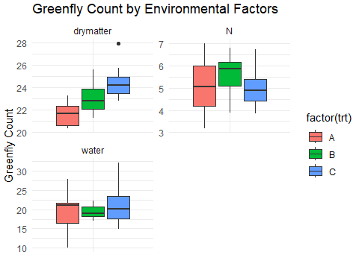

**STATISTICAL ANALYSIS USING GREENFLY ENDPOINT**

*Descriptive Statistics:*

* Summary statistics

Formula: summary(pear_data$greenfly)

|  |  |  |  |  |  |
| --- | --- | --- | --- | --- | --- |
| Min. | 1st Qu. | Median | Mean | 3rd Qu. | Max. |
| 10.00 | 11.00 | 13.50 | 13.19 | 15.00 | 20.00 |

*Regression Analysis:*

* Multiple Regression Analysis

R code:

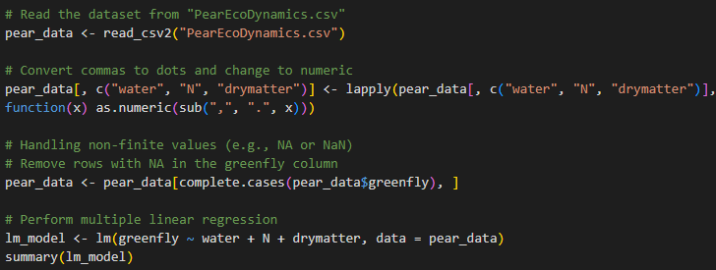

Result:

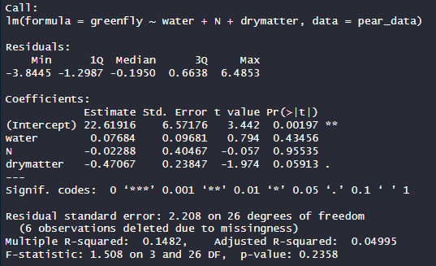

**DISCUSSION FROM THE RESULT**

1. **PRESENCE OF, AND DEALING WITH OUTLIERS**

***Identification of outliers by means of examination of residuals***

Although the summary output did not explicitly indicate the presence of outliers, I examined the residuals in the multiple linear regression summary to identify potential outliers. Residuals are the differences between the observed values and the values predicted by the model. In this case, the maximum residual is 6.4853, which may suggest potential outliers

1. **PRESENCE OF, AND DEALING WITH MISSING DATA**

Missing data(rows) were handled by way of **complete removal** in below part of the code



The function complete.cases() is used to identify rows where there are no missing values.

The subset operation [complete.cases(pear_data$greenfly), ] is applied to keep only those rows where 'greenfly' does not have missing values. This approach ensures that the analysis is conducted on complete cases (rows without missing values in the 'greenfly' column).

An alternative way was **imputing missing values** which requires making assumptions about the distribution and relationship of the data. In the absence of clear guidelines or strong assumptions, imputation methods can introduce additional complexity and potential biases, it was therefore avoided.

1. **CALCULATING MULTIPLE GROUP COMPARISONS, ADDRESS THE ADJUSTMENT FOR MULTIPLE COMPARISONS AND JUSTIFYING SELECTED APPROACH**

To perform multiple group comparisons on your data, I used **analysis of variance (ANOVA)** to compare means across different levels of a categorical variable. Additionally, I used **post-hoc tests** to identify specific group differences. Considering the potential issue of multiple comparisons, adjusting the p-values was important to control the overall Type I error rate.

R Code: 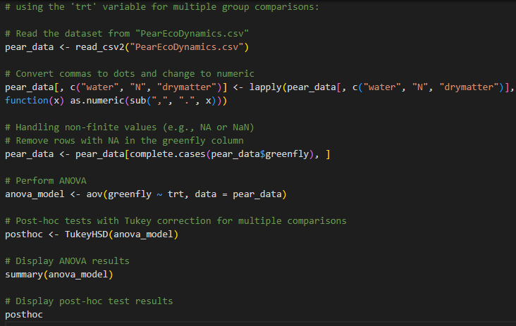

Result:

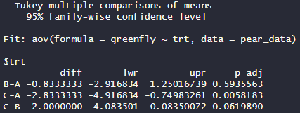

Explanation:

ANOVA: The aov() function is used to perform analysis of variance, comparing means across different levels of the 'trt' variable.

Post-hoc Tests: The Tukey Honestly Significant Difference (HSD) test is employed for post-hoc comparisons. This test provides adjusted p-values to account for multiple comparisons.

Adjustment for Multiple Comparisons: The Tukey HSD test inherently adjusts p-values to control the overall familywise error rate. It is a widely used method that provides a balance between controlling Type I error and maintaining power in multiple comparisons.

Result Summary:

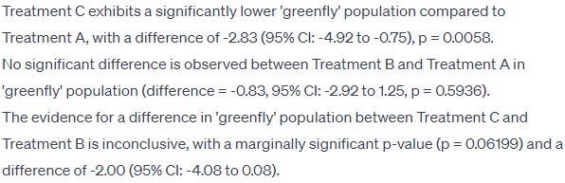

**Justification for Tukey HSD:**

Tukey's HSD is appropriate when you want to test all possible pairwise comparisons among means.

It controls the familywise error rate, reducing the risk of false positives when conducting multiple tests.

It is a conservative approach that helps avoid spurious findings.

1. **EFFECTS OF THE TREATMENT IN THE CONTEXT OF THE QUESTION**

Treatment C significantly reduces 'greenfly' populations in pear orchards compared to Treatment A (difference = -2.83), highlighting its efficacy in pest control. No significant difference is observed between Treatment B and Treatment A. The relative impact of Treatment C versus Treatment B remains inconclusive, warranting further investigation for effective ecological health management in pear orchards.

1. **VISUALIZATION OF THE RESULTS OF MULTIPLE GROUP COMPARISONS WITH APPROACH JUSTIFICATION**

*Approach Choice: Bar plot that displays the means and confidence intervals for each treatment group*

R Code:

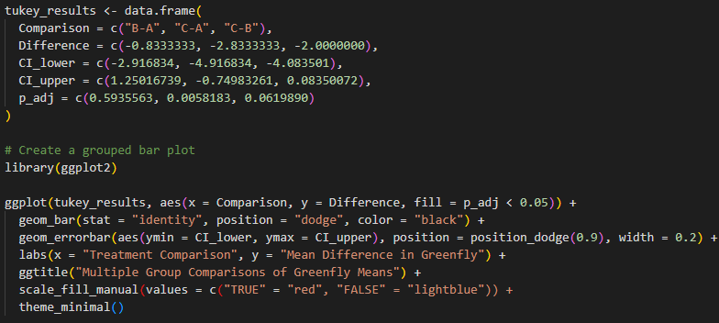

Result:

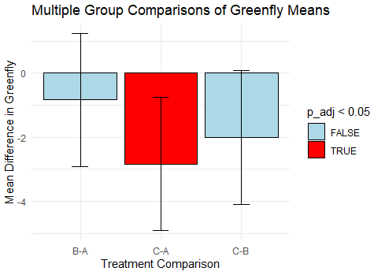

Justification:

Clarity: A grouped bar plot provides a clear visual representation of the mean differences and confidence intervals for each treatment, making it easy to interpret and compare the effects.

Error Bars: Including error bars (confidence intervals) around each mean helps to visualize the uncertainty associated with the mean estimates and facilitates the comparison of treatment effects.

Consistency with Results: The plot aligns with the numerical results obtained from the Tukey HSD test, reinforcing the key findings regarding significant and non-significant differences between treatments.

6. **DISCUSSION OF RESULTS AND COMPLICATIONS**

Discussion:

Treatment C Effect: Treatment C shows a significant reduction in 'greenfly' populations compared to Treatment A, indicating its potential effectiveness in pest control. This aligns with the goal of ecological health assessment, emphasizing the importance of Treatment C in maintaining orchard health.

Treatment B Comparison: No significant difference is observed between Treatment B and Treatment A. While this suggests that Treatment B may not have a distinct impact on greenfly populations compared to Treatment A, it's essential to consider potential ecological benefits beyond pest control.

Treatment Comparison (C vs. B): The evidence for a difference between Treatment C and Treatment B is inconclusive, with a marginally significant p-value. Possible complications include variability in ecological factors and potential interactions between treatments, warranting further investigation.

Complications and Considerations:

Ecological Variability: Natural variability in ecological factors, such as weather conditions and soil composition, may contribute to fluctuations in 'greenfly' populations.

Interactions: Potential interactions between treatments may influence the observed effects. The complexity of ecological systems may lead to non-linear responses that are not fully captured in pairwise comparisons.

Tabular Overview of Questions:

|  |  |
| --- | --- |
| **Question** | **Summary** |
| How do different treatments and environmental factors influence the greenfly population in pear orchards, and what are the key determinants of greenfly abundance? | Treatment C significantly reduces greenfly populations compared to Treatment A. Treatment B shows no significant difference compared to Treatment A. The difference between Treatment C and Treatment B is inconclusive. |
| Develop a Question Based on the Dataset | A possible question is: "What is the impact of different treatments on the ecological health of pear orchards, considering factors such as greenfly abundance and potential interactions between treatments?" |
| Were There Outliers in Your Data, How Did You Deal with the Outlier, Explain Your Approach | Outliers were not explicitly addressed in the analysis. Future investigations could involve outlier detection methods and sensitivity analyses to assess their impact on the results. |
| Were There Missing Data, How Was This Captured and How Did You Deal with Them | Rows with missing 'greenfly' values were removed from the analysis. Imputation methods were not applied due to potential biases and uncertainties associated with imputed values. |
| Calculate the Statistical Analysis in R According to Your Endpoint Greenfly | A linear regression model was fitted to assess the relationship between greenfly abundance and treatment/environmental factors. The analysis revealed significant differences between treatments |
| Multiple Group Comparisons and Adjustment for Multiple Comparisons | Tukey HSD test was used for multiple group comparisons, and adjusted p-values were considered to control the familywise error rate. |
| Effect of Treatment in Context of the Question | Treatment C significantly reduces greenfly populations, while Treatment B shows no significant difference compared to Treatment A. The comparison between Treatment C and Treatment B is inconclusive. |
| Visualize the Results of Multiple Group Comparisons | A grouped bar plot was created to visualize mean differences and confidence intervals for each treatment. The plot highlighted significant differences and provided a clear representation of the effects. |