./



Version Number:

Team Members :

Team No:

Module: Model Based System Engineering

|  |  |  |  |  |  |
| --- | --- | --- | --- | --- | --- |
| **Ver.Rel. No.** | **Release Date** | **Prepared. By** | **Reviewed By** | **Approved By** | **Remarks/Revision Details** |
|  |  |  |  |  |  |
|  |  |  |  |  |  |
|  |  |  |  |  |  |
|  |  |  |  |  |  |
|  |  |  |  |  |  |

**Document History**

# 

# TABLE OF CONTENT

**Introduction:…………………………………………………….3**

**Requirements:………………………………………………………3 to 5**

**Components Required……………………………..5**

**4W’s and 1H…………………………………………..6**

**Swoot Analysis……………………………………………7**

**Block diagram……………………………………………..**

**Auto Intensity Control of Street Lights**

**Introduction:**

**In this project i want to domenostrate how a street light intensity can be controlled using ldr(light dependent Resistor ) and Rtc(Real Time clock) according to the time and environment.**

**REQIREMENTS:**

**High level Requirements**

**• it calculate intensity.**

**• It calculates the time.**

**• It should display time.**

**• it should have Leds**

|  |  |  |  |
| --- | --- | --- | --- |
| **ID** | * **Low Level Requirements for HL1** | **ID** | **Low Level Requirements for HL2** |
| **Llr1** | **It shall have the light sensor and calculate the intensity.** | **Llr1** | **It shall have clock and it calculate time** |
| **Llr2** | **It connects to adc.** | **Llr2** | **It connected to input pin** |

|  |  |  |  |  |
| --- | --- | --- | --- | --- |
| **ID** | **Low Level Requirements for HL3** | **ID** | **Low Level Requirements for HL4** |  |
| **Llr1** | **It have lcd and it display time** | **Llr1** | **It should have led relays** |  |
| **Llr1** | **It connect to input** | **Llr1** | **It connect to port.** |  |

**Components Required**

**Power supply : It gives power to the hole circuit.**

**LDR : Light dependent resistor is used to calculate the intensity of light.**

**LCD : Lcd is used to display the time which read from ic .**

**RTC : Real time clock is used for to calculate the current time.**

**LED: It gives the output according to the input from the circuits.**

**MICROCONTROLLER: it is used to control all the circuits..**

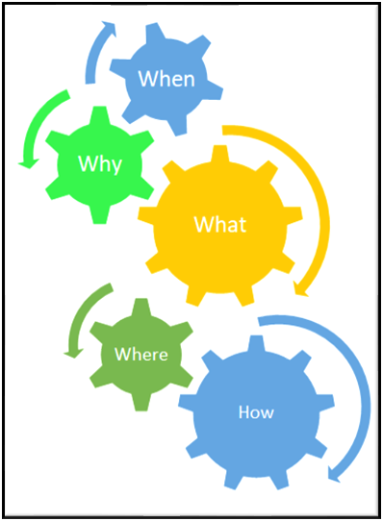

**4w’s and 1H?**

**Where?**

**It should used in traffics and in highway roads, etc.. to control the intensity .**

**What?**

**It should controls controls the light.**

**When?**

**it will be used when we want to save the power in peak times.**

**WHY?**

**By using this we can save power.**

**How?**

**WE use this as a controller it control the intensity of light.**

**Swoot Analysis?**

**strengths?**

**we can control 24/7.**

**it detects the intensity.**

**weeknees?**

**in some cases detects false intensity.**

**oppertunites?**

**we can save more more power.**

**Threats?**

**It may damages the microcontroller sometimes.**

**ldr may caluclates some false intensity.**

**Block DIAGRAM**

