2019-2020 Semestre 4

TONNELLE Nathan

Photography

AN0401

Table des matières

I. Photography 2

A. Etymology 2

B. History 2

II. Techniques 2

III. Types of photography 2

IV. Social and cultural implications 2

V. Links & Documents 3

A. Links 3

1. Information of the theme: 3

a. Web documents (READING) 3

b. Videos (LISTENING) 3

2. Other 3

B. Documents 3

1. Images 3

2. Videos links 3

VI. Draft version of writing summary 4

VII. Vocabulary who's help me 5

# Photography

## Etymology

## History

# Techniques

# Types of photography

# Social and cultural implications

# Links & Documents

## Links

### Information of the theme:

#### Web documents (READING)

* <https://en.wikipedia.org/wiki/Photography>
* <https://photographylife.com/what-is-photography>
* <https://www.thesprucecrafts.com/brief-history-of-photography-2688527>
* <https://www.britannica.com/technology/photography>

#### Videos (LISTENING)

### Other

* <https://www.linguee.fr> (dictionary)

## Documents

### Images

### Videos links

# Draft version of writing summary

With the document: <https://photographylife.com/what-is-photography>

Photography learning can be almost limitlessly complex.

Photography is the art of capturing light with a camera, via a digital sensor or film, to create an image. You can also take a photo of invisible light for human eye like UV, radio, etc.

The first photography who was take, it's in 1826 or 1827 by Joseph Nicéphore Niépce in France. He would capture the roof of a building:

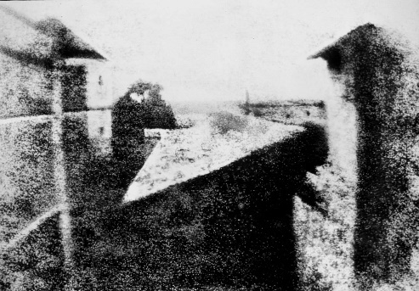

<https://cdn.photographylife.com/wp-content/uploads/2018/12/First-Photo-Ever-Taken.jpg>

The color photography become popular and accessible with the release of Eastman Kodak's "Kadachrome" film in the 1930s. Before all of photography were monochromatic colors (with some of shades of black & white).

https://cdn.photographylife.com/wp-content/uploads/2018/12/High-Resolution-Galaxy-Photo-by-NASA.jpg

# Vocabulary who's help me

* Wavelengths (*longueur d'onde*)
* Roof (*toit*)
* purpose (*le but*)
* shades (*nuances*)