**Assignment-1**

Design a database schema for railway ticket booking using the E-R model and design tables accordingly using the relationship model. The necessary information is given below :

Entities : Train, Ticket, Customer

Ticket can be reserved or unreserved.

Each reserved ticket must correspond to a train and a customer.

Each unreserved ticket must correspond to a customer.

A customer cannot be in two trains at the same time.

Assume columns accordingly and mention primary keys, weak and strong entities.

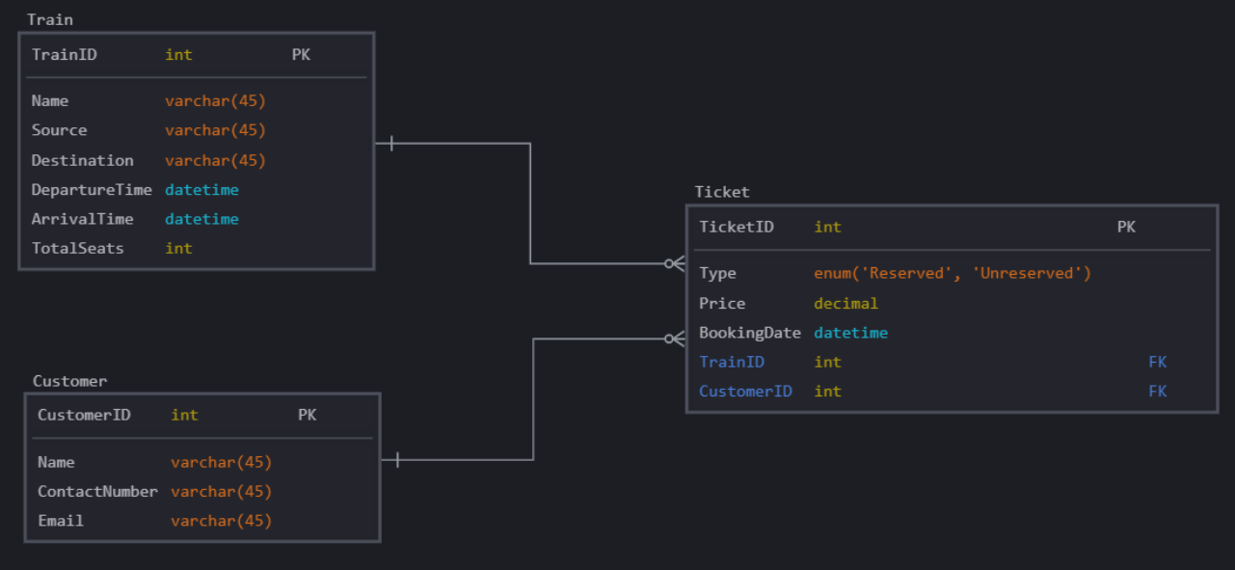

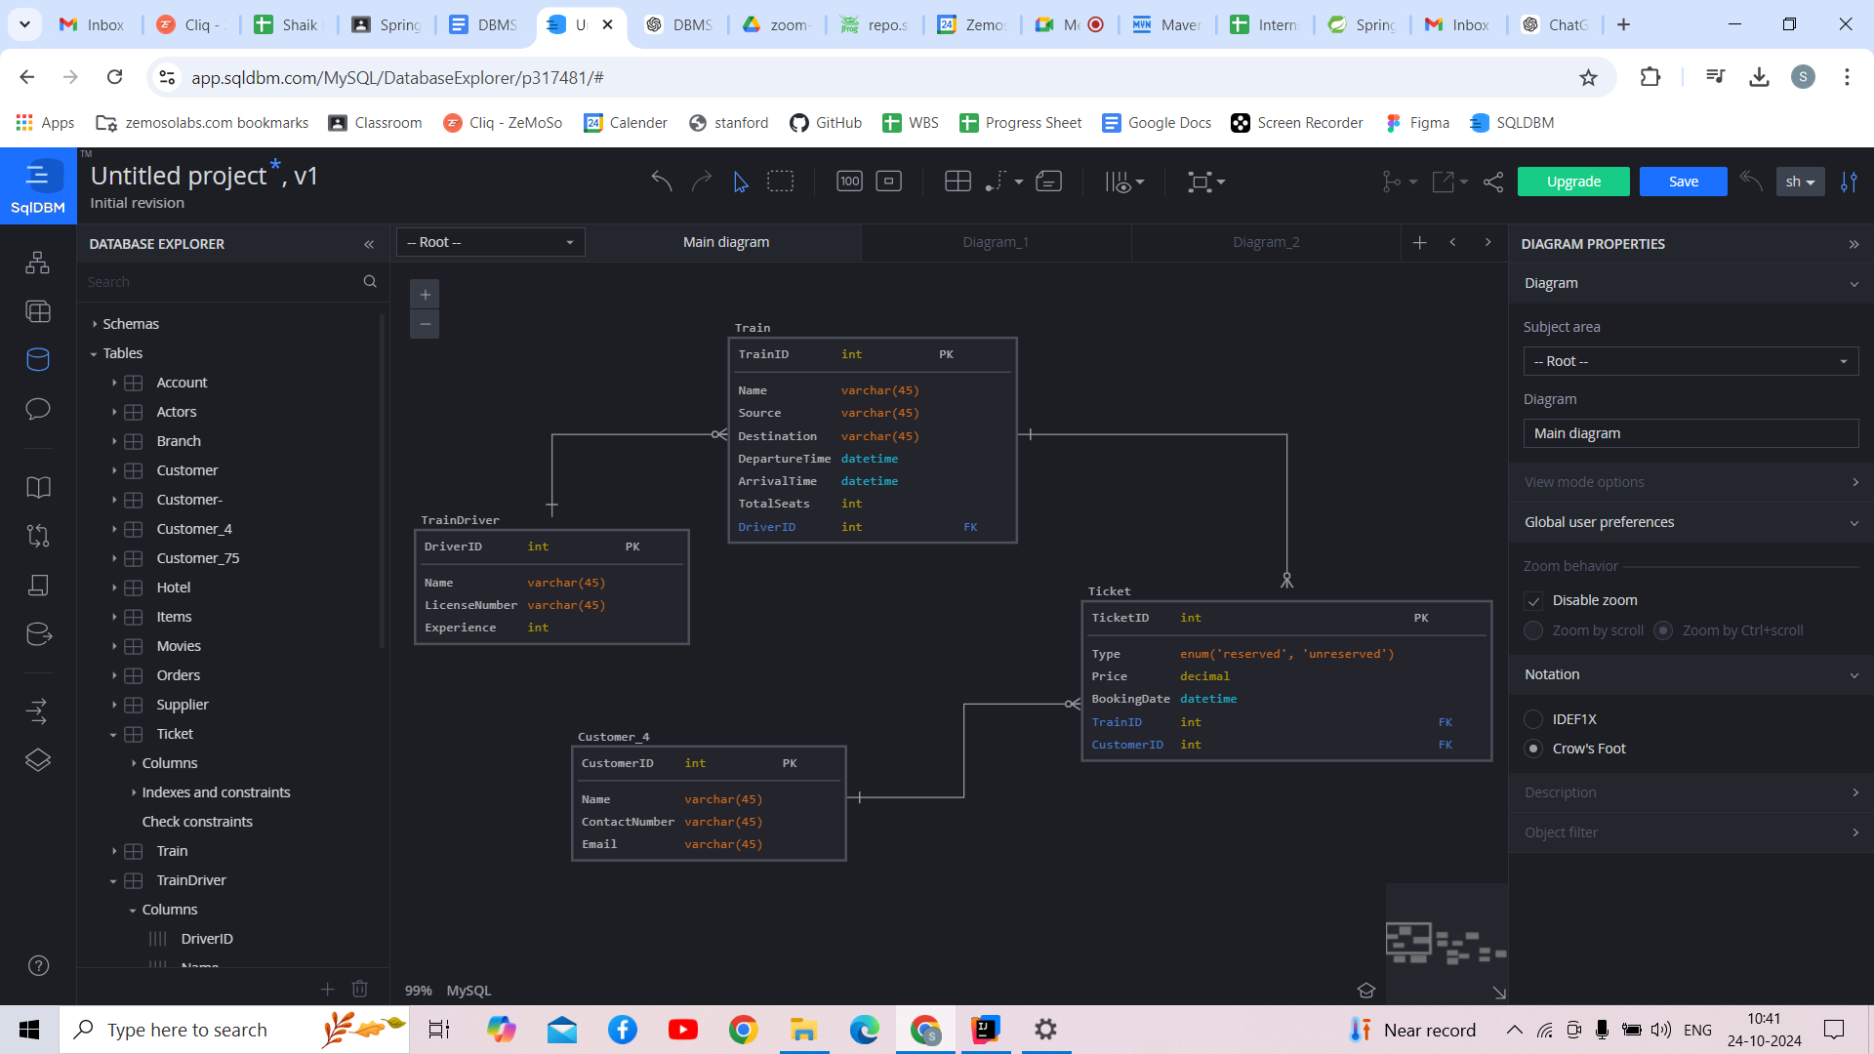

### **Primary and Foreign Keys**

* **Primary Keys:**
  + TrainID in **Train**
  + CustomerID in **Customer**
  + TicketID in **Ticket**
  + DriverID in **Train Driver**
* **Foreign Keys:**
  + CustomerID in **Ticket** referencing Customer(CustomerID)
  + TrainID in **Ticket** referencing Train(TrainID) (nullable for unreserved tickets)
  + DriverID in **Train** referencing TrainDriver(DriverID)

### **Weak and Strong Entities**

* **Strong Entities:**
  + **Train** (identified by TrainID)
  + **Customer** (identified by CustomerID)
  + **Ticket** (identified by TicketID)
  + **Train Driver** (identified by DriverID)
* **Weak Entities:**
  + There are no weak entities in this design, as all entities can be uniquely identified by their primary keys.

**Assignment-2**

Design a database schema for a hotel booking agency using the E-R model and design tables accordingly using the relationship model. The necessary information is given below :

Entities : Hotel, Customer

Customer can be first time user or loyal customer.

Customer can book from only only hotel at a time. A hotel can have many customers.

Assume columns accordingly and mention primary keys, weak and strong entities.

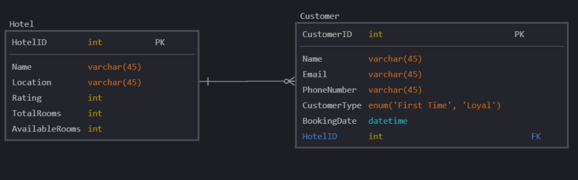

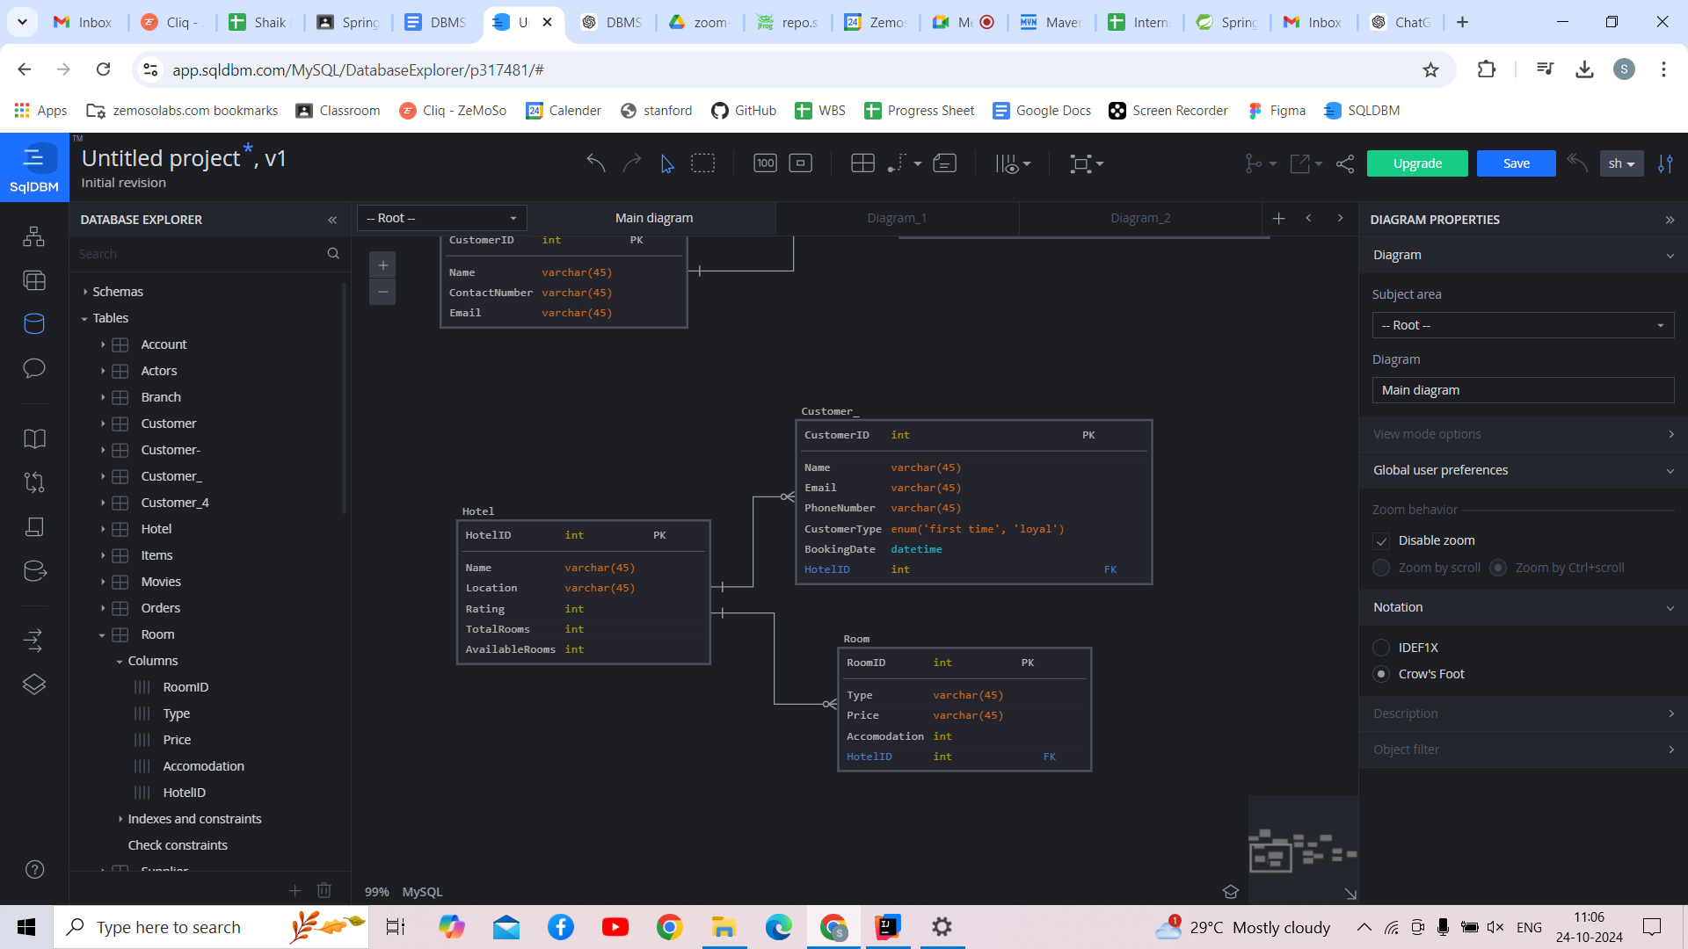

### **Primary and Foreign Keys**

* **Primary Keys:**
  + HotelID in **Hotel**
  + CustomerID in **Customer**
  + RoomID in **Room**
* **Foreign Keys:**
  + HotelID in **Customer** referencing Hotel(HotelID)
  + HotelID in **Room** referencing Hotel(HotelID)

### **Weak and Strong Entities**

* **Strong Entities:**
  + **Hotel** (identified by HotelID)
  + **Customer** (identified by CustomerID)
  + **Room** (identified by RoomID)
* **Weak Entities:**
  + There are no weak entities in this design since all entities are uniquely identified by their primary keys.

**Assignment-3**

Design a database schema for an e-commerce app using the E-R model and design tables accordingly using the relationship model. The necessary information is given below :

Entities : Supplier, Customer, Items, Order

Every item should correspond to a supplier. One supplier can have more than one items.

A customer can have one order at the same time. One order can have multiple items from multiple brands.

Assume columns accordingly and mention primary keys, weak and strong entities.

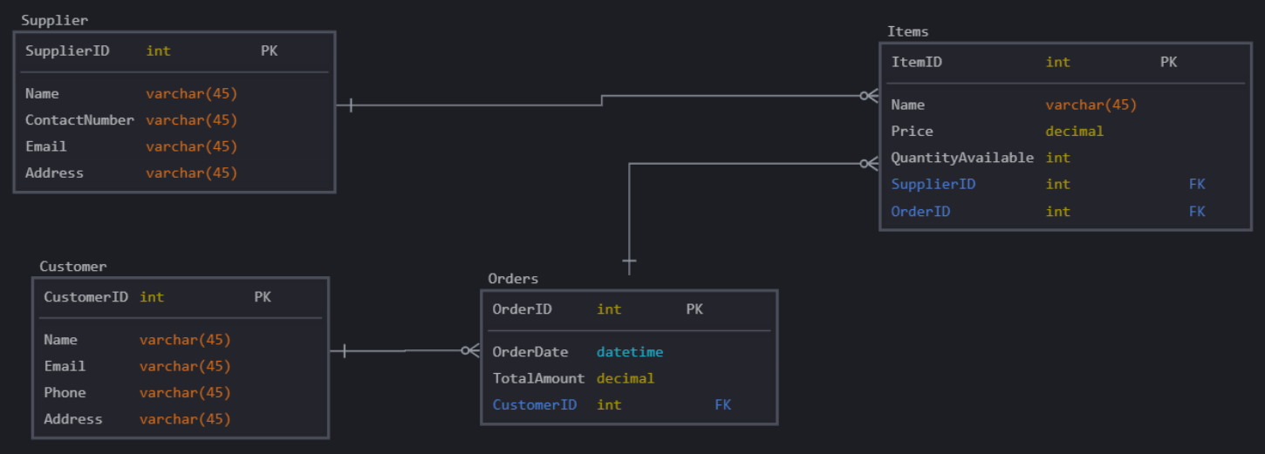

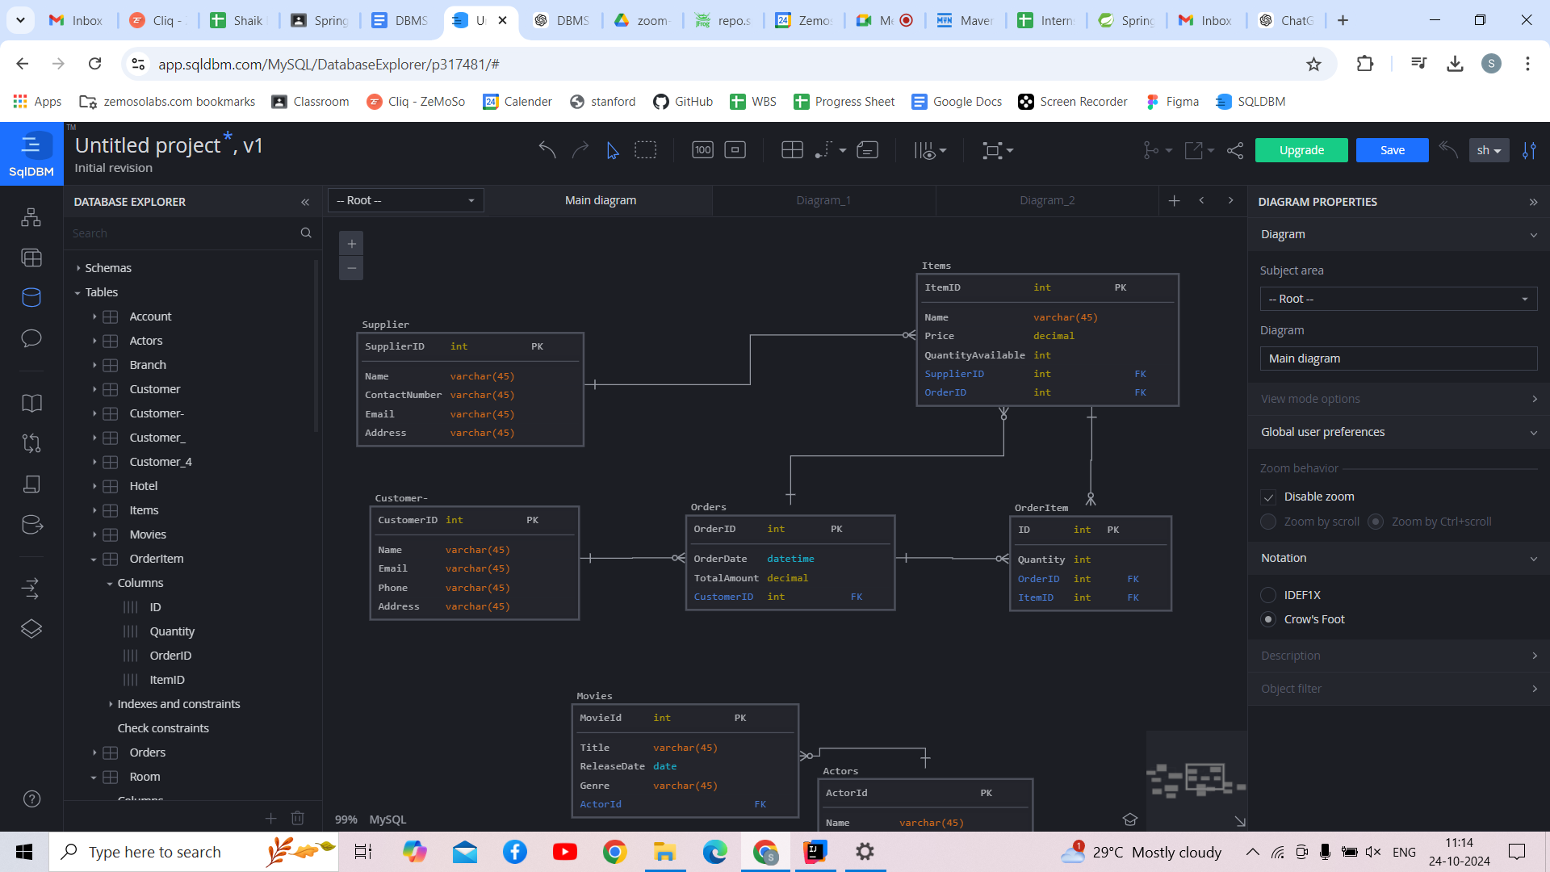

### 

### 

### **Primary and Foreign Keys**

* **Primary Keys:**
  + SupplierID in **Supplier**
  + CustomerID in **Customer**
  + ItemID in **Item**
  + OrderID in **Order**
  + OrderItemID in **OrderItem**
* **Foreign Keys:**
  + SupplierID in **Item** referencing Supplier(SupplierID)
  + CustomerID in **Order** referencing Customer(CustomerID)
  + OrderID in **OrderItem** referencing Order(OrderID)
  + ItemID in **OrderItem** referencing Item(ItemID)

### **Weak and Strong Entities**

* **Strong Entities:**
  + **Supplier** (identified by SupplierID)
  + **Customer** (identified by CustomerID)
  + **Item** (identified by ItemID)
  + **Order** (identified by OrderID)
  + **OrderItem** (identified by OrderItemID)
* **Weak Entities:**
  + There are no weak entities in this design since all entities can be uniquely identified by their primary keys.

**Assignment-4**

Design a database schema for a movie and tv series database using the E-R model and design tables accordingly using the relationship model. The necessary information is given below :

Entities : Movie, Actors, TV series

A TV series or a movie must have an actor. An actor can act in both.

Assume columns accordingly and mention primary keys, weak and strong entities.

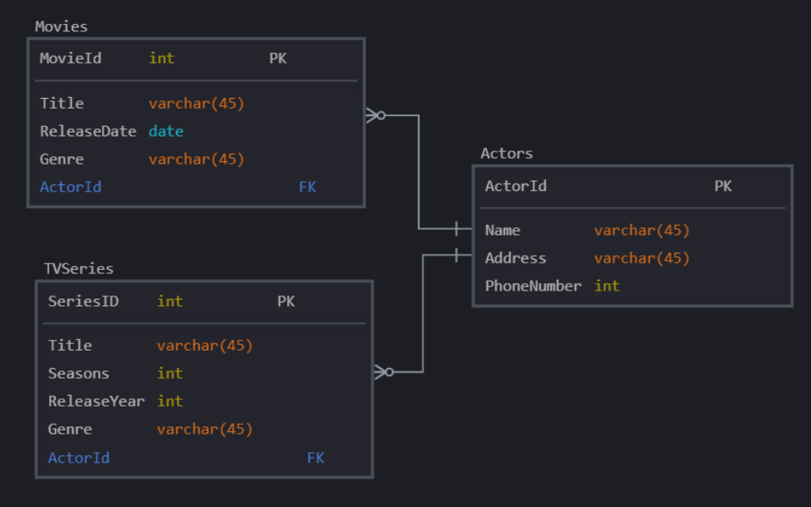

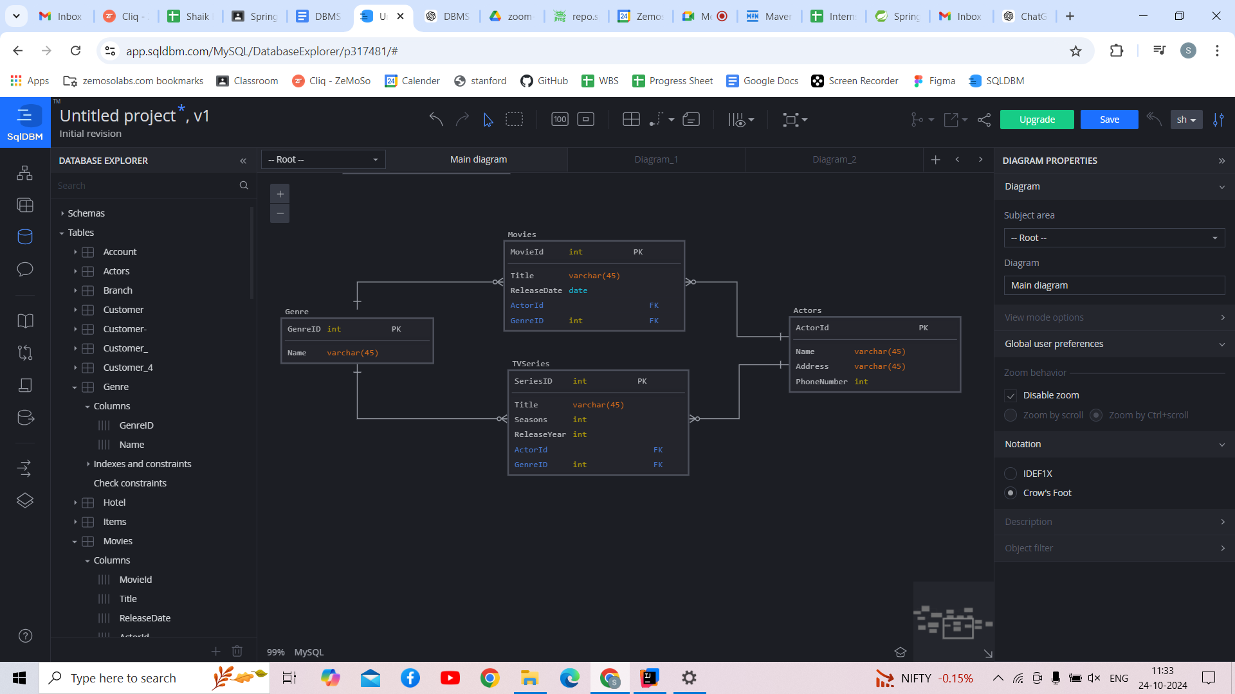

### **Primary and Foreign Keys**

* **Primary Keys:**
  + ActorID in **Actor**
  + MovieID in **Movie**
  + TVSeriesID in **TV Series**
  + GenreID in **Genre**
* **Foreign Keys:**
  + ActorID in **Movie** referencing Actor(ActorID)
  + ActorID in **TV Series** referencing Actor(ActorID)
  + GenreID in **Movie and TVSeries** referencing Genre

### **Weak and Strong Entities**

* **Strong Entities:**
  + **Actor** (identified by ActorID)
  + **Movie** (identified by MovieID)
  + **TV Series** (identified by TVSeriesID)
  + **Genre** (Identified by GenreID)
* **Weak Entities:**
  + There are no weak entities in this design, as all entities can be uniquely identified by their primary keys.

**Assignment-5**

Design a database schema for a banking app using the E-R model and design tables accordingly using the relationship model. The necessary information is given below :

Entities : Accounts, Customer, Branches

Each customer must have an account. Joint accounts are allowed.

A customer can have multiple accounts in different branch, but not in same branch.

A branch can have many accounts.

Assume columns accordingly and mention primary keys, weak and strong entities.

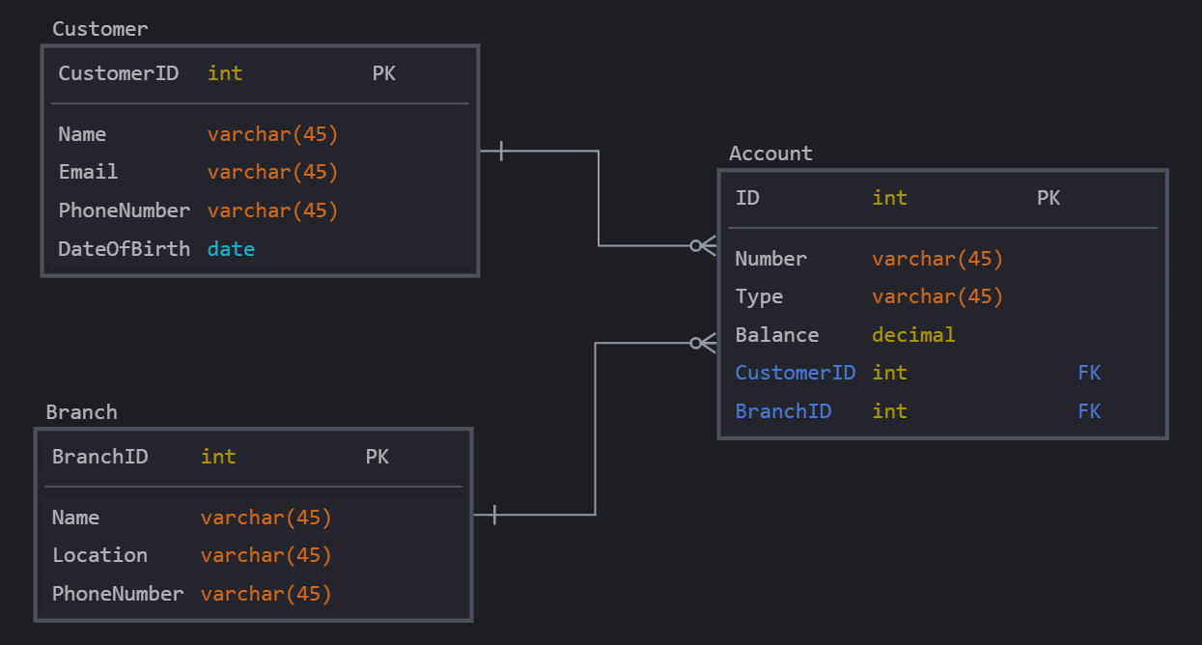

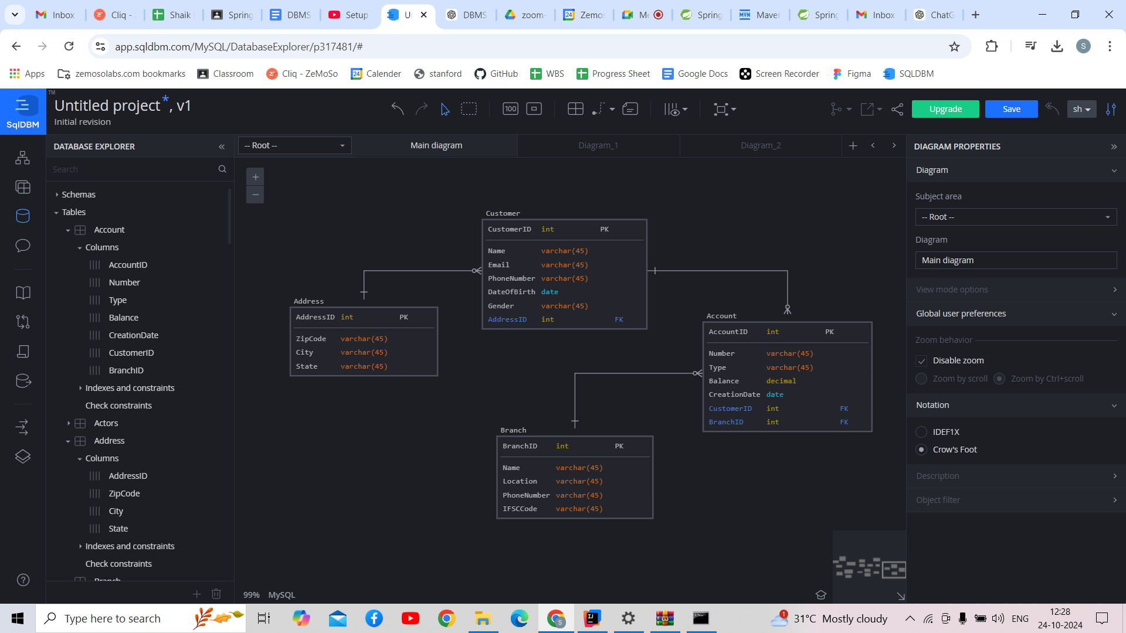

### **Primary and Foreign Keys**

* **Primary Keys:**
  + CustomerID in **Customer**
  + AccountID in **Account**
  + BranchID in **Branch**
  + AddressID in **Address**
* **Foreign Keys:**
  + CustomerID in **Account** referencing Customer(CustomerID)
  + BranchID in **Account** referencing Branch(BranchID)

### **Weak and Strong Entities**

* **Strong Entities:**
  + **Customer** (identified by CustomerID)
  + **Account** (identified by AccountID)
  + **Branch** (identified by BranchID)
* **Weak Entities:**
  + There are no weak entities in this design, as all entities can be uniquely identified by their primary keys.