Assignment-1
Design a database schema for railway ticket booking using the E-R model and design tables accordingly using the relationship model. The necessary information is given below :

Entities : Train, Ticket, Customer
Ticket can be reserved or unreserved.
Each reserved ticket must correspond to a train and a customer.
Each unreserved ticket must correspond to a customer.
A customer cannot be in two trains at the same time.
Assume columns accordingly and mention primary keys, weak and strong entities.

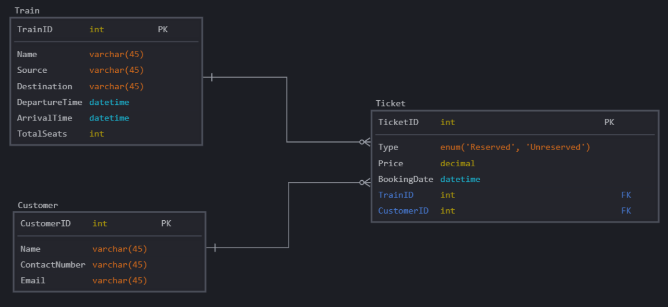

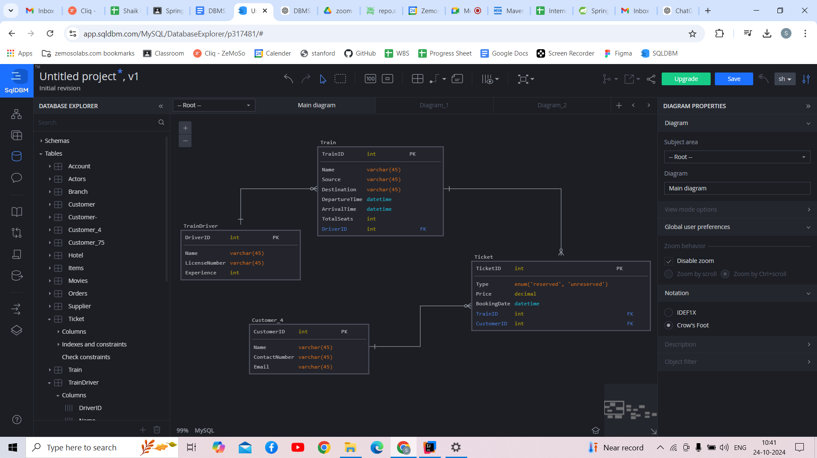

Primary and Foreign Keys
- Primary Keys:
  - TrainID in Train
  - CustomerID in Customer
  - TicketID in Ticket
  - DriverID in Train Driver
- Foreign Keys:
  - CustomerID in Ticket referencing Customer(CustomerID)
  - TrainID in Ticket referencing Train(TrainID) (nullable for unreserved tickets)
  - DriverID in Train referencing TrainDriver(DriverID)

Weak and Strong Entities
- Strong Entities:
  - Train (identified by TrainID)
  - Customer (identified by CustomerID)
  - Ticket (identified by TicketID)
  - Train Driver (identified by DriverID)
- Weak Entities:
  - There are no weak entities in this design, as all entities can be uniquely identified by their primary keys.

Assignment-2
Design a database schema for a hotel booking agency using the E-R model and design tables accordingly using the relationship model. The necessary information is given below :

Entities : Hotel, Customer
Customer can be first time user or loyal customer.
Customer can book from only only hotel at a time. A hotel can have many customers.

Assume columns accordingly and mention primary keys, weak and strong entities.

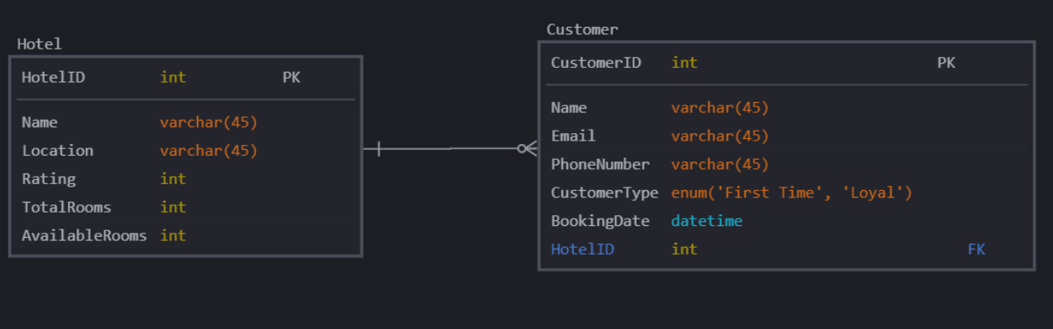

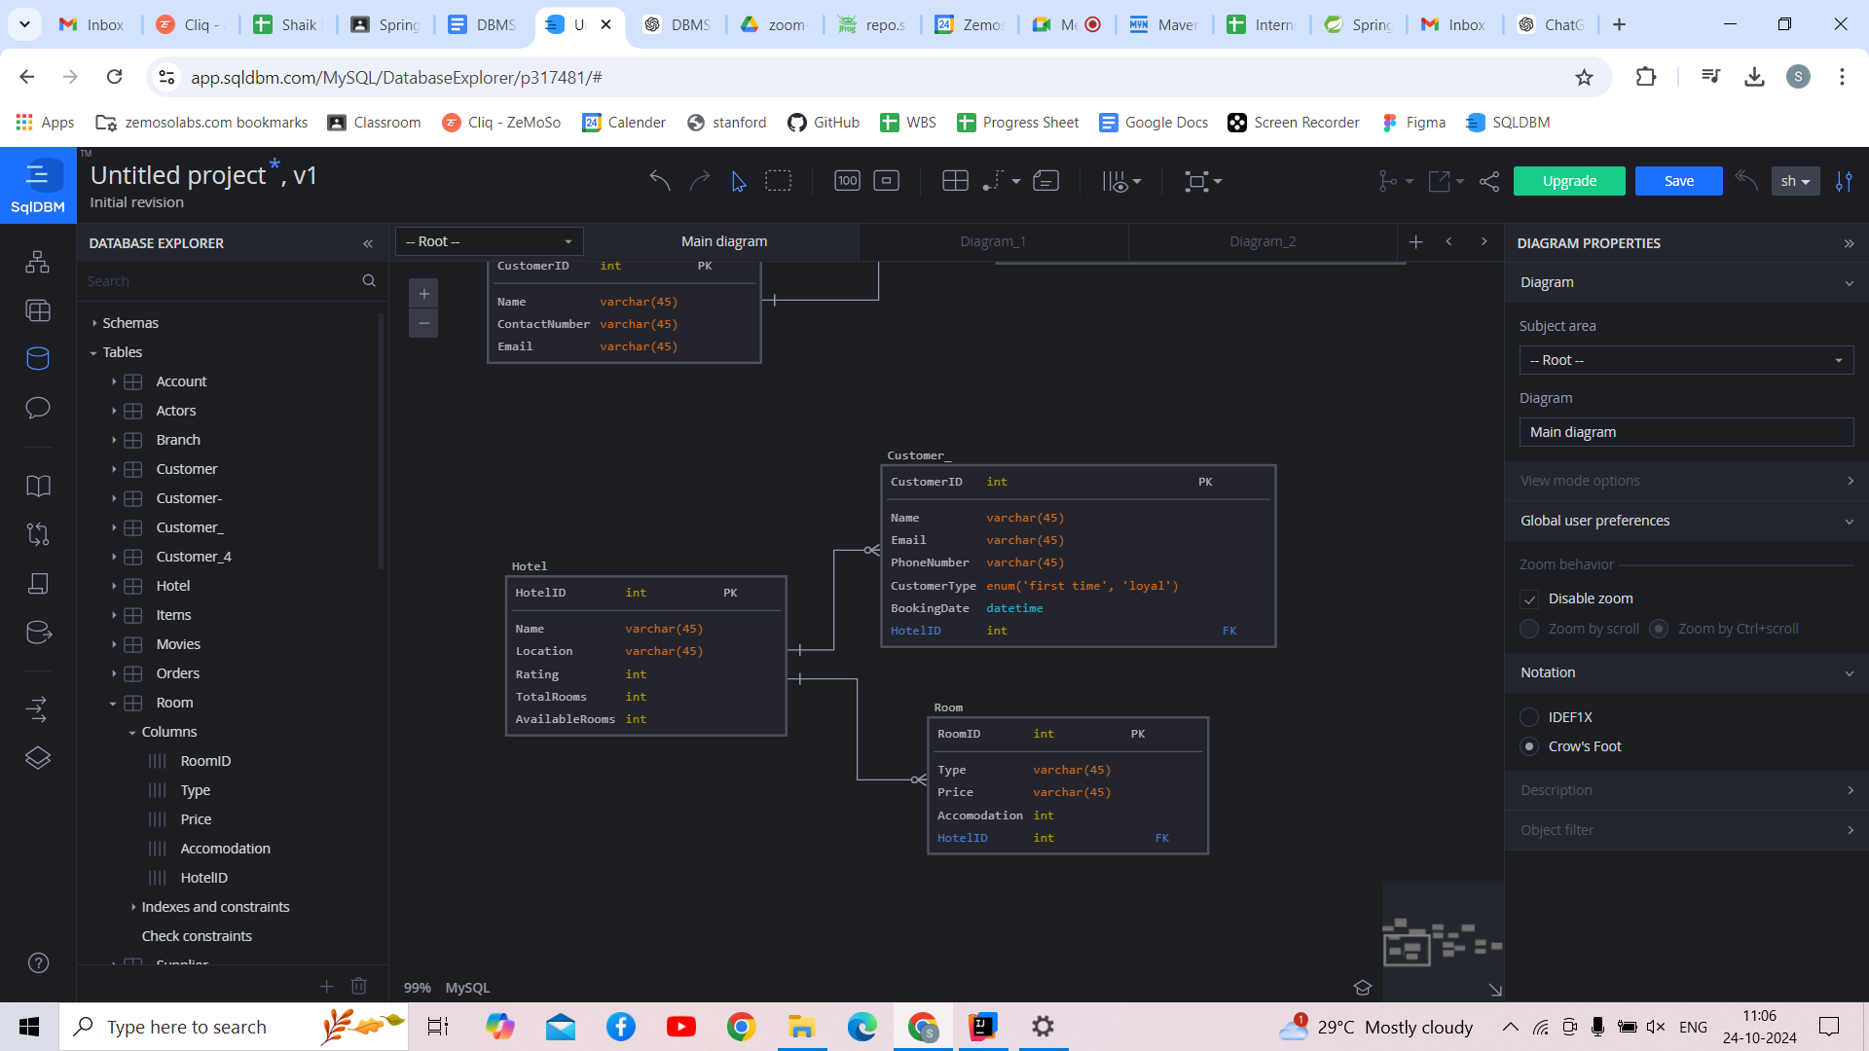

Primary and Foreign Keys
- Primary Keys:
  - HotelID in Hotel
  - CustomerID in Customer
  - RoomID in Room
- Foreign Keys:
  - HotelID in Customer referencing Hotel(HotelID)
  - HotelID in Room referencing Hotel(HotelID)

Weak and Strong Entities
- Strong Entities:
  - Hotel (identified by HotelID)
  - Customer (identified by CustomerID)
  - Room (identified by RoomID)
- Weak Entities:
  - There are no weak entities in this design since all entities are uniquely identified by their primary keys.

Assignment-3
Design a database schema for an e-commerce app using the E-R model and design tables accordingly using the relationship model. The necessary information is given below :

Entities : Supplier, Customer, Items, Order
Every item should correspond to a supplier. One supplier can have more than one items.
A customer can have one order at the same time. One order can have multiple items from multiple brands.

Assume columns accordingly and mention primary keys, weak and strong entities.
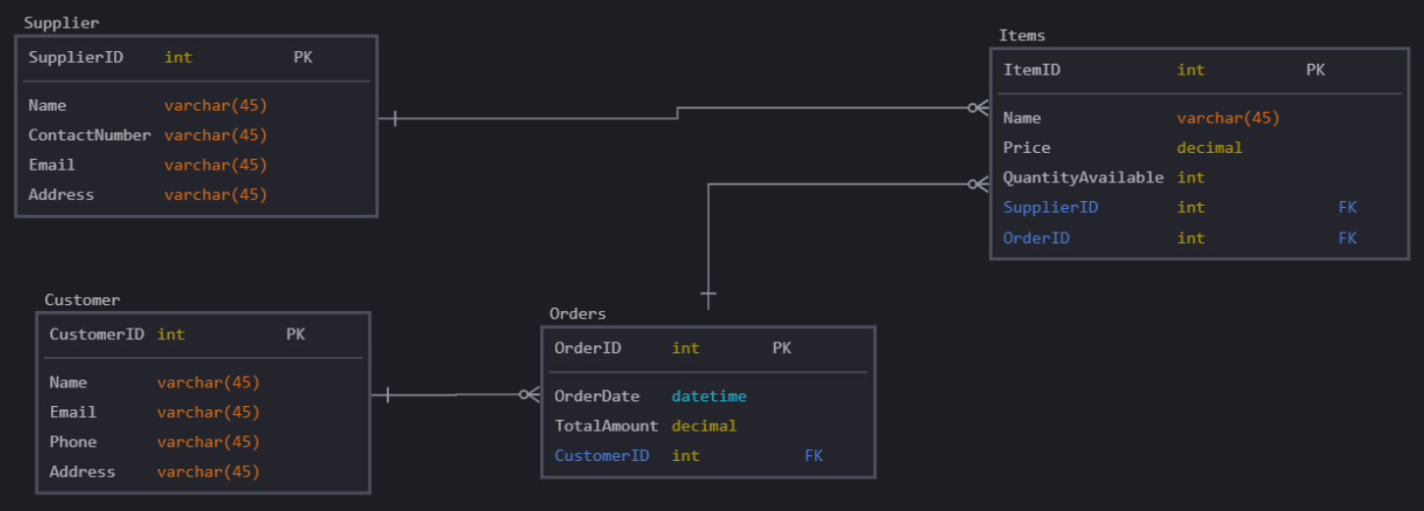

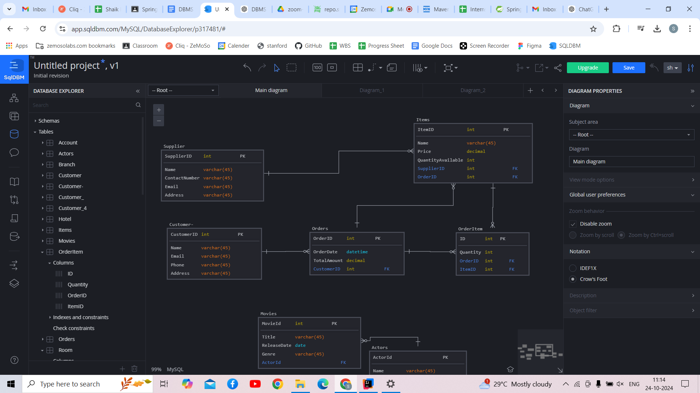

Primary and Foreign Keys
- Primary Keys:
  - SupplierID in Supplier
  - CustomerID in Customer
  - ItemID in Item
  - OrderID in Order
  - OrderItemID in OrderItem
- Foreign Keys:
  - SupplierID in Item referencing Supplier(SupplierID)
  - CustomerID in Order referencing Customer(CustomerID)
  - OrderID in OrderItem referencing Order(OrderID)
  - ItemID in OrderItem referencing Item(ItemID)

Weak and Strong Entities
- Strong Entities:
  - Supplier (identified by SupplierID)
  - Customer (identified by CustomerID)
  - Item (identified by ItemID)
  - Order (identified by OrderID)
  - OrderItem (identified by OrderItemID)
- Weak Entities:
  - There are no weak entities in this design since all entities can be uniquely identified by their primary keys.

Assignment-4
Design a database schema for a movie and tv series database using the E-R model and design tables accordingly using the relationship model. The necessary information is given below :

Entities : Movie, Actors, TV series
A TV series or a movie must have an actor. An actor can act in both.

Assume columns accordingly and mention primary keys, weak and strong entities.
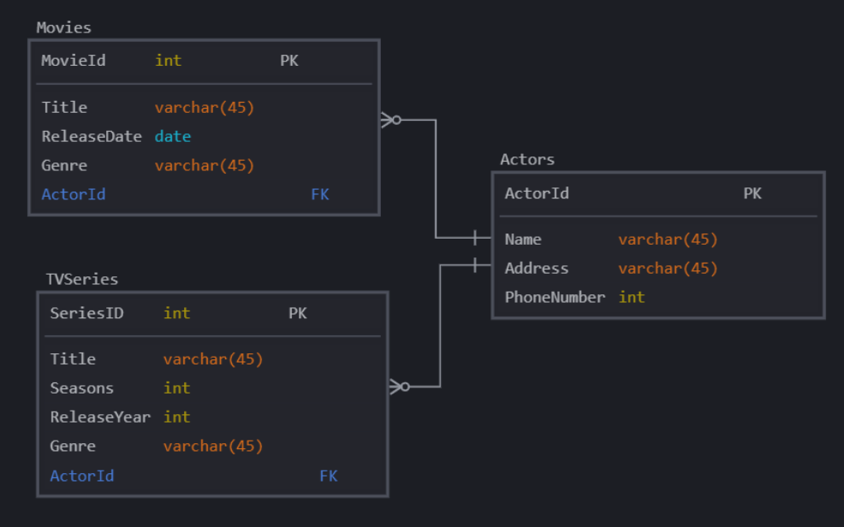

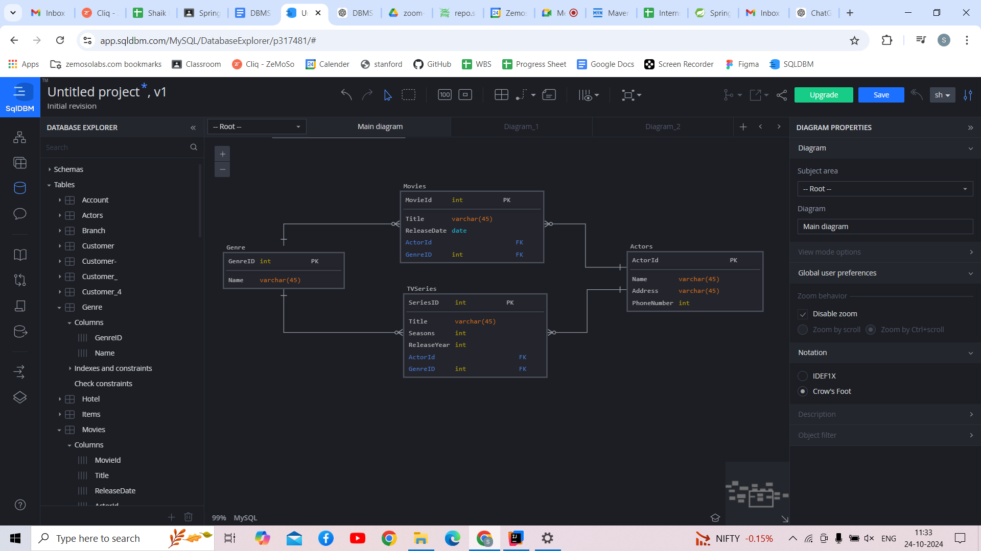

Primary and Foreign Keys
- Primary Keys:
  - ActorID in Actor
  - MovieID in Movie
  - TVSeriesID in TV Series
  - GenreID in Genre
- Foreign Keys:
  - ActorID in Movie referencing Actor(ActorID)
  - ActorID in TV Series referencing Actor(ActorID)
  - GenreID in Movie and TVSeries referencing Genre

Weak and Strong Entities
- Strong Entities:
  - Actor (identified by ActorID)
  - Movie (identified by MovieID)
  - TV Series (identified by TVSeriesID)
  - Genre (Identified by GenreID)
- Weak Entities:
  - There are no weak entities in this design, as all entities can be uniquely identified by their primary keys.

Assignment-5
Design a database schema for a banking app using the E-R model and design tables accordingly using the relationship model. The necessary information is given below :

Entities : Accounts, Customer, Branches
Each customer must have an account. Joint accounts are allowed.
A customer can have multiple accounts in different branch, but not in same branch.
A branch can have many accounts.

Assume columns accordingly and mention primary keys, weak and strong entities.
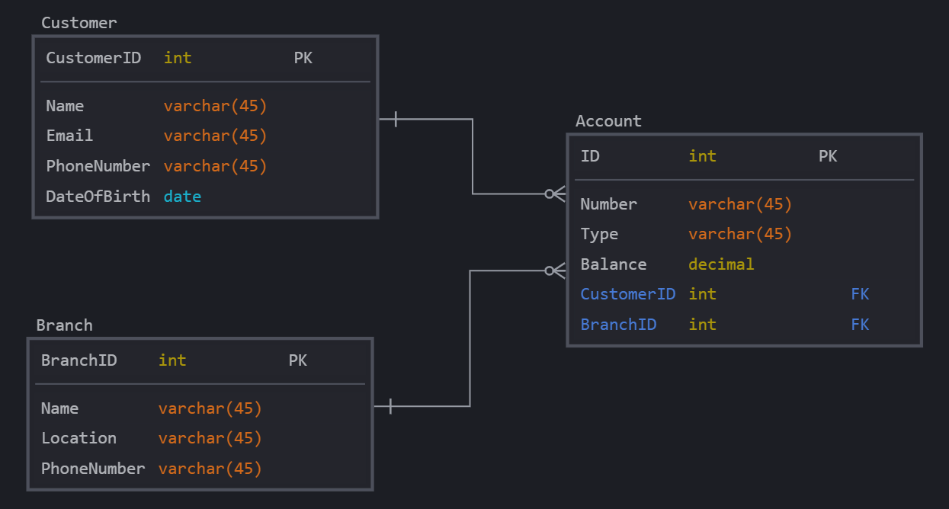

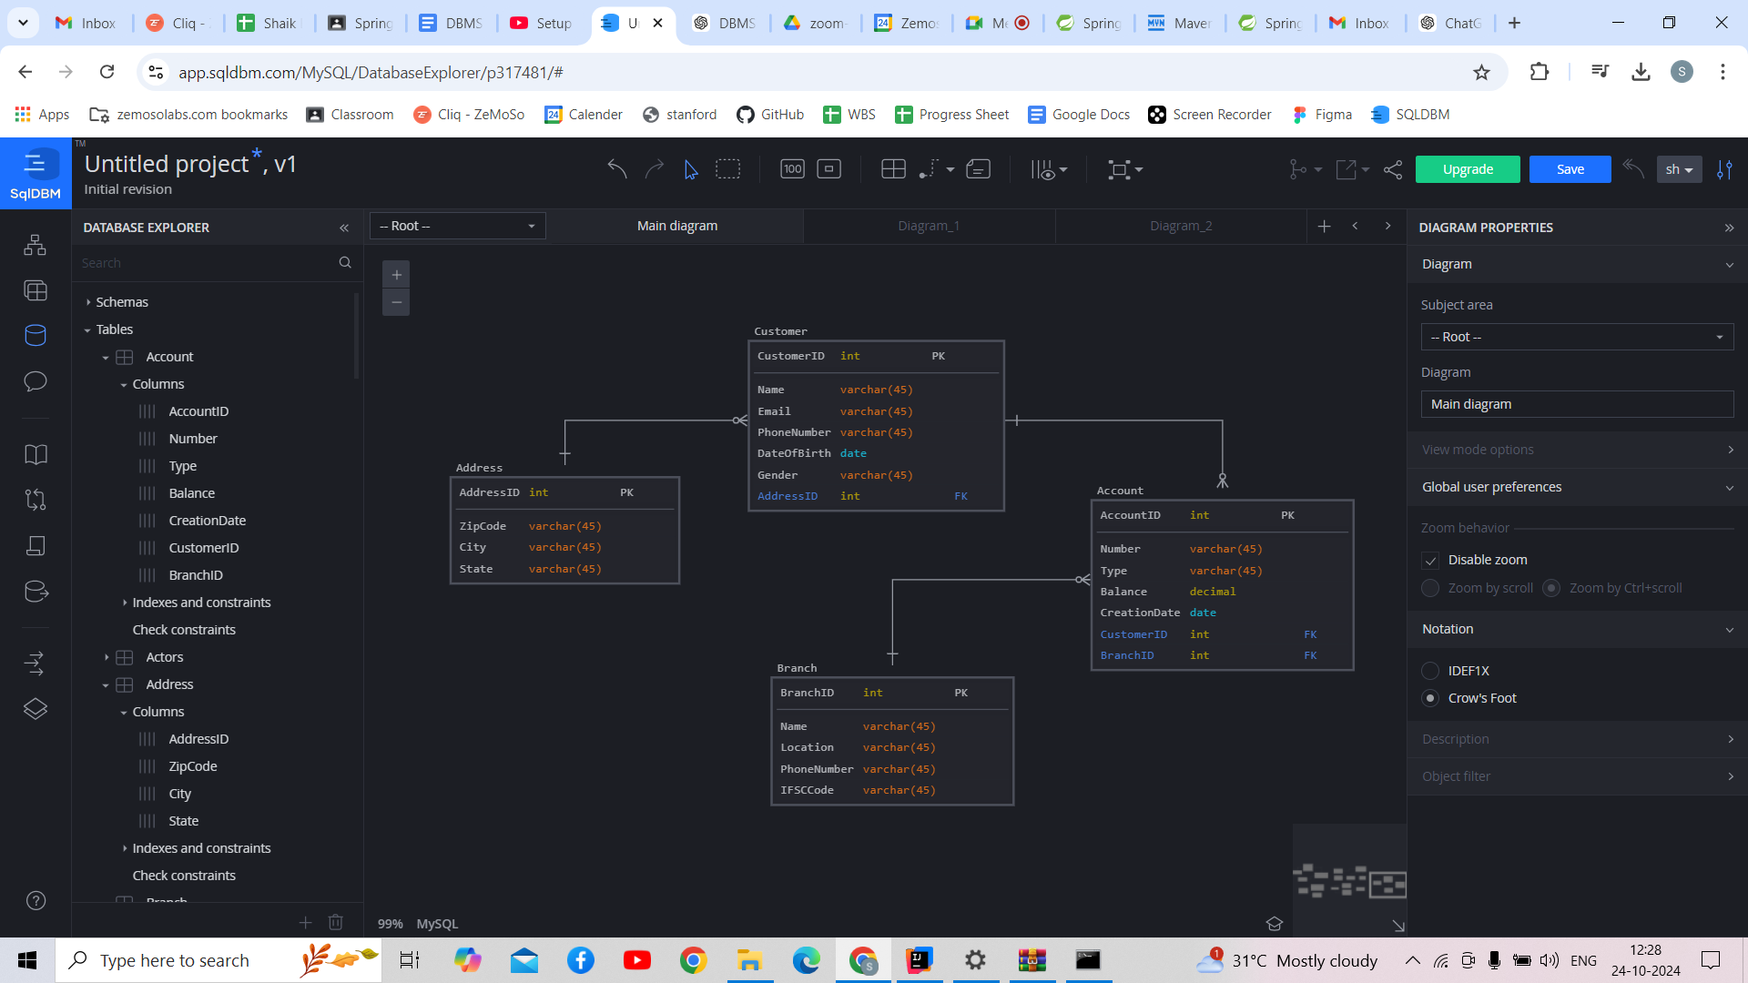

Primary and Foreign Keys
- Primary Keys:
  - CustomerID in Customer
  - AccountID in Account
  - BranchID in Branch
  - AddressID in Address
- Foreign Keys:
  - CustomerID in Account referencing Customer(CustomerID)
  - BranchID in Account referencing Branch(BranchID)

Weak and Strong Entities
- Strong Entities:
  - Customer (identified by CustomerID)
  - Account (identified by AccountID)
  - Branch (identified by BranchID)
- Weak Entities:
  - There are no weak entities in this design, as all entities can be uniquely identified by their primary keys.

