**CS 442 First Release Scenario:**

**FireScrum**

Written by Group #7: Bennett Maciorowski, Stephen Walden, Linda Zhou, Tian Zhou

Every company’s employees deserve innovative and hyper-intuitive ways to plan, track, and manage work. That’s where FireScrum comes in. The Scrum methodology is widely used in companies across the world and FireScrum is designed as agile development tool to help companies of every kind to accelerate every team to unleash their full potential, remotely, face-to-face, or otherwise. The information you and your team need are accessible at your fingertips.

FireScrum offers agile roles to the user such as developer, project manager, scrum master, designer, or QA/Tester. FireScrum offers many tools to the user. These tools can be used to create stories, create tasks, assign tasks to different team members, update the status of those tasks, assign time estimates to tasks, log bugs to a feature, conduct spring reviews, and generate report charts. There will be a centralized database that will store all data pertaining to each user for each task in a sprint. A burndown/burnup report would be generated at the end of each sprint.

**Scenario and Plans for 1st Release**

User registration:

A new user would register into the system by filling in a sign-up form. New users can select several roles. They can be a project manager, scrum master, developer, QA/Tester, or designer. New users select their role(s) as they complete their profile.

User login:

A returning user can just sign-in using their existing account.

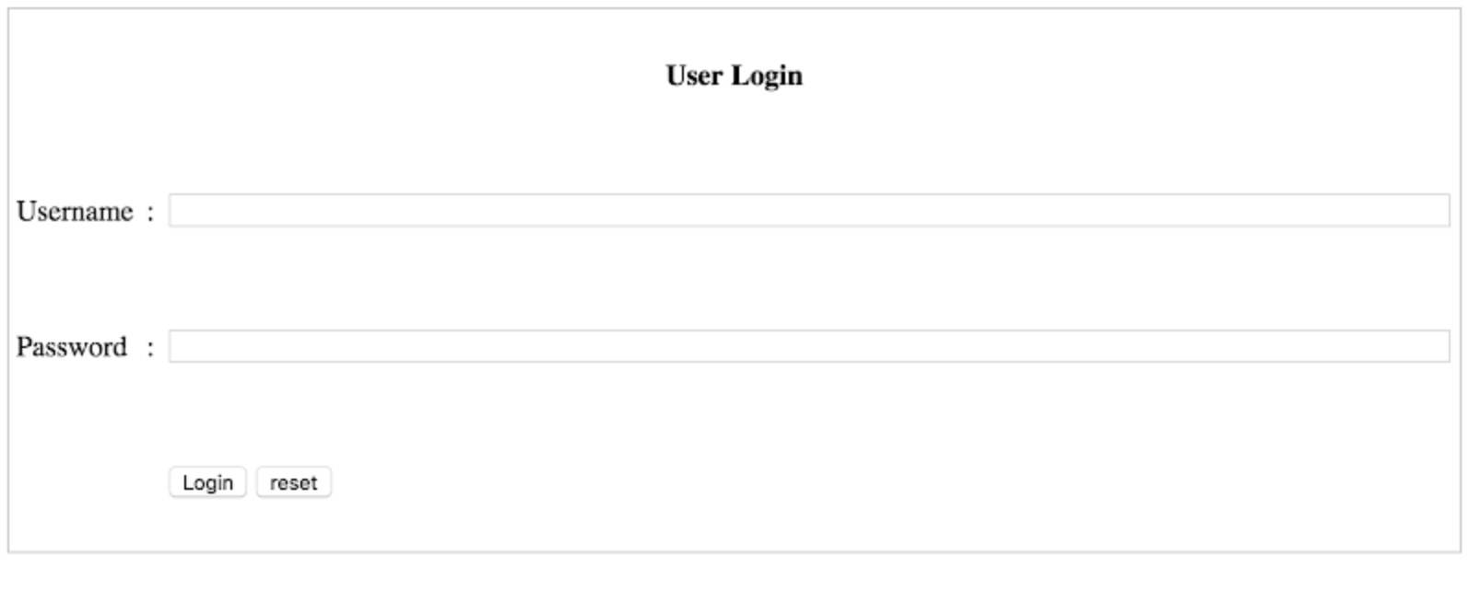

Figure 1. Sample page of FireScrum login.

User creates a project:

A user creates a project that will contain an empty collection of stories. Allowing them to edit details of the project.

User creates a story:

A user creates a story within their project. A story describes a scenario of all the technical requirements of the client depicted as functional requirements. This illustrates to the developers the actors of the system, the external system, and the interactions between them.

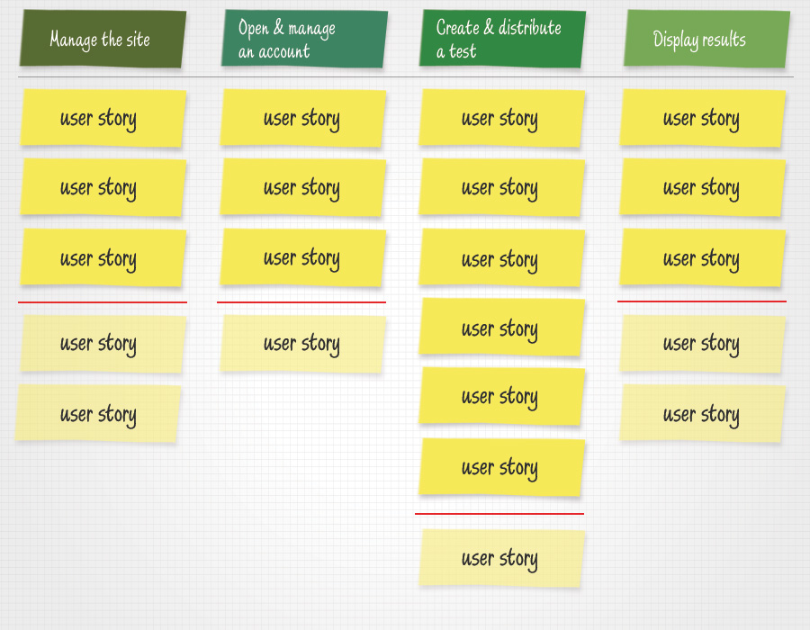

Figure 2. Sample organization of user stories bucketed into each project.