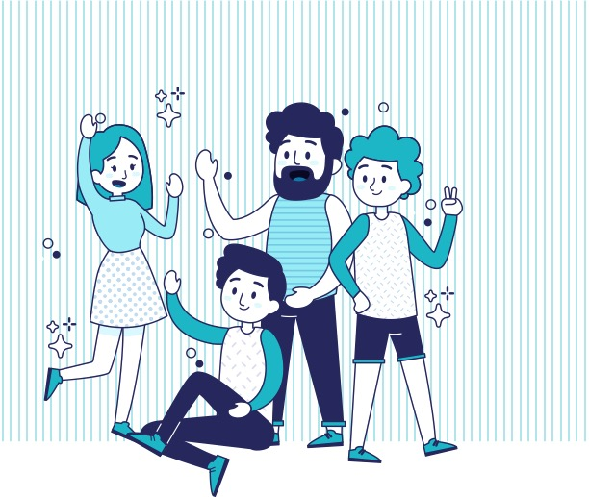

**Idioma extranjero I**

**| Reto 5. What are you doing now?**

**¿Quién eres?**

|  |  |
| --- | --- |
| Nombre completo | Benjamin Rivera |
| Matrícula | **19015478** |
| Fecha de elaboración | 10 de diciembre de 2019 |
| Nombre del asesor | Lissette |

|  |  |  |  |
| --- | --- | --- | --- |
| **1** | | **My daily routine**  Mi rutina diaria |  |
|  | **Instrucción:** completa la siguiente tabla, escribiendo en inglés, una oración en presente continuo que describa lo que sucede en la imagen. Puedes hacer uso del presente simple en positivo o negativo. | | |

|  |  |
| --- | --- |
|  | **Example**   * Oraciones **afirmativas** en presente continuo:   + I’m playing football. * Oraciones **negativas** en presente continuo:   + She isn’t playing football. * Oraciones interrogativas en presente continuo:   + Is he playing football? |

|  |  |  |
| --- | --- | --- |
| **My daily routine** | | |
| C:\Users\Mélida\AppData\Local\Microsoft\Windows\INetCache\Content.Word\IEI_R5_img_she is shopping at the mall.png  Figura 1. Beautiful young woman in shopping using a mobile phone (Djile & Shutterstock.com, s.f.). | Oración afirmativa: | She is shopping or texting |
| Oración negativa: | She is not running |
| Oración interrogativa: | Is she wearing a black dress? |
| C:\Users\Mélida\AppData\Local\Microsoft\Windows\INetCache\Content.Word\IEI_R5_img_she is making a cup of coffee.png  Figura 2. Photo of a woman on her break pouring herself a mug of hot filtered coffee from a glass pot (Puhhha & Shutterstock.com, s.f.). | Oración afirmativa: | She is serving coffee |
| Oración negativa: | She isn’t playing basketball |
| Oración interrogativa: | Is she serving tea? |
| C:\Users\Mélida\AppData\Local\Microsoft\Windows\INetCache\Content.Word\IEI_R5_img_she is swimming in the pool.png  Figura 3. Female swimmer at the swimming pool. Underwater photo. (Solis Images & Shutterstock.com, s.f.). | Oración afirmativa: | He is sweaming |
| Oración negativa: | He is not driving |
| Oración interrogativa: | Is he wearing a black swinwear? |
| C:\Users\Mélida\AppData\Local\Microsoft\Windows\INetCache\Content.Word\IEI_R5_img_he is cooking dinner for his family.png  Figura 4. View of a Young attractive man cooking in a kitchen. (Production Perig & Shutterstock.com, s.f.). | Oración afirmativa: | He is cooking |
| Oración negativa: | He is not sweaming |
| Oración interrogativa: | Is he using mandrel? |
| C:\Users\Mélida\AppData\Local\Microsoft\Windows\INetCache\Content.Word\IEI_R5_img_he is driving to work.png  Figura 5. Businessman driving a car. (Gutesa & Shutterstock.com, s.f.). | Oración afirmativa: | He is driving |
| Oración negativa: | He is not playing videogames |
| Oración interrogativa: | Is he wearing a tie? |

|  |
| --- |
| **Referencias de las imágenes** |

Djile & Shutterstock.com (s.f.). *Beautiful young woman in shopping using a mobile phone*. Recuperada de <https://www.shutterstock.com/es/image-photo/288958400> (imagen publicada bajo licencia Shutterstock Estándar de acuerdo a <http://www.shutterstock.com/licensing.mhtml>).

Gutesa & Shutterstock.com (s.f.). *Businessman driving a car*. Recuperada de <https://www.shutterstock.com/es/image-photo/515593483> (imagen publicada bajo licencia Shutterstock Estándar de acuerdo a <http://www.shutterstock.com/licensing.mhtml>).

Puhhha & Shutterstock.com (s.f.). *Photo of a woman on her break pouring herself a mug of hot filtered coffee from a glass pot.* Recuperada de <https://www.shutterstock.com/es/image-photo/317663774> (imagen publicada bajo licencia Shutterstock Estándar de acuerdo a <http://www.shutterstock.com/licensing.mhtml>).

Solis mages & Shutterstock.com (s.f.). *Female swimmer at the swimming pool. Underwater photo.* Recuperada de <https://www.shutterstock.com/es/image-photo/251794285> (imagen publicada bajo licencia Shutterstock Estándar de acuerdo a <http://www.shutterstock.com/licensing.mhtml>).

Production Perig & Shutterstock.com (s.f.). *View of a Young attractive man cooking in a kitchen.* Recuperada de <https://www.shutterstock.com/es/image-photo/255048322> (imagen publicada bajo licencia Shutterstock Estándar de acuerdo a <http://www.shutterstock.com/licensing.mhtml>).